Into the Field: Landscape Characterisation 2022
Assessment 2 (50% of module mark)

A landscape Characterisation Llanllyr, Talsarn, (1500 words, plus 500 equivalent for illustrations)

Deadline will be end of the last week of Block 7.

OUTLINE: Landscape characterisation involves the examination of processes that have shaped and formed the present-day landscapes. They can be centred on a particular place or space and involve both prehistoric and historic sites and monuments but be governed by cultural, political, social and economic factors. Many components can make up a Landscape Characterisation within a landscape such as field boundaries, field shapes, buildings, settlement patterns, parks, parklands, estates and gardens, trees planting, rights of way, paths, roads and railways, enterprise, industry, along with archaeological sites are all considered during a landscape characterisation. They can include all cultural impositions of either or both prehistoric and historic factors. Keep in mind the relationship of the cultural and natural factors that make up a landscape.

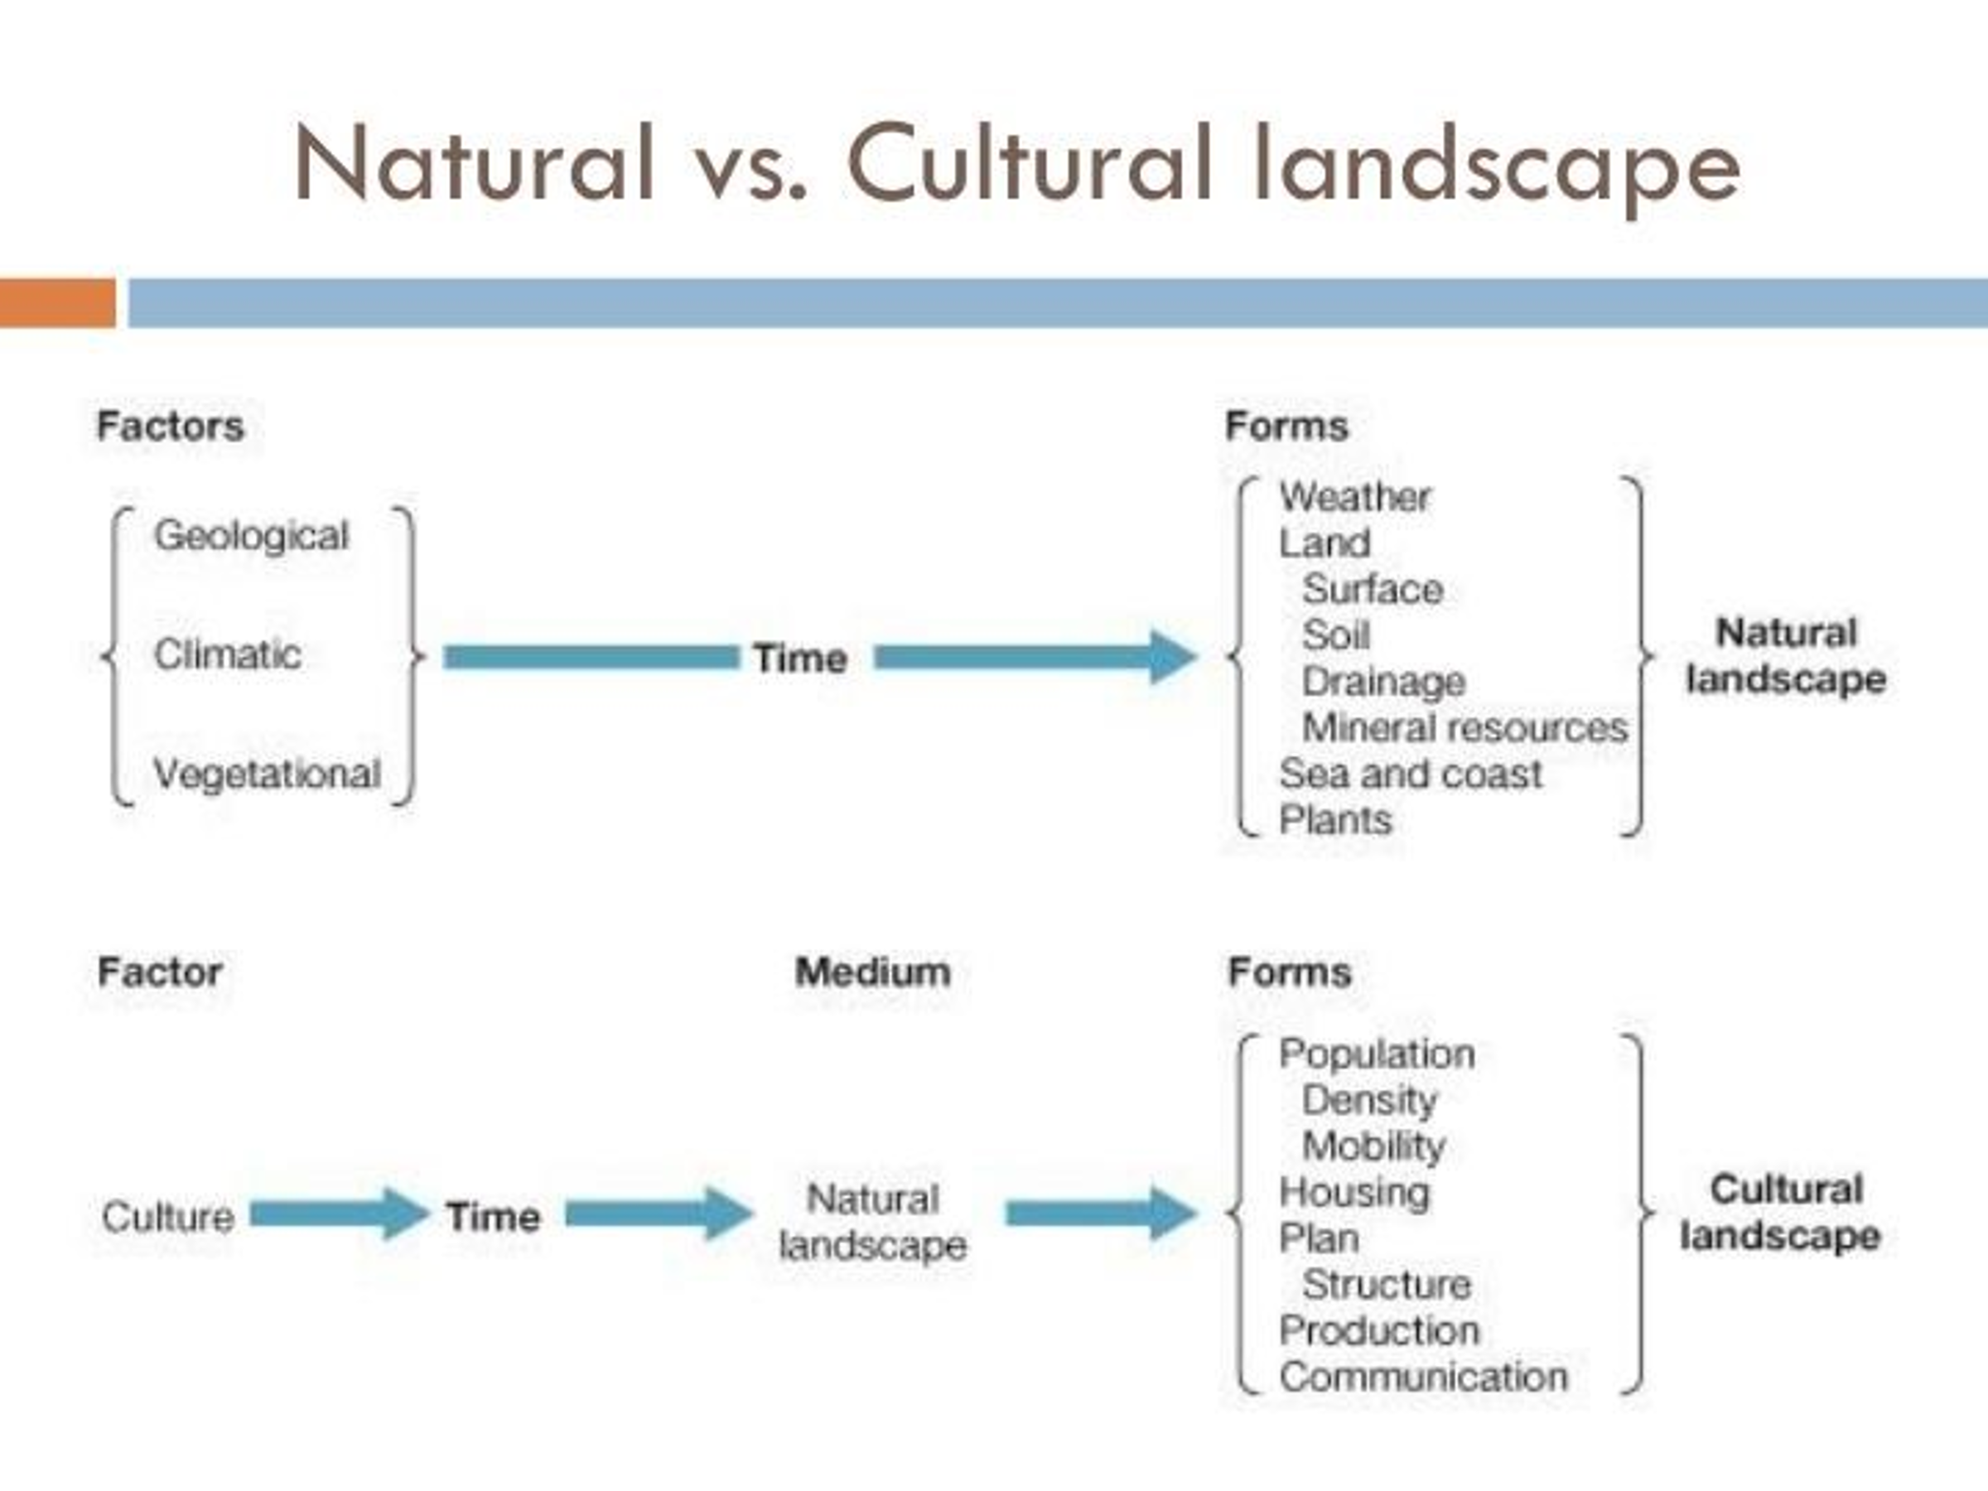

BRIEF: The focus of the research is up to you. You can choose how many elements and which elements to engage with and to concentrate on. You can look at any aspect of the landscape and feel free to approach this with your disciplinary perspective in mind, archaeological, anthropological, historical, environmental, etc. What you chose to use and how you define your landscape will form part of the assessment as will the appropriateness of the sources used. We are not proscriptive about what aspect of landscape characterisation you undertake or from what perspective. You set, define and justify the parameters of the characterisation. You can concentrate on any aspect or period you wish. You are working in a landscape that has a natural history (geology, flora, fauna etc.) prehistoric and historic archaeology, and all set within an active working environment of both a farm and mineral water industry, These are heavily linked to global pressure and forces in terms of function and funding.

The focus you take will vary but be mindful of the sources you use to support your work. Useful websites with source material are

Known scheduled monuments in Ceredigion, Scheduled monuments in Ceredigion - Wikipedia and the List of prehistoric scheduled monuments in Ceredigion - Wikipedia

Royal Commission Archive and particularly the Coflein, . RCAHMW | Royal Commission on the Ancient and Historical Monuments of Wales and RCAHMW | Search Our Records | Coflein

Dyfed Archaeological Trust (search their website for Historic Landscape Characterisation) as well as their interim reports on previous excavations e.g. llanllyrinterim.pdf (dyfedarchaeology.org.uk), Llanllyr Nunnery, Talsarn – Dyfed Archaeological Trust (dyfedarchaeology.org.uk) NOTE: there are four further links to previous interim reports, all of which give some historical background to the site.

PRESENTATION: the format is not proscriptive and should reflect the approach you are taking. Accounts could be factual, objective, report-like in feel, or more personally engaged, experiential, phenomenological, where you pitch it is up to you. Be aware of the word length for both the words and illustrations.

SCHOLARSHIP: Note that you do have ‘use of sources’ in your brief and sources have been given to you via Moodle, reported to you when on the field experiences and reading has been suggested so there is an expectation that these will be engaged with and used. Like all of your work you should understand that you are also engaged in scholarship and that this should be demonstrated – this means read, support your points, cite your sources and add a reference list, provide image numbers and captions for each image you include and refer to them by number in the text. Provide a reference for every idea and every piece of evidence that is not your own (author and date only—you do not need the initials or the title). Be especially mindful of the correct use of capital letters (e.g. for place names) write in complete sentences that make up a paragraph, and use punctuation, capital letters, conventions etc. correctly. Do not string sentences together using comma splices (i.e. compounding points).
As with all work you need to use a recognised referencing system but this can either be Harvard (author/date) or footnotes.

