What does the material culture from Tomb TT99 illustrate about the position of the person in life?
Tomb TT99 is situated within the Theban Necropolis in the upper enclosure of Sheikh Abdel Qurna on the West Bank of Luxor. The tomb owner of TT99 is thought to be Senneferi – not to be confused with the monument of Sennefer nearby, TT96 (Strudwick, 2016a). The titles that appear most frequently regarding Senneferi are ‘overseer of seal-bearers’ ‘chancellor’ and ‘treasurer’. This position would likely have brought with it some prestige and wealth. Senneferi appears to have been most active during the reign of Thutmose III (Strudwick, 2016b). The tomb is believed to date from around the 15th century BCE, the 18th Dynasty of the New Kingdom. There is evidence of theft of burial contents in the main shaft (Shaft I) but no obvious theft of wall paintings (Strudwick, 2016a). It is suggested that the tomb has been looted at least twice, during the late Ramesside robberies and the late 18th and 19th century period of Egyptomania. The tomb consists of four areas: the superstructure, an open courtyard, a chapel and the below ground burial shafts (Strudwick and Strudwick, 2016). The main focus will be on burial shaft I and the artifacts found there but the other areas will be explored briefly first.
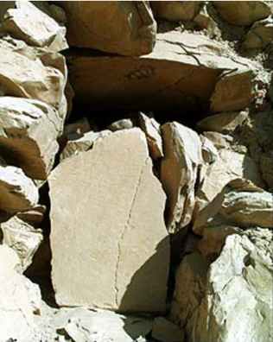
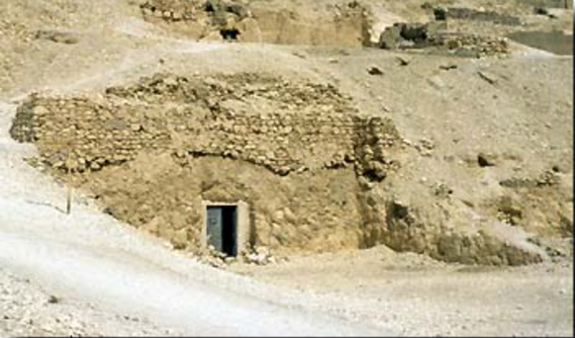
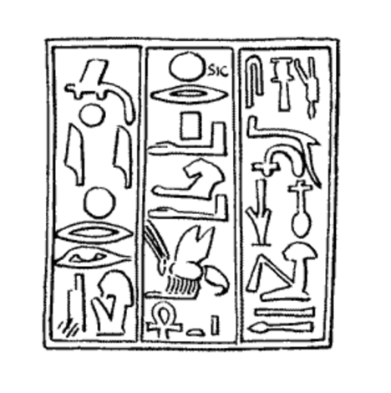
The superstructure refers to the above ground part of the tomb, the façade in this case, which also has a niche above the entrance door, see figures 1 and 2. It was originally thought that superstructures were uncommon and confined to the Ramesside Period (19th and 20th Dynasty), however TT99 is of 18th Dynasty and actually common layout (Strudwick and Strudwick, 2016). This suggests that the owner was non-royal but still had enough wealth and status to build a tomb as a member of the elite. It was also common (to elite tombs) in the 18th Dynasty to have a niche in the façade (figure 2) as opposed to a separate structure; there is no evidence of a flat area or foundations to have built a separate superstructure on (Strudwick and Strudwick, 2016). This illustrated the limitations of the area but also of Senneferi’s wealth and power as the structure of the tomb itself is not monumental but rather typical of 18th Dynasty elite tombs. 1320 stamped funerary cones were found throughout TT99, 251 were whole or partial cones, 9 bricks and 1060 fragments. These funerary cones had the name of Senneferi as well as others. Figure 3 shows the cone DM 154 which has been identified as Senneferi, there were 130 examples throughout the whole complex. These funerary cones may have been used within the façade in two rows comparable to TT87, however due to disturbance it is impossible to be certain (Strudwick and Strudwick, 2016).
Figure 2: Niche above entrance (Strudwick, 1997 – 2018b)

Figure 1: Façade of TT99 (Strudwick, 1997-2018a)
Figure 3: Cone of Senneferi DM 154 (Davies and Malcom, unknown)
The courtyard is an open courtyard but may have had a front enclosing wall that no longer exists, it is an irregular rectangle, and the true extent cannot be determined as it slopes towards tomb TT100. Most of the contents found in this area are of a later period in the tombs history as opposed to being of the 18th Dynasty. However, there are indications that either side of the tomb entrance there may have been trees or other plants. These are an early example as it is not well documented in the 18th and 19th Dynasties, the trees themselves may have acted as a resting place for the deceased’s ba (Strudwick and Strudwick, 2016). Whilst the courtyard itself is typical of elite 18th dynasty tombs, the trees are not, this may be due to the loss of organic materials over time rather than a sign of Senneferi’s position.
The Chapel is also common to the 18th dynasty, an inverted t-shape form with a broad front room and corridor leading to the rear room. Within the Chapel there were pillars and an offering or statue niche. The varying quality of the rock has impacted the survival of features as well as rock falls and human interaction. Two types of plaster were used for the walls, one finer and one coarse, as well as instances mixing plaster and stone, and using Nile silt, though this may be later in date. Tomb paintings within the Chapel are in differing degrees of preservation but there was the ancient removal of certain gods during the Armana Period (Strudwick and Strudwick, 2016). This demonstrates the importance of understanding the impact of environmental factors and human interaction in how the tomb is now presented and the incomplete nature of it.
There are several burial shafts in TT99, shafts A-F located within the chapel were later additions in the Third Intermediate Period. In the courtyard areas there are three shafts, G, H and I. Shaft G appears unfinished, this may be due to a fault in the rock, within the shaft there was a mixture of contents including modern material. Shaft H was also unfinished, although one room may have been completed and mainly contained more modern material. Some 18th Dynasty material has been identified including a fragment of a blue faience bracelet, a wooden headrest with a slot through the middle for the upper part and a large faience shabti. In shaft H there was the remains of at least 21 unidentified individuals potentially interred in two phases, phase one between the reign Thutmose II and Thutmose III and second phase between Amenhotep III to Horemheb (Strudwick and Strudwick, 2016). The continued use of the tomb after the death of Senneferi may suggest that he remained known to either relatives or those buried there, this may be due to his position as an elite and official in life. One of his relatives is depicted in statue form, Senneferi’s son-in-law Amenhotep whose tomb C.3 is 60m away, however it is unclear how this statue came to be in shaft H. As is an issue with many ancient tombs, thieves have removed fill and ransacked bodies, this was possibly in the New Kingdom but may have been looted again later (Strudwick and Strudwick, 2016).
The main burial shaft was shaft I, it is 14.25m deep, one of the deepest knowns in the area and time period. It’s 18th dynasty and produced a large number of finds including, over 100 fragments of granite for a false door - one fragment bearing his name, potential limestone stelae fragments, papyri, coffin fragments, ceramics, jar labels, human remains, animal remains and a currently unidentified large sandstone object. The human remains were identified as two males and three females, one female was elaborately mummified and covered in some plaster-like substance, this is potentially his wife Taiamu.
From Shaft I several small fragments of at least four anthropoid coffins were recovered. The majority of fragments found in Shaft I were small (rarely larger than 30cm) which limits the understanding of what the entire coffin would have looked like, though it does show that coffins for more than just the tomb owner could be afforded. The coffins were thoroughly smashed though it’s impossible to tell when. Fragments cannot be identified as belonging to a specific coffin, although it is clear one or more of the coffins belonged to the tomb owner Senneferi. One fragment has his name and three his principal title. The consistency of style suggests some of them belonged to close contemporaries or immediate family of Senneferi. The style that can be identified is that of the ‘Black’ type coffins from the middle 18th Dynasty to early 19th Dynasty however, black coatings on coffins can be attested in the Middle Kingdom (Taylor, 2016 and Fulcher, et al. 2021). These ‘Black’ type coffins replaced the preceding ‘White’ type coffins during the reign of Hatshepsut/Thutmose III with most examples coming from the Theban Necropolis (Sartini, 2015). This style of coffin usually was comprised of a lid and a case, which was normally deeper than the lid, with angled walls and a flat base. They were constructed from two different pieces of wood joined using dowels and clamps that required considerable care to be taken at all phases of construction. The coffin would have been anthropoid and depicted the image of the deceased as a transfigured spirit or sah in wrapping with the head exposed. The contours of the body were represented as well as headdresses, a wesekh collar with falcon-head terminals on the upper breast and below that a vulture or the kneeling goddess Nut with wings outstretched as a protective symbol (Taylor, 2016). Due to the fragmentary nature of the coffins, it is impossible to be certain which elements are shared with existing examples of the ‘Black’ type coffins of the New Kingdom.
What can be explored is the treatment of the coffin fragments as it varied, some were covered in a base layer of linen with white plaster attached for inscription and design, with an overlay of gold leaf and black varnish on blank surfaces. Gilding and black varnish was sometimes replaced by black and yellow paint for a lower cost. Persons of higher status had two or three anthropoid coffins sometimes enclosed in a wooden case. There may be evidence of this as two wooden beards found in Room 3 may be two male burials or from the same burial attached to an inner and outer coffin (Taylor, 2016). The ‘varnish’ mentioned refers to the superficial heterogeneous organic layer covering the coffins, and the polychrome paint was usually matt. In the New Kingdom there were two varnishes used black and yellow, which has darkened over time (Sartini and Nardella and Ribechini, 2019). Black in ancient Egypt could be used to symbolise many things including, Osiris and the underworld, night particularly when used with yellow or gold, and fertility and regeneration (Fulcher, et al. 2021). The yellow varnish equally may have had religious interpretations relating to the sun and light, along with promoting healing and rebirth. The colour yellow was also seen as the flesh of the gods and a symbol of life and growth (Sartini and Nardella and Ribechini, 2019). Several elements used to create the black varnish would have needed to be imported – bitumen, conifer resin and Pistacia resin. Bitumen may be from the Black Sea but there are sources in Egypt. Conifers are available to the north in the east Mediterranean. Pistacia resin was likely from the Levant (Fulcher, et al. 2021). Components may be Pistacia resin heated and mixed with binders such as, protein (egg and animal glue), carbohydrates (vegetable gums) and lipids (oil and beeswax). Beeswax mnḥ was linked to the sun and the transition between life and death (Sartini and Nardella and Ribechini, 2019).
On some of the coffins in Shaft I, black varnish was used on the fine-grained reddish wood, sometimes directly on wood or over a layer of linen or plaster. There is also evidence of yellow paint, yellow varnish, gilding on a few pieces and loose gold leaf (Taylor, 2016). Gold leaf was expensive, and paint was a cheaper alternative with carbon black being the most common pigment in ancient Egypt for black paint (Sartini and Nardella and Ribechini, 2019). However, the coffins appear to have been sparse in decorative elements which is in line with early black type coffins (Taylor, 2016). The presence of gold leaf and black varnish illustrate the access Senneferi had as much of the ingredients used needed to be imported, unfortunately testing on the varnish on these fragments has not been done and no concrete conclusion can be drawn on the composition. Eleven small fragments with a different light-coloured coarse wood had black paint, not varnish which would have been cheaper and the quality of the wood is worse. It is proposed that this coffin may be later in date then Senneferi (Taylor, 2016).
The owner of TT99 Senneferi was a member of the elites during the New Kingdom (18th Dynasty) most active during the reign of Thutmose III, his tomb reflects his status and wealth (Strudwick, 2016b). The architecture of his tomb is typical for the most part of a 18th dynasty tomb, his burial shaft is however deeper than usual. Several stages of looting have taken place in this tomb and human interaction has undoubtedly altered it. The ‘Black’ type coffins are interesting as they are from early on in their introduction suggesting that Senneferi may have been aware of new and changing funerary practices. The architecture and coffin fragments explored here illustrate his position within society as an elite but offers little beyond that, perhaps his character may be clearer in other aspects of material culture such as wall painting and papyri. Overall, TT99 leaves no doubt that Senneferi was in life an elite member of Ancient Egyptian society.

Reference List
Davies and Malcom (unknown) Cone of Senneferi DM 154. [drawing] in Strudwick, N. and Strudwick, H. (2016) ‘The tomb, its architecture and history.’ In Strudwick, N. (ed) The Tomb of Pharaoh’s Chancellor Senneferi at Thebes (TT99). Oxford: Oxbow Books pp. 45-83
Fulcher, K. et al. (2021) ‘Molecular Analysis of Black Coatings and Anointing Fluids from Ancient Egyptian Coffins, Mummy Cases, and Funerary Objects.’ Proceedings of the National Academy of Sciences of the United States of America, 118 (18), pp. 1–10.
Sartini, L. (2015) ‘THE BLACK COFFINS WITH YELLOW DECORATION: A TYPOLOGICAL AND CHRONOLOGICAL STUDY.’ Egitto e Vicino Oriente, 38, pp. 49–66.
Sartini, L. et al. (2019) ‘GC/MS ANALYSES OF VARNISHES FROM BLACK COFFINS WITH YELLOW DECORATION OF THE NEW KINGDOM IN THE EGYPTIAN MUSEUM OF FLORENCE.’ Egitto e Vicino Oriente, 42, pp. 69–82.
Strudwick, N. (1997-2018a) Façade of TT99. [photograph] Available at: https://tt99.fitz.ms/architecture/super.html (Accessed on: 6th March 2026)
Strudwick, N. (1997-2018a) Niche above entrance. [photograph] Available at: https://tt99.fitz.ms/architecture/super.html (Accessed on: 6th March 2026)
Strudwick, N. (2016a) ‘Introduction.’ In Strudwick, N. (ed) The Tomb of Pharaoh’s Chancellor Senneferi at Thebes (TT99). Oxford: Oxbow Books pp. 1–7.
Strudwick, N. (2016b) ‘Senneferi, his family and related monuments.’ In Strudwick, N. (ed) The Tomb of Pharaoh’s Chancellor Senneferi at Thebes (TT99). Oxford: Oxbow Books pp. 8-36.
Strudwick, N. and Strudwick, H. (2016) ‘The tomb, its architecture and history.’ In Strudwick, N. (ed) The Tomb of Pharaoh’s Chancellor Senneferi at Thebes (TT99). Oxford: Oxbow Books pp. 45-83
Taylor, J. (2016) ‘The coffins from Shaft I.’ In Strudwick, N. (ed) The Tomb of Pharaoh’s Chancellor Senneferi at Thebes (TT99). Oxford: Oxbow Books

