Cover Page

Table of Contents
Introduction 1
Task 1. e-Commerce Website builders or software solutions 1
1.1 WooCommerce 1
1.2 Wix 4
Task 2. Mind-map of contemporary software applications 4
a. Mind mapping and explain the benefits of using mind mapping in business operations 4
b. Create a mind map of contemporary software applications 6
Task 3. Office Applications 6
a. Four office software solutions for business operations 6
MS Word 6
MS PowerPoint Error! Bookmark not defined.
MS Excel 8
MS Access 9
b. Practical demonstration of Two Office Features 10
Mail Merge 10
If Statement 14
Task 4. Communication and Collaboration applications 15
a. One contemporary Communication and one Online Collaboration applications/tools 15
MS Outlook Error! Bookmark not defined.
MS Teams 16
b. One feature of a freely available Communication (1) and one feature of a Collaboration (1) application 17
MS Outlook 17
Ms Teams 19
Conclusion 20
References 20

Introduction
In modern business environments, effective communication tools are essential for supporting remote work, team coordination, and real-time information sharing. Microsoft Teams has become one of the most widely adopted communication platforms, offering a unified space where users can send messages, hold video meetings, share files, and collaborate seamlessly. As part of the Microsoft 365 ecosystem, Teams integrates multiple communication channels into one interface, making it a powerful tool for organizations that require flexibility, speed, and reliability. Its combination of instant messaging, voice and video calls, and collaborative features enables both synchronous and asynchronous communication, ensuring that teams can stay connected and productive from any location.

Task 1. e-Commerce Website builders or software solutions

1.1 WooCommerce
WooCommerce is a popular open-source e-commerce plugin designed for WordPress, enabling users to create fully functional online stores with ease. Developed by Automatic in 2011, WooCommerce allows businesses to sell physical and digital products, manage inventory, process secure payments, and customize storefronts without extensive technical expertise.
One of its main advantages lies in its integration with WordPress, which provides access to thousands of themes and plugins, offering flexibility and scalability for small to large enterprises.

WooCommerce supports multiple payment gateways, including PayPal, Stripe, and credit card payments, as well as regional options for local markets. It also facilitates seamless tax and shipping management, along with analytics tools for sales tracking and customer insights. The platform’s open-source nature allows developers to extend its functionality using REST APIs and custom extensions, making it highly adaptable to specific business needs.

From a usability perspective, WooCommerce’s dashboard offers an intuitive interface for product management, order processing, and customer communication. Its SEO-friendly architecture, inherited from WordPress, enhances visibility and traffic. generation. However, while WooCommerce is free to install, many advanced features. features such as premium themes, plugins, and hosting—may incur additional costs. Overall, WooCommerce remains a leading e-commerce solution due to its affordability, customization options, and strong community support.

1.2 Wix

x is a cloud-based website development solution that assists in designing and managing visually appealing websites without having to possess advanced computer programming skills. Since being established in 2006, Wix has emerged as a top website development solution provider that offers an integrated solution set to support e-commerce functionality. This solution provides a Drag-and-Drop Editor that makes website development incredibly easy for small to medium-sized enterprises (SMEs) to efficiently create an online presence.
For e-commerce platform development, Wix provides an e-commerce solution, which consists of features such as customizable templates, payment processing, inventory management, and mobile optimization tools. Businesses using this platform allow customers to connect different payment systems, including PayPal, Stripe, and credit cards, providing them with flexibility.

Besides, to promote as well as maintain customer interest, advanced marketing features such as email marketing, search engine optimization, and analysis tools are also available in this platform. The App Market of this platform further assists by providing integration capabilities for different tools, including shipping, accounting, and CRM tools.
Wix also features scalability via its store solution for inventory management, which helps in order fulfilment processes for large quantities of products. However, even as it provides convenience and an affordable solution, it may also prove to be restrictive in terms of flexibility in backend control, as in open-source platforms like WooCommerce or Magento.
In general, Wix is an easy-to-use, cost-effective e-commerce platform that is perfect for those who wish to create a professional e-commerce site hassle-free.

Task 2. Mind-map of contemporary software applications

Mind mapping and explain the benefits of using mind mapping in business operations
Clarity and Organization Improvement One of the biggest benefits of mind mapping is that it makes complex information visible. For instance, as opposed to having to scroll down a page of lengthy texts, mind maps allow an individual This makes it possible for teams, as well as team managers, to get an idea of what they are dealing with, as well as prevent them from overlooking hidden relationships between different aspects of a business initiative.to map out key goals, roles, and other things around a central project theme.
MindManager Blog Mind maps help in prioritizing tasks by identifying the small, inter-related tasks that constitute large, daunting tasks, by creating visual relationships between them.
Enhancing Creativity & Idea Generation
As mind mapping stimulates thinking in an irregular, branched manner, it is an effective tool for innovativeness and creativity. By beginning from a central idea, mind mapping allows thoughts to branch out in all possible directions, which makes teams less susceptible to linear thinking patterns.
business.com
The addition of colours, pictures, and visual elements also encourages creative thinking as well as memory recall. for business operations, this implies that functional areas in an organization, for instance, marketing, product development, or strategic planning, can apply mind mapping to investigate novel thoughts, identify latent opportunities, as well as promote interventional ideation.
Mind maps provide a collective visual tool, which is further built upon in a team environment, allowing for real-time editing as well as group review of this collective resource. When using a mind map during a meeting, all attendees understand how their input is connected to all other input in relation to the central idea, as they have a collective visual to work from.
A business always faces complex problems, as well as multiple variables. Mind mapping assists in understanding the entire domain of a decision, including choices, risks, resources, etc. Decision trees, or solution pathways, allow teams to explore root causes of problems, examine different solutions, and understand how different variables interrelate. Decision trees provide a visual map to guide team decisions, making them more informed and more transparent as a result.
As information is structured, it is easy to comprehend, even if a team member is not present, as they would not spend time interpreting documents, explaining what needs to be accomplished, and so forth. Mind maps allow for easy review, revision, and planning of actions to be taken Project planning, for instance, is facilitated because milestones, dependencies, as well as responsibilities, can all be represented in one map, which in essence reduces planning time.
Learning support, training, and development
Mind maps, in addition to planning and implementation, find applications in learning as well as in training new team members by documenting processes. As mind maps portray interlinking ideas, they also work well in recalling and understanding concepts.
In business operations, this implies that maps can be employed to create visualizations of standard operating procedures, workflows, as well as lessons from previous projects—adding to the idea of continuous improvement. Summary In conclusion, mind mapping is an extremely useful tool in business processes. Mind mapping increases understanding, stimulates creativity, facilitates teamwork, assists in reaching decisions, increases productivity, and facilitates learning. Offering a visual structure that reflects the functioning of the brain, which expands from a central idea, it helps teams organize information, create ideas, synchronize strategies, and implement them effectively.

Create a mind map of contemporary software applications
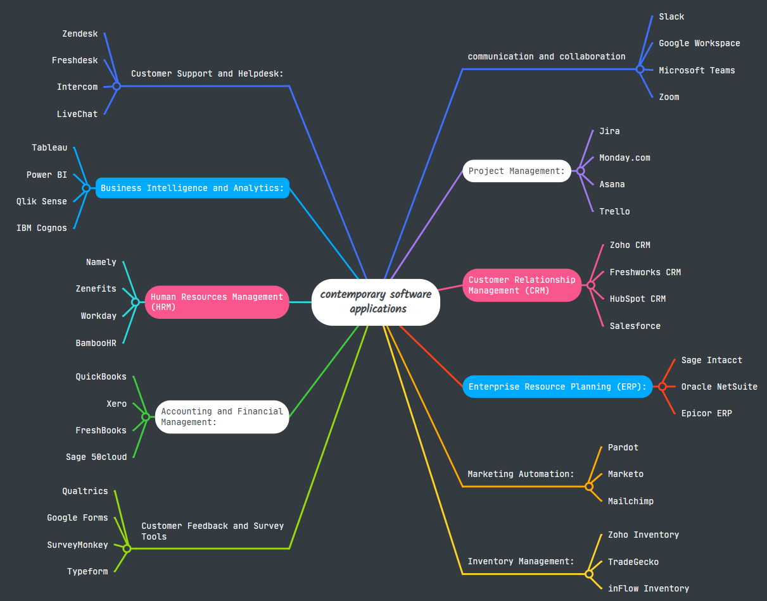

Task 3. Office Applications

Four office software solutions for business operations

MS Word
Microsoft Word is recognized as one of the most used word processing software in the world, in addition to being an essential component of Microsoft Office applications. Ever since Microsoft Word came into existence, it has completely changed the way people create, modify, as well as distribute text documents. As an efficient office solution, MS Word is an essential part of business operations in organizations for producing documents.

One of the significant benefits of Microsoft Word is that it is quite versatile when it comes to creating documents. Businesses find it useful for creating documents such as writing reports, preparing business letters, composing proposal documents, creating business brochures for companies, as well as documenting meeting minutes. Microsoft Word also has several document templates that allow companies to create documents easily. For example, companies can utilize resume, invoice, and business letter templates, which save time, as well as maintain uniformity in the documents of companies. Furthermore, Microsoft Word is also capable of creating different styles, allowing companies to maintain a uniform professional look.

The other important aspect of Microsoft Word is the editing, and collaboration features it contains. Collaborations in today’s workplace require teamwork and effective communication, which is also supported by Microsoft Word’s real-time collaboration enabled by OneDrive and SharePoint, permitting several people to work simultaneously on a document. This makes collaborating even more efficient by providing an easy means of editing a document, as it removes the possibility of people being confused by different versions of documents. Microsoft Word’s “Track Changes” is also an efficient means of approving documents, which is important in an official working context to maintain accountability.

From an operations perspective, Microsoft Word also increases business productivity and efficiency. Microsoft Word comes equipped with inbuilt features that include spell check, grammar check, as well as suggestions using artificial intelligence algorithms. Such features help employees preserve professionalism in writing, at the same time as they save time that would have been used in manually reviewing documents for writing errors. Such advanced features as mail merge also help organizations implement an automated process for sending personalized letters to clients, for example, using emails, which otherwise may require a lot of time to accomplish manually.

Integration is another important strength of Microsoft Word in a business setup. Microsoft Word integrates perfectly well with other Microsoft Office applications, including Excel, PowerPoint, and Outlook. For instance, a user can incorporate data from an Excel spreadsheet into a Word report, as well as attach a Word document to an email using Microsoft Outlook, all from within Microsoft Word itself.

Additionally, Microsoft Word has both security and accessibility capabilities that make it an appropriate tool for both small and large organizations. The program provides password protection for documents, permissions, as well as cloud storage for document backups inversions. Furthermore, Microsoft Word’s accessibility features, such as text-to-speech capabilities, support for screen readers, ensure that everyone in an organization, including those who are visually impaired, can utilize this program effectively. Cross-platform capabilities of Microsoft Word to run on Windows, Mac, as well as smartphones, also make it possible for employees to work from anywhere to access documents for editing at any time. Conclusion
Therefore, Microsoft Word is an essential component of business processes because of its strong capabilities, teamwork, and integration features. Microsoft Word helps organizations create high-quality documents in an efficient manner, facilitates teamwork by collaborating in Microsoft’s cloud, and further boosts work efficiency by automating work processes using Artificial Intelligence support. As an integral part of office applications, Microsoft Word continues to remain an essential tool for facilitating effective business processes of communication, documentation, as well as management.

MS Excel
Microsoft Excel continues to be a commonly utilized business software that serves as a versatile tool in the management and analysis of data in various functions. Microsoft Excel’s usability, affordability, and versatility allow companies of different sizes to utilize it as a tool in improving efficiency and optimizing regular business workflows.

One of the primary ways in which Microsoft Excel has benefited the business world is through the data management functions that it provides. Microsoft Excel allows data managers or business users to handle large volumes of data via tables, filtering mechanisms, and data validation functions. For example, companies are able to maintain databases or contact lists and personnel rosters. This helps in ensuring that data accuracy and consistency are not compromised. The data environment provided by Microsoft Excel helps in ensuring that there are fewer errors in data through data validations and conditional formatting functions.

Microsoft Excel also plays other important functions in data analysis and decision-making. The functions implemented in the software include VLOOKUP function, INDEX-MATCH function, SUMIFS function, and PivotTable analysis functions. These functions make it possible to perform complicated analyses in Microsoft Excel with little technical know-how. The use of Microsoft Excel provides managers with the ability to track sales and create estimates based on this data. This further provides managers with the capacity to calculate the overall performance based on the data obtained.

Furthermore, Microsoft Excel is widely utilized in financial manage.

MS Access
Microsoft Access can be defined as the Database Management System (DBMS) developed in support of small- to medium-scale business activities in order to allow effective data processing and generation of reports. Microsoft Access being part of the Microsoft Office family provides organizations with an affordable and accessible tool that would otherwise not require advanced technological know-how and infrastructure investment in order to perform business-related data functions in terms of data organization, automation, integration, and report generation.

The first benefit of Microsoft Access is that it has the capability of centralizing business information. This is the case because most companies handle vast amounts of information such as customer information, inventory information, business transactions, and employees’ information. Microsoft Access makes it possible for this information to be arranged in relational tables and hence reduces information duplication. This functionality enables companies to be able to relate information such as customers’ information with orders.

Apart from data management, Access provides support in terms of forms and queries. The forms in Access allow users to create customized interfaces that pertain to business-related procedures. For example, employees can use the forms in Access to create data in a more accurate manner. The query feature in Access enables users to obtain information quickly from the database regarding products or services that are overdue or in short supply. The queries in Access support parameter queries and action queries. For instance, users can obtain up-to-date prices or delete outdated information.

Automation is another significant benefit. The Microsoft Access software allows users to use macros or Visual Basic Applications (VBA) in automating many routine functions in the software. For example, users can use macros or Visual Basic Applications (VBA) in automating the process of generating reports or sending notification emails. This not only reduces possible human errors but also boosts productivity in various business functions. For example, companies can use this software to create automatic sales reports every week and send them via email.

Further enhancement in functionality comes with the ability to interface with other applications from Microsoft and other developers. The databases in Access are perfectly compatible with Excel, Outlook, SharePoint, and Microsoft's SQL Server. This makes interapplication functionality possible and helps small business owners start with Access and later migrate to more complex systems based on business requirements.

Further, Access provides business intelligence support through its reporting feature. The software enables users to create customized reports with information regarding key business performance indicators like sales, expenses, or the number of customers. This feature of Access enables users to take effective business decisions based on data analysis. The software provides users with templates and wizards that help create professional-looking reports and documents even without technical expertise. Despite not being suited for larger or more complex databases, Microsoft Access can be considered an effective tool in many business-related functions. This database software provides functionality, usability, and affordability in one tool that makes it more suitable than ever before for many small business needs regarding information management.

Practical demonstration of Two Office Features

Mail Merge

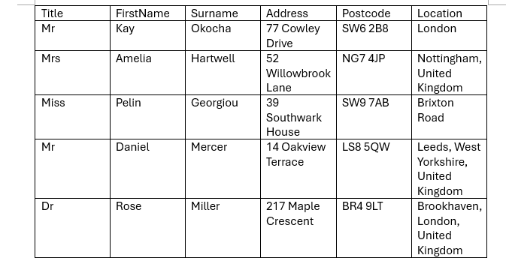





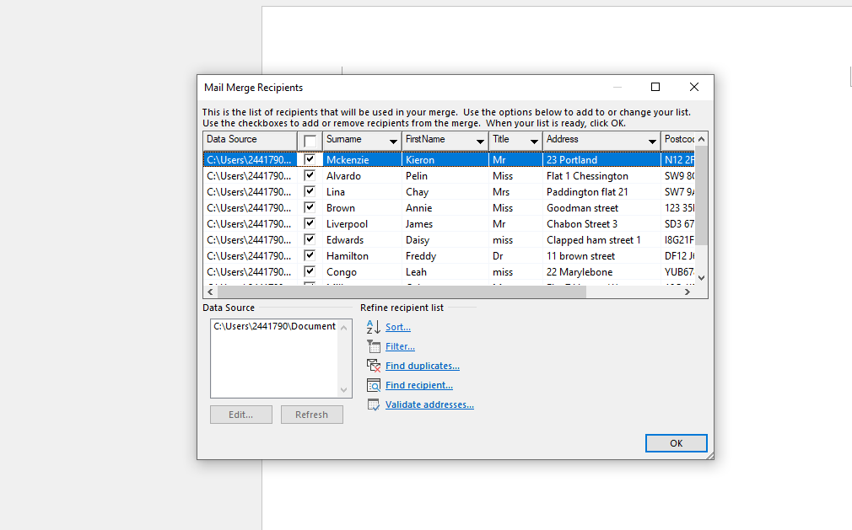



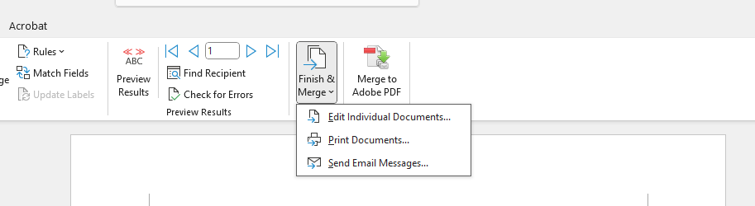



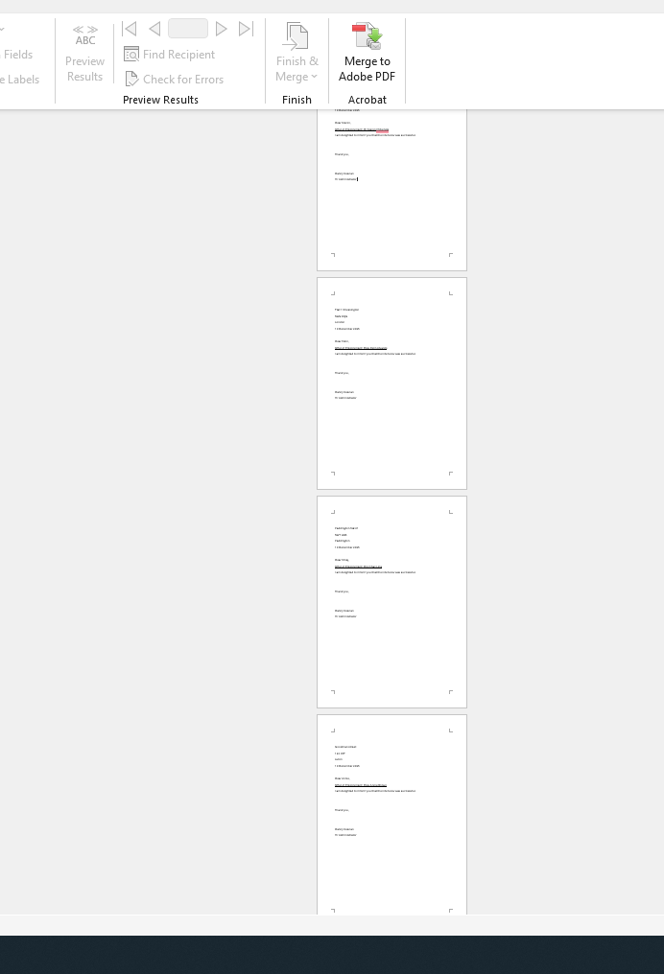

If Statement


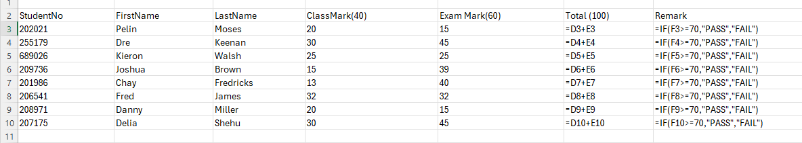

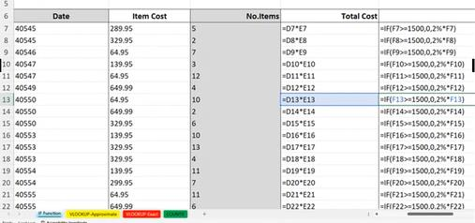

Task 4. Communication and Collaboration applications

One contemporary Communication and one Online Collaboration applications/tools

Microsoft Outlook is well-known as one of the most frequently used applications in the realm of electronic mail communication and personal information management. The software provides a broad range of communication functions in relation to email communication, the calendar system, personal contact management, and task management. Talking about the software’s position in the communication process, Microsoft Outlook is seen to deliver secure and trustworthy email services that support both asynchronous and synchronized communication approaches. Various functions of this software are directly linked with information prioritization and management.

Microsoft Outlook's greatest feature lies in its use in combination with other Microsoft 365 tools. The software allows individuals to create meeting invites through the calendar feature in the software. This feature helps in ensuring smooth transitions in business processes. The software incorporates advanced levels of IT security features such as multi-factor authentication, spam protection, and encryption methods. This helps in ensuring business data remains secure. The software also includes a mobile interface that provides flexibility in accessing business-related emails and schedules from distant locations. This feature keeps Microsoft Outlook up-to-date and able to support communication in business entities.

Microsoft Teams, in more feature-laden and business-tailored shape

Microsoft Teams is a cloud-based service with the capacity to facilitate collaboration in real-time among teams that are distributed. Microsoft Teams can integrate communication and collaboration features like messaging, video meetings, file sharing, and co-authoring in one interface. Microsoft Teams enables guided collaboration through channels that users create based on organizational groups or functions (such as HR or projects) to share files, have conversations, or co-author Microsoft Office documents such as Word or PowerPoint.

One of the key features of Teams that defines the platform is the functionality that enables real-time collaboration between users through video meetings, screen sharing, and the use of whiteboard services. The platform also provides functionality that enables the automation of workflows and integration with other apps. The collaboration functionality of Teams is protected by enterprise levels of compliance and data protection mechanisms. Conclusion: Microsoft Outlook and Microsoft Teams together provide a complete platform that boosts productivity. Microsoft Outlook helps handle mail effectively, and Microsoft Teams provides effective collaboration functionality by allowing users to engage with each other in real-time and access common documents. Microsoft Teams and Microsoft Outlook are necessary in today’s digital transformation process in terms of improving communication and collaboration.

MS Teams
In today's digital workplace, companies need platforms that work together to make communication, information sharing, and teamwork easy. Microsoft Teams has emerged as one of the most widely adopted solutions for these needs, offering a unified space for messaging, audio–video conferencing, file management, and teamwork. As part of the Microsoft 365 ecosystem, Teams provides users with a comprehensive suite of communication and collaboration functionalities that align with the increasing demand for remote and hybrid working environments.
Microsoft Teams provides an extensive range of communication features that support both synchronous and asynchronous interactions. Its core communication capabilities include instant messaging, voice calls, and high-definition video conferencing. Instant messaging allows team members to exchange messages quickly, share multimedia content, and tag colleagues for attention. Features such as message threads, reactions, and chat search functions help users manage conversations efficiently.

For synchronous communication, the platform offers voice and video calls with support for screen sharing, meeting recording, and live captions.

Microsoft Teams as a Contemporary Communication Tool

Microsoft Teams provides an extensive range of communication features that support both synchronous and asynchronous interactions. Its core communication capabilities include instant messaging, voice calls, and high-definition video conferencing.

One feature of a freely available Communication (1) and one feature of a Collaboration (1) application

MS Outlook





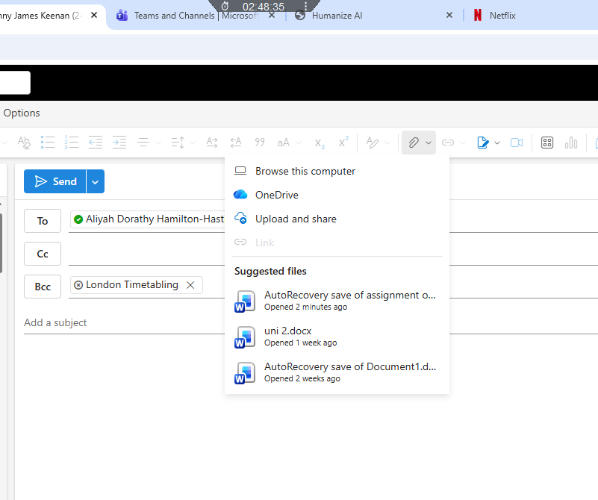
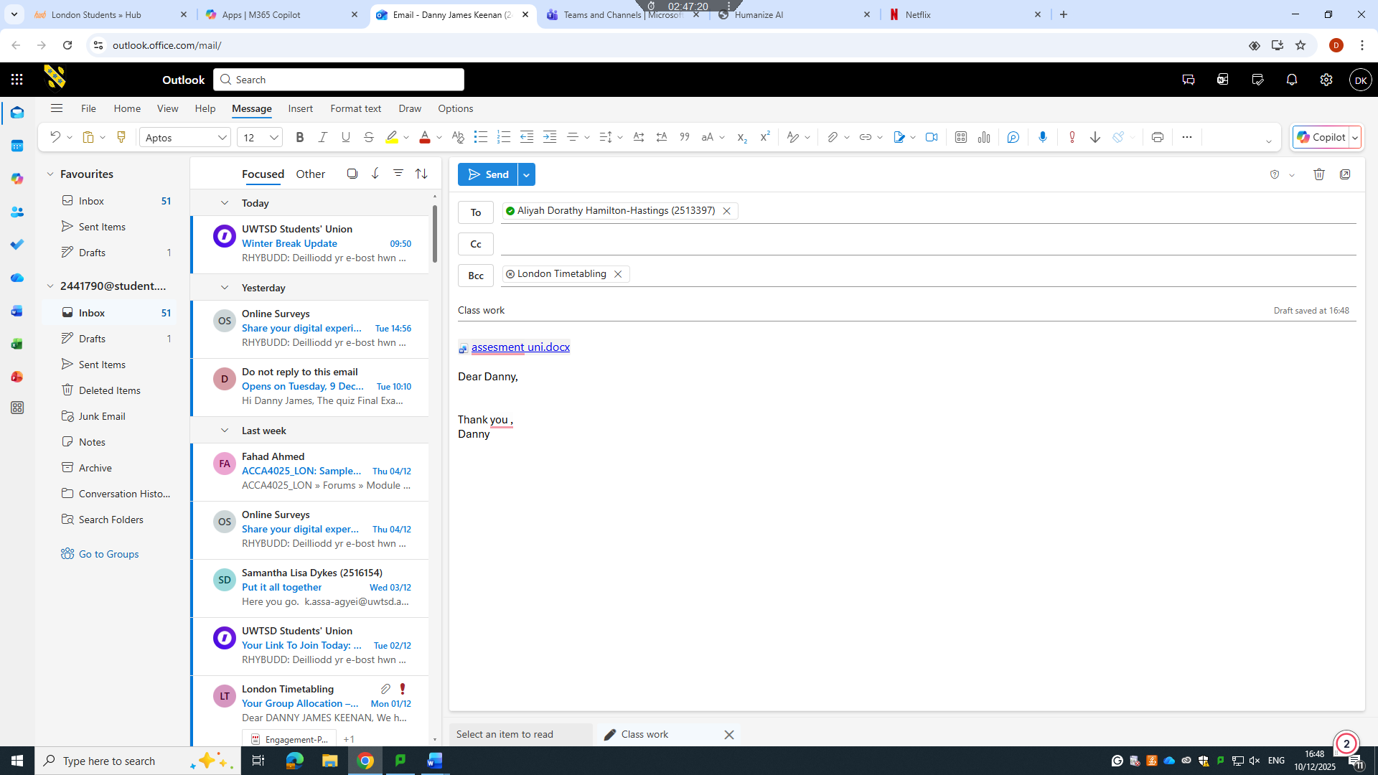

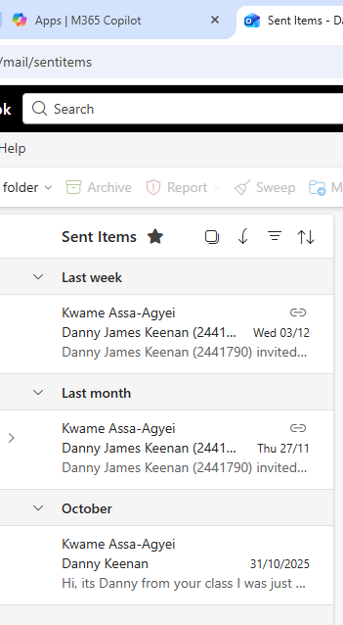

Ms Teams

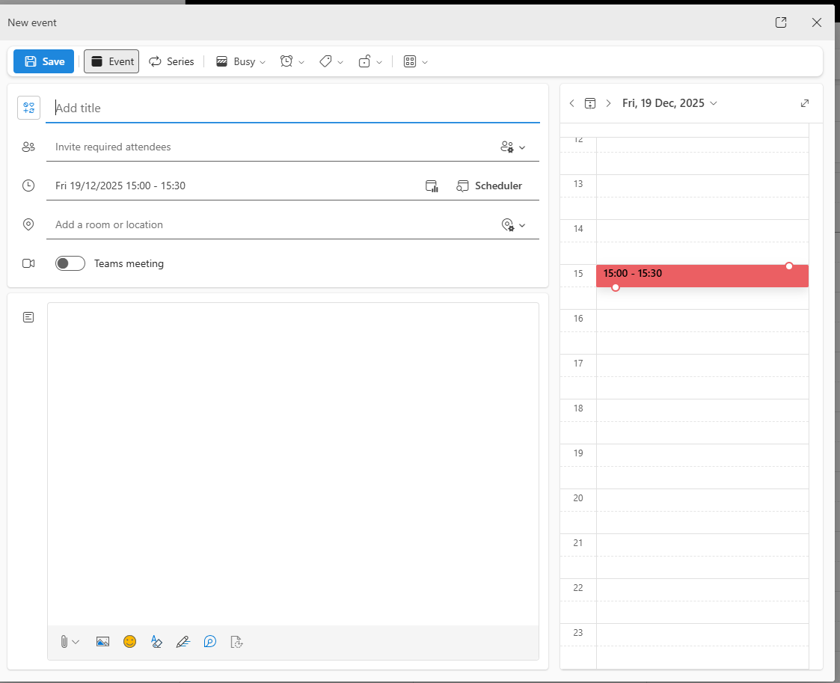
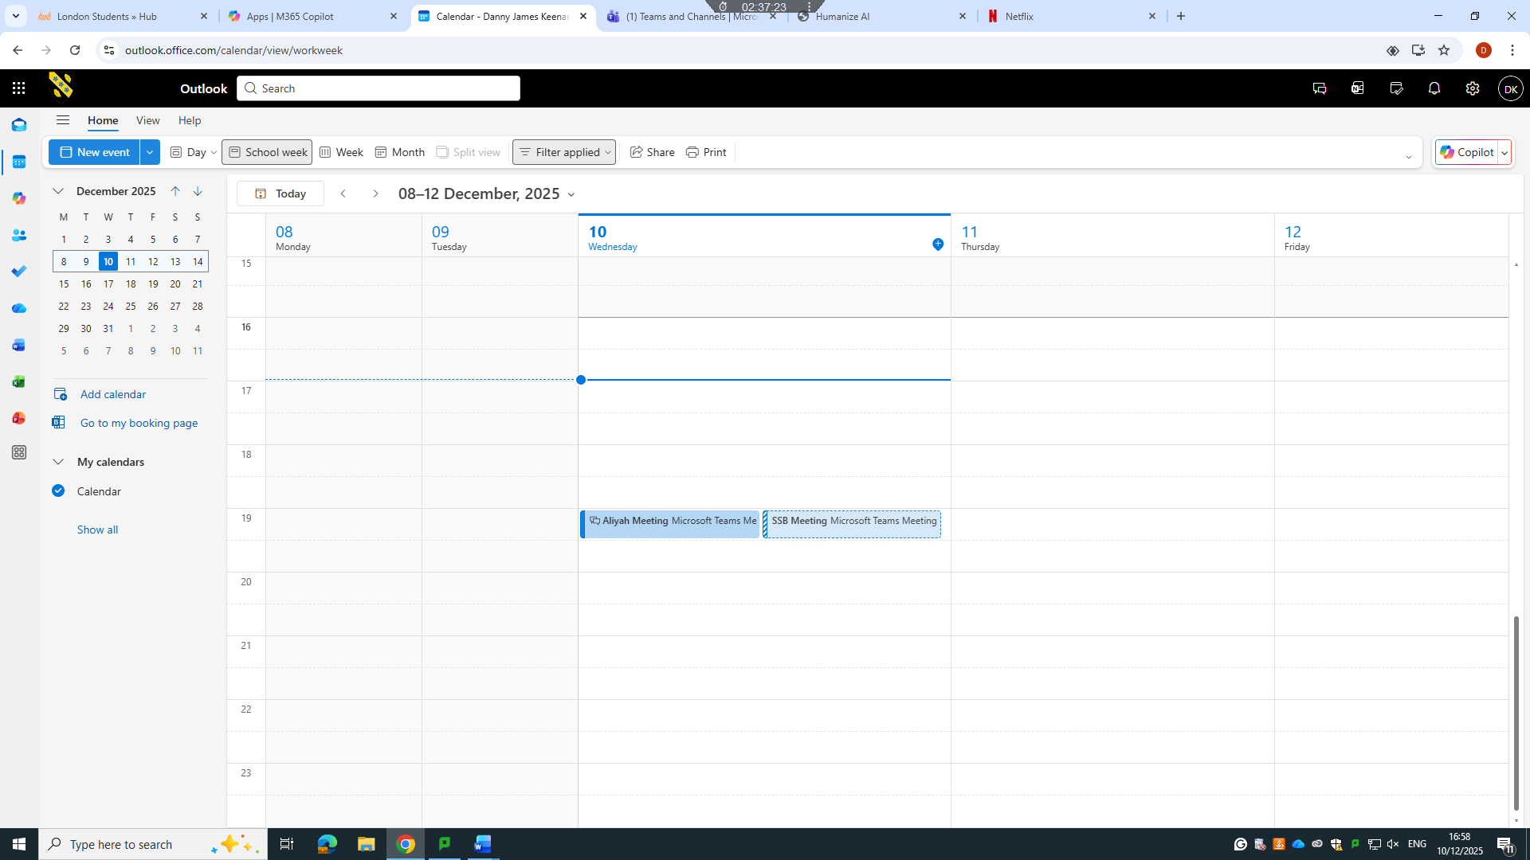

Conclusion
In conclusion, Microsoft Teams has established itself as a key communication and collaboration tool in today’s digitally driven workplaces. Its ability to integrate messaging, video conferencing, file sharing, and real-time co-authoring within a single platform allows teams to work more efficiently and stay connected regardless of location. By supporting both synchronous and asynchronous communication, Teams enhances productivity, strengthens teamwork, and simplifies day-to-day workflows. As businesses continue to adopt remote and hybrid working models, Microsoft Teams remains an essential solution for improving communication, collaboration, and overall organisational effectiveness.

References

Automatic, “About WooCommerce,” WooCommerce.com, 2024. [Online]. Available: https://woocommerce.com/about/
WordPress.org, “WooCommerce Plugin Overview,” 2024. [Online]. Available: https://wordpress.org/plugins/woocommerce/
[3] WooCommerce Docs, “Payments and Gateways,” 2024. [Online]. Available: https://docs.woocommerce.com/document/paying-with-woocommerce/
WooCommerce Developers, “REST API Documentation,” 2024. [Online]. Available: https://developer.woocommerce.com/
Kinsta, “WooCommerce Review: Is It Worth It in 2024?” Kinsta Blog, 2024. [Online]. Available: https://kinsta.com/blog/woocommerce-review/
Wix.com, "About Wix," 2024.
Wix .com, “Wix eCommerce Features,” 2024. [3] S. Sharma, Comparative Study of E-Commerce Website Builders, Int. J. Compute. Appl., vol. 182, no. 45, pp. 15-20
“Outlook – secure email, calendars and files,” Microsoft, 2023.
“Microsoft Teams: collaborating in the modern workplace,” Microsoft, 2023.

