University of Wales Trinity Saint David
Wales Institute of Science and Art


Electronic Circuits Testing and
Applications

Electronic Circuits Testing and
Applications ACHA4031

Adam Blackmore
2103079

26/04/2026
Contents
1 Task 1 1
2 Task 2 1
3 Task 3 2
3.1 Scope Time Division Calculations 2
3.2 Function Generator output square wave 2
3.3 Capacitor charge and discharge wave marked at correct points. 2
3.4 Basic Capacitor Calculations 3
3.5 Capacitor discharge table 3
3.6 Plot log(V) Gradient 3
3.7 Gradient Calculations and Compare 3
3.7.1 Gradient Calculations 3
3.7.2 Comparison table 3
3.8 Capacitor Uses 4
3.9 Inaccuracies Question 5
3.10 Risk Question 6
4 References 7

Task 1



Task 2

Task 3

Scope Time Division Calculations

Function Generator output square wave

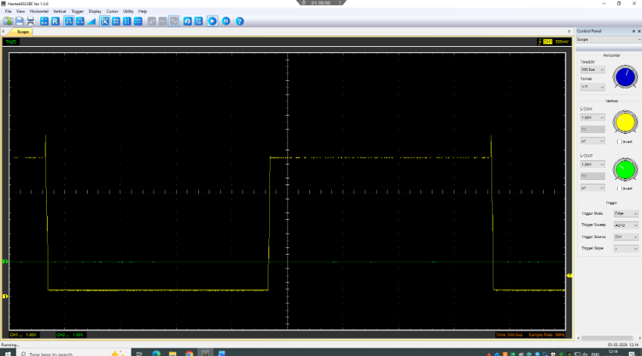

Capacitor charge and discharge wave marked at correct points.

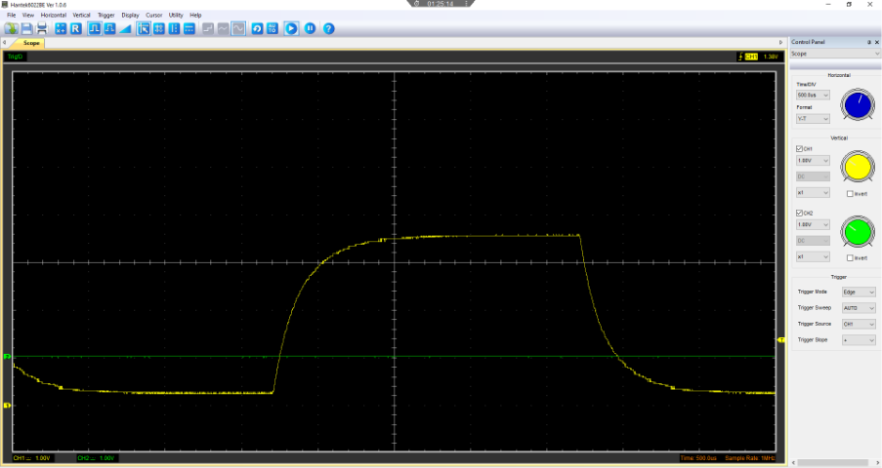

Basic Capacitor Calculations

Capacitor discharge table

Plot log(V) Gradient

Gradient Calculations and Compare

Gradient Calculations

Comparison table

Capacitor Uses

What is a Capacitor?
Capacitors are similar to batteries in where, they can store electrical charge, however, unlike batteries, they do not convert chemical energy to electrical. Capacitors can store charge rapidly and release it rapidly when it is required. (Brain and Pollette, 2021)
Capacitors or otherwise referred to as condensers are often used within motor vehicles. Below is a list of ten uses and applications they have.

- Points based ignition –

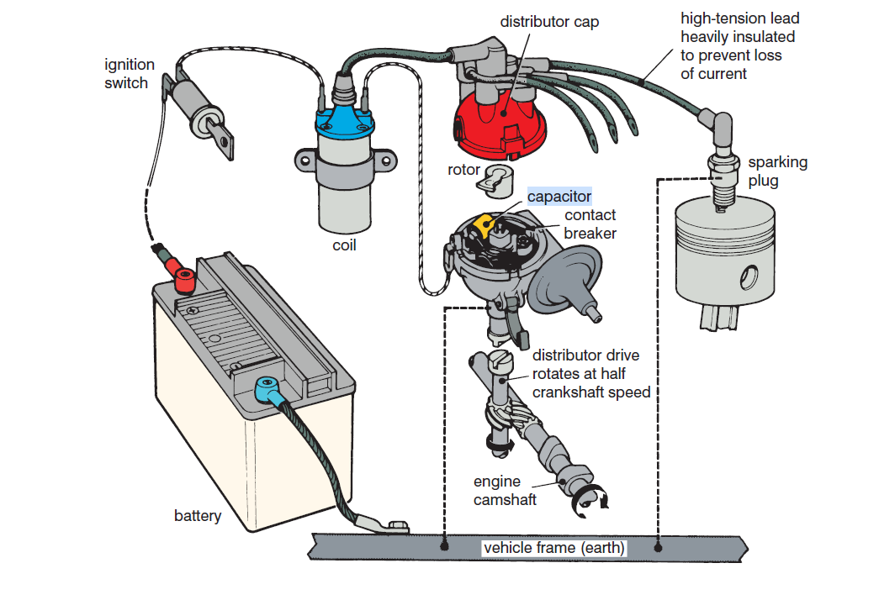
Figure 1 - Capacitor in Ignition Circuit (V A W Hillier and Calex Uk, 2014)
For example, in points based ignition systems, when the points are open, the magnetic field inside the ignition coil collapses, producing back EMF (back electromotive force), which is what is remaining from the surge of current required for the spark to be sent across the two points. This back EMF is then absorbed by the capacitor, preventing premature sparking across the two points and reducing wear of the points. The energy absorbed by the capacitor is then released rapidly. (V A W Hillier and Calex Uk, 2014)

- Stop start technology
Vehicles with start stop technology use a type of capacitor called a supercapacitor. Its purpose in this application is to assist in restarting the engine, providing high current rapidly alongside the AGM battery to prolong the lifespan of the battery. (Skeleton Technologies, 2020)

- Indicators (left, right, hazard)
Another use for capacitors in an automotive vehicle is for the indicators and hazard lights. The capacitors are used to determine the frequency of the on and off switching inside relays. (Autotec, 2026)

More uses include...
- Radio
- Airbag Systems
- Hybrid regenerative braking
- Active suspension
- ECU
- Car audio systems (with subwoofers)
- Windows/ mirrors/ seats/ heated seats/ lights (control modules)

Inaccuracies Question

What could have caused the measurements taken be different to those of an expected measurement?
There are multiple reasons why the results measured could differ from what could be expected. One reason is due to the quality of the function generator. As it was a low-end function generator and scope equipment, inaccuracies, spikes and random peaks were expected. More expensive equipment such as Pico, would have produced more accurate and reliable results and measurements. Another variable that could have caused the measurements to differ is the quality of wire and circuit components. Further to this, temperature can also affect the capacitance of the capacitor, however the normal working range is -30°C to 125°C. (Electronics Tutorials, 2013) At first the main problem faced was the use of the breadboard as the wires and components were not forming a circuit. This could have been due to the heavy usage of the breadboard or the wires themselves. In the end the decision was to reproduce the circuit without the use of a breadboard.

Risk Question

What is CANBUS?
CANBUS is the abbreviation used when referring to a vehicle’s controller area network. CANBUS is the network which allows various sensors, actuators and the vehicle’s ECU to communicate with each other. This system consists of two wires that transfer signals based on high and low priority, these are named CAN high and CAN low. (V A W Hillier, 2014)

What is ISO/SAE 21434:2021?
ISO/SAE 21434:2021 is a standard written by ISO that is used internationally. Its purpose is to provide manufacturers with requirements to conform to in order to manage and minimise the risk of cyberattacks in the automotive industry. (ISO, 2021)

What can be done/ be put in place to protect CAN bus systems from cyberattacks?
There are many ways that the CANBUS systems can be protected from cyberattacks. One method is for manufacturers to conform to the correct standards. While this can minimise the possibility of any cyberattacks, it does not make it impossible.
One method of lowering the possibility of cyberattacks is to adopt OBD-II protection. For an OBD attack to occur, the individual would be required to have access to the vehicle in the first place, however, if the vehicle is left open or broken into, the OBD port is left vulnerable. The OBD ports main purpose is to allow for vehicle diagnostics and is linked to the CAN bus. This makes it possible for a criminal to hack and gain access to the vehicles CAN bus. (Payne, 2019) One way of protecting OBD is by physically restricting the OBD port. Companies such as TVL security, sell key-operated OBD port protection devices that prevent criminals from performing a cyberattack via the port. (TVL Security, 2016)
Another safeguard that can be put in place to lower the risk of cyberattacks that target the CAN bus is IDPS, otherwise known as, Intrusion Detection and Prevention Systems. IDPS is software that continuously monitors all signals being sent to and from the ECUs and CAN bus. The way in which it protects the CAN bus from cyberattacks is by identifying what signals and messages are expected and safe as well as preventing any dangerous or unknown signals and messages. (Abbott-McCune and Shay, 2016)

References

Autotec (2026). Flasher Units. [online] Autoteccomponents.com. Available at: https://www.autoteccomponents.com/item/flasher_units [Accessed 23 Apr. 2026].
Abbott-McCune, S. and Shay, L.A. (2016). Intrusion prevention system of automotive network CAN bus. [online] IEEE Xplore. doi:https://doi.org/10.1109/CCST.2016.7815711.
Brain, M. and Pollette, C. (2021). How Capacitors Work. [online] HowStuffWorks. Available at: https://electronics.howstuffworks.com/capacitor.htm [Accessed 3 Apr. 2026].
Electronics Tutorials (2013). Capacitor Characteristics and Capacitor Specifications. [online] Electronics Tutorials. Available at: https://www.electronics-tutorials.ws/capacitor/cap_3.html [Accessed 20 Apr. 2026].
ISO (2021). ISO/SAE 21434. [online] ISO. Available at: https://www.iso.org/standard/70918.html [Accessed 14 Apr. 2026].
Payne, B.R. (2019). Car Hacking: Accessing and Exploiting the CAN Bus Protocol. Journal of Cybersecurity Education Research and Practice, 2019(1). doi:https://doi.org/10.62915/2472-2707.1045.
Skeleton Technologies (2020). Ultracapacitor-powered Start-stop Systems in Passenger Cars. [online] Skeletontech.com. Available at: https://www.skeletontech.com/skeleton-blog/ultracapacitor-powered-start-stop-systems-in-passenger-cars [Accessed 22 Apr. 2026].
TVL Security (2016). OBD Port Protection (Key Operated). [online] Tvl-ltd.co.uk. Available at: https://www.tvl-ltd.co.uk/obd-port-protection-key-operated [Accessed 12 Apr. 2026].
V A W Hillier (2014). Hillier’s fundamentals of automotive electronics. Book 2. Oxford: Oxford University Press.
V A W Hillier and Calex Uk (2014). Hillier’s fundamentals of motor vehicle technology. Book 1. Oxford: Nelson Thornes.

