

INTRODUCTION TO PHYSIOLOGY
ASSIGNMENT 2: The Report

Student name: Massangbe Saran SY SAVANE
Student ID: 1807717
Module Code: BMHP5003
Lecturer Name: Dr. Noura MOHAMED

Table of Content
Cover Page………………………………………………….1
Table of Content…………………………………………….2
Introduction ………………………………………………….3
Case Study ………………………………………………….3
- What are the risk factors of Obesity on Patient A record?.....................................................................3
- What are the normal and the abnormal physiological condition a Health Assessment report?....................4
- Heath Assessment on eating patterns …………..4
- The normal physiological condition …………………4
- The abnormal physiological condition ………………5
- The impact of eating in front of TV on Obesity …….6
- Health Assessment of Smoking on Obesity……..6
- The normal physiological condition………………….7
- The abnormal physiological condition………………7
- Health Assessment of High Blood Pressure ……7
- The normal physiological condition………………….7
- The abnormal physiological condition……………….8
- Health Assessment of High Cholesterol………….8
- Health Assessment of sedentary Lifestyle……….8
- Health Assessment of drinking alcohol…………...8
- Recommendations……………………………………..9
Conclusion ……………………………………………..10
References List…………………………………………11
Appendix………………………………………………..13

Introduction
Anatomy and Physiology study respectively the structure and the function of human’s body also his systems and the interactions between cells, tissues and organs (Learn.org, 2021).
In this study, it will be an examination of normal and abnormal of physiology of an individual and his lifestyle. Based on the data collected on the questionnaire, an analyse and an evaluation of body functioning and relevant detailed anatomy and physiology on current health recommendations on Obesity will be done.
Also, given some lifestyle recommendations to the individual based on his physical, emotional, nutritional and spiritual needs to improve his health and wellbeing.
In the end, the summary of our findings following with the references list.

Case Study
The study is about a woman, her health and her lifestyle record. Patient A was born the first of January 1945, she is 45 years old. She smokes more than forty cigarettes a day with high blood pressure 140/90 and has high cholesterol (hyperlipidaemia). So, patient A Weight is 80 kg and her Height is 1.60m. As well as, patient A does not know how to cook, as a result, she eats most the time fast food, a lot of sugar, chips, chocolate and snack while watching the television. In addition, patient A seldom exercising and drinks between 1 and 2 units a day.

- What are the risks factors of Obesity on Patient A record?
According to the record on the lifestyle questionnaire of Patient A. the risks factors of Obesity are including:
- Eating pattern (eating a lot of sugar, fast food, chocolate, chips, snack) and eating in front of the Television.
- Smoking
- High blood pressure
- High cholesterol (Hyperlipidaemia)
- Weight
- Seldom exercising
- Alcohol
- Age
- Sex

- What are the normal and the abnormal physiological condition a Health Assessment report?
- Health Assessment on eating patterns.
Patient A eats a lot of fast food, a lot of sugar, chocolate, chips, and snack. Her Weight is 80kg and Height is 1.60
According to American Journal of Epidemiology some studies have suggested that eating patterns such as eating away from home, fast food, eating frequency may be related to Obesity (American Journal of Epidemiology, 2003).
Obesity is described as an extreme fat development that may impair health (World Health Organisation, 2020).
It result from a chronic imbalance between energy intake and energy expenditure (Jequier, 2006).
Obesity is BMI equal or greater than 30.
Healthy weight is BMI 18.5 to <25kg/m2

- The normal physiological condition:
According to Human Kinetics, fat in human body is formed from two types of fat; the essential body fat and the storage body fat. We find essential body fat in membranes, organs, in nerves tissues and bone narrow. The essential body fat plays essential role in physiological functioning of the body, consequently we cannot lose this fat without comprising the normal function of body. On the other hand, the storage fat is the excess of calories, stored as an energy reserve. This body fat is stored as energy reserve, therefore it can be lose if needed, by movements or by exercising. Essential body fat is about 3% of body mass for men and 12% of body mass for women. Women are supposed to have more essential body fat than men because of motherhood and hormonal functions. (Human Kinetics).
Body mass is normal or stable when macronutrient ingestion is equivalent to macronutrient oxidation. The extra of glucose transformed into glycogen and the remaining glucose stored as fat for future energy requirements.

- The abnormal physiological condition:
The remaining glucose is stored as fat in Adipose tissue, when is not used in daily basic and fat is accumulated until the individual becomes overweight and their adipocytes expand and produce more pro inflammatory proteins such as TNF alpha and interleukin 6 (IL-6). As the lipid droplet in each adipocyte gets bigger and bigger, the cell expands until it exceeds its blood supply and lack of oxygen. (Maria Conley). This person can be at risk for many diseases such as Cardiovascular disease, Diabetes type 2, some Cancer, Arthritis.

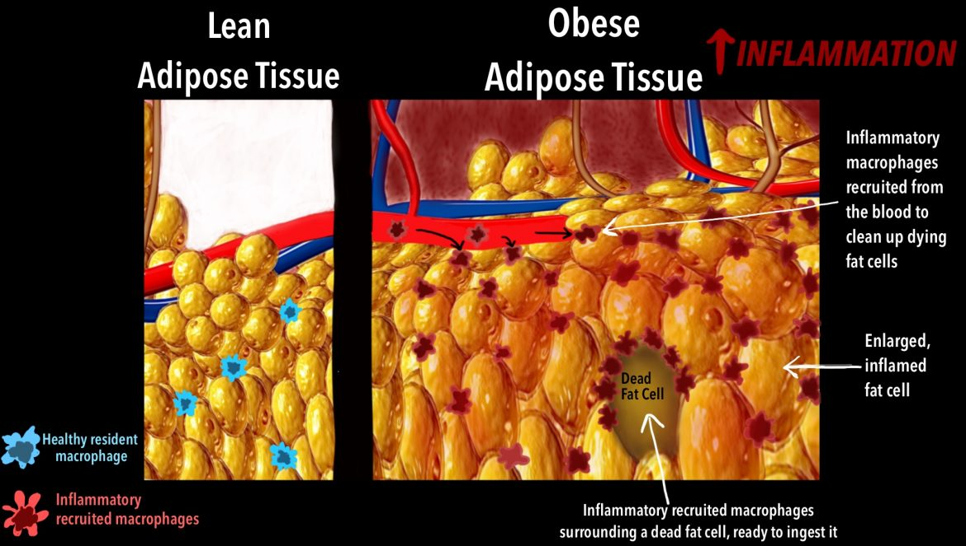

Lean Adipose Tissue and Obese Adipose Tissue

- The impact of eating in front of the Television on Obesity.
Patient A eats in front of the Television, eating while watching TV.
The Department of Psychology and Program in Neuroscience and Behavior, reported a research in TV watching raises intake of high-density foods.
Method: they calculated food intake and recorded feeding patterns of participants who ate Pizza or Macaroni and Cheese, two High density, familiar, agreeable foods, while viewing or not viewing TV. After the information gathering had been finalized, a report by Bellisle et al. showed that also clearly evaluated feeding during TV viewing. They duplicated the Bellisle et al. results and broaden them by reporting intake on various High density foods and presenting detailed explanations of feeding behavior patterns to discover how more food was eaten during TV viewing.
Result: the major outcomes are as observes:
- Caloric intake while watching TV was significantly increased for Pizza (36%) and Macaroni and cheese (71%)
- The correlation between intake when watching and not watching TV for Pizza and Macaroni and cheese was lined with a drop of 0.95 and an extra of 288 Kcal/meal during TV watching.
- Feeding pattern and frequency depended on watching condition
- Food intake was not consistently related to either BMI or eating restraint scores.

- Health Assessment of Smoking on Obesity
Patient A smokes more than 40 cigarettes a day.
Smoking and Obesity are the principal cause of inevitable illness and premature death, accountable for roughly 74,600 deaths a year in England. Smoking has negative effects nearly on every organs of the body and significantly reduces both quality of life and life expectance. (Action on Smoking and Health, 2021).
There are two categories of smokers: light smokers and heavy smokers.

- The normal physiological condition:
Several studies show that smoking could increase the metabolic rate, as a result body weight or body Mass Index on smokers is less than non-smokers. Also, these studies show losing weight in smokers can be the result of decreasing metabolic efficiency or decreasing caloric absorption. Smoking a single cigarette has been shown to induce a 3% rise in energy expenditure within 30 min. this is for light smokers.

- The abnormal physiological condition:
In the other hand, for people who smoke more than 40 cigarettes a day, the result is different. heavy smokers have a tendency of gaining high body weight than light smokers or non-smokers, which can possible reveals a clump of risky behaviours ( low degree of physical activity, poor diet, and smoking) that is favourable to weight gain.

- Health Assessment of High Blood Pressure on Obesity
Patient A has BP: 140/90
High blood pressure is commonly specified as a systolic blood pressure of ≥140 mm Hg or a diastolic blood pressure of ≥90 mm Hg or use of antihypertensive medications (Wiley online Library, 2012). Many overweight people are subject to have High blood pressure.
- The normal physiological condition:
According to the scientists from the University of Virginia School of Medicine in Charlottesville, describe that blood flow is regulated by Calcium ions signalling; the normal level of Calcium is indicator to tell cells vessels to dilate.

- The abnormal physiological condition:
When we consume too much salty food or in case of obesity, the level of Calcium is high in blood, as a result cells of vessels are commanded to constrict, and this mechanism provokes High Blood Pressure.

- Health Assessment of High Cholesterol on Obesity
Patient A has hyperlipidaemia.
Fat from food ingest in our body is transformed in Lipoprotein called Cholesterol. There are two categories of Cholesterol, those with High density lipoprotein (HDL) which are good for our body functioning, in the opposite those with Low Density Lipoprotein (LDL) which are bad for body physiological functioning. Having High Density Lipoprotein or Low Density Lipoprotein depends of the substances ingest. Many diseases (heart attack, stroke, cardiovascular disease, kidney failure) result from too much Low Density Lipoprotein in our blood.

- Health Assessment of sedentary Lifestyle
Patient A seldom exercising, she has an inactive lifestyle.
Obesity results from energy disparity; too much calories ingest and too few calories burned (Harvard School of Public Health, 2021).
Keep on in physical activity is the best way to be in healthy weight or lose weight. It can also reduce the risk of heart attack, others kind of heart disease, diabetes, stroke, high blood pressure, osteoporosis, and certain cancers. As well as, reduce stress and boost mood.
Sedentary Lifestyle do the opposite.

- Health Assessment of drinking alcohol on Obesity
Patient A drinks one or two units a day.
According to BBC news, previously, women were advised to drink no more than two or three units a day and men no more than three or four.
Though, new guideline stipulates that there is no safe drinking. The guidelines are just to minimising risk of illness (BBC News, 2016).

- Recommendations
In this case study, Patient A needs a change: healthy lifestyle to avoid complications and to live longer.
- Recommendations related to eating patterns:
- Trained on Food Labels; Patient A needs to make informed choices that favour good health, that can be provided in food labelling which offer vital information on factual data for the consumer (Obesity Action Scotland, 2016).
- Download apps for a good lifestyle, and be in control of your health. Apps help in many ways, as patient A does not know how to cook, for example, SimpyCook is an app which provide fresh health food with recipe and cooking instructions (Public Health England, 2020).
- Patient A can take part to the Major recent campaign urges millions to lose weight and cut COVID-19 risk (Public Health England, 2020).
- Dietitians can support patient A on how to cut down sugary food, snack, chocolate and chips and inform her the appropriate amount in daily food intake.
- Nutritionist also can help to replace Junk food to healthy eating by teaching her the importance of fruits and vegetables for losing weight and be in good health.

- Recommendations related to sedentary lifestyle:
- Get involved in community active project such as #ThemasonMile, this is community based miles, where everyone can come together to do #TheirMilesTheirWay, regardless of ability or disability; helping people to become happier, healthier, and more active (The Mason Mile).
- Patient A should follow United Kingdom Chief Medical Officers’ Physical Activity Guidelines:
- Daily physical activity, any kind of activity, for adult to boost physical and mental health and wellbeing.
- Adults should strengthening their muscle by doing activities such as gardening, heavy shopping or resistance exercise. This activity should be done two days a week.
- Adults can bear in mind that any kind of physical activity is better than nothing, to break up sedentary lifestyle (Department of Health and Social Care, 2019).

- Recommendations related to Smoking:
- Patient A can seek advice from her Generalist Practitioner to be part of government Plan for Smoke free Generation, in which all health professionals are trained to support individuals to quit smoking on Tobacco control Plan England.
- Recommendations related to Alcohol drinking:
- Patient A can get support from her local authority or National Health Services in Counselling such as talking therapist, they can support on any psychological or addiction problem.

Conclusion
Our lifestyle choice is determinant to live a healthy life, to be in good shape, and live longer. Therefore, be overweight or obese is links to many factors such as eating patterns, sedentary life, heavy smoking, drinking more alcohol units than you should do. This behaviour leads to obesity and life threatening diseases such as Cardiovascular Diseases, Diabetes type 2, and Cancer.
However, the good news is that obesity is preventable, prevention is better than cure. There is nothing more important than being in good health. Thus, make a responsible choice in terms of lifestyle, seek advice from specialists such as Nutritionists, Dietitians, GPs. All of those in one word ‘choose life’.

References List
Action on Smoking and Health (2021). Smoking Statistics. Available online on https://www.ash.org.uk/
American Journal of Epidemiology (2003). Association between Eating patterns and Obesity in a free living US adult population. Available online on https://www.academic.oup.com/
BBC News (2016). New alcohol guidelines: what you need to know. Available online on https://www.bbc.co.uk/news/uk/
Blass, E. M., Anderson, D. R., Kirkorian, H. L., Pempek, T. A., Price, I. and Koleini, M. F., (2006). On the road to Obesity: Television viewing increases intake of high-density foods. Physiology and Behavior, 88 (4-5), pp. 597-604.
Cohut. M. (2020). What is the mechanism behind high blood pressure in Obesity? Available online on https://www.medicalnewstoday.com/
Department of Health and Social Care (2019). UK Chief Medical Officers’ Physical Activity Guidelines. Available online on https://www.assets.publishing.service.gov.uk/
Harvard School of Public Health (2021). Obesity Prevention Source. Available online on https://www.hsph.harvard.edu/
Human Kinetics (2021). Normal ranges of body weight and body fat. Available online on https://www.humankinetics.com/
Lear.org (2021). What are Anatomy and Physiology? Available online on https://www.lear.org/
Obesity Action Scotland (2016). Obesity and Labelling. Available online on https://www.obesityactionscotland.org/
Public Health England (2020). Mayor new campaign encourages millions to lose weight and cut COVID-19 risk. Available online on https://www.gov.uk/
Science Daily (2015). Heavy smokers, smokers what are obese gain more after quitting? Available online on https://www.sciencedaily.com/
The American Journal of Clinical Nutrition (2008). Consequences of Smoking for body weight, boy fat distribution, and Insulin Resistance. Available online on https://www.academic.oup.com/

Appendix

