Name: Paul Richards

Student No: 0251968

Course: Applied Computer Networks and Cybersecurity

Module: Computer Forensics
(ACCD5000)

Date:26/04/2022

Contents

Task 1: Introduction 3
Autopsy Overview 4
FTK (Forensic Toolkit) Overview 6
OSForensics Overview 13
Forensic Tools Categories Table 20
Evaluation 22
Task 2 – Introduction 23
Digital Investigation Steps 24
Identification 25
Collection and Preservation 26
Analysis 35
Product and Presentation 38
Invoice 41
Appendix A 42
Bibliography 43

Task 1: Introduction

Will be reviewing three different forensic software programs, as listed below:

- Autopsy

- FTK Toolkit

- OS Forensics

After analysing the three software programs, will use a table to categorise the software forensic programs.

Autopsy Overview

According to Gerard Johansen [1], Autopsy is a graphical interface for the sleuth toolkit. Autopsy is an open source product and is free to use. Autopsy allows investigators to create cases for digital forensic investigations. Autopsy allows forensic investigators to add a suspect's drive to a case for forensic analysis. Autopsy supports many different data sources e.g. hard disk, disk images etc. Autopsy does not have the facility to perform data acquisitions, for example, Autopsy does not have a software tool to make an image of a suspect’s drive. An investigator will need to use a separate forensic tool to perform data acquisitions, e.g. FTK Imager. Autopsy does not allow you to generate a hash value to verify the integrity of a suspect's disk. To generate a hash value of a suspect’s disk, an investigator will need to use a separate hash tool e.g. FTK imager. Autopsy will verify the hash value when adding the suspect’s disk to a case. The investigator can enter the hash value when adding a disk. Autopsy will compare the hash value entered by the investigator with the hash value Autopsy calculates. If the hash values match, then the integrity of the data has not been compromised. If the hash values do not match, the integrity of the data has been compromised.

When an investigator creates a new case in Autopsy and adds the suspect’s disk to the case, the investigator will be presented with a file explorer view to navigate through the contents of the case as shown below.

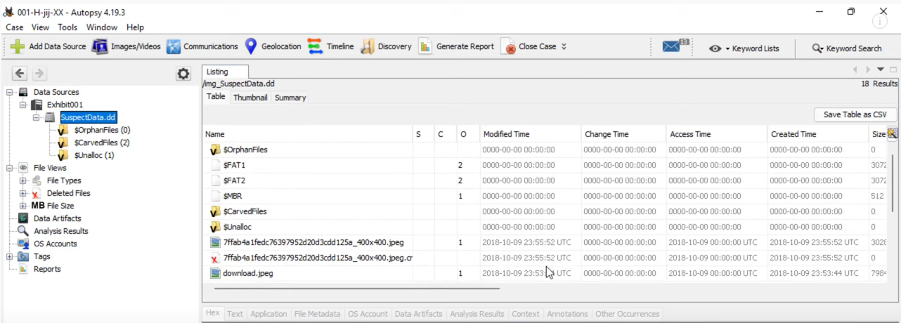

In the example above, we expand the nodes, data source, exhibit 001 and SuspectData.dd to view the contents of the suspect’s drive.
Autopsy comes with built-in filters which makes it easier for the investigator to search the suspect’s disk, e.g. the file views node breaks the files into different categories e.g. it places images files into an image container. This makes it easier for the investigator to analyse all the image files, as shown in the screenshot below.
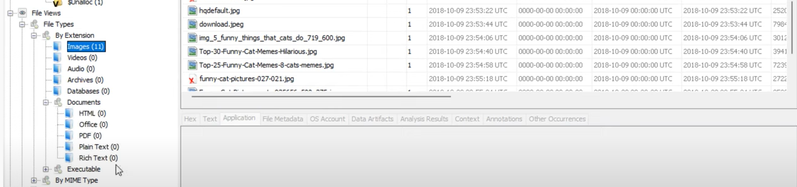

Autopsy allows you to search files on a suspect disk. Autopsy allows investigators to bookmark or tag a file to review the file later on or to highlight the file when the investigator is generating a case report. Bookmarking and Tagging allows investigators to highlight files in their reports which they think are important to an investigation. When a case is completed, Autopsy allows an investigator to generate a report on their findings.

Autopsy allows you to recover deleted files or data from a suspect’s drive. Deleted files can be located under the file views and deleted files nodes, as shown in the screenshot below:

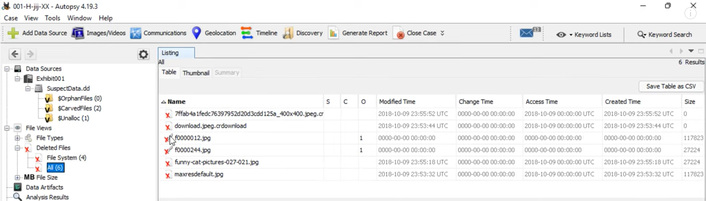

FTK (Forensic Toolkit) Overview

According to Charles Brooks [2] FTK is a commercial product. FTK was previously owned by Accessdata, but has recently been purchased by Exterro. Please refer to the vendor’s site (Exterro) for more information [3] . You need to pay a licence fee to use the product. FTK is a case management product which is bundled with FTK imager (Data Acquisition tool) and Registry Viewer. FTK supports many different data sources e.g. hard disk, disk images etc. FTK imager allows an investigator to make a digital image of the suspect's disk. Once the disk image is created in FTK imager, the disk image can be parsed through to FTK to analyse the contents of the suspect’s disk. To create a disk imager in FTK imager, the investigator clicks the file menu and clicks create disk image. As shown in the screenshot below:

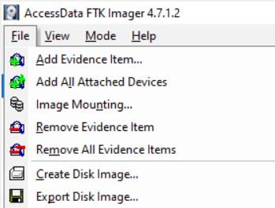

FTK imager allows investigators to generate hash values for a suspect's drive and verify the hash value. The example below shows how hash values are calculated in FTK imager.

Step 1: Select the drive that the hash value will be calculated.

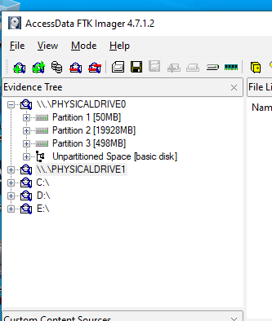

Step 2: Click on the file menu and the verify drive/image option.

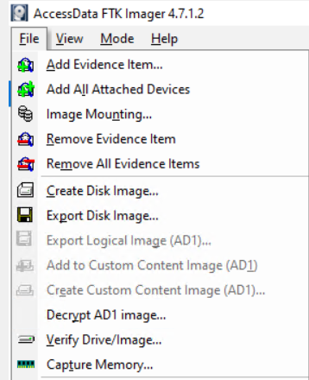

Step 3: Once the hash value is calculated, the results will be displayed as shown below.
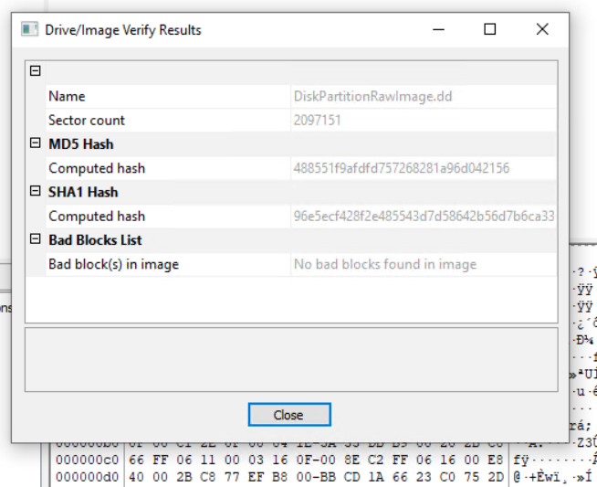

When an investigator creates a new case in FTK and adds the suspect’s disk to the case, the investigator will be presented with a file explorer view with tabs to navigate through the contents of the case, as shown in the screenshot below.
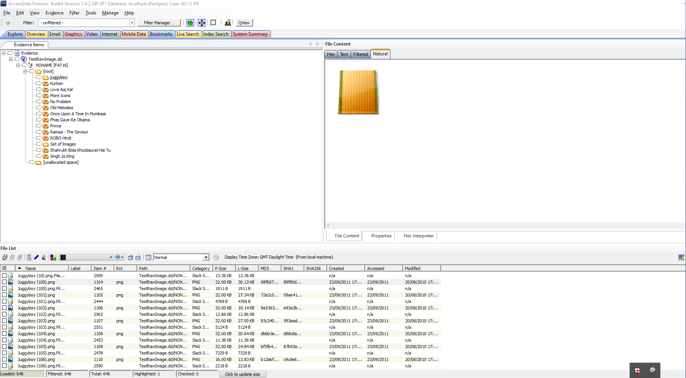

The investigator can expand the nodes as shown in the example above to view files or they can click on the tabs as shown below to view files.

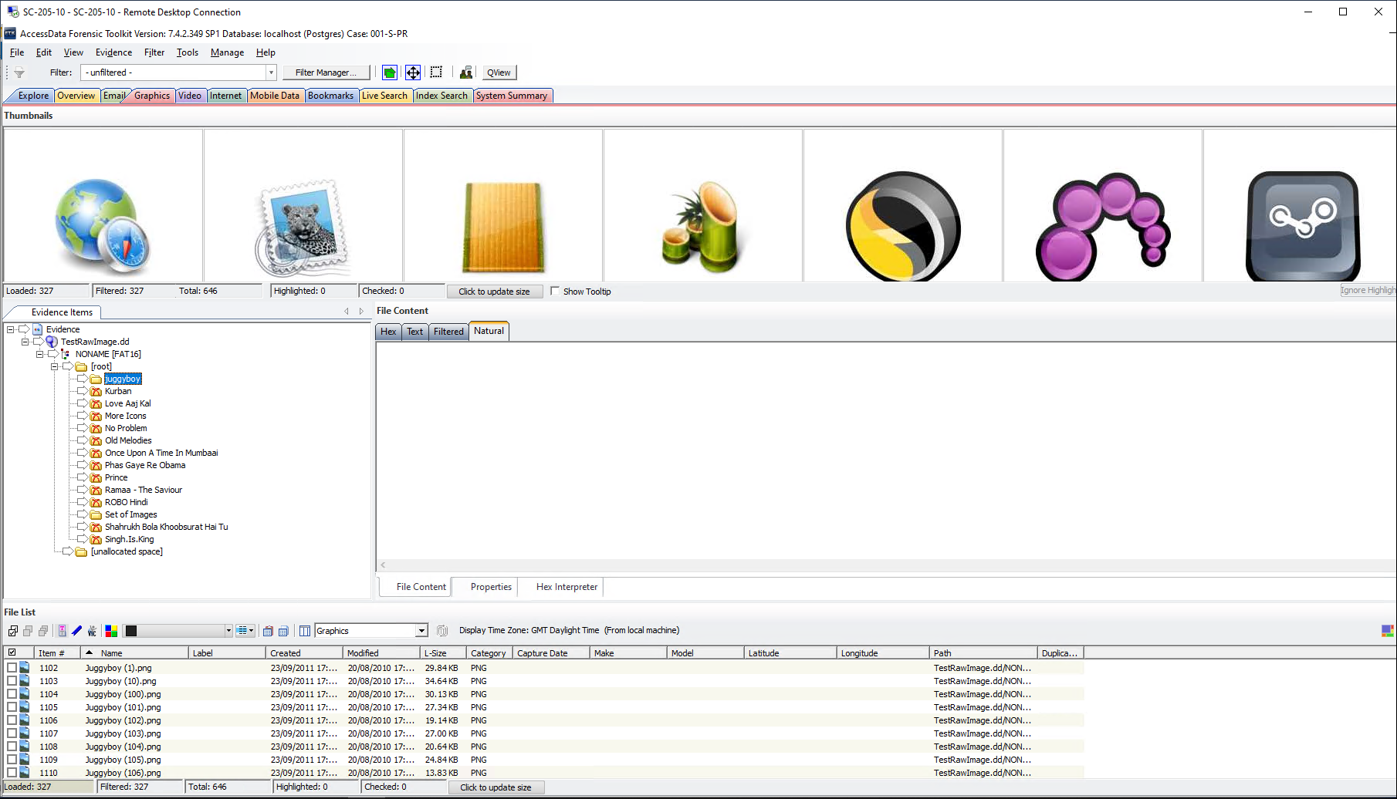

FTK toolkit includes built-in filters which are contained in the tabs and the file explorer views. This makes searching for files easier, e.g. when you click on the graphics tab it will display all the graphics files on the suspect’s disk, as shown in the screenshot below. This saves the investigator time trying to locate all the graphical files on the suspect’s disk.

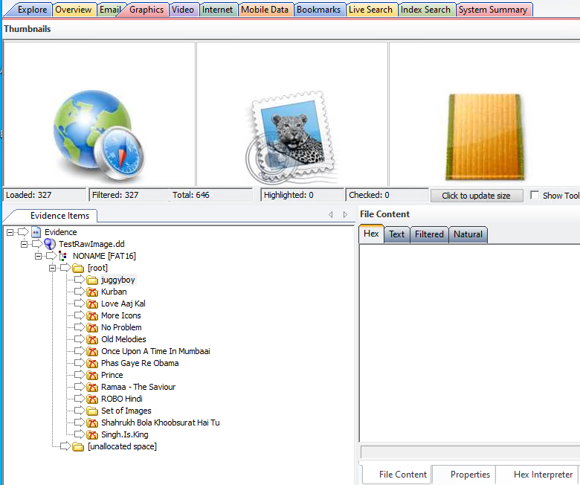

FTK allows you to recover deleted files and data. Deleted files can be viewed by clicking on the overview tab, file status and deleted files nodes, as shown in the screenshot below:
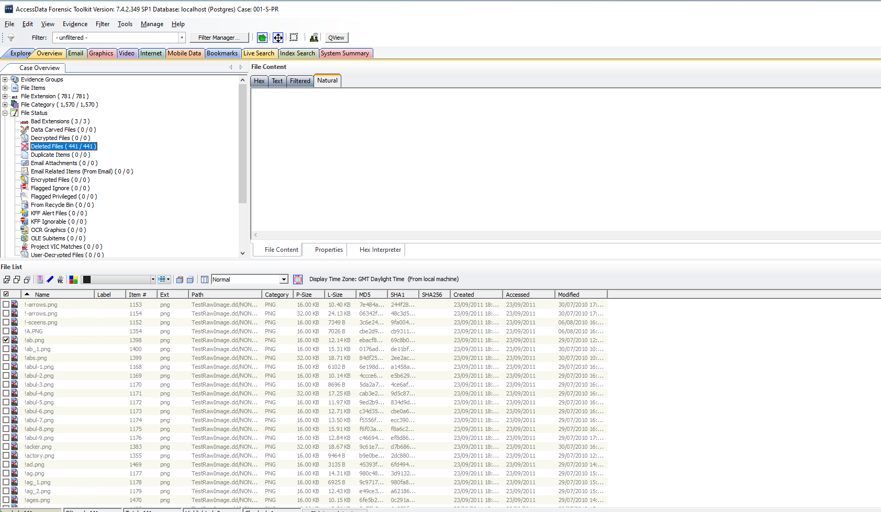

FTK allows you to search files on a suspect disk to make it easier to locate files. FTK allows investigators to bookmark or tag the files to review later on or to highlight the files the investigator thinks are relevant when creating the case report. When a case is completed FTK allows an investigator to generate a report of the data the investigator thinks is relevant to a case.

FTK does not allow an investigator to directly view the registry. They have to view the registry through a separate register viewer or program which is linked to FTK. The registry program is called Access Data Registry. An example of how to use the Access Data Registry is shown below.
Step 1: To view the contents of a registry hive, right click on the registry hive (e.g. software) and select ‘open in the registry viewer’.

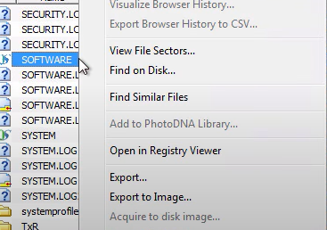

Step 2: The Access Data Registry program will pop up displaying the contents of the registry hive.
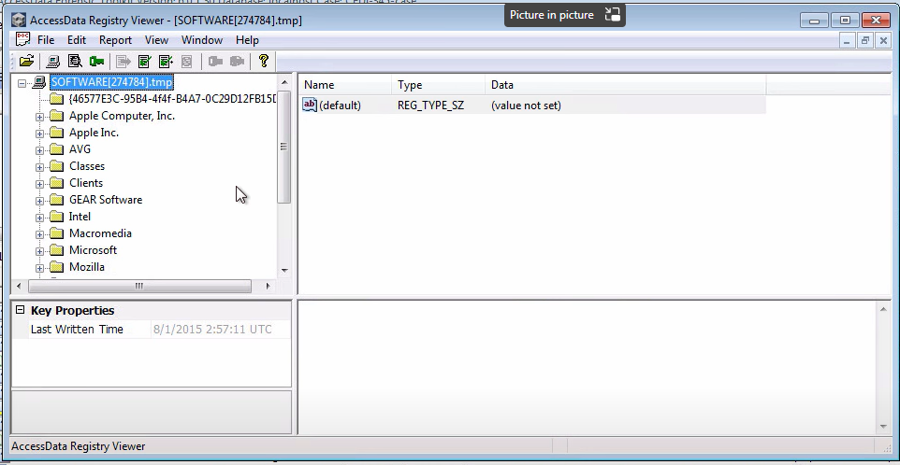
FTK imager allows an investigator to make a memory dump of the suspects’ machine. The memory dump can be viewed in another memory forensic tool like volatility. An example of how to make a memory dump is shown below.

Step 1: In FTK imager, click on the file menu and capture memory.
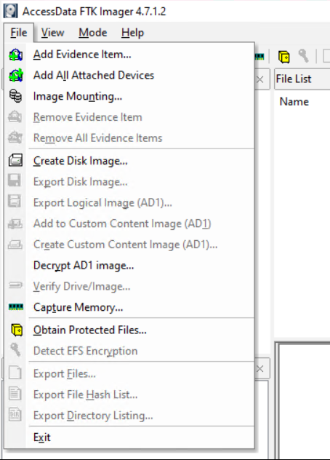

Step 2: In the capture memory screen, specify the location of the memory dump and click capture memory.
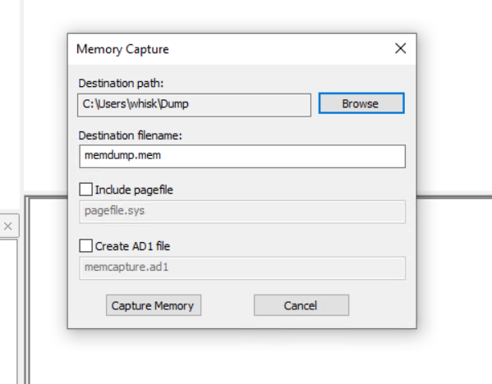

Step 3: A screen will pop up with a progress bar. Once the progress bar is completed, the memory dump will be created in the location you specified in step 2.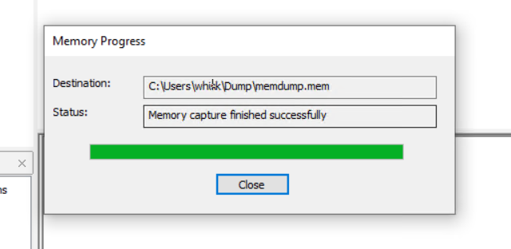

OSForensics Overview

According to Amelia Phillips et al [4], OSForensics is a commercial product which is owned by Pass Mark software. Users need to buy a licence to use the product. OSForensics allows an investigator to create a case and add a suspect’s hard disk to the case for forensic analysis. OSForensics supports many different data sources e.g. hard disk, disk images etc. OSForensics allows investigators to create a disk image of a suspect's disk. An example on how to create a disk image in OSForensics is shown below.
Click on the drive imaging menu option. In the drive imaging screen, specify the disk you wish to copy and the location to store the disk image. Click the create image button to finalise the process, as shown in the screenshot below.

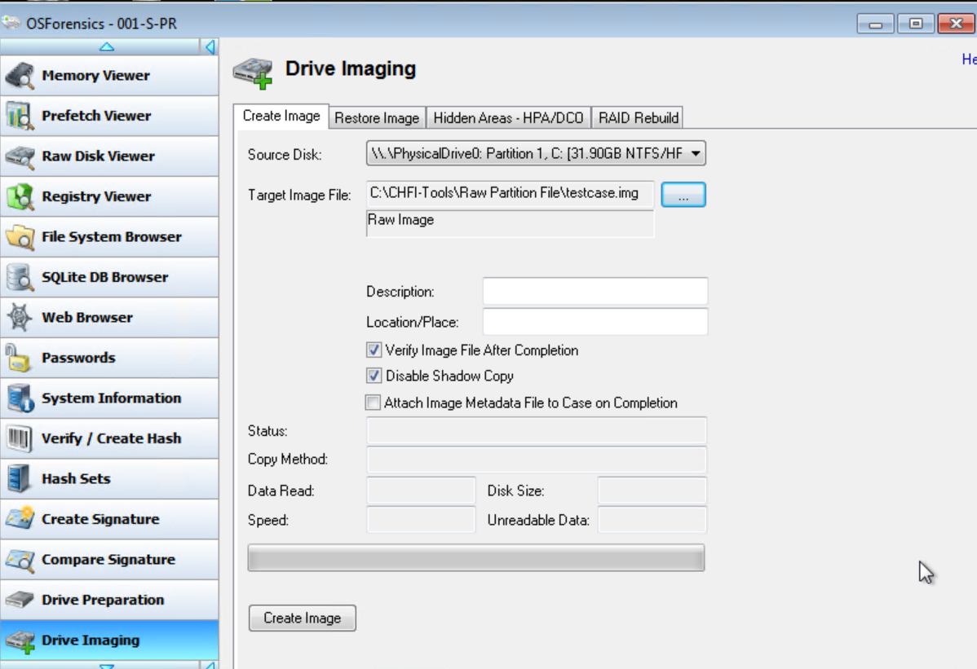

Investigators navigate through OSForensics using the main menu on the left or the start menu options on the right. The start menu option repeats many of the options available on the main menu, as shown in the screenshot below:

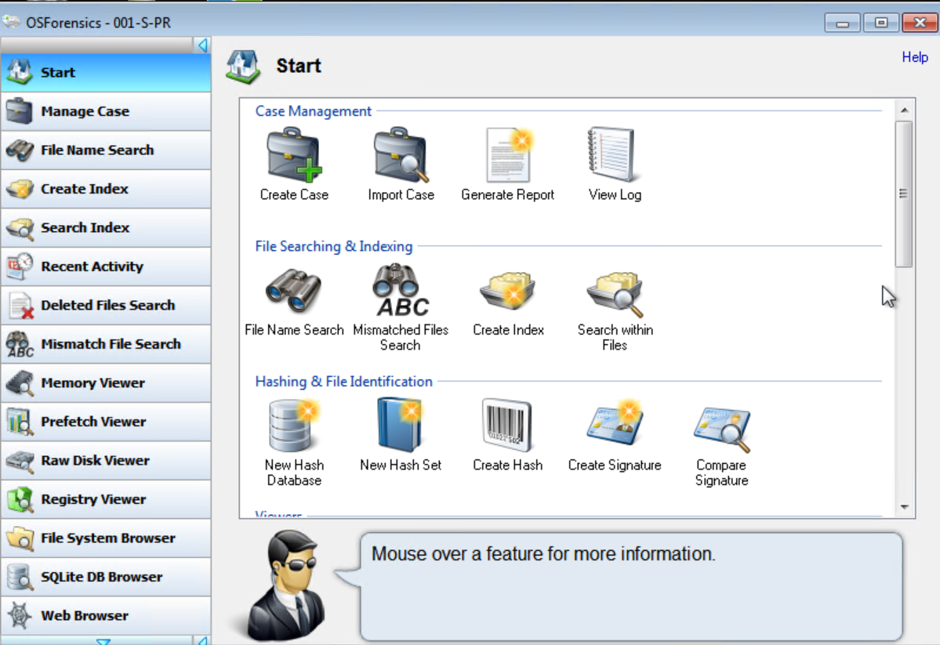
OSForensics allows investigators to generate hash values for a suspect's drive and verify the hash value. Below is an example on how to create and verify hash values in OSForensics.

Step 1: Click on the verify/create hash menu option. In the verify /create hash screen, click on the volume radio button and select the relevant drive. Click calculate to finalise the process, as shown in the screenshot below

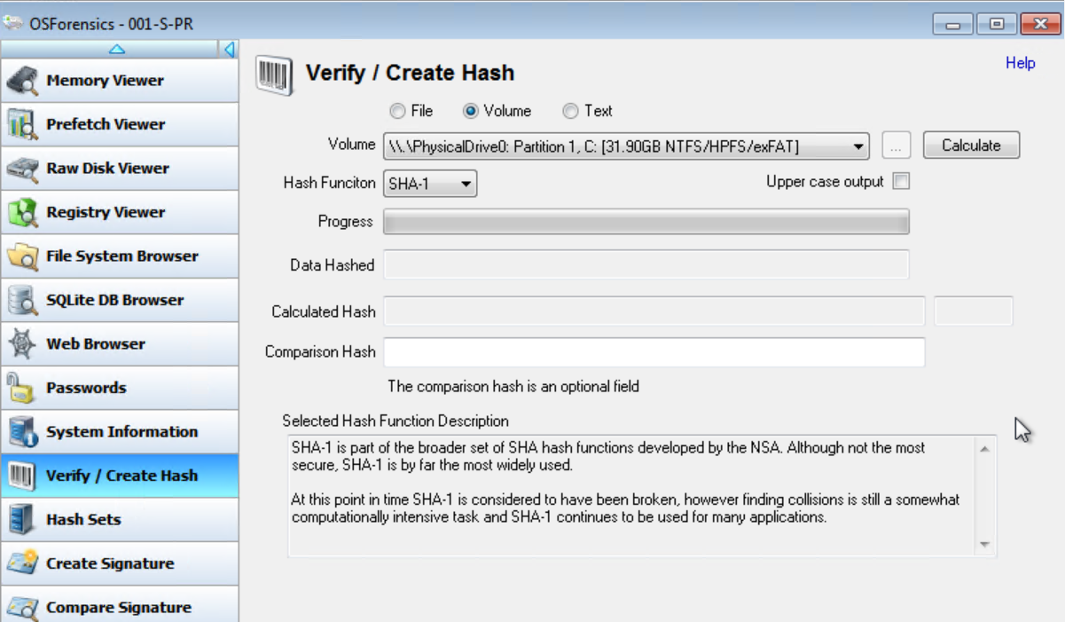

Step 2: It will start calculating the hash value and give you a progress bar, as shown in the screenshot below:
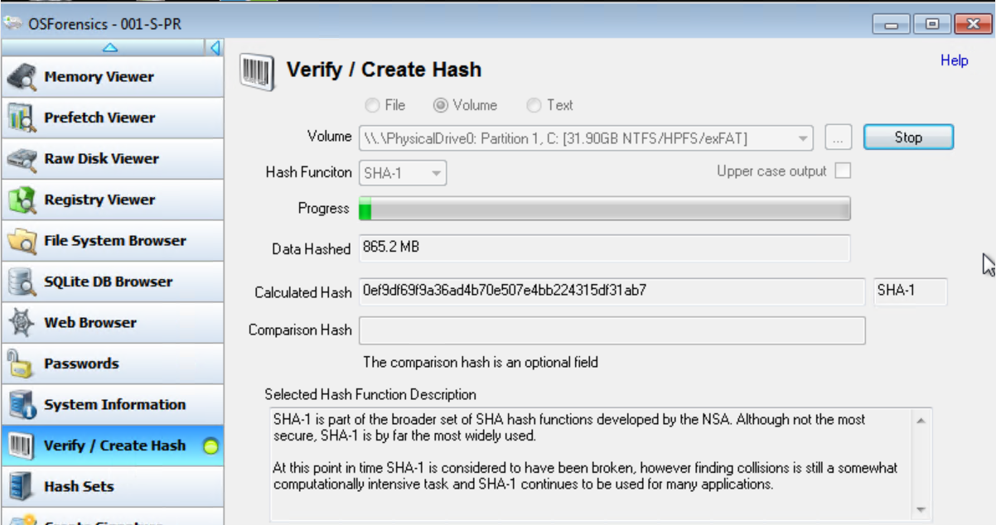

Step 3: Once the process bar is complete, it will return the hash value as shown in the screenshot below:

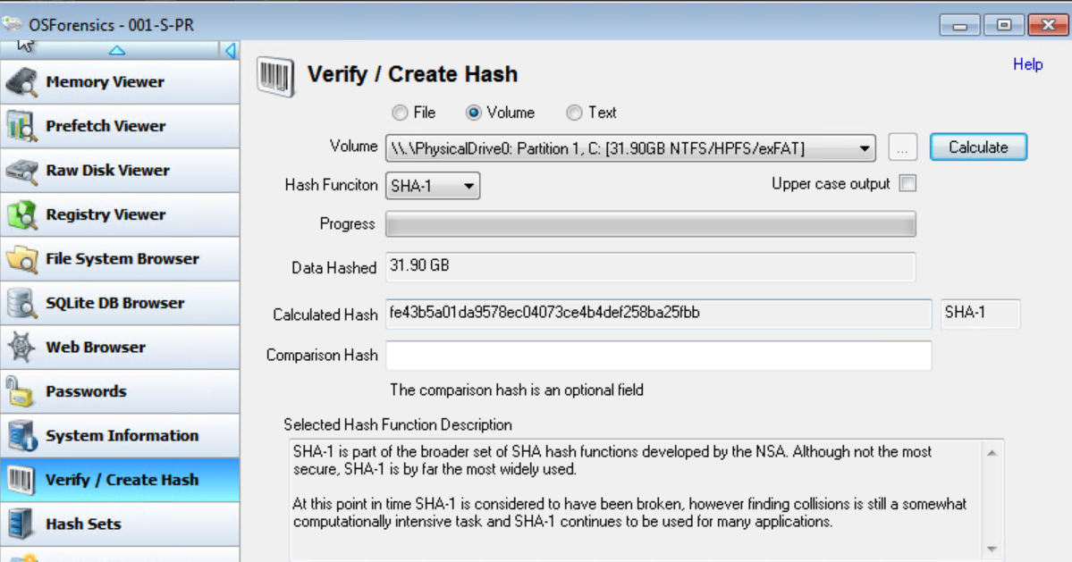

OSForensics allows you to search files on a suspect disk to make it easier to locate files. OSForensics allows investigators to bookmark or tag the files to review later on or to highlight the files the investigator thinks are relevant when creating the case report. When a case is completed, OSForensics allows an investigator to generate a report of the data the investigator thinks is relevant to a case.

OSForensics allows you to recover deleted files or data. To recover deleted files, click on the deleted files search menu option, select the drive you wish to search, click the search button and it will return all the deleted files on the disk, as shown in the screenshot below.

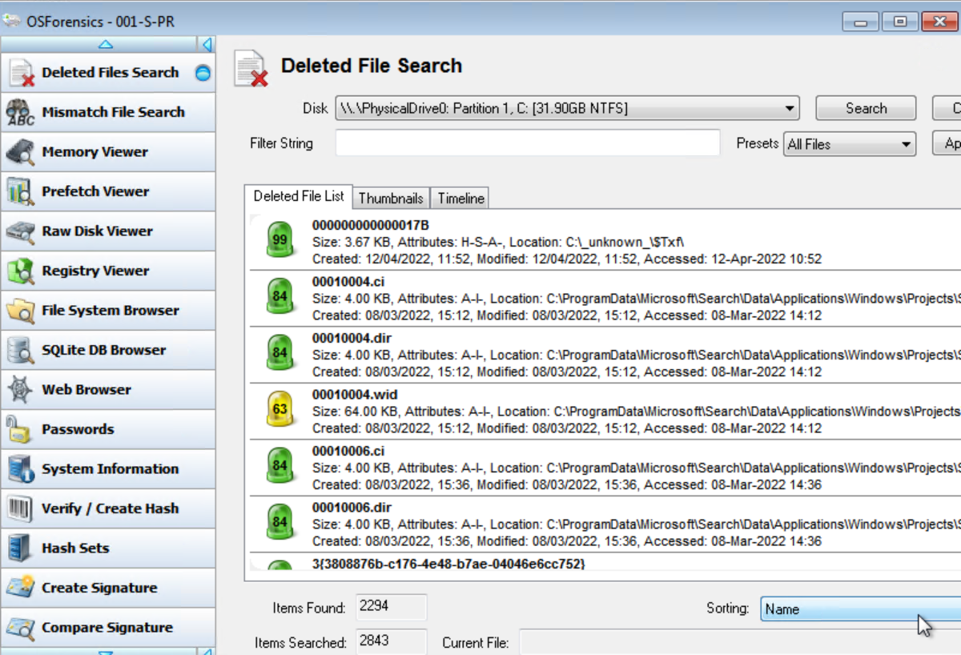
OSForensics allows an investigator to view the registry of a suspect's disk. Below is an example of how to use the registry viewer in OSForensics.

Step 1: Clicks on the registry viewer menu option, as shown below:


Step 2: Select the drive you wish to view the registry on, and the registry hive you wish to view, as shown in the screenshot below:

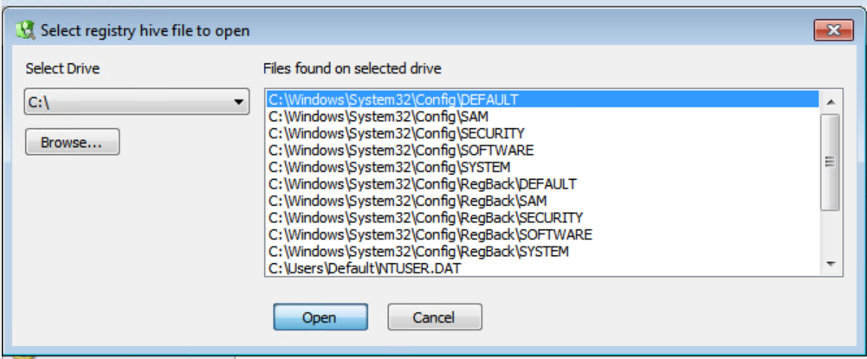

Step 3: Click on open and the contents of the registry hive will be displayed.

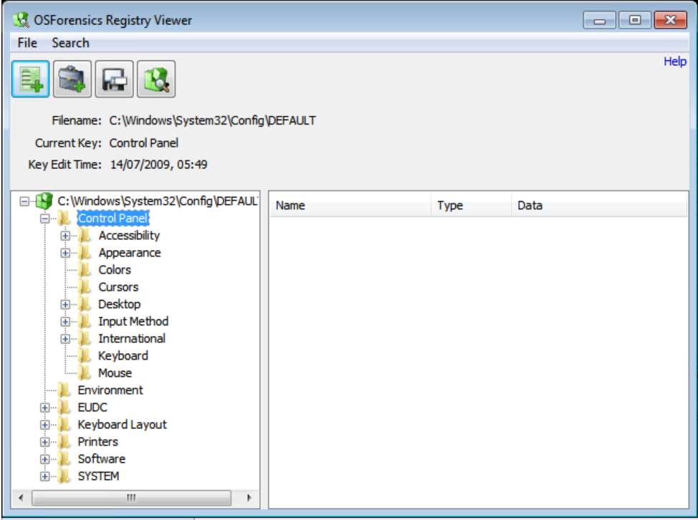
OSForensics allows you to recover passwords for files. Below is an example of how to recover a password in OSForensics for a file.
Click on the password menu option. Click on the decryption & password recovery tab. Enter the name of the file in the encrypted file password text box and click start. The program will try to crack the password of the file.
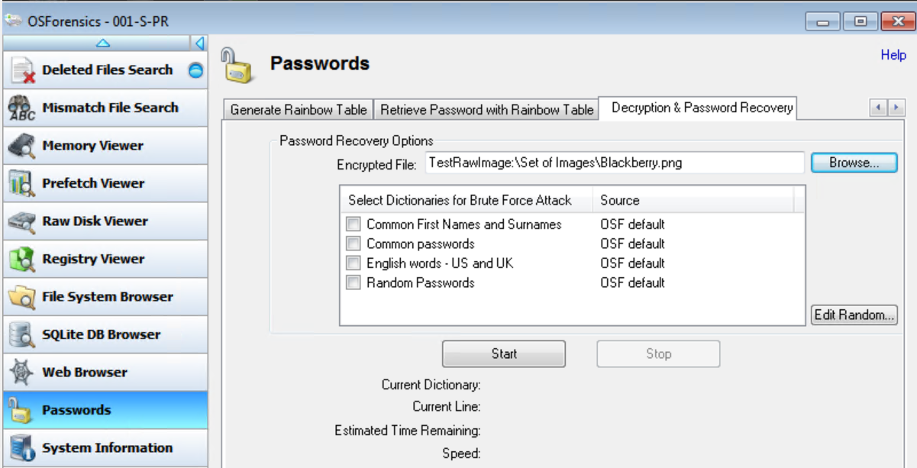

OSForensics allows an investigator to view the memory of a suspect’s computer and take a memory dump of the memory. The memory dump can be viewed in a separate memory analysis tool called Volatility. Below is an example of how to make a memory dump in 0Sforesnics.
Step 1: Click on the memory viewer menu option.

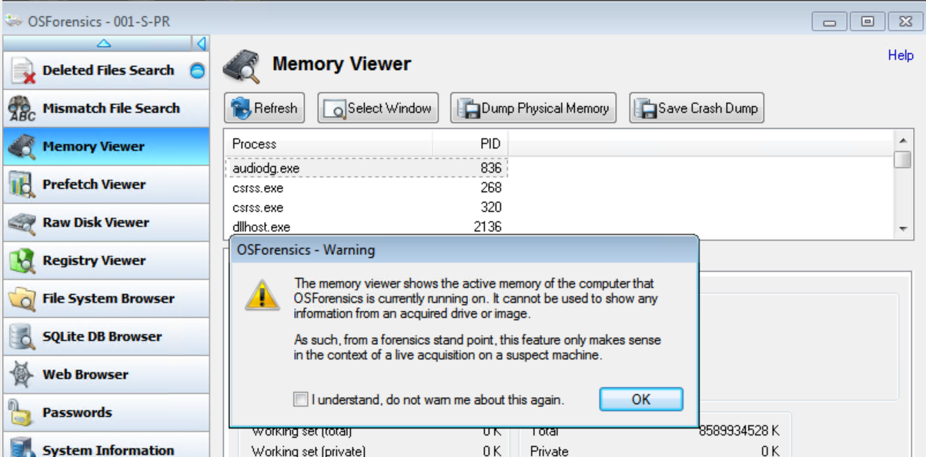

Step 2: Click the dump physical memory button.

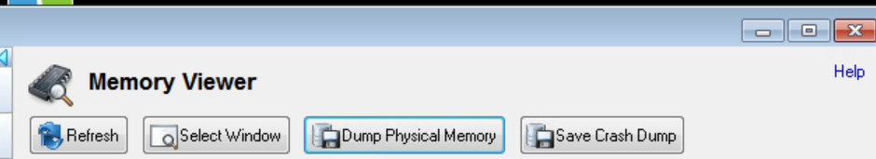

Step 3: Specify the name and location of the memory dump.
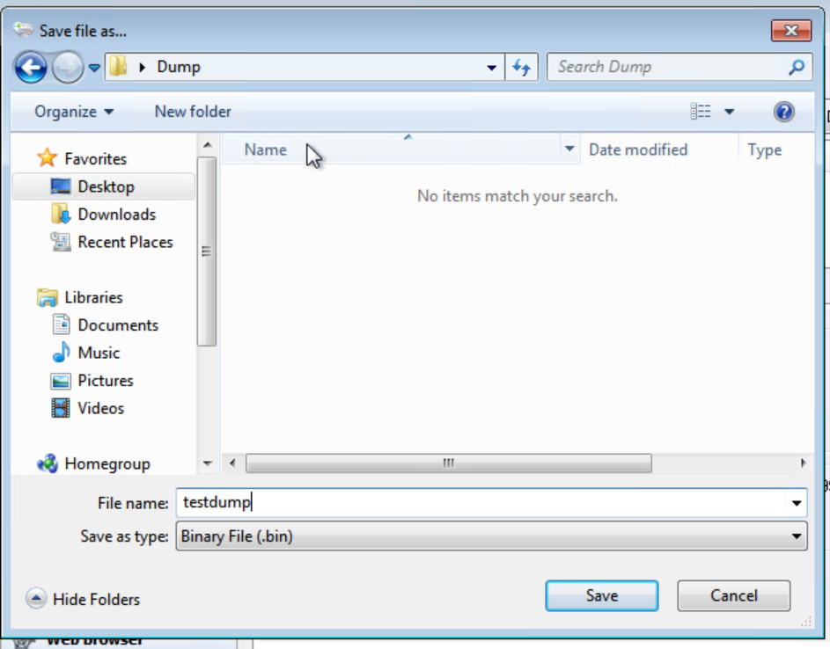

Step 4: A screen will pop up with a progress bar. Once the progress bar is complete, the memory dump will be created.

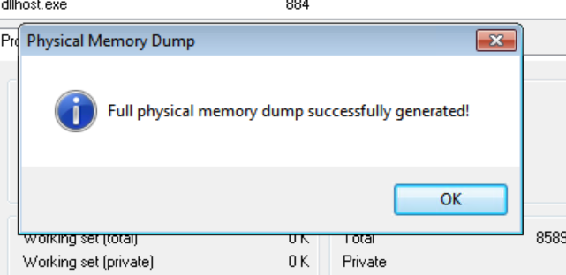
In the memory viewer screen, the investigator can view the memory of a suspect’s machine by navigating through the list of processes and clicking on them, as shown below.

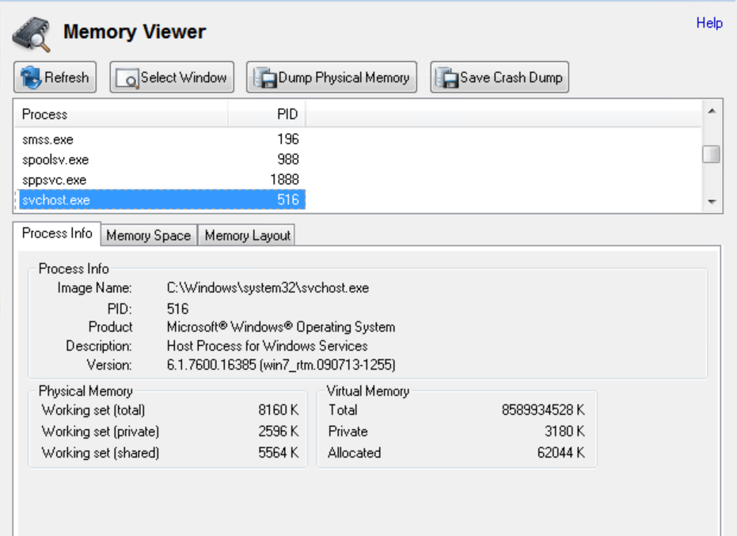

Forensic Tools Categories Table

Forensic Software | Autopsy | FTK | OSForensics
Software Category
Case Management | Autopsy allows an investigator to create a case and add a suspect’s data to a case. | FTK allows an investigator to create a case and add a suspect’s data to a case. | OSForensics allows an investigator to create a case and add a suspect’s data to a case.
Disk Imaging | Autopsy does not allow an investigator to make a copy of a suspect's disk. | FTK does not allow investigators to make copies of a suspect’s disk. However, FTK imager, which is bundled with FTK, allows an investigator to make copies of the suspect's disk. | OSForensics allows an investigator to make copies of the suspect's disk.
Data Recovery | Autopsy allows investigators to recover deleted files from a suspect’s disk. | FTK allows investigators to recover deleted files from a suspect’s disk. | OSForensics allows investigators to recover deleted files from a suspect’s disk.
File Hashing | Autopsy can verify hashes, but not generate them. | FTK cannot generate and verify hashes. However FTK imager, which is bundled with FTK allows investigators to generate and verify hashes. | OSForensics allows investigators to generate and verify hashes.
Password Recovery | Autopsy contains no tools for password recovery. | FTK does not contain a tool for password recovery. A separate tool called PRTK (Password Recovery Toolkit) was provided by the vendor of FTK, Exterro [3], to crack password files in the past. However if you try downloading PRTK from vendor’s site Password Recovery Toolkit (PRTK) version 7.6.0 | AccessData  It will inform you the download is no longer available. The last time the download was updated was in 2014. | OSForensics allows investigators to recover passwords for files etc.
Registry Viewer | Autopsy does not allow an investigator to view the registry. | FTK does not allow users to view the registry. However FTK is bundled with a separate software program called Access Data Registry, which allows users to view the registry of a suspect’s disk. | OSForensics allows investigators to view the registry of a suspect's disk.
Memory Analysis Tool | Autopsy does not allow you to create and analyse memory dumps. Autopsy does not allow an investigator to view the memory on a suspect’s machine. | FTK does not allow you to create and analyse memory dumps. FTK imager allows you to create memory dumps, but does not allow investigators to analyse the memory dumps. Investigators will need a separate software tool e.g. volatility to analyse the memory dump. FTK and FTK imager does not allow an investigator to view the memory on a suspect’s machine. | OSForensics allows investigators to create memory dumps, but does not allow investigators to analyse the memory dumps. You will need a separate software tool e.g. volatility to analyse the memory dump.  OSForensics allows you to view the memory on a suspect’s machine.

Evaluation

After reviewing Autopsy, FTK and OS Forensics, some of the software tools offer more functionality than other software tools. Autopsy allows investigators to create cases and add suspect’s data to those cases. Autopsy also allows investigators to view and recover deleted files. However, you need a forensic program like FTK imager if you wish to create disk images and disk hashing. Autopsy is free and there are no licence fees, therefore for a free tool it offers some functionality but not as much as a commercial product. FTK offers a lot more functionality. FTK allows investigators to create cases and add suspect data to a case. FTK allows investigators to view and recover deleted files. Apart from the functions provided by FTK itself, the other programs bundled with FTK offer additional functionality e.g. FTK imager allows investigators to create disk images and perform disk hashing. Although FTK and the other software programs that accompany it offer more functionality than Autopsy, not all of these functions are free. To obtain some of the functionality the investigator will need to pay a licence fee. OSForensics offers a lot more functions than FTK and the software programs bundled with FTK. OSForensics allows investigators to perform memory analysis on a suspect’s computer, which FTK cannot offer. Also, you have to switch between programs to obtain the different functions in FTK e.g. FTK imager creates the disk image and the disk image is parsed to FTK to perform a disk analysis. OSForensics allows investigators to create a disk image and analyse the disk image from within OSForensics without the need to switch between programs. OSForensics is not a free program and the investigator has to pay a fee.

Task 2 – Introduction

It is believed that a former employee of CEC Mobile Manufacturing, Rob Jengelley, has committed sabotage. CEC suspects that Rob has deleted a number of graphical designs while employed by the company. It is believed Rob deleted the graphical designs, so when he joined a rival company for more money, he could use the designs without any breach of intellectual law, e.g. patents. All of the graphical designs were stored on Rob’s computer. These designs are worth a lot of money. The only way CEC can protect the graphical designs is through patents, but this requires CEC showing the patent office that they originally created the graphical designs. The graphical designs that Rob created were worth a lot of money, and without designs, CEC cannot apply for a Patent.

CEC wishes to hire a forensic investigator to find out if Rob has deleted the designs and to recover the designs, so CEC can patent the designs and sell them to their customers.

Digital Investigation Steps

The investigation steps outlined below are those recommended by Aaron Philipp et al [5]. Aaron Philipp and his fellow writers have based their guidelines on the Electronic Discovery Reference Model (EDRM). The EDRM is an industrial working group responsible for industrial standards for the analysis and production of electronic data. We will follow most of Aaron's guidelines, but not all of them . The steps we will follow in the investigation are listed in the flow diagram below:
Identification:
  - Determines the scope of the investigation.

  - The data and volume of data to collect.

Collection and Preservation:
  - The collection and storage of data.

  - Chain of custody

  - Data Acquisition

  - Authenticity

Analysis:
Involves analysing a copy of the suspect’s data to see if the data can be recovered and if any wrong doings have taken place.

Product and Presentation:
Writing up the findings of your data analysis in a form a report and explaining the results of the report.

Identification

Determines the scope of the investigation, what data needs collecting and the volume of data.

Determine the scope and quantity of the data. It is the graphical designs that CEC wants to recover from Rob’s computer and to provide evidence if Rob deleted the graphical designs. The investigation will try to recover the graphical designs and show if Rob deleted the data. The volume of data that we need to focus on will be just the images or graphical design files.

Identify repositories. All of Rob’s designs were stored on his computer, therefore only the storage on Rob’s computer is relevant.

Collection and Preservation

This concerns collecting and preserving the data.

Data Collection and Storage. Rob’s computer needs to be retrieved and stored in a forensic lab away from other users. The computer will be stored in a secured or locked room which only authorised investigators have access to. This is to avoid users accidentally accessing Rob's computer and altering the data on the computer, which would invalidate any evidence on the computer if submitted to the court.

Chain of custody. A chain of custody will be established to ensure that the evidence is not altered during the investigation. If the evidence is altered during the investigation, the evidence cannot be submitted to the court. A custody log will be set up to show when the evidence entered the lab and who has accessed the evidence.

Data Acquisition. Once the computer is secure and in the forensics lab, the data needs to be captured so it can be analysed without altering the original state of the data. Rob’s graphical designs will normally be stored as images files on a hard disk. Therefore, we will need to use a software tool to make a copy of the hard disk. There are a number of tools that allow you to make copies of disks e.g. FTK imager, OSForensics etc. FTK imager will be used to make a disk image of Rob’s hard disk. This will preserve the original data and/or evidence and allow the investigator to analyse the data without fear of altering the original data. Below is an example of how to make a disk image of a physical drive in FTK imager. The process being applied in the example will be similar to one we will apply to Rob’s disk when making a digital image of his hard disk.

Step 1. In FTK imager, click on the file menu and select create disk image.

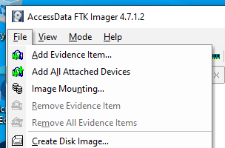

Step 2: On the source screen, select the physical drive.
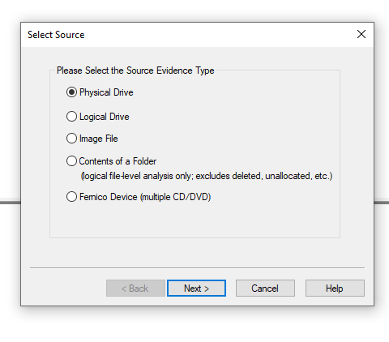
Step 3: On the select drive screen, select the drive you wish to image.
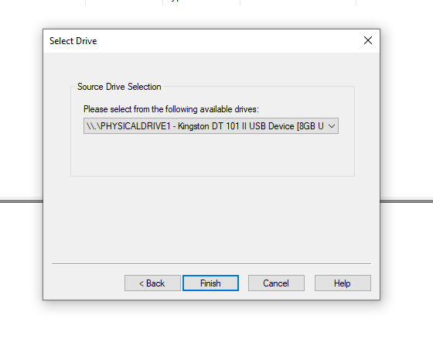

Step 4: On the create image, click on add.

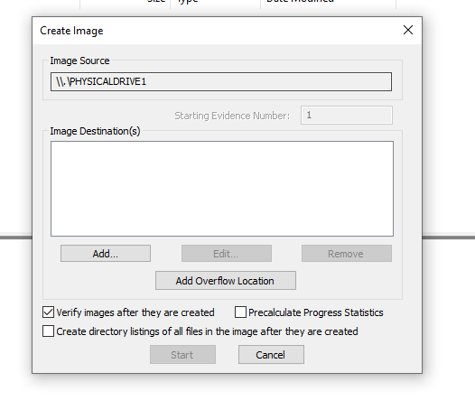

Step 5: On the select image screen, select Raw (dd)

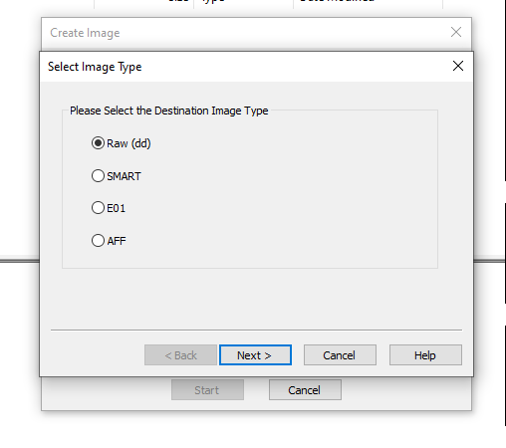
Step 6: On the evidence screen, enter a case number, evidence number, unique description and a forensic investigator’s name. This will help to reference which case the image is associated with and who is working on the case. Once you fill in the relevant details, click on next.

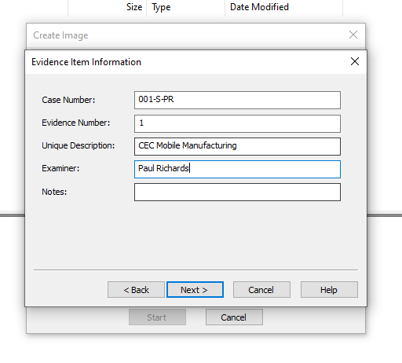
Step 7: On the select image destination screen, browse to the folder where you wish to store the image and give the image a file name as shown in the screenshot below. Then click on finish.
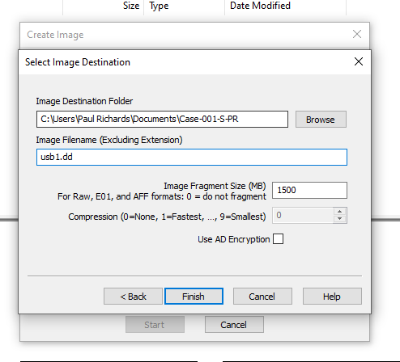
Step 8: On the create image, click on start.

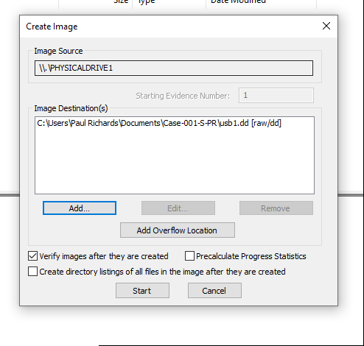

Step 9: A screen will pop up with a progress bar. Once the process is complete, the disk image will have been created.

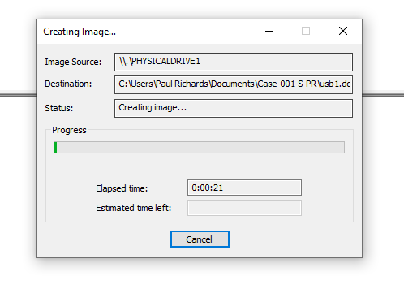
Authentication. After a disk image is made of Rob’s hard disk, we will need to show that the data in the disk image is identical to the data on Rob’s hard disk when presenting the evidence to the court. The best way to demonstrate that the original data is the same as the copy is through the use of metadata cryptographic hashes. A cryptographic hash will be generated on the original hard disk, then a cryptographic hash will be generated on the disk image. If both hash values match, then Rob’s hard disk and the disk image have not been altered. The hash values will be generated outside of Rob’s disk and disk image, e.g. storing the hash value in Rob’s hard disk will change the hash value when making a disk copy or image. We will not be using a simple checksum to validate the authenticity of the data because they can be easily spoofed and altered. We will use two established hashing algorithms to authenticate the data, SHA-1 and MD5, which are both accepted by the courts and the computer industry for verifying the authenticity of data. To verify a disk and disk image in FTK imager, follow the steps in the example below:
Step 1: In FTK imager, select the drive you wish to verify.

Step 2: Click on the file menu and select verify drive/image

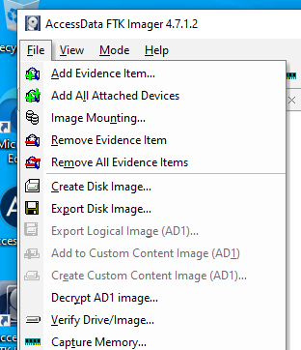

Step 3: A screen will pop with a progress bar.

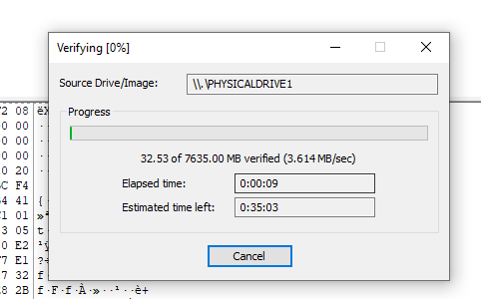

Step 4: Once the process is complete a screen will pop up with the hash values.

Analysis

The digital image or copy will be parsed through to FTK to analyse the contents of the disk and to see if deleted data can be retrieved from the disk. We will create a case and link Rob’s hard disk to the case. This case will be used throughout the whole of the forensic investigation when analysing Rob’s hard disk

We will create a case with the following details and default options in FTK.

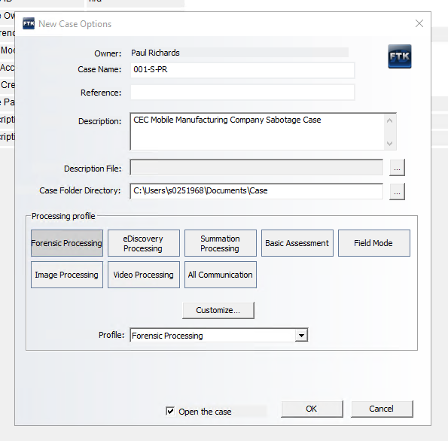

The case number and description will provide a reference for the case. The forensic processing profile is the standard profile for carrying forensic investigations on a disk or disk image.

After creating the case in FTK, we will add Rob’s hard disk to the case to analyse the contents of the disk. We will examine the deleted files section of FTK which shows what file have been deleted, as shown below:

If we find evidence of Rob deleting files, we will bookmark the files and include them in our report. We will also do a search of files that have been renamed in case Rob has tried to hide his work, rather than delete it.

Once we have completed the disk analysis, according to Amelia Phillips et al [4] any evidence of deleted files that we cannot recover through FTK. We will use another specialist data recovery tool called EaseUS to recover the data. EaseUS data recovery can recover disk partitions or files. Below is an example of how we will use EaseUS to recover deleted files.

Step 1: In the EaseUS recovery wizard, select the drive you wish to recover the missing files from.
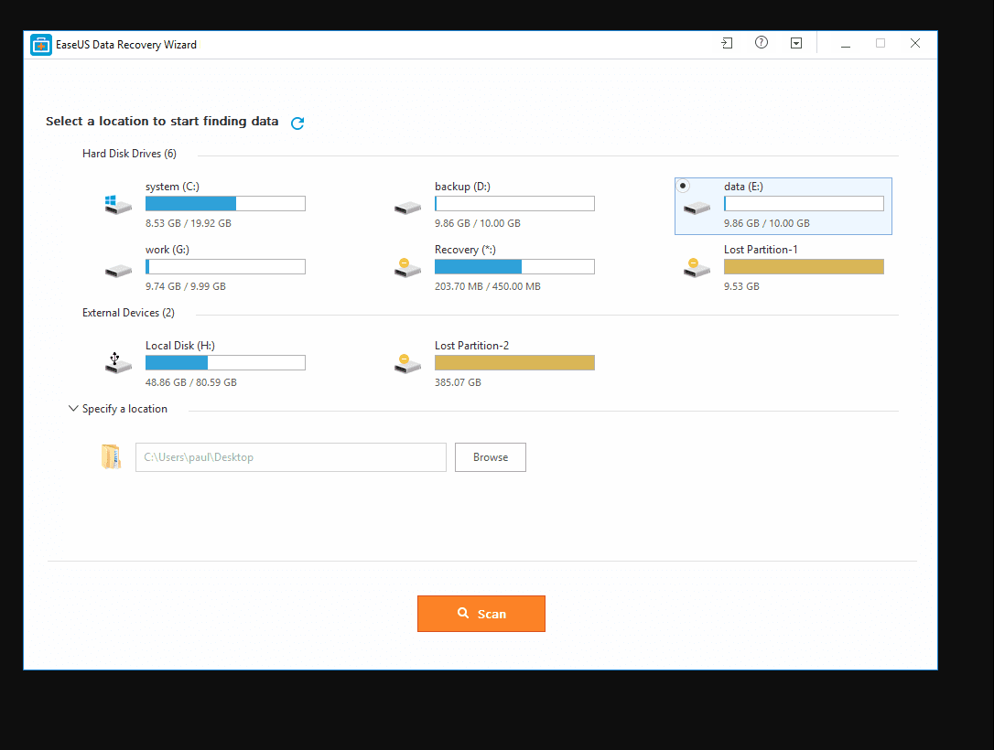

Step 2: EaseUS recovery will recover all the files that have been recently deleted or files emptied from the recycle bin. The application requires no user interaction at this stage of the data recovery process.

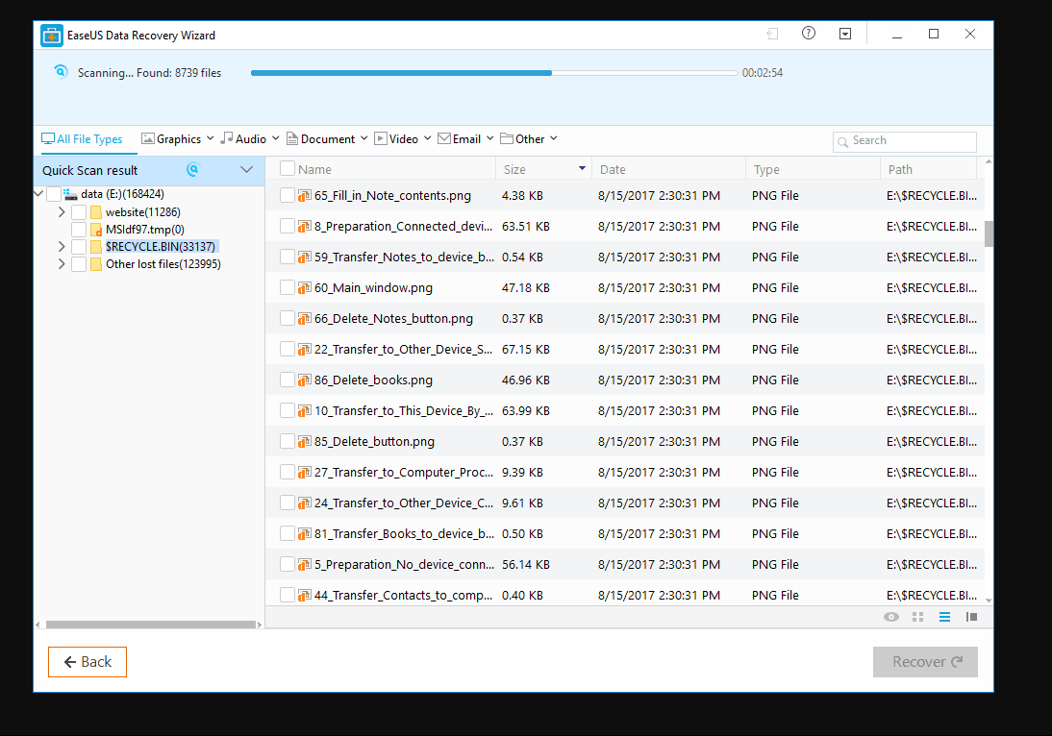

Step 3: EaseUS data recovery will present a list of deleted files. Select the files you wish to recover and click the recover button. Browse to the location where you wish to save the files and click ok.

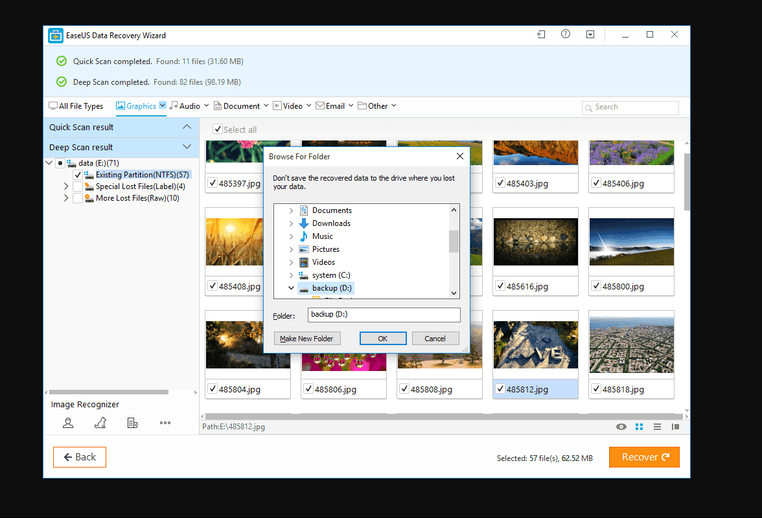

Product and Presentation

Once we have completed the investigation, we will use FTK to generate a report on our findings. The report will contain what files have been deleted and if any files have been renamed to prevent the employer from viewing the content of the files.
A sample of the report is contained in a separate file upload, called Case Report.
An example of how to create a report in FTK is shown below:

Step 1: In FTK, click on the file menu and select report.

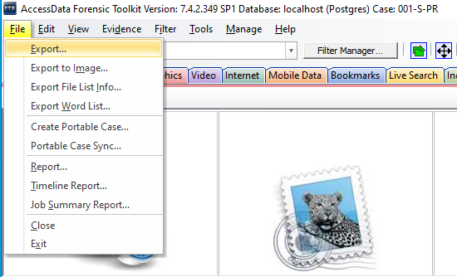

Step 2: A wizard will pop offering you what you want to include in the report e.g. file properties. Once you have selected which information you wish to include, click on the ok button.

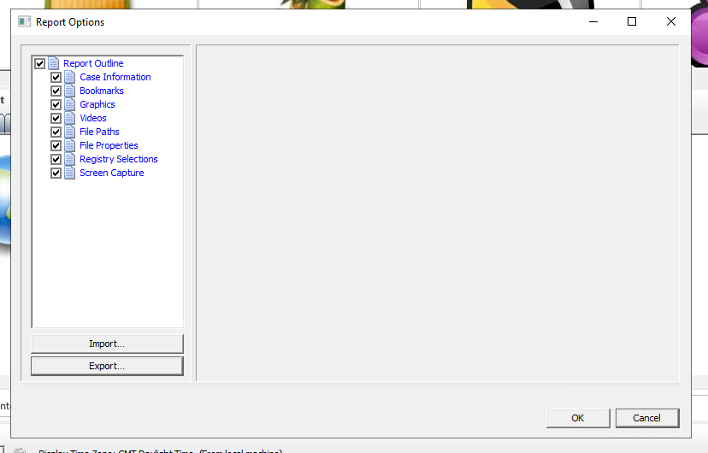

Step 3: A report output screen will appear. This provides the investigator with many options e.g. the format you wish to use for the report and where to store the report etc. In the example below, we have selected to save the report as a PDF file and to store the file in the following location C:\Users\0251968\Documents\Case Report. Once you have selected the appropriate options on the report output screen, click on ok to complete the process.

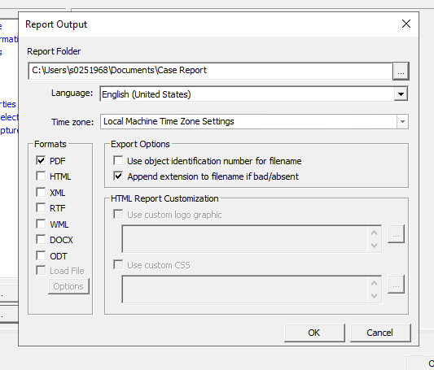

Step 5: A screen with a progress bar will appear.
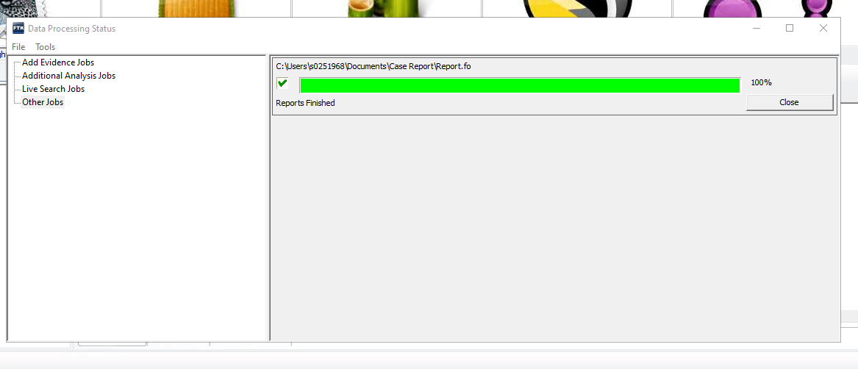

Step 5: Once the progress bar is completed, the report will appear on the screen. As shown below, a copy of the report will be stored in the location you specified in the report output screen.

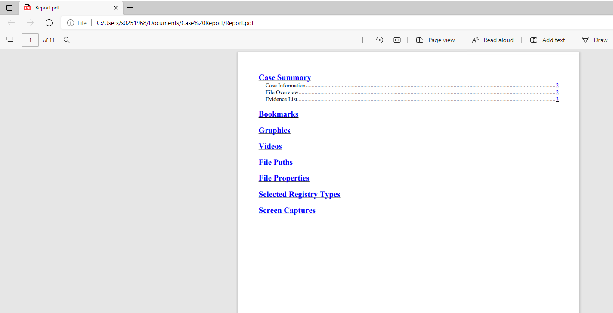

Invoice

An invoice will be sent to the customer which will provide a breakdown of the different parts of the forensic investigation and the fees for carrying out each part of the forensic investigation. The list of fees are listed below:

- There will be a fee for collecting and storing the evidence.

- There will be a fee for the disk imaging or copying of Rob’s hard disk. Also a fee for generating and verifying the hash values used for Rob’s disk and the disk image to make sure the evidence has not been altered.

- There will be a fee for analysing the contents of Rob’s drive to see if the graphical files were deleted or renamed.

- There will be a fee for recovering the data.

- There will be a fee for documenting the findings of the investigation in a form of a report.

A copy of the invoice is contained in Appendix A.

Appendix A
Invoice

Barry Lynch Forensic Investigator
11 Walters Road
Swansea SA1 2JA
Phone: 01792 231595
Email: Barry.lynch@lynch.co.uk
Website: www.barry.lynch.co.uk

Invoice Number: INV001
Date: 15/04/2022
For: Forensic Investigation
PO: PO00495

TO:
Ms Dee Rod
CEC Mobile Manufacturing
12 Brynmill Road
Swansea, SA4 3RN
01792 222020| dee.rod@cecmobile.co.uk

Description | Amount
Storage and Collection of Forensic Evidence | £1250.00
Disk Imaging and Authenticating | £750.00
Disk Analysis | £2225.00
Data Recovery | £3350.00
Forensic Report | £1000.00
Total | £8575.00
Make all checks payable to Company Name
Payment is due within 30 days.
If you have any questions concerning this invoice, contact Barry Lynch | 01792 231595 | Barry.lynch@lynch.co.uk
Thank you for your business!

Bibliography

[1] | G. Johansen, Digital Forensics and Incident Response: Incident response techniques and procedures to respond to modern cyber threats, Second ed., Birmingham: Packt Publishing, 2020, pp. 237-271.
[2] | C. L. Brooks, CHFI Computer Hacking Forensic Investigator Certification All-in-One Exam Guide, New York: McGraw Hill, 2014, pp. 180-185.
[3] | Exterro, “FTK Forensic Toolkit,” Exterro, [Online]. Available: https://www.exterro.com/forensic-toolkit. [Accessed 19 April 2022].
[4] | B. N. C. S. Amelia Phillips, Guide to Computer Forensics and Investigations, Boston: Course Technology Inc, 2018, pp. 150-151,281,305,326,349,395,429,471,479.
[5] | D. C. D. Aaron Philipp, Hacking Exposed Computer Forensics, Second Edition: Computer Forensics Secrets & Solutions, second ed., New York: McGraw-Hill, 2022, pp. 15-17.

