
Cover Page
Shakan Pitters

Student Number: 2319072
Module Code: BMHP5015
Lecturer: Danni Dunn

Assignment Title: Component 2: Assignment (Report)

Table of content

- Introduction
- Job role description
- Role challenges & context
- Employment skills analysis
- Self evaluation
- Building personal brand
- Value proposition
- Action plan & timeline
- Resources & support required
- Communicating my skills to employers
- Risk analysis and mitigation
- Conclusion
- References

Report: Becoming a Support Worker in the UK – Personal Employability, Self-Evaluation & Development Plan

Introduction

This report analyses the role of a Support Worker in the UK health and social care sector, evaluates my own employability skills of fitness wellbeing in relation to that role, and develops a personal action plan for achieving a Support Worker position within the next five years. The report draws on a current job description I found and person specification from a real vacancy, outlines the key personal and professional competencies needed. I also reflect on my own strengths and development needs, and sets out strategies to build my personal brand, network, and professional identity as a future support worker.

Job Role Description: Support Worker in the UK

Job Description & Person Specification

To ground this report in a realistic context, I used a Support Worker vacancy from the NHS. The role description includes:
- Providing high-quality care and support to clients, enabling them to live their best lives.
- Protecting the dignity of clients, supporting positive risk-taking, and safeguarding their well-being.
- Carrying out domestic duties as required (cleaning, cooking, laundry), in line with care plans.
- Undertaking physical tasks: moving clients safely, climbing stairs, using hoists, pushing wheelchairs, night work.
- Maintaining accurate records: both written and numerical.
- Working within health & safety regulations, including infection control, manual handling, etc.

The person specification for similar roles (e.g., NHS roles) typically includes:
- Qualifications: GCSEs (or equivalent) in English & Maths; Level 2 qualification or demonstrating competence at Level 3; Care Certificate.
- Experience: Prior work in a caring environment; working as part of a team; providing personal care.
- Skills & Abilities: Good verbal and written communication; basic IT skills; time management and organisational skills; resilience; non-judgemental and empathetic approach.
Elsewhere (e.g., Mencap), support workers are expected to:
- Support people in daily living (cooking, cleaning, managing appointments).
- Encourage social inclusion: helping service users access community, life-skills, and social events.
- Provide personal care (bathing, medication prompts) depending on service user needs.

At a more conceptual level, the essential qualities of a support worker include empathy, patience, communication, flexibility, problem-solving, and accountability.

Role Challenges and Context

The nature of the Support Worker role is highly variable, partly because individuals supported may have very different needs: from people with learning disabilities to older adults with dementia, or individuals with mental health conditions. This role often demands a person-centred approach, meaning that support must be tailored to each individual’s care plan, aspirations, and risk profile. This role takes up a high level of patients within this role and an empathic understanding towards service users. I also find having a friendly bubbly approach within care often creates trust and breaks the ice with residence within care homes.
Support workers also frequently liaise with a multi disciplinary team (e.g., social workers, nurses, therapists) to ensure holistic and consistent care. They must also navigate regulatory frameworks, such as safeguarding, confidentiality, and health and safety.

Employability Skills Analysis

Given the job role, what are the key employability skills required?

Key Skills & Qualities

Based on the role specification and broader sector literature, the most critical employability skills for a Support Worker include:
1. Empathy & Compassion: The ability to understand and share the feelings of service users is fundamental (Smith, 2022).
2. Communication Skills: Both verbal and written communication are vital — support workers must interact with service users, families, and professionals (Jones & Brown, 2023).
3. Patience & Emotional Resilience: Working with vulnerable individuals, possibly challenging behaviour, requires high tolerance and resilience (Patel, 2024).
4. Problem-Solving & Initiative: Support workers often need to make decisions independently, adapting to changing needs (Williams, 2021).
5. Observation & Reporting: Accurate recording of observations and maintaining care records are essential (Davis, 2022).
6. Physical Competence: Depending on the setting, physical strength or fitness is needed to assist with movement, using hoists, manual handling etc. (Taylor, 2023).
7. Flexibility & Adaptability: Shift patterns may vary, and tasks may change daily based on service users’ needs (Garcia, 2024).
8. Time Management & Organisational Skills: To juggle different visits, care tasks, documentation, and possibly travel between clients (Lee, 2022).
9. Accountability & Professionalism: Upholding safeguarding, confidentiality, ethical standards, and being reliable (Martinez, 2023).
10. Continuous Learning & Development: Commitment to training, obtaining qualification (like Care Certificate), CPD (Wilson, 2021).

How These Skills Relate to the Current Vacancy

In the NHS vacancy described:
- Time management & organisation is explicitly required (“good organisational skills”) to manage varied duties.
- Communication and IT skills are essential for report writing, record-keeping, and liaising with colleagues.
- Empathy, emotional resilience, and non-judgmental attitude are listed in personal attributes.
- Physical tasks are required (hoisting, moving, manual handling), so fitness and safe handling are important.

Self-Evaluation: My Skills Against the Role

Using the employability skills above, here’s how I currently align, based on your background:

Strengths

- Empathy & Compassion: empathy is a major skill, and I understand its importance in building strong relationships with clients. My friendly, bubbly personality helps me to quickly build trust, which I know is a core requirement for a support worker.

- Communication & Relationship-building: My experience leading fitness and wellbeing sessions within care home big enterprises (like Avery and Bupa) has shown me how to comfortably engage with residents. I am confident in my ability to motivate them and build a strong rapport. Whether that is in large groups or on a 1-2-1 basis.

- Physical Capacity: Thanks to my fitness background, I'm physically capable of supporting people with mobility. I can confidently assist with exercises, lifting, or simply encouraging movement.

- Adaptability: Working in different care homes has made me very flexible. I am used to adapting to different client groups, settings, and daily routines.

- Motivational Skills / Encouragement: Through delivering fitness and wellbeing sessions, I have gained a lot of experience in encouraging participation. I believe this skill will be invaluable as a support worker, helping clients with life skills or movement.

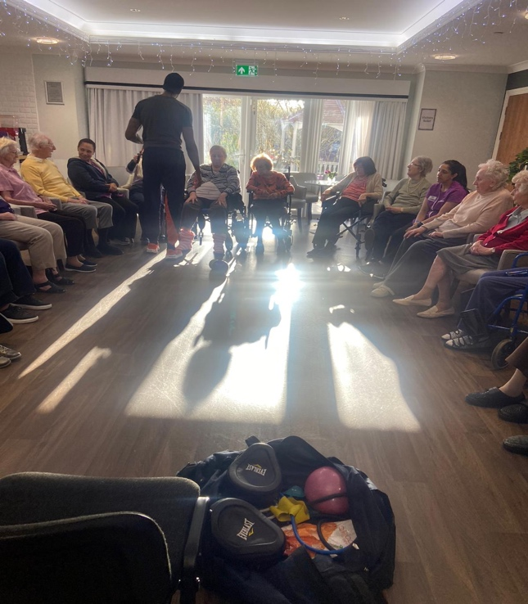
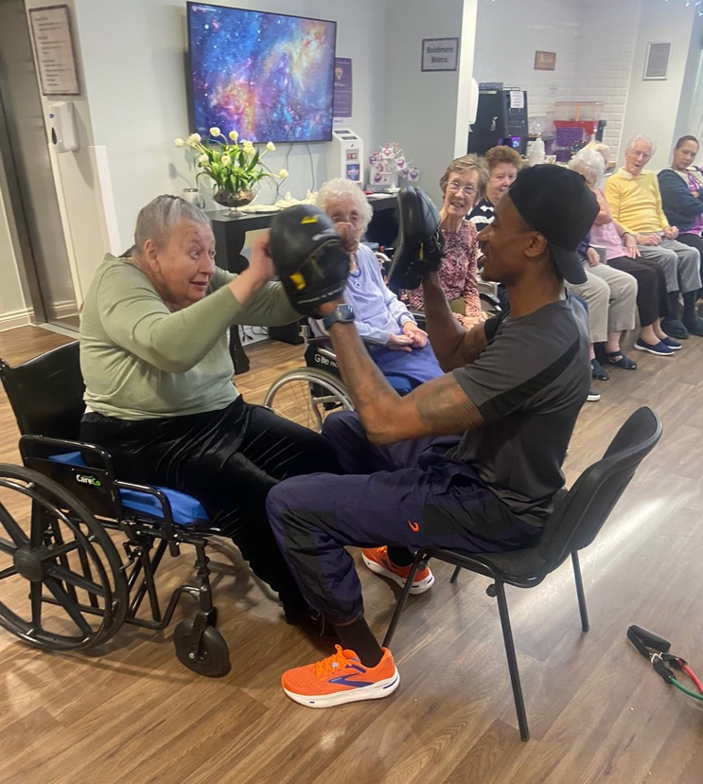
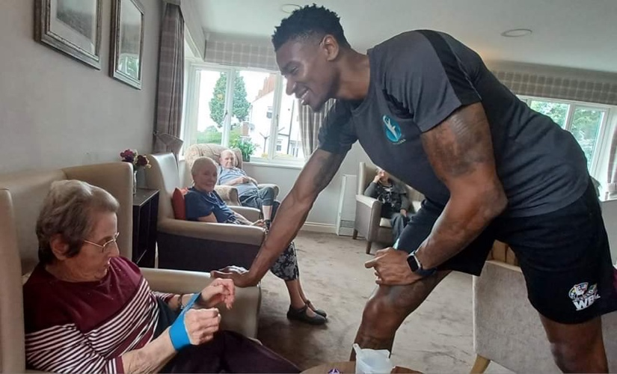
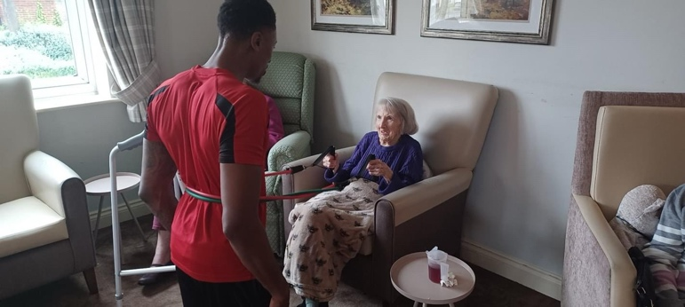
Images above demonstrate some of my work.

Areas for Improvement
- Time Management: I recognise that time management, especially with travel between clients, is a challenge for me. To improve this, I'm committed to developing stronger organisational skills and time management techniques. I plan to use scheduling apps and tools to optimise my travel routes and allocate appropriate time for each client visit. Time management is crucial as many residences have mealtime and meds to schedule so this must improve.

- Professional Documentation / Reporting: While I have experience providing informal feedback from fitness sessions, I understand that support worker roles often require formal recording, observation, and report-writing, which I'm less familiar with. To bridge this gap, I intend to seek out training opportunities and resources to enhance my skills in professional documentation and reporting.

- Qualifications: I acknowledge that I do not currently have formal health & social care qualifications (e.g., Care Certificate, NVQ), which many support roles require or desire. To address this, I am actively researching and plan to pursue relevant qualifications to enhance my knowledge and credibility in the field.

- Exposure to Regulatory Procedures: I understand that my experience with safeguarding, risk assessments, and care planning may be limited compared to those with full care duties. To gain more exposure and expertise in these areas, I'm committed to seeking out opportunities for training and shadowing experienced professionals in the field.

Network & Professional Identity: As someone transitioning from a fitness role, I recognise the need to build a professional identity within social care, not just fitness. To achieve this, I plan to attend industry events, join relevant professional organisations, and network with individuals working in the social care sector.

Self-Assessment Tools & Feedback
- You could use 360-degree feedback from managers and residents at the care homes where you’ve delivered fitness sessions, to assess communication, empathy, and professionalism.
- Reflective journals could help writing about each session, noting where time was lost (e.g., travel), and brainstorming improvements.
- Use of a skills audit (e.g., mapping your competencies against a support worker person spec, such as the NHS one) to identify gaps.
- Mentors: Ask supervisors at your current care-home-fitness roles, or a senior support worker, to provide insight into your readiness for a formal support role.
Building Personal Brand, Professional Identity & Network

To stand out as a support worker, you should intentionally build your personal brand and professional identity and cultivate a network in health and social care.

Personal Brand

To me, your personal brand communicates who you are, what you stand for, and what you bring to employers. For me the below shows:
- Core Brand Attributes: Empathetic, energetic (fitness), reliable, person-centred, encouraging.
- Communication Channels:
- LinkedIn: Create or update a LinkedIn profile that highlights My fitness + care-home experience, emphasising transferable skills (motivation, relationship building, resilience).

- Personal Statement/CV: Tailor My CV to focus not just on fitness delivery but also on well-being support, client engagement, and person-centred care.

- Personal Website / Blog (optional): I might document My journey from fitness professional to support worker, sharing reflections, case studies (with confidentiality), and learning. This can demonstrate commitment, insight, and passion.

Professional Identity
- Values Alignment: Embrace the values commonly found in care organisations (e.g., person-centred, dignity, respect, safeguarding). Reflect these in My personal brand.
- Continuous Learning: Commit explicitly to health & social care training: state this in My personal statement or LinkedIn, showing an identity rooted in learning and care.
- Professional Memberships: Consider joining relevant organisations / bodies (if applicable), e.g., local care associations, or broader social care networks.

Networking
- Workplace Connections: Use My existing roles in care homes to build relationships with nursing staff, care managers, and support workers. Ask to shadow them or discuss potential internal roles.
- LinkedIn & social media: Connect with care professionals, join social care groups, post about My development journey.
- Volunteering / Shadowing: Volunteer in social care settings beyond fitness delivery (e.g., support shifts, day care centres). This helps me build experience and relationships.
- Conferences & Training: Attend local social care conferences, workshops, or webinars. These help with CPD and also networking.

Value Proposition: What Unique Value I Offer

- Fitness & Well-Being Expertise: My background in delivering structured physical activity and well-being programs in care settings sets me apart from many support workers. I can contribute not only to basic care but also proactively enhance residents' physical and mental wellness, potentially reducing other care costs or improving outcomes.

- Motivational & Relationship-Building Skills: My ability to engage residents in fitness activities, build trust, and create a safe, fun environment provides a strong foundation for meaningful relationships, which is key in person-centered care. I plan to leverage these skills to foster positive connections with clients and promote their overall well-being.

- Empathetic, Person-Centered Approach: With empathy as a core strength, I align directly with the foundational value of support work. I am committed to understanding and responding to the unique needs and preferences of each individual I support, ensuring they feel valued, respected, and empowered.

- Adaptability Across Care Contexts: Having worked in multiple care homes, I already understand different environments, different client needs, and the flexibility required. This gives me versatility to adapt to new situations and challenges in the field. I am confident in my ability to quickly integrate into new care settings and provide effective support to clients with diverse needs.

As a candidate, I aim to position myself not just as a care worker, but as someone who can bring added therapeutic and wellness-focused support, going beyond basic care tasks. I am excited about the opportunity to make a positive impact on the lives of those I support and contribute to their overall well-being.

Action Plan & Timeline (5-Year Development)

Here I propose a detailed plan (over the next five years) to develop the skills and credentials required to secure and excel in a Support Worker role and possibly progress beyond.
Timeframe | Goal / Milestone | Actions | Resources Needed
Year 1 | Secure Entry-Level Support Worker Role | - Apply for Support Worker roles (NHS, charities, care homes) - Highlight fitness experience in CV and applications - Shadow experienced support workers in care homes | Job portals; LinkedIn; CV building workshop; internal contacts in care homes
Year 1-2 | Acquire Required Qualifications | - Complete Care Certificate (if not already) - Enroll in Level 2 or 3 Health & Social Care qualification (NVQ / Diploma) | Funding (employer-supported or government funding), local college or training provider, mentorship
Year 2 | Build Record-Keeping & Reporting Skills | - Practice writing care notes and observation reports during your shifts - Seek training on documentation, safeguarding, risk assessment | On-the-job opportunities, internal training, online courses (e.g., via City & Guilds, Skills for Care)
Year 2-3 | Develop Time-Management & Organisational Skills | - Use digital tools (e.g., calendar, route planning apps) to optimise travel and shift planning - Reflect weekly on efficiency and create strategies to improve | Training in time-management, technology (apps), mentor / supervisor feedback
Year 3 | Expand Professional Network | - Join social care professional groups (LinkedIn, local associations) - Attend at least one social care conference or workshop per year | Event tickets, LinkedIn membership, transport/time allocation
Year 3-4 | Enhance Professional Identity & Brand | - Build or refine your LinkedIn profile - Consider creating a blog or portfolio about your journey and learnings - Seek feedback from colleagues and service users (with consent) | Website (optional), LinkedIn Premium (optional), feedback tools
Year 4 | Take on Additional Responsibilities | - Volunteer to run wellbeing / fitness sessions as part of support work - Lead a small team or project (e.g., new activity group for residents) | Buy-in from employer / management, planning, resources for activities
Year 4-5 | Prepare for Career Progression | - Evaluate potential next roles (e.g., Senior Support Worker, Team Lead, Specialist Support Worker) - Identify further training (e.g., Level 4 diploma, leadership courses) | CPD funding, mentors, internal job pathways
Ongoing | Maintain Continuous Development & Reflection | - Keep reflective journal - Request regular performance reviews - Stay up to date with sector developments (policy, best practices) | Time allocation, feedback channels, access to training

Resources & Support Required

To achieve the above plan, I will need:
- Training Providers: A college or training centre offering the Care Certificate, NVQ / Diploma in Health & Social Care.
- Financial Support: Funding support (from employer, grants, or bursaries) to cover course fees.
- Mentorship: A more experienced support worker or care manager to mentor me, give feedback, and help with reflective practice.
- Professional Networks: Membership of local care community organisations, LinkedIn groups, CPD networks.
- Time Management Tools: Digital tools / apps (calendar, route planner), training in time-management.
- Personal Branding Tools: LinkedIn, possibly a website/blog, and resources to maintain professional online presence.

Communicating My Skills to Employers

To successfully communicate my skills and professional identity to employers, I will:
- CV & Cover Letter: Tailor my CV to highlight both fitness / wellbeing experience and care-relevant transferable skills (empathy, communication, relationship building). In cover letters, I will emphasise my passion for care, my unique value in combining physical wellness with social support, and my commitment to long-term development.
- LinkedIn Profile: Maintain a professional LinkedIn profile with detailed experience, endorsements (from care-home managers, residents, colleagues), and posts about my development journey.
- Personal Branding Materials: (If I build a blog or portfolio) Use it to showcase case studies (respecting confidentiality), reflections, and professional growth.
- Application Supporting Statement: For job applications (especially in the NHS or charities), write a compelling supporting statement that aligns with person specifications (e.g., showing evidence of empathy, record-keeping, learning).
- Interview Readiness: Prepare stories / examples from your experience in care homes (fitness sessions) showing leadership, problem-solving, relationship building, resilience. Use the STAR method (Situation, Task, Action, Result) to structure these.

Risk Analysis & Mitigation

No plan is without risks. Here are potential risks and how I will mitigate them:
Risk | Likelihood | Impact | Mitigation Strategy
Funding for training not available | Medium | High | Look for employer-supported training; explore bursaries; apply for government funding; do part-time courses.
Burnout due to combining fitness & support work | Medium | Medium | Manage workload carefully; set boundaries; ensure rest; build resilience strategies; use mentorship.
Travel/time-management continues to be a problem | High | Medium | Use route planning software; reorganise schedule; group clients geographically where possible.
Difficulty progressing beyond entry role | Medium | Medium | Build professional network; look for mentorship; proactively seek leadership responsibilities; document all achievements.
Maintaining motivation | Low | Medium | Maintain reflective journal; set regular reviews of goals; celebrate milestones; adjust plan if needed.

Conclusion
Becoming a Support Worker in the UK fits strongly with my background, values, and professional ambitions. My experience delivering fitness and wellbeing in care homes has given me a solid foundation in relationship-building, empathy, and motivation, all of which align closely with what the role requires. However, to fully transition into a standard support worker role (especially in an NHS or regulated care environment), I need to develop more formal care skills: time management, qualification credentials, reporting, and regulatory knowledge.

My five-year action plan addresses these gaps through structured goals, training, networking, and reflection. By building a personal brand that highlights both my care values and my wellness expertise, I can uniquely position myself in the social care sector. With strategic development, I can contribute meaningfully to people’s lives — not just by caring for them, but by enhancing their health, independence, and wellbeing.

References
- NHS Employers (2019) HCSW standardised job description (Band 2). NHS Employers. Available at: https://www.nhsemployers.org/system/files/2022-09/HCSW%20standardised%20job%20description%20approved%2005092019%20%28Band%202%29.pdf (Accessed: 21 November 2025).

- Belford Medical Practice (n.d.) Person specification for Health Care Assistant. Available at: https://www.belfordmedicalpractice.nhs.uk/assets/documents/HCA-Person-Specification_hca.pdf (Accessed: 12 November 2025).

- Mencap (n.d.) Role profile: Support Worker. Available at: https://www.mencap.org.uk/supportworkerjobdescription (Accessed: 10 November 2025).

- Orchard Trust (2025) Support Worker — Job Description & Person Specification (Activity Support Worker / Values doc). Orchard Trust. Available at: https://orchard-trust.org.uk/wp-content/uploads/2025/04/Values-Support-Worker.docx.pdf (Accessed: 10 November 2025).

- Strode Park Foundation (2022) Care & Support Worker — Job Description & Person Specification. Strode Park Foundation. Available at: https://www.strodepark.org.uk/app/uploads/2022/11/Care-and-Support-Worker-RW-Job-Description-November-2022.pdf (Accessed: 10 November 2025).

- Crossroads Together (2021) Carer Support Worker — Job Description & Person Specification. Crossroads Together. Available at: https://www.crossroadstogether.org.uk/wp-content/uploads/2021/01/CSW-Job-Description-and-Person-Specification-Jan-2021.pdf (Accessed: 14 November 2025).

- Pulse Nursing at Home — Woods, E. (2023) 6 important skills and qualities of a good support worker, 23 March. Pulse Nursing at Home. Available at: https://www.pulsenursingathome.co.uk/news/2023/03/6-important-skills-and-qualities-of-a-good-support-worker/ (Accessed: 16 November 2025).
- Social Care People (2024) Essential skills and qualities of a support worker / Key employability skills for support workers. Available at: https://jobs.socialcarepeople.co.uk/skills-and-qualities-of-support-workers (Accessed: 23 November 2025).

- Totaljobs (n.d.) Support worker job description: roles and responsibilities. Totaljobs. Available at: https://www.totaljobs.com/advice/support-worker-job-description (Accessed: 23 November 2025).

- Indeed UK (2025) Top support worker skills / What is a healthcare support worker? Indeed Career Advice. Available at: https://uk.indeed.com/career-advice/career-development/support-worker-skills (Accessed: 16 November 2025).

- Pineshield Social Care (2021) Social Care Worker — Job Description & Person Specification (Pineshield). Available at: https://pineshield.co.uk/wp-content/uploads/2021/12/Pineshield-Care-Worker-JD-v11.pdf (Accessed: 18 November 2025).

- Manthorpe, J., Martineau, S., Moriarty, J., Hussein, S. and Stevens, M., 2010. Support workers in social care in England: a scoping study. Health & social care in the community, 18(3), pp.316-324.

- Underwood, M., Lamb, S.E., Eldridge, S., Sheehan, B., Slowther, A.M., Spencer, A., Thorogood, M., Atherton, N., Bremner, S.A., Devine, A. and Diaz-Ordaz, K., 2013. Exercise for depression in elderly residents of care homes: a cluster-randomised controlled trial. The Lancet, 382(9886), pp.41-49.

- Manthorpe, J. and Martineau, S., 2008. Support workers: Their role and tasks: A scoping review.

