
Learning in the digital era  Lecturer: Malik Mehmood | Abstract  In this assignment, I will discuss how learning has changed in the digital era. I will explain how technology has made learning easier and more accessible, as well as some of the challenges it brings. I will also show and explain how I use different software and digital tools to support my learning and complete tasks effectively.  Mohammed Ismail (2539445)  ACCA4025

Contents
1A- Fundamental Academic and Employment Skills 2
1B- Turnitin Similarity Score Reflection 3
2A – Mind Map of Key Considerations of Effective Teamwork 4
2B – “Life Is a Team Sport” Academic Poster 5
3A- Virtual Collaboration – Topic 1, Forming a Team 5
3B- Use of RefWorks 7
4A- E-portfolio 9

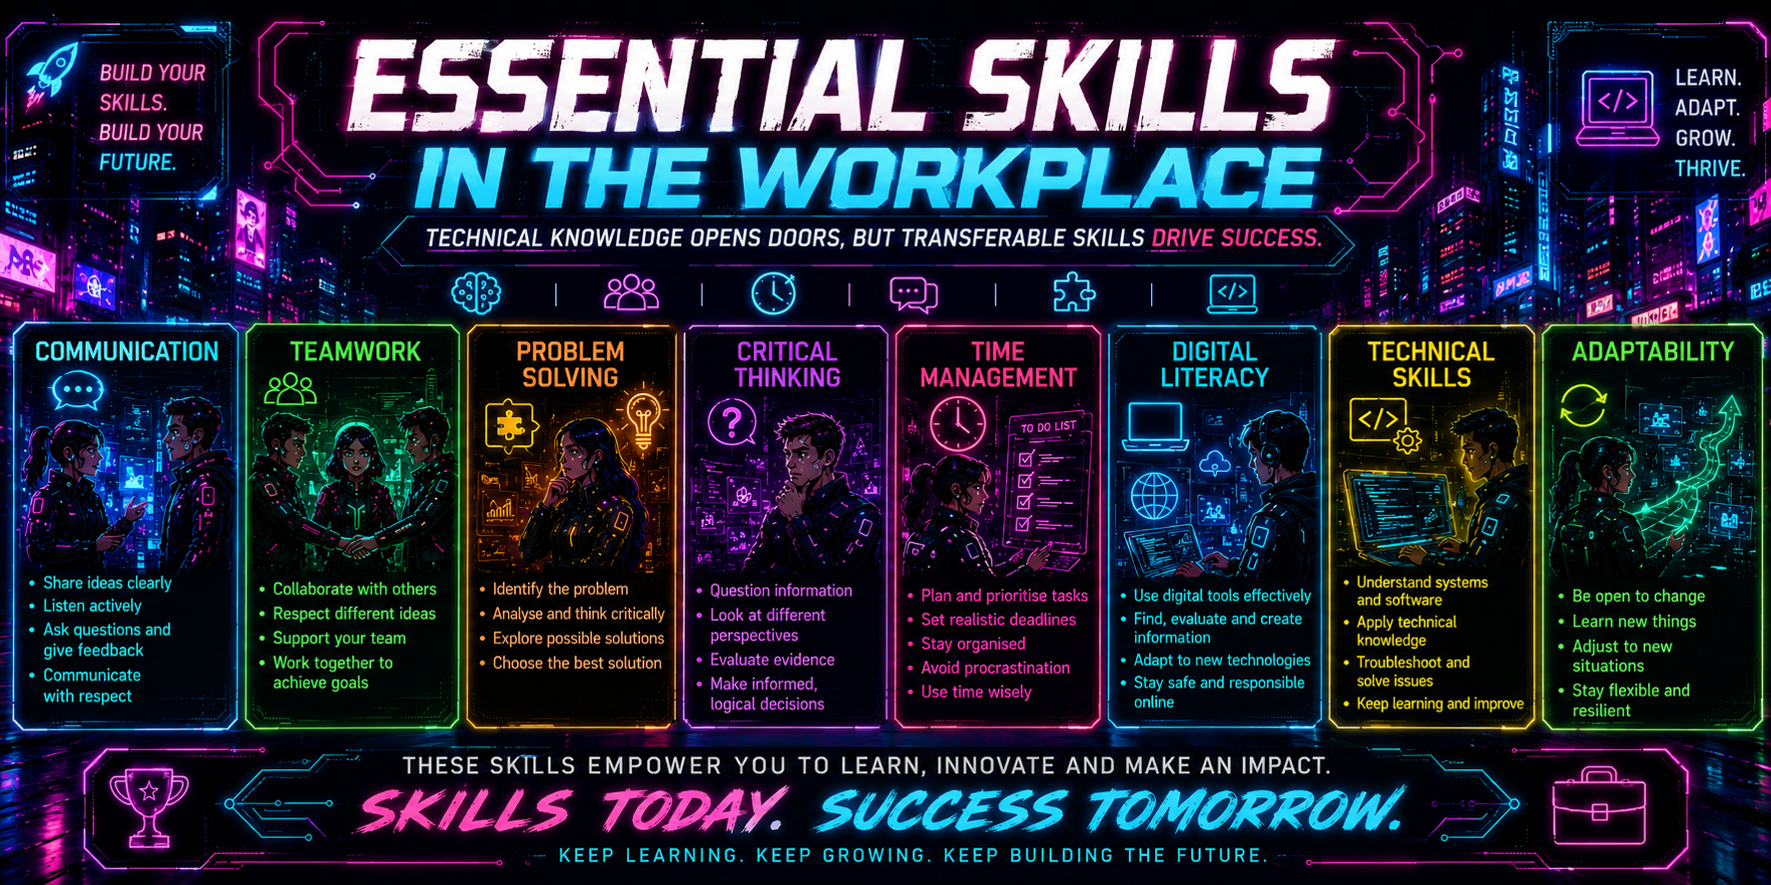
1A- Fundamental Academic and Employment Skills

[1]

In the computing and digital industry, having technical knowledge alone is no longer enough. As technology continues to develop, professionals must also build a range of transferable skills, including problem-solving, critical thinking, time management, communication, teamwork, and technical skills. Together, these skills provide a strong foundation for academic success and help prepare individuals for a successful career in the computing industry [2].
Digital and technical skills enable individuals to use various software, understand new systems, and keep up with technological changes. However, digital literacy goes beyond basic computer use. As a student, I have found that digital literacy has helped me complete assignments more effectively and improve my understanding of technology. This is supported by Gaddis [2], who explains the importance of digital skills for learning, while ICDL [3] highlights their value in education and preparing students for the workplace.
Good communication and teamwork are also essential because many computing projects are completed in groups. Effective communication involves thinking critically and questioning information rather than accepting everything at once. Asking questions such as "How?", "Why?", and "Is this correct?" Helps improve understanding, avoid mistakes, and ensure everyone is working towards the same goal. Research into employability skills for IT professionals shows communication and critical thinking as important workplace skills [4].
Time management and problem-solving are equally important because they enable individuals to work in an organised and efficient manner. As a student, these skills help me plan assignments, meet deadlines, and avoid leaving work until the last minute, giving me extra time to review and improve my work. During a group presentation, one team member became nervous and confused while presenting. I naturally continued by saying, "What Bea was also trying to say..." before explaining the point further. This ensured the presentation continued smoothly and proved the importance of remaining calm, adaptable, and supportive within a team [2], [4]

1B- Turnitin Similarity Score Reflection
My Turnitin similarity score was 12% which I believe is a good result because it shows that my work is original. The similarity mainly came from correctly referenced sources, common academic phrases, and the reference list rather than copied content. This has given me more confidence in my academic writing and references skills. After reviewing my Turnitin report and the mark I gave myself using the Generic Assessment Criteria, I have made improvements to my work by adding more detail and correcting small mistakes. In the future, I will continue to paraphrase information more carefully, avoid unnecessary direct quotations, and check my work before sending it. Based on the Generic Assessment Criteria I would award myself 70% because I have shown good research, correct IEEE referencing, clear organization, and original writing, while recognizing I can still improve my critical thinking and overall presentation.

Generic Assessment Criteria (GAC) | Self-Assessment (%)
Engagement with Literature Skills | 67%
Knowledge and Understanding Skills | 70%
Cognitive and Intellectual Skills | 68%
Practical Application Skills | 71%
Transferable Skills for Life and Professional Practice | 68%
Overall Self-Assessment | 70%

2A – Mind Map of Key Considerations of Effective Teamwork
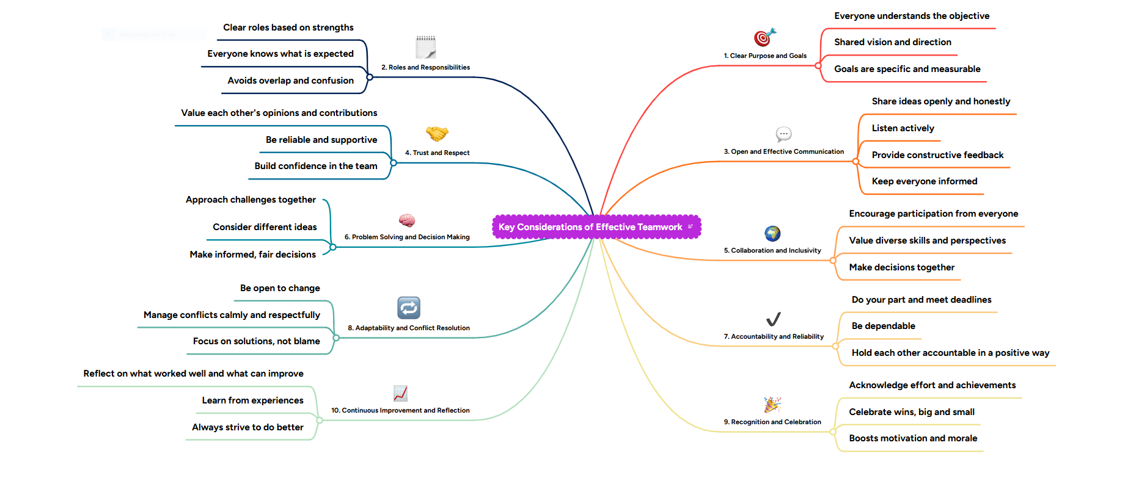

Link to the effective teamwork mind map - https://mm.tt/map/4034915789?t=UegHVwDs1n

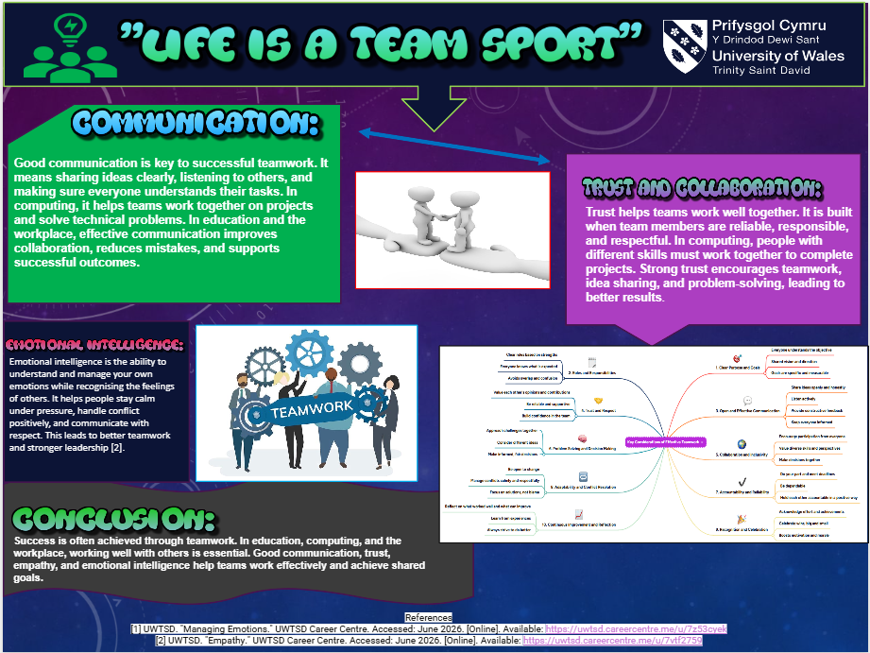
2B – “Life Is a Team Sport” Academic Poster
Link to the Academic Poster - MI - Poster.pptx

3A- Virtual Collaboration – Topic 1, Forming a Team
Virtual team dynamics describe how members personalities and interactions shape communication, task sharing, and overall success whether the group is long standing or formed just for one project before disbanding [5] . This fits well with Tuckman and Jensen’s well known five stage model: forming, storming, norming, performing, and adjourning. Forming is the very first step, where people meet, get to know each other, and start agreeing on shared aims [6].
At this early stage, members are usually polite but unsure. They often feel a mix of nervousness, curiosity, and excitement, while conversations stay fairly general and clear structure is often missing [7] . In virtual teams, these challenges are even greater without face-to-face contact, trust builds more slowly and keeping everyone motivated takes extra effort[8].
Trust is the foundation of any strong team. As Lencioni explains, a lack of trust is the biggest barrier to effective teamwork [9]. It grows when people are open and honest, willing to share both their strengths and their limits, creating a safe space where ideas can flow freely. Being genuine matters just as much, Inham points out that honesty and transparency build real, lasting connections [10]. Yet many people hide their true selves online, whether out of embarrassment, fear of judgment, or simply to seem more capable. This lack of authenticity weakens trust, lowers morale and makes it harder to assign roles and manage time well [7],[10]. A simple fix is to create a short, honest profile and adapt how you introduce yourself depending on whether the meeting is online or in person [7]
To set the team up well from the start, goals should follow the FAST framework: frequently discussed, Ambitious, Specific, Transparent [11]. Regularly checking in on goals keep everyone focused, challenging but achievable targets drive better work, clear aims make progress easy to track and sharing results openly encourages accountability. When trust, authenticity and clear goals come together a virtual team gets off to a strong, productive start.

3B- Use of RefWorks

I first created a RefWorks account using my university student email. I then used RefWorks to add and organise my references. The screenshots below show how I used RefWorks to generate IEEE references and include them in my assignment.

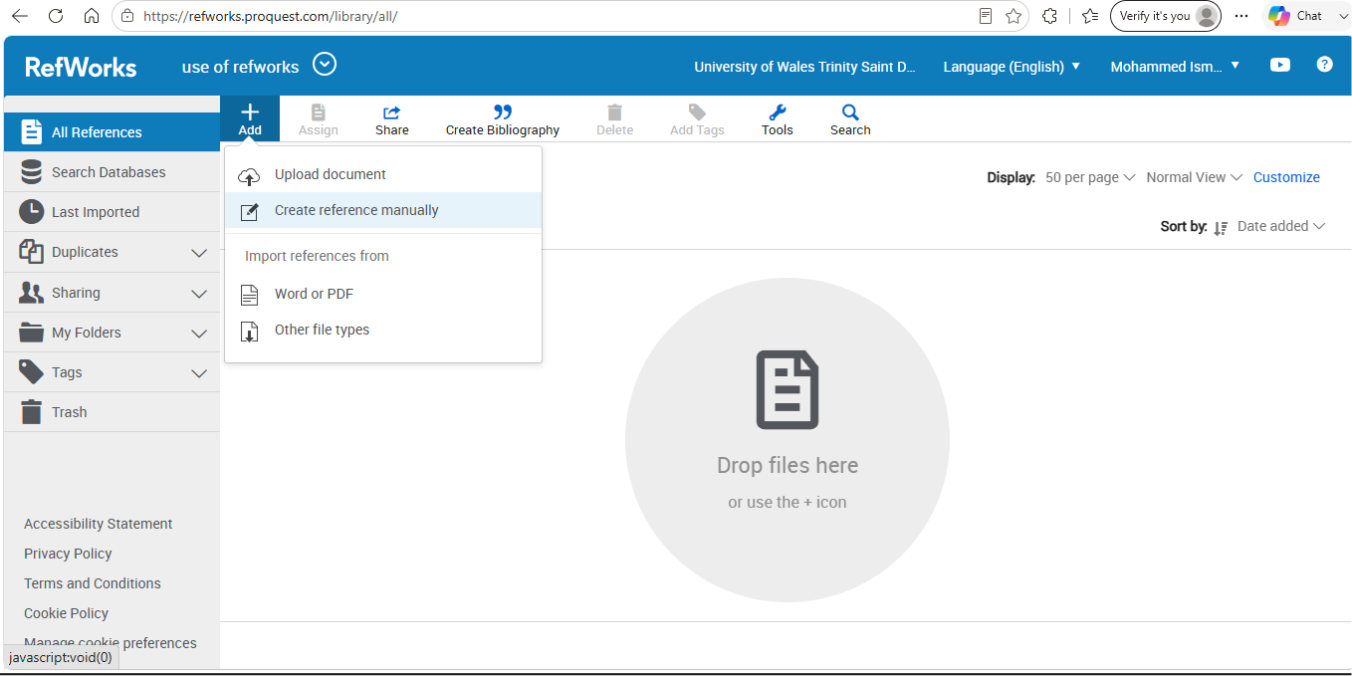
Firstly, I clicked the ‘+’ symbol and selected “Create Reference Manually” from the list of options.

Next, I selected the correct reference type and entered the relevant details before saving to my RefWorks library.

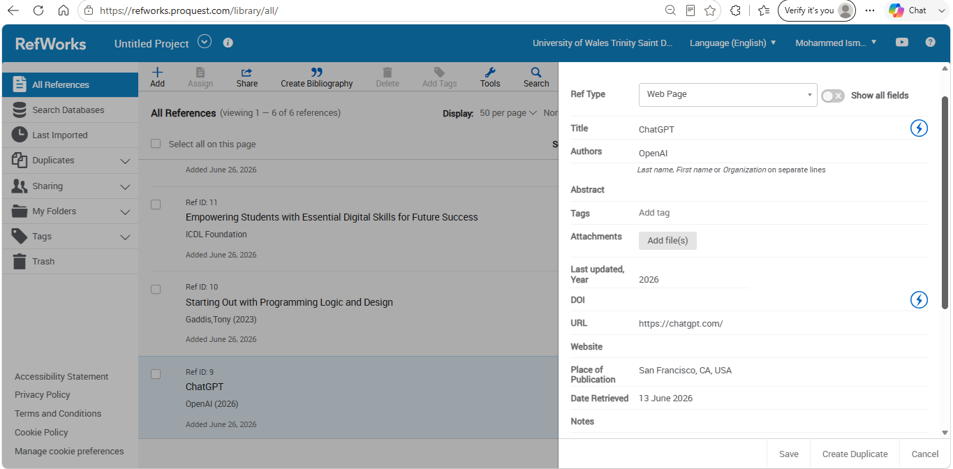

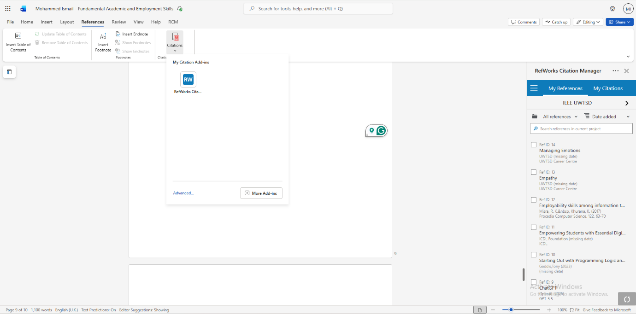
To insert my references into my assignment, I opened Microsoft Word and selected the References tab at the top of the screen. I then clicked citations, which opened the RefWorks citation manager. On the right–hand side of the screen, all my saved references were displayed, ready to be inserted into my document

After selecting the reference, I clicked Cite and RefWorks automatically inserted the in – text citation into my document in the correct IEEE format, linking it to the source in my reference list. RefWorks automatically generated my bibliography at the end of my document in the correct IEEE format.

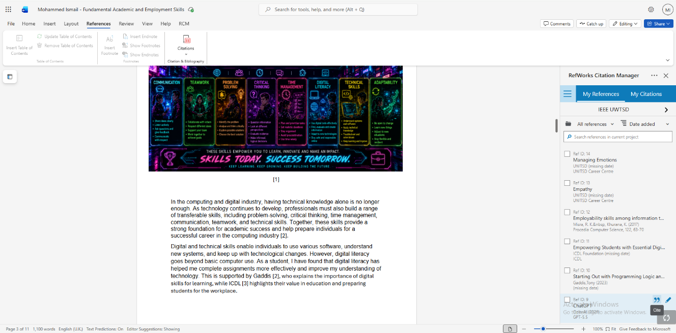

4A- E-portfolio

Link to E-portfolio - https://sites.google.com/view/mohammedismail2808/home

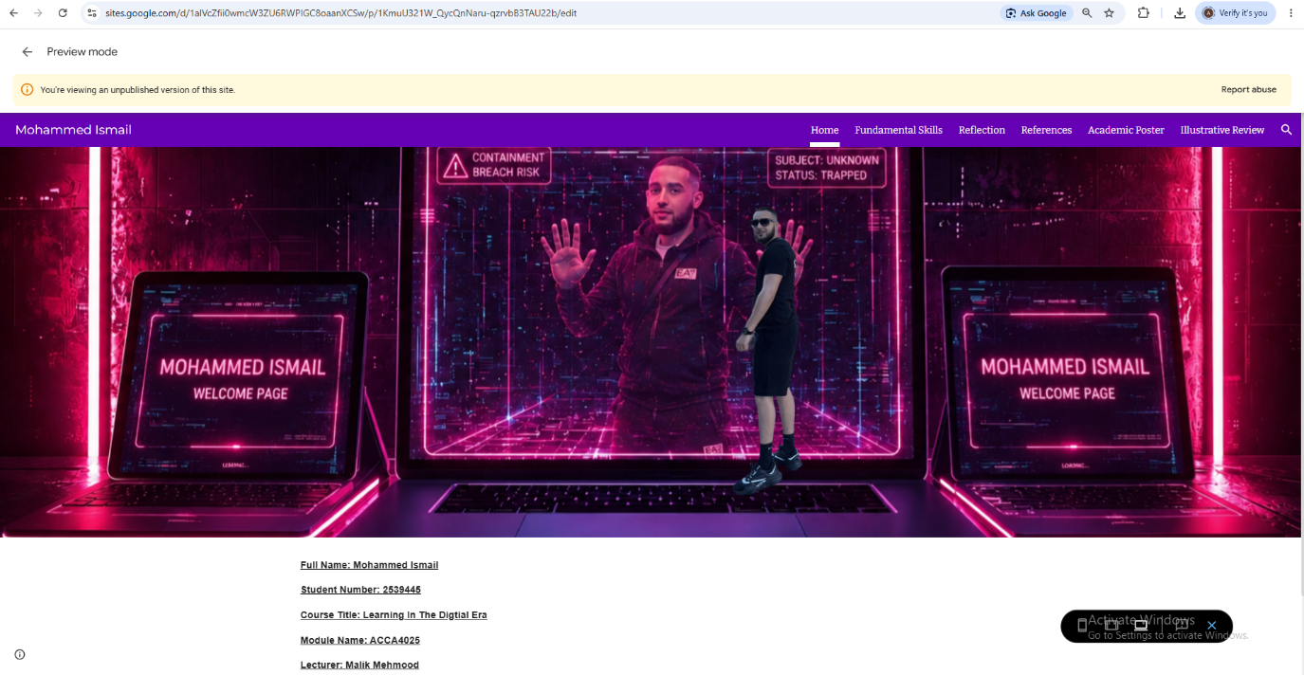

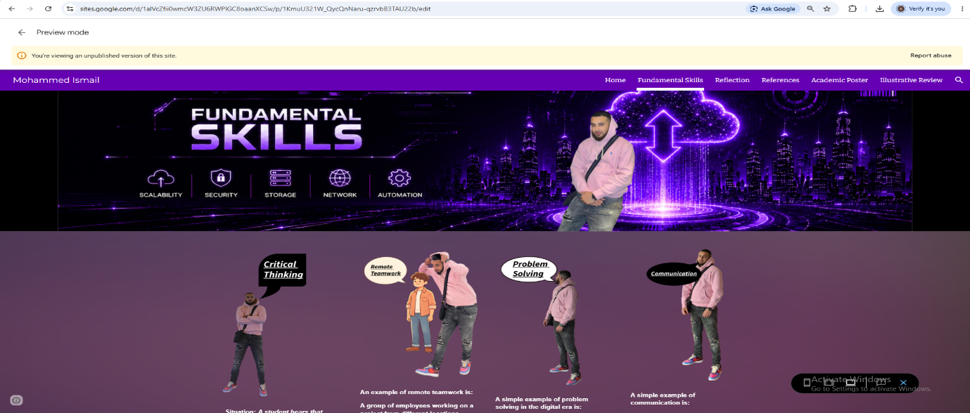

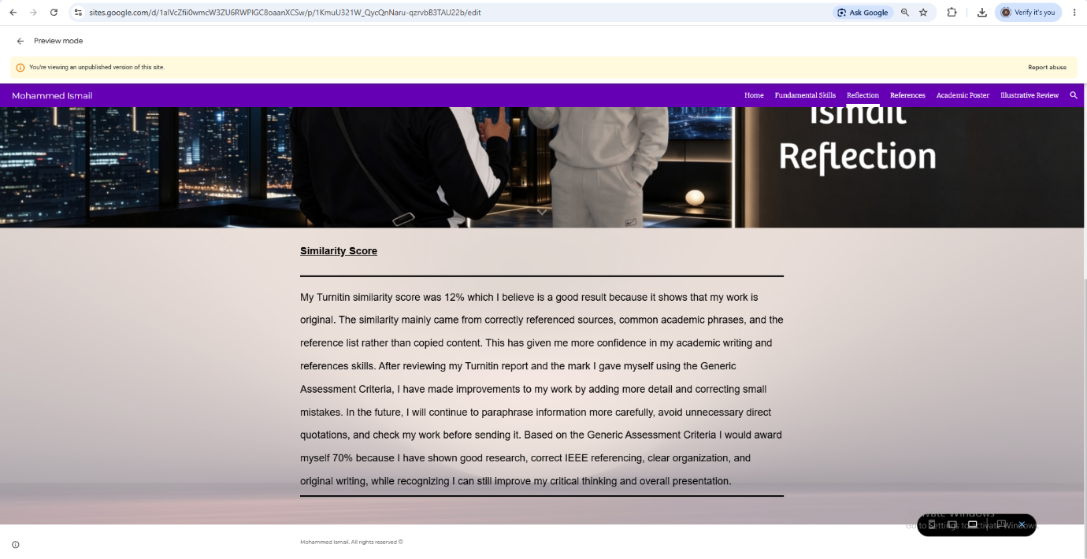

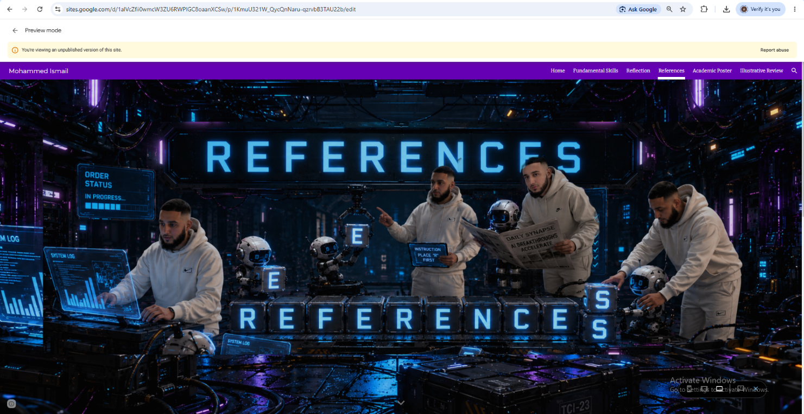

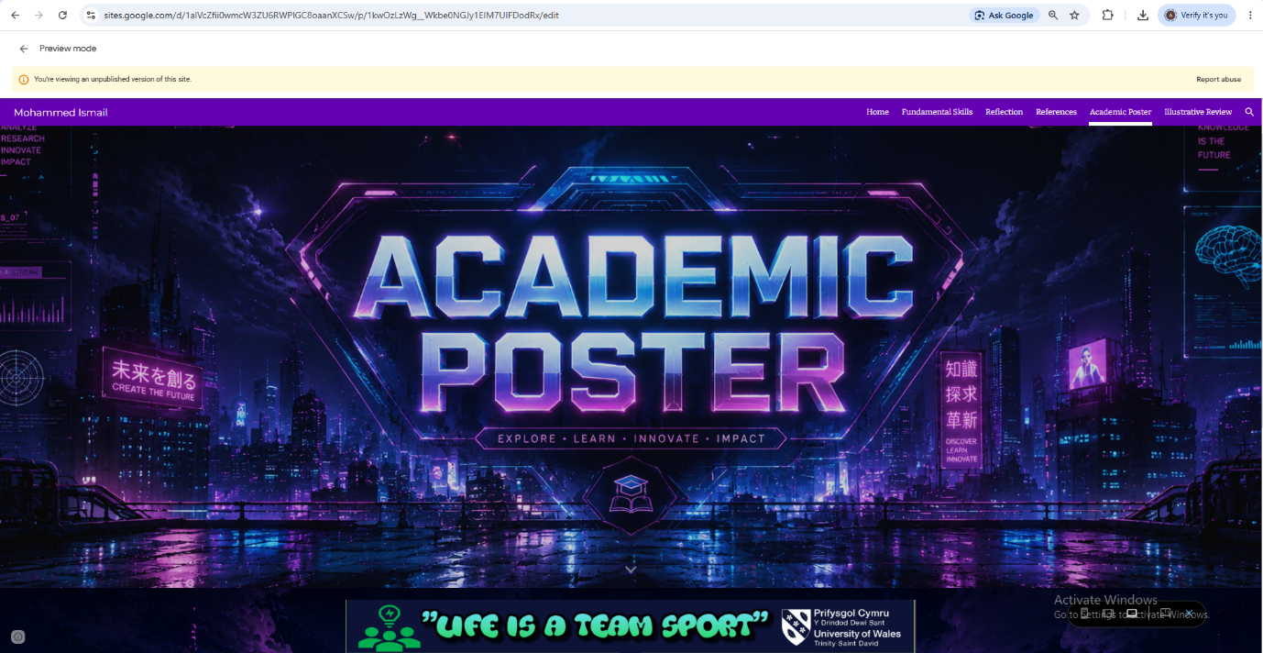

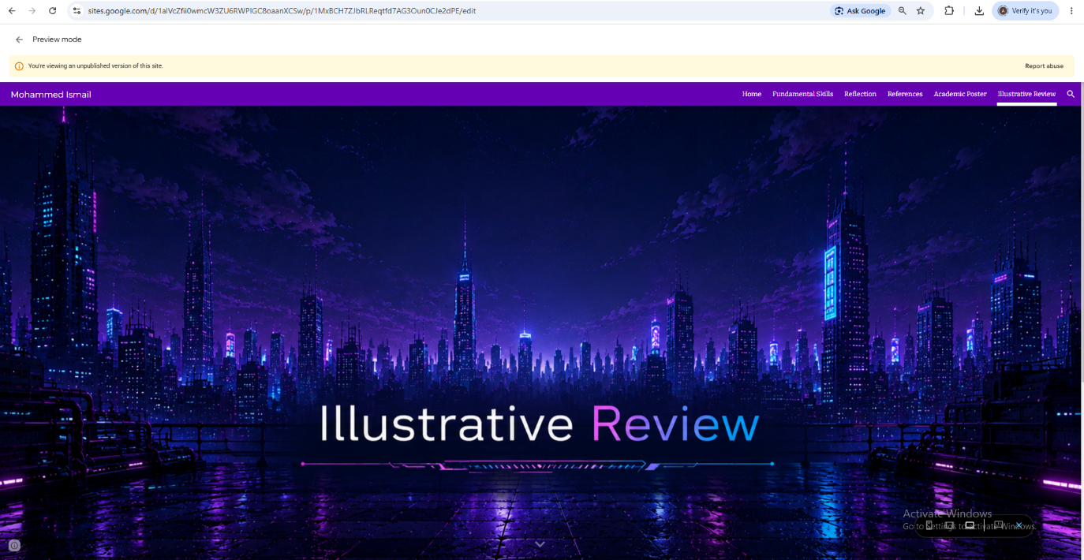

References
[1] OpenAI. "ChatGPT." Accessed: 13 June 2026. [Online]. Available: https://chatgpt.com/
[2] T. Gaddis, Starting Out with Programming Logic and Design, 6th Ed. Hoboken, New Jersey, USA: Pearson, 2023.
[3] ICDL Foundation. "Empowering Students with Essential Digital Skills for Future Success." ICDL. Accessed: 26 June 2026. [Online]. Available: https://icdl.org/empowering-students-with-essential-digital-skills-for-future-success/
[4] R. K. &. Misra and K. Khurana, "Employability skills among information technology professionals: A literature review," vol. 122, pp.63–70, 2017, doi: 10.1016/j.procs.2017.11.342.
[5] F. Norman. "virtual team dynamics." ulfire blog. Accessed: 1 july 2026. [Online]. Available: https://ulfire.com.au/virtual-team-dynamics/
[6] B. W. Tuckman and M. A. Jensen, "Stages of Small Group Development Revisted," vol. 2, no. 4, pp.415–427, 1977,
[7] L. J. Mullings, Organisational Behaviour in the Workplace, 12th Ed. Harlow: pearson,
[8] H. Hickok. "Why remote work has eroded trust among colleagues." BBC Worklife. Accessed: 1 july 2026. [Online]. Available: https://www.bbc.com/worklife/article/20210315-why-remote-work-has-eroded-trust-among-colleagues
[9] Absence of Trust: Pat Lencioni, Accessed: 1 july 2026. [Online video}. Available: https://youtu.be/aCPMB2Krh_A
[10] H. Inham. "The Importance of Being Authentic." Wharton Magazine. Accessed: 1 july 2026. [Online]. Available: https://magazine.wharton.upenn.edu/issues/fall-2016/the-importance-of-being-authentic/
[11] D. Sull and C. Sull, "With Goals, FAST Beats SMART." MIT Sloan Management Review. Accessed: 1 july 2026. [Online]. Available: https://sloanreview.mit.edu/article/with-goals-fast-beats-smart/

