Name: Kalpana Chiranjilal Mahawar
Student number: 2133406
Module: Human Resource Management(LCMB7000)
Lectures’s name: Glaudius Kulothungun
Date of Submission:
Word count: 2934

Contents:

Introduction- Definition of Labor Market and the Employment Structure of UK__________________________________2
Brief Description of Current Scenario of UK Labor Market_________________________________________3
Changes in Labor Market after Covid-19 Pandemic in UK_________5
Post Covid Strategies of Human Resource_____________________8
The New Strategies for Human Resource_________________________________________________________10
Human Resource Strategy Post Brexit_________________11
Employee Retention Scheme_______________________________12
The Positive Impact of Brexit on Human Resource________________________13
Trends that changed Human Resource in the last decade_________14
Effect of Brexit on Economy of UK____________________________15

Definition of Labor Market: The Labor Market is the Supply of and demand for the Labor, Supply provided by the employees and employer provides the demand.

Employment Structure:
The Employment Structure of a country shows how the Labor Force is divided between Primary, secondary and Tertiary sectors. The primary sector involves jobs related to Raw materials like Mining, Fishing and Farming. The secondary jobs are manufacturing and Tertiary jobs are the services.

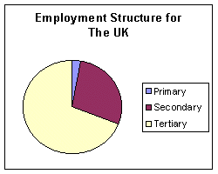
The above bar chart shows the basic Employment structure of UK, which states that majority of the Employment is in Tertiary sector, followed by the one in Secondary and least in Primary.

Labor Market in the United Kingdom- Current Scenario

From October 2019 to December 2019, there were an estimated 29.33 million UK national working in UK. 2.31 millions EU nationals working in UK and around 1.34 million non EU nationals working in UK. The graph below illustrates how the number of EU nationals working in UK rose from from just 500 in the 4th quarter of 2001 to more than 2000 in fourth quarter of 2019. And the non EU nationals rose from around 500 in fourth quarter of October 2001 to 1400 in the same until 2007 after which on and off rise and fall can be seen until 2019.

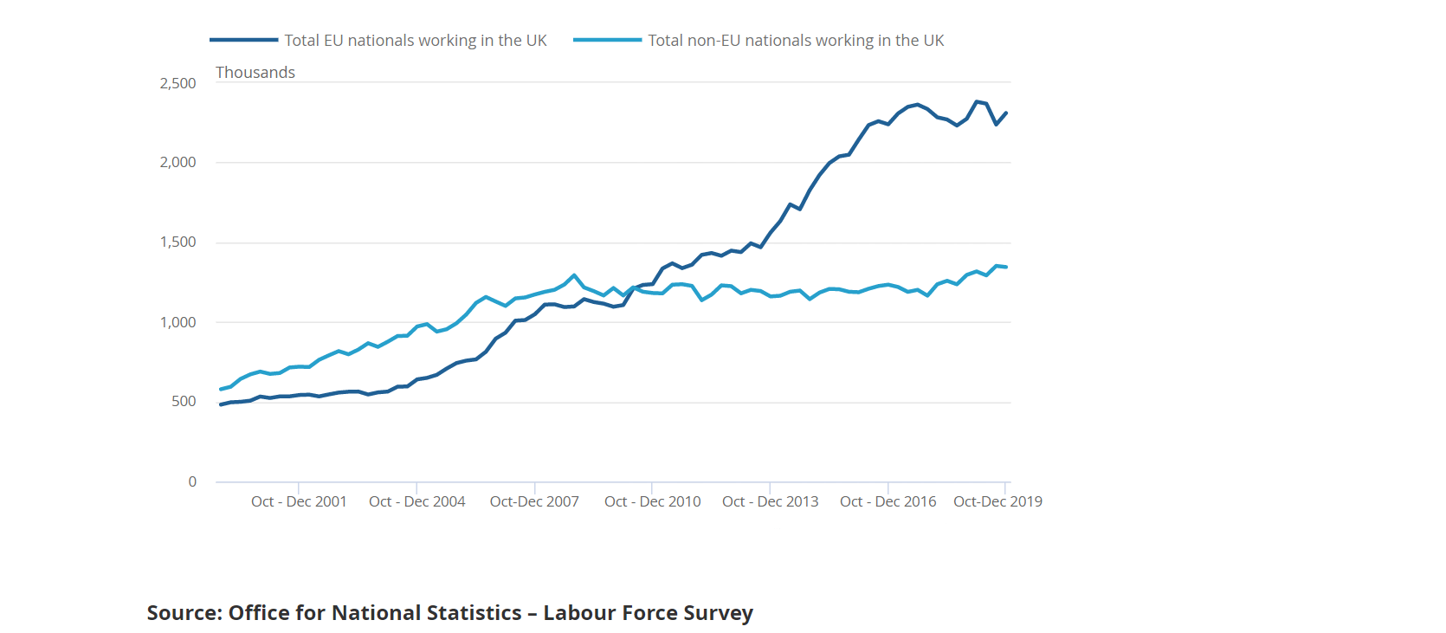

b.
The UK Labor market is characterized by the complex flow of workers between high productivity and low productivity working environment. High productivity firm pay higher wages and offer and offer greater security compared to the Low Productivity firms.

Latest Indicators at a Glance:

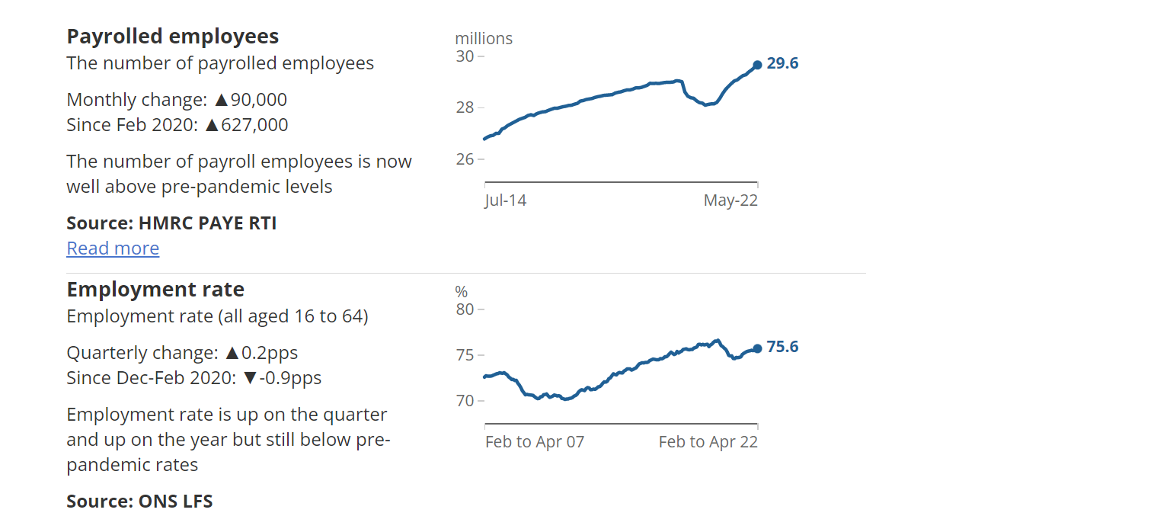
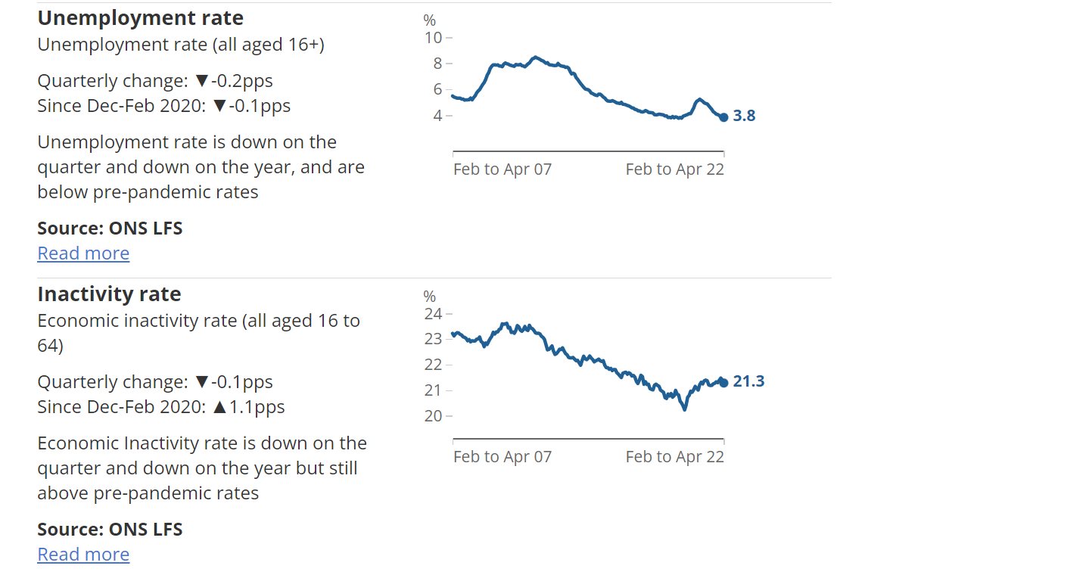

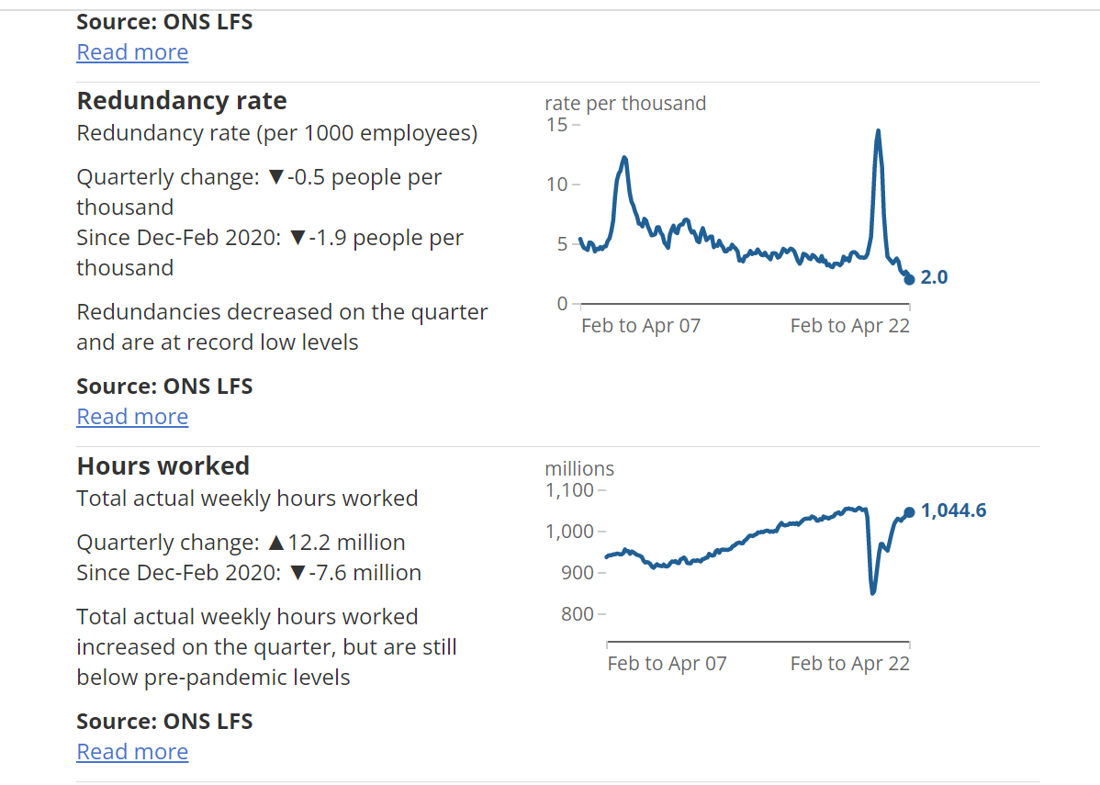
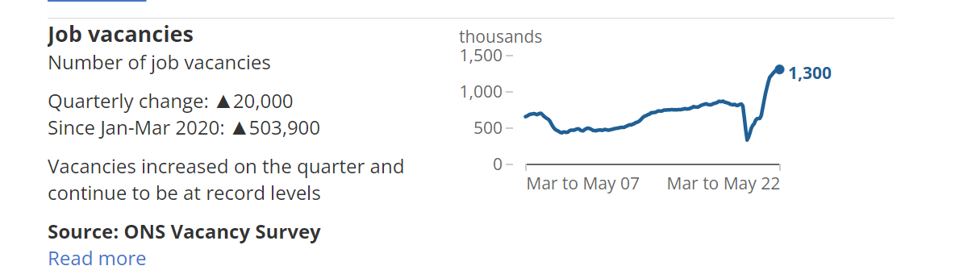
- The number of Pay rolled employees increased with time since July 2014 and reached 29.6 million by march 2022. There was a large fall between March and May 2020 when the number of pay rolled employees was 907, 000 below March 2020 levels. Since then these numbers has steadily increasing until March 2022. Some industries still has low number of employees pre pandemic level. These industries include mining and and Quarrying with 4.4% fall and Energy and Production with 7.6% fall.

- There were 1.3 million people who were unemployed in December 2021 to February 2022 which is 78,000 fewer than in January- March 2020. The fall in unemployment rate can be seen after March 2020.

- Around 8.46 million people were inactive between January to March 2020 which rose to 8.86 million for the period December 2021 to February 2022 which is around 4.7% increase.

- In December 2021- February 2022 the recorded level of redundancies was 75000, which was 30000 below pre pandemic levels. The level of redundancies between September to November 2020 was highest since 1995. The Largest number of redundancies recorded was in wholesale and Retail & Repair.

- Job Vacancies were above pre pandemic level and was highest in January- March 2022 which was 1.29 million and is 492,000 higher than the same in January- March 2020.
- The working hours fell to 845 million hours in April- June 2020 which was the lowest since 1995. However this increased in December 2021- February 2022 by 18.8 million.

- Emerging changes in the Human Resource Strategies post covid.

Changes in Labor Market in UK after covid- 19 pandemic.

According to the Article published by Chris Martin in April 2022, a DGCE model conducted that is designed to analyse the impact of covid- 19 pandemic on UK Labor market. At around 50% of workers were working during the peak of pandemic, while two- third of the employer made use of Job retention Scheme and upto 10 millions were Furloughed by the Employers.

There are 3 highlights of the DGCE survey model. Firstly the Labor market Experience of Graduates and Non Graduates differ, graduates have higher wages and greater job security than Non Graduates. Secondly, many Graduates are Employed in a Non graduate Occupations and vice versa. Third, There is a considerable movement of workers between jobs with most hirings coming from employed rather than the unemployed. The real wages of non- graduates falls more than the real wages of graduates. The reason for the more severe impact on non graduates compared to graduates as the sectors like tourism and hospitality comprises more number of non graduates

Impact of Covid 19 on Human Resource Management:

Over time the involvement of HR has grown from Limited to the centre of the Organization because HR can be considered as the intermediary between the Employees at the bottom of the Hierarchy and the Mangers and Leaders at the Top of the Hierarchy.

The Covid-19 Pandemic has affected all the industries whether commercial, Technological, Construction, Education, Agriculture, Financial and Professional Industries. However the repercussions are varied because it is easy for some companies to transform digitally and continue their operations with sometimes better productivity and outcome while for some the transformation was unsuccessful or not possible like in Agriculture and Construction industries where Man power is the ultimate backbone of the process.

Working Conditions: Working Conditions like Working hours, work Schedules, rest periods, etc were all impacted during the course of covid 19(ILO 2020). To insure Business continuity many organizations have shifted to remote working culture. For example google allowed its employees to work from home until the summer of 2021. Whereas Twitter has given flexibility to work from home indefinitely. However there are some industries where remote work is not possible, for example Construction and Manufacturing plants. Hence HRM Executives and Managers needs to identify the the sectors where remote work can be implemented. Though some sectors can be continued with remote work, there was no assurance if it will bring the same amount of productivity. There were some positive sides of remote work as well as negative side of remote work as listed below:

Remote Working Culture:

It was almost impossible for anyone to think of adapting to remote work before Pandemic hit, however working remotely has now become new normal and survey says that 42% of people prefer Hybrid model which allows working from home for either 2 or 3 days in a week and rest of the days they need to work from office.

While 30% employees prefer to work from Home Permanently because these people feel that working from home has better Professional- Personal life balance as they can cut off the time wasted in travelling and can spend that time with their families or other leisure activities.

Advantages of Remote Working according to the survey:
- Better Professional- Personal life balance.
- Better security as everyone is safe at home.
- Flexibility in terms of work patterns and Timings.
- Increase in Employment from other cities and in Female employees.
- Decline in the Absenteeism ratio.
- Better Productivity and more working hours.

Disadvantages of Remote Working according to the survey:

- Gap in Communication among employees
- Misuse of the resources and increase in number of Frauds
- Poor Internet connectivity at some places leading to the hustle and mismanagement of the process.
- Loss of Confidence and self esteem among people in facing other in person.

Staffing: Staffing is the process of Resourcing, Selecting and Interviewing the candidates to achieve organizational goals. This has been greatly impacted by COVID-19. The Repercussions of Covid 19 on staffing differs from one Organization to another because few organizations experienced decline in business while on the other hand some of them has to close their business temporarily.

Performance Management: Performance Management is a continuous process of Identifying, Measuring and gauging the performance of employees. It is crucial role of an HR to ensure that employee’s performance is aligned with the organizational goal. It has become a challenge for HR to measure the employee performance accurately because of alterations in working conditions like Lack of communication, family distractions, work overload, occupational stress factors, etc which severely impacted employees performance and hence the overall productivity of an organization. According to survey, majority of Managers find it hard to trust their employees for remote work which affects the relation between the two and hence the team’s performance.

Training and Development: Training is very important role which helps to develop the skills for employees. During the time of pandemic, not everyone has proper digital skills to cope up with these changes. According to Przytula, Strzelec, and Krysinska(2020), organizations faced the challenge of reskilling and upskilling their workforce to be able to deal with the new work pattern without the help of supervisors. The HRM Practitioners has to afce the challenge for the development of training programs and to choose the proper and most effective training method.

Compensation Management: Compensation is the method to reward the employees based on their performance. It can be in the form of bonus, incentives, etc. As a compensation some countries have implemented some government policies to provide financial support for employees and organization during the time of covid 19. The UK Government has granted its organization to allow paid sick leaves and 2 weeks of islolation for their employees and an insurance policy for their family members.

Safety and Health Management: Employees are responsible for the safety of their employees while working. Not just physical safety but mental well being as well, because there was less probability for physical hazard during the pandemic time, however on the contrary the mental health got impacted. Hence it was a challenge for HRM to take care of their employee’s well being and ensure that they seek the best assistance whenever required.

Employee relationship: Employee relationship is the relationship between employers and the employee. The relations of the employees with their peers and Managers. There were instances of the conflict between Mangers and the Employees because Managers do not trust their Employees when it comes to working remotely and hence this demotivate the employees and their feel the lack of trust with the Managers which make them feel less valued.

The New Strategies for Human Resource:

Respond: Dealing with the present Situation and managing continuity with the same pace.
Recover: Learning and Emerging stronger.
Thrive: Shaping new normal.
Reflect: Manage the time to think about what is next and what has worked, what is fulfilled and what is what is not accomplished.
Recommit: Reinforce commitment to physical and Mental well being of the employees.
Re Engage: Maximize the workforce Engagement and Contribution.

Human Resource Strategies post Brexit

Brexit was the withdrawal of the United Kingdom from the European Union from 31st January 2020. The European union is the political and economic union of 21 member states that are located primarily in Europe.

Whether it is cancellations in reservation due to less staff or longer treatment in the Hospitals due to shortage of medical staffs, Brexit has affected majority of the sectors in the Labor market.

How Retailers are struggling to continue with the supply chains:

The shortage of haulage Capacity and drivers are causing crunch in the UK Retail chain. Mote than 20, 000 drivers form EU Returned home during Pandemic and after Brexit which caused shortage in lorry drivers which directly impacted the supplier chain sector.
Another sector affected due to Brexit is agriculture, because majority of the Vegetable and fruit grower and pickers come from Europe and after Brexit they had to rely on Furloughed workers and University students which was not a convenient option for a longer run.

Apart from Retail and Agriculture industry, Hospitality industry also got affected and faced shortage of workers in the places like restaurants, Salons, shops, bars, etc.

How Brexit has affected the recruitment process?

- Application form process: The recruiters are advised to check the online application form and make sure if the candidate has right to work in UK.
- Onboarding process: Need to ensure the onboarding process is transparent, are offer letters and contract of employment are impermeable.
- Training and Staff: need to train the staff and themselves to conduct the right to work accurately and update whenever required.
- Sponsorship for the licence: The recruiter needs to make sure that they have the license to recruit EU candidates.
- Future Plans: The recruiters need to plan the Future requirements, whether to sponsor individuals, what immigration status permit is required for individuals to work without the need for sponsorship?
- Understand the new UK Immigration system: Anyone else coming to work in UK after January 2021 except the Irish citizens will need to comply with one of the immigration routes in the new rules.
- Review Employment Policies: Employers are advised to carry out an immigration audit, including Drafting, reviewing and amending policies to ensure they are compliant with the new immigration system.
- Keep an Eye on UK Employment rights: The Human Resource team needs to be updated with the recent Employment rights to work in UK because candidates outside UK need to apply for the work visa and need to go through the immigration process.
- Employee Retention: The employee retention is one of the key change in the Human Resource process. With Brexit and new immigration laws coming to picture many employees are forced to resign or withdraw their current employment, and there is nothing that a Human Resource can do to stop that. Hence employers are unable to retain the existing employees.
- GDPR: The General Data Protection Regulation which came into effect in May 2018. GDPR ensures to protect the data of the individuals in UK. Brexit has not impacted much on the GDPR because the data can be shared freely within UK and EU and other countries, however HR is suppose to ensure if there is no breach in the same as it will cause a huge penalty to any organization.

Employee Retention Scheme:

The Employee retention scheme was applied from March 2020 till September 2021. This scheme was made so that employers could retain their employees during coronavirus and pay staff by furloughing employees at upto 80% of their wages. Around 11.7 million employees were furloughed through this scheme.
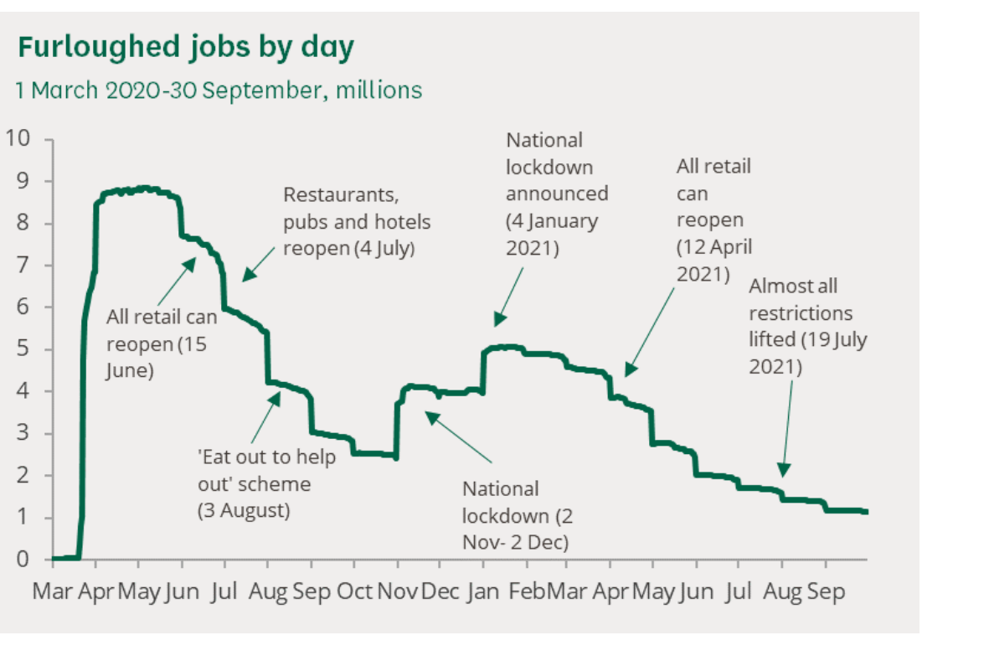
According to Brinkley and Crowley(2017), reduced access to the EU workers has forced UK to train and upskill their Existing workforce which would require huge investment and time.
Brexit has led to reliance on non EU migrant workers majorly from Asian Countries. And this will lead organizations to hire agencies outside EEA.
Despite early Concerns about Brexit’s impact on employment, employment levels has continued to grow sharply after Brexit.

The Positive Impact of Brexit on Human Resource:

Market Strength: Free Movement of Talent across borders from central locations has made UK an appealing base to access talent.

Free Movement of Attractive Talent: The UK market has supported free movement of skilled and unskilled workers from different continents like Asia.

Employee Rights: Organizations employing within UK are subject to Employee rights regulations like working time regulations, including working time regulations, entitlements around Maternity, discrimination protection, agency workers right and Holiday entitlement.

Trends that changed Human Resource in the last decade

- Social media Platforms: The Social media platforms like face book, twitter, Instagram has gained popularity over the last decade. Apart from social media platforms the job posting websites like Linkedin, job portals like CV Library, Indeed, etc has also taken over the traditional HR ways of posting jobs which included the newspapers and other ways of advertisement. The use of these platforms has not only made the overall resourcing process convenient but also it has proven time saviour.

- Employee Benefits: The Benefits like health and retirement programs were among the most common that employer provides, apart from the mentioned benefits, benefits like Accomodation, Paid leaves, Insurance, overtime compensation, etc are the other common benefits that are also provided by the employers including small firm and Large firms. These were limited 10 years ago but this has become more common during the course of years.

- Technologies: Technologies has moved work beyond the office premises as even pandemic has forced people to work remotely and this gave Flexibility to work beyond the premise of office. Not only just remote work the evolution in technology like the cloud computing and server database has made the work easy and fast.

- Analytics changed the game: Requirement of Data skills has grown to a greater extent in last few years, with the growing pace in the workforce, analytics has become key skill to measure productivity and keep every record updated.

Effect of Brexit on Economy of UK:

Brexit has large and immediate impact on the economy of UK, it has been assumed that british economy has faced 50/50 Recession. According to the studies published in 2018, the economic cost of the Brexit vote were 2% of GDP. According to Financial time analysis of December 2017, the british national’s income was reduced by 0.6% and 1.3%.

Reference 1: Internet Geography(2009) available at: http://www.geography.learnontheinternet.co.uk/topics/empstruct.html

Reference 2: census2021, Labour Market Overview(2022) https://www.ons.gov.uk/employmentandlabourmarket/peopleinwork/employmentandemployeetypes/bulletins/uklabourmarket/june2022#:~:text=The%20UK%20employment%20rate%20increased,number%20of%20part%2Dtime%20employees.
Reference 3: Martin, C & Okolo, M 2020 'Modelling the Differing Impacts of Covid-19 in the UK Labour Market's
Reference 4: Salima Hamouche(2021), Cambridge University press, Journal of Management and Organization, Page 1-16.
Reference 5: MHR Global available at: https://mhrglobal.com/uk/en/blog/how-brexit-will-affect- hr
Reference 6: Who.int, available at: https://www.who.int/publications-detail-redirect/9789240039001

