Transitioning Global Learning Institute (GLI) to Azure Cloud Services

Georgiana Anghel
1914799
Renuga Jayakumar

Contents
1
Introduction 2
Overview of the assessment objectives 3
Purpose of the Transition 4
Overview of GLI and its present IT infrastructure 4
Migration Strategy 5
TCO (Total Cost of Ownership) Evaluation 6
Explanation of TCO Calculation Process 7
Application Migration Plan 8
Azure File Storage 11
Advantages of Azure File Storage. 11
Azure SQL Database 12
Azure Backup 14
Key Features of Azure Backup 14
Video of Backup Configuration Settings from Azure Portal 16
Azure Site Recovery 17
Benefits of Azure Cloud Services 19
Conclusion 20
References 22

Introduction

As a Cloud Architect, I'm working on a transition strategy to the Azure cloud platform for Global Learning Institute (GLI), which currently operates online courses and certifications with its IT infrastructure managed through on-premises servers hosting user profiles, course materials, and administrative systems. The institution is considering this transition due to scalability and cost efficiency.
Windows Azure provides an optimal platform for GLI to transition from localized server infrastructure to cloud-hosted services. Azure has the advantage of a mature and wide-ranging set of services with the flexibility to host anything from a simple web page to a complex software service. Azure services can be scaled up or down as needed, enabling efficiency gains as larger services can start small and grow in response to demand. Azure offers a familiar and comfortable development environment and good potential for cost savings through reduced need for system administration and hosted infrastructure. The broad goals of the transition are to enhance the reliability and sustainability of GLI services within reduced unit and campus infrastructure, to refocus staffing resources into areas of unique value and contribution, and to position GLI and the campus at the forefront of developments in educational technology. The transition to Azure will involve restructuring many services as new and more efficient technologies are employed, including measures for disaster recovery to ensure service continuity even in the face of natural disasters.
This transition represents a strategic initiative aimed at leveraging Azure's capabilities to enhance GLI's technological infrastructure, improve service reliability, and optimize cost efficiency. Through a well-planned transition strategy, GLI aims to achieve its goals of efficiency, scalability, and excellence in educational technology.

Overview of the assessment objectives

The assessment objectives for Global Learning Institute (GLI) while evaluating a move to Azure cloud services are varied and strategic. To begin, GLI intends to reduce the high maintenance costs associated with its current on-premises infrastructure by leveraging the cost-effectiveness and scalability of Azure cloud services. This transformation is vital for optimising operational expenses and reallocating resources to other critical initiatives inside the organisation.
Second, GLI aims to improve the resilience and stability of its IT ecosystem by lowering risks associated with hardware failures, power outages, and natural disasters using Azure cloud services' robust disaster recovery capabilities. This emphasis on data resilience and business continuity is critical for assuring continuous access to educational resources for students worldwide.
Furthermore, GLI plans to overcome the limitations of its current infrastructure's storage and processing capabilities by leveraging Azure's scalable storage solutions. This scalability enables GLI to dynamically alter its IT resources in response to demand, ensuring that the school can successfully meet the changing needs of its student population without sacrificing performance or user experience.
Furthermore, GLI intends to improve data security and privacy for its sensitive educational resources and student data by leveraging Azure's superior security capabilities and compliance certifications. By implementing Azure cloud services, GLI can reduce cybersecurity risks, assure regulatory compliance, and promote trust among students and stakeholders.
Furthermore, moving to Azure cloud services gives GLI access to cutting-edge technology and services that can spur innovation in online education delivery. From AI-powered analytics to IoT connectivity, Azure provides a varied ecosystem of tools for improving teaching techniques, personalising learning experiences, and optimising administrative procedures inside the institution.
In summary, the assessment objectives for GLI's migration to Azure cloud services include cost savings, scalability improvements, increased reliability and resilience, data security enhancements, innovation prospects, and overall operational efficiency. By deliberately matching these goals with the capabilities of Azure cloud services, GLI hopes to position itself for long-term success in providing high-quality online education while maintaining a seamless and robust IT infrastructure.

Purpose of the Transition
The purpose of this document is to provide a step-by-step guide to transitioning Global Learning Institute (GLI) to Azure cloud services. The document will outline the methodology, execution, testing, and how to set up the case study to understand where the transition was successful and where improvements are needed. This documented transition can be a critical element to provide a clear pathway on how the current GLI platform utilizes various technologies and tools how the Azure equivalent will be configured and why.
Therefore, through this assessment of introducing cloud computing as a solution for GLI, I will acquire new theoretical and practical knowledge that will add value to the knowledge gained previously. This document hopes to highlight that cloud computing should be an option regarding how future GLI environments should be hosted. There are some clear advantages to the capabilities of cloud services, which are described below, and cloud services could potentially save time from setting up servers and save costs from hosting servers. This case study will demonstrate how Azure cloud services are a valid option and how easy it is to configure environments.

Overview of GLI and its present IT infrastructure

Global Learning Institute (GLI) is a growing medium-sized educational institution dedicated to providing students globally with easily accessible online courses and certifications. Despite its great aim, GLI is facing serious issues with its present IT infrastructure. The institution faces high maintenance expenses, hardware breakdowns, and restricted scalability, all of which impede its capacity to efficiently satisfy the growing demands of its online programmes.
To address these limits and build a more agile and robust IT ecosystem, GLI is investigating the capabilities of Azure cloud services. This deliberate migration to cloud services intends to reduce expenses while using Azure's complementary services to improve operational efficiency and performance. By transferring its file storage system and databases to Azure, GLI hopes to overcome the limits of its current infrastructure and open up new avenues for innovation and growth in providing high-quality online education.
The GLI evaluation of Azure cloud services provides a chance to create a strategic plan for the seamless migration of important IT components. This strategy prioritises cost savings, scalability improvements, and leveraging Azure's capabilities to improve the institution's IT infrastructure. By using cloud technology, GLI can successfully streamline operations, improve data security, and increase scalability to meet the changing needs of its student community.
Through this migration process, GLI hopes to position itself for long-term success in the digital education landscape while assuring a smooth transition that is consistent with its strategic goals. GLI can better serve its global student base by utilising Azure cloud services, which will improve operational efficiency, data management capabilities, and overall IT infrastructure resilience.

Migration Strategy
In my role as a Cloud Architect, I've closely examined the hurdles GLI currently confronts with its on-premises infrastructure. The mounting maintenance expenses, susceptibility to hardware malfunctions and environmental catastrophes, along with the constrained storage and processing capabilities, underscore the pressing need for a shift to the Azure cloud platform. Let's delve into how GLI can harness Azure's robust file storage and database solutions to effectively tackle these challenges.
Firstly, transitioning GLI's file storage to Azure offers a plethora of benefits. Azure Blob Storage provides scalable, cost-effective storage for a wide array of unstructured data types, including documents, images, and videos. By migrating their files to Azure Blob Storage, GLI can bid farewell to the constraints of on-premises storage limitations. Moreover, Azure's redundancy options ensure data durability and availability, mitigating the risk of data loss due to hardware failures or unforeseen disasters [1]. This move not only enhances data resilience but also streamlines backup and disaster recovery processes, bolstering GLI's overall data management strategy.
Secondly, leveraging Azure's database services presents a compelling opportunity for GLI to modernize its data infrastructure. Azure SQL Database offers a fully managed, scalable relational database service, eliminating the need for on-premises database management and maintenance. By migrating their databases to Azure SQL Database, GLI can unlock unparalleled scalability and performance, seamlessly accommodating fluctuating workloads and growing data volumes. Additionally, Azure's built-in security features, including advanced threat detection and encryption capabilities, fortify data protection, ensuring compliance with regulatory requirements and safeguarding against cyber threats.
So, migrating GLI's IT infrastructure to Azure represents a strategic imperative in the face of mounting operational challenges. By embracing Azure's file storage and database services, GLI can not only reduce costs and enhance scalability but also fortify data resilience and security. As a Cloud Architect, I stand ready to guide GLI through every step of this transformative journey, empowering them to thrive in the era of cloud computing. So below you will find all migration documentation for exact costs to Azure benefits.

TCO (Total Cost of Ownership) Evaluation

The Total Cost of Ownership (TCO) Evaluation is an important component in determining the financial consequences and benefits of migrating from on-premises infrastructure to cloud services, notably Azure, for the Global Learning Institute (GLI) [2]. This review digs into a thorough analysis of the costs associated with maintaining and updating on-premises servers, as well as the potential savings and efficiencies gained by shifting to Azure cloud services. GLI intends to acquire a better understanding of the financial implications of its IT infrastructure decisions by carrying out a TCO evaluation. This review will provide insights into cost factors such as hardware maintenance, scalability limits, and disaster recovery readiness, allowing GLI to make more educated decisions about migrating to Azure cloud services. Through this TCO Evaluation, GLI will be able to estimate the potential cost savings, operational efficiency, and strategic benefits of adopting Azure's scalable and cost-effective cloud solutions. GLI may examine the long-term financial consequences of switching to Azure by analysing the total cost of ownership over a set period, allowing it to make data-driven decisions that correspond with its business goals and IT strategy.
In short, the TCO Evaluation lays the groundwork for GLI to assess the economic viability and benefits of shifting to Azure cloud services, offering a road map for cost savings, scalability improvements, increased resilience, and overall operational efficiency. This review will help GLI make educated decisions that create value and support its purpose of providing high-quality online education to students globally.

Explanation of TCO Calculation Process

- I define the scope and objectives.
- Determine the exact asset or product being evaluated.
- Establish the aim of the TCO assessment to focus efforts and collect relevant data [2].
- I identify cost categories:
- Costs can be divided into two categories: initial purchase costs (e.g., purchase price and installation expenditures).
- Operating costs include maintenance, repairs, and upgrades.
- Training and support costs.
- Maintenance costs.
- Residual Cost (the expected value of the asset over time) [2].
- Collect data and quantify costs:
- Collect information on all costs linked with the asset under consideration.
- Quantify each expense category appropriately.
- Calculate the Present Value:
Use the formula: TCO = initial purchase price + operating costs - residual value [2].
- We make Informed Decisions and Implement Cost-Control Strategies.
- Use TCO analysis to make better procurement decisions, negotiate contracts, and achieve long-term cost reductions.
- TCO analysis should be reviewed and updated regularly to reflect changing market conditions and business needs.

Following these stages allows firms to acquire a thorough understanding of the total cost of owning an asset or product across its full lifecycle. This method enables informed decision-making, cost optimisation, and improved financial performance by implementing effective cost-control strategies.

Application Migration Plan

To begin with, I analyzed the current differences and the cost of Azure, so I want this transition to be documented with clear benefits. I conducted an analysis using the Azure Total Cost of Ownership (TCO) Calculator. This process entailed collecting information about GLIs existing on-premises infrastructure. Such as their server quantity and specifications database software, storage needs and network usage patterns.
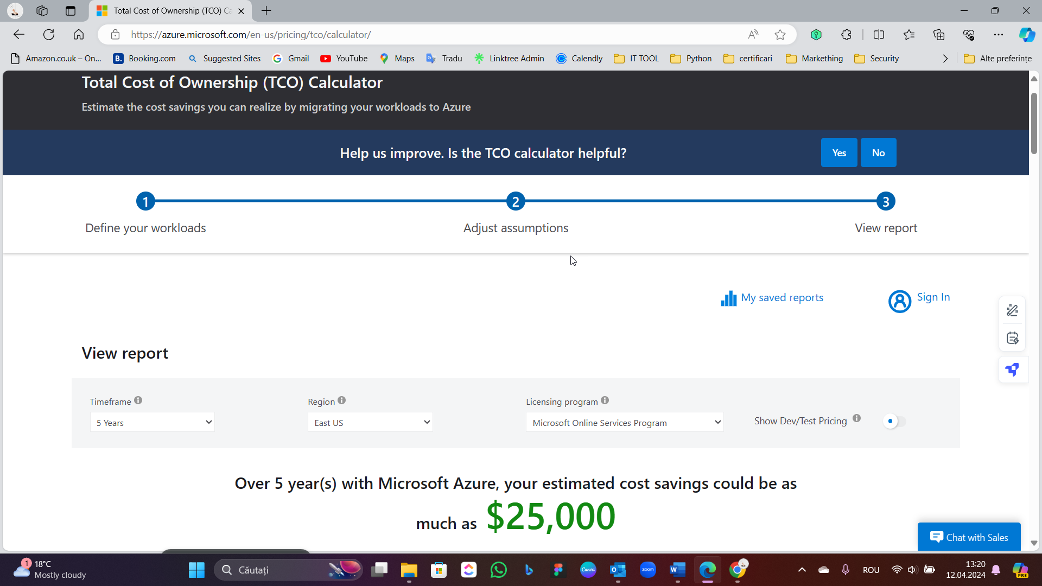
Figure 1- Total Cost of Ownership TCO Calculator
I meticulously entered all this data into the TCO Calculator to accurately project their expenses related to maintaining their setup. This estimation covered hardware costs, software licenses IT personnel for operations and maintenance tasks as facility expenses like power consumption and cooling requirements.
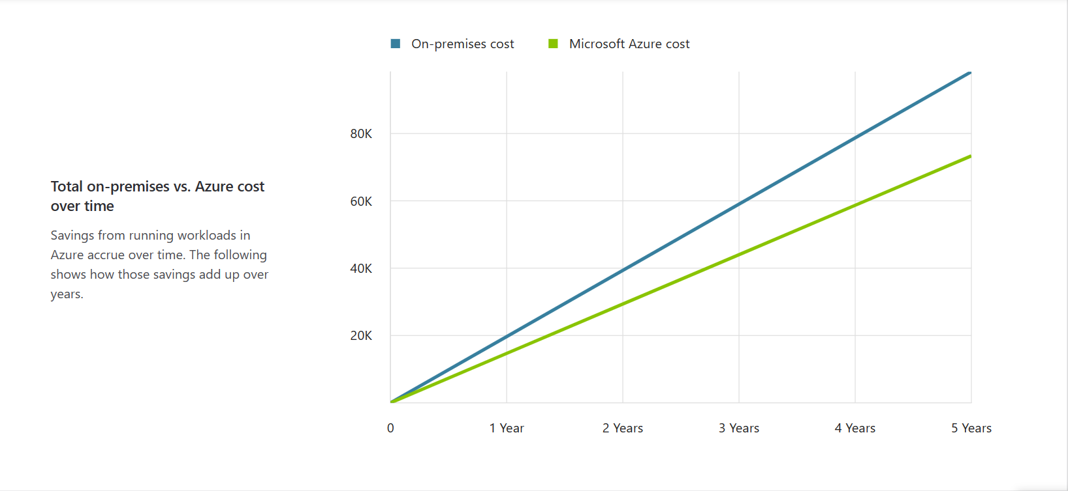
Figure 2- Total on-premises vs Azure cost
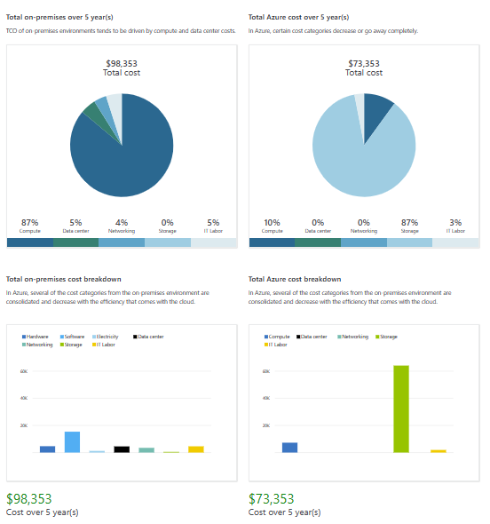
Figure 3- Cost differences
Subsequently, I set up the cloud services that could potentially serve as alternatives for GLIs on-premises infrastructure. This involved outlining machines, database services, storage solutions and networking needs essential, for the transition. After examining the pricing details of Azure and exploring discounts I managed to forecast the anticipated expenses, for operating these tasks in the cloud. Assumptions for On-premises Servers and Azure Pricing Comparison in the United Kingdom When comparing the Total Cost of Ownership (TCO) of on-premises servers versus Azure cloud services in the UK, certain assumptions and cost comparisons can be highlighted using the search results:
The cost of running a typical power-consuming server in the United States is around £14.670 per year.
When comparing the costs of on-premises operations with those of cloud services I discovered some encouraging potential savings. According to the data provided transitioning to Azure could lead to a $25,000 reduction in expenses over five years.
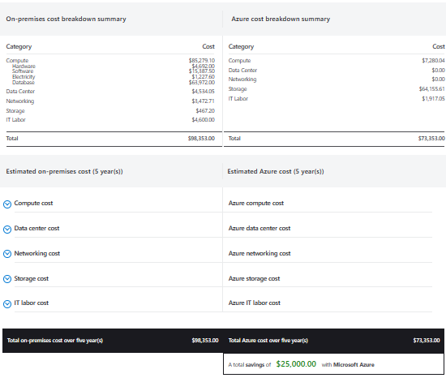
Figure 4 - TCO result.
The final stage involved documenting these, I made a point to emphasize the areas where Azure could offer cost savings, including hardware, software licenses and IT labour. In conclusion, I recommended that GLI move forward with migrating to Azure based on the data-driven analysis indicating it as a choice.
This total cost of ownership (TCO) assessment has played a role in GLIs planning for transitioning to cloud services. By showcasing advantages, I am confident that we can validate this decision and facilitate a seamless implementation process that positions GLI for long-term success, within the digital education sector.

Azure File Storage

Azure File Storage is a file storage service managed by Microsoft Azure, providing file shares accessible through standard protocols such as SMB (Server Message Block). It represents an easy-to-use, scalable, and redundant file storage solution that can be accessed from both on-premises and cloud environments. By combining scalability, accessibility, security, and integration with the Azure ecosystem, Azure File Storage is a robust and user-friendly file storage solution that can help organizations more efficiently manage their data in the cloud. Given its utility and benefits for GLI, Azure File Storage is a significant assetAzure File Storage is a managed file-sharing service that smoothly replaces GLIs and on-site file storage setups. Azure File Storage offers advantages for GLI. Below, I will outline all the advantages of its usage.

Advantages of Azure File Storage.

- Scalability: Azure File Storage easily adjusts to meet GLIs growing course and certification storage needs. This adaptability allows GLI to expand without concerns about storage limitations.
- Reliability: With built-in redundancy and high availability features Azure File Storage protects GLI data from hardware issues and natural disasters. This guarantees uninterrupted access to files. Reduces the risk of data loss or downtime.
- Cost Efficiency: Operating on a pay-as-you-go pricing structure Azure File Storage eliminates the need for investments in hardware. GLI can scale storage resources based on demand optimizing expenses and preventing overprovisioning.

By utilizing Azure File Storage GLI can benefit from the scalability, reliability and cost effectiveness in managing its file storage needs supporting its initiatives, with a resilient and adaptable storage solution.
Leveraging Azure's Free Services
To support the initial phase of migration while adhering to GLI's budget constraints, you can take advantage of Azure's free services:

- Azure File Storage Free Tier: Azure provides a free tier for File Storage, offering up to 5 GB of storage and 100 GB of monthly data transfer. This allocation should suffice for the preliminary migration phase, allowing GLI to transfer essential files and assess the suitability of Azure File Storage for its needs without incurring additional costs.
- Azure Active Directory Free: GLI can leverage Azure Active Directory (Azure AD) Free to manage user identities and control access to Azure File Storage. This service enables GLI to establish secure user authentication and authorization mechanisms without any extra expenses.

By harnessing these complimentary Azure services, GLI can initiate the migration process while staying within budgetary constraints. This approach enables GLI to evaluate the benefits and feasibility of a comprehensive transition to the Azure cloud platform without financial commitment upfront.

Azure SQL Database

Microsoft Azure offers Azure SQL Database, a managed database service that enables users to store and manage relational data in the cloud without the hassle of handling database infrastructure. Azure SQL Database stands out for its features, including being managed by Microsoft Azure. This means that users can focus on developing applications and managing data while Microsoft takes care of infrastructure, security, backups and system updates.

- One of the highlights of Azure SQL Database is its scalability feature allowing databases to adjust their scale based on workload demands and performance needs seamlessly.
- Security is a priority, with Azure SQL Database as it incorporates security measures like data encryption, access auditing and threat detection to safeguard data from unauthorized access or loss.
- Users can trust in the compliance standards upheld by Microsoft Azure services like Azure SQL Database ensuring an environment for storing and managing information.
- Moreover, high availability is guaranteed with Azure SQL Database through features such as data replication and automatic failover management to minimize disruptions and potential data loss incidents.
Overall, Azure SQL Database emerges as a solution for cloud-based storage and management of data due, to its user-friendly interface, scalability options, top-notch security protocols and reliable high availability measures. Ideal, for creating websites, mobile apps and business software that need organized databases performing at a high level.
In the Azure Portal to create an SQL Database we need to click on the "Create a resource" button. Look for "SQL Database”, in the options and choose it. Setting Up Database Details
We fill in the information.
- Subscription Pick your Azure subscription.
- Resource Group Create a group. Use an existing one.
- Database Name Give a name to your database.
- Server Create a server Select an existing one.
- Compute and Storage Select the service level and performance based on your needs.
- Collation Choose the collation for your database.
- Backup Retention Period Set how long backups should be kept.
- Tags Add tags for organization.
- Setting Up Server Details
- Enter authentication details for the server.
- Choose the region for your server.
- Adjust firewall settings to enable access, to the database.
Review and Deployment
For greater safety, it is recommended to do a double-check. Then hit "Create" to deploy your SQL database.

Deployment Process
We are waiting for deployment completion. Once done we can access your SQL database through the Azure Portal. Moving to Azure. Once the database is set up on Azure we have the option to migrate the on-premises database to Azure SQL Database using either Azure Data Migration Service or Azure Database Migration Service. To work within GLIs budget constraints we can make use of Azures services during the migration phase.
Shifting to Azure SQL Database will enable GLI to tackle existing challenges by offering a cost-dependable solution for storing user profiles and other essential data. With Azures managed services, in place, GLI can prioritize delivering high-quality education without having to deal with the upkeep and management of the infrastructure.

Azure Backup
Microsoft Azure offers Azure Backup, a cloud service that provides a cost-effective solution, for safeguarding your data, applications and workloads in both cloud and on-premises environments. With Azure Backup businesses can easily back up. Recover data to ensure continuous operations, regulatory compliance and data protection. Whether we need to secure file shares, databases, virtual machines or entire applications Azure Backup offers a solution to address your backup and recovery requirements. It includes automated scheduling, customizable retention policies and seamless integration with Azure services for streamlined management of backup tasks through a centralized interface.

Key Features of Azure Backup
- Automated Backups: We set up backups for your data and applications to ensure protection without manual efforts.
- Flexible Retention: We establish retention policies to retain backups for varying durations based on your business needs.
- Scalability Easily: We expand your infrastructure as your data volume increases without requiring hardware investments.
- Security: We encrypt backups, during transmission and storage to maintain data privacy and adhere to industry standards.
Using Azure Backup helps organizations reduce the chances of data loss, system malfunctions and ransomware threats protecting their business resources and maintaining business activities. Whether you run a company, or a large corporation Azure Backup provides an effective backup system designed to address your specific data protection requirements.
I analysed how GLI can configure backup schedules and retention policies using Azure Backup options for file shares and databases, along with the process of restoring files and databases from backups. Configuring Backup Schedules and Retention Policies using Azure Backup
Azure Backup for File Shares
- Backup Schedule: Policy-Based Backups: Azure Backup allows us can create backup policies that define the backup schedule (daily, weekly, etc.) and retention period (days, weeks, months, or years).
- Retention Policies: Long-Term Retention: Azure Backup offers long-term retention policies, allowing us can retain backups for up to 99 years.
- Backup Vault: All backups are stored in a secure Backup Vault in Azure, ensuring data durability and compliance.
Azure Backup for Databases (Azure SQL Database)
- Backup Schedule: Automated Backups: Azure SQL Database provides automated backups that are taken weekly, differential backups taken every 12 hours, and transaction log backups taken every 5-10 minutes.
- Retention Policies: Point-in-Time Restore: With Azure SQL Database, we can restore your database to any point in time within the retention period, which can be set up to 35 days.

Process of Restoring Files and Databases from Backups, Restoring Files from Azure Backup
- Navigate to Azure Portal: Open the Azure Portal and navigate to the Backup vault where your file share backups are stored.
- Select Backup Item: We select the file share backup item from the list.
- Initiate Restore: Click on the “Restore” option and select the recovery point from which you want to restore the files.
- Restore Location: Choose the destination to restore the files, either to the original location or a new location.
- Confirm and Restore: Review the restore settings and confirm to initiate the restore process.

Restoring Databases from Azure Backup (Azure SQL Database)
We navigate to Azure Portal:
- We open the Azure Portal and navigate to the Azure SQL Database server where your database backups are stored.
- Select Database: We select the database for which you want to restore from the backup.
- Initiate Restore: Click on the “Restore” option and select the backup point in time from which we want to restore the database.
- Restore Options: We choose the restore options like restoring to a new database, replacing the existing database, or restoring to a specific point in time.
- Confirm and Restore We review the restore settings and confirm to initiate the restore process.
Mor exactly configuring backup schedules and retention policies using Azure Backup provides GLI with robust data protection and recovery options for both file shares and databases. With Azure’s flexible and scalable backup solutions, GLI can ensure data integrity, compliance, and availability, mitigating risks associated with data loss and system failures.

Video of Backup Configuration Settings from Azure Portal

Here is an overview of how the Global Learning Institute (GLI) can make use of Azure services. We have put together a video showcasing the setup and customization of Azure File Storage Azure databases, as well as backup and recovery routines, for the storage account and databases developed.
In this video, I will guide you through the steps to establish these solutions offering detailed explanations of their key aspects and functionalities. The aim is to show how GLI can take advantage of the scalability, security and user-friendly nature of these services to enhance data management and ensure business continuity in case of events. The link to the video tutorial will be included in the report giving you a demonstration on how GLI can integrate these Azure solutions, for maximum benefit.
Linck

Azure Site Recovery
Azure Site Recovery could prove to be an asset, for GLI aiding in maintaining business operations and reducing downtime during disruptions or emergencies. This service offers disaster recovery solutions that enable organizations to replicate switch over and restore their applications and data.
Here's how it can benefit GLI:
- Switchover:
By utilizing Azure Site Recovery GLI can duplicate its machines along with storage. Databases to a backup Azure region. Should a disaster or outage occur in the region Azure Site Recovery can automatically switch over the replicated resources to the region ensuring continued availability of GLIs services.
- Disaster Recovery Management:
With Azure Site Recoverys orchestration and control panel GLI can efficiently manage the disaster recovery process. This platform allows GLI to set up monitor and test their disaster recovery strategies through one interface guaranteeing a prompt execution when required.
- Data Security:
Integration with Azure Backup enables Azure Site Recovery to deliver data protection, for GLIs storage systems and databases. In case of data loss or corruption incidents, the recovery points generated by Azure Backup can be utilized by GLI to restore their data swiftly and resume operations.
- Scalability and Cost Effectiveness:
Azure Site Recovery is a cloud-based service that allows GLI to easily adjust their disaster recovery capabilities as needed without having to invest in, on-premises infrastructure. The flexible pay-as-you-go pricing model of Azure Site Recovery can also assist GLI in managing their disaster recovery expenses. By utilizing Azure Site Recovery GLI can safeguard their storage and database resources ensuring recovery in case of any disasters or unexpected disruptions. This approach will enable GLI to uphold business operations reduce downtime and establish a yet cost-efficient disaster recovery strategy for their online courses and certifications.
The Azure Total Cost of Ownership (TCO) Calculator is designed to help estimate the potential cost savings achievable by migrating application workloads to Microsoft Azure. This tool enables users to enter information about their on-premises infrastructure such, as servers, databases, storage and network usage. It then compares the projected costs of operating workloads on premises versus in the Azure cloud offering an analysis of cost reductions. By utilizing the Azure TCO Calculator GLI can accurately evaluate the advantages of shifting from their, on-site server setup to the Azure cloud platform. The tool considers factors like hardware, software licenses IT personnel and facility expenses giving GLI the information to decide on the migration. The TCO assessment aids GLI in justifying its transition to Azure by showcasing the cost savings that can be realized. Moreover, it highlights how Azure could lead to cost reductions in areas, like hardware, software and IT management thereby reinforcing the business case for moving to the cloud.
In essence, the Azure TCO Calculator serves as a resource for GLI to assess the impact of moving its IT infrastructure to Azure. It enables them to make an informed decision that aligns with their objectives and financial limitations.

Benefits of Azure Cloud Services

Azure Cloud Services avoids the use of in-house data centres. Previously, Global Learning Institute (GLI) used to use its data centres hosted in its different regional offices, which represented a significant fixed cost of investment. By moving to Azure Cloud Services, this cost can become a variable cost and has the potential to save the company a substantial amount of money. Azure is designed for building, managing, and deploying applications and services through Microsoft-managed data centres. It provides Platform as a Service (PaaS), Software as a Service (SaaS), and Infrastructure as a Service (IaaS), and supports many different frameworks, programming languages, and operating systems. This will replace anything from on-premises web applications to complex, cloud-enabled software as a service. With the use of GLI's MSDN Ultimate Subscription license, it can save a significant amount of test and development time and resources by avoiding having to manage on-premises servers. Another benefit of GLI transitioning to Azure is the massive scalability of applications and the vastly distributed caching that is provided. Global Learning Institute has a vast number of employees based in regional offices in various parts of the world, and some potential clients will access GLI's web applications and services from every part of the world. Azure allows GLI to quickly and easily deploy applications, services, and data to its employees and customers by providing vast Microsoft-managed data centres located all over the world. From the developer's perspective, Azure provides automatic scaling of the application as demand changes, and it allows the creation of a highly resilient application that can handle hardware failure and remain fast and responsive. Last but not least, Azure offers a lower total cost of ownership (TCO) and a higher user experience. Azure provides a 99.9% availability Service Level Agreement (SLA) for its SQL Azure, which is far higher than smaller database service providers. Moreover, it can save costs on any storage or services used as it can utilize the pay-per-usage framework offered by Azure. In terms of user experience, users and administrators have secure access to data and applications from anywhere, and it also provides easy connectivity to remote and mobile users. This is very beneficial for MSU and GHRI, which have large amounts of staff employees and need to access data and applications quickly and efficiently from all over the world.

Conclusion

In my role as a Cloud Architect, I have meticulously assessed the challenges GLI faces with its current on-premises infrastructure. The escalating maintenance costs, vulnerability to hardware failures and environmental disasters, coupled with limited storage and processing capacities, highlight the urgent need for GLI to transition to the Azure cloud platform. By migrating GLI's file storage to Azure Blob Storage and adopting Azure's robust database services, we can address these challenges head-on. Azure offers scalable, cost-effective storage solutions for diverse data types and fully managed database services that eliminate the complexities of on-premises management. This shift not only optimizes costs but also enhances data resilience, security, and scalability, positioning GLI for future growth and innovation.
In conclusion, embracing Azure's cloud solutions is not just a tactical move for GLI; it's a strategic imperative that promises to revolutionize its IT landscape. As a Cloud Architect, I am committed to guiding GLI through this transformative journey, ensuring a seamless transition and empowering them to leverage the full potential of cloud computing for sustainable success. Together, we can build a resilient, agile, and future-ready infrastructure that drives GLI's mission forward in the digital era. The transition to Azure cloud services represents a strategic imperative for the Global Learning Institute (GLI) to address the mounting challenges with its on-premises IT infrastructure. The purpose of this documented transition plan is to provide a step-by-step guide for GLI to migrate its digital assets and services to the Azure platform.
The key drivers behind this transition are the need to enhance the reliability and sustainability of GLI's services, refocus staffing resources on areas of unique value, and position the institution at the forefront of educational technology developments. By leveraging Azure's robust file storage and database solutions, GLI can overcome the limitations of its current infrastructure, including high maintenance costs, hardware failures, and restricted scalability. The Total Cost of Ownership (TCO) evaluation plays a crucial role in justifying the migration to Azure. The analysis conducted using the Azure TCO Calculator demonstrates the potential for significant cost savings over five years, with an estimated $25,000 reduction in expenses compared to the on-premises setup. This data-driven insight helps validate the business case for the cloud transition.
The migration strategy outlines the specific steps for transitioning GLI's file storage to Azure Blob Storage and its databases to Azure SQL Database. These cloud-based services offer scalability, reliability, security, and seamless integration with the broader Azure ecosystem, empowering GLI to streamline operations, improve data management, and increase overall IT infrastructure resilience.
To support the initial phase of migration within GLI's budget constraints, the plan also explores the utilization of Azure's free services, such as the Azure File Storage free tier and Azure Active Directory Free, enabling a cost-effective evaluation of the cloud platform's suitability.
Furthermore, the assessment covers the implementation of Azure Site Recovery to ensure business continuity and minimize downtime in the event of unexpected outages or disasters. This disaster recovery solution provides replication, failover, and data protection capabilities, safeguarding GLI's critical storage and database resources.
By embracing the Azure cloud platform, GLI can create new opportunities for innovation, collaboration, and the delivery of high-quality online education. This transition represents a strategic shift that will position the institution for long-term success in the digital education landscape while ensuring a smooth and cost-effective migration aligned with its organizational goals.

References

[1] | Rajaniesh, "Azure Blob Storage vs File Storage vs Disk Storage. Which is right for you?," Beyond the Horizon, 08 04 2023. [Online]. Available: https://rajanieshkaushikk.com/2023/04/08/azure-blob-storage-vs-file-storage-vs-disk-storage-which-is-right-for-you/. [Accessed 11 04 2024].
[2] | S. J. Bigelow, "What is TCO," TechTarget, 01 11 2021. [Online]. Available: https://www.techtarget.com/searchdatacenter/definition/TCO. [Accessed 08 03 2024].
[3] | G. L. INFRASTRUCTURE, "GLOBAL LISTED INFRASTRUCTURE," November 2023. [Online]. Available: https://www.morganstanley.com/im/publication/insights/articles/article_globallistedinfrastructure_en.pdf.
[4] | M. Stanley, "An Update on Global Listed Infrastructure," 16 NOVEMBER 2023. [Online]. Available: https://www.morganstanley.com/im/en-us/individual-investor/insights/articles/update-on-global-listed-infrastructure.html. [Accessed 08 03 2024].

