THE ANALYSIS OF THE STRATEGIC PLAN. CASE STUDY LIDL GB
A CRITICAL REPORT

Student Name: Mihaela Sandu Rizea
Student ID: 2126225
Module code: LCBB6004_BIRM
Assignment section: Component 1 WRITTEN REPORT
Lecturer’s name: Dr Abdi Rehman

TABLE OF CONTENT

- INTRODUCTION……………………………………………………………….3
2. OVERVIEW ……………………………………………………………………4
3.1 Strategic intent of LIDL GB………………………………………………….4
3.2 The curent Business performance ………………………………………5
3.3 The analysis of strategy. Competitive Environment……………………6
A. EXTERNAL …………………………………………………………………6
B. INTERNAL…………………………………………………………………..7
- STRATEGY FORMULATION. DISCUTION OVER STRATEGIC
CHOICES FOR BUSINESSES …………………………………………….9
- CONCLUSIONS …………………………………………………………..10
REFERENCES …………………………………………………………….11

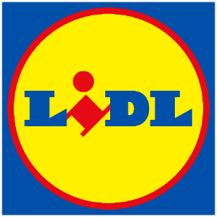
GB

The first Lidl GB store opened its doors in 1994 and 29 years later, we now have more than 960 stores and 14 regional distribution centres across Britain, employing over 31,000 people. We take great pride in providing our customers with the highest quality products at the lowest possible prices and work closely with our suppliers to make this possible. We're also passionate about sourcing locally where possible and more than two thirds of our products are sourced from British suppliers. https://corporate.lidl.co.uk/

- INTRODUCTION
The strategic management can be defined as the preparing process of evaluation, planning, and then implementation and monitoring of the actions through which an organization can obtain, maintain or improve competitive advantage. Or simple sayd, the plan of action through wich an organization achieve its objectives. Having a strategic plan of action it helps the organization following their main vision, and to be able to respond to any changes that may appear in the business environment (Sammut-Bonnici, 2015).
The process of planning involves to develop a business model, to sett up a clear direaction, to adopt a strategic plan, to make some acquisitions and to conceive a competitive plan of actions. In the second stage of implementation is required to have leadership and management (David, 2011).
The purpose of this report is to examine and outline the practices of strategic management chosen by LIDL GB. The report will analyse how this practices conducted to the organization’s performance, indentifing if there are any areas of improvement and what recomandations can be made in order to enhance the performance.
The report’s structure follow a clear plan, presenting a short overview of the subject matter and an briefly istoric about the choosen organization, LIDL GB, and continue with the introduction to the vission-mission and objectives of this retailer. After that, the report present some findings about the financial perfomance of this company just to sustain the overal presentation about the strategic performances obtained by ALDI over the years. An semnificative attention is going to the presentation of the main tools that are avalable to help with planing and developing strategies (Gamble, et.al., 2014).
2. Overview. LIDL is a discount retailer chain that offers a wide range of products, such as groceries, bakery, fresh produces, clothing and electronics, household essentials concentrating on discount grocery market by keeping operational cost low, getting discounts from supliers, and selling own brand products at low price.
LIDL started in Germany in 1930, and developped, becoming internationally. They operates now in over 12,000 stores across 31 countries. Part of the SCHWARZ GROUP, LIDL is in the present, one of Europe’s biggest food retailers. The brand’s name was given by its founder, profesor Ludwig Lids and the LOGO stands out for its colour palet which means joy, reability, it is happy and friendly, and simbolyse authority and expertize.
In 1994 they open operation across GB market, and grown since then curently counting over 963 stores, 14 regional distribution centers, and over 31,000 employee (LIDL, 2024).
3.1Strategic intent of LIDL GB.
In order to deliver perfomance, the organizations need to come with a strong plan which must present clearly which are the vission, mission, goals and objectives, setting some direction of development, steps and strategies.
Vission. The organization’s vision for LIDL GB it is to be the first choice for shoppers promoting high-quality at low price as can be observed also from its annual report.
Mission. This growth of the business can be explaine by the commitment of the organization to offer high-quality produces at a low price, to ‘offer value for money’. The retailer focuses its activity on value for money and sustainability which emphasised by the organization’s mission statement. The organization concentrate its effort on sustainability reducing food waste to 43% aiming to reach 50% in 2038, and plastic bagages to 29%, as they commite to provide value and quality while minimising the impact on the environment. Their support for local communities can be demonstrate by the fact that two-thirds from their products come from British supliers. Also, LIDL launched the program “Too good to waste”.
Objectives. The organization focuses on costumers satisfaction, market leadership, sustainability, supliers relationship, growth and expansion.
The LIDL GB strategic intent included in its vision, mission and objectives, demonstrate that the organization it is focused on future development, by anticipating and planing for the society’s interests, constantly innovating and optimising its activity.
3.2 The curent Business performance.
Financial performance. For the fiscal year ending in February 2023, LIDL GB reported 18.8% revenue growth, reaching £9.3 billions. Also LIDL’s market share increased from 6.1% to 7.1%, being the most rapid growth over the last 5 years. Even they reported a revenue growth, for the same periode LIDL GB reported a Loss Before Tax of £75.9 million (Bedford, 2023).
LIDL GB reported for the same period an increased of the number of shoppers with over 770,000 shoppers, explained also by the fact that they opened more new stores than any other competitor. The organization continue its plan of expansion and development by making substantial investments in its operations aiming to open 1,100 new stores by 2025.
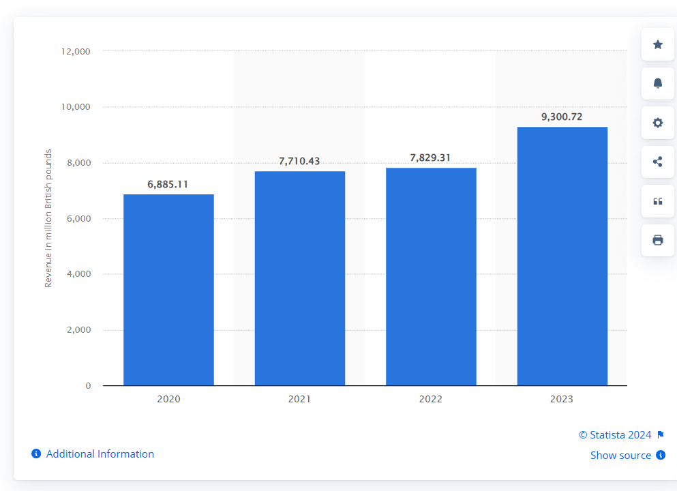
Fig. nr.1 (Bedford, 2023)
Dispite some financial challengies, the organization continue its strategic plan of investments and development encouraged by its financial performance, a semnificative revenue growth of 18.8%. However, the reported Loss Before Tax should be analysed as there may be some areas of improvement.
3.3 The analysis of strategy. Competitive Environment.
The activity of any organization is influenced by both, internal and external factors, and can affect how they build their organizational culture and strategy. Such tools as PESTEL, PETER’S 5 FORCES, SWOT, or MCKINSEY’S 7’S FRAME WORK can be used to shape and elaborate strategies for competitive advantages, which will contribute to de future development (Hakala and Vuorinen, 2020).
- THE EXTERNAL ENVIRONMENT
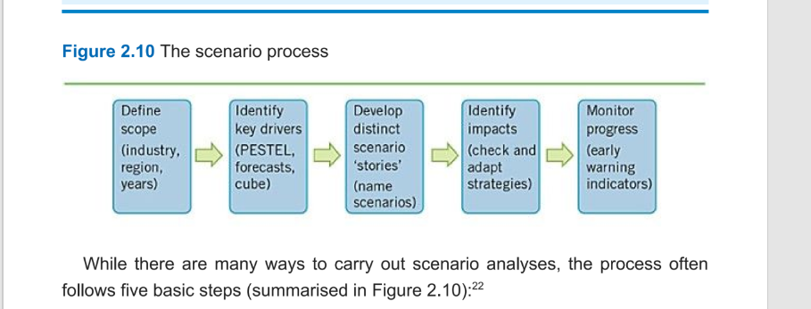
Fig.nr.2 (Johnson, et.al., 2020)
PESTEL.
- Political factors had impacted the businesses through Brexit which affected the trade tariffs, the regulations for import/export, and the supply chain.
- Economic: businesses have been affected by the inflation rates with impact on purchasing and pricing strategy, the exchange rates affecting the costs paid for the products from import. All this reflected in the spending power of consumers.
- Social. We have notice an increased interest of the clients for sustainable products.
- Technological. During COVID 19 and after, retail businesses had to adapt and to find new sales channels, becoming available online (Kouzes and Posner, 2023).
- Environmental. The impact on environment has to be addressed and organizations must come with strategies to reduce the carbon foothprint and waste.
- Legal. Businesses have to comply with health and safety regulations, and respect food standards.

PORTER’S 5 FORCES.
- Threats of new entrants. The threats are moderate if consider the fact that to enter the market involve high capital investments.
- Bargain power of suppliers. We can consider low to moderate, as LIDL use multiple supplyiers.
- Bargain power of customers. The market being shared by more players results in more choises for the customers, which makes that the power of customers to be high.
- Threats of substitutes. Moderate as LIDL offer high quality own brand products at low price.
- Industry rivalry. High because of the competitors such as ALDI.

B. THE INTERNAL ENVIRONMENT. SWOT, VRIO, BCG, VALUE CHAIN
SWOT.
- Strengths. We can outline the brand reputation gained by LIDL for’value for money’, efficient supply chain, customers loyalty programs, enhancing brand image through sustainability programs. LIDL commited to a program to make food available to everyoane, making sure that their products are produced and sold in ways tha are beneficial for the costumers, comunities and the planet (LIDL Financial Report, 2023).
- Weaknesses. Limited online presense, diversification low and the impact of Brexit for the supply with european products.
- Opportunities. For online development and also diversification of products offered.
- Threats. Intense competition, inflation and legislation changes continue to put pressure on finding new strategies to remain competitive.

VRIO.
The VRIO analysis by looking to each of the companie resources can assess if thise are enough to provide advantages on the market.
- Value. LIDL’s value for money represents attractivenes and value for its customers. Also LIDL’s VRIO analyse provide as with the understanding that the employees are valued by the organization as they are highly trained, which contribute to increase loyality and retention of staff.
- Rarity. Strong label oferings and strong supply chain.
- Imitability. Campaigne offers or products range can be imitated by the competition, therefore the local food produces provede them with posible competitive advantages.
- Organization. LIDL it is a strong organization with resoucers which contrinute to maintain them in a leading position on the market.
From the VRIO analysis we can oserve less interest for inovation or investition in research, which can take time and money, and therefor does not represinte a value for the organization and it is more a competitive disadvantages. The subject stands for future consideration and can represents a point for improvements.
Start order now
BCG.
- Stars. LIDL continue to offer freash produce and bakery products with potential for growth.
- Cash cows. LIDL has a variety of products that have a stady demand.
- Question marks. They offer a range of products such as clothing or home esential, which may not have a growth potential.
VALUE CHAIN
- Imbound logystic. Efficient suply chain with a focus on finding local sourcing.
- Operations. Efficient management sistem and store opperations.
- Outbound logistic. Effective distribution network.
- Marketing and sales. Strong commitment for value for money.
- Service. Focused on product quality and availability.

4.STRATEGY FORMULATION. DISCUTION OVER STRATEGIC CHOICES FOR BUSINESSES
4.1 The competitive environment it is affected and shaped by the internal and external factors (Porter, 1980). As any other business, LIDL’s activity is impacted by this factors and just by a profaund analysis of them, the organization can continue its expansion and progres.
LIDL GB builded its success on a strong strategy based on client satisfaction, value for low price, and an efficient suply chain management. There are few areas which needs further consideration.
Market penetration. LIDL GB can increase its market share by continue the strategy of extention opening new stores as declared 1100 more till 2025. LIDL GB can atract more costumers through loyalty programs and investing in marketing campaigns.
Product development. By introducing new products and innovative options such as eco-friendly packaging they can obtaine consumers that are atracted by this trend.
Market development. LIDL GB needs to continue its expansion and becoming more present in the community, developing its online prezence.
Diversification. An opportunity for diversification can be the development of their non-food product line and extending the colaboration with local supliers.
  - New strategy ideas. Findings and recomandations.
In order to ensure growth and boost its competitive advantages, LIDL GB should look into new strategies such as a dual-focus strategy:
- Innovation and digital transformation, building a strong online platform, adopting multiple option of shoping such click and colect, using data analysis in order to understand more about teir customers.
- Concentrating on sustainabilty and ethical practices. Investing in new renewable energy for their stores, for example.
Also, improving their communication and new marketing campaigns, can atract more shopers.
By prioritising such investition in innovation and new resources, they can enhance their growth, atract new customers and positioning themselves on a leading position for the future.
- CONCLUSIONS
Through the analysis of LIDL’s strategy, the present report outlined the importance of understanding how to use such tools like PESTEL, PETER’S 5 FORCES, SWOT, VRIO or BCG and value chain, in order to develop new and performing strategies. Since open in 1998 on the British market, the retailer managed to place itself on a leading position, which demonstrate a good planning strategy.
The report presented some findings and recommendations for the organization, in order to secure some competitive advantage for the future, such as innovating and building a strong online platform, concentrating in the same time on sustainability and ecological alternatives, or investing in renewable energy.

REFERENCES
- Bedford, E., 2023. Statistica, accessed on Revenue of Lidl supermarket Great Britain 2023 | Statista
- David, F, 2011. Strategic management: Concepts and cases., P.705
- Hakala, H., and Vuorinen, T., 2020. Tools for Strategy. Available on Tools for Strategy by Henri Hakala | 9781108879774
- Hayes, J., 2010. The Theory and Practice of Change Management, Palgrave
- Hunger, J.D. 2020. Essentials of strategic management.
- Johnson, G. and Scholes, K., 2020. Exploring Strategy, Harlow: FT Prentice Hall, p.809.
- Gamble, J.E., Thompson, A.A. and Peteraf, M.A., 2014. Essentials of strategic management: The quest for competitive advantage., p.440.
- Kouzes, Posner, 2023. The leadership challenge, How to make extraordinary things happen in organizations. Seventh edition., p.416.
- McClinton, P., 2017. Strategic Management,
- Mintzberg, H., Ahlstrand, B., and Lampel, J. Strategy Safari, 2008. The Complete Guide Through the Wilds of Strategic Management, Harlow: FT Prentice Hall.
- Porter, M.E., 1980. Competitive Strategy: Techniques for Analysing Industries and Competitors.

12.LIDL GB Annual report, 2023. Accessed on LIDL GREAT BRITAIN LIMITED filing history - Find and update company information - GOV.UK
13.Stock Market News, 2023. Accessed on
Lidl GB annual revenue jumps 19% - MarketScreener
14.Euromonitor International. LIDL SWOT analysis, 2023. Acessed on Search - Euromonitor.com
15.Julia Kollewe, The Guardian, 2023. Aceesed on UK grocery price inflation slows but shoppers worried by soaring bills | Supermarkets | The Guardian
16. Tanya Sammut-Bonnici, 2015, Strategic management, accessed on (PDF) Strategic Management
17. (LIDL, N.D.) accessed on About Lidl GB - Lidl Great Britain

