BA BUSINESS MANAGEMENT
LCBB5000 Data Handling and Business Intelligence
Module Lecturer : Zahra Mohammadanzari
Component 2 – Coursework – Written Report

Part 1

Contents
(a) 3
1 3
2 3
3 3
4 4
5 4
6 5
(b) 6
(c) 9
1 9
2 12
References 16

(a)
There are various statistical terms which are commonly used when attempting to analyse data related to an organization or something else. In this case, GreenMed Innovations’ data has been provided which needs to be analysed, so various statistical term needs to be applied which will be applied one by one to obtain the required result.

1
The first goal is to find out the mean value when using Hadoop because it will provide a clear idea about the usual time that Hadoop required. Mean refers to the average value which can be obtained by summing up a range of data, and the summed up value is divided with the total number of inputs present in the dataset (De Levie, 2004). To be able to find mean, the strategy is to use Average value that is available in Microsoft Excel. Hadoop data is available on the B column, so this data needs to be considered to be able to obtain the average value.
=Average(B:B)
Using this formula, instruction was provided to calculate the average value and write it down, and Excel provided the output as 2.77689 which means this is the mean value of Hadoop.

2
The next goal is to analyze the data of another platform which is called Spark, and the statistical term that will be used for this analysis is called median (De Levie, 2004). Median is another statistical term which is superior to average in many cases, such as the median does not get affected with outliers, thus the median needs to be calculated in any analysis. Spark is available in the C column, so this column needs to be considered for the analysis.
=MEDIAN(C:C)
This is the formula that has been written for this analysis which includes the processing time data of Spark platform, and uses the data to find the median which was found to be 2.74691

3
The processing time of a platform is not constant as the processing time changes daily. There can be various factors that comes into play in terms of the processing time on each day. It is important for this analysis to be able to find the date when the processing time of R platform was highest. As two different column needs to be utilized this time, so such a formula needs to be introduced. The VLOOKUP is such a formula that can perform the job and obtain the required result in this case. The back draw of VLOOKUP is that it can find the value on the right side columns, not on the left side, for example, the R value is in D column, so Date needs to be on the right side from D for VLOOKUP to find the value (Schmuller, 2013). This is the reason why the Date column was copied and pasted to G column. Also the maximum value needs to be found first so in a different cell, =Max(D:D) formula was used which provided with the value in H4 cell.
=VLOOKUP(H4,D2:G51,4,FALSE)
This is the formula that was inputted here which has provided with the value 1/16/2023 that means that the highest processing time took place on this date (Schmuller, 2013).

4
Standard deviation is another statistical term related to data analysis, and in case of Python, this term needs to be utilized.
=STDEV.S(E:E)
Using this formula, the E column was taken into consideration, and standard deviation of the value present in this column was analyzed. After the analysis, the standard deviation was found to be 1.2972057 which is the result (Walkenbach, 2007).

5
The goal of this step is to find the platform which had the lowest average processing time across the dataset, and to obtain the result, each one of the platform’s data needs to be analyzed (Nelson and Nelson, 2014). For this task to work, the strategy can be finding out the average value of each column or each platform separately, and then using a minimum function to find out the minimum of the average (Walkenbach, 2007).
Average Hadoop | Average Spark | Average R | Average Python | Average Tableau
2.77689 | 2.93222 | 2.75478 | 2.57318 | 2.83028
These are the average of each platform that has been obtained with the help of average formula, and the data was written in new columns (Walkenbach, 2007). Finally, minimum formula was applied to be able to find the minimum value among these.
=MIN(J2:N2)
Using this formula, the minimum value has been obtained which is the final result of this part, and the value is 2.57318 which means that average of Python platform is the lowest among them all.

6
Average Hadoop | Average Spark | Average R | Average Python | Average Tableau
2.77689 | 2.93222 | 2.75478 | 2.57318 | 2.83028
These are the processing time average for each platform where the processing time required to perform a task on average is shown. Based on this data, it can be found that the average value of Spark is the highest, that means that Spark will require more time than the other platforms to be able to execute a single task (Alexander et al., 2018). On the other hand, the lowest time required is found for Python which means that Python will be able to complete tasks before the other platforms (Alexander et al., 2018). In case of Tableau, the average time is high but not the highest, and Hadoop and R has less processing time than Tableau and Spark but requires more time than Python.

(b)
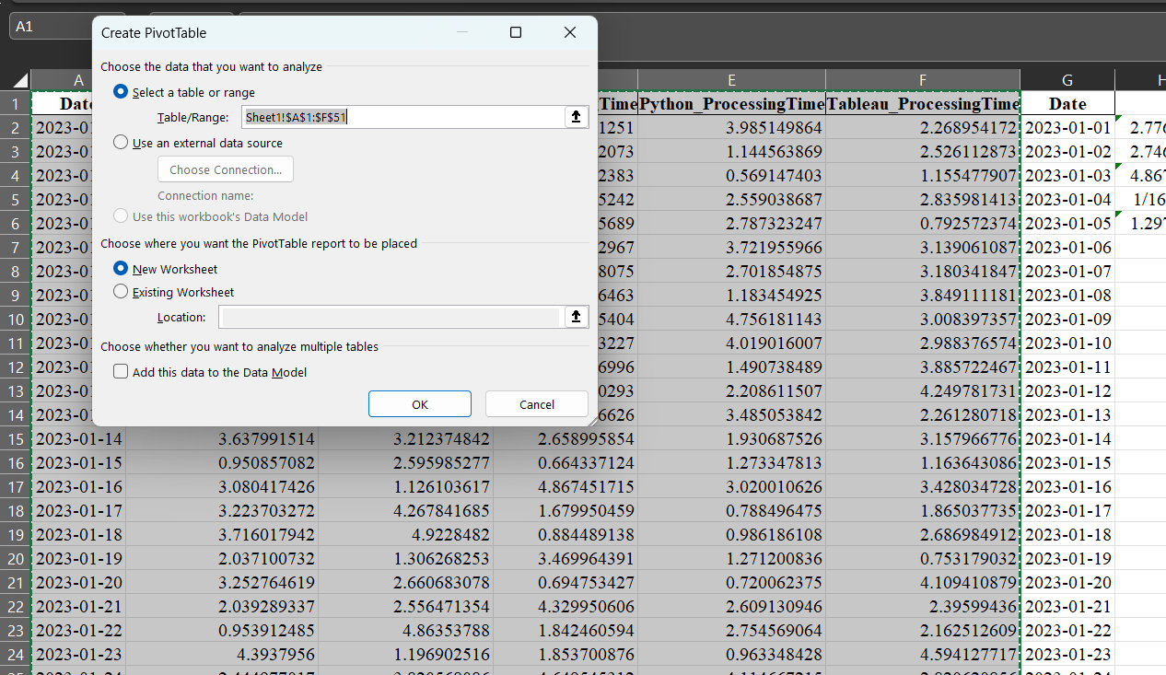
The task is to present data, and to present data, there are various features of Microsoft Excel that can be utilized. The one chosen for this part is known as PivotTable and PivotChart which are Excel functions and can be utilized to present various types of data (Aitken, 2007). To insert PivotTable, the cells that need to be included in the PivotTable needs to be selected at first. As shown in the picture date, and processing time of various platforms were chosen which provides the perfect opportunity to be able to analyze and present these data through PivotTable (Aitken, 2007). Once done, from insert, PivotTable and PivotChart was chosen which provided with the new tab that is shown in the picture. Here the columns are selected and “New Worksheet” is chosen which is why the PivotChart has been inserted in a new sheet as “OK” was pressed (Nelson and Nelson, 2014).
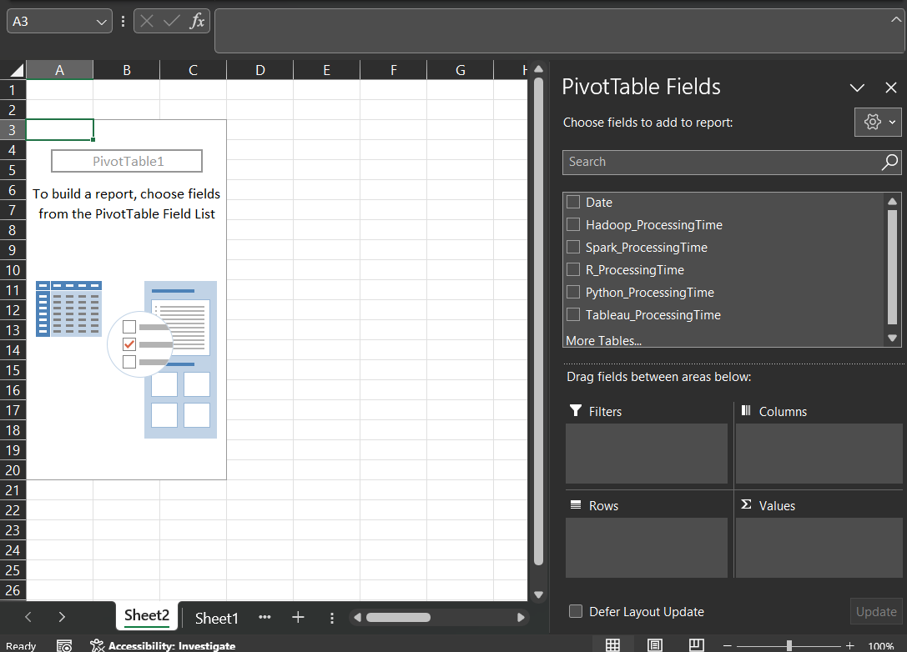
This is the PivotChart page which has been created on Sheet 2 and there are various functions provided in various sides that can be utilized for the analysis and presentation purposes. First of all, the sheet is blank, even though some demo picture type visuals are shown, those are empty cells (Aitken, 2007). There are various options available on the right side which can be selected so that they come into play in this PivotTable. As soon as any of the variables are activated, they get shifted in one of the boxes shown on the right bottom corner and those can be manually changed.
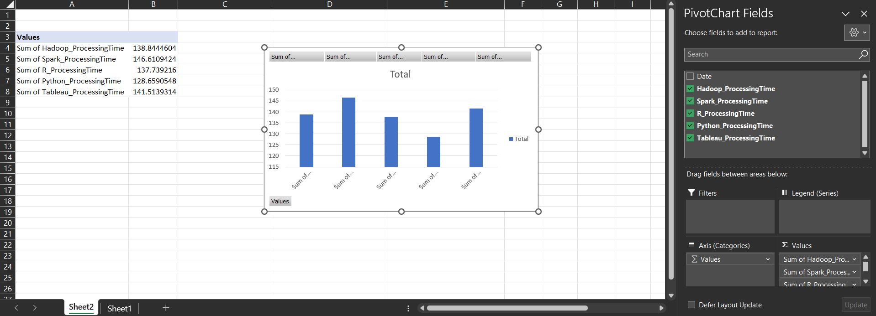
By ticking the boxes, the values has been considered as sum of the values of each platforms, and has been placed as rows. This is the reason why the values are being shown as rows in the PivotTable and a PivotChart has also been automatically created in this page.

A bar chart has been created based on the data through the PivotChart where the data, and their comparison can be easily visualized (Aitken, 2007).

(c)

1
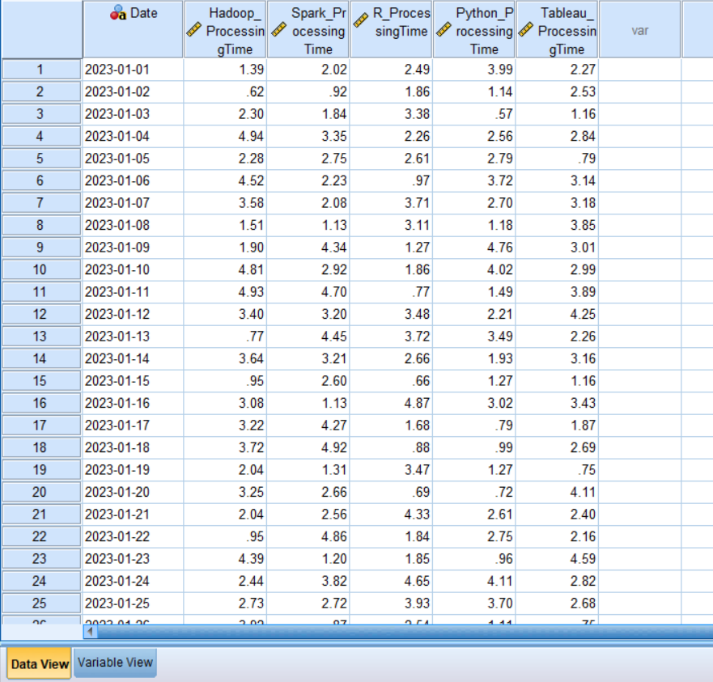
For this part, use of SPSS is required which is a separate software also focused on data analysis. The SPSS software has been opened and the Excel data that has been provided was copied and pasted in the SPSS so that these data can be utilized for the analysis that is to be performed through SPSS (Morgan et al., 2004). In the SPSS, the variable names are showing, but that part was performed separately in the SPSS under the variable view tab, and additional steps need to be implemented over there.
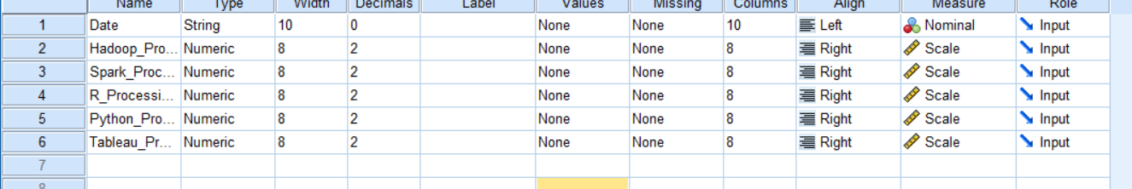
This is the variable view tab where the measures for each of the data was set as scale, except data. The variable data that are provided here are numeric and the bigger value means that it required more time, so scale has been set (Morgan et al., 2004). Under the situation, the SPSS file is ready for further analysis as required for this task (Morgan et al., 2004).
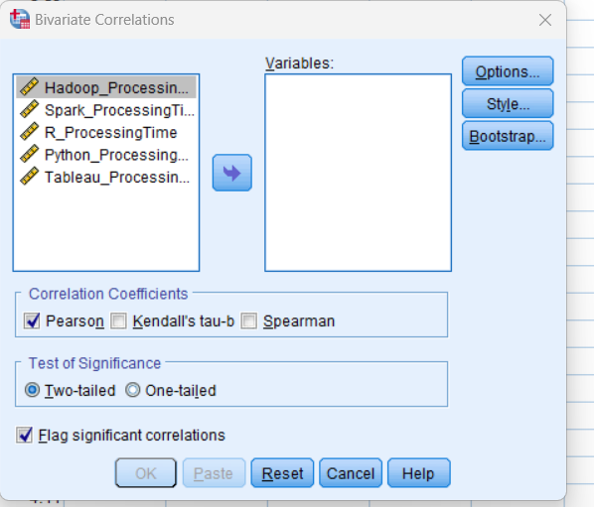
Almost any form of analysis that is to be performed through SPSS is available under Analyze option, and from there correlate was chosen. Correlate provided various options, and among them, Bivariate Correlations was chosen. After the selection, this new tab came up where the required variables were chosen.
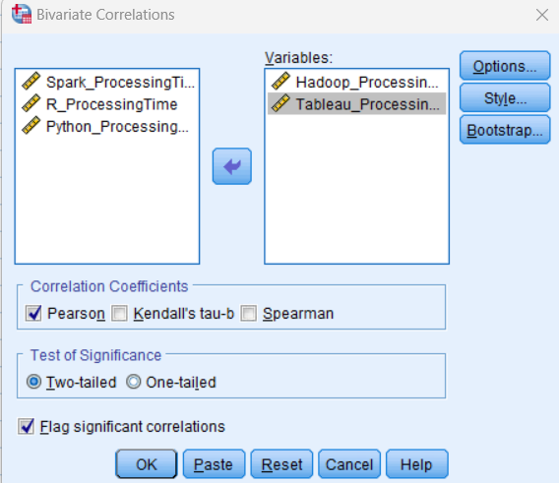
The two platform as shown in the above picture has been chosen and sent to the right side of the tab which instructs SPSS to analyze the data (Morgan et al., 2004).
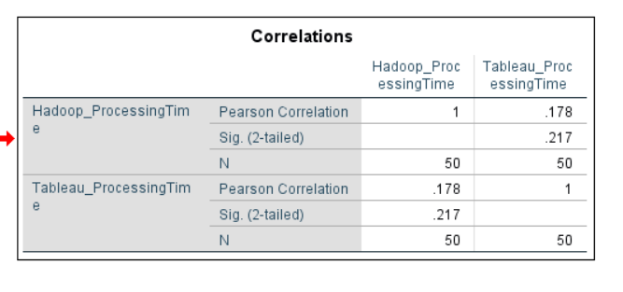
This is the result that SPSS has provided as output where various types of values are present. There are Pearson correlation value has been found to be .178 which communicates various significant result. This value can range from -1 to 1 and 0 means no correlation, and .178 is close to 0 but positive, that means the correlation is weak and positive (Morgan et al., 2004). It means that the values might be related and the relation might be positive, that means that if one value increases, there is a chance that the other value will also increase, yet the correlation that exists between these two variables are very weak.

2
Scatterplot is a type of graph where various dots are used to present data, and is a useful chart in various cases. In the Excel and SPSS, scatterplot can be easily created in terms of presenting data or studying trends among data (Hinton et al., 2014). In this task, scatterplot will be utilized to be able to identify the relation or trend among Hadoop’s and Tableau’s data processing time.
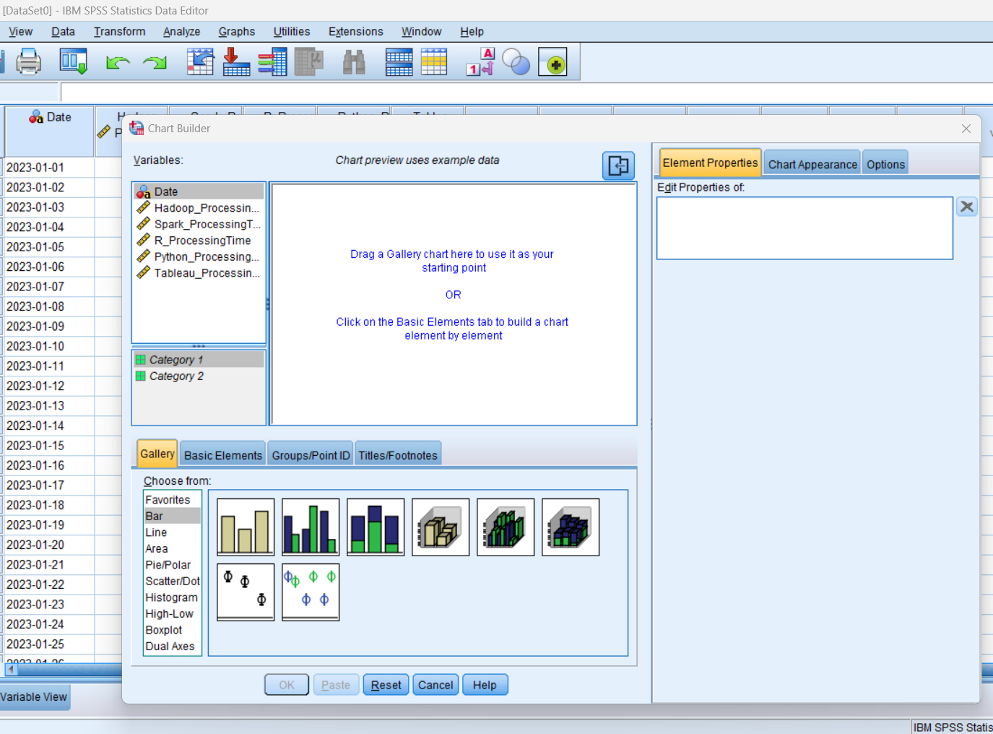
In SPSS, the task of creating graph is almost straightforward because there is an option called Graphs where various types of graphs can be built. The advantage of this chart builder is to use two different types of axis in a graph as needed, so those inputs need to be provided (Hinton et al., 2014). First, the Hadoop’s processing time will be placed on the horizontal axis, and the tableau’s processing time will be placed on the vertical axis to be able to obtain the graph that is needed in this case.
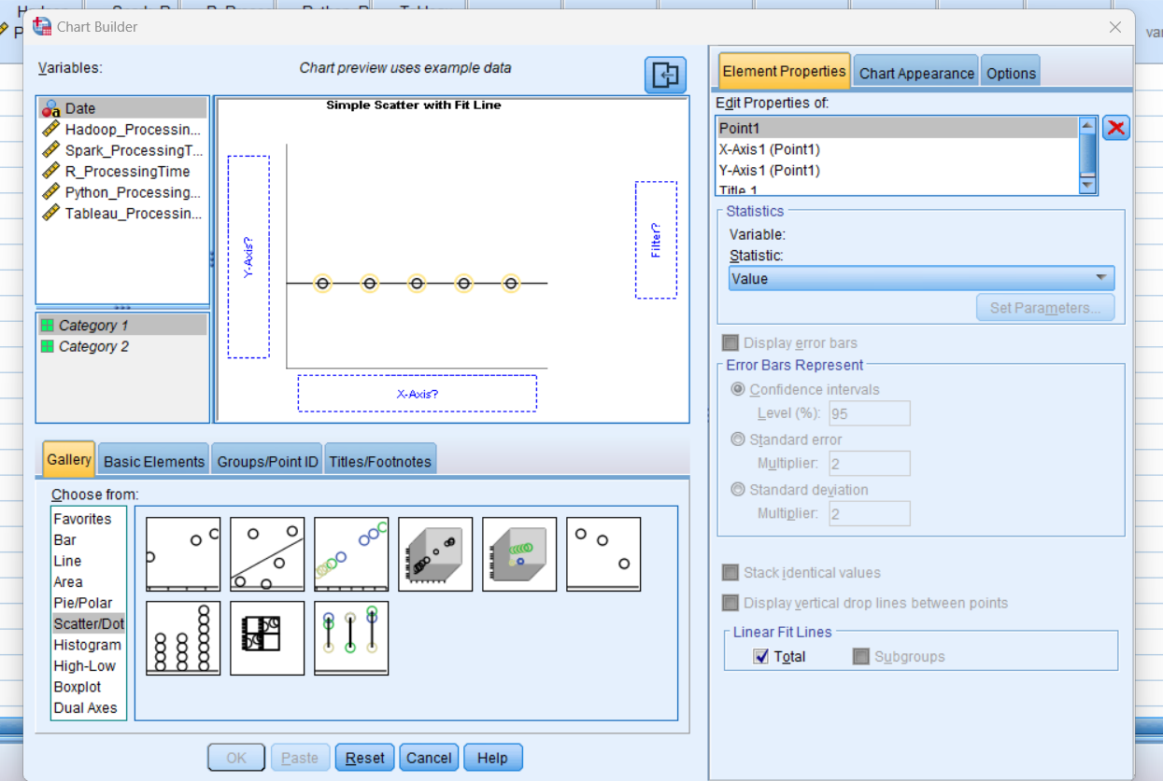
From below of the chart, scatterplot was selected which provided this graph where the x and y axis are empty, so the axis variable needs to be placed (Hinton et al., 2014).
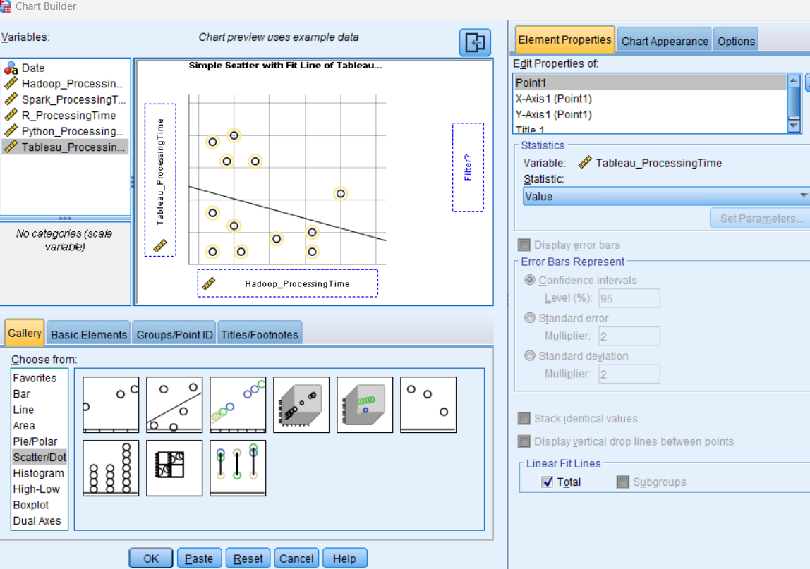
After placing the axis data, the outcome that has been obtained is shown in the above picture, but this is not the final outcome. To be able to obtain the final outcome, the chart needs to be created by SPSS.
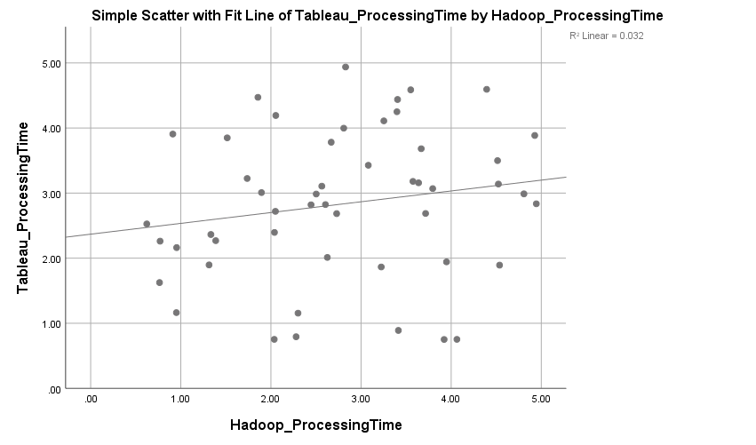

This is the final outcome that SPSS has provided where all the scatter data and the best fitted line is shown. The special message that can be obtained from this graph is most of the points are located far away from the best fitted line that means that correlation that exist between these two variables are very weak (Hinton et al., 2014).

References
Aitken, P.G., 2007. Excel 2007 PivotTables and PivotCharts. John Wiley & Sons.
Alexander, M., Kusleika, R. and Walkenbach, J., 2018. Excel 2019 bible. John Wiley & Sons.
De Levie, R., 2004. Advanced Excel for scientific data analysis. Oxford University Press, USA.
Hinton, P.R., McMurray, I. and Brownlow, C., 2014. SPSS explained. Routledge.
Morgan, G.A., Leech, N.L., Gloeckner, G.W. and Barrett, K.C., 2004. SPSS for introductory statistics: Use and interpretation. Psychology Press.
Nelson, S.L. and Nelson, E.C., 2014. Excel data analysis for dummies. John Wiley & Sons.
Schmuller, J., 2013. Statistical analysis with excel for dummies. John wiley & sons.
Walkenbach, J., 2007. MICROSOFT EXCEL 2007 BIBLE (With CD). John Wiley & Sons.

Part 2 – Report

- The advantages and disadvantages of using SPSS, Excel or Tableau using relevant practical examples.

Discussing the advantages and disadvantages of SPSS, Excel, and Tableau involves a comparison of three diverse tools commonly used for data analysis and presentation.

SPSS (Statistical Package for the Social Sciences)

Advantages:
- Advanced Statistical Analysis: SPSS is renowned for its ability to perform complex statistical analyses, making it a staple in social science research (Field, 2013). Its capabilities in handling large datasets and performing a variety of statistical tests (ANOVA, Regression Analysis, etc.) are highly valued in academic and research settings.
- User-Friendly Interface: Compared to other statistical software, SPSS has a more intuitive and user-friendly interface. This makes it accessible for users with limited programming skills (George & Mallery, 2010).
- Data Management: SPSS is proficient in handling and manipulating large datasets, providing tools for data cleaning and preparation that are essential in research (Pallant, 2011).

Disadvantages:
- Cost: One of the significant drawbacks of SPSS is its cost, which can be prohibitive for individual researchers or small organisations (Bryman & Cramer, 2011).
- Less Flexibility in Scripting: Although SPSS has scripting capabilities, they are less flexible compared to other statistical software like R or Python (Field, 2013).

Excel

Advantages:
- Versatility and Accessibility: Excel is a versatile tool used in various fields for data entry, manipulation, and basic statistical analysis. Its widespread availability as part of the Microsoft Office suite makes it a go-to tool for many (Walkenbach, 2015).
- User-Friendly Interface: Excel is known for its user-friendly interface, making it easy to use for beginners. It provides a straightforward way to visualise data through charts and graphs (Frye, 2016).

Disadvantages:
- Limited Statistical Analysis Capabilities: Excel is not suitable for advanced statistical analyses. Its capabilities are limited compared to specialised software like SPSS or R (Walkenbach, 2015).
- Data Size Limitation: Excel has limitations in handling large datasets, which can be a significant drawback for extensive data analysis projects (Frye, 2016).

Tableau

Advantages:
- Advanced Data Visualisation: Tableau excels in creating interactive and visually appealing data visualisations. It is particularly useful for presenting complex data in an understandable format (Chabot, 2013).
- Handling Large Datasets: Unlike Excel, Tableau can handle large datasets efficiently, making it suitable for big data analysis (Murray, 2017).

Disadvantages:
- Cost: Similar to SPSS, Tableau is expensive, which can be a barrier for small businesses or individual users (Murray, 2017).
- Steep Learning Curve: Learning to use Tableau effectively can be challenging, especially for users without a background in data analysis (Chabot, 2013).

Conclusion
Each of these tools has its place in data analysis. SPSS is ideal for complex statistical analysis, Excel for basic data manipulation and analysis, and Tableau for advanced data visualisation. The choice of tool depends on the specific needs of the project and the skillset of the user.

b) The importance of Data Governance , examples.

Data governance is a critical aspect of managing organisational data. It involves the processes, standards, policies, and technologies that ensure the effective and efficient use of information in enabling an organisation to achieve its goals. In the UK, the importance of data governance has been increasingly recognised across various sectors. This recognition is fueled by the growing reliance on data-driven decision-making, the need for data privacy and security, and the compliance with legal and regulatory requirements.

Compliance with Laws and Regulations
One of the key drivers of data governance in the UK is the need to comply with various laws and regulations. The General Data Protection Regulation (GDPR), which the UK has retained post-Brexit, sets stringent guidelines on data privacy and protection. Organisations are required to manage personal data lawfully, transparently, and securely (Information Commissioner's Office, 2018). Non-compliance can lead to significant fines and reputational damage. For example, in 2020, the Information Commissioner's Office fined British Airways £20 million for failing to protect the personal and financial details of more than 400,000 customers (BBC News, 2020). This incident highlights the need for robust data governance frameworks to ensure compliance and protect customer data.

Enhancing Data Quality and Reliability
Effective data governance ensures that data is accurate, consistent, and reliable. In the UK, sectors such as healthcare and finance heavily rely on high-quality data for decision-making. For instance, the National Health Service (NHS) uses patient data to improve healthcare services and outcomes. Data governance ensures that this data is correct, up-to-date, and used appropriately, which is crucial for patient care and operational efficiency (NHS Digital, 2019). Similarly, in the financial sector, companies like Barclays use data governance to ensure the integrity of financial data, which is vital for risk management and regulatory reporting (Barclays, 2018).

Supporting Data-Driven Decision Making
Data-driven decision-making is increasingly becoming the norm in the UK's public and private sectors. Data governance provides a framework to ensure that the data used for these decisions is relevant, complete, and timely. For example, the UK government’s use of data during the COVID-19 pandemic for making public health decisions underscored the importance of having accurate and timely data governed by clear policies and procedures (GOV.UK, 2020).

Protecting Against Data Breaches and Cybersecurity Threats
With the rise in cybersecurity threats, data governance plays a crucial role in protecting sensitive information. Organisations in the UK are investing in data governance to safeguard against data breaches, which can have severe financial and reputational consequences. The 2017 cyber-attack on the NHS, which led to the cancellation of thousands of appointments and operations, demonstrated the devastating impact of inadequate data security (NHS, 2017).

Ensuring Ethical Use of Data
Data governance is also crucial for ensuring the ethical use of data. In the age of big data and AI, concerns around privacy, consent, and bias are prevalent. The UK's Centre for Data Ethics and Innovation (CDEI) emphasizes the role of data governance in addressing these challenges, ensuring that data is used responsibly and ethically (CDEI, 2019).

Conclusion
Data governance in the UK is not just a regulatory requirement; it's a strategic imperative. It plays a vital role in ensuring compliance, enhancing data quality, supporting decision-making, protecting against cyber threats, and ensuring ethical data use. As data continues to be a critical asset for organisations, the importance of data governance will only grow, making it an essential element of organisational strategy and operations.

References:

Barclays. (2018). Annual Report 2018. Barclays PLC.

BBC News. (2020, October 16). British Airways fined £20m over data breach. Retrieved from https://www.bbc.com/news

Bryman, A., & Cramer, D. (2011). Quantitative Data Analysis with SPSS. Routledge.

Centre for Data Ethics and Innovation (CDEI). (2019). Annual Report 2019. CDEI.

Chabot, C. (2013). Tableau Your Data!. Wiley.

Field, A. (2013). Discovering Statistics Using IBM SPSS Statistics. Sage.

Frye, C. (2016). Microsoft Excel Data Analysis and Business Modeling. Microsoft Press.

George, D., & Mallery, P. (2010). SPSS for Windows Step by Step: A Simple Guide and Reference. Allyn & Bacon.

GOV.UK. (2020). Coronavirus (COVID-19) in the UK. Retrieved from https://www.gov.uk/coronavirus

Information Commissioner's Office. (2018). Guide to the General Data Protection Regulation (GDPR). ICO.

Murray, D. (2017). Tableau Data Visualization Cookbook. Packt Publishing.

NHS. (2017). 2017 Cyber Attack on the NHS. National Health Service.

NHS Digital. (2019). Data Quality Strategy. NHS Digital.

Pallant, J. (2011). SPSS Survival Manual. McGraw-Hill Education.

Walkenbach, J. (2015). Excel 2016 Bible. Wiley.

