Sustainable Business Revenue Generation Plan based on Intercontinental Hotel Group

Student name: | Md Arif Uddin Khan | Student ID number: | 2107274
Programme: | BA International Hotel Management
Module: | Financial Management for the Hotel Industry
Module code: | BMIH5007
Lecturer: | Dale Clarke
Assignment Title: | Sustainable Business Revenue Generation Plan for IHG

Executive Summary
The report aims to analyse the two alternative options available for housekeeping to Intercontinental Hotel Group (IHG). Firstly, it demonstrates that outsourcing housekeeping is beneficial for providing quality guest service, saving costs, and incorporating technology. However, poor communication, high initial set-up costs, and decrement in control outsourcing may not be suitable. It is also found that an outsourcing strategy is better than insourcing for cost savings purposes. Therefore, it is recommended to Intercontinental Hotel Group that it should outsource housekeeping services.

Table of Contents
Executive Summary 2
Introduction 4
Arguments for Outsourcing Housekeeping Department 5
Offering Better Quality 5
Cost Savings and Return 6
Incorporation of Technology 6
Arguments against Outsourcing Housekeeping Department 7
Decrement in Control 7
Incurring high levels of cost 7
Communication Problem 8
Comparison of Inhouse and Outsourcing Housekeeping 9
Conclusion 10
Reference List 11
Appendix 14

Introduction
The report aims to analyse the financial implications and comparison of in-house and outsourcing housekeeping services in the Intercontinental Hotel Group (IHG). Firstly, the arguments that support the outsourcing of housekeeping are discussed. Here, the main advantages or benefits that IHG hotels will face for choosing to outsource are pointed out. Secondly, the arguments that do not support the outsourcing of housekeeping are discussed. Here, the main disadvantages and their implications are discussed from the perception of hotels taking findings from different authors. Finally, the report will do an overall comparison of the in-house sourcing for housekeeping and outsourcing for housekeeping. Here, the financial implications of each alternative are discussed to demonstrate the cost of each alternative. Besides, theoretical justifications for both alternatives will be discussed. Finally, based on the evaluation in the comparison stage, a recommendation will be made which will choose any one of the alternatives.

Arguments for Outsourcing Housekeeping Department
Hotels prefer to outsource their housekeeping service due to their seasonal activities. Therefore, outsourcing for Intercontinental Hotel Group (IHG) will mean that the hotel will not need to go through additional difficulties of recruitment, employee absenteeism, and satisfaction. However, there are some arguments regarding the outsourcing Housekeeping department.

Offering Better Quality
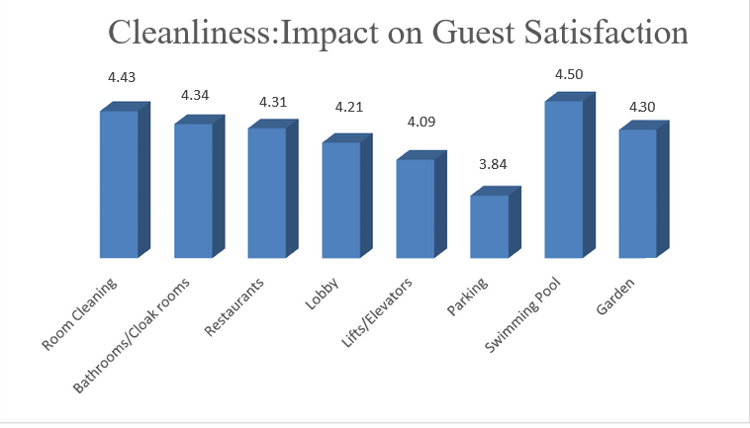
Outsourcing housekeeping providers are professionals; have training facilities and design their services according to the need of customers. Therefore, outsourcing providers can offer better service quality to IHG hotels. According to (Nimri et al., 2020), outsourced housekeeping services can provide better service to the customers and thus customers tell other customers about their experience which helps hotels to attract new customers. Sharma and Kaushik (2021) found that factors such as cleanliness, bathroom, swimming pool, garden, and so on play important roles in the customer satisfaction of a hotel. Outsourcing in these areas can ensure customer satisfaction. The following graph is showing the relative value of the factors.

Figure 1: Outsourcing housekeeping services impact on customer satisfaction (Source: Zagade and Tyagi, 2017)

The author argued that outsourcing housekeeping affects these factors and ensures guest satisfaction.

Cost Savings and Return
Outsourcing housekeeping services ensure specialisation of routine tasks. Therefore, it will help the IHG hotel to become more efficient. As a result, efficiency will lead to less waste of resources and time. Consequently, the hotel company can save a significant amount of costs. According to Calbone (2016), outsourcing helps hotels to generate more value in terms of money and thus, it helps an organisation to reduce waste and earn more revenue. Furthermore, (Cali et al., 2015) found that the cost-benefit ratio of outsourcing housekeeping services in an organisation stands at $1.06. It means that if IHG hotel invests $1 in outsourcing housekeeping services, it would bring a return of six cents to the hotel which is $1.06 in total. BAQUERO (2022) also argued that hotels that outsource housekeeping services can decrease their labour cost by at least 25%. The author also argued that increasing annual investment of $25,000 in outsourcing housekeeping services can save a hotel $275,000 worth of employees’ productivity. Besides, if other operational costs associated with the housekeeping service are considered, the annual savings of a hotel’s operational cost would be $1 million. Because, the author thinks that there is a relationship between a hotel’s internal environment, operational cost, and productivity. By outsourcing the housekeeping service, employees are getting free and use that effort to achieve other important goals.

Incorporation of Technology
The usage of technologies in hotels has disrupted the hotel industry. Therefore, using the latest and upgraded technologies outsourcing housekeepers can identify which areas of a hotel need to be worked on first. It ensures the effectiveness of the tasks associated with housekeeping. As the tasks are effective, there is a very low chance that the resources and time will be wasted on aimless activities. Moreover, Alcalde-González, Mozo, and Bustos (2021) argued that outsourced housekeepers use the latest industry innovations to complete their tasks. Therefore, they can offer better service to the hotels which the hotels could not have access to otherwise. Also, to afford those latest technologies the hotels had to incur a high level of capital expenditures. For example, IHG is already using artificial intelligence software such as DocMax, a solution to reduce operational costs. Therefore, IHG has the habit of incorporating technologies and can further benefit by integrating the technologies used in housekeeping with its existing system (Rosemberg, M.A.S. and Li, 2018). Furthermore, outsourcing housekeeping will allow IHG to have services with technologies such as housekeeping training technology, automatic scheduling of housekeeping, robotic housekeeping, and so on. These technologies are available to professional housekeeping service providers and if IHG wants to have them, its cost will increase significantly.

Arguments against Outsourcing Housekeeping Department

Decrement in Control
Hotels invest a large amount of time and resources to build their assets. However, according to Horst and Sinanan (2021), letting third parties handle hotels’ assets for housekeeping can be a high trust issue. Besides, the author argued that this practice can reduce the control of the hotel in various operational areas. Hence, it can raise further complications and even reduction in customer service. Moreover, Tiwari, Singh, and Dahiya (2022) stated that hotels can not all the time oversee the tasks and performance of third-party housekeepers while they are working. This can also hamper the service quality control procedure of the hotel. Also, while outsourcing a third party for housekeeping, hotels usually engage in a contract. In the contract, the tasks and responsibilities of the third party are mentioned. However, hotels lack the authoritative power to lead the third party for doing additional tasks which may be essential for customer service but the contract does not include those tasks. At the same time, Singh (2015) argued that contracting third parties can over-empower them and the hotel companies can lose their authority over the actions of outsourcing housekeepers. In this way, outsourcing third-party housekeepers can reduce the control of hotels.

Incurring high levels of cost
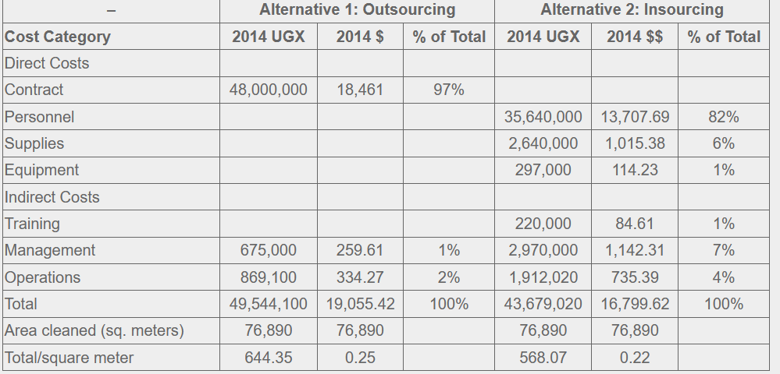
According to Tyagi and Zagade (2015), outsourcing the housekeeping department can cost more to a hotel compared to insourcing. The author found that the initial cost of sourcing a third party for housekeeping responsibility can cost more. However, after adjustment which is done considering the efficiency and quality of service, the outsourcing’s benefits exceed the cost. Therefore, if initial costs for outsourcing are considered, then it is costlier. For example, the following table demonstrates the comparative annual cost of outsourcing and insourcing housekeeping. Mujasi and Nkosi (2018) conducted research and found the annual cost in which he shows the comparison.

Figure 2: Annual Cost comparison of outsourcing and insourcing housekeeping (Source: Mujasi and Nkosi, 2018)

The table is showing that if a hotel outsources housekeeping, it has to bear a cost of $0.25 per square meter. Whereas, for insourcing, the cost is only $0.22 per square meter. Therefore, the cost of outsourcing is higher than that of insourcing. But these values are not adjusted and after adjustment, the values can be different.

Communication Problem
According to Tölkes (2018), outsourcing the housekeeping services to a third party can create communication problems creating difficulties. The author argued that contracting and working with another third party regularly can be challenging. Therefore, communication problems, misunderstandings and delayed service can be seen in the hotel. Also, Brody (2016) found that outsourcing housekeeping can lead to ineffective communication which can waste the utilisation of time and resources. The author also found that 88% of employers in the hotel industry think that poor communication is the main reason for workplace failure. Furthermore, Ramadanty and Martinus (2016) pointed out that another reason for which communication problems can arise in outsourcing housekeeping services in hotels is because of one-way communication. Most of the time, the hotels guide or tell the outsourced housekeepers what to do and what should be done. However, this process can lead to the creation of false assumptions which ultimately can create confusion and problems. Hence, the outsourced housekeepers can not provide any feedback or ask for something important. It is causing missing important details in the workplace. As a result, it will impact the customer satisfaction ability of the companies.

Comparison of Inhouse and Outsourcing Housekeeping
Housekeeping in a hotel includes all the functions related to cleaning, organise, and maintaining guest rooms. In both ways e.g. in-house or outsourcing, hotels have to bear costs for functions. Therefore, firstly, the cost of each alternative will be evaluated. In in-house housekeeping the hotel, IHG first has to hire new staff for different roles. Hence, the first cost is the employees’ salary cost. According to UK Indeed (2023), per hour salary of a housekeeping employee is £10.32. Therefore, if IHG hotel hires at least 20 people for housekeeping service, the employee cost would be (£10.32*8*30) £2,476 or $2988. On the other hand, Mariott International pays a yearly salary of $32,255 to a housekeeper (Glassdoor, 2023). Apart from hiring employees, IHG hotel also needs to purchase new pieces of machinery capable of doing housekeeping functions. Therefore, pieces of machinery such as cleaning machines, polishing machines, vacuum cleaners, project management software, and so on have to be purchased. It would cost in total (£4357 + £270 + £600 + £400 + £5000) £10627 for one machine each. The cost is for a couple of pieces of machinery which are basic and essential. If IHG hotel decides to purchase two or three of each machine then the cost would increase further. Besides, there is employee training cost. Because, to perform housekeeping properly, IHG hotel has to provide training. The average salary of an employee trainer in the UK is £31,745 in the UK yearly. Besides, there are other costs associated with the training.
However, if IGH hotel outsources the housekeeping service, then the cost would be $30 per hour (Wang, 2023). Therefore, the hotel has to pay for the working hours of service provided. For example, if the outsourcing housekeeper takes 4 hours to complete cleaning the hotel, it would take only ($40*4) = $160 for one day. However, the hotel does not need the housekeeping service every day. Rather, it may need the service one day a week. So the monthly cost stands at ($160*4) = $640 or around £530. It is less than the monthly housekeeping cost incurred by insourcing.
But, one of the major benefits that insourcing can provide is security. Because, if IHG hotel engages a third work party, it has to rely solely on a trust basis regarding the security issue. But if IHG hotel insources the housekeeping service, there will be no issue regarding security issue. Furthermore, in-house housekeeping can assist the hotel to improvise. For example, if any accidents or unwanted events happen in the hotel, then the in-house pieces of staff will come first to solve the issue. Whereas, outsourcing service providers will not be available all the time to tackle such issues. Hence, the risk can be reduced using in-house sourcing. Finally, IHG hotel has to incur a large number of costs to continue maintaining the employees for housekeeping. Because they are employed permanently. However, the hotel can avail of the service without paying continuously for housekeeping services by outsourcing. Thus, it will assist to reduce the cost.
Therefore, if costs are considered it is recommended that IHG hotel should outsource its housekeeping services.

Conclusion
The report has analysed the financial implications of outsourcing housekeeping services for the International Hotel Group (IHG). It is found that outsourcing housekeeping can assist to provide better service quality to customers, can save costs and provide a higher return and make the operation efficient using technology. However, it has also some drawbacks which are decrement in control, incurring a high level of cost, and communication problems. Finally, a comparison is done which shows that outsourcing is more cost-efficient than in-house sourcing. However, in-house sourcing can ensure security and reduce risk in the hotel. But it is recommended that IHG hotel should use the outsourcing alternative for housekeeping.

Reference List
Alcalde-González, V., Mozo, A.G. and Bustos, A.V., 2021. No clean rooms, no hotel business: Subversion tactics in Las Kellys’ struggle for dignity in hotel housekeeping. Annals of Tourism Research, 91, p.103315

BAQUERO, A., 2022. Customer and Employee Satisfaction in Hotels. Journal of Hospitality and Tourism Issues, 4(2), pp.69-83

Brody, D., 2016. Housekeeping by Design. In Housekeeping by Design. University of Chicago Press.

Calbone, A., 2016. The pros and cons of outsourcing housekeeping positions. The Rooms Cronicle, 19(1).

Cali, J., Cogswell, H., Buzwani, M., Ohadi, E. and Avila, C. (2015). Cost-benefit analysis of outsourcing cleaning services at Mahalapye hospital, Botswana. Journal of Hospital Administration, 5(1), p.114. doi:https://doi.org/10.5430/jha.v5n1p114.
Glassdoor (2023). https://www.glassdoor.com/Salary/Marriott-International-Housekeeper-Salaries-E7790_D_KO23. [online] www.glassdoor.com. Available at: https://www.glassdoor.com/Salary/Marriott-International-Housekeeper-Salaries-E7790_D_KO23.
Horst, H. and Sinanan, J., 2021. Digital housekeeping: Living with data. New Media & Society, 23(4), pp.834-852.

Mujasi, P.N. and Nkosi, Z.Z. (2018). A Comparative Analysis of the Costs and Benefits of Outsourcing Vs. Insourcing Cleaning Services in a Rural Hospital in Uganda. The Open Pharmacoeconomics & Health Economics Journal, 06(1), pp.9–20. doi:https://doi.org/10.2174/1876824501806010009.
Nimri, R., Kensbock, S., Bailey, J., Jennings, G. and Patiar, A., 2020. Realizing dignity in housekeeping work: Evidence of five star hotels. Journal of Human Resources in Hospitality & Tourism, 19(3), pp.368-387.

Ramadanty, S. and Martinus, H., 2016. Organizational communication: Communication and motivation in the workplace. Humaniora, 7(1), pp.77-86.

Rosemberg, M.A.S. and Li, Y., 2018. Effort-reward imbalance and work productivity among hotel housekeeping employees: a pilot study. Workplace Health & Safety, 66(11), pp.516-521.

Sharma, S. and Kaushik, T., 2021. Aesthetically clean to clinically clean–A study on new housekeeping practices in Delhi hotels beyond COVID-19 pandemic. Worldwide Hospitality and Tourism Themes, 13(5), pp.646-659

Singh, A., 2015. Hotels Housekeeping Innovative Trends and Modern Practices-An overview. Journal for Studies in Management and Planning, 1(3), pp.540-548.

Tiwari, A., Singh, M. and Dahiya, A., 2022, March. A study on the effect of Technological Innovation on Outsourcing in the Hotel Housekeeping Department. In 2022 International Mobile and Embedded Technology Conference (MECON) (pp. 37-40). IEEE.

Tölkes, C., 2018. Sustainability communication in tourism–A literature review. Tourism Management Perspectives, 27, pp.10-21.

Tyagi, H. and Zagade, S., 2015. Outsourcing: A study on Benefits to Housekeeping Department in Hotels.

UK Indeed (2023). Housekeeper salary in United Kingdom. [online] UK Indeed. Available at: https://uk.indeed.com/career/housekeeper/salaries.
Wang, C., 2023. Research on the Benefits of Government Purchasing Housekeeping Training Services Based on Evolutionary Game

Zagade, Dr.S. and Tyagi, H. (2017). Impact of Outsourced Housekeeping Services on Guest Satisfaction with Respect to Star Hotels. International Journal of Trend in Scientific Research and Development, Volume-2(Issue-1), pp.1076–1080. doi:https://doi.org/10.31142/ijtsrd7187.

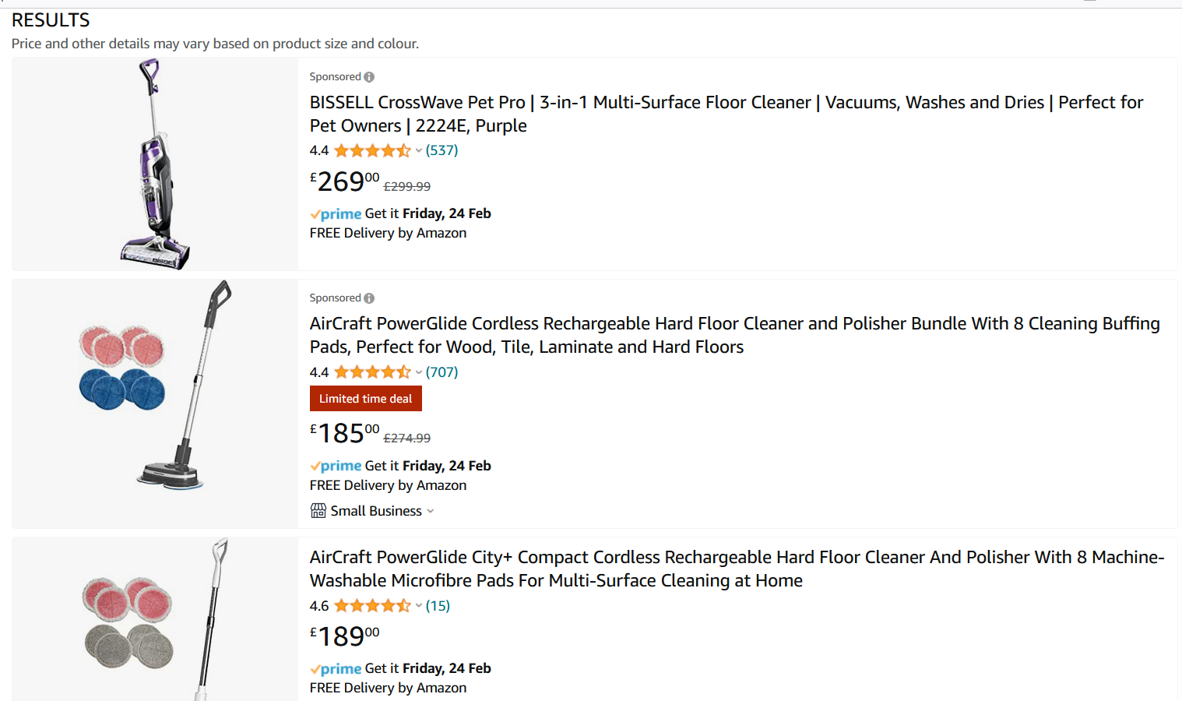
Appendix



