Part B
How a school develops one aspect of its SDP: a report that critically reflects on the actions, impact and evidence base

ECAD7003
Name: Toni Al-Hagin
Student Number: 1050383

Targets from previous ECAD7004 assignment- Researching the learning.

 | Target | What I have done in this report to meet those targets:
Target 1 | Check that referencing conventions are followed exactly. | I have continuously spent time reviewing the Harvard referencing document. I have ensured to check all references to mitigate errors.
Target 2 | Aim to explain all ideas in good depth. | I am conscious of the allocated word count, which does affect my depth of explanation but in this assignment, I decided to solely focus on one objective within the high-level priorities of School X SDP and not all three, meaning I am able to explain my ideas in more depth.
Target 3 | Proofread with greater care. Errors do have a negative impact on clarity. | I have ensured to proof read with care, to reduce the errors in my work in the hope to improve clarity.

Introduction
The purpose of this report is to critically reflect on the actions, impact and evidence base of how school X develops one area of their school development plan (SDP). The area of focus being absenteeism. A repercussion of school absenteeism would be the impact it has on student’s academic attainment (Sian Hughes, 2023).
In order for School X to improve student progress and wellbeing, they have set six high-level priorities, great leadership, great behaviour, great support, great curriculum, great teaching and great assessment (School X, 2022). Within each of these high-level priorities are objectives. The priority of focus is great behaviour and the three objectives set to achieve great behaviour are ‘to embed the whole school routines for learning’, ‘to develop positive attitudes to learning’ and ‘to reduce persistent absenteeism especially for ALN and FSM students’ (School X, 2022). The last objective is the focus of this report. See Appendix A for school development priorities.

The school which the report is based, is an 11-16 English-medium mixed comprehensive school in Swansea. As of the latest Estyn report in 2019, around 29% of pupils are eligible for free school meals, which is higher than the national average of 18% for secondary schools. Also, around 34% of pupils are on the special educational needs register (Estyn, 2019).
The schools’ rights to confidentiality and anonymity, as per the British Educational Research Association (BERA), will be upheld and for that reason the school will be referred to as School X throughout this report. (BERA, 2018).

Literature review
The school development process is a continuous cycle, and is the responsibility of the school as they are best suited to recognise areas for development and to implement changes (Department of Education , 2022). The requirements for the SDP are set out in the Education (School Development Plans) (Wales) Regulations 2014 and “is proposed to support schools in embedding a thorough strategic planning approach to achieve improvements in student outcomes” (Welsh Government, 2014).
The stakeholders involved in SDP are the government, all school staff, students and the school community. “Engaging with stakeholders is an important part of developing schools as effective learning organisations” (Welsh Government , 2021).

The purpose of an SDP is school improvement, to improve student outcomes. The aim of an SDP is to create a vision for the school, identify strengths and weaknesses of the school, and then set SMART objectives to mitigate weaknesses. SMART objectives are an acronym that stands for objectives that are” specific, measurable, achievable, realistic and time-bound” (Kellams, 2020). The vision and objectives need to be shared throughout the school, as it takes a whole school approach to successfully implement and achieve the aims and objectives set. The SDP is also continually monitored and adapted, if needed. By setting SMART objectives, schools are able to measure progression and improvement. (Welsh Government , 2014) (Department of Education , 2022).

School absenteeism can be defined as a student not attending school. This can either be when they are given permission to not attend school, due to illness for example. This is known as an authorised school absence or when students are absent without being given permission, this is known as an unauthorised school absence (Mentally Healthy Schools , 2023).

There are numerous reasons why students may be absent from school, illness, medical or dental appointment, holiday or religious holiday, exclusion, mental health reasons, being bullied or from a negative family influence and just not wanting to attend school. Some of these reasons may be deemed authorised absences and others may be deemed unauthorised absences, it is at the schools’ discretion. “If the school has not agreed with the reason why a student is not at school, then the school may record it as an unauthorised absence” (LawStuff, 2023, p. 1).

Persistent absence is where a students’ absence worsens and they miss ten per cent or more of school. This is equivalent to missing at least one day of school a fortnight over the school year. Where this is the case, “schools and local authorities are expected to work together to put additional support in place to remove any barriers to attendance and reengage those students” (Department of Education , 2022, p. 32).

A vital impact of school absence would be the effect it has on student’s academic attainment (Sian Hughes, 2023). Low attendance correlates with low attainment. This is echoed by the Welsh Government who state “attendance has a strong impact on learner outcomes, standards and progression and that examination results hugely correlate to attendance rates” (Welsh Government, 2022). There are some exceptions to this, as all cases are different. Nevertheless, this is an important finding and one which school’s need to combat in order to improve students’ progress and well-being. As missing school can have an impact on student wellbeing or also be linked to well-being and mental health (Sian Hughes, 2023).
Absenteeism linked to well-being and mental health could be caused by a number of complex issues such as anxiety, depression or other mental health illnesses, trauma or even factors like being a young carer, being bullied or having a special educational need (Mentally Healthy Schools, 2023).

“Family engagement in student’s learning makes a difference, it is the most powerful school improvement lever we have” (Harris & Goodall, 2008, p. 70).
Family involvement is another key influence to better attendance. It is widely documented that when families take an active involvement in their child’s education, the child outcomes are improved. They act more positively, attend school more often with a lower risk of exclusion, are more motivated to learn and achieve improved outcomes (Iqbal, 2018). This is also echoed by the Welsh Government who state that once schools invest their time, commitment and resources into family engagement, they see positive impacts in many areas, one of which being attendance (Welsh Government , 2023).
Family involvement not only helps better attendance, but it can have a positive impact on many areas, one of which being attainment. While a lot of students on FSM have lower attainment than their more affluent peers in school, it was found that “those with strong parental support can buck the trend” (Welsh Government, 2016). Which in turn can have a positive effect on attendance for FSM and ALN students. It would plausible to say that if lower attendance at school is linked to lower attainment, better attainment would lead to better attendance, but this is not generalisable.

Families have an obligation to ensure their child regularly attends school under the Education Act 1996, section 7, “which places a duty on all parents/careers to ensure their child receives a suitable education, either by regular attendance at school or otherwise” (UK Government, 2022).

Developing an action point
The School Development Plan (SDP) used by School X is a continuous cycle which is reviewed and adapted with self-evaluation leading to strategic planning, making improvement via action and reviewing impact, in a continuous cycle (Welsh Government , 2014). Leading to self-improvement at the core of their SDP. School X SDP is a live document that is monitored frequently and reviewed annually. See appendix B for continuous SDP cycle.

School X SDP is clear and simple with six high-level priorities, these being great leadership, great behaviour, great support, great curriculum, great teaching and great assessment. Each of the six high-level priorities has objectives School X intends to meet in order to achieve these high-level priorities. The objective of focus being ‘To reduce persistent absenteeism especially for ALN and FSM students’, which is an objective of great behaviour. The objectives are derived from self-evaluation, local and national priorities and from Estyn recommendations.
School X SDP is current and in the first year of the newly adapted plan, 2022-2023, but their last Estyn inspection was in 2019 so any recommendations made previously may not be applicable.

School X state that “to gain the greatest benefit from their education, students should attend school, on time, every day” (School X , 2023). The whole school attendance target is to reach 95%.

The actions School X takes to reduce persistent absenteeism are “to consistently reinforce the benefits of good attendance at school, to set high expectations for all students and to communicate those high expectations to the students and their families” (School X , 2023).
On the first day a student is absent without reason, school X contact home. school X state “this helps them to understand why a student may be away from school” (School X , 2023). If school X are unable to reach them, they will visit the home to determine if an absence should be deemed an authorised absence or an unauthorised absence. (School X, 2022).

School X analyse the attendance and exclusion data to identify and address students and patterns as soon as possible so they can work with the students and their families to resolve it. This is important as “poor attendance is habitual, prevention and early intervention is crucial” (Department of Education, 2022, p. 14). School X puts an emphasis on working with the students and their families during this process.
Attendance data is a form of data analysis School X uses to monitor absenteeism. By reviewing this data, school X were able to identify that students on Free School Meals (FSM) and students with Additional Learning Needs (ALN) were often absent more regularly than students not on FSM and not with ALN. Their data is continually examined and reviewed.

When all other efforts have been exhausted and the support is ineffective, School X enforce attendance through prosecution to protect the students right to an education in accordance with the Education Act 1996 (UK Government, 2022), (School X, 2022).

Reflection and Evaluation
A reflection of what School X has done to develop one area of their SDP, this being attendance, and an evaluation of findings will be discussed.
School X identified that persistent absences were higher in students on FSM and students with ALN than of those students not on FSM or without ALN, this is the case nationally regarding higher absences in FSM students. Esyn found that “students eligible for FSM were far less likely to have an overall attendance of over 95%” (ESTYN, 2017, p. 2). Estyn also found that the gap in attendance between FSM pupils and peers increases at every key stage. As mentioned previously, there is a strong link between low attendance and low attainment (UK Government , 2022). This highlights the fact that FSM students statistically have lower attendance, which is a factor regarding the attainment gap between eFSM students and students not eligible for FSM (ESTYN, 2017, p. 3). In order for schools to close the attainment gap, the ‘absence gap’ needs to be addressed. By working towards closing these gaps, a ‘more equal Wales’ is within reach. ‘A more equal Wales’ is one of the seven well-being goals set out in the ‘well-being of future generations (Wales) Act 2015’ (Future Generations Commissioner for Wales, 2015).

There are some students whom face greater barriers to attendance compared to their peers (Department of Education, 2022, p. 17). When examining the attendance rates of students with ALN, illness is a factor to consider as illnesses related with conditions and medical appointments may be more frequent (Gov.Wales, 2021). With those students whom have behavioural or emotional needs, “it is more important to consider their improved attendance over time” than to try and fit them into a desired attendance percentage (Gov.Wales, 2021, pp. 15-16).

The prosecution of students’ families to protect their right to an education, as per the Education Act 1996 (UK Government, 2022), does not always have the desired outcome to improve student attendance. It can have a negative effect and cause attendance to worsen. According to a study commissioned by the Local Government Association, which included interviews with twenty families whom had been prosecuted, over half of the parents interviewed felt prosecution did not work because it did not increase attendance nor did it address the reasons why students were absent (Local Government Association, 2004, p. 86). It can also have a negative impact on the relationship between the school and students’ families.
To improve attendance, schools should work with students and their families to mitigate any barriers that may exist regarding attendance by building strong relationships with the students and their families and working together to ensure the right support is available.
School X adopt the praise in public and reminded in private (PIP and RIP) philosophy based on the work of Paul Dix, in ‘reinforcing positive behaviour’ (Dix, 2017).
School X could implement a tangible reward system for 100% attendance, using student voice so students are involved in choosing the rewards they would like. Which would help to motivate them to achieve full attendance in order to receive the reward. Thus, rewarding positive behaviour in accordance with their positive behaviour philosophy. School X could also use this opportunity to build stronger ties with their local community by implementing reward schemes with local businesses for students with full attendance. It is clear from the literature that school improvement and community relations go hand in hand.
A barrier to this may be the cost and also the time needed with arranging student voice and to work with the local businesses.

Another way school X can reward positive behaviour, instead of focus on negative behaviour, is to offer attendance postcards which are posted home. Attendance postcards can be sent out to students who have improved attendance and also to students who have full attendance. This is a visual recognition of what the student and family have achieved. Again, including students’ families and strengthening those invaluable relationships.

Not all stakeholders are provided with the full SDP, school X share limited information of their SDP on their webpage. By school X not fully involving all external stakeholders such as the students’ families and the wider community, these external stakeholders are not able to completely aid school X in achieving their aims.

Conclusion
To conclude, the report has reflected on one element of School X SDP this being to reduce absenteeism and found that absenteeism affects all areas of a SDP, in order for schools to develop student progress and improve student well-being, students need to attend school. If students are absent from school, all the aims and objectives set in an SDP for improvement to overall improve student outcomes and wellbeing, are meaningless for the student who are not in school.
Absenteeism is a multifaceted issue with numerous reasons as to why students may be absent from school, it is crucial that schools find a way of overcoming the barriers in order to re-engage the students back into school life and with the right SDP it can be achieved.
I now know the importance of a SDP cycle and that not only are teachers’ reflective practitioners, continuously learning and improving, but schools are also.
Teachers are the most important element of implementing and achieving the schools SDP. ‘Teachers are agents of change’ (Pantić & Florian, 2015). This will influence me professionally in the future as I know, as a teacher, I have an important role to play in helping schools to achieve their SDP successfully which is all in the effort of raising standards and improving the outcomes for all students so they can become ambitious, capable learners, enterprising, creative contributors, ethical, informed citizens, and healthy, confident individuals. (Donaldson, 2015, p. 30).

Reference List
BERA, 2018. Ethical Guidelines for Educational Research, London: The British Educational Research Association.
Department of Education , 2022. School Development Planning. [Online]
Available at: https://www.education-ni.gov.uk/articles/school-development-planning#:~:text=It%20is%20based%20on%20the,of%20the%20school%20improvement%20policy.
[Accessed 07 March 2023].
Department of Education, 2022. Working together to improve school attendance: Guidance for maintained schools, academies, independent schools, and local authorities. [Online]
Available at: https://assets.publishing.service.gov.uk/government/uploads/system/uploads/attachment_data/file/1099677/Working_together_to_improve_school_attendance.pdf
[Accessed 26 April 2023].
Dix, P., 2017. When the adults change, everything changes. Carmarthen: Crown House Publishing.
Donaldson, G., 2015. Successful Futures: Independent Review of Curriculum. [Online]
Available at: https://gov.wales/sites/default/files/publications/2018-03/successful-futures.pdf
[Accessed 7 April 2023].
ESTYN, 2017. Targeted Funding to Improve Educational Outcomes. [Online]
Available at: https://business.senedd.wales/documents/s71221/TF%2011%20Estyn.pdf
[Accessed 11 April 2023].
Estyn, 2019. A report on 'school X' , Swansea: Estyn, Her Majesty’s Inspectorate for Education.
Future Generations Commissioner for Wales, 2015. Well-being of Future Generations (Wales) Act. [Online]
Available at: https://www.futuregenerations.wales/about-us/future-generations-act/
[Accessed 2 April 2023].
Gov.Wales, 2021. Supplementary guidance: learners with additional learning needs (ALN). [Online]
Available at: https://www.estyn.gov.wales/book/print/pdf/20862
[Accessed 26 March 2023].
GovernerHub Knowledge , 2022. Your role in school improvement planning. [Online]
Available at: https://schoolgovernors.thekeysupport.com/school-improvement-and-strategy/strategic-planning/school-improvement-planning/role-of-governors-in-school-improvement-planning/
[Accessed 02 April 2023].
Harris, A. & Goodall, J., 2008. Do parents know they matter? Engaging all parents in learning. [Online]
Available at: https://www.researchgate.net/publication/228532361_Do_parents_know_they_matter_Engaging_all_parents_in_learning
[Accessed 04 March 2023].
Iqbal, D. K., 2018. Community in the school and school in the community. [Online]
Available at: https://blog.optimus-education.com/community-school-and-school-community
[Accessed 30 March 2023].
Kellams, T., 2020. Smart Goals- Understanding Of The Smart Method For Goal Setting And Achievement. England: Independently Published.
LawStuff, 2023. School attendance and absence. [Online]
Available at: https://lawstuff.org.uk/education/school-attendance-and-absence/
[Accessed 20 March 2023].
Local Government Association, 2004. School attendance and the prosecution of parents: effects and effectiveness , Berkshire: National Foundation for Educational Research .
Mentally Healthy Schools , 2023. Absenteeism. [Online]
Available at: https://mentallyhealthyschools.org.uk/risks-and-protective-factors/school-based-risk-factors/absenteeism/#:~:text=School%20absenteeism%20can%20refer%20to,because%20they%20refuse%20to%20go
[Accessed 04 April 2023].
Mentally Healthy Schools, 2023. Addressing emotionally-based school avoidance. [Online]
Available at: https://mentallyhealthyschools.org.uk/resources/addressing-emotionally-based-school-avoidance/
[Accessed 04 April 2023].
Pantić, N. & Florian, L., 2015. Developing teachers as agents of inclusion and social justice. Education Inquiry, 6(3), pp. 333-351.
School X , 2023. Pupil Attendance and Well-Being. [Online]
Available at: SchoolXwebsite
[Accessed 02 April 2023].
School X, 2022. School Development Plan, Swansea: School X.
Sian Hughes, S. R. W. P., 2023. Increased school absence – how did the pandemic affect school attendance. [Online]
Available at: https://research.senedd.wales/research-articles/increased-school-absence-how-did-the-pandemic-affect-school-attendance/#:~:text=The%20most%20obvious%20consequence%20of,strongly%20correlate%20to%20attendance%20rates%E2%80%9D.
[Accessed 03 April 2023].
UK Government , 2022. Back to school week – Everything you need to know about school attendance. [Online]
Available at: https://educationhub.blog.gov.uk/2022/09/02/back-to-school-week-everything-you-need-to-know-about-school-attendance/
[Accessed 29 March 2023].
UK Government, 2022. Education Act 1996. [Online]
Available at: https://www.legislation.gov.uk/ukpga/1996/56/section/7/enacted
[Accessed 18 March 2023].
Welsh Government , 2014. School development plans. [Online]
Available at: https://www.gov.wales/sites/default/files/publications/2018-03/school-development-plans.pdf
[Accessed 02 April 2023].
Welsh Government , 2021. Engaging with stakeholders. [Online]
Available at: https://hwb.gov.wales/evaluation-improvement-and-accountability/the-national-resource-evaluation-and-improvement/evaluation-and-improvement-principles/engaging-with-stakeholders
[Accessed 16 March 2023].
Welsh Government , 2023. Annex 3: Developing family engagement in Community Focused Schools. [Online]
Available at: https://www.gov.wales/annex-3-developing-family-engagement-community-focused-schools-html
[Accessed 12 March 2023].
Welsh Government, 2014. The Education (School Development Plans) (Wales) Regulations 2014. [Online]
Available at: https://www.gov.wales/education-school-development-plans-wales-regulations-2014
[Accessed 08 April 2023].
Welsh Government, 2016. FaCE the challenge together family and community engagement toolkit for schools in Wales. [Online]
Available at: https://www.gov.wales/sites/default/files/publications/2018-12/face-the-challenge-together-family-and-community-engagement-toolkit-for-schools-in-wales-main-guidance.pdf
[Accessed 30 March 2023].
Welsh Government, 2022. Attendance review – implications of the COVID-19 pandemic for school attendance. [Online]
Available at: https://www.gov.wales/sites/default/files/publications/2022-04/attendance-review-implications-of-the-covid-19-pandemic-for-school-attendance.pdf
[Accessed 31 March 2023].

Appendix A
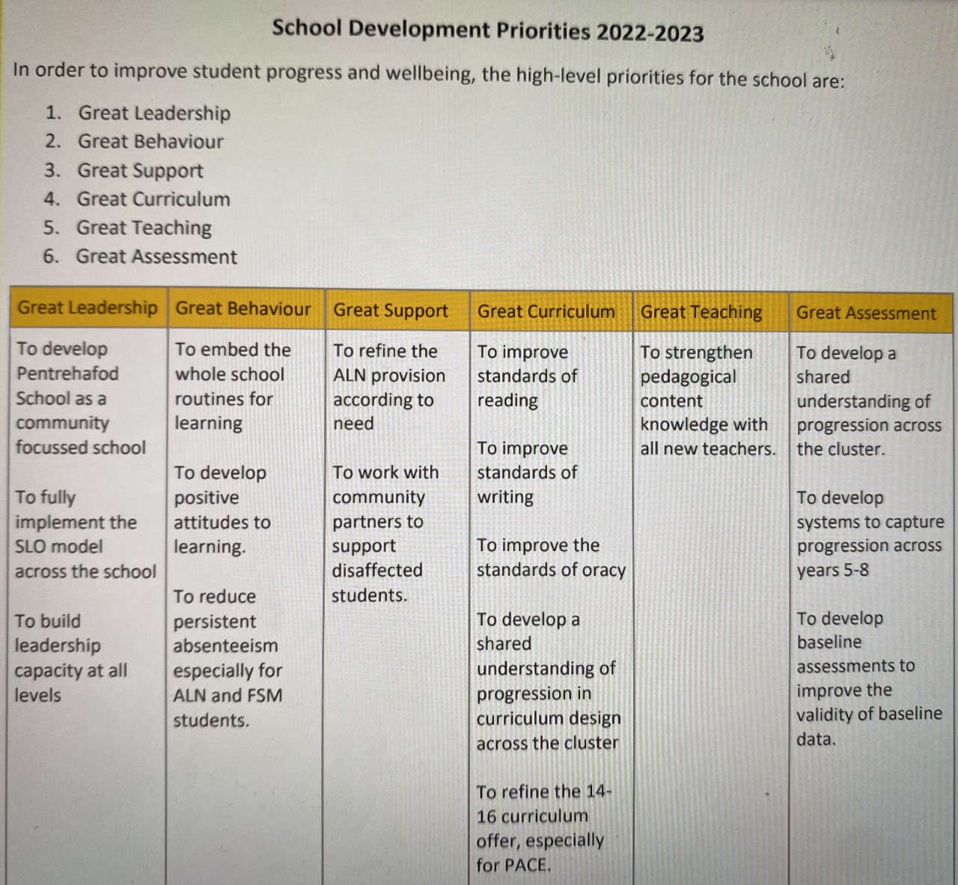

(School X, 2022)

Appendix B

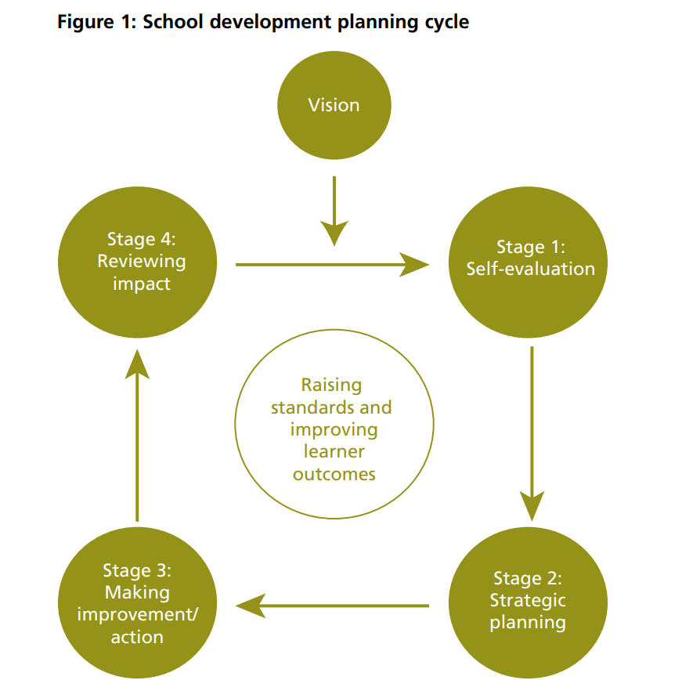

(Welsh Government , 2014, p. 7)

