Theresa Angier
ECIE4003
Additional Needs in Context

Portfolio

Student Number: 2417258

Element 1

Poster – Outlining good practice in terms of supporting learners with a specific learning need
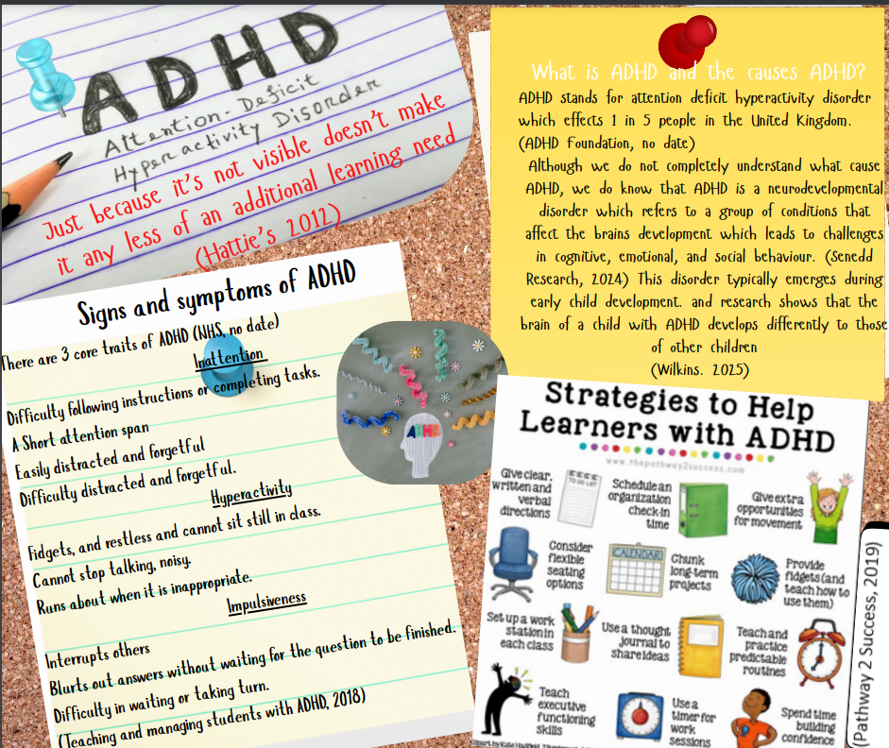

References for Poster

ADHD Foundation (no date) What is ADHD? Available at: https://www.adhdfoundation.org.uk/resources/what-is-adhd (Accessed: 14 September 2025).
NHS. (no date) ADHD in children and young people. Available at: https://www.nhs.uk/conditions/adhd/children-and-young-people (Accessed: 14 September 2025).
Parliament, W. (2024). Neurodevelopmental services in Wales.
Available at: https://research.senedd.wales/media/rdsnhrh4/24-13-neurodevelopmental-services-in-wales.pdf
(Accessed 14th September 2025).
Shire. (2018) Teaching and managing students with ADHD. [PDF]. Available at: Teaching-and-Managing-Students-with-ADHD.pdf (Accessed: 14 September 2025).
Welsh Government. (2018) Support for children and young people with ADHD in educational settings [PDF]. Available at: https://www.gov.wales/sites/default/files/publications/2023-12/ways-of-supporting-learners-with-attention-deficit-hyperactivity-disorder-adhd.pdf (Accessed: 14 September 2025).
The Pathway 2 Success. (20219).25 strategies for kids with ADHD. Available at: Pathway 2 Success. Available at: https://www.thepathway2success.com/25-strategies-for-kids-with-adhd/ (Accessed: 14 September 2025).

Element 2
Exploring the Wide and Complex Spectrum of Additional Needs
This essay will explore the wide and complex spectrum of additional needs. What is meant by the term Additional Learning needs and Special educational needs? The Additional Learning Needs (ALN) and Special Educational Needs (SEN) refer to conditions where children and young people require extra support to access learning and help them reach their full potential. (Welsh Government, 2009).
The SEN framework is more widely used across the United Kingdom, which covers a broad spectrum of needs that go beyond those of their peers. According to CCC. (2025) SEN can include emotional and social difficulties, behavioural challenges, speech and language impairments, visual and hearing impairments, multi-sensory impairments, physical disabilities, and conditions such as autism. In England children with SEN have what is called an Education, Health care plan, or EHCP.
In 2021 Wales moved away from the SEN framework creating a more inclusive system called ALN Additional Learning needs (Welsh Government, 2022). Unlike the SEN system the ALN framework focuses more on the individual, by introducing an individual development plan or IDP which is a legal document which describes a child or young person’s additional learning needs, outlining the support they require and the outcomes they would like to achieve (Snap Cymru, no date). Unlike the SEN system which only focuses on severe complex needs the ALN system extends the rights to statutory plans to all learners with ALN and does not limit the provision to those with more severe or complex needs. (Welsh Government, 2022). This framework includes the views of not only other health professionals but the views of the child and their parents.
There are two recognised models of disabilities, (Mencap,2023) Medical and Social are both used within the educational setting to help determine what support each child needs, however the ALN framework tends to steer more towards the social model (Welsh Government, 2021).
The Medical model of disability tends to have the view that the disability is a direct result of the person’s impairment or illness, condition (Sense, 2025) which implies the problem is located within the individual which suggests the person is the problem (Mencap,2023). This model focuses more on what the individual cannot do rather than what can be done to support (Disability Wales, no date).
Unlike the Medical Model the Social Model was created by disabled people giving first hand experiences, it sees an individual’s impairment, health condition as or neurodivergence as a characteristic of human differences to be valued on its own terms (Disability Wales, no date). The Social Models focus on more what can be done to support the person to lead a more independent life. The Additional Learning Needs Code for Wales (2021) refers to the social model of disability advising local authorities and other bodies to work together. (Welsh Government, 2021). The Social Model argues that it is not the individual that is the problem but that society that creates barriers either through attitudes or the environment. This model takes a positive approach to disability, by identifying and removing barriers to promote equality, it focuses on the “can do” rather than the “cannot” (Welsh Government, no date)
In the educational setting, the Social Model is used to support the learner and their parents to have more of a voice allowing educational staff and parents to work closely with outside agencies to take down the barriers preventing them from learning, taking a more inclusive creative approach enabling parents and educational staff to stop worrying about the learners additional needs and concentrate instead on the child’s learning experience (Richards and Armstrong, 2016). The Social model Approach identifies that difficulties in learning often arise not from a child’s impairment, but from the way teaching, resources and learning environments are structured, it recognises by removing these barriers the learner is able to participate fully in education (Welsh Government, 2021).
To put both models into context, a doorway to a classroom is too narrow for a student using a wheelchair. The medical model would view this as the wheelchair user as the problem or the barrier making the student feel unwelcome and isolated putting up a barrier whereby the learner will feel excluded from their peers and not able to reach their full potential in regards to their education. In contrast the social model would view this as the environment as the barrier to the learner and one that needs to be fixed, taking away the negative perception from the learner (Armstrong, 2016).
How would the social model look while promoting good practice within an educational setting? In Setting A, it states that all children should be treated equally regardless of their additional learning needs. There ALN Policy states that pupils develop in a supportive environment, and to identify pupil’s barriers to learning (Greenhill, no date.). This places the learner at the centre, ensuring that teaching approaches are inclusive and tailored to individual needs. An example of how this would look for a child with autism would be to create a structured, welcoming environment and avoid changes to their routine (National Autistic Society, 2025). Give instructions in a list form breaking these down into chunks; by adapting the chunking method into your everyday teaching it will make the child with ALN feel more inclusive and not singled out. Allow them to have rest breaks outside the classroom when they become over stimulated. Use visual aids to help support the learner such as a pictured timetable, providing structure, reducing anxiety and promoting independence. Strong relationships are essential with learners with additional learning needs as it gives them a sense of belonging and safety. This directly supports the theory of Maslow’s hierarchy of needs whereby; he states that basic and psychological needs must first be met before self- actualisation can occur (Bates,2023).
In conclusion the wide and complex spectrum of Additional learning needs covers a varied and complex area that encompasses a range of medical and social needs. Creating inclusive environments and good relationships can support pupils with ALN to thrive. Under the new ALN code in Wales, the individual is placed at the centre of the planning process ensuring the support is tailored to their specific needs. The level of support required will determine whether a pupil requires an IDP or if their needs can be met with appropriate universal provisions. The social model aligns closely with the principles of the new code, as it focuses on identifying and removing barriers. In contrast the medical model emphasises the diagnosis which can create a negative view.

Reference
Bates, B. (2023). Learning theories simplified. 3rd end. London: Sage
council, C. c., (2025). Early Years education for parents and carers of children with special educational needs and disabilities.[PDF]
Available at: https://www.gov.wales/sites/default/files/publications/2018-03/13-children-with-additional-learning-needs.pdf (Accessed on: 19th September 2025)
Downs, K., (2024). What Educators Need to Know about the Social Model of Disability.
Available at: https://researchschool.org.uk/bradford/news/social-model-of-disability
(Accessed 27 september 2025).
Greenhill, Y. (n.d.). Additional Learning Needs. [PDF].
Available at: https://ysgolgreenhill.s3.amazonaws.com/uploads/document/Additional-Learning-Needs-Policy.pdf?t=1705921619
(Accessed 28 September 2025).
Gov.Wales (2009). Children with Additional Learning Needs. [PDF]
Available at: https://www.gov.wales/sites/default/files/publications/2018-03/13-children-with-additional-learning-needs.pdf (Accessed: 21st September 2025).
Gov.Wales (2022). The additional learning needs transformation programme: frequently asked questions.[PDF] Available at: The additional learning needs transformation programme: frequently asked questions [HTML] | GOV.WALES (Accessed: 21st September 2025)
Gov.Wales (2022) Who will be entitled to an IDP? When is it necessary for a local authority to maintain an IDP?[PDF]. Available at: https://www.gov.wales/additional-learning-needs-transformation-programme-frequently-asked-questionshtml#:~:text=The%20ALN%20Act%20creates%20a,for%20specific%20groups%20of%20children. (Accessed: 21st September 2024)
Gov.Wales (2021). The Additional Learning Needs. [PDF]
Available at: https://www.gov.wales/sites/default/files/publications/2024-04/220622-the-additional-learning-needs-code-for-wales-2021%20%282%29.pdf
(Accessed: 26th september 2025).
Gov.Wales (2021). The Additional Learning Needs. [PDF]
Available at: https://www.gov.wales/sites/default/files/publications/2024-04/220622-the-additional-learning-needs-code-for-wales-2021%20%282%29.pdf
(Accessed: 10th October 2025).
mencap, (2023). The models of disability.
Available at: https://www.mencap.org.uk/easyread/models-disability
(Accessed 26th september 2025).
Richard, G. and Armstrong, F. (2016) Teaching and Learning in Diverse and Inclusive Classrooms. 2nd edn. London: Routledge (Accessed: 26th September 2025)
sense, (2025). The social model of disability.
Available at: https://www.sense.org.uk/about-us/the-social-model-of-disability/#:~:text=The%20social%20model%20of%20disability%20is%20an%20alternative%20to%20the,barriers%20they%20experience%20in%20society.
(Accessed: 26 september 2025).

Society, N. A., (2025). Teaching secondary school autistic students.
Available at: https://www.autism.org.uk/advice-and-guidance/professional-practice/top-tips-secondary#:~:text=Ask%20the%20student%20where%20they,difficulty%20for%20some%20autistic%20students.
(Accessed 28 September 2025).
wales, d., (n.d) . Social model of disability. [PDF]
Available at: https://www.disabilitywales.org/wp-content/uploads/2024/08/Social-Model-of-Disability.pdf
(Accessed: 26 september 2025).

Element 3
Explore and summarise the additional learning needs of a pupil using a person-centred planning approach.
(Based upon Section 1C IDP: Profile (About me)
and
2A IDP: Description of the child or young person’s additional learning needs (ALN))

Section 1C: Profile (About me)
What is important to the learner:
- My Family and friends
- I enjoy listen to Music and going to concerts, I enjoy watching films based on history and love anything to do with Harry potter.
- History, and travel
- Honestly is important to me, consistency, needs prior notice of change.
- Relationships with staff
- For people to understand when I am under pressure, I struggle to relay this to my peers, I’m not being rude I just don’t know how to tell people that I am struggling.

What is important for the learner:
- Time to regulate and manage their anxiety,
- The option to be able change their uniform within the school if there is the need too.
- Leave the door open when child A is in the class.
- The Opportunity to listen to music discreetly during the school day using ear pods.
- Laptop being wiped down at the start of the school day.
- Staff to understanding of Child A needs, and to be empathetic.
- Clear routine and structure

What is working and should be built on:
- Using the Y Bont provision and the friendship group within the provision
- Check in with key adults and timetabled sessions with advisory teacher.
- Having support to go to the toilet at lunch and break time
- Visual timetable, structure, and consistency
- Laptop being cleaned at the start of every lesson.
- Consistent and clear instructions
- History lessons and seating plan being able to set near the door on the outside edge of the table.
- Not being challenged to attend lessons
- Form time

What is not working and needs to change. Consistent sessions with the school counsellor, to improve this situation it would be easier if appointments could be scheduled at the end of the day allowing Child A more time to prepare.

Section 2A: Description of the child or young person’s additional learning needs (ALN)
Communication and Interaction: Child A has a diagnosis of ASD.

Sensory and/or Physical: Child A has OCD and has school-based anxiety, when they become anxious their senses are heightened, they are unable to tune out sounds and struggle to maintain concentration. Child A is averse to silence,
and some background noise is helpful. Child A OCD presents through the fear of germs, touch, sickness, and specific environments that they fear are unclean. Child A struggles to open doors in school, enter specific classrooms and prepare their own food.

Behaviour, Emotional and social development: Child A struggles to make and maintain friendships with peers of her own age. Child A finds it very easy to communicate with adults and pupils that are younger than her. Child A enjoys adult company and finds building relationships with adults more predictable and safer. Child A is not very trusting of her peers and worriers that they may not understand her and could possibly be unkind. Child A can over think situations and often worries what people are thinking about them. This can hold her back from progressing academically and socially. Child A become attached to named key adults, so it is important that child A learns to work with a number of named key adults to prepare them for life after school and their next steps, potentially university and the world of work.

Element 4
Discuss the potential support provided to your chosen pupil (utilising the key principles, approaches and policies that guide inclusive practice).
Based upon Section 2B IDP: Description and delivery of the child or young person’s additional learning provision (ALP)

Section 2B1: Description and delivery of the child or young person’s additional learning provision (ALP)
2B1.1) Intended outcome:  These outcomes should be SMART (Specific, Measurable, Achievable, Realistic,  Timebound). | Child A will develop independence and confidence in their learning. By taking increased responsibility for managing their time and study routines, setting deadlines. Attending and being seated on time for 50% of their lessons and seeking support when challenges arise.  Enabling them to achieve their full academic potential and transition successfully into university.
2B1.2) ALP to be provided:  This should include how often (daily, weekly); the type of support; who provides the support. The description of the Additional Learning Provision (ALP) should be very clear and precise, the above could then be split into smaller goals and targets. |  | 2B1.3) Should the ALP be provided in Welsh? | 2B1.4) Organisation/  Service to provide the ALP, (e.g. NHS, Inclusion Service, Specialist Teacher, etc.): | 2B1.5) Start date: | 2B1.6) End / Review date:
Two identified key adults to support child A to navigate their school day if child A feels dysregulated and feels overwhelmed. The key adults will support Child A by escorting them to their lessons. Collect Child A from their current lesson and escort them either to their next lesson or back to the provision as required. Provide reassurance and practical support to help child A to enter classrooms, as they struggle with door handles and initial entry due to OCD related anxieties. Offer organisational prompts to ensure Child A is prepared for their lessons, including having the necessary materials and being seated on time. |  | Yes / No | With the Educational Setting | September 2025 | November 2025
2B1.7) Rationale for the ALP listed above:  If there is a difference of opinion it should be recorded here e.g. a difference of opinion between the child, child’s parent or young  person and professionals. The section could explain how different opinions have been taken into consideration before a particular decision was reached. |  | Child A’s OCD creates significant barriers for them to access mainstream lessons independently. There fear of contamination prevents them from touching door handles or entering certain environments without assistance.  Child A’s anxiety affects their ability to organise themselves for lessons, requiring structured support to minimise stress and optimise their engagement in learning. The provision of a consistent key adult ensures Child A feels reassured, maintains a predicable routine to help develop their independence over time.

Section 2B1: Description and delivery of the child or young person’s additional learning provision (ALP)
2B1.1) Intended outcome:  These outcomes should be SMART (Specific, Measurable, Achievable, Realistic,  Timebound). | For child A to develop their independent living skills in preparation for life after school, enabling them to access university and live independently. By the next review date, the aim for Child A would be to: Prepare their own toast and tea during form time with minimal or no prompting, demonstrate the ability to plan and follow routines by attending lessons on time with little promoting or assistants and meet deadlines regarding study hand in dates.
2B1.2) ALP to be provided:  This should include how often (daily, weekly); the type of support; who provides the support. The description of the Additional Learning Provision (ALP) should be very clear and precise, the above could then be split into smaller goals and targets. |  | 2B1.3) Should the ALP be provided in Welsh? | 2B1.4) Organisation/  Service to provide the ALP, (e.g. NHS, Inclusion Service, Specialist Teacher, etc.): | 2B1.5) Start date: | 2B1.6) End / Review date:
Identified key adults to support Child A to access the school staff toilets during scheduled times of the day: by opening the doors turning on taps and providing assistance with the soap dispenser. Identified key adults will support child A by ensuring their hands are washed appropriately during these sessions. A key adult will clean child A’s laptop during form time, ensuring Child A observes the cleaning process to alleviate their OCD related anxieties. Identified key adults to support child A to prepare their own food during lunch time. |  | Yes / No | With the Educational Setting | September 2025 | November 2025
2B1.7) Rationale for the ALP listed above:  If there is a difference of opinion it should be recorded here e.g. a difference of opinion between the child, child’s parent or young  person and professionals. The section could explain how different opinions have been taken into consideration before a particular decision was reached. |  | Childs A OCD creates significant barriers to their ability to manage hand washing independently and use the school facilities. They are unable to access toilets without adult assistance. Child A ‘s OCD also extends to the use of their laptop, as they cannot focus on their schoolwork unless they have witnessed the device being cleaned. By providing structured support in these areas, Child A can gradually develop the skills and confidence needed to manage their OCD and foster greater independence, Child A’s OCD currently prevents them from preparing their own food and their restrictive diet further complicates this challenge. To ensure That Child A has adequate sustenance during their school day and to build their independence, staff support them in preparing their own food. This structured support helps child A develop confidence and essential life skills, preparing them for the demands of university and independent living.

Section 2B1: Description and delivery of the child or young person’s additional learning provision (ALP)
2B1.1) Intended outcome:  These outcomes should be SMART (Specific, Measurable, Achievable, Realistic,  Timebound). | Child A will develop the ability to understand their feelings and emotions, this will enable them to be able to identify and communicate their emotions, Child A will use self- regulation strategies at least once a day when and if they feel dysregulated. This will make them feel safe and stable within the school environment, enabling them to continue to make social and academic progress.
2B1.2) ALP to be provided:  This should include how often (daily, weekly); the type of support; who provides the support. The description of the Additional Learning Provision (ALP) should be very clear and precise, the above could then be split into smaller goals and targets. |  | 2B1.3) Should the ALP be provided in Welsh? | 2B1.4) Organisation/  Service to provide the ALP, (e.g. NHS, Inclusion Service, Specialist Teacher, etc.): | 2B1.5) Start date: | 2B1.6) End / Review date:
Identified key adults will provide consistent support for child A during the school day. A structured program of emotional and academic support. 1x sessions per 4 weeks with an external agency. Advisory teacher to support child A to develop a deeper understanding of their ASD and implement effective strategies for managing their feelings. |  | Yes / No | With the Educational Setting  Pembrokeshire county council | September 2025 | November 2025
2B1.7) Rationale for the ALP listed above:  If there is a difference of opinion it should be recorded here e.g. a difference of opinion between the child, child’s parent or young  person and professionals. The section could explain how different opinions have been taken into consideration before a particular decision was reached. |  | Child A’s ASD and OCD significantly impact their ability to manage and maintain their emotions, leading to difficulties in self- regulation and heightened anxiety throughout the school day. Regular check-ins, wellbeing sessions, and targeted interventions provide Child A with the support and strategies needed to recognise and manage their emotions effectively. Advisory teacher sessions are instrumental in helping child A understand their ASD and develop practical strategies for self- regulation. This holistic and consistent approach ensures that child A feels emotionally safe and stable, enabling them to make continued progress academically and socially.

