

Student name: Analisa Caunceran
Student ID:251290

Module name: Introduction to Health and Social Care
Module code: LCHS4003_LON
Lecturer name : Jolly Nwankwo

Content page

Element 1 …………………………………………………………….. page

This picture shows a central graphic of a brain with symbols, representing stress and anxiety. It highlights key concepts related to mental health awareness and care.
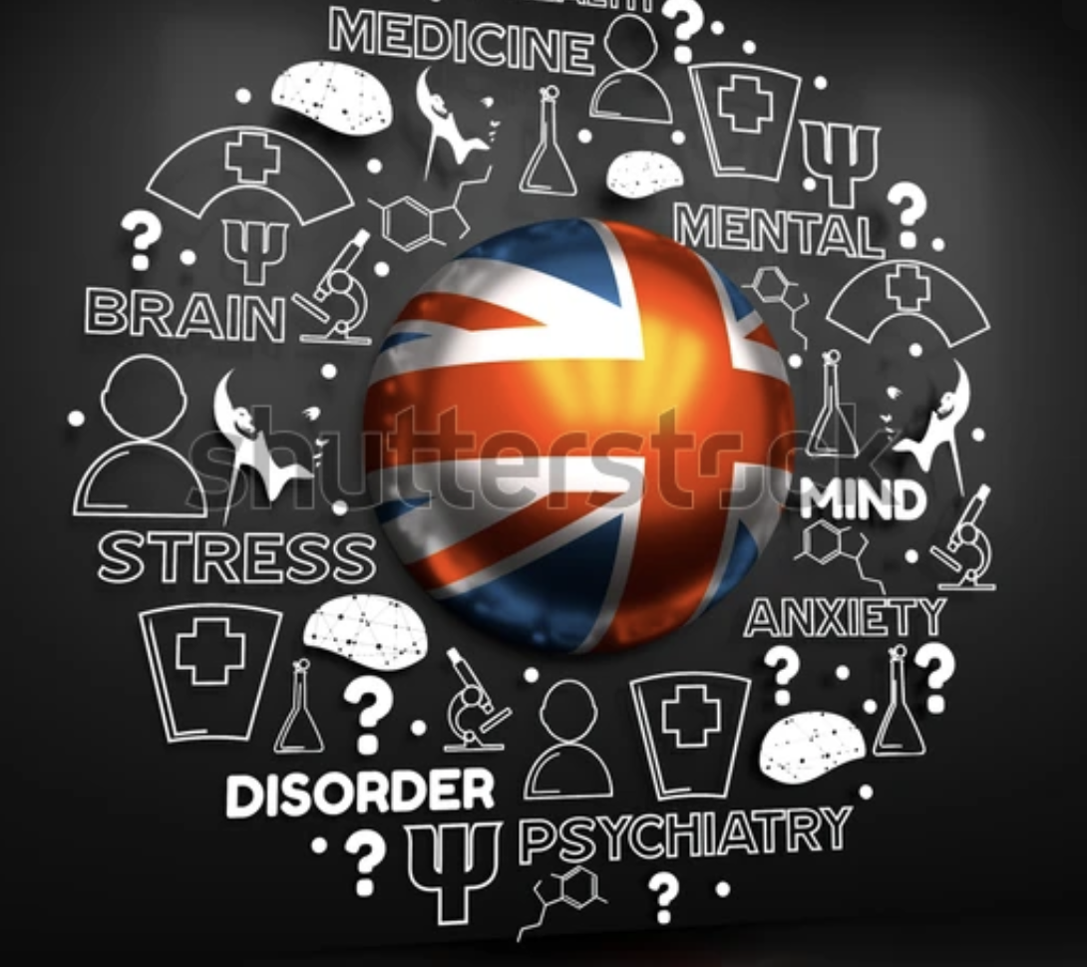
The history of mental health services in the United Kingdom has undergone significant transformation, shifting from institutional care to more community-based support. Before the 19th century, people with mental health conditions were often misunderstood and poorly treated, frequently being confined in prisons or workhouses. During the 1800s, large public asylums were established to provide specialised care; however, these institutions often became overcrowded and isolated patients from wider society (Rogers and Pilgrim, 2014).A major turning point came with the creation of the National Health Service (NHS) in 1948, which aimed to provide healthcare free at the point of use, including mental health services. Despite this progress, care remained largely hospital-based for many years. The introduction of the Mental Health Act 1959marked a significant shift, encouraging deinstitutionalisation and promoting treatment within general hospitals and community settings (Rogers and Pilgrim, 2014). From the 1960s onwards, the policy of “Care in the Community” further transformed mental health services by focusing on supporting individuals in their own environments rather than in large institutions. This led to the closure of many asylums and the development of community mental health teams and outpatient care. In more recent years, there has been a growing emphasis on early intervention, improving access to services, and reducing stigma. However, challenges such as funding pressures and long waiting times continue to affect the system (Rogers and Pilgrim, 2014). Overall, mental health services in the UK have evolved towards a more patient-centred and inclusive approach, reflecting both advances in medical knowledge and changing societal attitudes

Mental Health Services
Analisa Caunceran, Introduction to Social Health Care, 2512900

EXPLANATION
Mental health services are the systems and supports designed to help individuals maintain, improve, or recover their mental well-being. These services include a variety of interventions such as counselling, psychotherapy, psychiatric assessment, medication, and community-based support programs. They aim not only to treat mental illness but also to promote overall well-being, helping individuals function effectively in daily life and maintain relationships (Thornicroft, Deb and Henderson, 2016). Mental health services typically operate across a continuum of care, ranging from early intervention and prevention to long-term treatment and rehabilitation. Effective services are often person-centred and accessible, ensuring that individuals receive support tailored to their needs. Research highlights the importance of community-based care, which allows people to receive help within their social environment, reducing stigma and improving recovery outcomes (Kohrt et al., 2018; van Genk et al., 2023). Furthermore, mental health services address more than just clinical symptoms. They also focus on social, emotional, and practical aspects of life, recognising that mental health involves the ability to cope with stress, work productively, and contribute to society. This broader approach ensures a more holistic form of care that supports long-term well-being (Fuser-Poli et al., 2020). Overall, mental health services are essential in supporting individuals through challenges and enabling recovery and resilience.

Mental health services face several ongoing challenges, two of the most significant being workforce shortages and unequal access to care. One major issue is the shortage of trained mental health professionals. Many countries struggle to recruit and retain psychiatrists, psychologists, and support staff, leading to long waiting times and reduced quality of care. Burnout is also common due to high caseloads and emotional strain, which further worsens staffing gaps. As a result, patients may experience delays in receiving treatment, which can allow their conditions to worsen over time (Health Foundation, 2023). This shortage not only affects immediate care but also limits the ability of services to provide early intervention, which is crucial for better outcomes. Another key challenge is inequality in access to mental health services. Factors such as socioeconomic status, geographic location, and cultural stigma can prevent individuals from seeking or receiving help. For example, people living in rural or low-income areas often have fewer services available, while minority groups may face discrimination or lack culturally appropriate care. Digital services have improved access in some cases, but they can also exclude those without reliable internet or digital literacy (Patel et al., 2018). These disparities mean that many individuals do not receive the support they need, increasing the overall burden on healthcare systems.
Overall, addressing workforce shortages and improving equitable access are essential steps toward strengthening mental health services and ensuring better outcomes for all individuals.

The image shows that mental health care is not just one service.
The current function of mental health services in the UK is to provide accessible, person-centred care that supports prevention, early intervention, treatment, and recovery. These services are mainly delivered through the National Health Service (NHS), which operates a stepped-care approach (NHS England, 2023). This means individuals receive support based on the severity of their condition, starting from primary care such as General Practitioners (GPs) and progressing to specialised services like community mental health teams and inpatient care. A central function of UK mental health services is early intervention. Programmes such as Improving Access to Psychological Therapies (IAPT) are designed to provide timely support for common mental health conditions, including anxiety and depression. This approach helps individuals receive treatment at an early stage, improving recovery outcomes (NHS England, 2023). Another key function is the shift towards community-based care. Rather than relying heavily on hospital treatment, services aim to support individuals within their own communities, promoting independence and social inclusion. Mental health services also focus on recovery-oriented care, encouraging individuals to actively participate in their treatment and long-term wellbeing (NHS England, 2023).
Additionally, there is an increasing emphasis on integrating mental and physical healthcare, recognising that both are closely linked (NHS England, 2023). Overall, mental health services in the UK aim to provide holistic care that supports individuals throughout their mental health journey.

THE PHARMACY SERVICES
The development of pharmacy services in the United Kingdom reflects a long history shaped by professionalisation, legislation, and the evolution of the wider healthcare system. Early origins can be traced back to medieval guilds regulating the sale of medicines, but modern pharmacy began to take shape in the nineteenth century. The establishment of the Pharmaceutical Society of Great Britain in 1841 marked a turning point, introducing formal training, examinations, and professional standards (Anderson, 2007). This was reinforced by the Pharmacy Act 1852, which created a register of qualified pharmacists and restricted the professional title, laying the foundation for regulation and public trust. During this period, pharmacists were often seen as the “poor man’s doctor,” providing accessible advice and remedies, especially for those unable to afford medical care.
The creation of the National Health Service (NHS) in 1948 significantly transformed pharmacy services. It expanded access to medicines regardless of income and integrated pharmacists into a broader, publicly funded healthcare system. Over time, the role of pharmacists shifted from compounding medicines to dispensing manufactured drugs and, more recently, to providing patient-centred care. This evolution reflects wider societal changes, including advances in pharmaceutical science and increasing demand for primary care services.
Today, pharmacy services function as a key component of primary care, alongside general practice and dentistry. Pharmacists now deliver a range of clinical services, including medication reviews, management of long-term conditions, and public health interventions such as vaccination and smoking cessation. Evidence suggests that over 80% of pharmacists are involved in direct clinical care, demonstrating a significant expansion beyond traditional dispensing roles. However, this expanded role is not without challenges. Financial pressures, workforce shortages, and pharmacy closures have raised concerns about sustainability and equitable access to services. Critics argue that while expectations of pharmacists have increased, funding and structural support have not kept pace, potentially limiting the effectiveness of these services.
Despite these challenges, pharmacy services play a crucial role in enhancing the quality of life for service users. Their accessibility—often without the need for appointments—allows for early intervention, improved medication adherence, and better management of chronic conditions. Pharmacists also contribute to reducing pressure on other parts of the healthcare system, particularly general practitioners, by managing minor illnesses and providing preventative care. This not only improves patient outcomes but also supports a more efficient healthcare system overall.

In summary, the history and evolution of pharmacy services in the UK highlight a clear shift from a primarily trade-oriented role to one centred on clinical practice. Although modern pharmacy continues to encounter structural and financial pressures, its impact on patient outcomes and overall quality of life remains substantial. Enhancing investment and policy support for pharmacy services is crucial to ensure they can fully contribute to modern healthcare systems and meet increasing patient needs effectively, sustainably, and innovatively.

References

Fuser - Poli, P., et al. (2020) ‘What is good mental health? A scoping review’, European Neuropsychopharmacology, 31, pp. 33–46.
Health Foundation (2023). Workforce pressures in mental health services.

Kohrt, B.A., et al. (2018) ‘The role of communities in mental health care in low- and middle-income countries: A meta-review’, International Journal of Environmental Research and Public Health, 15(6), p. 1279
National Health Service (NHS) (2023) Mental health services. Available at: https://www.nhs.uk
Patel, V., Saxena, S., Lund, C., et al. (2018). The Lancet Commission on global mental health and sustainable development. The Lance
Rogers, A. and Pilgrim, D. (2014) A Sociology of Mental Health and Illness. 5th edn. Maidenhead: Open University Press.
Thornicroft, G., Deb, T. and Henderson, C. (2016) ‘Community mental health care worldwide: Status and further developments’, World Psychiatry, 15(3), pp. 276–286.
World Health Organization. (2022). World mental health report: Transforming mental health for all. WHO Press.

