Student 1704356
Penarth Forest Nursery

A transition guide for key workers.

Topics covered

Introduction
Section 1: Aims and objectives
Section 2: Role of the adult
Section 3: Needs of the child
Section 4: Transition activities
Section 5: Partnerships and interventions
Section 6: Successful transition from Forest nursery to Reception
Section 7: Proposed outcomes
Section 8: Transition forms
Section 9: References


This handbook is to be used by key workers to assist children that are transitioning from Penarth Forest Nursery into reception year at School. Here at the nursery we pride ourselves on the happiness of the children and from experience we know that a smooth transition is beneficial for the child to ensure a positive start in their school life.
It requires careful thought and planning and should be done with a clear understanding of a young child's social and emotional needs. The key worker plays a big part in this process and this handbook can be used as a useful guide.

************

Starting at a new setting can be a nervous and unsettling experience for a child. Even though as adults we may try to convince them how exciting and happy it is the child may be very nervous and anxious. This will also be different for each child and care should be taken accordingly to suit the needs of each individual child.
*Strong relationships between a child and their key worker promotes a child’s wellbeing.*
Leaving a key worker whom the child may have had for many months or years can be a daunting time for the child, it is important to allow the child to ask many questions, and to feel comfortable in doing so even if it’s something that is deemed small or irrelevant to the adult. Answering any questions they may have will put the child at ease. Most questions will be of a practical nature, for example “where will I leave my coat, or where will I be collected from”, these are what will be at the forefront of the child’s mind, they will be leaving the familiarity of their current setting and entering a building which they may have never been to before.
*A key part of this smooth transition will be communication. It’s important to develop good communication links between the local settings.*
“Many settings and schools are now working closely together to ensure a gentle and phased transition into a reception class. Settings and schools are increasingly beginning to tailor-make a transition to meet each child’s needs, rather than expecting every child to fit in to one size of provision”. Dowling, M (2014).
If possible, when many children are transferring to the same setting, into school for example, it may be easier for the staff to visit the children in their current setting. This will also mean the children will be more at ease. The class teacher can get to know each child in an environment they feel comfortable in, and this will also mean the children will see a familiar face when they visit the school for the first time. The teacher can read a story for the children or organize some fun arts and crafts session to do with the children. They may even take them back to the school with them, so they can continue working on them when they visit the school, this gives the child something positive to look forward to.

It is important to remember that –
If a child has severe learning difficulties, they are more likely to struggle with transitions (Carlson et al. 2009).
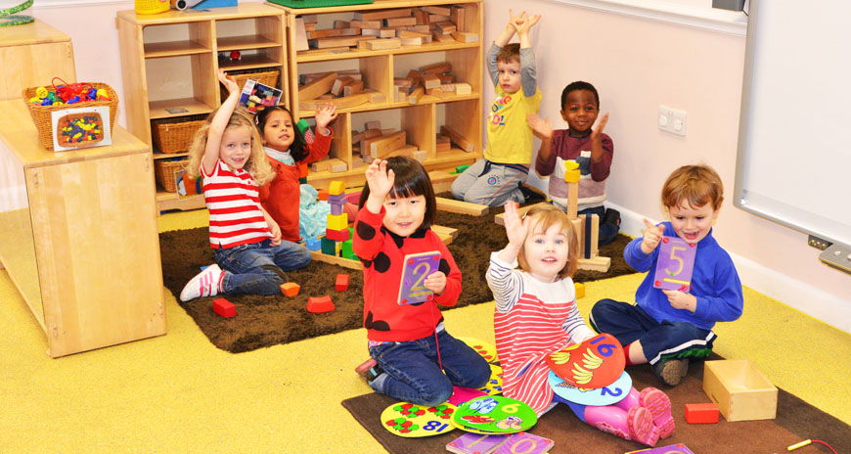

Children with low confidence or self-esteem can be more vulnerable at times of transition due to a lack of skills relating to emotional resilience (Working with men; Evangelou et al. 2008).
Some differences may be apparent depending on when the child has his or her Birthday. The youngest children in the school year, sometimes referred to as ‘summer babies’, can be at a slight disadvantage during transition in the early years. This is due to them obviously being younger than their peers and there may be developmentally inappropriate expectations on that child, (Sanders et al. 2005; Crawford et al. 2007), although the extent of these differences in attainment levels seem to decrease in transitions beyond the age of compulsory schooling. (Crawford et al. 2007; Sharp et al. 2009).
Summer-born pupils are also significantly more likely to be identified as having a special educational need than their older classmates. At the end of Key Stage 1, August-born pupils are nearly 90% more likely to be identified with SEN than September-born pupils; at Key Stage 2, this reduces to 60% more likely, and further to 25% more likely by Key Stage 4.
The types of special educational need most disproportionate in summer-born pupils are moderate learning difficulties, specific learning difficulties, speech, language and communications needs, and other (unclassified) needs. (DfE 2010).
There seems to be a relationship between socio-economic deprivation and poor experiences of transition. This could be linked to poor opportunities to socialise and regulate emotions (Miller et al. 2003).

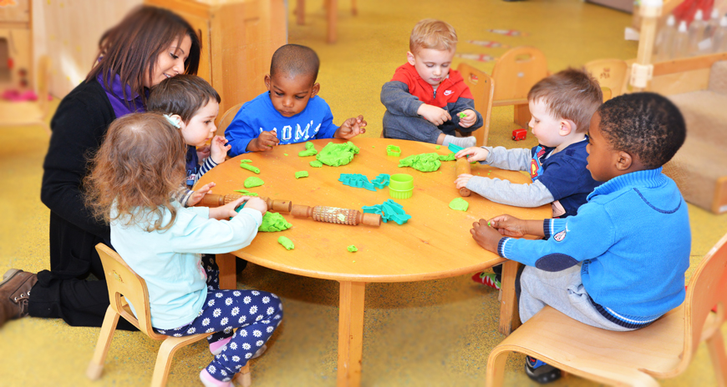

Communicating with parents or guardians at this time is also important as children may be asking questions at home that the staff should know about. ‘The effectiveness and quality of programmes depends largely on communication and collaboration between all people involved in the process’ (Margetts, K 2004). They may have questions that the staff may be able to explain further as they’ll be familiar with the school layout and daily timetable. This is especially important in the case of any medical or dietary issues.
Children may feel sad about leaving nursery, this is a big step for them and for their parents which the child may pick up on, moments of sadness of their child growing up may be confusing for the child, it can also be more difficult if the child has been at the nursery for a long time and may also be leaving some friends behind.
******************
A key aim of any transition programme should be that it supports the child and family to feel suitable in the new environment (Brostrom, S 2004). This in turn will help the child to feel secure, confident and in a position to tackle the challenges ahead. It needs to be considered as a process and not a one-off event.
A book of memories can make a big difference, with photos of the child and some of his friends, and some of the work that they enjoyed doing. This is also something visual that the chid can look back on in years to come.
Visiting the new setting is vital for the children. Normally they will be invited to their new setting with their parents, carer or key worker. This is important for children to meet the staff and other children that will be starting at the same time. This first experience children have of school has a great impact on their progress and future schooling (Margetts, K. 2007).
When a child starts at school a record will be made all about the child which will be shared with the parents, this should be written by the child’s key worker.
This record should then be updated every six months and it should record all aspects of the child’s learning, their strengths and weaknesses and any other relevant information.
A laminated set of photographs of the school may be used by the Forest Nursery showing key areas of the school so that the children can familiarise themselves with the new building and areas that may be of interest to the child, these can be used by the parents and nursery staff.

*******************

Around Easter time, staff should be asking parents what school their child will be going to, and a letter should be given out regarding transition and how the parents or guardian can help with the smooth transition by reading stories or talking about the daily routine.
The feeder schools will know by May what children will be going starting there and they along with their key workers will be invited to the school for a couple of hours. This is an opportunity for the child to visit the new school with somebody that they know and trust. They can then continue to talk about their experience over the next few weeks and months and perhaps set up an area of the nursery that is like school, with desks and books about school. There will also be a summary written up detailing all the child’s information, likes and dislikes which will normally be passed on to the child’s new teacher. Also for any children with additional learning needs a meeting will be set up to discuss the child’s learning.
The key worker can practice standing in a line with the children, raising their hands and replying when their name is called out, these are all things they will need to do at school.

********************
Occasionally meetings will be set up for children who have special educational needs. It is important that the school knows of any help or guidance the child may need, or often there may be communication between a health visitor, speech therapist, Doctor or social worker. These will be set up months in advance to the child starting school, and they key worker may be asked to liaise with the relevant professional.

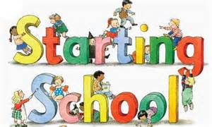

Transition Form

Name of child: ……………………………………………………………
Date of birth: ……………………………………………………………..
Current setting: …………………………………………………………...
Entry date to current setting: ……………………………………………..
Setting address …………………………………………………………...
Setting phone number: ……………………………………………………
Setting e-mail address: ……………………………………………………
Key person: ……………………………………………………………….
New school/setting: ……………………………………………………….
Siblings in new School …………………………………………………....
Parents or Guardian name …………………………………………………
Parent or Guardian phone number ………………………………………...
Parent or guardian email address …………………………………………..


References
Brostrum , S (2004) Communication and continuity in the transition from kindergarten to school. In Fabian, H and Dunlop, W (Eds) Transition in the Early Years . London: Routledge Falmer
Carlson, E., Daley, T., Bitterman, A., Heinzen, H., Keller, B., Markowitz, J., & Riley, J. (2009). Early school transitions and the social behavior of children with disabilities: Selected findings from the Pre-Elementary Education Longitudinal Study. Rockville, MD: Westat.
Crawford, C., Dearden, L., and Meghir, C. (2007). When you are born matters: The impact of date of birth on child cognitive outcomes in England. Centre for the Economics of Education.
DfE (2010). Month of Birth and Education. Schools Analysis and Research Division. Research Report DfE RR017. www.gov.uk/government/uploads/system/uploads/attachment_data/file/182664/DFERR017.pdf
Dowling, M. (2014) Young Children’s Personal, Social and Emotional development (4th Edition). London: Sage Publications Limited.
Evangelou, M., Brooks, G., & Smith, S. (2007). The Birth to School Study: Evidence on the effectiveness of PEEP, an early intervention for children at risk of educational underachievement. Oxford Review of Education, 33(5), 581-609.
Margetts, K (2004) Planning Transition Programmes. In Fabian H, and Dunlop, W (Eds) Transitions in the Early Years : London: Routledge Falmer
Margetts, K (2007) Understanding and supporting children: shaping transition practices. In Dunlop, A and Fabian, H (Ed) Informing transitions in the Early Years. Berkshire: Open University Press pp107-119.
Sanders, D; White, G; Burge., Sharp, C; Eames, A; McEune, R. and Grayson, H. (2005). A study of the transition from the foundation stage to key stage 1. (DfES Research Report SSU/2005/FR/013). London.

