University of Wales Trinity Saint David
Wales Institute of Science and Art


Research proposal

Biodiversity and ecosystem services ACNA4002

Ysabelle Tuddenham
2205445
December 2023
Contents
1 Introduction 1
1.1 Aims 1
1.2 Objectives 1
2 Method 2
2.1 Equipment 2
2.2 Experimental Method 2
3 Results and Discussion 3
4 Conclusion 4
5 References 5

Table 2-1 This table contains the species found and the amount documented within the two sites 2
Figure 3-1 Brief Description of figure. 3

Introduction
Examining owl pellets from two different sites to see species diversity in Parc-Le-Breos which were gathered from owl boxes active between 2007 and 2011 and comparing them to owl pellets sourced in Newport wetlands which were gathered in 2021 (the age of the oldest known pellets) due to the fact they are collected at different times and in different techniques out of our control but stored the same way to preserve them, these provide valuable insights into species diversity and ecological dynamics. The pellets at Parc Le-Breos were degraded with age and the way they were stored before coming into the university of Wales Trinity Saint David’s facility.

Aims
This report aims to show the population of small mammals in two different sites and show how human interference can disturb the ecosystems and also show the population difference between a wetland and a park, doing this by using skulls found in the pellets and identifying them using teeth size, colour patterns, teeth holes, and size of the skulls/ jaw bones.

Objectives
The objective of this is to show population differences between different ecosystems. We would consider things such as species abundance and look for any significant differences in prey species between the two different sites.

Method

Equipment
The equipment I used for dissecting the owl pellets were; tweezers which are used for the handling of tiny teeth pulled out from the skulls found in the owl pellets, a scale which is used for weighing the samples as to maintain a consistent start weight, a microscope with a light as this is essential for examining small details of the bones making us able to do a more accurate identification, a scoop as this is essential for collecting the sample from the tray as these are degraded and more like chips, three trays which are used to organise and separate fur, bones and teeth, lab coat which is standard safety practise in the laboratory and an identification guide as a reference and as an aid to identify different species based on their skeletal remains, all of these pieces of equipment serves a different purpose and contributes to the analysis of prey species present in the local owl diet.

Experimental Method
I weighed 5g of owl pellet per sample as this serves as a standardised unit and ensures consistency, collected all of the jawbones and skulls from the sample as this is crucial for species identification as they provide crucial information to help identify the species, and used the identification guide to determine what species they originated from I did this with various methods such as pulling teeth out and measuring the samples to identify species. The decision to focus on quantitative measurement provides a numerical basis for understanding abundance in two different sites. We did this using two methods tooth extraction and measurement for species identification. As teeth can be informative they have unique characteristics. The measurement of samples as different species have characteristic bone dimensions.

Table 2-1 This table contains the species found and the amount documented within the two sites
 | Bank vole | Field vole | Pygmy shrew | Common shrew | Water shrew | Wood mouse | House mouse | Harvest mouse | Dormouse | Rat | Bird | other
Parc-Le-Breos | 0 | 150 | 9 | 9 | 0 | 1 | 5 | 0 | 0 | 0 | 0 | 0
Newport wetlands | 8 | 94 | 5 | 5 | 1 | 16 | 0 | 0 | 0 | 3 | 0 | 1 water vole
On the Parc-Le-Breos site, it is clear that it is dominated by field voles as it was found that 150 skulls and jawbones were found within the samples. Four different analysts tested samples from Parc Le-Breos making a total of 20 of the sample pellets which were dissected. This may be because Parc Le-Breos is a deer park making the grassy field with damp grass a perfect habitat for the field voles as there is plenty of food sources such as grasses, roots, tree bark and small insects and this shows in the data above. However, rodents such as the brown rat wouldn’t survive here as it isn’t urbanised rats survive better in cities as there is a larger food source generated by humans this is also shown in the data above as it was shown that 0 brown rats were shown in the owl’s diet this could also be due to the fact that the owls might not be able to catch them

On the Newport Wetlands site is not only a haven for bird species but also supports small mammals, particularly it is clear that it also has a large field vole population with a total of 94 being identified but also has more range in species difference such as wood mice with 16 being counted within the owl pellets that were dissected. Within the wetlands there are a variety of microhabitats and ecological niches as its brackish water and fields creating a variety of habitats and micro ecosystems, the presence of all of these small mammals suggests that its not as affected by human interaction.

Data comparison

Figure 2- this shows volume of small mammals in two different sites
This graph shows that despite the hypothesis of having more water shrews and bank voles present in the Newport wetlands as there is saltmarshes, saline lagoons and lakes meaning it is the perfect environment for these animals to thrive, we found that there was no evidence of water shrews in the owl pellets. However, we still found a significant amount of field voles in both the Parc Le-Breos site and the Newport Wetlands site this does not match the hypothesis either as we though we would see a large decline in field voles and an increase in bank voles in the Newport Wetlands site but we didn’t as there was hardly any evidence that there were many bank voles, however, a large abundance of field voles still this may be because they thrive in tall grasses meaning that they are easier for the predators, in this case, for owls to feed on. This may be because owls have evolved to have stealthy flight and fast reflexes to creep up on their prey.
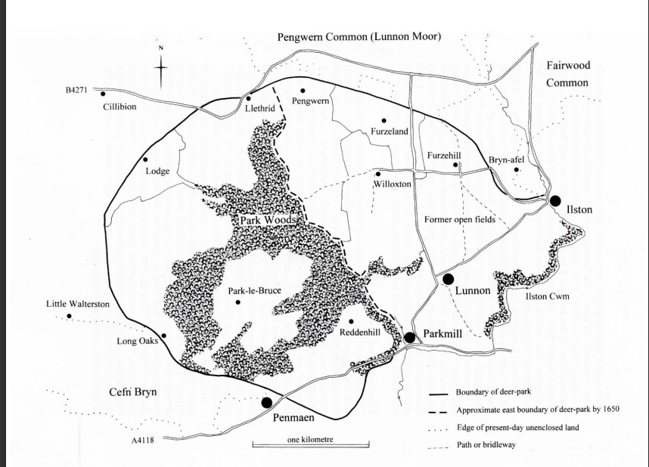
(Leighton, D 1999)
Some of the known species of Parc Le-Breos are wood mice, house mice, common shrew, pygmy shrew and field voles, each of theses are adapted to the conditions that Parc Le-Breos provides, for example wood mice will be found in the woodlands, whilst the open fields provide foraging grounds for field voles. An conservation technique for this site might be inoculating the soils and substrates to grow healthy fungi and making it have a wealth of species for small mammals to feed on (ecological restoration, 2012) . This has many habitats such as woodlands, open fields and a lodge these provide habitats for many different species such as deer, which find suitable grazing areas in open fields, avian mammals, which they use as nesting sites in the branches and against tree trunks. and small mammals. Some of the predators of small mammals are foxes, owls, avian mammals and humans. However, this is maintained by predator and prey relationships, such as field voles and mice face predators such as foxes and owls this plays a role in regulating the population of small mammals preventing over population. Human presence can also influence the ecosystem through habitat alteration, pollution and the introduction of non-native species which may become invasive and harmful towards our native species. The owner of the Parc Le-Breos house are expected to keep it desirable whilst also being expected to be custodians of the land and protecting wildlife (Constantine, mary ann, 2022)
Newport Wetlands.

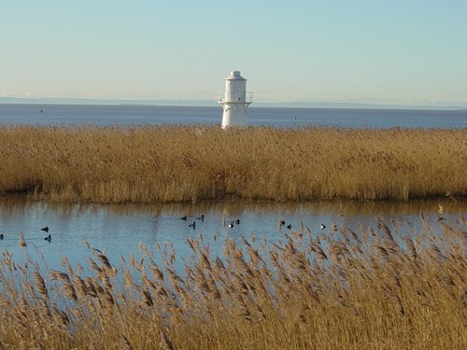
(natural resources Wales, N.D)
The habitats at the Newport Wetlands include low-lying habitats, wet grasslands, reedbeds, saltmarsh these serve as a ecosystem for mammals, insects and vegetation. (Robert Kerry Turner, Fisher and Stavros Georgiou, 2011) On a noticeable concern rats cause implications on ground nesting birds as they are scavengers and opportunistic feeding habits which means that they will eat anything they find for example fruit, seeds, human food waste, insects, bird eggs or even small mammals, making them a threat to avian mammals meaning they will attack the ground nesting birds and eat their eggs, or young chicks this is an issue if it attacks rare birds which are found on the Newport wetlands (the wildlife trusts, 2019) this poses a threat to there breeding successes. Three rats were found in the Newport Wetland owl pellet data which suggests that it is successful in any area it is put in (a shot of wildlife, 2021). Water voles will also be found here but not as many as they are on the red list for both Great Britain and England (The Wildlife Trusts, 2019) meaning that they will not be found as much in the owl pellet research as there are fewer of them in the Newport Wetlands and with predators without human interference they could go extinct, or at least die off in England, the lower abundance of water voles suggests that a conservation plan should be put in place to protect them. This could be done by doing bankside vegetation management to create shelter for them for example trees and undercutting roots(Waterways & wetlands, 2001) the optimal time for carrying out surveys and mitigation is dependent on weather (Working with wildlife, 2005) however, no work is cleared when working with pine martins, red squirrels, and water voles. Continuous research and monitoring are essential for creating an effective conservation strategy.

Conclusion
The examination of the two sites by owl pellets has provided valuable insights into species diversity and ecological dynamics, despite these challenges the practice of consistent storage methods has allowed for these pellets to have comparisons. In the study of owl pellets in Parc Le-Breos, they were in use between 2007-2011. Revealed species diversity is shown In the table above. This ensures thinking about storage conditions and other factors such as ecological research. The owl pellets from the Newport Wetlands(oldest dating back to 2021) represent a recent view of the species in the wetlands compared to Parc Le-Breos which had older pellets, making the comparison of small mammal population inconsistent.
Furthermore, this highlights the impact of human interference this is shown by the degraded pellets from Parc Le-Breos or the Newport Wetlands where the wetlands visitor centre was made, this disturb the wildlife. This comparative analysis allows insights into different ecosystems and can help make informed decisions on conservation strategies.

References
A Shot Of Wildlife (2021). Things you need to know about BROWN RATS! YouTube. Available at: https://www.youtube.com/watch?v=gqb0yGZ3McE [Accessed 13 Nov. 2022].
Brooks, A. and Agate, E. (2001). Waterways and Wetlands. BTCV.
Clewell, A.F. and Aronson, J. (2012). Ecological Restoration : Principles, Values, and Structure of an Emerging Profession. Covelo: Island Press.
Constantine, mary ann (2022). Shaping Landscape. Planet, the Welsh internationalist, 28 Feb., pp.63–69.
Leighton, D. (1999). A Fresh Look at Parc le Breos. Gower, [online] 50, pp.71–80. Available at: https://coflein.gov.uk/media/76/694/dd2012_005.pdf [Accessed 9 Dec. 2023].
naturalresources.wales. (n.d.). Natural Resources Wales / Newport Wetlands National Nature Reserve. [online] Available at: https://naturalresources.wales/days-out/places-to-visit/south-east-wales/newport-wetlands-national-nature-reserve/?lang=en.
naturalresources.wales. (n.d.). Natural Resources Wales / Newport Wetlands National Nature Reserve. [online] Available at: https://naturalresources.wales/days-out/places-to-visit/south-east-wales/newport-wetlands-national-nature-reserve/?lang=en.
Newton, J., Thackray, C. and Nicholson, B. (2005). Working with Wildlife Site Guide. CIRIA.
Robert Kerry Turner, Fisher, B. and Stavros Georgiou (2011). Valuing ecosystem services : the case of multi-functional wetlands. London: Earthscan.
The Wildlife Trusts (2019). Brown rat | The Wildlife Trusts. [online] Wildlifetrusts.org. Available at: https://www.wildlifetrusts.org/wildlife-explorer/mammals/brown-rat.

