

Web and Mobile Technologies JAVASCRIPT JQUERY-ENABLED WEBSITE

Paul Newman 1805494
Module ACCA5031
Gaynor Thomas

Assignment 1

1 Introdution 3
2 Development 4
2.1 Page one/index 5
2.2 Page two/quiz One 6
2.3 Page three/quiz Two 7
2.4 Page four/quiz Three 8
2.5 Page five/under con 9
3 Conclusion 9

Figure 1. Index page title 5
Figure 2 Menu in Index page 5
Figure 3 Quiz one menu 6
Figure 4 Quiz options 6
Figure 5 Quiz one menu and answer button 6
Figure 6 Quiz Two 7
Figure 7 Quiz Two incorrect display 7
Figure 8 Quiz Two Correct display 7
Figure 9 Quiz Three menu 8
Figure 10 Incorrect display 8
Figure 11 Quiz Three Correct display 8
Figure 12 Quiz Three Error message 8
Figure 13 Page 5 unfinished page 9

Introdution
This assignment is to develop a website with Javascript/JQuery features that allow some interaction with a user. The subject and content of the site is left to the student.
- A hobby.
- An interest.
- A fansite for a TV show or Game.
- Or local sports club.
Once decided, the subject should be approved by the lecturer before commencing the assignment, This report will be a quiz on different Martial arts.

Development
In this assignment the F patten was taken into account and used for page one, two and three and the Z patten was used for the forth page ( as this was intended for users’ in the west), however if the web page was to be used primarily in the east (Asia) then the text would have to be in the opposite direction (this is something the programmer has to take into account before starting coding).
In this assignment the idea for an evolving website that would change as the quiz’s got better on each page.
- Page one
The first page is a very basic no frills menu page only a hint of colour.
- Page two Quiz one
The introduction of pitchers and radio buttons to help the user to understand what they are looking at again not much colour on the text but some on the background.
- Page three Quiz two
This page utilises the same concepts same as the previous Quiz, but with a few different concepts on positioning.
- Page four Quiz three
In the Quiz the choices and animated gifs, with the added colour and better answer button for a better understanding for the user to interface with.
- Page five
This is a page that is under development.

Page one/index
This is a basic layout that could have been improved on with use of banners/headers and tables to divide the navigation options from the content. In the Index page or start page, it can be seen as a very basic menu not much to keep a person interest the page is very bland and boring there is not much colour.

Figure 1. Index page title

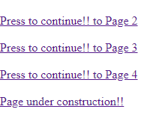
Figure 2 Menu in Index page

Page two/quiz One
In quiz two there is java script to utilise the radio buttons to give a different output based on the user’s selection. In addition, CSS has been implemented to change look and feel to the background. This page could have been improved with a header banner and navigation pane to the left-hand side.


Figure 3 Quiz one menu
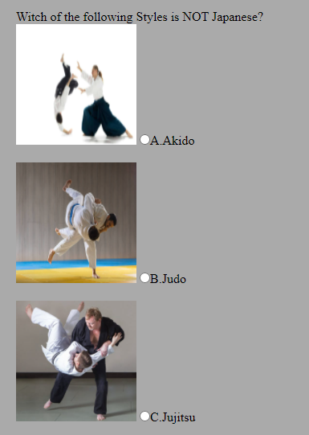
Figure 4 Quiz options
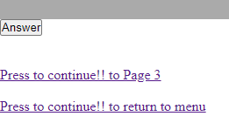
Figure 5 Quiz one menu and answer button

Page three/quiz Two
This page utilises the same concepts same as the previous Quiz, however the answers, graphics and radio buttons have been arranged inline (It provides a better astatic look to the page). In addition, apron hitting the answer button the user is presented with a graphic. As with all previous pages a more formalised layout would be recommended for further development.

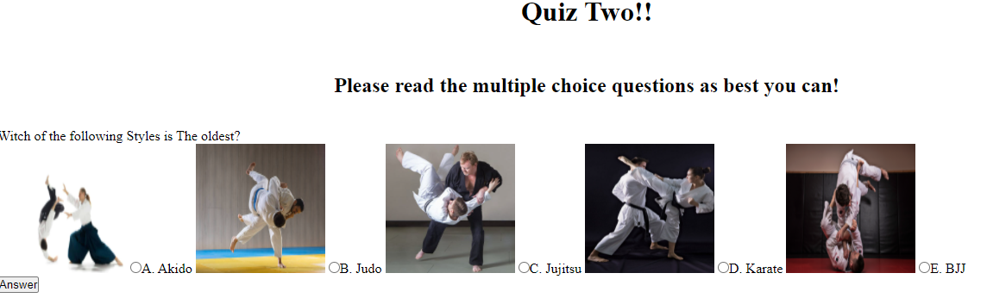
Figure 6 Quiz Two


Figure 7 Quiz Two incorrect display

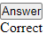
Figure 8 Quiz Two Correct display

Page four/quiz Three
In the Quiz the choices and animated (gifs) have been placed into a table (5 columns and 2 rows) an adjustment has been made to the answer button, in addition to this, the outcome of the result now appears in a popup pane as opposed to static text on the page. Background colours on the page, table rows and popup menu are provided via CSS script.

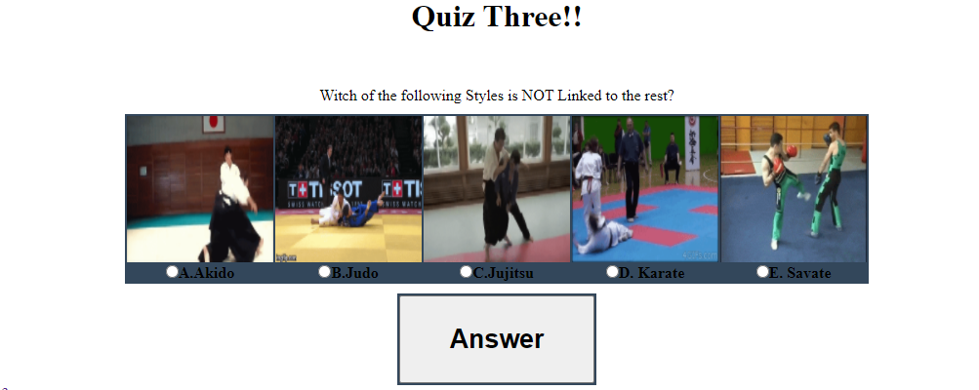
Figure 9 Quiz Three menu
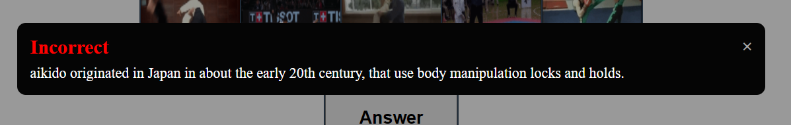
Figure 10 Incorrect display
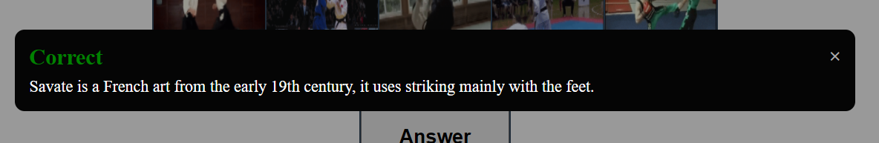
Figure 11 Quiz Three Correct display

Figure 12 Quiz Three Error message

Page five/under con
This website is an ongoing project and as such the following image would be displayed to any user who try to progress in the quiz to a page that is under development.


Figure 13 Page 5 unfinished page

Conclusion
As stated in the introduction this assignment was designed around the F patten for the most part and the evolution of each page from basic to more advanced in it inner and outer workings.
- What went well?
Some of the HTML mixed with the JS and CSS mixed very well and was happy on how they held up the look on quiz four looked a lot better and the table worked very well in coding.
- What went Badly?
The popup menu on Quiz 4 was very hard to get to work took over 3 weeks to crack, and the answer button kept hiding the correct and incorrect statement until the popup box started to work.
- What would I change?
I originally wanted some small anime boxes with sound for correct and incorrect display screens but time was a factor I didn’t have.

