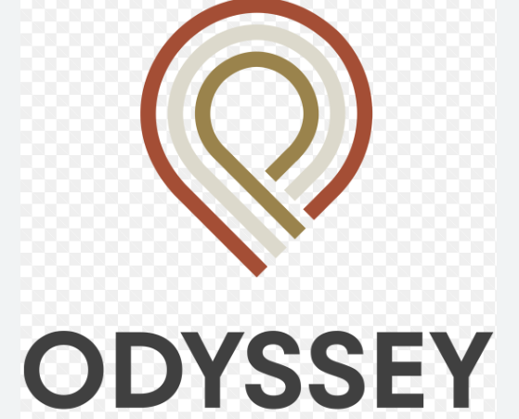

NEW ODYSSEY HOTEL CONSULTANCY REPORT

Name: Sougkoumi Kim
Student ID: 2011245
Module: BMIH6005
Lecturer: Laurence Blake

Table of Contents
Introduction 5
Aim and Objectives 5
Background 6
Scope & Analysis 7
PESTEL Analysis for the New Odyssey Hotel in the UK 9
SWOT Analysis for the New Odyssey Hotel in the UK 11
Competitive Landscape 12
Customer Base 13
Fig 2: Positive Customer Reviews 16
Current Operations 16
Improving Online Booking System 18
Improving Staffing Levels 20
Fig 3: Negative Customer Reviews 22
Expanding Offerings 22
Improving Customer Service 23
Situational Analysis using SOSTAC for New Odyssey Hotel 26
Fig 4: SOSTAC 28
Conclusion 28
Reference List 30

Fig 1: New Odyssey Hotel
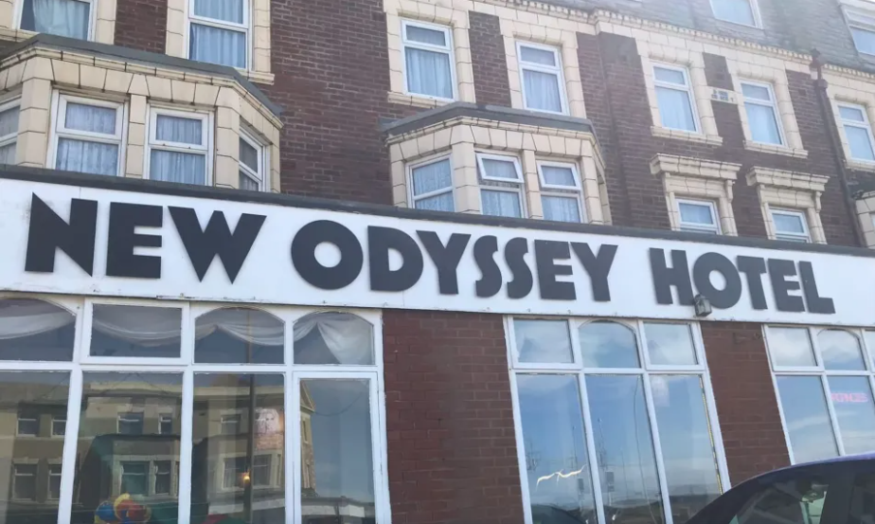Executive Summary
This report has been prepared to assess the operations and potential of the New Odyssey Hotel, a hotel located in the UK. The report's purpose is to provide the client, the Odyssey Hotel, with an analysis of the hospitality industry and a comprehensive evaluation of the hotel. To complete the report, the PESTEL and SWOT methods of Analysis were employed. Primary and secondary sources were used to compile information for the Analysis. Secondary materials included internet industry data, market research, and news stories, while primary sources included interviews with hotel workers and management. According to the report's conclusions, the tourism sector is transitioning as the COVID-19 epidemic significantly affects demand and profits. The Odyssey Hotel is facing several challenges, including outdated facilities and weak marketing strategies. In particular, the hotel needs to catch up to its competitors regarding its digital presence, customer service, and modern amenities. The paper evaluates the current affairs at the Odyssey Hotel and suggests future enhancements. In order to be competitive, the hotel must adapt to the evolving market and new technologies in the hospitality sector, including virtual reality and AI. To ensure that the Odyssey Hotel can respond to the changing environment, the report also provides several implementation strategies. These include a transition to online booking and payment systems, implementing a loyalty program, and adopting a customer-focused marketing approach. Furthermore, the report also recommends that the hotel explore new revenue generation opportunities, such as offering additional services and amenities.

Introduction
The New Odyssey Hotel is a Caribbean-based hotel and resort currently facing the challenges of the ongoing COVID-19 pandemic. To better understand the external and internal factors affecting the Odyssey Hotel and to gain insight into how best to improve its performance, this report will analyze the hotel using a combination of PESTEL and SWOT analyses (De Greff, 2018). PESTEL (Political, Economic, Social, Technological, Environmental, and Legal) Analysis is a tool used to assess the macro-environment surrounding the hotel and can provide insight into the external factors influencing its performance. SWOT (Strengths, Weaknesses, Opportunities, and Threats) Analysis will be used to evaluate the internal environment of the Odyssey Hotel, such as its competitive landscape, customer base, and current operations (Rahman, 2021). By utilizing these two assessments, this report will provide a comprehensive overview of the current state of the Odyssey Hotel and make recommendations for improvement. This will include examining the hotel's existing strategies, customer and staff satisfaction, marketing strategies, financial performance, and other vital areas (Fu et al., 2019, p. 7). Additionally, this report will provide insight into the external factors impacting the Odyssey Hotel, such as the economic environment, the global pandemic, and the changing legal landscape. Overall, this report will provide a detailed analysis of the current state of the Odyssey Hotel and make concrete recommendations for how the hotel can improve its performance and profitability in the face of the current global pandemic. By utilizing PESTEL and SWOT analyses, this report will provide an in-depth assessment of the Odyssey Hotel and help to identify areas of improvement to ensure long-term success.

Aim and Objectives
This consultant report aims to provide an in-depth analysis of the Odyssey Hotel and make recommendations on how the hotel can improve its performance and profitability in the long term. This includes an overview of the hotel's competitive landscape, customer base, and current operations (De Greff, 2018). Additionally, the report will provide recommendations for improving the hotel’s competitive position, customer service, and marketing efforts.
The objectives of this consultant report are as follows:
1. Analyze the current competitive landscape of the hospitality industry and identify the Odyssey Hotel’s primary competitors.
2. Assess the Odyssey Hotel’s current customer base and determine the best strategies for appealing to these customers (Migdadi, 2021, p. 121).
3. Evaluate the hotel’s current operations and identify areas for improvement.
4. Develop strategies for enhancing the hotel’s competitive position, customer service, and marketing efforts (Fu et al., 2019, p. 7).
5. Make recommendations on how the Odyssey Hotel can increase its profitability in the long term.

Background
The New Odyssey Hotel is a four-star boutique hotel located in the heart of London, United Kingdom. It is part of the esteemed Odyssey Hotels Group, operating for over a decade (De Greff, 2018). The hotel is renowned for its luxurious and modern style, offering guests a unique and memorable stay. The hotel's location puts guests within walking distance of several of the city's top sights. There are a wide variety of dining choices, retail stores, and cultural activities within walking distance, offering visitors a full taste of the city. The hotel is conveniently located near several of London's top attractions, including Westminster Abbey, the London Eye, as well as Buckingham Palace. The hotel has several high-end features, such as a spa, a gym, and a business center. The rooms are large, and they include all the conveniences of a contemporary hotel, such as flat-screen TVs, high-speed internet, as well as room service (Hossain, Rahman, and Zhou, 2021, pp.162). The property also offers a variety of dining options, from fine dining to casual meals. Guests can also enjoy the hotel's bar and lounge, which offers a variety of drinks, cocktails, and snacks. The hotel is well known for its exceptional staff, who are dedicated to ensuring guests have a pleasant and memorable stay (Talón-Ballestero et al., 2018, p. 177). All staff members are highly trained and experienced in hospitality and are always willing to go the extra mile to ensure guest satisfaction. Odyssey Hotel is a perfect destination for business and leisure travelers (Gil-Gomez et al., 2020, p. 2733). The hotel is located in the city's heart, making it an excellent option for exploring all London offers. Whether one is looking for a relaxing getaway or an exciting business trip, Odyssey Hotel is a perfect choice.

Scope & Analysis
The COVID-19 epidemic has substantially influenced the hospitality sector, with many resorts and hotels experiencing lower demand and decreasing profitability. The Odyssey Hotel is no exception, as it faces many challenges due to its outdated facilities and weak marketing strategies (Guillet & Chu, 2021, p. 607). This report will provide an in-depth analysis of the current state of the hotel, including its competitive landscape, customer base, and operations. This Analysis will provide recommendations for improving the hotel's performance and boosting its profitability in the long term. To begin, an overview of the current competitive landscape of the hospitality industry will be provided (Lona, 2021). The hospitality industry is highly competitive, with various players offering different services and amenities.
Hotels and resorts are particularly competitive, as travelers can choose from many available options. The Odyssey Hotel needs to understand its competitors to better position itself in the market (Itani et al., 2020, p. 266). The Odyssey Hotel is located in a popular tourist destination in the UK. The hotel's primary competitors are other resorts in the area, which offer various services and amenities. These competitors range from large, all-inclusive resorts to smaller boutique hotels. It is important to note that each of these competitors has unique offerings and pricing structures, which the Odyssey Hotel needs to be aware of to remain competitive. The hotel's customer base is comprised mainly of vacationers and business travelers. Vacationers typically look for the best value for their money and are drawn to hotels with attractive amenities and competitive prices. Business travelers usually prioritize convenience, with location and business-friendly amenities critical factors in their decision-making (Kim & Jeong, 2018, p. 120). The Odyssey Hotel's current operations need to be well-positioned to take advantage of either customer segment. The hotel's facilities are outdated and lack the amenities and services that modern travelers are looking for. Additionally, its marketing strategies need to be improved, with a need for more focus on digital and social media channels (Fu et al., 2019, p. 7). The hotel is missing out on potential customers increasingly relying on digital sources for travel research.
Several recommendations should be considered to improve the hotel's performance and profitability. The first is to focus on upgrading the hotel's facilities and amenities. This could include renovations to the rooms, common areas, and modern amenities such as spa services and a fitness center (Gursoy & Chi, 2020, p. 527). Such improvements can make the hotel more attractive to potential customers and help to create a positive perception of the hotel. Additionally, these improvements boost customer satisfaction, leading to increased loyalty and repeat business. The hotel should also focus on expanding its digital presence and marketing strategies. This could include developing a strong social media presence and utilizing digital advertising platforms to reach potential customers (Guha, Harrigan, and Soutar, 2018, pp.194). Additionally, the hotel should consider investing in a comprehensive website that provides detailed information about the hotel and its services. This website should be mobile-friendly, as most travelers use mobile devices to research and book travel arrangements. A comprehensive website can also help improve the hotel's visibility among travelers and make booking their stay easier. The hotel should consider implementing loyalty programs and other incentives to encourage repeat customers (Itani et al., 2020, p. 266). Loyalty programs provide customers with rewards and incentives to stay at the hotel, which can help to boost customer satisfaction and loyalty. Additionally, the hotel can offer special discounts and promotions to attract customers and encourage repeat bookings.

PESTEL Analysis for the New Odyssey Hotel in the UK
Political: The UK is a stable political environment, and the government supports business growth and tourism, which benefits the Odyssey Hotel. The government has recently introduced incentives for businesses to hire more staff and invest in training, which could help the Odyssey Hotel reduce costs and remain competitive in the hospitality industry (Kim & Jeong, 2018, p. 120). Additionally, the government has implemented various regulations and laws related to the hospitality industry, such as the minimum wage, health and safety regulations, and fire safety regulations (Rahman, 2021). The Odyssey Hotel must follow these regulations to remain compliant and avoid fines.
Economic: The UK is currently performing well, with a GDP growth of 1.4% in 2020. The Odyssey Hotel will benefit from increased consumer spending on hospitality services (Dixit, Lee, and Loo, 2021, pp.5). Additionally, the UK has attractive tax rates for businesses, which can help the Odyssey Hotel to remain profitable. The UK also has a strong currency, which benefits international travelers.
Social: The UK has a diverse population, with a mix of different cultures, ages, and backgrounds. This gives the Odyssey Hotel many potential customers (Kumar & Reinartz, 2018). Additionally, the UK is one of the most popular tourist destinations in the world, which can provide the Odyssey Hotel with a continuous stream of customers. The UK is known for its high service standards, which the Odyssey Hotel can use to differentiate itself from its competitors.
Technological: The UK has advanced infrastructure and a well-developed digital economy, which benefits the Odyssey Hotel. Technology has transformed the hotel business, enabling the Odyssey Hotel to leverage digital technologies, such as online booking as well as customer relationship management systems, to enhance its operations (Buhalis et al., 2019). In addition, the Odyssey Hotel can contact prospective clients and build a strong presence online by using digital marketing tools.
Environmental: The UK is a highly developed country with a strong focus on sustainability and environmental protection. The government has implemented various regulations to reduce emissions and promote renewable energy sources. This benefits the Odyssey Hotel, as it can take advantage of opportunities to reduce its environmental footprint, such as installing energy-efficient lighting and using renewable energy sources.
Legal: The UK has various laws and regulations related to the hospitality industry, such as fire safety regulations and health and safety regulations. In order to avoid fines and penalties, the Odyssey Hotel must maintain compliance with certain requirements. Moreover, the Odyssey Hotel must comply with British legislation regarding protecting client data and using customer information. SWOT Analysis for the New Odyssey Hotel in the UK
Strengths: The Odyssey Hotel has a number of strengths, including its location in the UK, one of the most popular tourist destinations in the world. Additionally, the Odyssey Hotel can take advantage of the UK's advanced infrastructure and digital economy to improve its operations and reach new customers (Lies, 2019). The Odyssey Hotel also has a strong reputation for providing high-quality service, which can help it to differentiate itself from its competitors.
Weaknesses: The Odyssey Hotel's weaknesses include its need for more experience in the hospitality industry and its limited financial resources. Additionally, the Odyssey Hotel may need help competing with established UK competitors, as they have more experience and resources. Finally, the Odyssey Hotel may need help to differentiate itself from its competitors, as many other hotels in the UK provide similar services.
Opportunities: The Odyssey Hotel can take advantage of the UK’s attractive tax rates and the government’s incentives for businesses to hire more staff and invest in training. Additionally, the Odyssey Hotel can use digital marketing tools to reach potential customers and establish a strong online presence (Liu & Burns, 2018, p. 32). The Odyssey Hotel can also take advantage of the UK's focus on sustainability and environmental protection by investing in energy-efficient lighting and renewable energy sources.
Threats: The Odyssey Hotel may face competition from established competitors in the UK, which have more experience and resources. Additionally, the UK is a highly competitive market, making it difficult for the Odyssey Hotel to differentiate itself from its competitors. Finally, the UK is a highly regulated market, making it difficult for the Odyssey Hotel to comply with all regulations.
Overall, the Odyssey Hotel has a number of opportunities to improve its performance and profitability in the long term. By upgrading its facilities and amenities, expanding its digital presence, and implementing loyalty programs, the hotel can gain a competitive edge over its rivals and better serve its customer base (Moro & Rita, 2018, p. 343). With these strategies, the Odyssey Hotel can become a leading resort in the Caribbean and a tourist destination. Additionally, these strategies can help improve the hotel's customer satisfaction and loyalty, leading to increased bookings and revenue in the long term.

Competitive Landscape
The Odyssey Hotel is currently in a highly competitive market, with dozens of other hotels and resorts in the same area vying for the same customers. While the Odyssey has been operating for a long time and has a devoted client base, it is crucial to note that many of these other resorts and hotels are more contemporary than the Odyssey, as they have been able to adapt to the fast-changing hospitality business environment (Khatri, 2019, p. 76). Many of these competitors offer a variety of amenities, such as pools, spas, and other recreational activities that the Odyssey does not offer. In addition, many of these competitors are also more price competitive than the Odyssey, meaning they can offer lower rates while still providing a comparable level of service (Moriuchi, 2021). This puts the Odyssey at a significant disadvantage in attracting new customers and competing with the other hotels in the area. Furthermore, the Odyssey is located in a high-traffic area, so there is high competition for local customers looking for a hotel.
The Odyssey Hotel must find a way to differentiate itself from the competition and stand out to remain competitive. This can be done by offering unique amenities like a pool or spa or providing superior customer service. Additionally, the Odyssey should look into ways to lower its prices to remain competitive with the other hotels in the area. Additionally, the Odyssey should focus on marketing itself to draw in customers who may need to be aware of the hotel or its services (Kim & Jeong, 2018, p. 120). Marketing could include advertising in local newspapers and magazines and using social media and other digital marketing platforms. Ultimately, the Odyssey Hotel must find ways to stand out and remain competitive in the marketplace. By offering unique amenities and services, providing superior customer service, and engaging in effective marketing, the Odyssey Hotel can stay ahead of the competition and remain successful in the long term.

Customer Base
The Odyssey Hotel currently has a customer base comprising business and budget-conscious travelers. Business travelers are more cost-conscious and tend to focus more on finding the best value for their money (Khatri, 2019, p. 76). The Odyssey has been able to offer them competitive rates, but the outdated facilities of the hotel can make it difficult to compete with other hotels. On the other hand, budget-conscious travelers are looking for the best deal available. The Odyssey needs a strong presence on social media, which has challenged the hotel to reach new customers (Guha, Harrigan, and Soutar, 2018, pp.194). To increase customer numbers and improve customer loyalty, Odyssey needs to invest in modernizing its facilities and strengthening its marketing campaigns. To modernize its facilities, the Odyssey should consider renovating the hotel and implementing new technologies, such as mobile check-in and payment systems. Mobile check-in and payment systems make it easier for customers to book and pay for their rooms and can provide a more seamless experience. Additionally, the Odyssey should focus on developing a comprehensive social media strategy to engage potential customers (Foroudi, 2020). This strategy should include creating engaging content, utilizing influencer marketing, and optimizing website searches. The Odyssey should also consider partnering with travel agents and other industry partners. Travel agents can help the Odyssey reach a larger audience and provide discounts and additional services to attract customers.
The Odyssey should also invest in building relationships with its current customers. This can be done through email marketing campaigns, special offers, and loyalty programs. Loyalty programs are beneficial as they incentivize customers to return and can help build brand loyalty (Khatri, 2019, p. 76). The Odyssey may also collect significant consumer data via loyalty programs, which can be utilized to comprehend client preferences better and create more successful marketing efforts. In addition, the Odyssey should prioritize offering superior customer service. This involves delivering rapid replies to client questions, tailored services, and timely resolution of customer concerns (Sharma, 2021, p. 77). The Odyssey can also increase its customer base by utilizing online marketing strategies. This includes optimizing website content, engaging with customers on social media, and running targeted online campaigns (Guha, Harrigan, and Soutar, 2018, pp.194). Furthermore, the Odyssey should focus on building relationships with industry partners and influencers who can help to increase its visibility and reach more potential customers. Additionally, the Odyssey should explore new marketing opportunities, such as participating in trade shows and conferences or sponsoring events. The Odyssey should focus on providing excellent customer service and developing comprehensive loyalty programs, as these can help to build customer loyalty and increase customer numbers. Additionally, the Odyssey should explore new marketing opportunities and build relationships with industry partners and influencers. Combining these strategies, the Odyssey can increase its customer base and improve customer loyalty.

Fig 2: Positive Customer Reviews
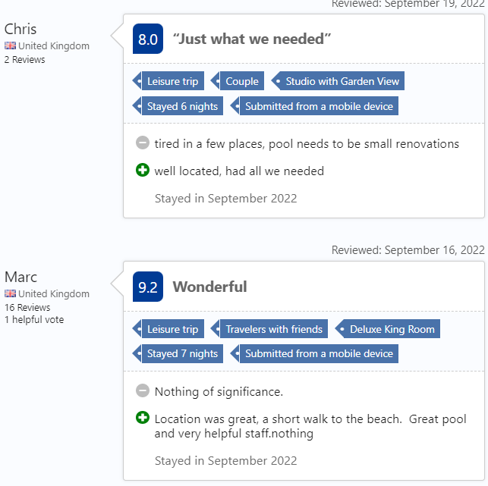

Current Operations
The Odyssey Hotel currently needs to perform better and take full advantage of its potential. This is a common issue among hospitality businesses in the current market due to competition from online booking sites, ever-changing consumer preferences, and the rise of other forms of accommodation (Dixit, Lee, and Loo, 2021, pp.5). In order to become successful and thrive, the Odyssey Hotel should improve its marketing efforts, hire more staff, explore new revenue streams, and create a unique customer experience. To begin, the Odyssey Hotel should focus on improving its marketing efforts. Despite being established for over a decade, the hotel still needs to properly market its online booking system, resulting in lost revenue. In order to increase its profits and efficiency, the hotel should focus on advertising its online booking system and offering discounts and promotions to encourage more customers to use the system (Myers, 2019, p. 22). Additionally, the hotel should create an engaging presence on social media, providing customers with a direct line to the hotel and promoting its offerings. This will help to increase the hotel’s visibility and create an online community, leading to increased revenue.
Next, the Odyssey Hotel should address its staffing levels. The hotel currently needs more staffing levels, leading to slow service and a lack of customer satisfaction. In order to improve the speed and quality of service, the hotel should hire more staff (Kim & Jeong, 2018, p. 120). This will not only help to improve customer satisfaction but also result in increased revenue. Furthermore, the Odyssey Hotel should explore other potential revenue streams. The hotel could offer additional services such as spa treatments, fitness classes, and rental cars. Additionally, the hotel could explore expanding its offerings to include more luxurious amenities, such as a rooftop pool or private villas. These changes would help the hotel to stand out from other local hotels, resulting in increased profits. The Odyssey Hotel should focus on creating a unique customer experience. The hotel should provide exceptional customer service, attentive staff, and personalized experiences for each customer. Additionally, the hotel should strive to create a unique atmosphere, with attractive decor and a relaxing atmosphere (Liu & Burns, 2018, p. 32). These changes would help the hotel to stand out from the competition, resulting in increased profits. In order to implement these changes, the Odyssey Hotel should invest in its staff and infrastructure (Lado-Sestayo & Vivel-Búa, 2018, p. 456). The hotel should create a detailed training program to ensure that its staff is properly trained and equipped to provide exceptional service. The hotel should also invest in its facilities, ensuring they are up-to-date and attractive.
The hotel should invest in its technology, ensuring that its online booking system is easy to use and secure. The Odyssey Hotel can become more efficient and profitable by improving its marketing efforts, hiring more staff, exploring new revenue streams, and creating a unique customer experience (Buhalis et al., 2019). The Odyssey Hotel can become a thriving business with the right strategies and investments. The hotel should focus on creating an engaging presence online, investing in its staff and facilities, and providing exceptional customer service. With these changes, the Odyssey Hotel can attract more guests, increase its profits, and become a leader in the hospitality industry.

Improving the Online Booking System
The Odyssey Hotel should invest in marketing its online booking system to take advantage of the potential revenue it can generate. Various online and offline methods can be used to market the hotel's online booking system and attract more customers (Kim & Jeong, 2018, p. 120). These methods include search engine optimization (SEO), pay-per-click (PPC) advertising, email campaigns, and social media campaigns. SEO is a powerful tool for improving the visibility of a website in search engine results pages (SERPs). The hotel should ensure that its website is optimized for the relevant keywords to appear higher in the SERPs. This can be done by optimizing the site for relevant keywords, using targeted content, optimizing the website for mobile, and ensuring that the website is fast and responsive. PPC advertising is another way to increase the visibility of the hotel’s online booking system. This involves paying search engines and other websites to display ads for the hotel’s website (Lado-Sestayo & Vivel-Búa, 2018, p. 456). Ads can be targeted to specific audiences and tailored to particular keywords. PPC campaigns can drive traffic to the hotel's website and increase bookings.
Email campaigns are another way to market the hotel’s online booking system. The hotel can send out emails to potential customers to inform them about the availability of rooms, special offers, and discounts. The emails can be tailored to the customer’s interests and can be used to direct them to the website for more information. Social media is another powerful tool for marketing the hotel’s online booking system (Guha, Harrigan, and Soutar, 2018, pp.194). The hotel can create social media accounts and post regular updates about the hotel, its services, and its online booking system. The hotel can also use social media to engage with potential customers, respond to queries, and build relationships. In addition to marketing its online booking system, the hotel should also focus on improving the user experience of its website in order to make it easier for customers to book rooms. This could include features such as allowing customers to view photos of the rooms, providing detailed descriptions of the rooms, and offering discounts or special promotions. The hotel should also ensure that the website is easy to navigate and that the checkout process is straightforward and secure. The hotel should also consider offering additional services and amenities to customers who book online. These services could include free Wi-Fi, meal discounts, and other perks. This will encourage customers to book online and will encourage them to return in the future.
The hotel should ensure that its online booking system is secure. It should use secure payment processors and encryption to keep customer data safe. Additionally, the hotel should provide customers with an easy way to contact the hotel in case of any problems. By investing in marketing its online booking system and improving the user experience of its website, the Odyssey Hotel can take advantage of the potential revenue it can generate from its online booking system. This will help the hotel to attract more customers and to increase its revenue.

Improving Staffing Levels
The Odyssey Hotel should also improve its staffing levels to improve customer service and satisfaction. This can be done by hiring additional staff members and training them in customer service and hospitality (Kim & Jeong, 2018, p. 120). Hiring staff with the right experience can benefit the hotel as they help ensure customers have the best possible experience. Providing customer service training to existing staff can help them provide better service and ensure customer satisfaction. The hotel should also focus on hiring staff with experience in the hospitality industry to provide customers with the best possible service. Experienced staff members can be more knowledgeable about the hotel's services and policies, allowing them to meet customer needs better. Furthermore, experienced staff members are more likely to be able to handle challenging customer service situations effectively and professionally. Hiring experienced staff can also reduce the time required to train new staff members, thus reducing costs associated with employee training.
The hotel should also focus on creating a customer service and hospitality culture among its staff so that customers feel welcome and comfortable. This can be done by incentivizing employees who go above and beyond in providing exceptional customer service. Additionally, the hotel should provide employees with regular customer service training and feedback to ensure they provide the highest service level (Lado-Sestayo & Vivel-Búa, 2018, p. 456). The hotel should also ensure that its staff is available when customers need them. This can be done by addressing any issues with staff availability and scheduling, such as ensuring that staff members are available during peak hours. Additionally, the hotel should consider providing additional customer service staff during busy periods to ensure that customers can get the help they need when they need it.
The hotel should ensure that its staff is adequately compensated for their work. Providing competitive pay, benefits, and bonuses can help to ensure that employees are motivated to provide the best possible customer service (Liu & Burns, 2018, p. 32). Additionally, providing a positive, supportive work environment helps ensure that employees are happy and willing to go the extra mile for customers. The Odyssey Hotel can improve its staffing levels and customer service by hiring experienced staff, creating a culture of customer service and hospitality, ensuring that staff is available when customers need them, and providing adequate compensation. This helps ensure that customers have the best possible experience when they stay at the hotel, thus leading to increased customer satisfaction and loyalty.

Fig 3: Negative Customer Reviews
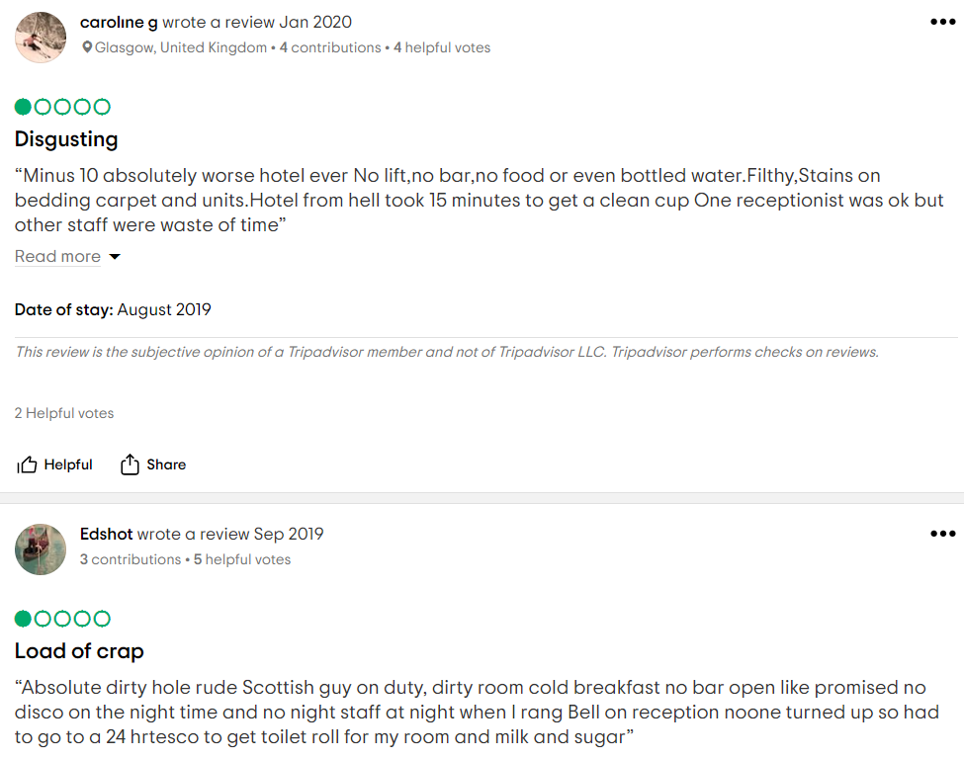

Expanding Offerings
To maximize its potential revenue streams, the Odyssey Hotel should look into expanding its offerings. The hotel should consider offering additional services, such as spa treatments and in-room dining, to its guests (Liu & Burns, 2018, p. 32). These services can draw in a more extensive customer base and increase revenue. Spa treatments are becoming increasingly popular among travelers, and having a massage or other relaxation therapies available in-room could be a great way to draw in more customers (Mariani et al., 2018, p. 3550). In-room dining is also popular among travelers, and offering a variety of menu items can help to draw in more customers who may want to stay in the comfort of their room to eat. The Odyssey Hotel should also look into expanding its offerings to include different types of rooms. This could include offering suites or family-friendly rooms. Having these types of rooms available could help attract a more extensive customer base, as travelers looking for more than just a standard room could be more likely to stay at the hotel. Additionally, offering different types of rooms could increase revenue, as travelers are more likely to book more expensive rooms. In addition to expanding its offerings, the Odyssey Hotel should consider offering packages and deals.
Offering discounted rates or packages that include add-ons such as spa treatments or in-room dining could be a great way to attract more customers. Additionally, offering loyalty programs or rewards points could be a great way to incentivize customers to come back and stay at the hotel. The Odyssey Hotel should utilize technology to maximize its potential revenue streams (Buhalis et al., 2019). An up-to-date website and engaging social media accounts could be a great way to reach a larger audience and draw in more customers. Additionally, the hotel should consider offering online booking and payment options, as this could make the booking process more accessible and more convenient for customers. The Odyssey Hotel has the potential to become one of the most sought-after destinations for travelers. By expanding its offerings, offering packages and deals, and taking advantage of technology, the hotel can maximize its potential revenue streams and become a more attractive destination for travelers (Buhalis et al., 2019). With its luxurious amenities and modern design, the Odyssey Hotel is sure to become a popular destination for business and leisure travelers.

Improving Customer Service
Customer service is an integral part of the hospitality industry, and it is essential that customers feel valued and appreciated during their stay at The Odyssey Hotel. At The Odyssey Hotel, customer service is of the utmost importance, and the staff always looks for ways to enhance the customer experience (Liu & Burns, 2018, p. 32). The Odyssey Hotel should focus on providing customers with more information and assistance during their stay. This can be done by providing customers with a detailed stay itinerary, including available amenities such as breakfast, spa, and concierge services. Additionally, the hotel should ensure that customers know about any available discounts or special promotions offered to make their stay even more enjoyable. The Odyssey Hotel should also look into providing better customer service, such as personalized attention and assistance with any issues that customers may have. This can include providing knowledgeable staff members willing to answer questions, provide assistance, and respond quickly to any customer inquiries or complaints. Additionally, the hotel should provide customers with a contact list of staff members available to help with any needs or issues that may arise during a stay.
The hotel should offer discounts or special promotions to customers to encourage them to book rooms and increase revenue. This could include offering regular discounts on rooms, meals, or other services, as well as special promotions such as a stay two nights get one free deal or a free night with every two nights booked offer (Liu & Burns, 2018, p. 32). Additionally, the hotel should look into offering loyalty programs for regular customers, such as a rewards program that allows customers to accumulate points for every night that they stay at the hotel, which can then be used towards discounts or rewards. By providing customers with more information and assistance during their stay and offering discounts and special promotions, The Odyssey Hotel can ensure that customers have a pleasant and enjoyable experience. This will not only increase customer satisfaction but can also lead to increased revenue for the hotel. Additionally, providing better customer service can help create a positive reputation for the hotel, leading to more customers in the future.
The Odyssey Hotel should strive to create an atmosphere of trust and respect between staff and customers. This can be done by having a friendly and knowledgeable staff willing to answer questions and provide assistance when needed (Mariani et al., 2018, p. 3550). Additionally, the hotel should have staff members willing to go the extra mile to make customers feel welcome and appreciated. This can include helping customers with luggage, offering complimentary snacks and beverages, and providing helpful tips and advice on local attractions and activities. The Odyssey Hotel should strive to provide guests with a clean and comfortable atmosphere. This can be done by regularly cleaning and maintaining the hotel rooms and providing comfortable furniture and bedding (Phillips & Moutinho, 2018, p. 160). Additionally, the hotel should ensure that all public areas, such as the lobby and common areas, are regularly cleaned and maintained. By taking these steps, The Odyssey Hotel can ensure that customers have a pleasant and comfortable stay.
By improving customer service, the Odyssey Hotel can ensure that customers have a pleasant experience every time they stay at the hotel. This can include providing customers with more information about their stay and any available amenities and better customer service, such as personalized attention and assistance with any issues that customers may have (Mahmutović, 2021). Additionally, the hotel should look into offering discounts or special promotions to customers in order to encourage them to book rooms and increase revenue. The Odyssey Hotel should strive to create an atmosphere of trust and respect between staff and customers by having friendly and knowledgeable staff willing to go the extra mile to make customers feel welcome and appreciated. By taking these steps, The Odyssey Hotel can ensure customer satisfaction and create a positive reputation for the hotel.

Situational Analysis using SOSTAC for New Odyssey Hotel
In order to ensure the success of the hotel, it is important to create a comprehensive marketing strategy that will help to attract new customers, retain existing customers, and increase revenue. The SOSTAC framework can create such a strategy (Foroudi, 2020).
Situation Analysis: The first step in the SOSTAC framework is situation analysis. The situation analysis involves understanding the current situation of the hotel, including the current environment, customers, competitors, and the hotel itself (Foroudi, 2020). The current environment consists of the market's trends, opportunities, and threats. The customers consist of their needs, wants, and preferences (Ojasalo & Ojasalo, 2018, p. 71). The competitors are other hotels located in the same area and offering similar services. The hotel includes its mission, vision, goals, offerings, and current performance.
Objectives: The second step in the SOSTAC framework is setting objectives. The objectives should be SMART: specific, measurable, achievable, relevant, and time-bound. The objectives of the new Odyssey Hotel should include increasing customer satisfaction, revenue, brand awareness, and customer loyalty.
Strategy: The third step in the SOSTAC framework is to create a strategy. The strategy should include the methods and tactics used to achieve the objectives (Stephenson, 2020). The strategy for the new Odyssey Hotel could include using digital marketing, creating loyalty programs, and offering discounts and promotions.
Tactics: The fourth step in the SOSTAC framework is to create tactics. Tactics are the specific steps that will be taken to execute the strategy (Foroudi, 2020). For the new Odyssey Hotel, the tactics could include creating a website, using social media, creating an email marketing campaign, creating loyalty programs, and offering discounts and promotions.
Actions: The fifth step in the SOSTAC framework is to create a plan of action. The action plan should include the tasks that need to be completed to implement the tactics (Mahmutović, 2021). For the new Odyssey Hotel, the action plan could include creating a website, setting up social media accounts, creating an email marketing campaign, setting up loyalty programs, and running promotions and discounts.
Control: The sixth and final step in the SOSTAC framework is to create a system for monitoring and controlling the plan of action. This includes tracking the performance of the tactics and making adjustments as needed (Liu & Burns, 2018, p. 32). For the new Odyssey Hotel, this could include tracking website visits, social media engagement, open email rates, and loyalty program signups. Using the SOSTAC framework, the new Odyssey Hotel can create a comprehensive marketing strategy that will help attract new customers, retain existing customers, and increase revenue (Stephenson, 2020). The framework provides a structured approach to developing a strategy that can be used to guide the implementation of the tactics. The hotel can provide its guests with the best possible experience with a well-thought-out strategy.

Fig 4: SOSTAC
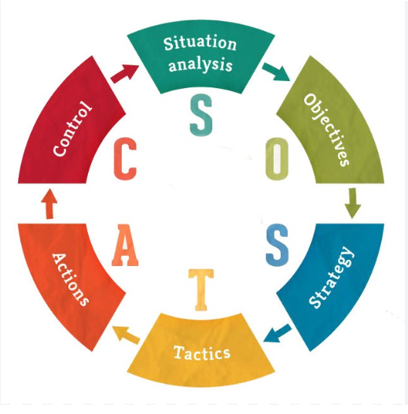

Conclusion
The New Odyssey Hotel has the potential to be a successful and profitable business. The hotel is a popular tourist destination in the UK, giving it access to a large customer base. Additionally, the UK has a stable economic and political environment, which can help the hotel to remain competitive in the hospitality industry. In order to ensure the success of the hotel, it is important to create a comprehensive marketing strategy that considers the current situation, objectives, strategy, tactics, actions, and control. The SOSTAC framework can be used to create a strategy, which should include digital marketing, loyalty programs, and discounts. By utilizing the SOSTAC framework, the hotel can create a comprehensive marketing strategy that will help to attract new customers, retain existing customers, and increase revenue. Finally, the hotel should explore new opportunities for revenue generation, such as offering additional services and amenities. The New Odyssey Hotel can ensure long-term success and profitability by following these recommendations.

Reference List
Buhalis, D., Harwood, T., Bogicevic, V., Viglia, G., Beldona, S. & Hofacker, C. (2019). Technological disruptions in services: lessons from tourism and hospitality. Journal of Service Management. https://www.emerald.com/insight/content/doi/10.1108/JOSM-12-2018-0398/full/html
De Greff, D., (2018). The Odyssey Hotel (Doctoral dissertation, University of Miami). https://scholarship.miami.edu/esploro/outputs/graduate/The-Odyssey-Hotel/991031447816602976
Dixit, S.K., Lee, K.H. and Loo, P.T., (2021). Consumer behavior in hospitality and tourism. In Consumer Behaviour in Hospitality and Tourism (pp. 1–9). Routledge. https://www.taylorfrancis.com/chapters/edit/10.4324/9781003181071-1/consumer-behavior-hospitality-tourism-saurabh-kumar-dixit-kuan-huei-lee-poh-theng-loo
Foroudi, P. (2020). Corporate brand strategy: drivers and outcomes of hotel industry's brand orientation. International Journal of Hospitality Management, 88, p.102519. https://www.sciencedirect.com/science/article/pii/S0278431920300712
Fu, H., Okumus, F., Wu, K. and Köseoglu, M.A., 2019. Entrepreneurship research in hospitality and tourism. International Journal of Hospitality Management, 78, pp.1-12. https://www.sciencedirect.com/science/article/pii/S0278431918304432
Gil-Gomez, H., Guerola-Navarro, V., Oltra-Badenes, R. and Lozano-Quilis, J.A., 2020. Customer relationship management: digital transformation and sustainable business model innovation. Economic research-Ekonomska istraživanja, 33(1), pp.2733-2750. https://hrcak.srce.hr/file/370046
Guha, S., Harrigan, P. and Soutar, G., 2018. Linking social media to customer relationship management (CRM): A qualitative study on SMEs. Journal of Small Business & Entrepreneurship, 30(3), pp.193-214. https://www.tandfonline.com/doi/abs/10.1080/08276331.2017.1399628
Guillet, B.D. and Chu, A.M.C., 2021. Managing hotel revenue amid the COVID-19 crisis. International Journal of Contemporary Hospitality Management, 33(2), pp.604-627. https://www.emerald.com/insight/content/doi/10.1108/IJCHM-06-2020-0623/full/
Gursoy, D. and Chi, C.G., 2020. Effects of COVID-19 pandemic on hospitality industry: a review of the current situations and a research agenda. Journal of Hospitality Marketing & Management, 29(5), pp.527-529. https://www.tandfonline.com/doi/full/10.1080/19368623.2020.1788231
Hossain, M.S., Rahman, M.F. and Zhou, X., 2021. Impact of customers' interpersonal interactions in social commerce on customer relationship management performance. Journal of Contemporary Marketing Science, 4(1), pp.161-181. https://www.emerald.com/insight/content/doi/10.1108/JCMARS-12-2020-0050/full/html
Itani, O.S., Krush, M.T., Agnihotri, R. & Trainor, K.J. (2020). Social media and customer relationship management technologies: Influencing buyer-seller information exchanges. Industrial Marketing Management, 90, pp.264–275. https://www.sciencedirect.com/science/article/pii/S0019850119309447
Khatri, I. (2019). Information technology in tourism & hospitality industry: A review of ten years' publications. Journal of Tourism and Hospitality Education, 9, pp.74–87. https://www.nepjol.info/index.php/JTHE/article/view/23682
Kim, H.J. and Jeong, M., 2018. Research on hospitality and tourism education: Now and future. Tourism Management Perspectives, 25, pp.119-122. https://www.sciencedirect.com/science/article/pii/S2211973617301393
Kumar, V. and Reinartz, W., 2018. Customer relationship management. Springer-Verlag GmbH Germany, part of Springer Nature 2006, 2012, 2018. https://link.springer.com/content/pdf/10.1007/978-3-662-55381-7.pdf
Lado-Sestayo, R. and Vivel-Búa, M., 2018. Profitability in the hotel sector: a PLS approach. Journal of Hospitality and Tourism Technology, 9(3), pp.455-470.https://www.emerald.com/insight/content/doi/10.1108/JHTT-10-2017-0118/full/html
Lies, J., 2019. Marketing intelligence and big data: Digital marketing techniques on their way to becoming social engineering techniques in marketing. https://reunir.unir.net/handle/123456789/12532
Liu, X. and Burns, A.C., (2018). Designing a marketing analytics course for the digital age. Marketing Education Review, 28(1), 28–40. https://www.tandfonline.com/doi/abs/10.1080/10528008.2017.1421049
Lona, J. (2021). Digital marketing management key drivers. https://esource.dbs.ie/bitstream/handle/10788/4120/ebook_lona_j_2021.pdf?sequence=1
Mahmutović, K., 2021. Development and validation of the scale for measuring digital marketing orientation in the hotel industry. economic issues, 34(1). https://www.academia.edu/download/65757626/kenan_mahmutovic_copyedited_12945_Article_Full_Text_54007_1_9_20210218.pdf
Mariani, M., Baggio, R., Fuchs, M. and Höepken, W., 2018. Business intelligence and big data in hospitality and tourism: a systematic literature review. International Journal of Contemporary Hospitality Management, 30(12), pp.3514-3554. https://www.emerald.com/insight/content/doi/10.1108/IJCHM-07-2017-0461/full/html?journalCode=ijchm&utm_source=TrendMD&utm_medium=cpc&utm_campaign=Emerald_TrendMD_1&WT.mc_id=Emerald_TrendMD_1
Migdadi, M.M., (2021). Knowledge management, customer relationship management, and innovation capabilities. Journal of Business & Industrial Marketing, 36(1), pp.111–124. https://www.emerald.com/insight/content/doi/10.1108/JBIM-12-2019-0504/full/html
Moriuchi, E., (2021). Cross-Cultural Social Media Marketing: Bridging Across Cultural Differences. Emerald Group Publishing.
Moro, S. and Rita, P., 2018. Brand strategies in social media in hospitality and tourism. International Journal of Contemporary Hospitality Management, 30(1), pp.343-364. https://www.emerald.com/insight/content/doi/10.1108/IJCHM-07-2016-0340/full/html?fullSc=1&mbSc=1&fullSc=1
Myers, M.D. (2019). Qualitative research in business and management. Qualitative research in business and management, pp.1–364. https://www.torrossa.com/gs/resourceProxy?an=5018482&publisher=FZ7200
Ojasalo, J. and Ojasalo, K., 2018. Service logic business model canvas. Journal of research in marketing and entrepreneurship, 20(1), pp.70-98. https://www.emerald.com/insight/content/doi/10.1108/JRME-06-2016-0015/full/html?_ga=2.94012889.59237076.1656838625-2060309989.1648296082&utm_source=TrendMD&utm_medium=cpc&utm_campaign=Journal_of_Research_in_Marketing_and_Entrepreneurship_TrendMD_0&WT.mc_id=Emerald_TrendMD_0
Phillips, P. and Moutinho, L., 2018. Contemporary issues in strategic management (pp. 159-177). Routledge.https://api.taylorfrancis.com/content/books/mono/download?identifierName=doi&identifierValue=10.4324/9781315674827&type=googlepdf
Rahman, M. (2021). PESTEL analysis of the tourism industry. URL: https://howandwhat. Net/pestle-analysis-tourism-industry. https://www.howandwhat.net/pestel-analysis-tourism-industry/
Sharma, H. (2021). Effectiveness of Online Marketing Tools: A Case Study. Paradigm, 25(1), 77–86. https://journals.sagepub.com/doi/pdf/10.1177/09718907211003717
Stephenson, R. (2020). Writing a digital marketing plan using PR Smith's SOSTAC planning model. Verfügbar unter: https://digitaldimensions4u.com/how-to-write-a-digital-marketing-plan-sostac-model/
Talón-Ballestero, P., González-Serrano, L., Soguero-Ruiz, C., Muñoz-Romero, S. and Rojo-Álvarez, J.L., 2018. Using big data from customer relationship management information systems to determine the client profile in the hotel sector. Tourism Management, 68, pp.187-197. https://www.sciencedirect.com/science/article/pii/S0261517718300670

