- New entrants to the parcel delivery market and other labour market competitors have adversely affected ParcelCare’s ability to compete in labour markets. Explain how ParcelCare can strategically position themselves in competitive labour markets. (AC 1.1)
Due to the increase in competition within the labour market within the parcel industry, ParcelCare will need to consider their approach when it comes to how ParcelCare can attract new employees. Their approach can be multifaced depending on the options available to Parcel Force.

Improved Branding and Competitor Analysis
The CIPD (2024) states that employers can benefit from effective employer branding when it comes to all aspects of the employee lifecycle. CIPD (2024) outlines that an employer brand is how an employer is seen as a place of work and drives employee loyalty and helps a business compete within their respective labour markets. The recommendation is that an employer brand should be visible across all aspects of a business from induction to leaving employees. ParcelCare can undertake some investigations within their workforce to help them identify a new employer brand which can work alongside their organisational values but not reiterate them.

When approaching a change in branding, ParcelCare can conduct a competitor analysis to help identify gaps within their strategy and to compare it with their competitors. Fisher et al. (2020) outlines the function of competitor analysis is to give an organisation a complete picture of the competitive landscape through a systematic process via identifying current and potential competitors, identifying an organisations strengths and weaknesses, identify and compare competitor strategies and future plans. To aid with this competitor analysis, Parcel Force can use a SWOT analysis to identify their strengths, weaknesses, opportunities and threats. Externally, Parcel Force can conduct a PESTLE analysis which will give an outline of the external factors to their strategies such as those which are political, environmental, social, technological, legal and economical. This will also inform Parcel Force of the benefits provided to employees by other firms and allow them to compete through the creation of an effective benefits package and by allowing them to compete on pay. By conducting these types of analysis, ParcelCare can then effectively plan for the future.

Employer Value Proposition (EVP)
The Employer Value Proposition according to CIPD (2024) outlines the set of standards expected by an employer along with the conditions of the ‘psychological contract’ which the CIPD (2025) considers is the relationship between employer and employee and is based on fairness and trust. A breach of the psychological contract can adversely affect employee morale, performance, commitment and employee satisfaction, which can increase turnover.

Workforce Planning
Implementing a workforce plan within parcel force will aid the organisation with identifying peak recruitment activity. Cambridge University (2025) explains workforce planning as analysing the current workforce, planning for the future workforce needs and identifying the gap between the present and future workforce while strategizing towards your organisational goals. This view is shared with the CIPD (2025) which outlines that workforce planning is the gathering of information to inform future demand. ParcelCare can future plan by identifying their peaks and troughs or by analysing seasonal demand for their service, ParcelCare can strategize recruitment activity around these key areas.

In recommendation, ParcelCare could utilize the above tools to effectively strategize and future plan to compete with their respective competitors by making more informed decisions.

- Explain the impact of changing labour market conditions on resourcing decisions at ParcelCare. (AC 1.2)
Loose and Tight Markets
According to Andolfatto D, Birinci S (2022), a tight labour market can be explained as a market where there are a high number of available vacancies, with a low number of available workers. Contrast to this, a loose market is where there are a high number of available workers and a low number of vacancies to be filled. In Spring 2025, within the private sector, of which ParcelCare will be a part of, the CIPD (2025) have projected a fall in the number of organisations recruiting and the Office of National Statistics (2025) outlines that unemployment has risen. These factors may create a loose labour market within the private sector which will mean that organisations such as parcel care may experience high demand on any vacancies they advertise due to the rise in available workers within the United Kingdom.

Political Pressures
Following the general election which resulted in a change in government, businesses and workers within the UK are experiencing changes in employment law and policy for example, the rise in national insurance contributions by employers which increased by 1.2% from 13.8% to 15% on salaries above £9100 per annum (Campbell. J, 2025). This rise may be a concern for some employers such as ParcelCare as the effect may limit their funds when it comes to recruiting and maintaining current staffing levels. The economic implications of this could be less vacancies available to the respective workforce, creating a looser market.

Technological Advancements
Advances in available technology will also impact the way ParcelCare compete within the labour market. The use of AI to plan the most efficient routes for couriers to take along with estimated drop times will no doubt help the efficiency of the current workforce and affect overall workloads. CEO Monthly (2025) outlines further that AI can be used to plot routes to lower fuel consumption while making the route more efficient and to monitor driver performance and offer the best driver for specific jobs. Smart devices can also be used as a way to contact couriers regarding any extra packages or inform them of any changes to their routes, making the role more efficient and able to adapt to change. The impact on the labour market due to these advancements could be that less staff are required due to the more efficient planning of routes and more funds available through the savings on fuel. An issue that could arise due to these technological advancements are skills gaps being identified during implementation. AI is a specialist tool and could require the procurement of a provision or the hiring of a specialist to create and effectively implement a programme. Also, not all drivers may have a smart device which could lead to some friction when introducing the use of smart devices within the service.

To Summarise, these additions within the labour market may require ParcelCare to evaluate their Employer Value Proposition (EVP) and make adjustments to effectively tap into their labour market.

- You are aware that workforce planning has not been carried out in the past and decide to persuade the senior leadership team that this activity is worth doing. Analyse the impact of effective workforce planning, making clear how ParcelCare could benefit from this activity. (AC 2.1)
Workforce Planning
CIPD (2025) lists that workforce planning can reduce labour costs, identify and respond to changing customer needs, identify potential strategies to develop current workforce, identify and target inefficiencies, improve employee retention and offer career pathways or allow succession planning, increase productivity and aid in the development of reward and recognition strategies.
Hard and Soft Workforce Planning
The CIPD factsheet on workforce planning implies that there are two types of workforce planning, hard planning and soft planning. Hard planning is described as looking at the numbers and predicting what staff an employer will need and of these how many staff with specific skills sets are also required. Soft planning is outlined as the strategic planning or development of a framework to analyse available information on the current workforce to maximise efficiency of staff and highlight potential development opportunities and upskilling. Soft planning identifies workloads and generates key performance indicators (KPI’s), to help an organisation track output against workloads.
6 Stages of Workforce Planning
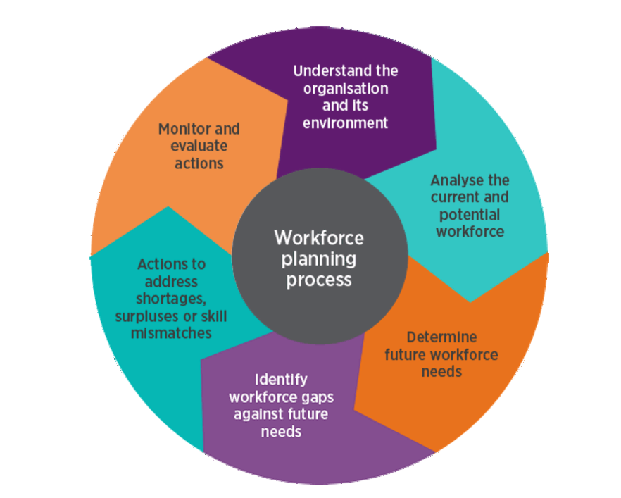
The stages of workforce planning, CIPD 2025
These steps provided by the CIPD (2025) are key aspects of workforce planning. For an organisation to effectively workforce plan, they will first need to understand the whole organisation and where it fits within their markets. By understanding their organisation, individuals can then effectively analyse and compare their current workforce against competitors and plan ahead during peak times to increase their workforce when required. The next step highlights the importance of an organisations future workforce needs which will assist an organisation with staying competitive within their labour market and aid with the advancements of technology. By future planning, an organisation can then identify gaps within their workforce and address these proactively to ensure that services are not disrupted. The last step for an organisation to monitor and evaluate their actions and adjust as necessary. These steps will help an organisation create an effective workforce plan and assist with keeping recruitment costs at a minimum while retaining current staff.
Assessing Effectiveness of Workforce Planning
While implementing a workforce plan may be a priority for an organisation, assessing the effectiveness of the implemented plan is essential. During the implementation process, an organisation should look at the current state of the organisation as a whole, which includes staffing levels across the organisation, what roles are required and at what level of skill are these different roles. Following this exercise, and projecting intake for peak times, an organisation should then measure how successful their workforce plan was and adjust where needed. HSBC (2025) highlights that successful workforce planning can be measured by reviewing the KPI’s set during the hard and soft planning stages during the creation of a workforce plan. These KPI’s could be the time taken to fill a vacancy, the cost to fill a vacancy, retention rates of current staff and employee performance against other KPI’s set.

If ParcelCare were to implement an effective workforce plan, the organisation could benefit from increased retention, a more skilled and motivated workforce, and more focused recruitment activities during peak demand for their service. If a plan is not implemented, ParcelCare may have retention issues due to not properly forecasting demand and planning recruitment activities during peak times which will negatively impact customer satisfaction and ultimately lose custom for ParcelCare.

- To strengthen your argument to introduce workforce planning, evaluate techniques that can be used to support the process of workforce planning. (AC 2.2)

- Currently, vacancies are advertised on ParcelCare’s website. Line managers then interview shortlisted applicants. You feel that these are suitable recruitment and selection methods to use but want to broaden the methods used. Evaluate the strengths and weaknesses of two different recruitment methods and two different selection methods. (AC 2.3)
- On examining employee turnover rates, you feel the rate is higher than it should be, and higher than internal targets. To try to understand this further, discuss differences between avoidable and unavoidable turnover and differences between push and pull factors. (AC 3.1)
- Retention of warehouse staff is an issue, as there are many labour market competitors. Compare the following retention approaches: realistic job previews; induction; job enrichment; and reward. (AC 3.2)
- To influence the senior leadership team to accept that employee turnover should be addressed, explain the impact of dysfunctional employee turnover. (AC 3.3)
- ParcelCare employs the majority of employees on permanent, full-time contracts. You feel these contracts have their place, but it is time to consider whether other types of contractual arrangements could be beneficial to the organisation, especially when demand for delivery services increases and decreases. Assess the suitability of permanent, full-time contracts for delivery drivers as well as two other types of contracts. (AC 4.1)

- At present, an ad hoc approach is taken to onboarding and typically involves the line manager ensuring new starter forms are completed and health and safety training provided. You identify that onboarding can be improved but first need to convince others that investment in this area is worthwhile. Explain the benefits of effective onboarding. (AC 4.2)

