The Impact of Interdepartmental Coordination Between Front Office and Housekeeping on Guest Satisfaction: A Case Study of DoubleeTree by Hilton Stratford-upon-Avon

Student Name: Bianca Beatrice Matal
Student ID: 2244785
Module Title and Code: Hotel Placement Research Project BMIH6008
Lecturer’s Name: Kathryn Flynn
Wordcount: words: 8084 words

AI DECLARATION:
I acknowledge the use of Grammarly (https://www.grammarly.com) on 25 February 2026 to check my whole work for grammatical mistakes and misspellings.
I confirm that I have not presented any AI generated text as my own work. I confirm I have copies of my draft, notes, and other resources I use before, and after the use of AI tools which I may be asked to provide in evidence.

Acknowledgement
I am grateful to each of individuals who are constantly supporting me in completing my research work based on the impact of interdepartmental coordination between the front office staff and housekeeping staff to ensure the guest satisfaction level. I am very much obliged to my family and friends who have provided me with adequate time to complete the research work. Lastly, I am very much thankful to the tutor who guided me in every instance to complete the research work.

Abstract
Guest satisfaction has become a crucial benefit of competitive edge, brand recognition and revenue results in the modern hospitality sector. Hotels are complex service systems, where various departments need work hand in hand to provide smooth experiences to the guests. Front office and housekeeping departments are among them, and they have the most significant effect, as these specific departments have a direct impact on such essential service contacts as check-in efficiency, readiness of rooms, their cleanliness, and responsiveness. The current study is a significant study that aims to understand how interdepartmental coordination in terms of front office / housekeeping would influence guest satisfaction using a case of DoubleTree by Hilton Stratford-upon-Avon as a research sample in the hospitality industry in UK. The first chapter showed the research background, which focuses on the increasing effects of operational coordination on the growth of guest satisfaction. Its arguments on industry data and organisational background confirm that lack of effective communication between front office and housekeeping could cause service delays, dissatisfaction. This damages the business reputation. The chapter also presents the research aim, objectives, and questions that consist of findings on the current coordination mechanisms. Thiese are determining their effectiveness, and analysing operational challenges. This is suggests a practical strategy for improvement. The second chapter is a critical literature review about the available literature regarding interdepartmental coordination, guest satisfaction and hospitality operations. The chapter expounds on importance of structured communication systems, teamwork and integration of technology in ensuring quality of the services provided, besides highlighting the challenges that remain unresolved, including labour problems, likeness of information and cultural diversity. Relevant theoretical constructs, such as Systems Theory and Social Exchange Theory, are used to state that coordination is dependent on organisational performance and perceptions of its guests. A notable literature gap is identified, especially in the current lack of empirical attention to front-office and housekeeping coordination in branded hotel settings. The third chapter describes methology of the research followed in the study. The investigation is performed with the help of an interpretivist research philosophy and an inductive approach that would provide the opportunity to gain a profound insight into coordination practices in the real-world context. The qualitative mono-method design is used, based on secondary data delivered by academic journals, industry reports, company reports, and hospitality data bases published in 2020 and 2025. The chapter defends the choice of a case study design and talks about the possibility of accessing data and its limitations. The fourth chapter contains discussion and findings. The analysis shows a high level of effective coordination achieved with help of Property Management Systems like OnQ and Opera PMS, daily briefings. The standardised procedures positively affect guest satisfaction. These are evidenced by following aspects: room readability, shortened waiting times, and enhanced service uniformity. There are problems such as high staff turnover, peak pressure, and dependence on human responsiveness that restrict the effectiveness of coordination. The chapter also shows how effective interdepartmental coordination is a competitive advantage and has been reinforced through SWOT and PESTLE research. In the fifth chapter, the summarisation is that the coordination between front office and housekeeping is key to guest satisfaction and operational excellence. The study shows that technology in itself is not enough without proper human cooperation. Recommendations are presented, cross-departmental training, real-time communication infrastructure, performance-based KPIs and initiatives aimed at employee well-being. The study presents quite interesting insights into hospitality management practice. This shows the strategic aspects of the significance of using internal coordination in presenting guests with high-quality experience.

Table of Contents
Chapter 1: Introduction 6
Research rationale 7
Research aim and objectives 9
Chaper 2: Literature Review 10
Critical analysis of the initiative regarding the interdepartmental coordination of Front Office and Housekeeping staff. 10
Impact of the coordination to ensure the guest satifaction level. 11
Critical analysis of the challenges faced by different departments 11
Analysis of the solution to improve the guest satisfaction level 12
Theoretical interpretation 12
Literature gap 13
Conceptual framework 13
Summary 14
Chapter 3: Methods 14
Research philosophy 14
Research approach 14
Research design 14
Research strategy 15
Research choise 15
Data collection and analysis 15
Accessibility for secondary data 16
Chapter 4: Fiding and Discussion 16
Fidings 16
Discussion 23
Summary 25
Conclusion 26
Recommendations and Practical Strategies 28
Reference List 30

Chapter 1: Introduction
In the contemporary environment of hospitality, satisfaction has emerged as one of the critical ways of competitive advantage. According to Statista (2025a), around 82% of hotel guests report that both the readiness of the room and cleanliness are primary factors influencing satisfaction. Staff responsiveness and service efficiency account for approximately 45% of repeat intentions of guests (Singgalen, 2024). The dimensions are dependent on the coordination between the housekeeping departments and front office. The front office the primary communication hub of the hotel in charge of varied duties. Business research helps undergraduate and postgraduate students (Collis and Hussey, 2014). The culmination of both departments due to a lack of coordination such as miscommunication, leads to guest dissatisfaction.
DoubleTree by Hilton Stratford-upon-Avon is a 4-star hotel located in Warwickshire, England. The hotel is a globally recognised herige destination which attracts over 2.5 million visitors annually (Thestratford-hotel.co.uk, 2026). It is operated under the Hilton Woldwide Holdings Inc. Additionally, DoubleTree by Hilton Stratford-upon-Avon forms part of the most prominent hotel groups in the wold, with more than 7500 properties across 126 territories and countries. The sub-brand DoubleTree individually operates over 660 hotels across the globe and represents a primary segment of the upscale market offering of Hilton (Stories from Hilton, n.d.). Efficient communication between both of these departments at DoubleTree by Hilton Stratford-upon-Avon is vital to uphold Guest Satisfaction Index (GSI) targets. The main aim is to have a minimum satisfation rating of 85% across the managed properties of Hilton (Hilton, 2021). The study investigates how interdepartmental coordination between the Housekeeping and Front Office has some impact on the guest satisfaction at the hotel.
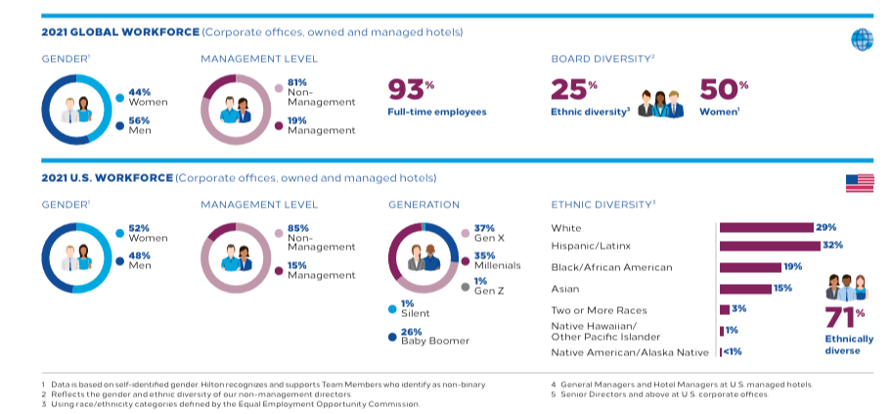
Figure 1: Management Satisfaction
(Source: Hilton, 2021)

Research rationale
The central issue pinpointed is the ineffective interdepartmental coordination between the two departments, which can impact the satisfaction of guests and the quality of services within hotels. The departments are operationally interdependent, and thus, when communication or coordination fails, it leads to service requests and guest dissatisfaction (Asgeirsson et al. 2024). At DoubleTree by Hilton Stratford-upon-Avon, the central aim is to provide exceptional services. Therefore, due to challenges in coordination, operations are disrupted and damage the of the brand.
The issue is critical because satisfaction of the guests directly determines brand image, financial performance and loyalty among customers. Research shows that hotels achieving high coordination between operations and departments can experience up to 18% higher satisfaction in the guest ratings (Wilson, 2025). Responsiveness and cleanliness are considered to be the strongest predictors of hotel satisfaction. Poor coordination only results in lower satisfaction among guests and parallel increases in efficiency (Tran et al. 2025). Within the properties at Hilton, the GSI is 85%, which makes interdepartmental efficiency a crucial performance metric.
The issue is relevant in the post-pandemic environment of hospitality. According to the reports of Statista (2025b), the UK hotel industry generated over £23 billion in 2024. This reflects a strong rebound in the demand for travel.
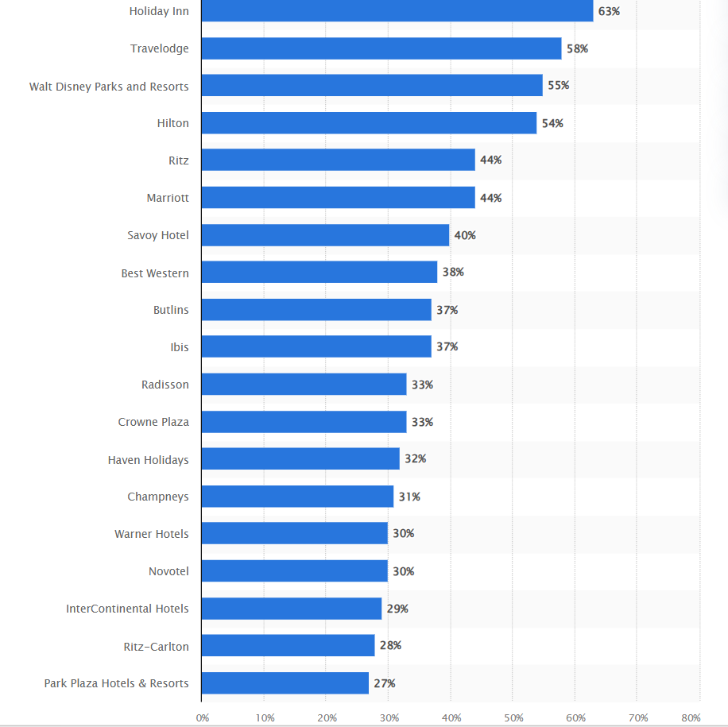
Figure 2: Popular hotel brands in the UK (2025)
(Source: Statista, 2025b)

Within this environmental shift, the slightest lack in communication can significantly disrupt guest perception. In order to overcome the challenges, the hotels should supplement the integrated communication system and provide extensive training staff. KPI is defined as Key Performance Indicator and for DoubleTree by Hilton on Stratford-upon-Avon, it is projected to maintain ADR, RevP and occupancy rate as per industrial parameter. The use of the modern Property Management System (PMS), such as Opera Cloud and OnQ, enables real communication between departments and reduces errors (Michel-Häggström, 2022). In addition to this, the management at the hotel can introduce shared service KPIs comprising guest satisfaction targets.
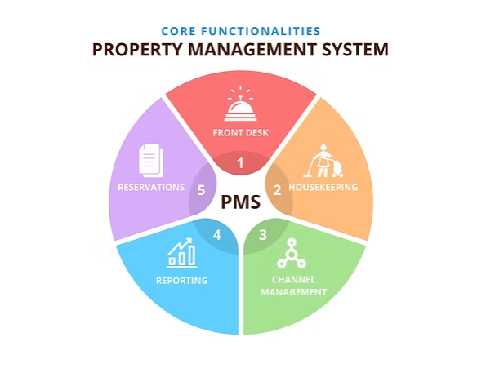
Figure 3: Property Management System (PMS)
(Source: Michel-Häggström, 2022)
DoubleTree by Hilton on Stratford-upon-Avon should promote a culture of collaboration and accountability. Through these measures, the hotel can sustain its global reputation in the hospitality market.

Research aim and objectives
Aim
The research aims to explore the impact of effective interdepartmental coordination between the Front Office and Housekeeping department establishing satisfaction within the hospitality industry.
Research Objectives
- To identify the present interdepartmental coordination initiatives between the Front Office and Housekeeping departments adopted by the hotel.
- To assess the impact of effectiveness and coordination between the departments at the hotel, ensuring satisfaction is provided to the guests within the UK hospitality sector.
- To examine the challenges faced by the departments at DoubleTree by Hilton Stratford-upon-Avon in ensuring guest satisfaction within the UK hospitality sector.
- To propose practical solutions and strategic recommendations aimed at improving the guest satisfaction level for DoubleTree by Hilton Stratford-upon-Avon.
Research questions
- What interdepartmental coordination motive currently exists between the Front Office and Housekeeping departments at DoubleTree by Hilton on Stratford-upon-Avon?
- How does the effectiveness of coordination between the departments influence guest satisfaction at the hotel?
- What challenges Front Office and Housekeeping encounter in maintaining effective coordination?
- What operational improvements can be implemented to enhance guest satisfaction between the two departments at the hotel?

Chapter 2: Literature Review
The front office is designed to serve as the initial guest interface, where it focuses on managing the reservations, incorporating different types of check-ins, and also ensuring guest communications. Further, the back-office staff or the housekeeping staff focus on maintaining the physical environment, which is responsible for shaping the guest experiences.

Critical analysis of the initiative regarding the interdepartmental coordination of Front Office and Housekeeping staff.
The interdepartmental coordination between front office and housekeeping staff represents a fundamental pillar in terms of accessing organisational excellence. According to Laia and Widagdo (2025), human resource management plays a vital role in Front Office in terms of emphasising employee engagement and also increasing service quality. However, the research work of Abbas et al. (2025) slightly contradicts the above insights and suggests that team performance can drive digital capabilities within the hospitality industry, which ensures the growth rate of the business. The seamless communication between the two departments may be able to directly influence service delivery in terms of assessing quality and also ensure organisational efficiency. The teamwork activity is similar in the hospitality department to assess interdepartmental coordination (Londhe, 2024). The research work is projected to demonstrate hotels which are fostering some interdepartmental collaboration by evaluating different types of joint performance metrics. It can be achieved through different types of cross-training programs where it focuses on achieving a high level of coordination in terms of formulating effectiveness rather than focusing on communication protocols. The coordination of front office and back office staff helps Hilton group to earn adequate amount of revenue.
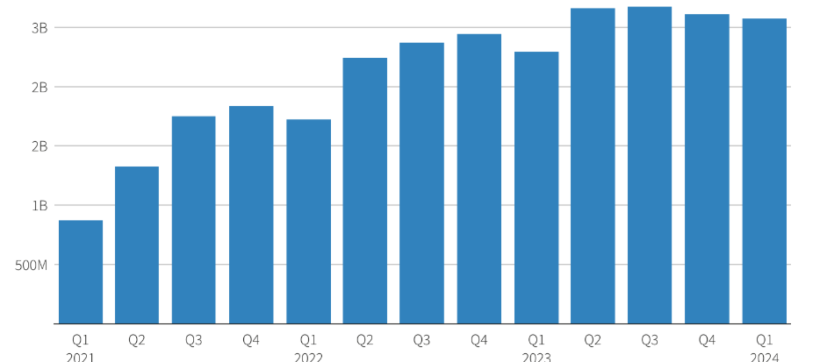
Figure 4: Global revenue of Hilton in the last three years
(Source: Jain and Oladipo, 2024)
The above figure indicates that the global revenue of the hotel group is increasing rapidly. It is reccommended that proper coordination between front office and back office helps in generating adequate amount of revenue.

Theoretical interpretation
Theoretical framework explains interdepartmental coordination and its impact on accessing the impact on the satisfaction level of the guest. Systems theory conceptualises the hotels as an interconnected system in which the front office and the interactions may be able to determine the system performance (Jia et al. 2024). The theory helps in managing the complex communication in the business orientation (Arnold, Kleve and Pieper, 2024). Systems theory helps in articulating the decision-making criteria (Hallioui et al. 2022). This category of perspectives emphasises towards the optimisation of individual departments despite considering interdependencies, where it produces better outcomes.
On other hand, it is determined that Social Exchange theory can be interpreted about the interdepartmental coordination through the orientation of different norms and incorporates towards the trust-building processes. Social exchange theory is useful to identify the future direction regarding business growth (Ahmad et al. 2023). The process leads to successful coordination of business approach, which requires having some positive exchanges between different departments, which may further involve creating a social capital which is able to facilitate future cooperation.

Impact of the coordination to ensure the guest satifaction level.
The guest satisfaction represents the fulfilment of the expectations level through the orientation of different service encounters, along with the proper coordination of service quality, which may influence the overall fulfilment process. According to Lvov and Komppula (2024), hotel management plays a crucial role of shaping the guest experience within the hospitality industry. It is assessed through service quality, HRM practices, and technological innovation, which may influence the customer satisfaction rate and organisational performance by a certain margin. However, the research work of Makivić et al. (2024) fully contradicts the above parameter and indicates that AI has an impact on the assessment of guest satisfaction within the hotel. The study of Kazakov et al. (2025) further includes that guest satisfaction level can be improved by identifying the micro-element failures within the hotel services. It can be further assessed through deep learning of online reviews.
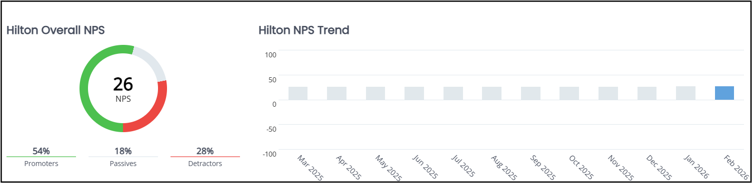
Figure 5: NPS trend in Hilton hotel
(Source: Hilton, 2024)
The above figure indicates the Net Promoter Score for Hilton Hotels in the last one year.

Critical analysis of the challenges faced by different departments
The majority of the problems arise owing to orientation of information asymmetry that occurs among various departments. It can be incorporated through the assessment of shift-based operations and indulging physical separation and may also create some coordination gaps. As indicated by Segura-Cedres et al. (2025) front office staff is expected to be operating on the guest-facing schedules, where they often struggle in terms of synchronising with housekeeping teams through different types of operational factors. The working conditions of hotel are projected to create certain challenges during the time of crisis (Martín-Duque and Romero-Padilla, 2023). The working conditions after the pandemic are considered to remain an unsolved issue, especially for hotels run by women managers. The use of AI in hospitality industry is elevating the experience of guests through the help of innovation (Sahota, 2024). The issue related to cultural diversity occurs in DoubleTree by Hilton on Stratford-upon-Avon due to international business as staff impose different backgrounds and the cross cultural factors are projected to come into play. According to Khatter (2025), the majority of challenges faced by the two departments are because they failed to adapt to rising trends as per market consequences. However, the study of Ghani et al. (2022) indicates that common challenge is the retention of proper employees in terms of accessing the growth rate. Language and cultural diversity are also considered primary factors that may hamper the trust level of customers.

Analysis of the solution to improve the guest satisfaction level
The guest satisfaction level can be improved by the use of technology. It can be accessed through the help of real-time communication platforms, which may enable providing instant updates on room status and maintenance issues. The upgradation in mobile applications and orientation of cloud-based systems may be able to facilitate some options regarding information sharing, the process of reducing coordination, along with the lag times, which may negatively impact guest experiences (Duyen and Tuan, 2025). According to Permatasari, Maghrifani and Wibowo (2025), guest satisfaction level can be improved through the orientation of improving the budget of the hotels. The approach of management in terms of building proper infrastructure can satisfy the customers by a certain margin. However, the study of Olorunsola et al. (2022) contradicts and adds some points to the parameter that guest experience can be improved with the help of eco-friendly experiences. The process to maintain standardised communication protocols and implement formalised procedures access towards managing the room status, interpreting the priority communications, and further creating certain pathways (Azzahra and Asshofi, 2025). The process also reduces the consistent coordination regardless of individual personalities or shifts made towards accessing certain changes.

Literature gap
The overall study experience shows some gaps whiin the literature. The study of Ghani et al. (2022) explains that the common challenges are about retaining staff, but the aproach or training process is not properly explained. The research work of (Londhe, 2024) explained the team working activities, but it failed to explain its implications. The research work of Makivić et al. (2024) indicates that AI has an impact on the assessment of guest satisfaction within the hotel, but the coordination of front-office and back-office staff is not explained.

Conceptual framework
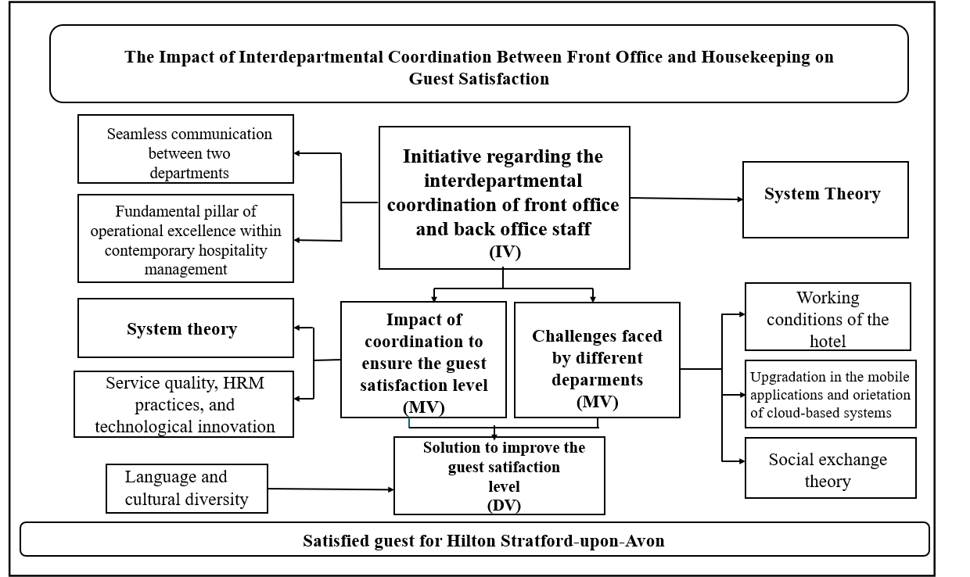

Figure 5: Conceptual framework
(Source: Self-developed from the whole literature review)
The above figure conceptual framework explains different parameters of literature review for hotel group.

Summary
Summarising literature, it can be said that interdependency occurs between the tow departments by maintaining some structured coordination protocols. The research work identifies the guest satisfaction level, challenges faced by departments and the improvement strategies.

Chapter 3: Methods
The study is conducted through secondary data, which is collected from different valid sources and fits with aims and objectives of the research project.
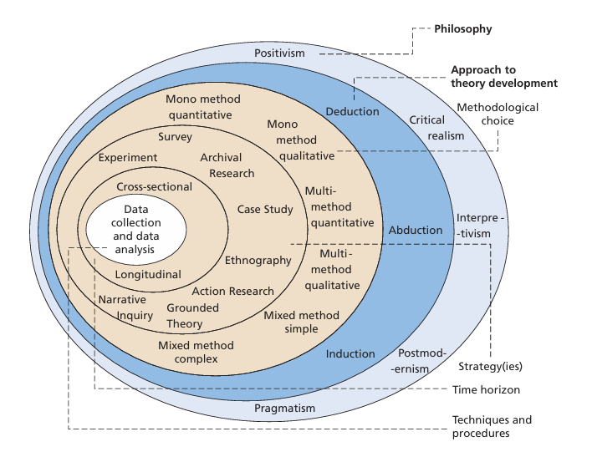
Figure 7: Interpretation of data collection and data analysis
(Source: Saunders, Lewis and Thornhill, 2019)
The data collection and data analysis for the selected group of hotel is explained through help of research onion.

Research philosophy
Interpretivism philosophy is selected for research, which interprets the approach regarding coordination of front office and housekeeping staff. The interpretivism philosophy helps in the development of the subjective approach and also manages the experience of an individual. The philosophy is identical to analysing use of technology within the business. In the present context of research, interpretivism philosophy is appropriate as determining correlation between the impact of the factors on business operations can be effectively established through different variables.

Research approach
Research approach is defined as set of processes and plans identical towards collecting data and logically analysing them. The inductive approach is selected as it suits exploration of new phenomena (Saunders, Lewis and Thornhill, 2019). The inductive approach is selected because it coordinates properly with the initiatives regarding interdepartmental coordination of front office and housekeeping staff.

Research design
An exploratory design is selected because it helps in the development of a proper theoretical approach and further enchances the criteria in terms of making a proper investigation of the study. The selected research design will further help in the development of an implementation roadmap in terms of enhancing strategy regarding the incorporation of resource requirements (Saka, Chinagozi and Joe, 2023). The exploratory design is also identical in the development of flexibility within certain methods regarding the source of data. An in-depth analysis of factors is possible with the exploratory design as this method supports variability of the factors.

Research strategy
In terms of determining the research strategy, case study analysis is identical as it helps towards exploring real-world examples regarding the accessibility of guest experience within the hospitality industry. The case study analysis helps focus the research towards proper direction and it helps determine the impact of the factors on operations efficiently. This also makes the arguments evidence-based which helps identify themes which, in turn, helps determine effective conclusions.

Research choise
The mono method is selected in terms of accessing the qualitative approach, which helps to develop consistency regarding the collection of adequate data. The method also helps towards streamlining the analysis and assessing the process of collecting data. It helps to understand different challenges faced by the respective company (Veal, 2006). The method also helps towards streamlining the analysis and assessing the process of collecting data. It also emphasises the depth of analysis due to themes generated are not focused on singular facts but propose different horizons of information which are appropriate for the present research.

Data collection and analysis
In the research work, secondary data is generated from various sources, including, journals, articles, books, and industry data access. The information is obtained from contemporary newspaper articles, Google Scholar, and government sites (Mazhar et al. 2021; Cheong et al. 2023). The keywords used in terms of collecting data are interdepartmental coordination among front office and housekeeping, the impact of departmental coordination in the hospitality industry, and how proper coordination helps in improving the guest satisfaction level. The study of Lim (2025) explains that qualitative data is identical in the representation of findings, and also gains some descriptive results about the topic. The secondary approach is considered to be productive in terms of collecting detailed information different varieties of credible sources (Kelly, Peters and Farber, 2024). The primary sources of information include goverment reports, company websites, and journals expected to be published by some renowned scholars. The selected databases for the research work are Google Scholar, ResearchGate and hotel websites. The timeline used in terms of collecting data is 2020 to 2025. The approach is identical in gaining the trust of the stakeholders for the selected hotel group. The existing case studies are also part of the reports which are essential for the development of research evidence.
The research project was formulated through qualitative data in terms of accessing the secondary method data collection. The collected data are enforced in a systematic way, where it focus on the implementation of the effective techniques used for data collection and analysis (Ganesha and Aithal, 2022). The inspection models, along with the transformation of the gathered data are identical in their aim of extracting better insights in terms of supporting the decision-making process.

Accessibility for secondary data
The secondary data is considered to be available easily and can be cost-effective which is also a reason for choosing this research method. However, the challenges may occur due to restrictions along with quality and control issues before the integration and ethical aspects. The problem may also occur owing to the lack of relevance in the utilisation of the sources of secondary data.

Chapter 4: Fiding and Discussion
Departmental coordination, as found in the earlier literature, showcases its role in harnessing stakeholder satisfaction. Even for the case of the hotel industry and prominent players with their branches namely DoubleTree by Hilton on Stratford-upon-Avon such effectiveness is unprecedented. However, the focus of earlier studies was too broad but emphasised the strong interplay between the coordination of front office and housekeeping. This chapter intends to critically cover the mechanisms that can be comprehended for establishing strong coordination between front office and housekeeping.

Fidings

Theme 1 : Interdepartmental Coordination Mechanisms Between Front Office and Housekeeping
The interdepartmental communication between Front Office (FO) and Housekeeping (HK) departments of DoubleTree by Hilton Stratford-upon-Avon is mainly supported through the organised operations systems and a uniformity in communication practices. The utilisation of an integrated Property Management System (PMS) like Opera PMS can be compreheded as a central coordination mechanism (Oracle n.d.). It helps to share the real-time room status information across departments even within the organisation. Statuses such as vacant clean, vacant dirty, and out of order of rooms are constantly updated by the housekeeping and viewed by front office to assist in the correct allocation of rooms and efficient check-in processes of guest (FSM, 2025a). This is a coordination system based on a system that eliminates confusion and service delays especially in peak seasons.
Basides technological integration, coordination of daily operations is also strengthened by morning briefings and handover reports. Such briefings enable the supervisors of the two departments to coordinate on the anticipated arrivals, departures, special guest requests and priority rooms (Hospitality Institute, 2024). The internal operations guidelines of Hilton are based on the idea of cross-departmental communication as one of fundamental pillars of consistency in the service provided (Hilton, 2023). It has allowed the organisation with its branches such as DoubleTree by Hilton to build reputation among customers, enabling it to service more than 224 million customers (Hilton, 2024). Such numbers indicate that departmental coordination is strongly linked with the growth in the number of customers with high satisfaction.
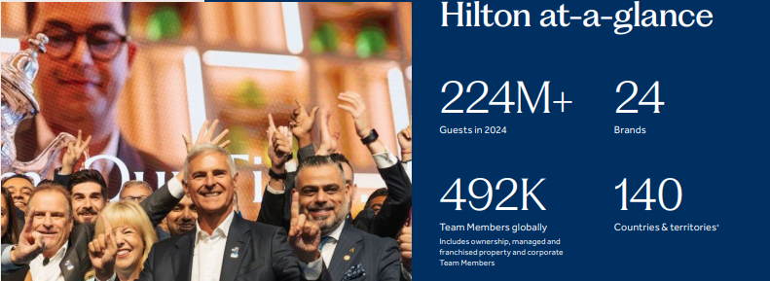
Figure 8: Hilton Customer Number and Expansion
(Source:Hilton, 2024)
The mechanism of coordination has widespread use in the brand as examples of other Hilton-branded properties in UK indicate. As per industry metrics, established hotels in operation are using PMS systems to coordinate the activities of the housekeeping team and front office groups (Hollander, 2025). Eventually the market growth for PMS systems has been increasing, with the present stance at £1.28 billion ($1.73 billion) which is expected to reach £1.81 billion ($2.44 billion) by 2031 with a CAGR 7.05% (Mordor Intelligence, n.d.). Notifications about real-time room availability are displayed to reduce the average room turnover significantly. This reflects the majority of the best-practice coordination models applied in global hotel chains where communication mediated by technology is given a prioritising stance in enhancing technological efficiency.
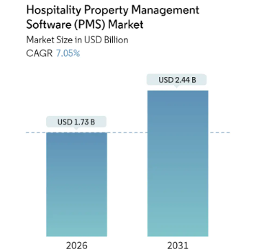
Figure 9: Market Growth of PMS System for Hospitality
(Source: Mordor Intelligence, n.d.)
Althrough standardisation enhances stability and regulation, it can reduce flexibility in operations in cases of unforeseen interferences (McCarthy, 2024). The results hence indicate that technology based coordination is effective but its success is subject to the responsiveness of staff and flexibility in standard operating procedures.

Theme 2: Impact of FO-HK Coordination on Guest Satisfaction
An assessment of the information from guest reviews emphasises that most frequent positive areas include-room prepared upon arrival, well-sized and well-maintained rooms and responsive and knowledgeable front desk workers (Oracle, 2025). It is indicated by these remarks that the quality of services is normally seen by guests as collective accomplishment and not the departmental performance. The effectiveness of FO-HK coordination is closely related to the level of cleanliness, as such scores are always among the top parameters that determine the level of satisfaction with hotels (Hospitality Institute, 2024). With the Front Office having proper visibility of housekeeping progress, there is a possibility to control all the expectations of the guests and avoid dissatisfaction associated with waiting or unclear information. Hilton has its own standardised policies of maintaining quality and other associated factors related to guest experience. This can also be seen in the case of DoubleTree by Hilton on Stratford-upon-Avon in regards to check-in systems, room readiness, cleanliness and other related areas.
Feedback Theme | Positive Evidence OR/AND Negative Evidence | Link of FO-HK Coordination
Check-in systems | 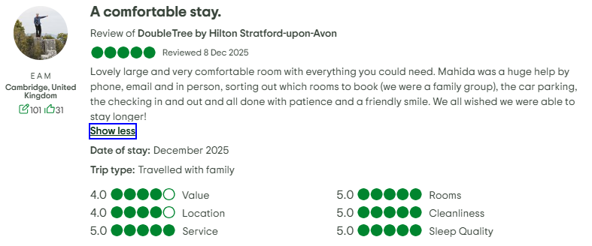  Figure 10: Evidence on Cleanliness  (Source: Tripadvisor, 2025)  Friendly behaviour of staff and polite actions impressed guests and compelled them to stay longer (Tripadvisor, 2025). | Efficient guest services and professional staff behaviour showcased.
Room readiness | 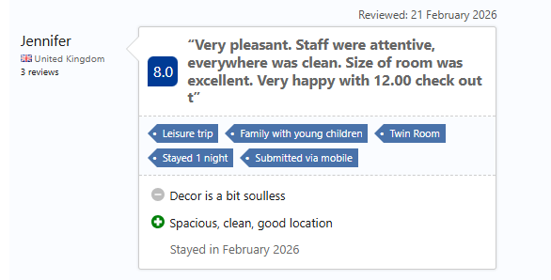  Figure 11: Room Readyness  (Source: Booking.com, 2026)  Spacious, clean, good location of rooms is a positive sign while soulless decoration was found objectionable (Booking.com, 2026). | Indicates professional yet less personalised efforts.
Cleanliness | 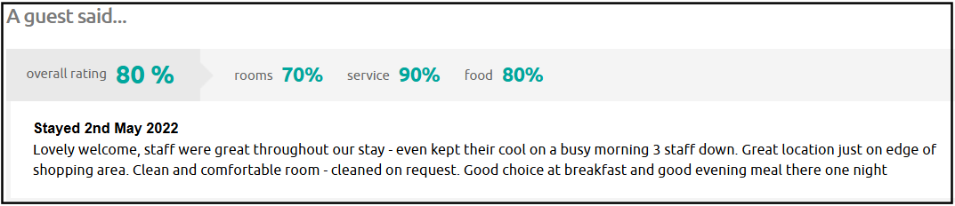  Figure 12: Clean and Confortable Rooms  (Source: Myhotelbreak, 2022)  Rooms are cleaned and service delivery is also good as per the review of the guest regarding room service on demand (Myhotelbreak, 2022). | Efficiency in cleanliness and service delivery is seen.
Table 1: Summary of Key Feedback
(Source: Self-developed)
This is also strengthened through the use of qualitative indicators. According to the benchmarkers in the industry, the average of the cleanliness ratings and higher scores of Guest Satisfaction Index (GSI) are observed in hotels where the FO-HK communication systems are combined than in the ones where similar practices remain disintegrated (FSM, 2025a). The Hilton portfolio performance at the brand-level suggests that the hotels that have smooth workflow between departments are likely to boast a guest satisfaction rating of 694 out of 1000 points (Hilton, 2025). The efficiency of operation is also correlated with improvements in the perception related to the guests and decreased levels of service delays can be interpreted as an improvement of overall scores under review.
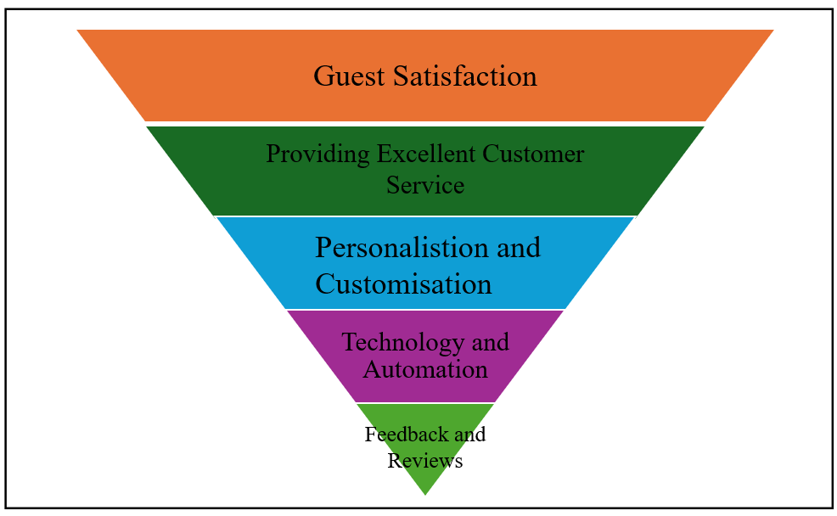
Figure 13: Relationship of Front Office and Housekeeping with Guest Satisfaction
(Source: Self-developed)
One of critical observations evaluated from the preceding analysis is the indirectness of guest judgment. Although Front Office staff normally interacts with guests at the point service, latent problems of failure to have rooms ready on time are usually encountered as a lack result of coordination between Housekeeping and individual staff performance (FSM, 2025b). The delays in room preparation are often linked by guests to poor coordination rather than performance by housekeepers only (Vipspms, 2025). This explains why it is important to perceive guest satisfaction as a by-product of operational alignment, which is the strategic value of FO and HK coordination in the delivery of same service quality.

Theme 3: Challenges in Front Office-Housekeeping Coordination
Among the biggest issues, one of most impactful is the high occupancy seasons resulting increasing check-outs and arrivals at the hotel, causing the departments encounter significant pressure. Even minor delays caused during the cleaning rooms or communicating the status of guests during peak times for check-in process are is derogatory for an organisation’s delivery of services (Catala Consulting, n.d.). The other glaring limitation is staff shortages. The UK hospitality industry reports indicate that exceptionally high levels of staff turnover rate 2024 stand at 52% (Moore Kingston Smith, 2024). This employee turnover limits the degree of business stability and imposes an additional burden on the remaining employees which increases the probability of communication failure and errors in the process (Shkuri, 2025). In this instance, FO staff may not receive the information regarding room preparedness in a timely or fully equipped, which will weaken the ability to meet the needs of customers at the check-in counter.
The structural benefits of coordination and challenges that emerge from the absence of coordination among departments can be more effectively illustrated with SWOT analysis of DoubleTree by Hilton Stratford-upon-Avon.
Strenghts  - Firm brand systems.  - Integrated PMS (Property Management Systems).  - Standardised service protocols. | Weaknesses  - High reliance on labour supply.  - Low flexibility in times of high demand.  - Training gap in the usage of a system.
Opportunities  - Increased employee training.  - Automation of processes. | Threats  - Growing labour deficits (Moore Kingston Smith, 2024).  - Higher expectations of guests.

Table 2: SWOT Analysis
(Self-developed)
These difficulties are further amplified by the failure of communication. Through systems like PMS platforms which allow technology-enabled coordination are made to help streamline cooperation, their success is determined by the proper and timely use of technology (Priority n.d.). It may be caused by technology lag, systems downtimes, or staff training inconsistency which can cause outdated information about room status thus making check-ins or room switchover very challenging at the last minute. These problems demonstrate that the failures of coordination could hardly be pointed out to one specific department, but instead they are manifestations of bigger systemic and structural constraints. The cause-effect correlation that has arisen out of the results is evident from lack of coordination between FO and HK. These may cause delays in the readiness of rooms, which further may cause frustration in guests and aggravate the negative reviews on the internet (Bajpai, 2025). To the guests, such failures are usually construed as lack of efficiency in service, notwithstanding the operational factors. This illustrates the reputational risk that is involved in trying to coordinate branded hotels.

Theme 4: Coordination as a Source of Competitive Advantage
Good interaction between Front Office (FO) and Housekeeping (HK) activities is a strategic performance driver and a competitive advantage generator for DoubleTree by Hilton Stratford-upon-Avon. Coherent interdepartmental synchronisation guarantees that brand norms are met in a way that ensures consistency in delivery of brand promises across guest touchpoints (Dehan, 2024). It reinforces the value proposition of Hilton which is quality delivery of service and professionalism in operations. With the coherent functioning of FO and HK, service experiences, like check-in and rooms preparation, and resolution of issues become more successful (Traininghotels, n.d.). It can lead to greater brand consistency and increased trust in guests. Such consistency is more vital when it comes to branded hotels where by consumers anticipate a consistent service delivery pattern despite the geographic location.
On performance aspects, repeat visitations and brand loyalty are directly related to coordination. Reports revealed that travelers have an increased chance of returning to the same property where they receive an excellent service and disruption of operations is minimal (Mogelonsky and Mogelonsky, 2025) Efficient coordination of FO-HK in DoubleTree by Hilton Stratford-upon-Avon can prevent failures of services which usually cause dissatisfaction from delayed availability of rooms or concerns over cleanliness, resulting in enhancement of guest retention rates. Compared to non-branded or self-managed hotels, branded properties enjoy the combined economies of systems and common operating practices that enable coordination to be scaled efficiently between periods of high demand (Hotel Online, 2025). It helps them to build their competitive positioning. The relevance of coordination as a competitive advantage to operations can also be examined with utilisation of PESTLE framework.
Factors | Details | Relevanance to Coordination and Competitive Advantage
Political | Health and safety compliance for workers through Health and Safety at Work Act 1974 reduces chance of pressuring workers to improve their business needs in hotels (MSL, n.d.). | The adherance ensures coordination actions among FO and HK.
Economic | No less than 16% rise in national Living Wage puts pressure on profitability for hotels (PwC, n.d). | It necessitates departmental coordination to reduce overtime related changes.
Social | The rising demands of guests towards speed, preference and convenience (BDO, 2024). | It puts FO and HK on the same page to provide timely and precise service responses.
Technological | Advanced PMS allows real time changes in room status, facilities more rapid check-ins and minimises service mistakes (Oracle, n.d). | It leads to a perceived improvement in service quality.
Legal | Employment laws and working time regulations have an impact on the flexibility of staffing (MSL, n.d.). | Flexibility can be assured if the laws are properly adhered to.
Environmental | Proper disposal of waste is a subject of focus for staff under sustainability (Zestrecycle, 2024) | FO-HK coordination improves that function.

Table 3: PESTLE Analysis
(Source: Self-developed)

Discussion
The research objectives firstly aimed at discovering the interdepartmental coordination programmes that were currently employed by FO and HK departments within the hotel of DoubleTree by Hilton Stratford-upon-Avon. The results prove that the main forces of coordination at the case-study hotel are the systems facilitated by technology and standardised practices of communication. Real-time updates to room status by the introduction of Property Management Systems (PMS), especially Opera PMS help FO staff to allocate rooms correctly and minimise service delay (Oracle, n.d.). Moreover, morning briefings and handover reports were found to be the primary coordination mechanisms that supported the continuation of operational alignment cycle in daily service. These results indicate that DoubleTree by Hilton Stratford-upon-Avon needs to solidify cross-departmental harmonisation significant challenge can be prominent in terms of service delivery.
During the review of literature, these results are highly consistent with previous studies on the significance of coordination protocols that are structured in the operations of the hospitality business. According Laia and Widagdo (2025), interdepartmental interaction that is facilitated by standardised systems boosts the reliability of services. Again, Abbas et al. (2025) suggest that digital capabilities may also intensify the work of terms when integrated in the organisational routine. The results also support the facts of Systems Theory that conceptualises hotels as interconnected subsystems which rely on the quality of internal interactions to perform (Arnold, Kleve and Pieper, 2024). Nevertheless, findings are an addition to the literature since they show that technical coordination cannot be effective without the efforts of responsiveness of staff and flexibility of procedures. This supports the fact that the standardisation should be moderate with human flexibility to guarantee competency in the dynamic service setting.
Following that the objective was to scrutinise the effect of FO-HK coordination on the satisfaction of guests. Results obtained show that successful coordination will have a positive impact on guest experiences, including a shorter waiting time in the check-in area, appropriate information regarding the ready room and an increased perceived standard of cleanliness (Hospitality Institute, 2024). The brand-level Guest Satisfaction Index (GSI) score of 694 is part of the Hilton-based chain that additionally confirms the connection between the organised internal processes or operations and the positive attitude of guests (Hilton, 2025). The outcomes indicate that customers usually have a holistic view of the service quality whereby they tend attach satisfaction or dissatisfaction to the entire hotel rather than giving any departmental priority.
The third research problem was on the difficulty of effective coordination in FO and HK departments. The results in this suggest that the most critical hindrances to coordination at DoubleTree by Hilton Stratford-upon-Avon are high occupancy periods, labour shortages, communication breakdowns, and technology misuse. Industry statistics indicate that employee turnover in UK hospitality industry has been up to 52% in 2024 which contributes to the instability in operations and a higher risk of coordination failures (Moore Kingston Smith, 2024). Even a slight delay in cleaning rooms or updating the status may cause a huge waiting line, frustration on the part of the guests, and a poor online review in the case of peak times.
The current research is profoundly convincing these findings since labour instability and information asymmetry have been cited a acute challenges in the operations of the hospitality sector. Martín-Duque and Romero-Padilla (2023) support the use of shift-based work organisation and the physical division between departments due to increasing the coordination gaps especially when experiencing pressure. On the same note, Ghani et al. (2022) note that employee retention and training shortages are some of the main causes of service irregularities. Nonetheless, the results can refute the simplified explanations in which failures are seen as caused by individual departments, and they favour a systems explanation of the breakdown of coordination. It fits with the systems theory, which reminds us that in many cases, performance failures are manifested through a mismatch of processes rather than inefficiency of individual (Hallioui et al. 2022). The results, therefore, support the literature’s call for structural solutions that focus on workforce stability, training continuity, and adaptive coordination frameworks.
The final study goal empirically investegated coordination as a competitive advantage to some extent. The results indicate that successful coordination of FO-HK helps boost brand consistency, value proposition of Hilton and increases repeat visitation. Coordination helps branded hotels such as DoubleTree to provide consistent service results, which boost their confidence in a job and consequently their loyalty (Dehan, 2024). Further performance indicators indicate that the chances of guests returning to the property, in which service disruptions are insignificant, and operational efficiency is apparent, are higher (Morelonsky and Mogelonsky, 2025). The coordination of the integrated systems and standard operating procedures of Hilton can be scaled more efficiently in times of high demand than in non-branded hotels.
The Theory of Resource-Based View implies that interdepartmental alignment is a type of resource that can generate long-term competitive edge in case the capabilities are valuable, inimitable and embedded in the organisational routines. The PESTLE analysis also reveals that external environmental factors like rise in labour costs, rising expectations of the guests, and technological changes thus affect the coordination (PwC, n.d.). The discussion supports the fact that interdepartmental coordination of FO and HK is at the heart of guest satisfaction, operational stability and competitive advantage. Technology provides the framework of coordination and its final product is human cooperation, training and dynamic management practices. This gives more power to the central thesis that sustainable service excellence in hospitality is achievable through harmonisation of the systems, people and organisational culture rather than the application of operational solutions that are isolated. Although operational systems and procedures exist, success of coordination process between housekeeping (HK) and front office (FO) departments in the DoubleTree by Hilton Stratford-upon-Avon is influenced by various operational issues. A high number of check-outs and arrivals at the hotel in seasons is also one of the largest problems and is most evident as it concurrently strains the departments. It stresses that improvement in hospitality services can be achieved (Widiastini et al. 2024).

Summary
The results indicate that the key to guest satisfaction at DoubleTree by Hilton Stratford-upon-Avon is coordinated interdepartmental efforts of Front Office and Housekeeping departments. Real-time communication systems like those provided by integrated Property Management Systems are facilitated by technology to reduce delays in the receipt of services and organised briefings improve alignment of daily operations. The perception of cleanliness, readiness of the room and responsiveness of the service are seen as the results of group efforts by several departments. Again, issues such as a shortage of labour, high staff turnover and peak occupancy pressures keep on disrupting coordination. In general, the results indicate that coordination is more than a functional mechanism as a strategy leading to service quality and competitive advantage.

Conclusion
The research sets out to critically navigate the impact of interdepartmental coordination between the Front Office and Housekeeping departments on guest satisfaction. Along with this, the study aimed to understand how coordination, communication and operational efficiency between two departments shape guest perception and service quality within the UK hospitality sector. Parallelly, it also contributes to a growing body of literature which emphasises the interdependence between internal coordination and customer satisfaction within the hotel industry. The research revealed that in service-based organisations, specifically in hotels, department coordination is considered to be one of the primary strategic determinants of guest satisfaction. The Housekeeping department and Front Office department act as the heart of the hotel operations. The former represents the face of the interaction with guests and the other ensures the physical manifestation of service is provided through comfort and cleanliness. When the departments work in isolation, a lack of communication leads to failure in guest satisfaction. At the hotel, DoubleTree by Hilton on Stratford-upon-Avon, the findings indicate that while the hotel benefits from standardised systems including ONQ PMS, the coordination between humans remains a crucial challenge.
The primary finding of the study includes the fact that effective coordination directly correlates with the higher satisfaction level of the guests. Moreover, when the communication is effective, the readiness of the room and the guest expectations are minimised. On the contrary, when coordination weakens, guest experience stems from unclean rooms as well as delayed check-ins. The outcomes demonstrate that the experience among guests is only as strong as the collaboration behind it. The primary strength of DoubleTree Stratford-upon-Avon is its reputation as a brand, integration of technology as well as a global framework of operations.
The investigation within coordination mechanisms in theme one shows that the hotel has adopted an integrated PM, namely, the OnQ system which helps in streamlining real-time communication between housekeeping and front office. The integration eliminates confusion, which ensures that room readliness information, such as vacant clean as well as out of order, is simultaneously updated. According to Michel-Häggström (2022), the integration of PMS has become a cornerstone of operational communication within global hotel chains. Technology solutions leverage transparency and reduce miscommunication. Findings from the case study suggest that success is contingent on responsiveness of staff and proper training.
Theme 2 explored the direct and indirect effects of coordination on guest satisfaction. The reviews from the guests and service performance data continuously indicate that satisfaction is not perceived as an individual department outcome rather a whole achievement. The components like prompt room availability, cleanliness and responsive front disk interactions are connected outcomes of effective FO-HK coordination. As identified by the hospital institute, the guest’s mode of value is seamlessness and smooth internal communication. The brand-wide GSI of 694 out of 1000 supports the relationship which demonstrates that collaborative departments and operations lead to higher satisfaction.
Theme 3, however, uncovered several challenges that inhibit optimal coordination. The primary issues included labour shortages, elevator-staffed turn, and over- 52% in 2024 within the UK hospitality sector. Comprehensively, all these factors are related to training communication systems and creating service delays.
The fourth theme demonstrates that interdepartmental coordination is not only an operation but also serves as one of the strategic sources in competition. The framework of PESTLE reveals that coordination is influenced by both internal and external forces.
Furthermore, the study suggests that Hilton can strengthen coordination through the implementation of Key Performance Indicators (KPIs). The development of the modules of training focuses on empathy and communication, which helps in improving staff collaboration and models. Through regular feedback from staff between the two departments, housekeeping teams and front office help the hotel identify the recording issues as well as improve the services. The results showcased that technology alone could not ensure effective coordination. Therefore, the management is required to balance the digital reliance as well as interpersonal engagement. Therefore, investment in the relationship building across the department can reduce friction as well as align all the staff towards a common vision goal. From the perspective of the industry, it can be said that the findings have broader implications for the UK hospitality sector. Moreover, according to the report, the hotel industry will generate over £23 billion in 2024. This marks a steady recovery post the pandemic with the intensification of the competition. Hotels that ensure interdependent efficiency are in a better position in order to deliver excellent services as well as maintain profitability. Additionally, the research provides a framework unlike other hotels, specifically within the last chance of adopting to improve synergy within the operations.
However, the study is not without limitations. Therefore, DoubleTree by Hilton on Stratford-upon-Avon restricts generalisation across all types of hotels. Along with this, the research reinforces that within the hospitality industry, giving satisfaction initiatives behind the scenes, such as within the quality of communication among those who delivered the experience.
Conclusively, it can be said that the study confirms that effective coordination between the Housekeeping department and Front Office is much more fundamental to achieving satisfaction for guests and operational excellence. At the hotel, DoubleTree by Hilton Stratford-upon-Avon, the synergy determines not only the smoothness of internal operations but also the final impression of guests with regard to the brand. Due to an increase in competition in the market, as well as guests’ expectations, the hotel’s ability to serve a seamless experience through collaboration becomes a definitive strength.

Recommendations and Practical Strategies
Overcoming challenges in front office-housekeeping coordination:
Cost: Low to Medium
Difficulty: Easy
Rationale: The recommendations are provided in terms of providing a monthly bonus and assessing the staff properly. The implementation of housekeeping standards helps in solving crucial problems (Aldi et al. 2025). The quarterly team excellence award and social bonding activities can be able to drive the growth.
Timeframe: Mid-term (12 months)
Establishment of real-time communication infrastructure:
Cost: High
Difficulty: High
Rationale: The practical implication for real-time communication infrastructure includes deploying mobile devices and integrating real time room status. The real-time communication feasibility in an IoT based system can be able to solve certain issues (Micheletto et al. 2023). Open innovation in hospitality management can be accessed through leveraging AI driven dynamic scheduling systems (Pitakaso et al. 2025). It helps in reducing the check-in and waiting times and also decreases communication errors.
Timeframe: Mild-term (11 months)
Creation of a dedicated coordination role:
Cost: Medium
Difficulty: Low
Rationale: The coordination can be maintained through designating a staff member with experience in both departments. The enhancement of teamwork in the hospitality industry is considered to be the crucial aspect to drive the growth (Jung, Lee and Lim, 2023). It helps towards enhancing communication during operational periods and is able to increase accountability.
Timeframe: Short-term (6 months)
Implementation of cross-departmental training programme:
Cost: Medium
Difficulty: Medium
Rationale: The job shadow programme or a monthly workshop for two hours can be able to solve issues. The cross-functional training process among the employees in 5-star hotels is projected to drive the growth. The approach also helps in building loyalty. The approach also includes a rotational scheme for new employees and the ongoing programme launch in 2 months.
Timeframe: Short-term (2 months)
Enhancement of performance management and accountability:
Cost: Medium
Difficulty: Medium
Rationale: The approach is suitable for assessing average check-in time and determining room readiness scores through the dashboard. The performance accountability provides an impact on performance management (Sun, 2024; De Araújo et al. 2024). The performance measurement system provides an impact towards the organisation performance depending on the transition economy (Tran and Nguyen, 2020). It helps achieve zero guest complaints, and 90% of rooms will be ready within 30 minutes of check-in.
Timeframe: Mid-term (1.5 years)
Investment in employee well-being and development process:
Cost: Medium
Difficulty: Medium
Rationale: The approach focuses on enforcing career development pathways along with fair workload distribution. The workplace must focus on investing in employee well-being to ensure resource allocation in a proper manner (Henstock et al. 2025). Sustainable development in corporate organisations helps improve health and employee well-being (Thakur and Pathak, 2023). Employee morale and job satisfaction levels will improve.
Timeframe: Long-term (3 years)
Implementation of proactive guest communication:
Cost: High
Difficulty: Medium
Rationale: It can be accessed through real-time arrival management. The proactive strategies help in enhancing the guest communication (Nazifi, Murdy and Olya, 2025). The training can be provided to front desk staff, who can access the growth rate.
Timeframe: Mid-term (2 years)
From the overall facts, it can be cocluded that interdepartmental coordination of the Front Office and Housekeeping departments is a strategic competence and not an operational requirement. At DoubleTree by Hilton on Stratford-upon-Avon, in spite of the fact that the transparency is improved by the application of technological systems (OnQ PMS), the key elements of sustainable guest satisfaction are human cooperation and the level of communication. Futher, it can be concluded that enhancing operational efficiency by strengthening the existing coordination mechanisms will also provide support to competitive positioning in constantly competitive UK hospitality market. However, similar research can be extended to various hotel categories in future to increase the generalisability of the studies.

Reference List
Abbas, M., Hussain, K., Bajwa, S.U. and Rasheed, M.A. (2025) ʻDriving team performance through digital capabilities in the hospitality industry: a transactive memory system perspective.ʼ Journal of Hospitality and Tourism Insights, 56(23), pp.1–17. Available at: https://doi.org/10.1108/JHTI-03-2025-0393?urlappend=%3Futm_source%3Dresearchgate.net%26utm_medium%3Darticle (Accessed: 29 January 2026)
Ahmad, R., Nawaz, M.R., Ishaq, M.I., Khan, M.M. and Ashraf, H.A. (2023) Social exchange theory: Systematic review and future directions. Frontiers in Psychology, 13(2), pp.1–13. Available at: https://www.frontiersin.org/journals/psychology/articles/10.3389/fpsyg.2022.1015921/full (Accessed: 01 February 2026)
Aldi, A., Adiatma, D., Deden and Dhamayanty, S. (2025) ʻCHALLENGES AND OPPORTUNITIES IN IMPLEMENTING GLOBAL HOUSEKEEPING STANDARDS AT THE GRAND PRINCE HOTEL OSAKA BAY, JAPAN.ʼ Journal Ilmiah Manajemen Ekonomi & Akuntansi (MEA), 9(1), pp.2785–2800. Available at: https://doi.org/10.31955/mea.v9i1.5449 (Accessed: 12 February 2026)
Arnold, T., Kleve, H. And Pieper, T.M. (2024) ʻSystems Theory.ʼ Edward Elgar Publishing eBooks, 29(36), pp.431–435. Available at: https://doi.org/10.4337/9781800888722.ch108 (Accessed: 01 February 2026)
Asgeirsson, M.H., Gudlaugsson, T. And Jóhannesson, GT., (2024) The Relationships between Service Quality, Reputation, and Performance in Hospitality. Tourism and Hospitality, 5(3), pp.736–752. https://www.researchgate.net/publication/383437483_The_Relationships_between_Service_Quality_Reputation_and_Performance_in_Hospitality (Accessed: 28 January 2026).
Azzahra, M.S. and Asshofi, I.U.A., (2024) ʻStudy of the cooperation relationship between the front office and housekeeping departments through communication at hotel tentrem semarang.ʼ Journal of Gastro Tourism, 2(2), pp.75-92. Available at: https://doi.org/10.52465/jogasto.v2i2.457 (Accessed: 01 February 2026)
Bajpai, M. (2025) How to Handle Negative Hotel Reviews Without Damaging Your Reputation?. Available at: https://famepilot.com/how-to-handle-negative-hotel-reviews/ (Accessed: 04 February 2026)
BDO (2024) Hotel Britain. Available at: https://www.bdo.co.uk/getmedia/a950671c-7313-47f4-88d9-83872740906b/BDO-Report-Hotel-Britain-2024.pdf (Accessed: 11 February 2026)
Booking.com (2026) Review score. https://www.booking.com/reviews/gb/hotel/doubletreestratford.en-gb.html?aid=356980&label=gog235jc-10CA0oUEITZG91YmxldHJlZXN0cmF0Zm9yZEgzWANobIgBAZgBM7gBF8gBDNgBA-gBAfgBAYgCAagCAbgCqsPlzAbAAgHSAiQzMzA0ZWI3My1lNzY3LTQ5M2ItOWYzYS0yNmI1NzQ3NjA5MmXYAgHgAgE&sid=25f40de390113903cea88239edcf6179&customer_type=total&hp_nav=0&keep_landing=1&order=featuredreviews&page=1&r_lang=en&rows=75& (Accessed: 23 February 2023)
Catala Consulting (n.d.) From Check-ins to Challenges: Everything You Need to Know About the Front Office Department. Available at: https://catalaconsulting.co.uk/front-office-department-in-hotel/ (Accessed: 04 February 2026)
Cheong, H., Lyons, A., Houghton, R. And Majumdar, A. (2023) ʻSecondary Qualitative Research Methodology Using Online Data within the Context of Social Sciences.ʼ International Journal of Qualitative Methods, 22(1), pp.1–19. Available at: https://doi.org/10.1177/16094069231180160 (Accessed: 02 February)
Collis, J and Hussey, R (2014) Business Research, A Practical Guide for Undergraduate and Post Graduate Students, Palgrave, London. https://www.researchgate.net/publication/38177413_Business_research_A_practical_guide_for_undergraduate_and_postgraduate_students (Accessed: 28 January 2026)
De Araújo, M.L., Caldas, L.S., Barreto, B.S., Menezes, P.P.M., Silvério, J.C. dos S., Rodrigues, L.C., Serrano, A.L.M., Neumann, C. And Mendes, N. (2024) ʻHow to Evaluate the Effectiveness of Performance Management Systems? An Overview of Literature and a Proposed Integrative Model.ʼ Administrative Sciences, 14(6), pp.117–123. Available at: https://doi.org/10.3390/admsci14060117 (Accessed: 14 February 2026)
Dehan, H. (2024) Interdepartmental Communications & Two-Way Staff Messaging will Elevate Hotel Operations in 2024. Available at: https://www.hospitalitynet.org/opinion/4119814.html (Accessed: 04 February 2026)
Duyen, N.T. and Tuan, N.M. (2025) ‘Hotel Service Quality Management at the Tourist Destination of Sa Pa’, Vietnam. Star, 3(2.07), pp.1-13. Available at: https://doi.org/10.62225/2583049X.2025.5.5.4864 (Accessed: 01 February 2026)
FSM (2025a) Interdepartmental Communication: How Housekeeping Coordinates with Other Hotel Departments. Available at: https://fsm.how/accommodation-facilities/interdepartmental-communication-hotel-housekeepin/ (Accessed: 03 February 2026)
FSM (2025b) Exploring the 7 Key Sections of a Hotel’s Front Office Department. Available at: https://fsm.how/accommodation-facilities/exploring-hotel-front-office-sections/ (Accessed: 04 February 2026)
Ganesha, H.R. and Aithal, P.S., (2022) ‘How to choose an appropriate research data collection method and method choice among various research data collection methods and method choices during Ph. D. Program in India’, International Journal of Management, Technology, and Social Sciences, 7(2), pp.455-489. Available at: https://doi.org/10.5281/zenodo.7277944 (Accessed: 03 February 2026)
Ghani, B., Zada, M., Memon, K.R., Ullah, R., Khattak, A., Han, H., Montes, A.A. and Castillo, L.A. (2022) ʻChallenges and strategies for employee retention in the hospitality industry: A review.ʼ Sustainability, 14(5), pp.1–26. Available at: https://doi.org/10.3390/su14052885 (Accessed: 01 February 2026)
Hallioui, A., Herrou, B., Santos, R., Katina, P., Khadiri, H. And Egbue, O. (2022) ʻSystems Theory and Evidence-Based Decision-Making as Keys for Arbitrating between Optimal Production and Efficient Maintenance: A Case Study.ʼ Discrete Dynamics in Nature and Society, 2022(29), pp.1–12. Available at: https://doi.org/10.1155/2022/7660082 (Accessed: 01 February 2026)
Henstock, L., Johnson, R., Kinghorn, P., Beach, D. And Al-Janabi, H. (2025) ʻWhy and how do workplaces invest in mental health and wellbeing? A systematic review and process tracing study.ʼ Social Science & Medicine, 366(89), pp.117–133. Available at: https://doi.org/10.1016/j.socscimed.2024.117633 (Accessed: 13 February 2026)
Hilton (2023) Global Reporting Initiative (GRI). https://travelwithpurpose.hilton.com/wp-content/uploads/sites/4/2024/05/2023-GRI-Index.pdf (Accessed: 03 February 2026)
Hilton (2024) Travel with Purpose. Available at: https://travelwithpurpose.hilton.com/wpcontent/uploads/sites/4/2025/06/2024Report.pdf (Accessed: 03 February 2026)
Hilton (2024) Hilton NPS & Customer Reviews. Comparably. Available at: https://www.comparably.com/brands/hilton (Accessed: 24 February 2026)
Hilton (2025) Hilton Celebrates Triple Win in J.D. Power 2025 North America Hotel Guest Satisfaction Index Study. Available at: https://stories.hilton.com/releases/hilton-celebrates-triple-win-jd-power-2025-north-america-hotel-guest-satisfaction-index-study (Accessed: 04 February 2026)
Hilton, (2021) Travel with Purpose: Hilton 2021 Environmental, Social and Governance Report. Available at: https://stories.hilton.com/uploads/2022/05/2021-ESG-Report-Updated.pdf (Accessed: 28 January 2026)
Hollander, J. (2025) What Is a Hotel Property Management System (PMS): Complete Guide. Available at: https://hoteltechreport.com/news/what-is-hotel-pms (Accessed: 03 February 2026)
Hospitality Institute (2024) How Housekeeping Coordinates with Other Hotel Departments. Available at: https://hospitality.institute/bha105/housekeeping-coordinates-hotel-departments/ (Accessed: 03 February 2026)
Hospitality Institute (2024) Setting Cleaning Priorities in Housekeeping: Strategies for Efficiency. Available at: https://hospitality.institute/bha105/setting-cleaning-priorities-in-housekeeping-strategies-for-efficiency/ (Accessed: 03 February 2026)
Hotel Online (2025) Hotels: Branded or Independent? 5 Key Considerations for Owners & Investors. https://www.hotel-online.com/news/hotels-branded-or-independent-5-key-considerations-for-owners-investors (Accessed: 11 February 2026)
Jia, Y., Garg, A. And Balasubramanian, K. (2024) ‘An exploration of factors affecting hotel consumers’ health from an ecological systems theory perspective: A meta-analytical study’, Journal of Hospitality and Tourism Management, 60(1), pp.1-11. Available at: https://doi.org/10.1016/j.jhtm.2024.07.008 (Accessed: 01 February 2026)
Jain, A. And Oladipo, D. (2024) Hilton lifts profit forecast on international travel demand. Reuters. Available at: https://www.reuters.com/business/hilton-lifts-2024-profit-forecast-international-travel-demand-2024-04-24/ (Accessed 21 February 2026)
Jung, H.J., Lee, S.H. and Lim, S. (2023) ʻEnhancing teamwork in the hospitality industry: The importance of empathy.ʼ International Journal of Hospitality Management, 114(1), pp.103–157. Available at: https://doi.org/10.1016/j.ijhm.2023.103557 (Accessed: 12 February 2026)
Kazakov, S., Cuesta-Valiño, P., Butkouskaya, V. And Muravsky, D. (2025) Improving guest satisfaction by identifying hotel service micro-elements failures through Deep Learning of online reviews. Cuadernos de Gestión, 25(1), pp.71–88. Available at: https://addi.ehu.es/handle/10810/73232 (Accessed: 30 January 2026)
Kelly, M.M., Peters, T.M. and Farber, J.S. (2024) ʻSecondary data analysis: Using existing data to answer new questions.ʼ Journal of Pediatric Health Care, 38(4), pp.615–618. Available at: https://doi.org/10.1016/j.pedhc.2024.03.005 (Accessed: 02 February 2026)
Khatter, A. (2025) CHALLENGES AND TRENDS IN THE HOTEL INDUSTRY. Transforming Tomorrow: Leveraging Opportunities to Create Change in Tourism, Hospitality and Events, 78(98), pp.12–15. Available at: https://search.informit.org/doi/abs/10.3316/informit.T2025052900019892101947025 (Accessed: 30 January 2026)
Laia, S. And Widagdo, C.S. (2025) ʻOptimizing Human Resource Management in the Front Office Department: A Study on Employee Engagement and Service Quality.ʼ International Journal of Economics, Business Management and Accounting (IJEBMA), 7(2), pp.141–152. Available at: https://doi.org/10.59890/ijaeam.v3i5.74 (Accessed: 29 January 2026)
Lim, W.M., (2025) ‘What is qualitative research? An overview and guidelines’, Australasian Marketing Journal, 33(2), pp.199-229. Available at: https://doi.org/10.1177/14413582241264619 (Accessed: 02 February 2026)
Londhe, R.C. (2024) THE IMPORTANCE OF TEAM WORK IN HOSPITALITY INDUSTRY FOR INTERDEPARTMENTAL CO-ORDINATION. ResearchGate. Available at: https://www.researchgate.net/publication/378906572_THE_IMPORTANCE_OF_TEAM_WORK_IN_HOSPITALITY_INDUSTRY_FOR_INTERDEPARTMENTAL_CO-ORDINATION (Accessed: 01 February 2026)
Lvov, A. And Komppula, R. (2024) ‘The essence of the hotel room in the hotel business–the hotel managers’ perspective’, European Journal of Tourism Research, 36, pp.1-22. Available at: https://doi.org/10.54055/ejtr.v36i.3158 (Accessed: 30 January 2026)
Makivić, R., Vukolić, D., Veljović, S., Bolesnikov, M., Dávid, L.D., Ivanišević, A., Silić, M. And Gajić, T. (2024) ʻAI Impact on Hotel Guest Satisfaction via Tailor-Made Services: A Case Study of Serbia and Hungary.ʼ Information, 15(11), pp.700–705. Available at: https://doi.org/10.3390/info15110700 (Accessed: 30 January 2026)
Martín-Duque, C. And Romero-Padilla, Y. (2023) ʻHotel working conditions and challenges in a time of crisis: Perceptions of Spanish women managers.ʼ Tourism management perspectives, 48(53), pp.108–153. Available at: https://doi.org/10.1016/j.tmp.2023.101153 (Accessed: 30 January 2026)
Mazhar, S. A., Anjum, R., Anwar, A. I., and Khan, A. A. (2021) ʻMethods of data collection: A fundamental tool of research.ʼ Journal of Integrated Community Health (ISSN 2319-9113), 10(1), pp. 6-10. Available at: https://doi.org/10.24321/2319.9113.202101 (Accessed: 02 February 2026)
McCarthy, C. (2024) Adapting to the Flexible Working Act: Rethinking Hotel Operations. Available at: https://www.hospitalitynet.org/opinion/4123271.html (Accessed: 03 February 2026)
Micheletto, M., Zabala, P., Ochoa, S.F., Meseguer, R. And Santos, R. (2023) ʻDetermining Real-Time Communication Feasibility in IoT Systems Supported by LoRaWAN.ʼ Sensors, 23(9), pp.4281–4288. Available at: https://doi.org/10.3390/s23094281
Michel-Häggström, V., (2022) Why is PMS Integration with the Opera Hotel System Important? Metasphere. Available at: https://www.metasphere.global/post/interface-opera-hotel-system (Accessed: 12 February 2026)
Mogelonsky, A. And Mogelonsky, L. (2025) Using Hotel Data to Identify Recurring Customers Versus Loyal Guests. Available at: https://www.hospitalitynet.org/opinion/4129379.html (Accessed: 11 February 2026)
Moore Kingston Smith (2024) Addressing labour shortages in the hospitality sector. Available at: https://mooreks.co.uk/insights/addressing-labour-shortages-in-the-hospitality-sector/ ( Accessed: 05 February 2026)
Mordor Intelligence (n.d.) Hospitality Property Management Software (PMS) Market Size & Share Analysis – Growth Trends and Forecast (2026 – 2031). Available at: https://www.mordorintelligence.com/industry-reports/hospitality-property-management-software-market (Accessed: 03 February 2026)
MSL (n.d.) The Importance of Health and Safety Compliance in Hospitality. Available at: https://msl-ltd.co.uk/health-and-safety-compliance-in-hospitality/ (Accessed: 11 February 2026)
Myhotelbreak (2022) DoubleTree by Hilton Stratford-upon-Avon, Stratford Upon Avon. Available at: https://www.myhotelbreak.com/hotel/reviews/1383/doubletree-by-hilton-stratforduponavon.html (Accessed: 23 February 2026)
Nazifi, A., Murdy, S. And Olya, H. (2025) ʻRedefining service recovery: critical insights into proactive strategies and a future research agenda.ʼ International Journal of Contemporary Hospitality Management, 38(1), pp.328–347. Available at: https://doi.org/10.1108/IJCHM-09-2024-1402 (Accessed: 15 February 2026 )
Olorunsola, V.O., Saydam, M.B., Arasli, H. And Sulu, D. (2022) ʻGuest service experience in eco-centric hotels: A content analysis.ʼ International Hospitality Review, 38(1), pp.81–100. Available at: https://doi.org/10.1108/IHR-04-2022-0019 (Accessed:; 01 February 2026)
Oracle (2025) Hospitality In 2025: Automated, Intelligent… And More Personal. Available at: https://www.oracle.com/in/a/ocom/docs/industries/hospitality/hospitality-industry-trends-for-2025.pdf (Accessed: 03 February 2026)
Oracle (n.d.) Welcome to OPERA Property Management System (PMS). Available at: https://docs.oracle.com/cd/E98457_01/opera_5_6_core_help/welcome_to_pms.htm (Accesed: 03 February 2026)
Permatasari, W., Maghrifani, D. And Wibowo, A. (2025) ʻA qualitative exploration of guest satisfaction with budget hotels from online review: the case of Indonesia.ʼ Cogent Business & Management, 12(1), pp.30–35. Available at: https://doi.org/10.1080/23311975.2025.2475987 (Accessed: 01 February 2026)
Pitakaso, R., Golinska-Dawson, P., Luesak, P., Srichok, T. And Khonjun, S. (2025) ʻEmbracing Open Innovation in Hospitality Management: Leveraging AI-Driven Dynamic Scheduling Systems for Complex Resource Optimization and Enhanced Guest Satisfaction.ʼ Journal of Open Innovation: Technology, Market, and Complexity, 11(1), pp.100–187. Available at: https://doi.org/10.1016/j.joitmc.2025.100487 (Accessed: 12 February 2026)
Prayogi, R. And Wijoyo, T.A., (2025) ʻRoom Attendant Performance in Hotel Service Quality: A Qualitative Exploration.ʼ International Journal of Business and Management Practices, 3(2), pp.137-150. Available at: https://doi.org/10.59890/ijbmp.v3i2.16
Priority (n.d.) What is PMS integration and why do hotels need it?. Available at: https://www.priority-software.com/resources/hotel-pms-integration/ I(Accesed: 04 February 2026)
PwC (n.d.) Hotels must accelerate transformation as cost pressures hit the bottom line. Available at: https://www.pwc.co.uk/industries/hospitality-leisure/insights/hotel-operating-efficiency-in-spotlight-with-rising-costs-on-track-to-outstrip-revenue-growth.html (Accessed: 11 February 2026)
Sahota, N. (2024) AI In Hospitality: Elevating The Hotel Guest Experience Through Innovation. Forbes. Available at: https://www.forbes.com/sites/neilsahota/2024/03/06/ai-in-hospitality-elevating-the-hotel-guest-experience-through-innovation/ (Accessed: 21 February 2026)
Saka, R., Chinagozi, O.G. and Joe, O.N. (2023) ʻExploratory Research Design in Management Science: A Review of Literature on Conduct and Application.ʼ International Journal of Research and Innovation in Social Science (IJRISS), 7(4), pp.1384–1395. Available at: https://doi.org/10.47772/IJRISS.2023.7515 (Accesed: 02 February 2026)
Saunders, M., Lewis, P. And Thornhill, A. (2019) Research Methods for Business Students, FT/Prentice Hall: Harlow. Available at: https://www.researchgate.net/publication/330760964_Research_Methods_for_Business_Students_Chapter_4_Understanding_research_philosophy_and_approaches_to_theory_development (Accessed: 05 February 2026)
Segura-Cedres, M., Manzano-Farray, D., Aguiar-Castillo, C.L., Perez-Jimenez, R. And Guerra-Yanez, V. (2025) ‘An Ontology Proposal for Implementing Digital Twins in Hospitality: The Case of Front-End Services’, Sensors, 25(14), pp.1-28. Available at: https://doi.org/10.3390/s25144504 (Accessed: 30 January 2026)
Shkuri, A. (2025) Why High Turnover is Hurting Guest Experiences in Hotels. Available at: https://futureofhospitality.org/why-high-turnover-is-hurting-guest-experiences-in-hotels/ (Accessed: 04 February 2026)
Singgalen, Y.A. (2024) ‘Hotel customer satisfaction: A comprehensive analysis of perceived cleanliness, location, service, and value’, Journal of Business and Economics Research (JBE), 5(3), pp.352–369. Available at: https://www.researchgate.net/publication/384936108_Hotel_Customer_Satisfaction_A_Comprehensive_Analysis_of_Perceived_Cleanliness_Location_Service_and_Value (Accessed: 28 January 2026)
Statista, (2025a) Topic: Hotel industry in the United Kingdom. Available at: https://www.statista.com/topics/3146/hotel-industry-in-the-united-kingdom-uk/?srsltid=AfmBOorTaAy-HaVkDCfgRGo1ARcwgwEPd8pPs2zft23Y4RAaod9gtnOH#topicOverview (Accessed 28 January 2026)
Statista, (2025b) Most popular hotel brands UK 2025 | Statista. Available at: https://www.statista.com/statistics/951262/most-popular-hotel-brands-uk/?srsltid=AfmBOorW8DuB50vELOTMRpaEMyx-qqKw-R8G21wR4726a8gmUZ1j9EeG (Accessed: 29 January 2026)
Stories From Hilton, (n.d). DoubleTree by Hilton Fact Sheet. Available at: https://stories.hilton.com/doubletree-by-hilton-fact-sheet (Accessed: 28 January 2026)
Sun, Y. (2024) ʻThe study of the effect of performance accountability on performance management.ʼ Highlights in Business, Economics and Management, 32(85), pp.187–198. Available at: https://doi.org/10.54097/pvfcd854 (Accessed: 13 February 2026)
Thakur, V. And Pathak, G.S. (2023) ʻEmployee Well-being and Sustainable Development: Can Occupational Stress Play Spoilsporta.ʼ Problemy Ekorozwoju, 18(1), pp.188–198. Available at: https://doi.org/10.35784/pe.2023.1.20 (Accessed: 15 February 2026)
Thestratford-hotel.co.uk, (2026) Discover DoubleTree by Hilton Stratford-upon-Avon. Available at: https://www.thestratford-hotel.co.uk/about-us/ (Accessed: 28 January 2028)
Traininghotels (n.d.) The Importance of Streamlining Arrival and Departure. Available at: https://traininghotels.com/2025/04/03/optimizing-hotel-check-in-and-check-out-processes-for-efficiency/ (Accessed: 11 February 2026)
Tran, D.T., Nguyen, K.T., Huynh, D.V. and Stangl, B, (2025) ʻSatisfaction with response: The impact on potential customers’ perceived service quality and intent to stay.ʼ Annals of Tourism Research Empirical Insights, 6(1), pp.100179–100179. Available at: https://doi.org/10.1016/j.annale.2025.100179 (Accessed: 14 February 2026)
Tran, Y.T. and Nguyen, N.P. (2020) ʻThe impact of the performance measurement system on the organizational performance of the public sector in a transition economy: Is public accountability a missing link?.ʼ Cogent Business & Management, 7(1), pp.179–269. Available at: https://doi.org/10.1080/23311975.2020.1792669 (Accessed: 29 January 2026)
Tripadvisor (2025a) A comfortable stay. Available at: https://www.tripadvisor.in/ShowUserReviews-g186399-d192854-r1041801345-DoubleTree_by_Hilton_Stratford_upon_Avon-Stratford_upon_Avon_Warwickshire_Englan.html (Accessed: 23 February 2026)
Veal, A J (2006) Research Methods for Leisure and Tourism, 3rd Ed, Financial Times/ Prentice Hall. Available at: Research Methods for Leisure and Tourism - A.J. Veal - Google Books (Accessed: 02 February 2026)
Vipspms (2025) Cross-Department Cooperation: Enhance Your Hotel’s Performance. Available at: https://www.vipspms.com/en/article/cross-department-cooperation-enhance-your-hotels-performance (Accessed: 04 February 2026)
Widiastini, N.M.A., Santiara, I.M. and Rahmawati, P.I., (2024) ʻAnalysis Operational Efficiency Strategy and Improvement of Hotel Housekeeping Communication System.ʼ Journal Manajemen Pelayanan Hotel, 8(2), pp.338-353. Available at: http://dx.doi.org/10.37484/jmph.080221 (Accessed: 11 February 2026)
Wilson, (2025) ʻEnhancing Operational Efficiency and Guest Satisfaction in Hotel Management: A Strategic Approach.ʼ OTS Canadian Journal, 4(5), pp.72–81. Available at: https://www.researchgate.net/publication/391690842_Enhancing_Operational_Efficiency_and_Guest_Satisfaction_in_Hotel_Management_A_Strategic_Approach (Accessed: 29 January 2026)
Zestrecycle (2024) How to Enhance Sustainability in Hotels and Restaurants. Available at: https://www.zestrecycle.co.uk/news-media/sustainability-in-hotels-and-restaurants/ (Accessed: 12 February 2026)

