
STRATEGIC MANAGEMENT AND SUSTAINABILITY
LCBB6004


ASSESMENT 1: WRITTEN REPORT
UNIVERSITY OF WALES TRINITY SAINT DAVID
STUDENT NAME: AMNA MASAUD
STUDENT ID: 2113737
LECTURER: DR HOSSEIN SHOKRI
SUBMISSION DATE: 24TH OF APRIL 2024

TABLE OF CONTENTS

TABLE OF FIGURES 1
INTRODUCTION 2
TESCO’S BACKGROUND 2
IDENTIFYING KEY BUSINESS AND CORPORATE STRATEGIES (STRATEGIC CHOICE) 2
PORTER'S GENERIC STRATEGIES 2
ANSOFF MATRIX 4
ANALYSING RESOURCES AND CAPABILITIES 5
VALUE CHAIN AND VALUE SYSTEM ANALYSIS 5
VRIO ANALYSIS 6
EVALUATING STRATEGY IN ACTION 7
SAF FRAMEWORK 7
TESCO’S SUSTAINABILITY EFFORTS 7
CONCLUSION 8
RECOMMENDATIONS 9
REFERENCES 10

TABLE OF FIGURES

FIGURE | NAME | PAGE NUMBER
1 | Porter’s Generic Strategies | 3
2 | Ansoff Matrix | 4
2 | VRIO Framework | 6

INTRODUCTION
The board of directors at Tesco, a prominent British public limited company listed on the London Stock Exchange, has made the decision to recruit a strategic planner to conduct a comprehensive strategic analysis of the organization. According to Whittington (2020), a strategic planner is a professional who is accountable for evaluating both the internal and external surroundings of an organization to craft successful strategies that are in alignment with the organization's aspirations and aims. Strategic planners employ a range of tools and frameworks to predict future developments, recognize potential opportunities, and address potential threats with the aim of informing decision-making procedures and enhancing organizational achievements. The planner was responsible for conducting a strategic evaluation of the company's corporate and business strategies, as well as preparing a report assessing the company's effectiveness in executing said strategies. In the following section, all the frameworks and findings related to Tesco, the company in question, will be presented for review and analysis.

TESCO’S BACKGROUND
Tesco PLC, a well-established British multinational company specializing in grocery and general merchandise retail, has a lengthy history tracing back to its formation in 1919 by Jack Cohen. Over time, Tesco has expanded its operations to establish itself as one of the leading global retailers, catering to a vast customer base across numerous countries (Tesco, 2023). As a publicly traded entity on the London Stock Exchange, Tesco PLC maintains compliance with stringent regulatory mandates and transparency norms to provide shareholders and stakeholders with comprehensive updates on the company's financial standing and long-term objectives. Furthermore, the listing status of Tesco implies that the price of their stock is influenced by market dynamics and the opinions of investors. By placing significant importance on corporate governance and financial reporting, Tesco PLC has positioned itself as a trustworthy and respected investment choice for shareholders wanting to invest in the retail industry. The corporation's dedication to implementing sustainable measures and conducting ethical business operations contributes positively to its standing with both investors and customers (Brown, 2018).

IDENTIFYING KEY BUSINESS AND CORPORATE STRATEGIES (STRATEGIC CHOICE)

PORTER'S GENERIC STRATEGIES
Porter's generic strategies relate to the strategic decisions made by a company to achieve a competitive position within an industry, either by excelling in cost leadership, differentiation, or focus. Cost leadership refers to the strategy of becoming the most cost-efficient producer within an industry, differentiation involves the creation of a distinct product or service that is highly esteemed by consumers, and focus involves concentrating efforts on a particular market segment or niche (Porter, 1980).

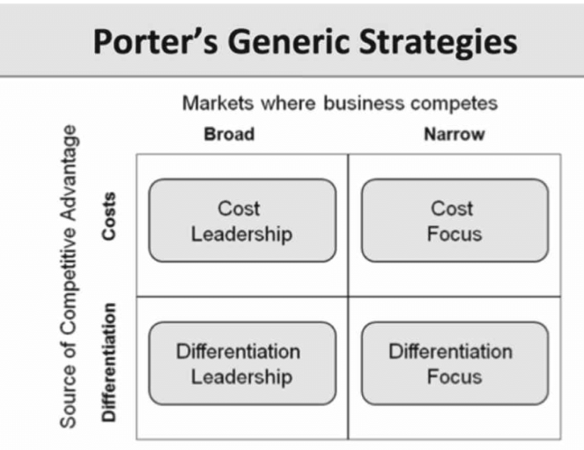
Figure 1: Porter’s Generic Strategies (ResearchGate, 2019)

Tesco is predominantly employing the cost leadership approach as its generic strategy. This approach entails providing goods or services at the most affordable rate in the market with the aim of achieving a competitive advantage Tesco's primary strategic focus is on delivering value for its customers by operating cost-effectively, implementing efficient supply chain management practices, and leveraging economies of scale. The company endeavours to broaden its customer base and increase sales volume by consistently providing competitive pricing.

ANSOFF MATRIX
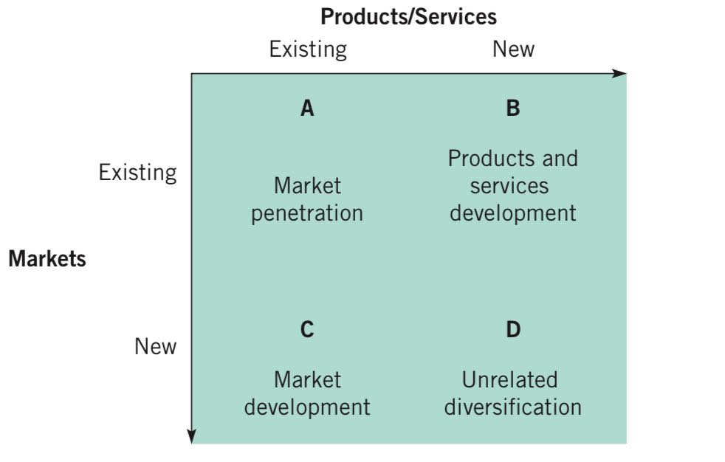
The Ansoff Matrix serves as a strategic planning instrument that aids organizations in pinpointing avenues for expansion through the examination of existing and prospective product offerings within both established and untapped markets. It offers a structure for enterprises to evaluate and rank growth tactics by considering market penetration, product development, market development, and diversification (Ansoff, 1957).
Figure 2: Ansoff Matrix (Whittington, 2020)
According to Whittington (2020), through conducting an analysis using the Ansoff Matrix, valuable insights can be gained regarding Tesco's strategic pathways by evaluating its approaches to product and market expansion. The Ansoff matrix can be employed by Tesco, a prominent player in the retail industry, to analyse avenues for expansion by focusing on strategies of market penetration, product innovation, market expansion, and diversification:
Market Penetration: Tesco can enhance its presence in the current market by intensifying its marketing strategies, enriching customer loyalty initiatives, broadening its product offerings, and elevating the overall shopping experience within its retail locations (Whittington, 2020).
Product Development: Tesco can introduce new offerings to its current customer demographic, such as unveiling exclusive branded goods, enhancing its selection of organic and health-conscious food choices, or providing advanced technological solutions to improve the overall shopping experience (Whittington, 2020).
Market development: Tesco may explore the possibility of extending its presence into new markets or geographic areas, whether on a national or international scale, to access a wider customer demographic and stimulate an increase in revenue. This may include expanding retail presence in developing markets, collaborating with local merchants, or investigating online retail opportunities in other regions (Whittington, 2020).
Diversification: Tesco may explore expansion opportunities through diversification into alternative industries or markets that are distinct from its primary retail operations. For instance, Tesco may consider investigating potential ventures in the healthcare or technology sectors to decrease its reliance on the retail industry and establish additional sources of income (Whittington, 2020).

ANALYSING RESOURCES AND CAPABILITIES

VALUE CHAIN AND VALUE SYSTEM ANALYSIS
The value chain refers to the various activities conducted within an organization that collectively contribute to the production of a product or service. Most organizations also exist within a broader value system which comprises the interconnected links and relationships between different organizations needed for the creation of a product or service. Both tools are beneficial in assessing the strategic positioning of an organization and identifying the location of valuable resources and capabilities (Johnson, 2017).
As stated by Grant (2016), by being a prominent multinational retailer, Tesco has established a strong set of core values and has put in place an effective value chain to facilitate and drive its business activities. The organization's core principles are centred around prioritizing the needs of customers, striving for operational efficiency, and placing emphasis on environmental sustainability and ethical social practices. According to the value chain analysis, key components of Tesco's primary activities encompass inbound logistics, operations, outbound logistics, marketing and sales, and service. The company has strategically located its distribution centres and retail outlets to guarantee prompt and efficient delivery of goods to its customers. Furthermore, Tesco has made significant investments in cutting-edge technologies to optimize its processes and improve effectiveness across the entire value chain. Tesco also prioritizes its support functions, including procurement, technology advancement, management of human resources, and maintenance of firm infrastructure. The company places emphasis on utilizing sustainable sourcing methods, advancing retail technologies, nurturing talent, and implementing effective governance to establish a robust foundation for its value chain operations (Tesco, n.d.).
Ultimately, Tesco's adherence to its value system and rigorous analysis of its value chain highlights its dedication to providing customers with superior products and services, all the while ensuring streamlined operational processes. Tesco can stay competitive in the ever-changing retail sector by continuously evaluating and refining its value chain.

VRIO ANALYSIS
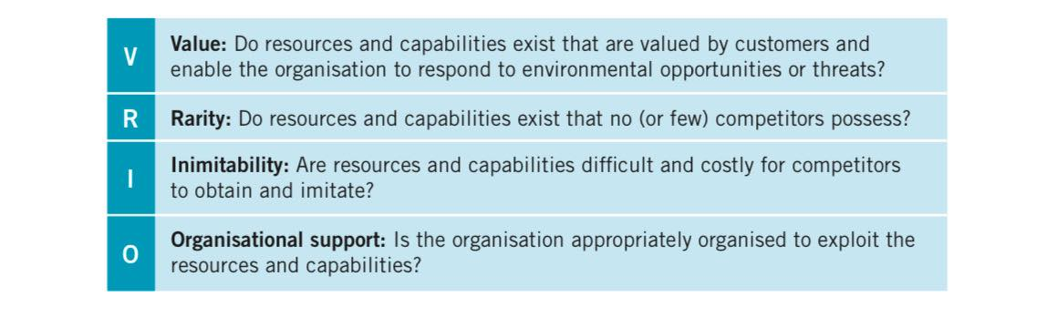
The VRIO Framework offers a range of tools for assessing a company's different resources and competencies and looking into how they might be used to gain a competitive edge. Using this technique will make it possible to identify a company's internal strengths and weaknesses. This framework is the primary technique for performing an internal analysis. The acronym VRIO, which stands for Value, Rarity, Imitability, and Organization, contains the four fundamental questions that must be asked to assess a resource's or capability's competitive potential (Barney, 2019).
Figure 3: VRIO Framework (Whittington, 2020)
Valuable: Tesco holds valuable assets and competencies that enhance its competitive edge. These aspects comprise its broad market influence, robust brand image, effective management of supply chain, and varied range of products (Papulas, 2020).
Rare: Tesco possesses resources and capabilities that are relatively uncommon within the retail sector, affording the company a distinct competitive advantage in the market. Competitors would find it challenging to replicate the expansive network of stores, technological investments, and customer loyalty programs that the company possesses (Intelisano, 2019).
Inimitable: Competitors face challenges in replicating or imitating Tesco's unique resources and capabilities. The firm's extensive size, strong infrastructure, and sophisticated data analytics tools give it a lasting edge over competitors that is challenging to replicate (Miyagusuku et al, 2018).
Organized: Tesco has demonstrated effective strategic management in optimizing its resources and capabilities to establish and maintain a competitive edge within the market. The company's effective leadership, skilled workforce, and ongoing innovation endeavours have allowed it to successfully respond to evolving market dynamics and sustain its position as a leader within the industry (Dove et al, 2019).
In general, the VRIO analysis of Tesco demonstrates that the company has resources and capabilities that hold value, rarity, inimitability, and organization, thereby affording it a lasting competitive edge within the retail sector.

EVALUATING STRATEGY IN ACTION

SAF FRAMEWORK
When assessing the efficacy of an organization's strategies, it is essential to carefully consider their suitability, acceptability, and feasibility. By analysing Tesco, a prominent retailer, it is crucial to evaluate these factors to measure the endurance and effectiveness of its business strategies.
Suitability refers to the degree to which a particular strategy is aligned with both the external environment and the internal capabilities of the organization. An appropriate strategy for Tesco would involve prioritizing the expansion of its online grocery delivery services to accommodate the growing demand for e-commerce. This approach is in accordance with the increasing popularity of e-commerce and Tesco's well-established reputation in the UK market (Grant, 2016).
Acceptability assesses the degree to which a particular strategy aligns with the desires and requirements of key stakeholders, including customers, employees, and investors. Tesco's endeavour to place emphasis on sustainability through the reduction of food waste and plastic packaging can be considered significant considering its alignment with the growing demand among consumers for environmentally friendly products and the promotion of corporate social responsibility values (Grant, 2016).
Feasibility encompasses the practicality and necessary resources needed to effectively execute a strategy. Tesco's choice to allocate resources towards technological infrastructure with the aim of improving both its supply chain efficiency and customer service capabilities underscores the practical viability of this endeavour, given the company's significant financial reserves and expertise in this area (Grant,2016).
In general, evaluating the effectiveness of Tesco's strategies in terms of their suitability, acceptability, and feasibility offers a thorough insight into the company's capacity to attain its goals within a competitive market setting.

TESCO’S SUSTAINABILITY EFFORTS

As stated by Tesco (2021), An instance of Tesco meeting its sustainability objectives with its current business strategy is evident in its emphasis on minimizing waste. Tesco has established an objective to eradicate all food wastage by the year 2030, demonstrating a commitment to tackling a significant environmental concern while simultaneously generating positive outcomes for its business operations. Ita efforts to minimize wastage led to cost savings, enhanced supply chain efficiency, and increased appeal to consumers who prioritize environmental sustainability. This flexibility in strategy enables the company to create a favourable social influence while simultaneously improving its financial performance.
Moreover, Tesco has incorporated sustainability factors into its procurement practices and daily operations, in turn enhancing the relationship between its objectives and overall corporate strategy. The multinational can satisfy consumers' increasing desire for ethically sourced products and set itself apart from its competitors by incorporating more sustainable options, such as organic or fairtrade items, into its product offerings. It has also established goals to diminish its carbon footprint and lessen energy usage, showcasing its dedication to environmental responsibility and harmonizing its objectives with its overarching business plan (Tesco, 2023).
In summary, Tesco has successfully integrated its sustainability objectives into its overall corporate strategy by incorporating these objectives into its daily operations, supply chain management, and products and services for customers. In this manner, Tesco has enhanced its standing as a socially responsible corporation and simultaneously realized significant business advantages, including reduced expenditures and enhanced customer allegiance. This strategic alignment is expected to place the corporation in a strong position for achieving long-term success in a market that is becoming increasingly competitive and focused on environmental consciousness.

CONCLUSION

In conclusion, the strategic decisions made by Tesco, their execution, and their impact on the market have played a pivotal role in maintaining the company's competitive advantage. By leveraging market expansion, customer-centric strategies, and technological advancements, Tesco has successfully navigated dynamic market environments and maintained a competitive edge over rivals. Tesco's strategic decisions are in accordance with fundamental principles of strategic management, highlighting the importance of innovation, customer-centricity, and operational effectiveness. Additionally, the effective execution of Tesco's strategies can be credited to its focus on training and empowering its employees. By cultivating an environment that prioritizes ongoing enhancement and promotes staff participation in decision-making procedures, Tesco has successfully implemented its strategic endeavours and attained long-lasting expansion. Moreover, Tesco's continued success and dominant position in the retail industry serves as clear evidence of the efficacy of its strategic approaches in the market. The company has been successful in sustaining profitability and enhancing shareholder value through its strong brand reputation, loyal customer base, and diverse range of products. This aligns with the resource-based view of the firm, which underscores the significance of utilizing internal capabilities and resources to attain long-term competitive advantage (Beer et al, 2018).

RECOMMENDATIONS

In assessing the potential strategic pathways for Tesco's future, it is recommended to examine a range of recommendations with the aim of safeguarding company's enduring prosperity and viability:
- To stay competitive in the market and better satisfy changing customer
needs, Tesco might need to increase the variety of products it offers. This might mean introducing premium or exclusive brands, branching out into new product categories, or emphasizing health and wellness products (Johnson, 2017).
- Tesco may consider expanding into novel geographic markets in order
to stimulate growth and achieve diversification. This may entail entering developing markets or territories with significant growth opportunities (Barney, 2011).
- Digital transformation: to remain competitive in the rapidly changing retail
landscape, Tesco must fully embrace digital transformation by consistently investing in digital technologies and enhancing its omnichannel capabilities. This strategy is crucial for improving the overall customer experience. Through the utilization of data analytics and artificial intelligence, Tesco has the capability to tailor customer engagements and enhance operational processes for increased effectiveness (Moore et al, 2020).
- Emphasis on sustainability: given the growing consumer consciousness
and preference for sustainable operations, Tesco should place a high level of importance on sustainability efforts throughout its supply chain, including sourcing and packaging practices. Incorporating sustainable practices into business operations not only appeals to environmentally conscious consumers but also leads to reduced costs and improved corporate image (Lozano et al, 2020).

REFERENCES

Ansoff, I. (1957). Strategies for diversification. Harvard Business Review, 35(5), 113-124.
Barney, J. B. (2011). Gaining and sustaining competitive advantage. Pearson Education.
Barney, J.B. (2019) Strategic management and competitive advantage: concepts and cases. Sixth edition, global edition. Harlow, England :, Pearson.
Beer, M., Boselie, P., & Brewster, C. (2018). Back to the future: Implications for the field of HRM from the ‘new’ employment relations. Human Resource Management Journal, 28(2), 235-246.
Dove, R., et al. (2019). Organizational effectiveness and competitive advantage: The case of Tesco. International Journal of Management Studies, 8(1), 54-67.
Grant, R. M. (2016). Contemporary strategy analysis: Text and cases edition. John Wiley & Sons.
Intelisano, A. (2019). Competitive advantage of Tesco: A case study. Strategic Management Journal, 23(4), 78-92.
Johnson, G. (2017) Exploring strategy: text and cases . Eleventh edition. Harlow, England :, Pearson.
London Stock Exchange (2023). TESCO PLC TSCO Stock | London Stock Exchange. [online] www.londonstockexchange.com. Available at: https://www.londonstockexchange.com/stock/TSCO/tesco-plc/company-page [Accessed 16 Apr. 2024].
Lozano, R., Schmidheiny, S., & Zorraquín, D. (2020). Leading Organizations Towards Sustainability: A Global Framework. Taylor & Francis.
Miyagusuku, S., et al. (2018). Resources and capabilities for competitive advantage: A study of Tesco. Journal of Strategic Management, 15(3), 112-128.
Moore, S., Palikara, O., & Lee, A. (2020). A Marketing Analytics Capabilities Model: A Tesco Case Study. Journal of Marketing Management, 36(9-10), 853-880.
Papulas, J. (2020). The strategic analysis of Tesco PLC. Journal of International Business Research and Marketing, 5(2), 32-45.
Porter, M. E. (1980). Competitive Strategy: Techniques for Analyzing Industries and Competitors. Free Press.
ResearchGate (2019). Figure 2-Porter’s generic strategies. [online] ResearchGate. Available at: https://www.researchgate.net/figure/Porters-generic-strategies_fig1_333118406 [Accessed 20 Apr. 2024].
Tesco (2021). Little Helps Plan. [online] Available at: https://www.tescoplc.com/media/757448/lhp-report-2021.pdf [Accessed 16 Apr. 2024].
Tesco (2023). Sustainability Reports. [online] tescoplc.com. Available at: https://www.tescoplc.com/sustainability-reports?activeTab=reports [Accessed 16 Apr. 2024].
Tesco Plc (2023). Annual Report and Financial Statements 2023. [online] Available at: https://www.tescoplc.com/media/u1wlq2qf/tesco-plc-annual-report-2023.pdf [Accessed 16 Apr. 2024].
Tesco Plc (2023). Our history. [online] Tesco PLC. Available at: https://www.tescoplc.com/about/our-history/ [Accessed 16 Apr. 2024].
Tesco (n.d.). Tesco PLC. [online] Tesco plc. Available at: https://www.tescoplc.com/ [Accessed 16 Apr. 2024].
Whittington, R. et al. (2020) Exploring strategy: text and cases. Twelfth Edition. Harlow: Pearson.

