Clive Paul Davies 2005775
Skills for Medievalists/Past Peoples, Medieval Societies: Research Methods and Skills (HPMS7004, HPHI7015)
Medieval Studies Assessments
Assessment 4
Commentary
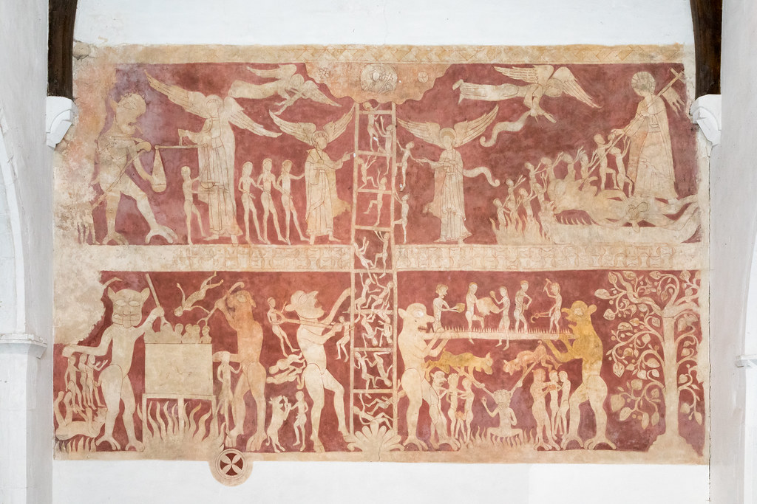

This essay will provide a commentary of the above image, a thirteenth century Doom painting, located in the church of St Peter and St Pauls, Chaldon, Surrey. It will examine the reasons why it was produced and the contemporary significance of this image to those that viewed such paintings, whilst, at the same time, placing it within the context of the evolution and transformation of the iconography of Western Christianity. In addition, it will discuss the techniques involved in its composition and attempt to put forward theories as to who the artist may have been.
It may be difficult for the modern reader to comprehend, however, during the medieval period churches were nearly always completely painted. Furthermore, our understanding is compounded by the fact that there are important nuances between our own concepts of visuality and space and pre-modern ideas. To the majority of the laity at this time, comprised of peasant farmers and their families who toiled long and hard to scrape a meagre existence, it was a brutal, harsh life and attendance at church offered them “a rare splash of color in their drab lives”. Conversely, it has been also suggested that the church intentionally sought to use imagery in places of worship as a medium through which to teach parishioners “clarity of faith, and promote faithful living”. This is discussed in greater detail below in the essay, but beforehand, it is useful to gain an understanding of the origins of Christian painting.
The debate surrounding the question of the use of iconography in the Christian faith has experienced a turbulent history although the first examples did not appear in churches at all, rather they originally appeared “as funerary decoration in the Roman catacombs”. Following the conversion of Constantine, churches became public buildings in which religious art flourished, although this did not prevent numerous iconoclastic challenges from the more puritan elements who objected to the art on the grounds of idolatry. One such incident led to a greater tolerance in the 6th century when Pope Gregory I condoned its didactic use for the illiterate by providing a picture for “the ignorant who look at it”. Its use continued throughout the Middle Ages until the Reformation of the 1530s created a schism in the ideologies of the Christian faith. It is against this backdrop that our image was created in a post 1066 corner of Anglo-Norman England.
The wall painting in the church of St Peter and St Pauls, Chaldon, believed to have been created was discovered in 1869 during restoration work and work was carried out to preserve it by the expert J.G. Waller. It was a familiar story throughout Britain that the offending wall paintings had been limewashed over during the Reformation, else replaced as they fell out of favor or into disrepair. It is situated on the west wall of the church, as opposed to the tradition for these images to be displayed over the chancel arch, although if this was unsuitable they would often appear on other walls. It is believed to have been painted circa 1200 by a “travelling artist-monk” and is based on similar Greek ecclesiastical art referred to as the “Ladder of the Salvation of the Soul and the Road to Heaven”. Waller refers to the technique as ‘tempera’, however, the church website refers to it as a ‘fresco’, but it is the author’s opinion that the former is a correct definition. The egg tempera painting is produced using a combination of red and yellow ochre, “mixed with water and egg before application”. The process was much more suited to the “thin chalk rubble” of the walls in southern England as opposed to the marble that was found in warmer climates. This genre of wall painting was referred to as a ‘Doom’ and represented a visual interpretation of the Last Judgement as described in the Bible, when the second coming of the Messiah was foretold. The following paragraphs will offer a more detailed description of the image and offer suggestions as to what messages it may have conveyed to the medieval viewer.
During the research for this essay it has become apparent that whilst the themes of medieval wall paintings tended to conform to a “code of signs” in terms of their content, each was a unique hand-painted work of art in which the artist, or perhaps their patron, decided which images to include. This is certainly the case for the Chaldon mural which consisted of a number of different allegorical messages. The central theme of the painting includes “The Ladder of Salvation” as stated in Waller’s title of the work. On the ladder are seventeen souls ascending the ladder, attempting to reach the gates of Heaven at the top and escape the depths of Hell. These figures are naked, perhaps to convey the biblical message that “they came from their mother's womb naked, naked they'll return”, which makes it difficult to identify them. The origins of this icon can be attributed to John Climatus, a 7th century Byzantine monk from Mt. Sinai. The original purpose of his ladder was to portray “a monk’s struggle towards perfection”, but it was later appropriated and applied to those from both religious and secular backgrounds.
The image at the top left of the painting is commonly referred to as ‘the Weighing of Souls’ and was often used to show St Michael weighing the good and bad deeds of the souls in order to determine their fate. Opposite him can be seen a large Demon who is attempting to tip the scales in favour of the bad deeds and confine the souls to Hell. On the right hand side can be seen the ‘Harrowing of Hell’ in which God descends into Hades to defeat Satan, a popular religious drama that could be found in medieval English literature.
The page is divided by a line of clouds, or nebuly, to give them their heraldic term, and is used to separate Heaven from Hell. In the bottom right of the painting can be found yet another allegorical reference, the ‘Tree of the Knowledge of Good and Evil’ based upon the temptation of Eve in the in the Garden of Eden. Waller finds the most intriguing image to be that of the ‘bridge of spikes’ an which various tradesmen can be seen attempting to cross the bridge that is flanked by two Demons. He relates this image to various similar stories from antiquity and deduces that they denote souls who are guilty of not having paid their tithes to the church. The bottom left hand of the image shows Demons boiling souls in a cauldron. As with many of the allegorical images, Waller relates this to the fantastical stories of Cisterian monk, Caesarius of Heisterbach’s Dialogus Miraculorum, widely copied in the thirteenth-century. It is certainly a complex work of art to the uninitiated which requires further examination to interpret its intended purpose in the religious lives of those that viewed it.
There exists a plethora of explanations from historians over the years regarding the purpose of medieval wall paintings and this essay will discuss a few of these to establish their validity. The most popular of these theories concerns their use as “books for the illiterate” based Pope Gregory I’s much quoted speech in the 6th century. This mindset continued well into the fifteenth-century when the laity were considered “’lewd’ and unlearned”, despite the fact that sermons were still being conducted in Latin. Kevin Lawson disputes this theory and suggests that a certain amount of prior knowledge would be required in order for the illiterate to interpret these images, a viewpoint that the author is in agreement with. Moreover, it has been suggested that they were very much entrenched in the liturgy of the church and were used as a tool visualize the lessons being taught. This would appear, on the surface, a more plausible explanation one that is reinforced by Paul Binski, who suggests that they served as a “’cognitive map’ of religious experience”. Eric Palazzo takes this further by proposing that medieval art played a theatrical role in what he refers to as creating a “ritual space” within the medieval church. In doing so, wall paintings transformed even the poorest of churches into a glimpse of Heaven which made “entering a church unlike any other experience”.
The Chaldon mural offers us a microcosm of the beliefs and aspirations of everyday people during the medieval period. The fact that it exists in such a humble parish church and without the pretensions of contemporary cathedrals lends it an air of authenticity which cannot be said for the later Renaissance examples to be found across Europe. For this reason, medieval wall paintings have tended to be overlooked by art historians due to their perceived lack of aesthetic value. Whilst the author would not be as bold as Pamela Tudor-Craig in suggesting wall paintings were the “Rosetta Stone of the English Middle Ages”, they undoubtedly offer a valuable insight into the hopes and fears of ordinary people during this era.
1934

Bibliography
Books
Chadwick, Henry, The Early Church (Penguin: Harmondswoth, 1993).
Rosewell, Roger, Medieval Wall Paintings in English and Welsh Churches 2nd edition (Boydell: Woodbridge, 2016).
Rouse, Clive E., Medieval Wall Paintings 4th edition (Shire: Princes Risborough, 2016).
Journals
Binski, Paul, ‘The English Parish Church and its Art in the Later Middle Ages: A Review of the Problem’, Studies in Iconography , 20 (1999), pp. 1-25.
Desmond, Marilynn, ‘The Visuality of Reading in Pre-Modern Textual Cultures’, Australian journal of French studies 46(3) (2009), pp. 219-234.
Dvornik, Francis, ‘Review of The Illustration of the Heavenly Ladder of John Climacus by John Rupert Martin’, The Catholic Historical Review, 41(3) (1955),
pp. 302-304.
Giles, Kate, ‘Seeing and believing: visuality and space in pre-modern England’, World Archaeology, 39(1) (2007), pp. 105-121.
Lawson, Kevin E., ‘More Than Silent Preaching: Didactic Use of Wall Painting in the Middle Ages’, CEJ: Series 3, 11(2) (2014), pp. 318-335.
Palazzo, Eric, ‘Art and Liturgy in the Middle Ages: Survey of Research (1980-2003) and Some Reflections on Method’, The Journal of English and Germanic Philology, 105(1) (2006), pp. 170-184.
Reiss, Athene, ‘Beyond ‘Books for the Illiterate’’, The British Art Journal, 9(1) (2001), pp. 4-14.
Waller, J.G., ‘On Recent Discoveries of Wall-Paintings at Chaldon, Surrey; Wisborough Green, Sussex; and South Leigh, Oxfordshire’, Archaeological Journal
30(1) (1873), pp. 35-58.

Internet
Bible Study Tools, Compare Translations for Ecclesiastes 5:15, (2020)
< https://www.biblestudytools.com/ecclesiastes/5-15-compare.html>[Accessed 18 December 2020].
Jaspal, Namita, Heritage Preservation Atelier, (2020),
< https://heritagepreservationatelier.com/2017/06/26/frescoes-vs-tempera/> [Accessed 18 December 2020].
WedExhibits, Pigments Through the Ages, (2020)
< http://www.webexhibits.org/pigments/intro/medieval.html> [Accessed 18 December 2020].
New Advent, Harrowing of Hell, (2020),
< https://www.newadvent.org/cathen/07143d.htm> [Accessed 18 December 2020].
Russian Icon, The Preaching Nature of the Last Judgement Icon, (2020),
< https://russianicon.com/the-preaching-nature-of-the-last-judgement-icon/> [Accessed 18 December 2018].
St Peter and St Pauls, Chaldon, History of Chaldon Church, (2013) <http://www.chaldonchurch.co.uk/history-chaldon-church> [Accessed 2 December 2020].
Videos
Chater, Andrew, Medieval Minds Timelines.tv <https://www.youtube.com/watch?v=jkhEdUxbaD0> [Accessed 15 December 2020].

St Peter and St Pauls, Chaldon Mural, (2013), <http://www.chaldonchurch.co.uk/history-chaldon-church> [Accessed 2 December 2020].
Clive E. Rouse, Medieval Wall Paintings (Shire: Princes Risborough, 2004), p. 9.
Kate Giles, ‘Seeing and believing: visuality and space in pre-modern England’, World Archaeology, 39(1) (2007) (pp. 105-121), p. 106.
Andrew Chater, Medieval Minds Timelines.tv <https://www.youtube.com/watch?v=jkhEdUxbaD0> [Accessed 15 December 2020]
Kevin E. Lawson, ‘More Than Silent Preaching: Didactic Use of Wall Painting in the Middle Ages’, CEJ: Series 3, 11(2), (pp. 318-33), p. .
Henry Chadwick, The Early Church (Penguin: Harmondswoth, 1993) p. 278.
Ibid. pp. 280-284.
Athene Reiss, Beyond ‘Books for the Illiterate’, Tbe British Art Journal, 9(1) (pp. 4-14), p. 5.
St Peter and St Pauls, History of Church http://www.chaldonchurch.co.uk/history-chaldon-church [Accessed 2 December 2020].
Rouse, Medieval Wall Paintings, p. 9.
Roger Rosewell, Medieval Wall Paintings in English and Welsh Churches (Boydell: Woodbridge, 2016), p. 77.
J.G. Waller, ‘On Recent Discoveries of Wall-Paintings at Chaldon, Surrey; Wisborough Green, Sussex; and South Leigh, Oxfordshire’, Archaeological Journal, 30(1) (1873), (pp. 35-58), p. 35.
Namita Jaspal offers a good explanation of the differences between frescoes and tempera on her webpage Heritage Preservation Atelier (2020) < https://heritagepreservationatelier.com/2017/06/26/frescoes-vs-tempera/> [Accessed 18 December 2020].
WedExhibits, Pigments Through the Ages (2020), < http://www.webexhibits.org/pigments/intro/medieval.html> [Accessed 18 December 2020].
Rouse, Medieval Wall Paintings, p. 24.
Russian Icon, The Preaching Nature of the Last Judgement Icon (2020), < https://russianicon.com/the-preaching-nature-of-the-last-judgement-icon/> [Accessed 18 Dember 2018].
Rouse, Medieval Wall Paintings, p. 16.
Waller, On Recent Discoveries, p. 35.
Bible Study Tools, Compare Translations for Ecclesiastes 5:15, (2020) < https://www.biblestudytools.com/ecclesiastes/5-15-compare.html> [Accessed 18 December 2020].
Francis Dvornik, ‘Review of The Illustration of the Heavenly Ladder of John Climacus by John Rupert Martin’, The Catholic Historical Review , 41(3)(1955) pp. 302- 304.
Francis Dvornik, ‘Review of The Illustration of the Heavenly Ladder’, pp. 302-304.
Rosewell, Medieval Wall Paintings, p. 81.
Waller, On Recent Discoveries, p. 46.
New Advent, Harrowing of Hell, (2020), < https://www.newadvent.org/cathen/07143d.htm> [Accessed 18 December 2020].
Waller, On Recent Discoveries, p. 36.
Rosewell, Medieval Wall Paintings, p. 35.
Waller, On Recent Discoveries, pp. 39-41.
Waller, On Recent Discoveries, pp. 39-41.
Ibid. p. 41.
Lawson, More Than Silent Preaching, p. 323.
Ibid., p. 325.
Marilynn Desmond, ‘The Visuality of Reading in Pre-Modern Textual Cultures’,
Paul Binski, ‘The English Parish Church and its Art in the Later Middle Ages: A Review of the Problem’, Studies in Iconography , 1999, Vol. 20 (1999), pp. 15.
Eric Palazzo, ‘Art and Liturgy in the Middle Ages: Survey of Research (1980-2003) and Some Reflections on Method’, The Journal of English and Germanic Philology , 105(1), (2006), pp. The State of Medieval Studies (Jan., 2006), pp. 175.
Rosewell, Medieval Wall Paintings, p. 150.
Binski, ‘The English Parish Church’, pp. 1-2.

