Database Analysis & Design

Wayne Howell (2207408)
Introduction to Web and Database Concepts (ACCA4023)
Applied Computing
University of Wales Trinity Saint David

Table of Contents
Introduction 4
Task 4
Identifying Types of Users 5
Identifying Types of Departments 6
Database Design 7
Entities, Attributes, Primary & Foreign Keys 8
Entity Relationships 9
Final Entity Relationship Diagram (ERD) 10
Northern Lights Ltd Database Management System 11
Access Tables, Forms, Reports and Relationships 11
Home Screen 12
Branch Managers 12
Event Lists 12
Create Event 13
View/Add Tasks 13
Add New Task 14
Patron Invoice Report 15
Orders Report 16
Staff Report 16
Department Managers / Staff 17
View/Update Tasks 17
Create Orders 17
Create Invoice 18
Patrons 18
Event List 18
Patrons Invoice Report 19
Suppliers 20
View Orders 20
Administration 20
View/Update Branch Details 20
View/Update Branch Managers 20
Update Manager 21
Add Manager 21
View/Update Staff 22
Add Staff 23
View/Update Departments 24
View/Update Patrons 25
View/Update Suppliers 26
Conclusion 27
References 28

Introduction

Northern Lights Pvt Ltd is an event organising company located in Swansea. They organise events for more than 10 people like conferences, Workshops, seminars, Music festivals or concerts etc.., excluding parties and business meetings. They have recently expanded and now have branches in Neath and Carmarthen. Each branch has a branch manager supervising a team of staff who takes care of setting up of audio and visual equipment, selling tickets, cleaning, maintaining and administrating events. The branch manager acts as a primary point of contact with event patrons. The patrons are usually companies and associations relating to the event topic. The branch manager receives the requirements from patrons to successfully run the event. Once the requirements are agreed, the branch manager assigns the task to various department heads. Northern Lights company also have several suppliers which they use to order resources required for the events as well as for the day to day running. Each branch will be responsible for all the tasks pertaining to the event that is booked within their area. Due to the expansion, they would like to change the manual administration process to a computerised system with the aid of database management system which can help for ensured success of the event. Despite having a physical office, they realise that an online presence could increase the number of customers. They would like to use a system that will allow them to record customer details along with event requested. To complete the accounting records, they would like to have automatic provision of customer invoices that should help them to keep a record of the income generated from the various events so that they may at some future date be able to calculate quarterly and yearly profits. The departments and their responsibilities are left to your discretion.
Initial findings
After your initial investigation, the following user requirements were to be highlighted:
• Identify the different type of users who might access the Database Management System.
• Identify the different type of departments each branch might require.
• When an event has been booked both the staff and clients should be able to query and view information as required.
• When purchases are made from the supplier the relevant department should be able to view, record and generate invoices for the transactions.

Task
Using systems design techniques that you have been investigating, develop a suitable solution for the above scenario that will highlight the new computerised processes and database requirements.

Identifying Types of Users

Identifying clients that will use the new database management system is crucial in its design so that requirements of each user can be met. Northern Lights pvt Ltd have many users and I have categorised them below:
Branch Managers
These will be the principal users of the system. Each manager is responsible for the branch's operations and are the primary contact for Patrons when making event requests. They will need to enter the event details and requirements into the system and then assign tasks to department leaders/staff whilst supervising and coordinate events. They need access to all features of the system to book events, assign tasks, generate invoices, and scrutinise financial reports.
Department Managers
These manage several departments within a branch. They will need access to specific features like the ability to re-assign tasks to staff, generate orders to suppliers and create invoices to Patrons.
Staff
Staff will need access to the tasks set by Branch and Department Managers. They will need access to features that enable them to fulfil their daily departmental duties.
Patrons
Patrons are the customers. They provide event details with specific requests to the Branch Manager. They need access to the system to view all events, verify event information, and receive invoices for services rendered.
Suppliers
Suppliers will provide resources for all events. They need to interact with the system to view orders placed by Northern Lights Pvt Ltd staff.

Identifying Types of Departments

The following departments have been identified to be overseen by a Department Manager.
Audio and Visual
This department will manage the audio and visual equipment for each event.
Ticketing
This department will be responsible for ticket creation and sales for events.
Cleaning
This department will be responsible for cleaning the branches and event venues.
Maintenance
This department will be responsible for maintaining the upkeep of the branches and event venues.
Administration
This department will be responsible for administrative tasks of each branch such as updating manager/staff records and branch information. They will handle all inquiries and create reports for all stakeholders.

Database Design

The design is an essential element in the success of the Database Management System (DBMS). It requires the creation of a detailed representation of the database schema.
Below, I have outlined the primary components of the new database system.
Entities
A database entity is a thing, person, location, unit, or object about which data must be captured and stored as properties, workflow, and tables. While workflow and tables are optional for a database entity, properties must be present [1]. The entities I have identified are Branches, Branch Manager, Departments, Staff, Patrons, Events, Tasks, Orders, Suppliers, and Invoices.
Attributes
Each row (tuple) is a set of information about one item, and each column has information about the rows. These rows are known as attributes [2]. Each attribute has been selected to collect the necessary information for each entity.
Primary Keys
A primary key refers to a distinct table column or a combination of columns that is specifically assigned to identify each individual record within the table [3]. There will be a primary key in each table of the Database.
Foreign Keys
A foreign key is a database field that establishes a connection between two tables through a relationship, whereby it is linked to the primary key field of another table [4]. Foreign Keys will be utilised in many tables to connect each table.
Multiplicity
Multiplicity is the number of instances of one entity that can be linked to instances of another entity. It provides information on the cardinality of relationships between entities. All tables will have a one-to-one, one-to-many, or many-to-many relationship.
Normalisation
Each database table will meet the rules of third normal form (3NF) to ensure the absence of redundant information and to optimise query execution and enhance overall efficiency.

Entities, Attributes, Primary & Foreign Keys

Table 1: Entities, Attributes, Primary Key (PK), Foreign Key (FK)

Entity Relationships

Table 2: Entity Relationships
Final Entity Relationship Diagram (ERD)

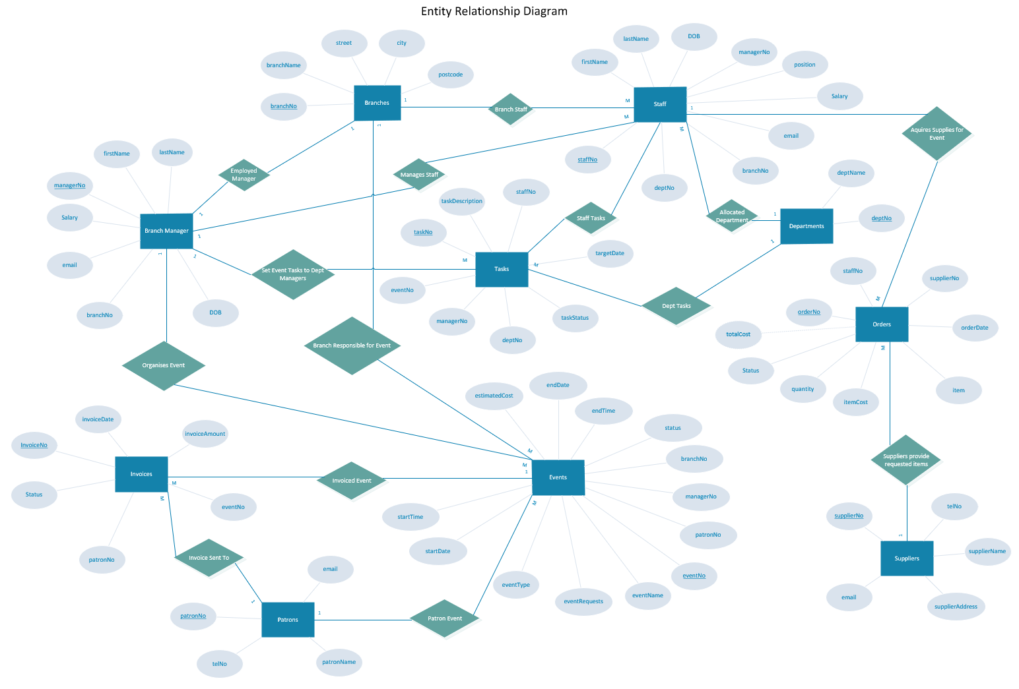
Figure 1: Final Entity Relationship Model (ERD)

Link to Visio: Northern Lights pvt Ltd.vsdx

Northern Lights Ltd Database Management System
The Database Management System has been created in Microsoft Access to the specification as outlined in the Final Entity Relationship Diagram (ERD) and Table 1 and Table 2.
Microsoft Access is a relationship database. It is a collection of data having pre-defined relationships between them. Tables with columns and rows are used to categorise the data that will be included into the database. The true value of an attribute is stored in a field, and each column carries a specific type of data. A primary key may be used to uniquely identify each row in the database, as well as to establish relationships (through foreign keys) with other tables [5].

Access Tables, Forms, Reports and Relationships
Below you will find screen shots of the tables, forms, reports, and relationships that have been created in the Access Database.
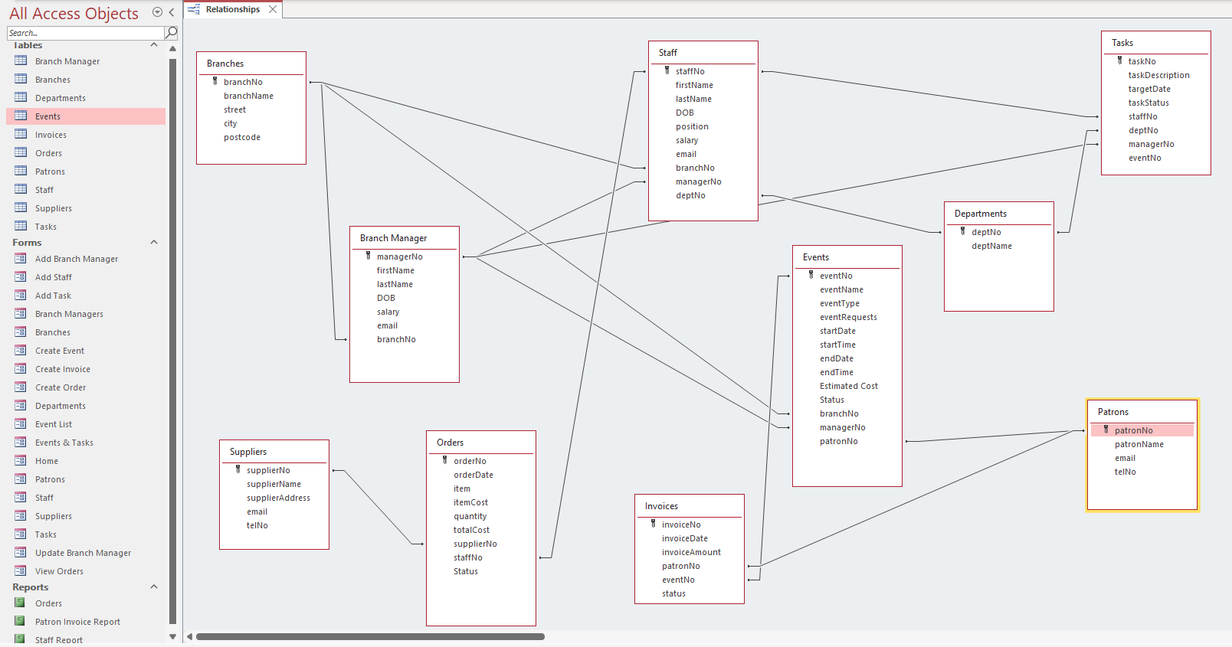
Figure 2: Access Tables, Forms, Reports and Relationships

Home Screen
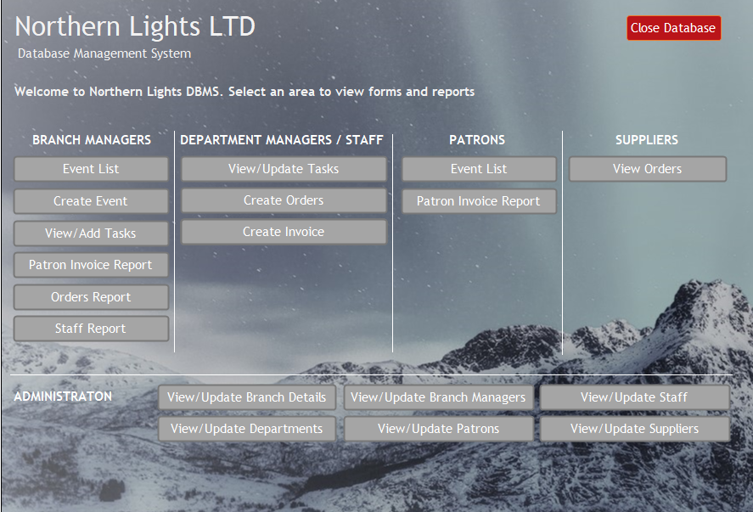
Figure 3: Home Screen of Northern Lights LTD DBMS
When opening the Northern Lights DBMS, the “Home” screen will appear automatically. Here we can navigate to several forms and reports which have been categorised into different areas.

Branch Managers

Event Lists
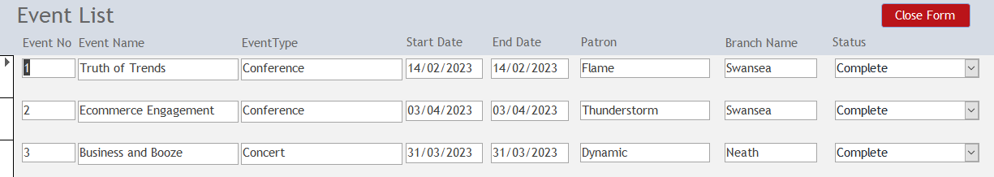
Figure 4: Event List of Northern Lights LTD DBMS
Managers can view all events in the system and update the status of each event with Pended, Cancelled, Postponed or Complete.

Create Event
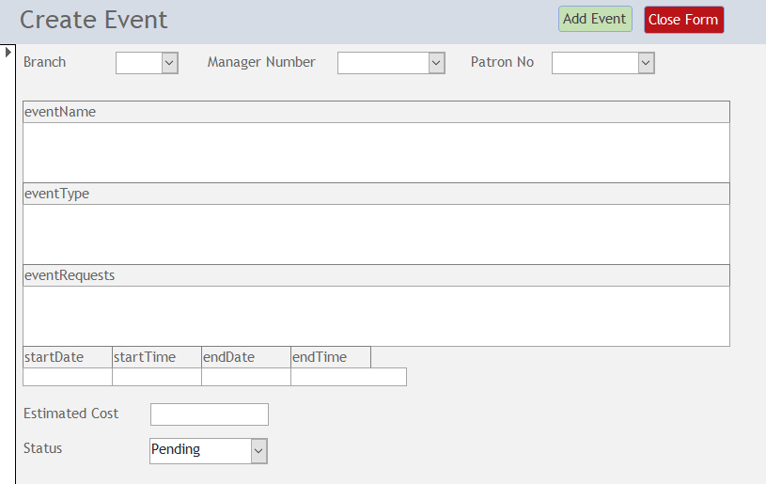
Figure 5: Create Event of Northern Lights LTD DBMS
Branch Managers can add a new event once they have acquired the requirements from the Patron.

View/Add Tasks
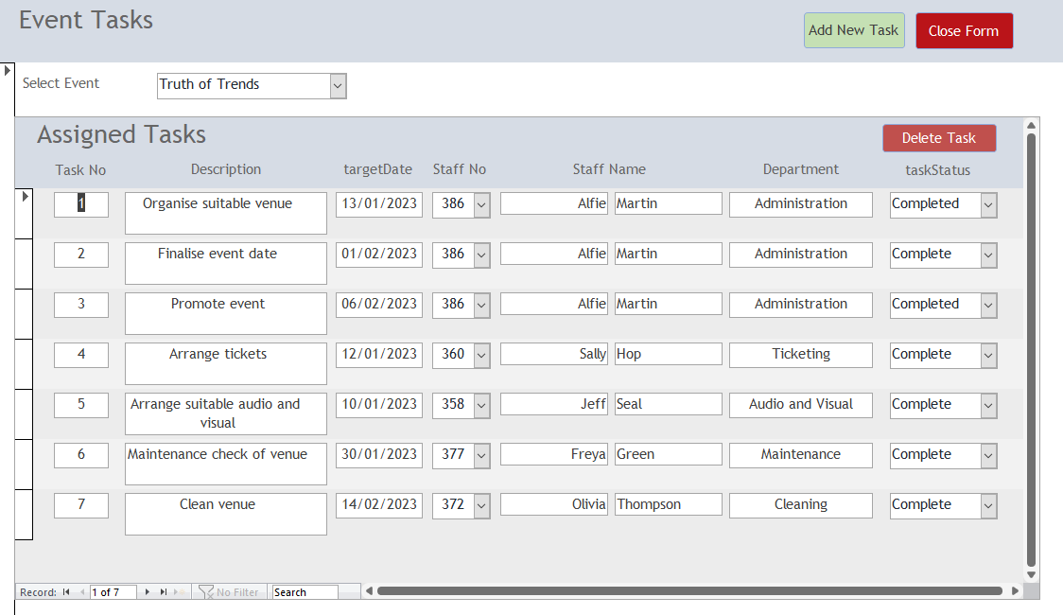
Figure 6: View/Add Tasks of Northern Lights LTD DBMS
Once an event is added. Branch Managers can view/add tasks. They can select an event from the dropdown, and the subform (Assigned Tasks) will show details of all tasks for the chosen event. Managers are able re-assign tasks to any member of staff by updating the staff no. Staff Name will automatically change to correspond with the selected staff no. Selecting a row of in the assigned tasks, you can remove the task by clicking “Delete Task” button. To create a new task, click the “Add New Task” button.

Add New Task
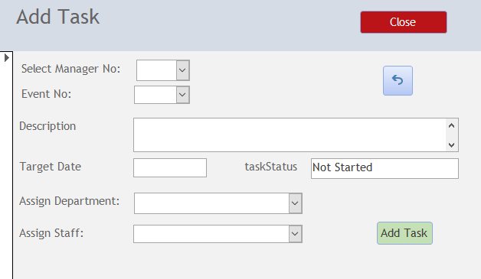
Figure 7: Add New Task of Northern Lights LTD DBMS
When adding a new task, the Manager selects their Manager No and then the Event No. They add a description of the task, outlining requirements. They set a target date, assign a department, and staff member responsible for its completion. Branch Managers will assign the task to Department Managers, who can then later assign to a staff member within their department.

Patron Invoice Report
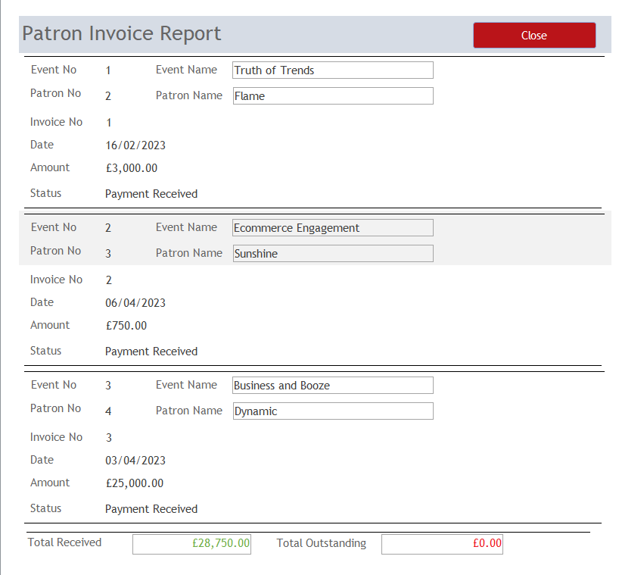
Figure 8: Patron Invoice Report of Northern Lights LTD DBMS
The Patron Invoice Report allows Branch Managers to track all invoices and to verify if money has been received or is outstanding. The Total Received and Total Outstanding fields are calculated fields within the report.

Orders Report
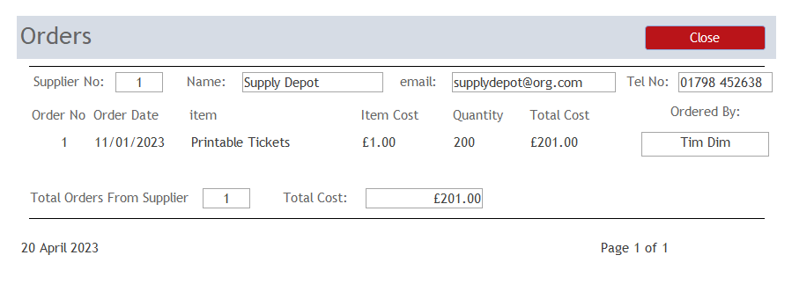
Figure 9: Orders Report of Northern Lights LTD DBMS
The Orders Report allows the Branch Managers to track expenditure.

Staff Report
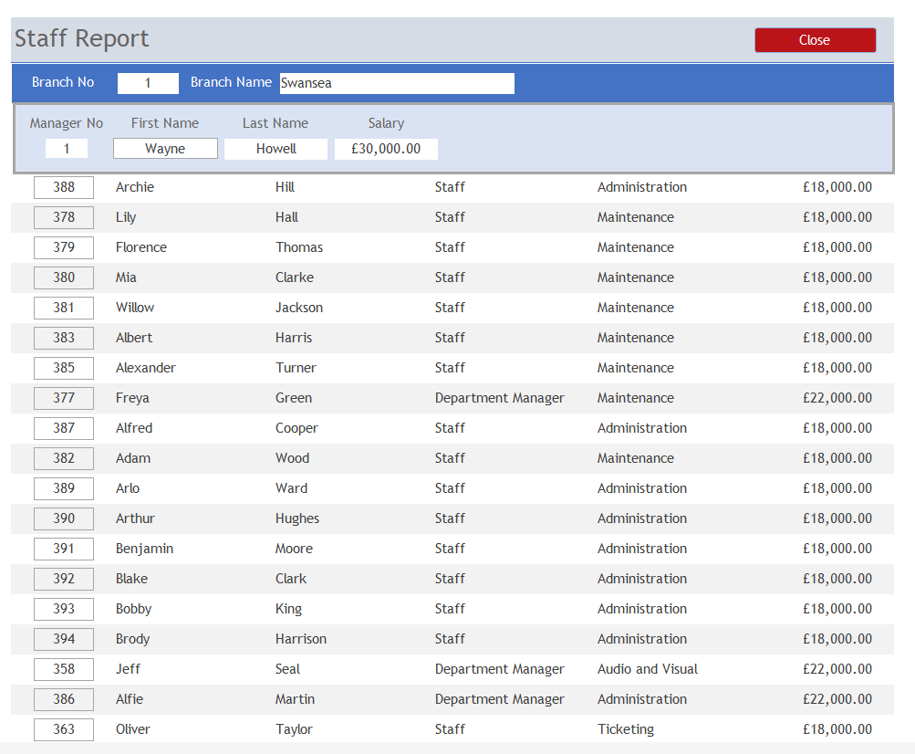
Figure 10: Staff Report of Northern Lights LTD DBMS
The Staff Report shows all Managers and Staff allocated to each Branch, along with their position, department, and salary.

Department Managers / Staff

View/Update Tasks
Figure 11: View/Update Tasks of Northern Lights LTD DBMS
Department Managers are initially assigned tasks by the Branch Manager. Here they can reassign tasks to individuals within their department, who can then update the status of each task with “Not Started”, “In Progress” or “Completed”.

Create Orders
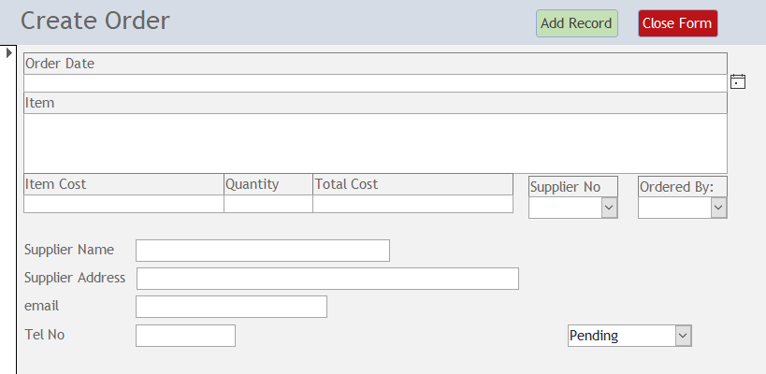
Figure 12: Create Orders of Northern Lights LTD DBMS
This allows staff to create supply orders that can then be viewed by suppliers. The default status is “Pending” as this is a new order.

Create Invoice
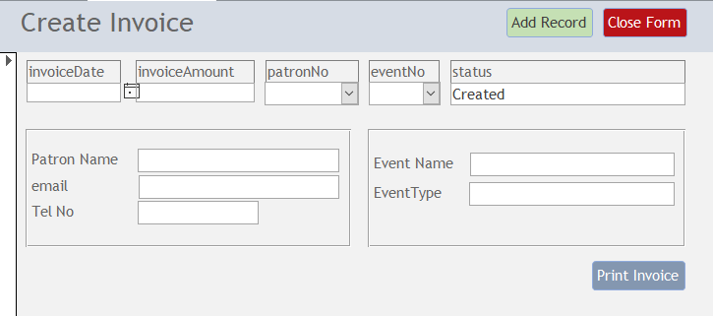
Figure 13: Create Invoice of Northern Lights LTD DBMS
Allows staff to create invoices to Patrons after an event has been completed. Default status is set at “Created” but can later be updated to “Sent” or “Payment Received”.

Patrons

Event List
Figure 14: Event List of Northern Lights LTD DBMS
Allows Patrons to view all future and completed events specific to them.

Patrons Invoice Report
Figure 15: Patron Invoice Report of Northern Lights LTD DBMS
Allows Patrons to track if they have been invoiced by Northern Lights Ltd and to confirm if payment has been sent.

Suppliers

View Orders
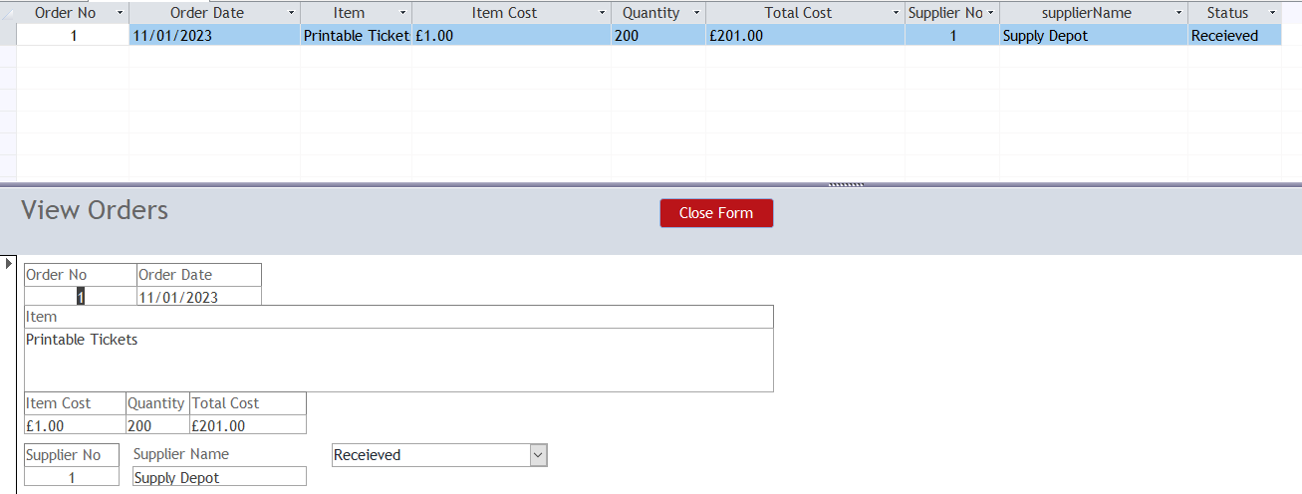
Figure 16: View Orders of Northern Lights LTD DBMS
Suppliers can view all “Completed” and “Pending” orders place by Northern Lights Ltd staff. Staff as well as supplier can utilise this form to update the order status.

Administration

View/Update Branch Details
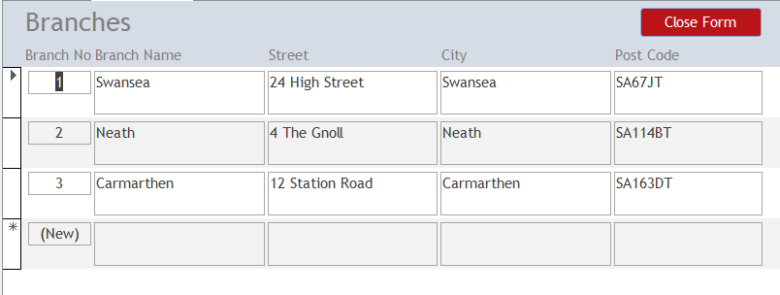
Figure 17: View/Update Branch Details of Northern Lights LTD DBMS
Administration staff can update all details and add new branches. To delete an entry, select the row and right press “Delete” on the keyboard.

View/Update Branch Managers
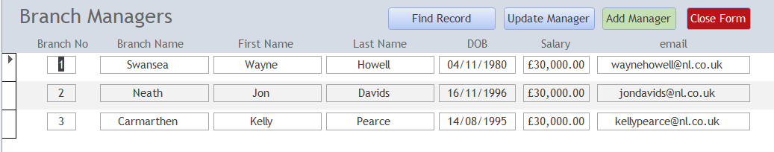
Figure 18: View/Update Branch Managers of Northern Lights LTD DBMS
Administration staff can update all Branch Manager details and add new managers.

Update Manager
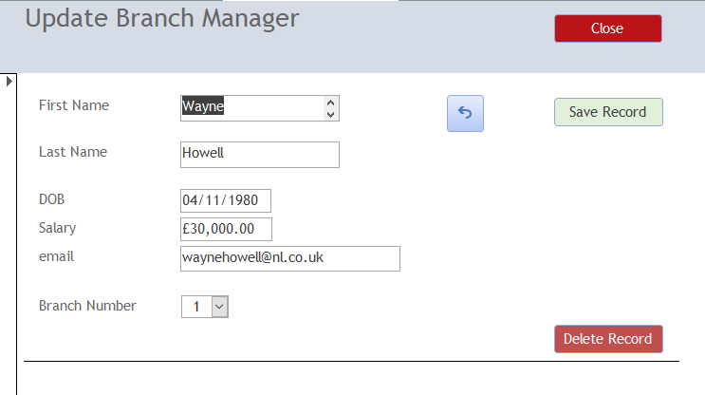
Figure 19: Update Branch Manager of Northern Lights LTD DBMS
Update the Manager details and click the “Save Record” button or click the “Delete Record” button to remove the Branch Manager.

Add Manager
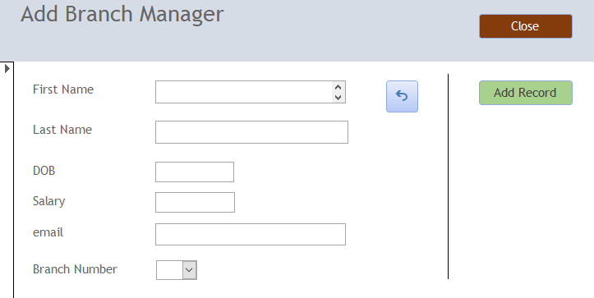
Figure 20: Add Branch Managers of Northern Lights LTD DBMS
Allows Administration staff to add new managers. Clicking “Add Record” will save the entry.

View/Update Staff
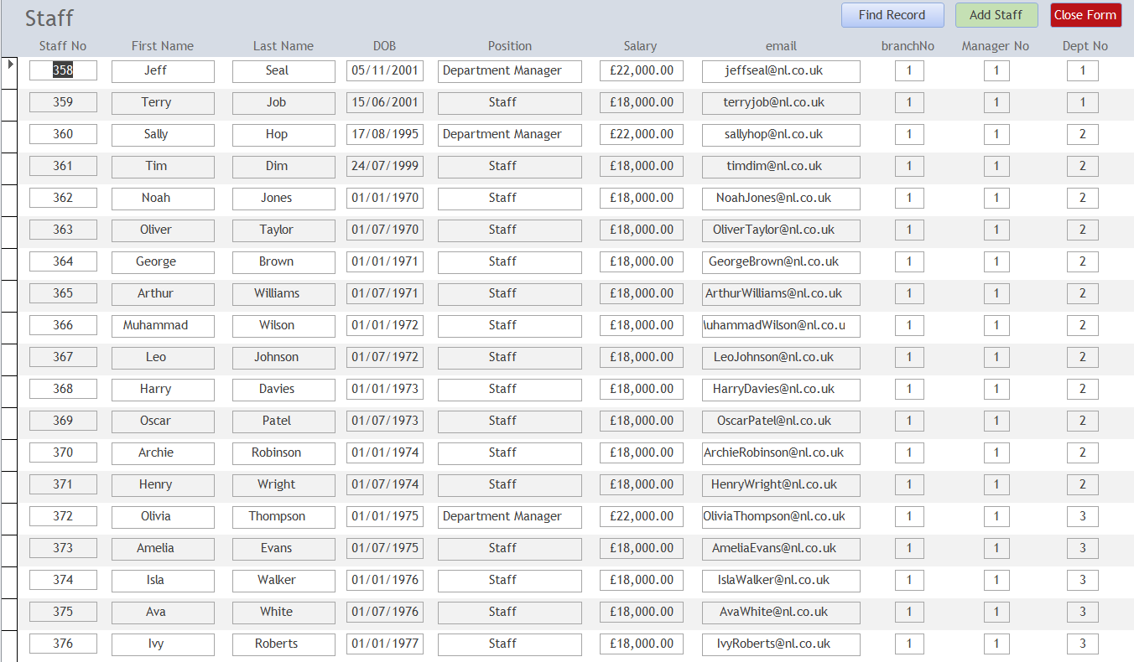
Figure 21: View/Update Staff of Northern Lights LTD DBMS
All Staff details can be updated so they are up to date and accurate. Clicking the “Add Staff” allows you to add an entry to the Staff table. To delete an entry, select the row and right press “Delete” on the keyboard.

Add Staff
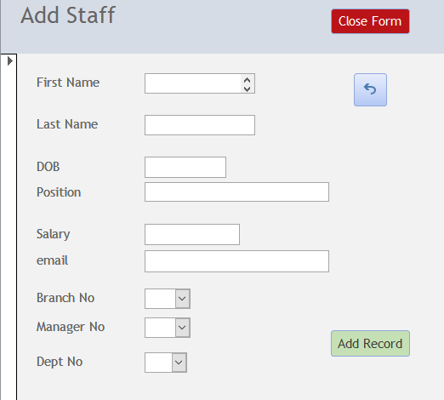
Figure 22: View/Update Branch Managers of Northern Lights LTD DBMS
Allows Administration staff to add new staff. Clicking “Add Record” will save the entry.

View/Update Departments
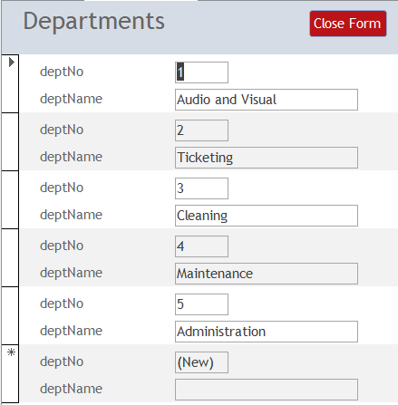
Figure 23: View/Update Branch Managers of Northern Lights LTD DBMS
Staff can update details of all departments as well as Add or Delete new ones. To delete an entry, select the row and right press “Delete” on the keyboard.

View/Update Patrons
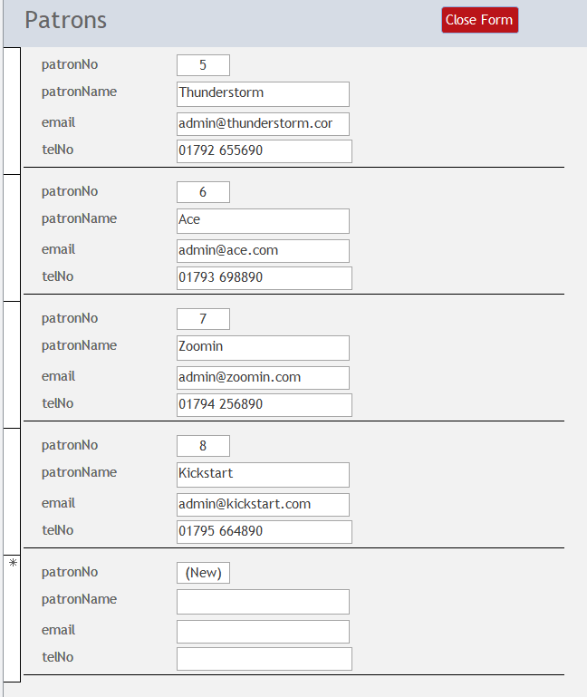
Figure 24: View/Update Patrons of Northern Lights LTD DBMS
Staff can update details of all Patrons as well as Add or Delete new ones. To delete an entry, select the row and right press “Delete” on the keyboard.

View/Update Suppliers
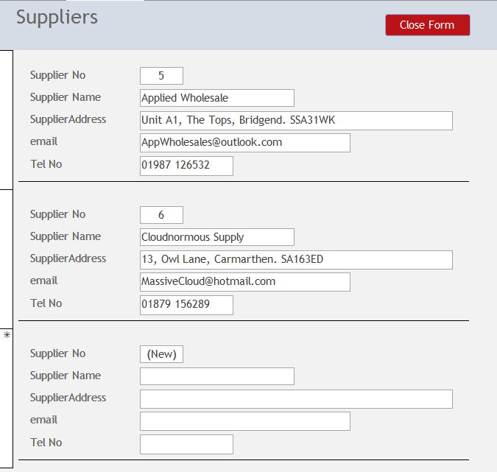
Figure 25: View/Update Suppliers of Northern Lights LTD DBMS
Staff can update details of all Suppliers as well as Add or Delete new ones. To delete an entry, select the row and right press “Delete” on the keyboard.

Conclusion
I believe that when the new Database Management System (DBMS) is deployed, it will meet the needs of Northern Lights LTD. Even though this is the first version of the database management system, it has the potential and scalability to be further developed to enhance the system's overall effectiveness.

References

[1] Database entity: Definition, relationship, attributes, and settings. [Online]. Available: http://www.centriqs.com/database-software/database-entity.php. [Accessed: 20-Apr-2023].
[2] Ian, Database.guide, 14-Feb-2023. [Online]. Available: https://database.guide/what-is-a-foreign-key/. [Accessed: 20-Apr-2023].
[3] M. Chapple, “Designing a database? give your tables attributes to be proud of,” Lifewire, 03-Jun-2021. [Online]. Available: https://www.lifewire.com/attribute-definition-1019244. [Accessed: 20-Apr-2023].
[4] Margaret Rouse Margaret Rouse is an award-winning technical writer and teacher known for her ability to explain complex technical subjects simply to a non-technical, M. Rouse, Margaret Rouse is an award-winning technical writer and teacher known for her ability to explain complex technical subjects simply to a non-technical, Editor, L. updated: 14 August, and L. updated: “Primary key,” Techopedia, 14-Aug-2020. [Online]. Available: https://www.techopedia.com/definition/5547/primary-key. [Accessed: 20-Apr-2023].
[5] J. Carter, “The relational database,” Amazon, 1995. [Online]. Available: https://aws.amazon.com/relational-database/. [Accessed: 20-April-2023].

