Managing Enterprise in the 21st Century:
Assignment 2

Table of Contents
Introduction 3
Managing or creating an enterprise mindset for the 21st century 3
Development of personal skill-set 5
Conclusion 8
Reference list 9
Appendices 11
Appendix 1: Skill development theory 11
Appendix 2: Transformational leadership 12

Introduction
The concerned report highlights personal learning reflection based on managing an enterprise for the 21st century on Max Car Rental, a car rental company. Management control refers to a function of management that aims to achieve defined goals within a stipulated time. While developing the presentation, I learnt that as a manager, I will require to set effective standards, measure actual performance and take corrective measures whenever appropriate. I further learnt that managers use management controls to accomplish organisational objectives. Moreover, in order to manage an enterprise for the 21st century, a leader or manager needs to create an enterprise mindset.

Managing or creating an enterprise mindset for the 21st century
Leaders having enterprise mindset usually treat the organisation's geographies, functions as well as systems as an interdependent and interconnected part of a cohesive structure that aims at delivering customer's requirements. While working on creating a mindset for the 21st century for Max Car Rental, I understood that a manager cannot change an element without considering its impact on the other elements. Further, Bolden (2016) stated that organisational needs should be prioritised ahead of a single project or functions. Approximately 79% of business executives consider enterprise thinking to be extremely essential for leaders, however, only 12% of CEOs lead this path.
It is a fact that traditional policies, cultures and structures of organisations do not support this enterprise mindset. CEOs manage large business units in a system that ties personal reward and business units together. Prioritising the greater good might endanger my reputation, bonus or promotion as a manager. Moreover, it creates a leadership mindset that focuses on short-term goals as well as the requirements of team members. However, it is difficult for managers to face present business challenges with such inflexible and narrow thinking. Based on the opinion of Butcher and Rose-Adams (2015), I learnt that in order to carry out the business of Max Car Rental in a smooth manner, business leaders are required to implement continual changes and rapidly respond to problems. Thus, as a business leader, I might be able to run my enterprise in a better manner by adopting an enterprise mindset.
I understood that I am required to make organisational decisions by thinking outside silos and the way in which this restructure enhance customer value. As influenced by Bratianu and Vatamanescu (2017), I should be informed about the expectations and requirements of customers and then focus on collective skills, knowledge and resources of business while delivering customer value. In order to create an enterprise mindset, I will have to appreciate that my business might be disrupted by new competitors, governmental changes and change in consumer sentiments. Further, I need to be prepared for adopting the changes and take the necessary actions instantly. Being a business leader, it will be my role to implement an organisational culture that embraces change and welcome innovation and risks. Encouraging sharing of skills, resources and skills in a manner that helps in delivering the best values to customers and further benefits the entire organisation. I have also learnt to understand the challenges, languages and cultures of each function and the way in which they fit together. In this manner, I might be able to connect with different people within the business as well as develop holistic solutions.
Managers are required to keep up with the issues and trends and determine the position of max Car Rental within the industry as well as the business environment. This will further help me to determine opportunities as well as challenges before the competitors could do the same. I also learnt that it in order to carry out effective teamwork, it is very important to choose empathy, openness and compassion over fear for command and control. Being a manager, I should use influence instead of the power of my position for motivating people in order to work together as well as behave differently. Further, managers should follow appropriate leadership responsibilities while making the right decisions. Deakin-Crick et al.(2018) opined that different solutions and ideas should be accepted along with promoting an enterprise mindset in the company.
In order to remodel within the 21st century, Max Car Rental needs to transition towards an outcome-based and customer-centric model as well as adopt lean and agile structure for adapting to the dynamic market continually. In order to adopt 21st century culture, managers are required to ensure a stronger emotional connection with customers that influences customer's hearts and minds largely. Providing a consistent experience to customers across channels is also very essential to attract more customers in the 21st century. The business leaders and managers are required to deliver an appropriate message to the appropriate person at the appropriate time that further requires advanced predictive analytical tools and digital marketing tools (De los Ríos-Carmenado et al. 2015). In order to survive as well as thrive in this environment, employees are required to advance themselves or increase their skills. However, it is a tough re-alignment and is the only way to cope with the fast-changing world.

Development of personal skill-set
In the first week, we decided the topic on which business plan presentation has been made. Conducting research and collection appropriate information was the first and foremost problem that we faced while making the presentation. First, we were unable to determine which is the relevant data or information. Gradually, after conducting continuous research, we were able to exclude unnecessary data and keep only the relevant ones. During this week, we worked together for collecting information related to our topic. While carrying out teamwork, communication is very important. Thus, I have gradually developed my communication skill and have been able to communicate effectively with other team members. As influenced by Jackson (2016), this skill has helped me to understand the importance of sharing essential information with my subordinates for the smooth running of the project. I developed the skill of showing a positive attitude to my team members instead of seeing the negative aspects of the project. This encourages the team members to accomplish the task effectively. Based on the opinion of Karakas et al. (2015), during the development of the presentation, I also supported my team members whoever faced any difficulty with something that I could help with. In case of any problem in the presentation, I used my communication skill in a diplomatic and friendly manner.
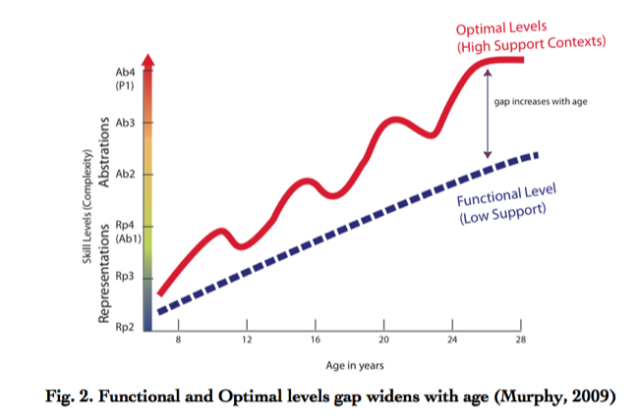
Figure 1: Skill development theory
(Source: Ramia et al. 2016)
In the next week, we started analysing the data that we had collected, which was another problem for us. Influenced by the opinion of Neary et al. (2016), due to differences in views and opinions of different team members, the conflict has arisen among us. In this situation, I had taken the initiative first to solve the problem and smoothly run the project. First, I talked with each team members and tried to understand their viewpoints that helped me to understand the base of the problem. Based on the viewpoint of Passmore and Theeboom (2016), after identification of the reason for the problem, I was able to devise a solution to resolve the conflict by communicating the importance of the project. Through this, I have also developed problem-solving skills in order to share and find insights that could help us resolve the problem. Further, after resolving the problem, data and information collected were analysed effectively. We also cross checked the information for eliminating any existing error in the presentation.
Applying skill-development theory, it could be stated that my or my team member’s past experience, feelings, beliefs and personality might impact the execution of the presentation largely (Ramia et al. 2016). Our professor has also guided in this step for analysing the data in a better manner. According to skill- development theory, my and team member’s previous knowledge has been considered while developing our skill in order to maintain engagement. [Refer to appendix 1]
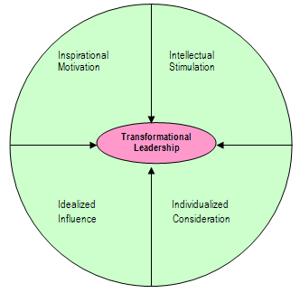
Figure 2: Transformational leadership theory
(Source: Neary et al. 2016)
In the subsequent week, while preparing the body of the presentation, I learnt that the implementation of effective leadership is important for carrying out a project smoothly. As influenced by Wall and Tran (2016), through the implementation of transformation leadership theory, I encouraged my team members to accomplish the task effectively by bringing positive changes in them. In was able to motivate them and enhance their morale during the occurrence of several problems. I tried to create a vision and identify the required changes that need to be implemented so that the presentation could be made effectively. Applying transformational leadership I could work towards the team’s benefit and work together in peace. I highlighted the priorities according to their importance so that my team could work accordingly that helped us later to complete the task appropriately. In my team, all the team members were provided with freedom of stating their opinion regarding any section of the task. [Refer to appendix 2]
After preparing the body of the presentation, I along with my team members worked on preparing the introduction as well as a conclusion. During this process, I learnt developing contents that are able to attract a large number of audiences. Further, I was able to effectively summarise the contents that have been discussed in the presentation body. An introduction is the crucial part of a presentation as it attracts the attention of the audience and builds interest to listen to the presentation. Thus, I had presented the introduction in an attractive manner and summarise the entire content appropriately. I developed the skill to present ideas in a concise manner within a presentation in such a manner that the audience could listen and understand the main ideas that we are presenting.
At the time of preparing the presentation, I have learned that it is very important to work in a team. Whiley et al. (2017) illustrated that coordination between team members helps to attain Maximum benefit and it can increase the productivity of the tasks. Hearing feedback of each member helps to obtain good results and make changes accordingly. Also, various data can be obtained from different members about Max Car rental. These data are helpful for making a presentation that is more robust in nature. Delivery of the presentation is one of the main to catch the attention of the audience. In order to connect with audiences, I had to maintain the flow of the presentation and make sure it did not lose track. Losing track of the presentation can distract the audiences so I had made sure that flow remained throughout the presentation. Visual and written communication was maintained while making the presentation. Visual elements have to be clear along with attractive visual effects. I maintained this throughout the presentation to keep audiences entertained.
After making the presentation on the respective topic, I am able to develop certain skills for myself which can help me in future to prepare much more complex PowerPoint presentations for any organization. I have developed a skill to highlight the most important points and also to understand the needs of the audience. I also learnt to keep slides simple by incorporating bullet points and more number of diagrams rather than inserting too many texts. I have improved my grammatical knowledge and also developed the skill to attractive themes, font styles and images to make the slides impactful. Lastly, I have learnt the skills to express the basic purpose of the presentation through the points mentioned in the slides.

Conclusion
Thus, it could be concluded that developing the presentation helped me to gain several new skills and enhance existing skills that are required while working in a team. During the accomplishment of the task, I learnt managerial skills that will help me to work in a team within an organisation in future. I have gained research conducting skill that helped me to collect relevant data or information. Development of problem-solving skills has helped me to resolve issues that occurred in the team and restrict it from affecting our task. With the implementation of transformational leadership style, I was able to guide my team members in accomplishing the task in a better manner. I developed motivational skills that helped me to motivate my team members in accomplishing the task in a better manner.

Reference list
Bolden, R., (2016). Leadership, management and organisational development. In Gower handbook of leadership and management development (pp. 143-158). Routledge.
Bratianu, C. and Vatamanescu, E.M., (2017). Students’ perception on developing conceptual generic skills for business: a knowledge-based approach. VINE Journal of Information and Knowledge Management Systems, 47(4), pp.490-505.
Butcher, J. and Rose-Adams, J., (2015). Part-time learners in open and distance learning: revisiting the critical importance of choice, flexibility and employability. Open Learning: The Journal of Open, Distance and e-Learning, 30(2), pp.127-137. Available from https://www.tandfonline.com/doi/full/10.1080/02680513.2015.1055719 [Accessed on 1/05/2019]
De los Ríos-Carmenado, I.G.N.A.C.I.O., Lopez, F.R. and Garcia, C.P., (2015). Promoting professional project management skills in engineering higher education: Project-based learning (PBL) strategy. International journal of engineering education, 31(1), pp.184-198.
Deakin-Crick, R., Huang, S., Godfrey, P., Taylor, C. and Carhart, N., (2018). Learning Journeys and Infrastructure Services: a game changer for effectiveness.
Jackson, D., (2016). Re-conceptualising graduate employability: the importance of pre-professional identity. Higher Education Research & Development, 35(5), pp.925-939.
Karakas, F., Manisaligil, A. and Sarigollu, E., (2015). Management learning at the speed of life: Designing reflective, creative, and collaborative spaces for millenials. The International Journal of Management Education, 13(3), pp.237-248.
Neary, S., Dodd, V. and Hooley, T., (2016). Understanding career management skills: findings from the first phase of the CMS LEADER project.
Passmore, J. and Theeboom, T., (2016). Coaching psychology research: A journey of development in research. In Coaching Psychology: Meta-theoretical perspectives and applications in multicultural contexts (pp. 27-46). Springer, Cham.
Ramia, E., Salameh, P., Btaiche, I.F. and Saad, A.H., (2016). Mapping and assessment of personal and professional development skills in a pharmacy curriculum. BMC medical education, 16(1), p.19. Available from https://bmcmededuc.biomedcentral.com/articles/10.1186/s12909-016-0533-4 [Accessed on 3/05/2019]
Wall, T. and Tran, L.T., (2016). A transcultural dance: enriching work-based learning facilitation. Facilitating work-based learning: A handbook for tutors, pp.227-246.
Whiley, D., Witt, B., Colvin, R.M., Sapiains Arrue, R. and Kotir, J., (2017). Enhancing critical thinking skills in first year environmental management students: a tale of curriculum design, application and reflection. Journal of Geography in Higher Education, 41(2), pp.166-181.

Appendices

Appendix 1: Skill development theory
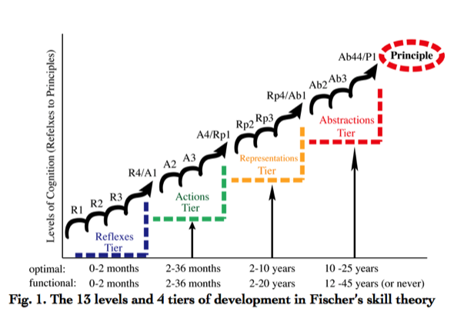
(Source: Ramia et al. 2016)

Appendix 2: Transformational leadership
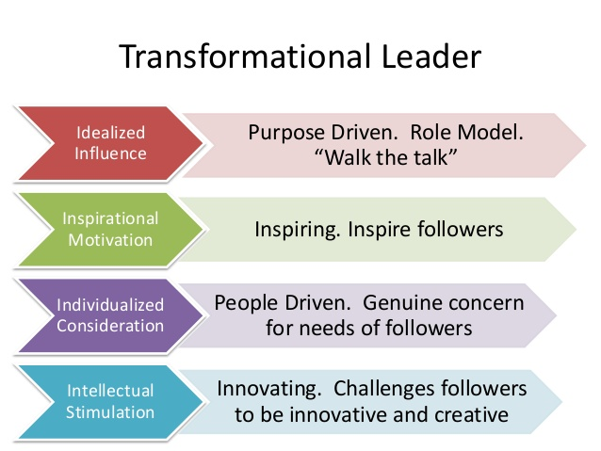
(Source: Whiley et al. 2017)

