Portfolio which presents evidence of the way in which you will have developed your Welsh language skills during the year

Written self-evaluation of your performance as a teacher developing learners’ Welsh language literacy skills (1500 words) which also includes evidence of the way in which you have responded to mentor/professional tutor comments during time on placement. You can use the ARC framework to help if you’d like.

Reflective practice is an important aspect of professional development (Dewey, 1993; Schon, 1983; Grigg, 2015, Tarrant, 2017). In this paper, I aim to reflect on my performance as a teacher developing learners’ Welsh language literacy skills. To demonstrate this, I have chosen to focus on one learning episode (See Appendix 1); Within the revised Professional Standards for Teaching and Leadership (Welsh Government, 2017a), teachers will be required to demonstrate how they engage in reflection and develop their Welsh language skills throughout their careers. In addition, the Curriculum for Wales (CfW) 2022 aims to develop a ‘’culture of professional reflection, dialogue and learning’’ (Welsh Government, 2020, p.229). The Languages, Literacy and Communication Area of Learning and Experience emphasises the importance of the Welsh Language, aiming to develop a bilingual education (Welsh Government, 2020).

Overall, the lesson was a success and the learners developed a range of Welsh Language literacy skills in oracy and writing. Learners demonstrated positive attitudes to learning and this impacted the progression in skill development. Dweck’s (2006) theory of fixed and growth mindset is perhaps key to language acquisition. Dweck’s research is embedded as a whole-school ethos that promotes learners to further their skills. Noels and Lou (2015) suggest that learners who ascribe language development to an inherent skill that can not be developed adopt a fixed mindset. Learners within the class are aware that intelligence can be developed, they recognise that mistakes are an essential part of learning and understand that effort is the path to mastery. Motivation in Second Language Acquisition is arguably a significant factor to sustained effort (Moskovsky, et al., 2013). As a teacher, it was therefore imperative that I motivated the learners to engage in the learning and modelled enthusiasm throughout the lesson.

Prior to introducing the new vocabulary, I activated the learners’ prior knowledge of the vocabulary that was introduced in the previous session. Constructivist theorists such as Piaget (1961) suggested that new knowledge is built on old and that learners should be constantly ‘’building’’ blocks of knowledge. In recapping the old knowledge and previous

vocabulary, it was apparent that there were some gaps in knowledge. Thus, I adapted my initial plan and spent additional time in ‘’Drillio’’ to consolidate the learners’ understanding. Grigg (2015) emphasises that flexibility and adaptability are perhaps two essential qualities that a teacher should possess.

To introduce the new vocabulary, I began the lesson with ‘Drillio’. On reflection the introduction was a strength of the learning experience. I employed various teaching strategies in order to motivate and engage the learners, these included utilising the ball for questioning, playing ‘Charades’ and ‘Swot It!’. Richards and Rogers (2014) suggested that interactive games are an effective strategy for motivation and to provide a change of pace to the learning. During these activities, I demonstrated enthusiasm and confidence; Estyn (2013) reported the impact that successful Welsh role models had on learners’ standards in Welsh language. Drillio is an effective teaching strategy as it utilises repetition; Bruner (1996) discussed the spiral curriculum, this involves regularly re-visiting the same educational topics over the course of a learner's education. Bruner (1996) indicated that repetition transforms short term memory into long term. Thus, I will continue to utilise ‘’Amser Drillio’’ in my future teaching.

Another strength of the lesson was the cross-curricular aspects of the learning. The lesson exploited all three cross-curricular responsibilities in the CfW 2022; literacy, numeracy and digital competency are considered fundamental to equipping learners with life-long learning skills (Welsh Government, 2020).

The Top Trump game enabled the learners to practice the ‘Anifeiliaid’ vocabulary and to also develop confidence in speaking Welsh. Baker (2011) suggests that utilising concrete materials can effectively support language acquisition. To support the discussions, learners were provided with ‘’Word Mats’’ that outlined the animal vocabulary and sentence patterns (See Appendix 2). These word mats were a successful resource that provided ‘’scaffolding’’ to the learning. The Zone of Proximal Development emphasises the importance of this ‘’scaffolding’’ in learning, a term developed by Bruner (1996). It is suggested that scaffolding can be provided by teachers or more experienced learner (Pound, 2014). I reflect that I could have perhaps differentiated these resources further to provide further support to the different abilities within the class. In working in small groups to play Top Trumps, learners were developing each other’s confidence and skill level. These interactions also created a language-rich learning environment. Vygotsky’s social constructivist theory emphasised the role of the social environment and interaction in learning. Piaget (1961) however suggested

that learning is egocentric, he referred to the learner as the ‘’lone scientist’’ and that learning is an internal process.

At the end of the lesson, learners were then required to write a ‘’Lesson Tweet’’ describing their favourite animal. These ‘’Lesson Tweets’’ are used regularly as a plenary across all Areas of Learning and Experience. Learners used the familiar sentence pattern ‘’Fy hoff’’ and were given additional sentence structure support to scaffold their writing. Those higher ability learners were encouraged to extend their writing. In using this resource in both English and Welsh, learners will become familiar to a climate where bilingualism in the classroom is normalised. The CfW 2022 outlines that learners should have opportunities to have pathways for learning bilingually, in both Welsh and English to develop confidence to use both languages in everyday life (Welsh Government, 2020, p.30). In reflection, I could have translated these cards into Welsh to further promote bilingualism in the classroom.

Elements of the learning experience that were perhaps disappointing was the lack of differentiation. I could have developed three different Word Mats to support three different abilities groups. Grigg (2015) emphasises the importance of differentiation in order to meet the individual needs of the learners, and to ensure that the learners remain focused and on task. I also reflect that within this individual lesson, I did not utilise enough formative feedback during Drillio.

The cause of the lack of differentiation to support the learners was perhaps due to my lack of knowledge in Welsh sentence patterns and vocabulary related to the topic, animals. The mistakes in the ‘’Lesson Tweets’’ also perhaps indicated that I did not emphasise the use of the plural and singular form of animals. I therefore recapped this in the following ‘’Drillio’’ session to address these misunderstandings.

Estyn (2017) identified that several teachers lack confidence in teaching Welsh; I can relate to this statement as I feel that although I am confident as a second language Welsh speaker, I struggle particularly in devising Welsh sentence patterns, to extend learners’ speaking and writing. To overcome this lack of confidence and Welsh language teaching skills I will need to further my own professional development in Welsh Language skills. Recently, I have completed a Welsh Language course that is specifically tailored to teachers (See Appendix 8). I was however enlightened in completing the course of my abilities and capabilities in the Welsh Language.

I reflect that there were several aspects of successful learning and teaching evident within this learning episode. Perhaps the most valuable success was that learners demonstrated enjoyment and enthusiasm in developing their Welsh language literacy skills. This enjoyment of learning is integral to the Welsh Government’s document, ‘’Education in Wales:
Our national mission’’ (2017b), which emphasises the importance that learners enjoy the learning experience in order to succeed. In future, to develop learners’ Welsh language literacy skills I will continue to devise stimulating activities that enrich the learning. The Welsh Government (2017c) outlined that learners need opportunities to use the Welsh language in a variety of contexts and situations to enrich their learning and development.

In addition, I reflect that during placement I demonstrated a dedication to developing my Welsh Language skills. In order to ensure that I modelled the language in the classroom, I devised a Welsh Language development plan (See Appendix 3). To develop my use of incidental Welsh, I set myself weekly targets, I then reflected on my efforts. This reflection process was an important element in developing my practice and also implementing Welsh language in the classroom.

The feedback that I received on placement from my class mentors celebrated my commitment to the incremental development in the use of the Welsh Language
(See Appendix 4). I also received positive feedback from this learning episode. In response to this feedback, I will continue to utilise the ball game in future lessons to develop learners’ Welsh language skills. Furthermore, I will utilise Drillio as an introduction, but also as a daily routine to introduce and recap vocabulary. Estyn (2019) reported the gains of using Drillio in the classroom in developing Welsh language skills.

In promoting a bilingual education, I reflect that overall, I implemented Welsh confidentially and naturally across the school environment. In giving instructions to the class I am confident to give these firstly in Welsh, then translated to the English. In giving step-by-step instructions, I use phrases such as ‘’Yn gyntaf’’, ‘’Yn ail’’ and ‘’Yn olaf’’ for the learners to respond to. In immersing the learners in an environment whereby Welsh is spoken as frequently as English, I am perhaps contributing to the CfW aim to develop a bilingual education (WG, 2020).

In conclusion, I reflect that I have demonstrated a commitment to the Welsh Language during the Professional Teaching Experience. In addition to this lesson, I also delivered a lesson to develop learners’ listening skills (See Appendix 5). In the Foundation Phase, I reflect on lesson in which learners created a rap to ‘’Sut mae’r tywydd heddiw?’’ (See Appendix 7). As well as developing learners’ oracy skills, this lesson also developed learners’ enthusiasm towards the language. Baker (2011) discusses how easily young children absorb information and how crucial the early years are in language acquisition. Finally, I set up and organised a Welsh afterschool club, along with my fellow PTE2 student teacher. We were pleased with the response we had to the club, as we had 17 learners who signed up. In club, we played Welsh games, made posters to promote the language and displayed these around the school, and sang Welsh songs in order to celebrate the language.

Link to clip - https://youtu.be/FYI0y3SsW3w

Reference List

Baker, C. (2011) Foundations of Bilingual Education and Bilingualism, 5th Edition. Clevedon: Multilingual Matters.

Bruner, J (1996) Culture of Education, Harvard University Press.

Dewey, J. (1993) How We Think. New York: Health&Co

Dweck, C (2006) Mindset: The New Psychology of Success. New York. Random House.

Estyn (2013) Whole-school approach to raising standards in Welsh. Available at: https://www.estyn.gov.wales/effective-practice/whole-school-approach-raising-standards-welsh (Accessed: 19 April 2020)

Estyn (2019) A report on Penllergaer Primary School Pontardulais RoadPenllergaerSwanseaSA4 9DBDate Date of inspection: November 2019 by Estyn, Her Majesty’s Inspectorate for Education and Training in Wales. Available at: https://www.estyn.gov.wales/sites/www.estyn.gov.wales/files/documents/Penllergaer%20Primary%20School_2.pdf (Accessed 19 April 2020)

Grigg, R. (2015) Becoming an outstanding primary school teacher. Second Ed.

Moskovsky, C & Alrabai, F & Paolini, S & Ratcheva, S. (2013). The Effects of Teachers’ Motivational Strategies on Learners’ Motivation: A Controlled Investigation of Second Language Acquisition. Language Learning. 63. 10.1111/j.1467-9922.2012.00717.x.

Noels, K & Lou, N. (2015). Mindsets, Goal Orientations and Language Learning: What We Know and What We Can Do. Contact: English Language Learning Magazine. 41.

Piaget, J. (1961) A genetic approach to the psychology of thought. Journal.

Pound, L (2014) How children learn. London: Practical Pre-School Books

Richards, J.C. & Rodgers, T.S. (2014) Approaches and Methods in Language Teaching, 3rd Edition. Cambridge: CUP

Schon, D. (1983) The Reflective Practitioner. London: Temple Smith

Tarrant, P. (2017) Reflective practice and professional development First.

Vygotsky, L. (1978) Mind in Society: The Development of Higher Psychological Processes. Cambridge: Havard University Press.

Welsh Government (2017a) Professional Standards for Teaching and Leadership. Cardiff: WG. Available at: https://learning.gov.wales/docs/learningwales/publications/170901-professional-standards-for-teaching-and-leadership-en.pdf (Accessed 12 March 2020)

Welsh Government (2017b) Education in Wales: Our national mission. Action plan 2017-21. Crown copyright. Available at: https://gov.wales/sites/default/files/publications/2018-03/education-in-wales-our-national-mission.pdf (Accessed 10 April 2020)

Welsh Government (2017c) Welsh in education: Action plan 2017-21. Crown Copyright. Available at: https://gov.wales/sites/default/files/publications/2018-02/welsh-in-education-action-plan-2017%E2%80%9321.pdf (Accessed: 10 April 2020)

Welsh Government (2020) Curriculum for Wales guidance. Crown copyright. Available at: https://hwb.gov.wales/storage/afca43eb-5c50-4846-9c2d-0d56fbffba09/curriculum-for-wales-guidance-120320.pdf (Accessed 12 March 2020)

Appendix

Appendix 1 – Lesson Plan

Appendix 2 – Word Mats

Appendix 3 – Welsh Language Development Plan

Appendix 4 – Class Mentor’s Feedback

Appendix 5 – Listening Task Lesson Plan + Evidence

Appendix 6 – Afterschool Welsh Club

Appendix 7 – Foundation Phase Lesson

Appendix 8 – Work Welsh Athrawon Certificate

Appendix 1

Lesson Plan Phase 1

Lesson Plan – Step 1 Cynllun Gwers – Cam 1

Student-teacher | Laura Powell | Class: | Year 6
AoLE or Subject | Welsh Second Language | Date: | 02/02/2020
Lesson Focus: | Anifeiliaid
Meaningful links to Curriculum | Welsh Second Language in the National Curriculum for Wales  Oracy  -View and listen carefully responding orally, in writing and non-verbally  -Communicate clearly and confidently and use intelligible Welsh pronunciation and intonation  -Reinforce Welsh syntax by the accurate use of a variety of:• vocabulary• phrases• questions• sentence patterns  Writing  -Spell simple words correctly, check spelling by using various methods, including ICT  -Write for a variety of purposes including:• to entertain• to present information• to express opinions• to convey feelings and ideas  -Write in a variety of forms, e.g. stories, poems, scripts, leaflets, posters, advertisements, reports, diaries, notes, electronic texts, portrayals, instructions, questionnaires, reviews  Four Purposes  -Ambitious, Capable Learners  -Enterprising, Creative Contributors  -Healthy, Confident Individuals
Meaningful links to:  Cross Curricular Responsibilities | LNF  -Use features and layout which are constructed to present data and ideas clearly.  -Use a range of strategies to make meaning from words and sentences, including knowledge of phonics, word roots, word families, syntax, text organisation and prior knowledge of context  -Produce fluent and legible handwriting  -Transfer Mathematical skills to a variety of contexts and everyday situations  DCF  -Work with others to create an online collaborative project for a specific purpose, sharing and appropriately setting permissions for other group members, e.g. editing, commenting, viewing.  -Select and combine a range of text, image, sound, animation and video to produce an outcome for a selected purpose; use software tools to enhance the outcomes for specific audiences
Personal Targets (Linked to QTS and identifed in weekly review)
To embed the four core purposes into my lessons and to outline the inclusion to the learners.

QTS - The teacher demonstrates a knowledge and understanding of the needs of all learners in planning, preparation and teaching, ensuring that the four purposes are the drivers for learners’ experiences

Learning Objectives (focus on Learning- use accessible vocabulary):
The pupils will learn to:
To identify the different animal habitats in Welsh and give examples of animals who live within this type of habitat.

Success Criteria (clearly linked to each Learning Objective and related to the process and/or product of learning) | Assessment of Pupils’ Learning  Evidence  (What have the learners to say/write/do/produce – to demonstrate learning)
I can listen to the correct pronunciation and repeat.  I can recall Welsh vocabulary.  I can use accurate sentence patterns. | Learners will have engaged in sllot drillio activities in order to develop Welsh pronunciation and extend vocabulary bank. Learners will have also in groups created ‘Top Trump’ cards in Welsh to practice Welsh Language skills.

Time | Activities/Methodology/Key Concepts  (Teacher’s Role – including key teaching points, differentiation strategies and key questions) | Pupil Tasks  (Pupils’ role –including differentiation, engagement in formative assessment and homework) | Resources  (Including Health and Safety requirement)
Opening phase (with links to prior learning) | Introduce learners to the ‘Nod y wers’  APK – Pwy sy’n gallu cofio..pa fath o anifeiliaid did we learn about yesterday? Ble?  Beth arall?  Teacher to introduce new Welsh vocab through drillio. Teacher to give the English, learners to say the Welsh. (No Hands Up)  Animal Charades  Teacher to then introduce the new habitat and the animals within this habitat. | Learners to activate prior knowledge of Welsh vocab and name as many animals in Welsh as possible.  Learners to listen, and to repeat. Learners to catch a ball and say the Welsh.  One learner to be chosen (Dojo Randomiser) to come up in front of the class, choose a card (animal in Welsh) and then act out the animal.  The class should put there hand up to answer the question. (1 dojo for the table who guesses correctly)  Sllot Ddrillio – Introduce new vocabulary | PowerPoint
Teaching & Core Learning | Top Trumps –  Learners to use Microsoft Publisher to create Top Trump cards. Learners will then share these cards with the teacher via HWB to be reviewed and marked.  LA – Top Trump Template to fill in  MA – Top Trump Template to copy key words  HA – Independent (Following template)  Learners will be showed WAGOLL, and introduced to the vocab  -Pwysau  -Cyflymder  -Cuddliw  -Deallusrwydd  Learners can make up scores for each category. | Learners will then devise Top Trump Cards based on the learnt vocabulary. Learners to work in groups and to create animal cards within a certain species.  Group 1 – Anifeiliaid Anwes  Group 2 – Anifeliaid ar y fferm  Group 3 – Anifeiliaid yr Arctig  Group 4 – Anifeiliaid y jyngl a’r fforest law.  Learners can use the PowerPoint slide to support their dialogue in playing Top Trumps. RULE – DIM SAESNEG O GWBL!!  Learners may want to guess what animal using questions such as  ‘’Oes … gyda anifail?’’ | Top Trumps Template
Plenary | Today’s Lesson Tweet – Learners are familiar and have used these other subject areas.  Show WAGOLL as an example.  Teacher to call out an animal and the learners to swot the correct animal.  Celebration of learners’ work. | Learners to use sentence patterns to write about their favourite animal.  SWOT IT – Various animal pictures will be displayed on the IWB. Two learners to then compete against eachother to use the fly swotter to beat each other to ‘’swot’’ the correct animal.  Walking Gallery – Learners to walk around the class to celebrate each other’s work. | WAGOLL  Tweet Cards  IWB  Swotters

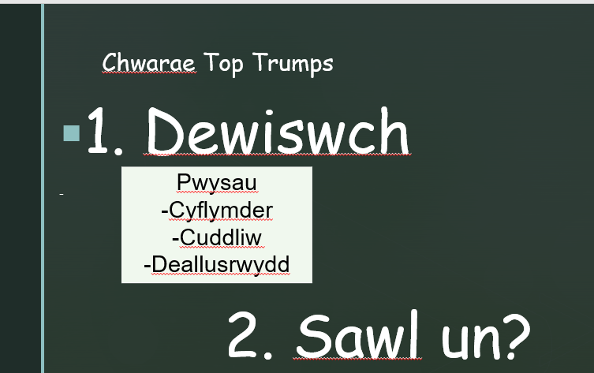
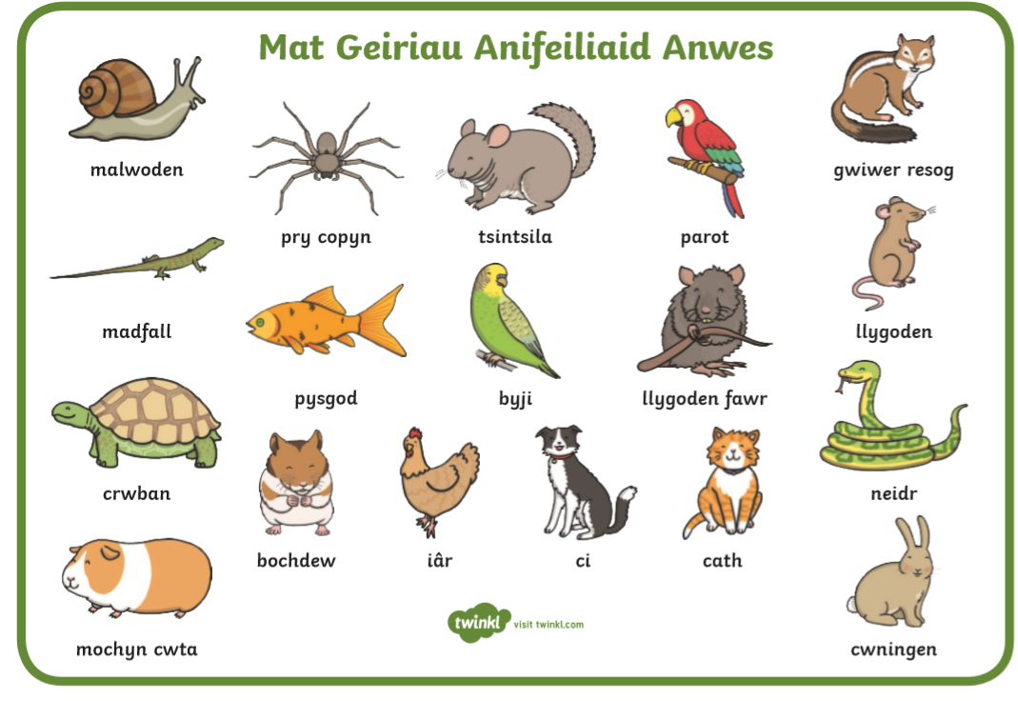
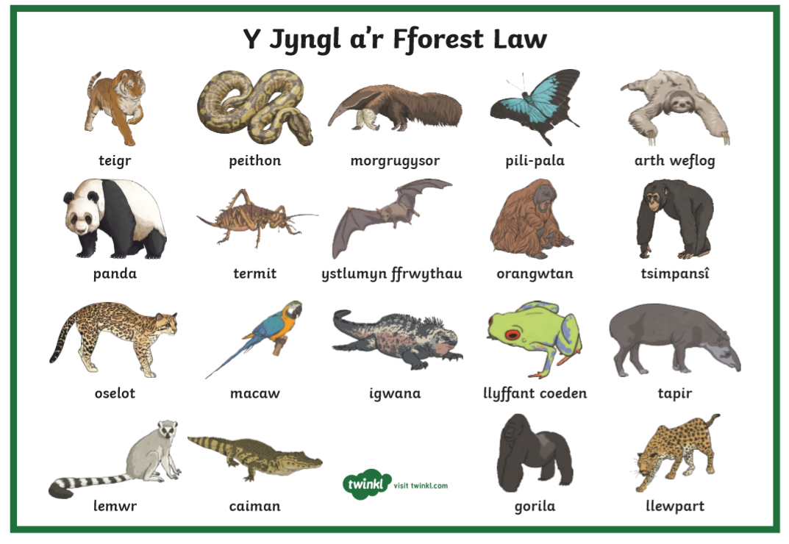
Appendix 2
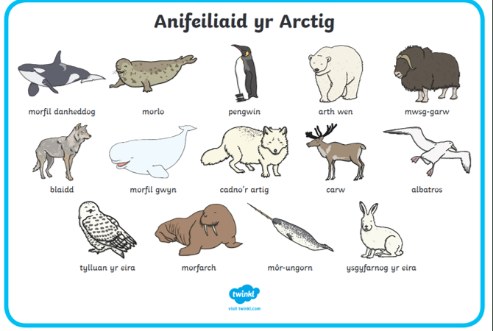

Appendix 3

 | Week 1 | Week 2 | Week 3 | Week 4 | Week 5
KEY TOPIC WORDS  (See Lesson Plans) | Anifeiliaid | Anifeiliaid | Anifeiliaid | Anifeiliaid | Anifeiliaid
INCIDENTAL WELSH | ‘Sdim ots  Gofynnwch i ffrind  Ateb da iawn  Amser chwarae gwlyb  Bore Da/Prynhawn  Da (Register)  Cinio neu Brechdannau  Ydy .. yma?  Ble mae ..?  Pwy sy’n gallu cofio?  Beth wyt ti’n eisau?  Dim siarad  Dw I’n falch iawn  Feedback  Bendigedig  Gwych  Da iawn  Da  Daliwch ati  Ymdrech dda  Gwaith taclus  Gwell  Dyna welliant  Rhaid canolbwyntio  Boddhaol  Gwaith anniben  Anniben ofnadwy | Yn cyntaf  Yn olaf  Bydden ni…  Ysgrifennwch y nod y wers a ddyddiad  Tawelwch  Sefwch yn dawel  Eisteddwch yn dawel  Gwnewch res wrth y drws  Edrychwch arna i..  Welwch i fory..  Feedback  Bendigedig  Gwych  Da iawn  Da  Daliwch ati  Ymdrech dda  Gwaith taclus  Gwell  Dyna welliant  Rhaid canolbwyntio  Boddhaol  Gwaith anniben  Anniben ofnadwy | Dim dwylo fynny  Pa sgilliau rydych chi wedi defnyddio?  Pa lliwiau rydych chi wedi defnyddio?  Beth rydych chi wedi defnyddio?  Ydych chi’n teimlo’n falch?  Dw i’n aros  Ble est ti?  Pwy sy’n barod?  Wyt ti’n cyntuno?  Feedback  Bendigedig  Gwych  Da iawn  Da  Daliwch ati  Ymdrech dda  Gwaith taclus  Gwell  Dyna welliant  Rhaid canolbwyntio  Boddhaol  Gwaith anniben  Anniben ofnadwy | Four Purposes –  Unigolion iach, hyderus  Dysgwyr uchelgeisiol, galluog  Dinasyddion egwyddorol, gwybodus  Cyfranwyr mentrus, creadigol  Llongyfarchiadau i …  Dim..  Paid..  Feedback  Bendigedig  Gwych  Da iawn  Da  Daliwch ati  Ymdrech dda  Gwaith taclus  Gwell  Dyna welliant  Rhaid canolbwyntio  Boddhaol  Gwaith anniben  Anniben ofnadwy | Gwela i di fory  Mae’n bwrw hen  wragedd o ffyn  Mae’n ddrwg ‘  Da fi  Allan a ti/chi!  Nol a ti/chi!  Ffwrdd a ti/chi!  Helpwch eich gilydd!  Peidiwch!  Heddiw, byddwn ni’n ….  Sut wyt ti’n gallu gwella hwn?  Beth wyt ti wedi gwned yn dda?  Feedback  Bendigedig  Gwych  Da iawn  Da  Daliwch ati  Ymdrech dda  Gwaith taclus  Gwell  Dyna welliant  Rhaid canolbwyntio  Boddhaol  Gwaith anniben  Anniben ofnadwy
Achieved – Yes / No  Reflection | Yes – I achieved the above vocabulary and more. The class mentor is fluent Welsh, and models a lot Welsh in the classroom. I therefore feel that this is motivating my own Welsh Language Development and I am also learning by working alongside the mentor. In every feedback comment that I wrote whilst marking the books, I wrote a Welsh comment. I also used a lot of Welsh in the classroom. Next week I will aim to lead the ‘’Sllot Ddrillio’’ every morning in order to develop my Welsh Language further. | As I have been absent from school 2 days I feel that I haven’t spent much time teaching due to the timetable this week. I have however made an effort to transfer my Welsh skills to the wider school environment, e.g. praise and commands in the Christmas concert. | It was pleasing that in my learning journal, my class mentor has commented on the amount of use that I include. I reflect that I am confident in using Welsh instructions and commands, rather than topic-related Welsh. I need to ensure that I use it in my focus-task groups, as well as in whole-class activities. | Yes. In reflection, I think that I have improved massively in regards to my use of Welsh in the classroom. I feel that when appropriate I give instructions in firstly Welsh, and then in English. I need to develop my use of topic-related Welsh. | Overall I feel confident that I have made significant improvements in my Welsh Language development during Key Stage Two. The class teacher, who is a first language speaker seems to have influenced my developing in using the Welsh language, and has support my confidence. I believe my oracy skills in particular have strengthened and I am more confident in using both incidental and topic related Welsh. The learners improvements in their Welsh language skills have also been evident as learners are able to confidently respond to Welsh commands and have learnt Welsh vocab.

Appendix 4

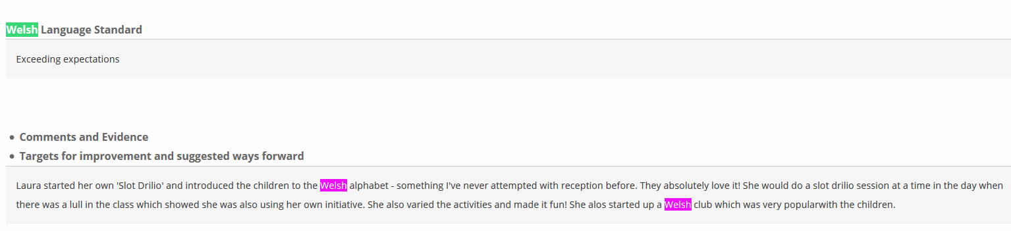
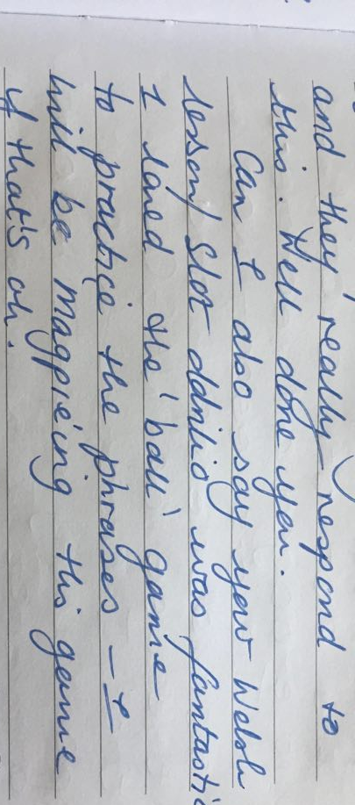

Appendix 5

Lesson Plan Phase 1

Lesson Plan – Step 1 Cynllun Gwers – Cam 1

Student-teacher | Laura Powell | Class: | Year 6
AoLE or Subject | Welsh Second Language | Date: | 10/01/2020
Lesson Focus: | To develop listening skills, in Welsh Second Language Development.
Meaningful links to Curriculum | Welsh second language in the National Curriculum for Wales  Skills + Range – Oracy  -View and listen carefully responding orally, in writing and non-verbally  -See and hear different people talking, including those with different dialects  -Experience a variety of audio, audio-visual, electronic, visual and written stimuli, ideas and texts
Meaningful links to:  Cross Curricular Responsibilities | LNF  -Listen carefully to presentations and show understanding of the speakers’ conclusions or opinions  -Use a range of strategies to make meaning from words and sentences, including knowledge of phonics, word roots, word families, syntax, text organisation and prior knowledge of context  -Produce fluent and legible handwriting
Personal Targets (Linked to QTS and identifed in weekly review)

Success Criteria (clearly linked to each Learning Objective and related to the process and/or product of learning) | Assessment of Pupils’ Learning  Evidence  (What have the learners to say/write/do/produce – to demonstrate learning)
I can listen, and note key vocabularly (such a byw, hoffi) as support to answer each information question.  I can then check my answers, by listening to the whole audio. | Learners will listen to the boy talking about himself and then select/write the correct information.

Learning Objectives (focus on Learning- use accessible vocabulary):
I can listen to a Welsh dialogue and answer questions accordingly.

Time | Activities/Methodology/Key Concepts  (Teacher’s Role – including key teaching points, differentiation strategies and key questions) | Pupil Tasks  (Pupils’ role –including differentiation, engagement in formative assessment and homework) | Resources  (Including Health and Safety requirement)
Opening phase (with links to prior learning) | Sllot Ddrillio – Teacher to utilise key Welsh vocabularly. Asking individuals questions, as well as whole class repetition. Important that teacher models correct pronounciation. | Learners will engage in drillio activities  -Questioning w/ball  -Repetition | Soft ball
Teaching & Core Learning | Teacher to firstly play the audio through with no stops.  Teacher to secondly play the audio with stops at appropriate points to allow learners to record answers.  Teacher to remind learners of the key vocabularly.  Teacher to then play the audio with more stops to support learners.  Lastly (depending on learners progression), play the audio through with no stops. | Learners to listen to the clip whilst reading through the questions.  Learners to identify and listen to the key words in order to answer the questions.  Learners to listen carefully to the audio in order to check answers. | Pecyn Pontio First Person Profile Boris Audio Tape  3X Differentiated Worksheets
Plenary | As a whole class, go through the worksheet questions asking individuals for answers. | Learners to self-assess, using green pens to mark. | Green Pens

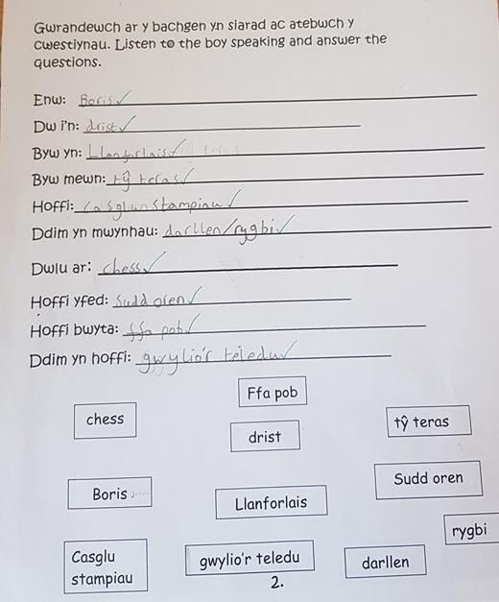
High Ability

Middle Ability
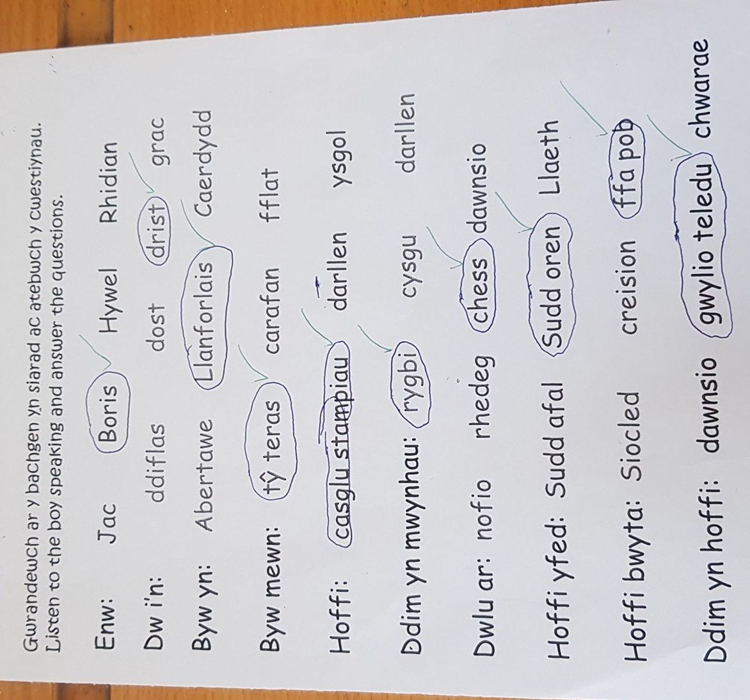

Lower Ability
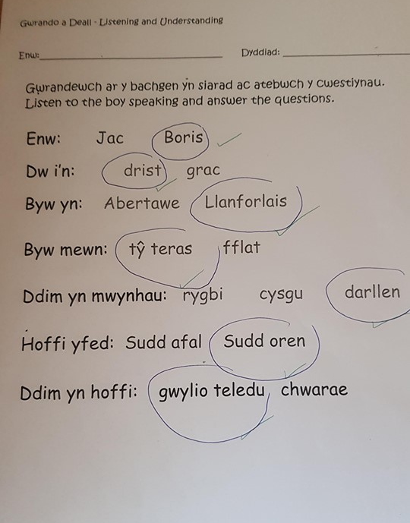

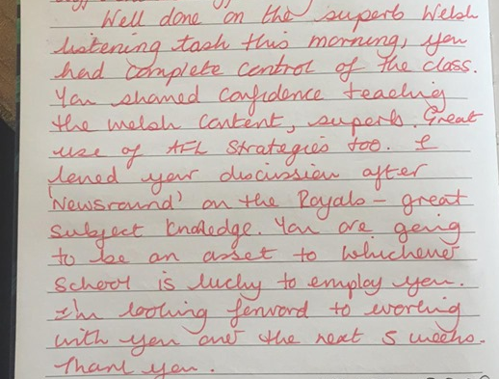

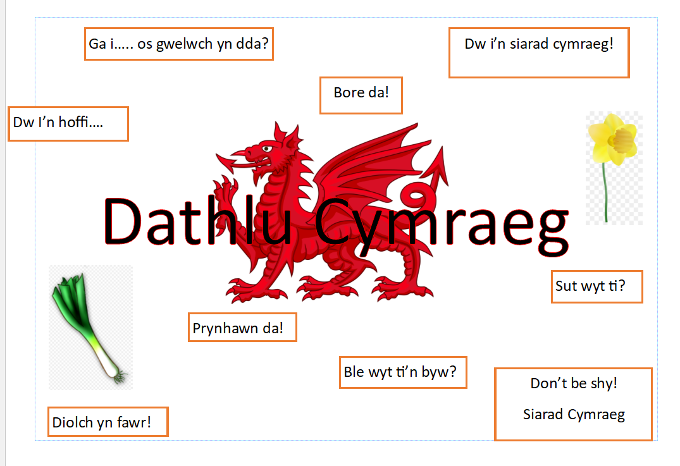
Appendix 6
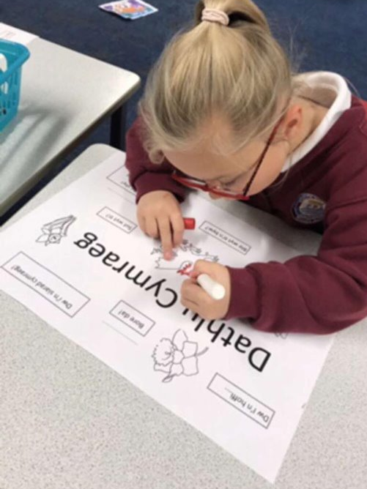
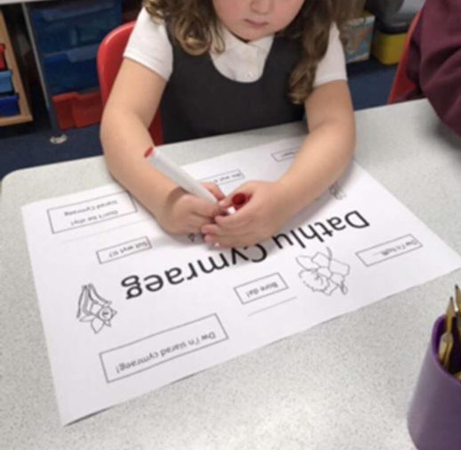

Appendix 7

Lesson Plan Phase 1

Lesson Plan – Step 1 Cynllun Gwers – Cam 1

Student-teacher | Laura Powell | Class: | Reception
AoLE or Subject | Welsh Language Development | Date: | 22/11/2019
Lesson Focus: | To learn vocab relating to the Weather in Welsh.
Meaningful links to Curriculum | Welsh Language Development (Range)  -Joining in with simple rhymes and stories  -Reciting or singing Welsh poems, songs and raps  -Read and make use, for different purposes, of a variety of printed and ICT resources.
Meaningful links to:  Cross Curricular Responsibilities | Literacy  Join in, repeat or memorise rhymes, songs and stories with some support  Convey meaning through pictures and mark making  DCF  Using the iPads to create a poster depicting the Weather.
Personal Targets (Linked to QTS and identifed in weekly review)
1. To implements AfL strategies in order to enhaunce the learning experiences
QTS -The range of purposes and practices for assessment is understood and articulated.

2. To model incidental Welsh as well as topic-related Welsh in the classroom, and wider school context.
QTS - There is a commitment to incremental development of personal skills in the use of the Welsh language

3. To devise enhaunced provision activities that encourage the learners to work independently, rather than teacher-led.
QTS - The teacher provides appropriate levels of challenge and expectations for the range of student abilities and characteristics, motivating learners to achieve.

Success Criteria (clearly linked to each Learning Objective and related to the process and/or product of learning) | Assessment of Pupils’ Learning  Evidence  (What have the learners to say/write/do/produce – to demonstrate learning)
I can ask, ‘What is the weather today?’ in Welsh.  I can describe what the weather is like in Welsh. | Learners should sucessfully engage with the bingo game, and be able to recognise the Welsh vocab in order to cross off the correct weather picture on the Bingo card. Learners to be encouraged to use as much Welsh vocab in the activities as possible.

Learning Objectives (focus on Learning- use accessible vocabulary):
To develops Welsh vocabulary relating to the weather. To take part in the Welsh weather song.

Time | Activities/Methodology/Key Concepts  (Teacher’s Role – including key teaching points, differentiation strategies and key questions) | Pupil Tasks  (Pupils’ role –including differentiation, engagement in formative assessment and homework) | Resources  (Including Health and Safety requirement)
Opening phase (with links to prior learning) | APK – What Welsh songs have you sang with Miss Powell?  Introduce the new song – Sut mae’r tywydd heddiw?  What does that mean in English?  Go through the different types of weather,  Wyntog, Heulog, Brwr Glaw, Brwr Eirau, Oer, Boeth. #Drillio #  Remind the learners of Miss Powell’s Ser Mawr. | No Hands Up Rule
Teaching & Core Learning | Whole Activities  Drillio  Repetition of ‘Sut mae’r tywydd heddiw?’, followed by the different types of weather. Teacher to give the English, and learners say the Welsh (Vis-Versa).  Charades  One individual to choose a type of weather, and then act it out for the children to guess. Only Welsh answers accept.  Roll the Dice  Stick weather cards onto each side of the dice. Throw the dice, and ask learners to say the pattern ‘’Mae hi’n..’’. | Focus Activity –  In learning groups, with support of teacher the learners should make a rap/song about a type of weather. Each group will be given an envelope to open (Weather revealed inside)  Outdoor Activity  Learners to draw a picture depicting a type of weather.  Chalk Board Area Outdoors  Teacher to write on the board, ‘’Mae hi’n......’’, learners to then copy the words ‘’brwr glaw’’, ‘’boeth’’.  Funky Finger Gym  Use the various resources / materials to display a type of weather. Can your partner guess what weather it is?  Carpet Area  Washing Line Activity – Learner to put the clothes on the Washing Line that most suits the Weather. Learners to be encouraged to use as much Welsh vocab as possible.  Literacy Area  Write a weather report. Use template to support. Different templates for each ability group.  RWI Area  Welsh Weather Cards to be Placed for learners to copy, understand and draw.  Craft Area  Colouring different weather conditions.  Welsh Bingo (Teacher to say the weather in Wales, (‘’Mae hi’n ....’’), LA - Learner to mark off the weather on the bingo cards. When finished – Shout ‘TY!’ (House). Support differientiated based on ability group.  Interactive Whiteboard - | Bingo Cards Laminated  Large Dice  Chalk  Laminated Cards
Plenary | Competition  Show the eachother our rap songs.  Celebration of learners work. | Learners to be encouraged to get into the competitive spirit.

Evidence -
https://uowtsd-my.sharepoint.com/:v:/g/personal/1801173_student_uwtsd_ac_uk/EfwVpGc1S9pGsqtZ2LLOa00BURfF8GaHZJNxcvlHkEhGYg?e=CTQZaR

https://uowtsd-my.sharepoint.com/:v:/g/personal/1801173_student_uwtsd_ac_uk/EQntyFuIwPVAiu5b6wXsjOkBa13yyiy81_pNA2Can7GodA?e=1fagjX

Appendix 8


