

Programme: BSc (Hons) Health and Social Care

Module name: Protecting and Supporting Families in Health and Care

Module Code: (BMHP5021_LON)

Assignment Title: Component 2. An examination and analysis of how the ‘Early Help’ system is signposted to UK families by their local authority website.

Student name: Yuliia Silman
Student number: 2431446
Lecturer’s name: Amanda Jones

Table of Contents
Introduction 3
The Early Help System 3
Multi-agency Working in the Context of Early Help 3
Evaluation of Each of the Three Local Authority Websites 4
Tower Hamlets 4
Leicester 5
Nottinghamshire 5
Comparative Analysis of Main Strengths and Weaknesses 6
Conclusion and Recommendations 10
Reference List 12

Introduction
For a parent or carer, a council website may be the first place to look when family difficulties begin. If information is difficult to find or unclear, a family may not reach the right support at the right time. This report examines how effectively the local authority websites of Tower Hamlets, Leicester and Nottinghamshire signpost Early Help and other support for families. It first outlines the Early Help system and multi-agency working, then evaluates each website and compares their main strengths and weaknesses. The conclusion identifies the most effective website and makes recommendations for improvement.

The Early Help System
The Early Help System Guide describes Early Help as a local system rather than one service. It brings together universal, community and targeted support so that families can receive help before difficulties become more complex. Depending on the local area, this may include Family Hubs, schools, health services and support with parenting, mental health, housing or domestic abuse (Department for Education, 2022).
Early Help is part of safeguarding as safeguarding includes preventing harm to children’s health and development. However, it is different from child protection, which concerns children who are suffering, or are likely to suffer, significant harm (Department for Education, 2026). Section 10 of the Children Act 2004 requires local authorities to work with relevant partners to improve children’s well-being (Children Act 2004, s.10).
Working Together to Safeguard Children 2026 uses the term Family Help for coordinated targeted Early Help and support for children in need. It also states that safeguarding partners must publish criteria for different levels of assessment in a transparent, accessible and easy-to-understand way (Department for Education, 2026). Families therefore need clear online signposting to understand when Early Help may be suitable and how to reach the right support.

Multi-agency Working in the Context of Early Help
Multi-agency working brings together services with different responsibilities, including education, health, social care and voluntary-sector organisations. It differs from multidisciplinary working, which refers to practitioners with different professional expertise. In Early Help, its purpose is to coordinate support around the child and family. Ofsted et al. (2022) state that Early Help pathways should be understood by both professionals and families.
Effective coordination requires more than referring a family to several services. It needs clear professional roles, timely information-sharing, a shared plan and review of progress. Research summarised by the NSPCC (2025) also identifies clear communication and access to relevant information as key features of effective multi-agency work.
Effective information-sharing depends on information being necessary, proportionate and relevant. Families should also be informed about what will be shared and with whom, unless this would create a safety risk (Department for Education, 2024). However, effective partnership is not automatic: communication, organisational commitment and different views about consent can create barriers (Purcell, Baginsky and Steils, 2026). For this reason, the website evaluation considers not only whether support is listed, but whether a family can understand how services connect.

Evaluation of Each of the Three Local Authority Websites
Each website was assessed from the perspective of a parent or carer looking for help without professional knowledge of local services. The assessment considered navigation, clear information, support for different needs, contact routes, local services, parenting support, family voice, feedback and digital accessibility, including translation and language support.

Tower Hamlets
In Tower Hamlets, Early Help can be found through Health and social care, Children and family care and then Early Help. For a parent looking for family support, the health and social care section may not be an immediately obvious starting point. However, once the section is reached, the information is clear and relevant to common family concerns. It explains support with housing, money difficulties, emotional wellbeing, parenting, children’s behaviour and substance use. It also explains what may happen after contact, including advice, access to other services, an assessment of the family’s needs or a meeting with relevant services to plan support.
Families can contact the council’s Early Help team by telephone or an online request form. The Early Help pages also link to local family support hubs, parenting information and the Local Offer, an online directory of local services. This gives families a route to request support and a route to find other help independently.
The website uses question-led sections, such as When should I get help? and What happens after you get in touch?, which may help parents who are unsure whether Early Help is right for them. It includes parent comments on its parental-conflict page. The council also states that families can give feedback by text message, website or form. An accessibility statement is available.

Leicester
Leicester provides a clear route through Children, young people and families and then Support for children and young people. Its Early Help page uses familiar examples that may help a parent recognise when support could be relevant. These include worries about a child’s behaviour or wellbeing, difficulty coping as a parent, housing problems and domestic abuse. The page also lists possible areas of help, including parenting, school attendance, mental health, money, housing, employment and youth services.
The page clearly states that parents and carers can request Early Help themselves. It gives a telephone number and email address and explains that a lead professional may discuss the family’s needs, complete an assessment and agree an action plan. However, although the page lists different areas of support, it does not provide clearly labelled links to services for each need or a searchable local support directory. A family may therefore understand that help is available but still need to look elsewhere to find a particular service.
No family stories, testimonials or Early Help FAQs were identified during the menu-based review. General council feedback and children’s social care complaints routes are available but are not directly linked from the Early Help page. Leicester provides an accessibility statement. It also has an automatic translation function, although the council explains that Google Translate may not be accurate and may not work for online forms, PDFs or maps.

Nottinghamshire
Nottinghamshire provides Early Help information through Family Hub Networks, which are local family support hubs, and a separate page called Referring to Early Help services. The referral page is located under Care, Early years and childcare and Childcare providers. This may be an unexpected place for a parent who is simply looking for Early Help. In contrast, the Family Hub Networks page presents itself as a starting point for local family support. It links families to information about parenting, health and wellbeing, education, relationships, employment and finances.
Families can contact the council’s Early Help team or their local Family Hub by telephone or email. They can also use an online enquiry form to request support. The Family Hub pages provide local contact details, a link to Your Notts Directory, an online directory of local services, and information about parenting courses and support. These options give families clear ways to ask for help or explore other local services.
The parenting-support page includes parent testimonials, which give some indication of families’ experiences of the service. Nottinghamshire also invites parents and carers to take part in the development of Family Hub Networks. However, this is different from a clear feedback route for families who have already used Early Help, so service-specific feedback is less visible. The accessibility statement identifies barriers in forms, keyboard navigation, search labels, colour contrast and heading structure. The council’s general contact page offers telephone interpreting, but this was not signposted within the Family Hub pages reviewed.

Comparative Analysis of Main Strengths and Weaknesses
Table 1. Comparison of strengths and weaknesses in Early Help website signposting
Comparative area | Tower Hamlets | Leicester | Nottinghamshire
Finding Early Help | Moderate - the route through health and social care is not immediately obvious. | Strong - Early Help is easy to find through children and family pages. | Weak - relevant information is divided across separate and unexpectedly labelled section.
Clear, family-friendly information | Strong - explains common concerns and what may happen after contact. | Strong - gives clear examples of when a family may need support. | Moderate - useful information is available, but families need to move between several pages.
Contact and self-referral | Strong - clear telephone and online request options. | Strong - parents can clearly request help by telephone or email. | Strong - telephone, email and an online contact form are available.
Finding help for a particular need | Strong - Early Help information links families to wider local support. | Weak - needs are listed, but there are no clear routes to relevant services. | Strong - topic-based information and a searchable local directory are available.
Parenting support | Strong - parenting information and resources are available within the Early Help section. | Weak - parenting is mentioned, but there is no direct route to relevant support. | Strong - dedicated parenting information, advice and courses are available.
Family voice and feedback | Strong - parent comments and opportunities to provide feedback are visible. | Weak - no comparable family stories were identified; feedback is not connected to Early Help. | Moderate - parent testimonials and opportunities to influence service development are available, but feedback from service users is less clear.
Digital accessibility and language access | Moderate - the council publishes an accessibility statement; translated resources were identified only for parental-conflict information. | Moderate - accessibility information and automated translation are available, but translation has stated limitations. | Weak - the council identifies barriers in forms, navigation, search labels, contrast and headings; interpreting is only signposted through the general contact page.
Table 1 shows that no website performs strongly across every area. Tower Hamlets has the most consistent pattern of strengths, particularly in clear information, contact routes, wider support, parenting information and family feedback. Leicester provides a clear entry point and self-referral route, but is weaker when families need links to more specific services or feedback. Nottinghamshire offers broad information and contact options, but fragmented navigation and digital accessibility barriers may make this information harder to use.
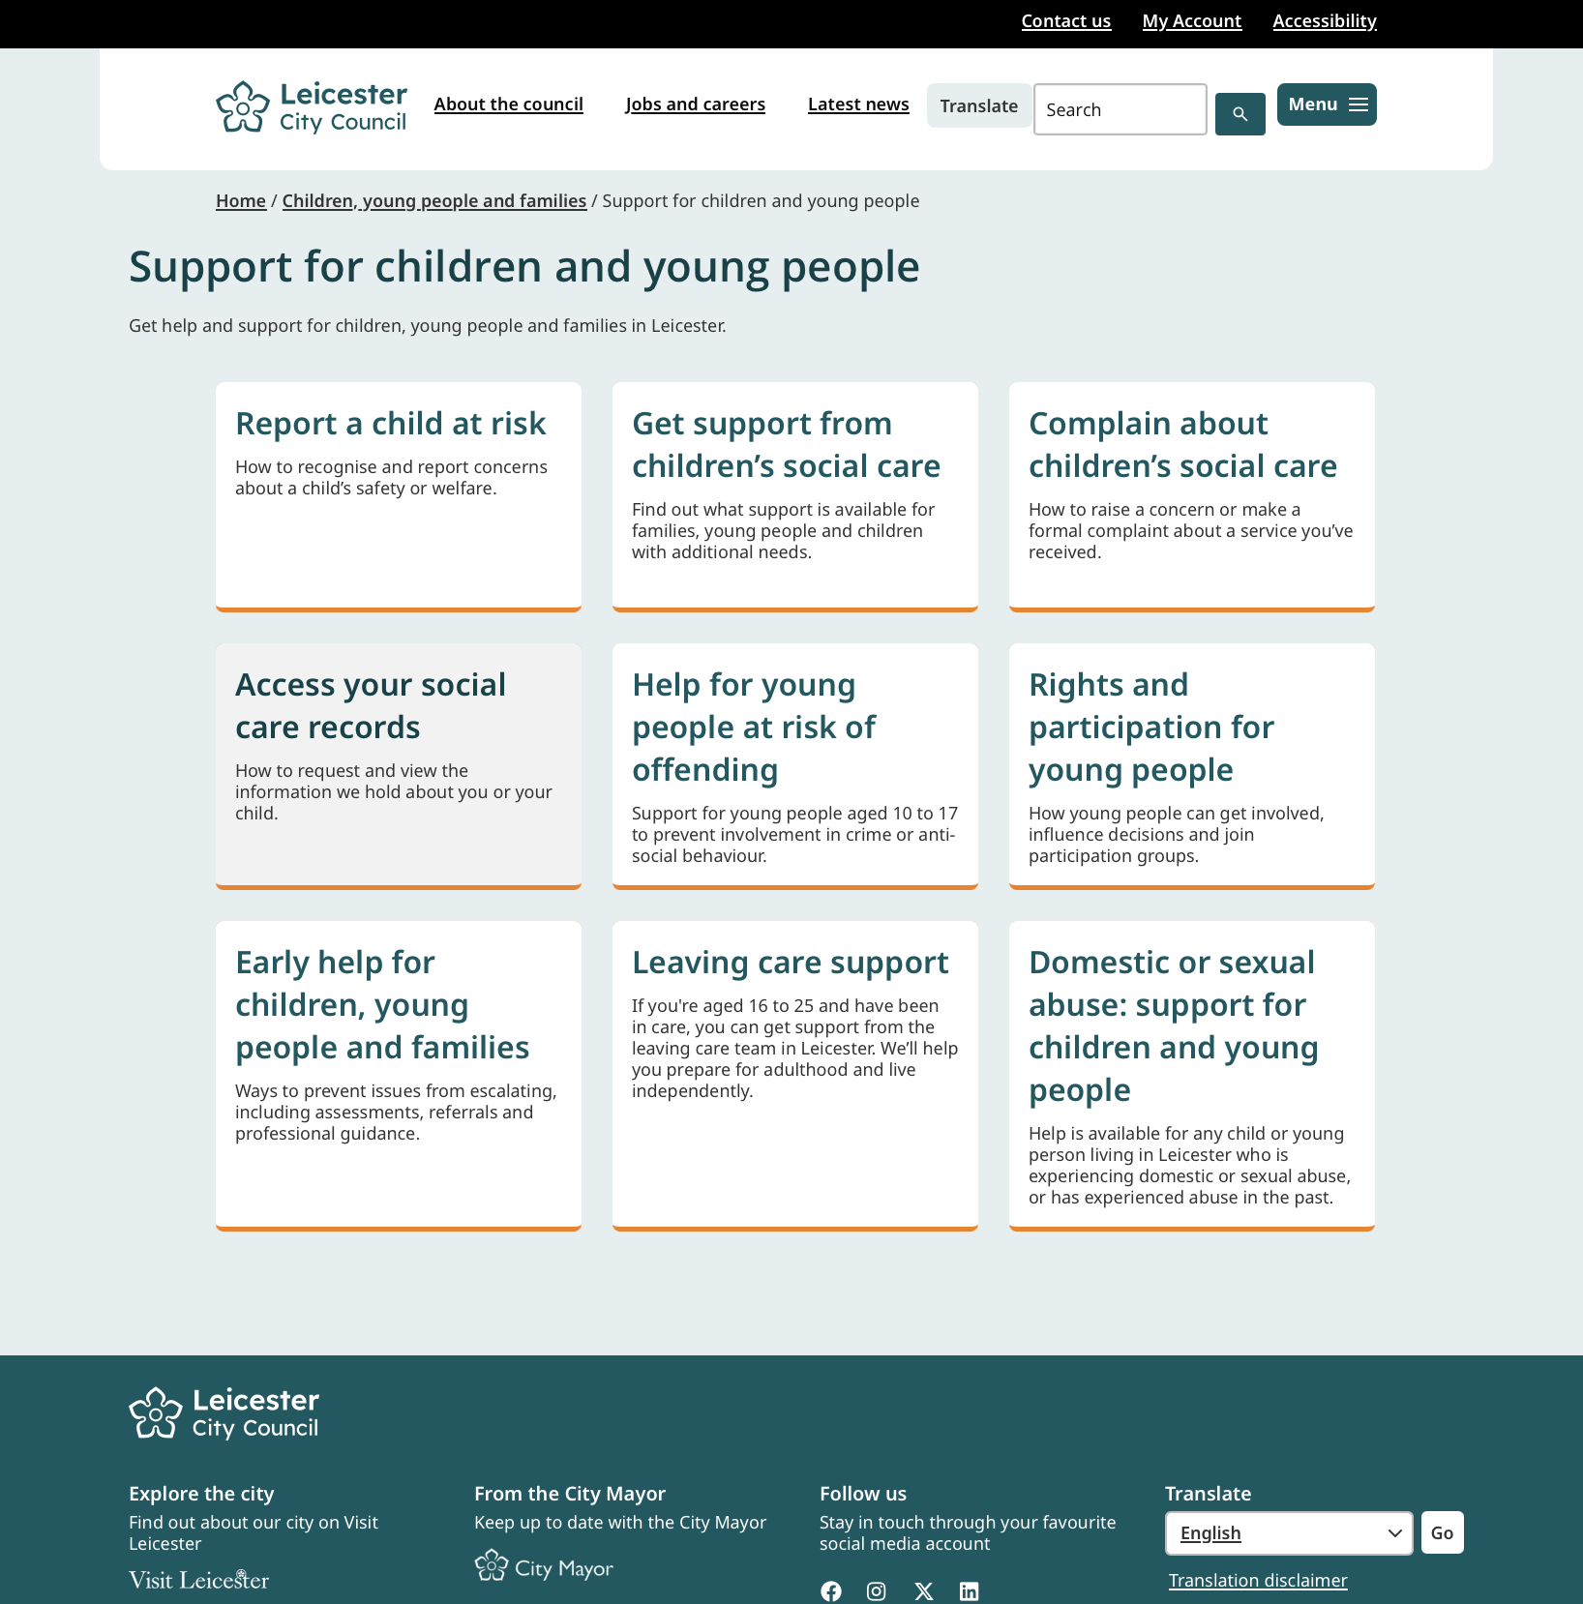
Figure 1. Leicester City Council navigation page showing Early Help as a clear option within Support for children and young people (Leicester City Council, n.d.).
Figure 1 shows why Leicester was rated strong for finding Early Help. The route begins in a familiar children and families section, and Early Help is presented as a clearly labelled option rather than being placed within a specialist category. This makes it easier for a parent to identify the relevant service at an early stage.
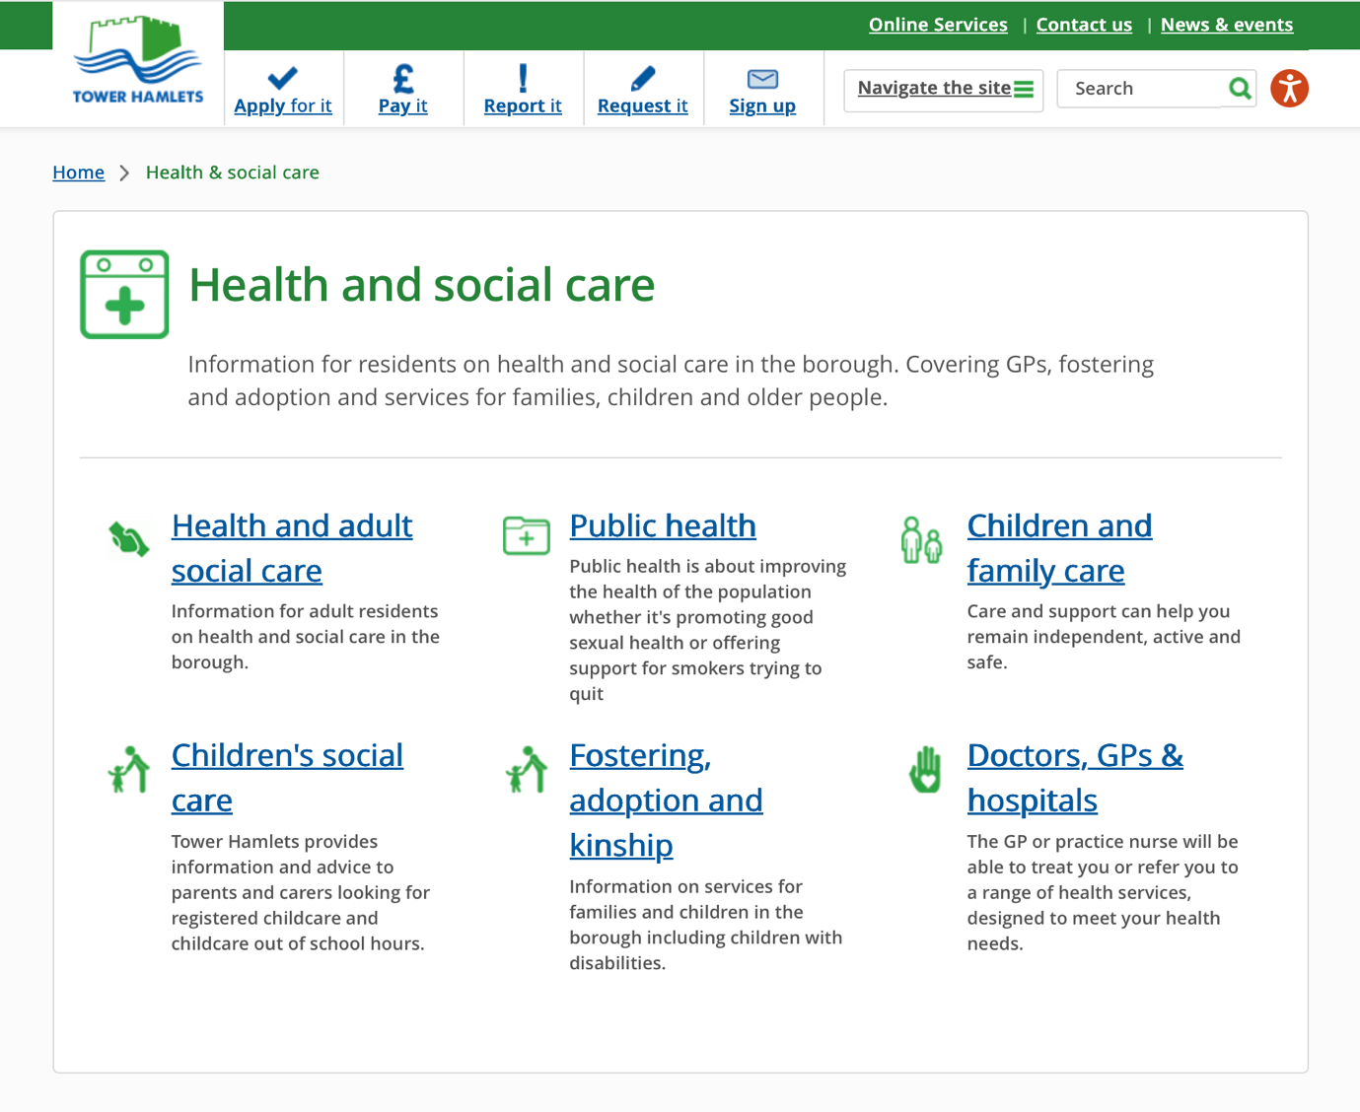
Figure 2. Tower Hamlets navigation page showing that families first enter the health and social care section before reaching Children and family care (London Borough of Tower Hamlets n.d.).
Figure 2 shows that Tower Hamlets provides a clear children and family category once the health and social care section has been selected. However, this may not be the first category that a parent chooses when looking for support with family difficulties. This explains its moderate rating for navigation.
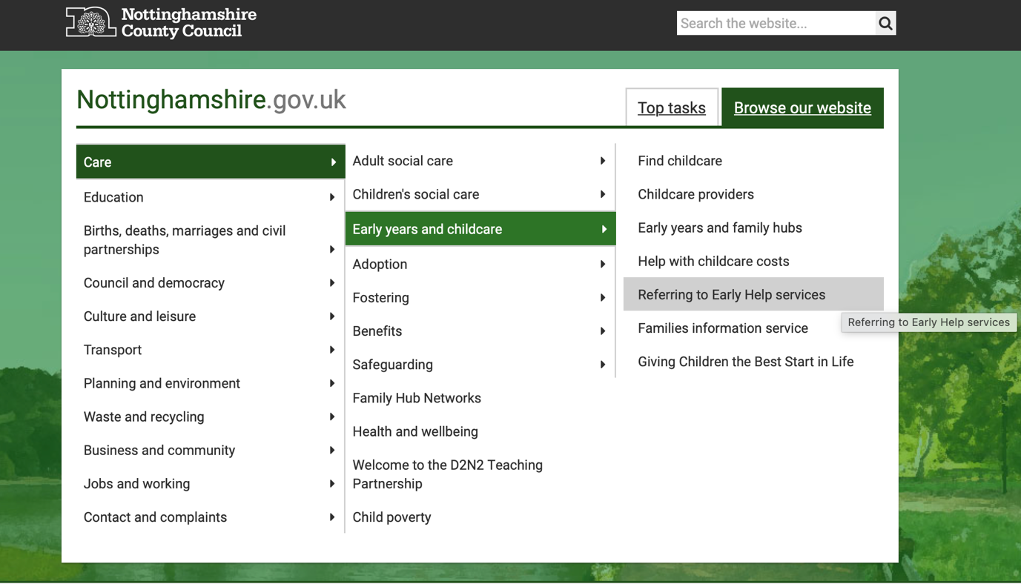
Figure 3. Nottinghamshire County Council navigation menu showing the Early Help referral option within Early years and childcare (Nottinghamshire County Council n.d.).
Figure 3 shows that Nottinghamshire’s Early Help referral route is available through the menu, but it is located under Early years and childcare alongside childcare-specific options. A parent who does not associate Early Help with childcare may not look in this section. This makes the route less intuitive than those shown in Figures 1 and 2.

Conclusion and Recommendations
Overall, Tower Hamlets appears to communicate Early Help and wider family support most effectively. Leicester provides the clearest starting point but gives less help when a family needs to find support for a particular problem. Nottinghamshire offers a wide range of information and contact options, but its fragmented navigation and published accessibility barriers may make this information harder to use.
Tower Hamlets should keep its connected Early Help information but add a direct route from the main children and families area. A clear starting point should help users understand what a service offers and give them an obvious next action (Government Digital Service, n.d.).
Leicester should add clearly labelled links from its Early Help page to relevant services and to a searchable local directory. This would help families move from recognising a concern to finding appropriate support, in line with the expectation that information for families is transparent and accessible (Department for Education, 2026).
Nottinghamshire should create clearer links between its Family Hub and Early Help pages. It should also address the barriers identified in its accessibility statement, particularly in online forms, keyboard navigation, search labels, colour contrast and headings. These areas are central to recognised web accessibility guidance (W3C, 2024).
These recommendations are based on website information, not on families’ experiences, response times or the quality of support received. Tower Hamlets provides a useful model because it connects Early Help with wider support, although its website structure may not work equally well in every local area. Each council needs to adapt improvements to its local services, website structure and population.

Reference List
Children Act 2004, c. 31. Available at: https://www.legislation.gov.uk/ukpga/2004/31/section/10 (Accessed: 8 August 2026).
Department for Education and Department for Levelling Up, Housing and Communities (2022) Supporting Families: Early Help System guide. Available at: https://www.gov.uk/government/publications/supporting-families-early-help-system-guide (Accessed: 8 August 2026).
Department for Education (2024) Information sharing advice for safeguarding practitioners. Available at: https://www.gov.uk/government/publications/safeguarding-practitioners-information-sharing-advice (Accessed: 10 August 2026).
Department for Education (2026) Working together to safeguard children 2026: statutory guidance. Available at: https://www.gov.uk/government/publications/working-together-to-safeguard-children--2 (Accessed: 8 August 2026).
Government Digital Service (n.d.) Help users start using a service, GOV.UK Design System. Available at: https://design-system.service.gov.uk/patterns/start-using-a-service/ (Accessed: 12 August 2026).
Leicester City Council (n.d.-a) Support for children and young people. Available at: https://www.leicester.gov.uk/children-young-people-and-families/support-children-and-young-people (Accessed: 11 August 2026).
London Borough of Tower Hamlets (n.d.-a) Health and Social care. Available at: https://www.towerhamlets.gov.uk/lgnl/health__social_care/health__social_care.aspx (Accessed: 11 August 2026).
Nottinghamshire County Council (n.d.-a) Nottinghamshire.gov.uk. Available at: https://www.nottinghamshire.gov.uk/care/early-years-and-childcare (Accessed: 11 August 2026).
National Society for the Prevention of Cruelty to Children (NSPCC) (2025) Effective multi-agency working and information sharing: evidence snapshot. Available at: https://learning.nspcc.org.uk/research-resources/2025/effective-multi-agency-working-information-sharing-evidence-snapshot (Accessed: 9 August 2026).
Ofsted, Care Quality Commission, HM Inspectorate of Constabulary and Fire & Rescue Services and HM Inspectorate of Probation (2022) Joint targeted area inspection of the multi-agency response to children and families who need help. Available at: https://www.gov.uk/government/publications/joint-targeted-area-inspection-of-the-multi-agency-response-to-children-and-families-who-need-help (Accessed: 9 August 2026).
Purcell, C., Baginsky, M. and Steils, N. (2026) ‘No quick fixes: challenges in multi-agency working to safeguard children’, British Journal of Social Work, 56(4), pp. 1610–1630. Available at: https://academic.oup.com/bjsw/article/56/4/1610/8324434 (Accessed: 9 August 2026).
World Wide Web Consortium (W3C) (2024) Web Content Accessibility Guidelines (WCAG) 2.2. Available at: https://www.w3.org/TR/WCAG22/ (Accessed: 13 August 2026).

