“If ever one art movement consumed the entire illustration genre, it was surrealism” Discuss with reference to modern illustration.

As defined by Oxford English Dictionary:
Surrealism: “having the disorienting, hallucinatory quality of a dream; unreal; fantastic”

The movement began in 1920s France by Mr Breton. Surrealism reached its peak in the 1930s. Breton was inspired by the writings of Sigmund Freud, who had theorised that “the unconscious mind is the primary source of human behaviour” – Dr, Saul Mcleod, Freud and the Unconscious Mind, 2009.

The concept of surrealism existed long before the name was coined. The practice of exploring illogical, absurd, and bizarre scenes was famously done by Hieronymus Bosch, a Dutch painter from the late 1400s to early 1500s. Although little is known about Hieronymus Bosch’s life, he greatly influenced art during the 16th century through his fantastical yet bleak approach to painting. In Bosch’s most famous work “The Garden of Earthly Delights” he created a triptych depicting Eden, Earth, and Hell, exploring the sins of humanity through the perspective of a Christian living in that era of change.

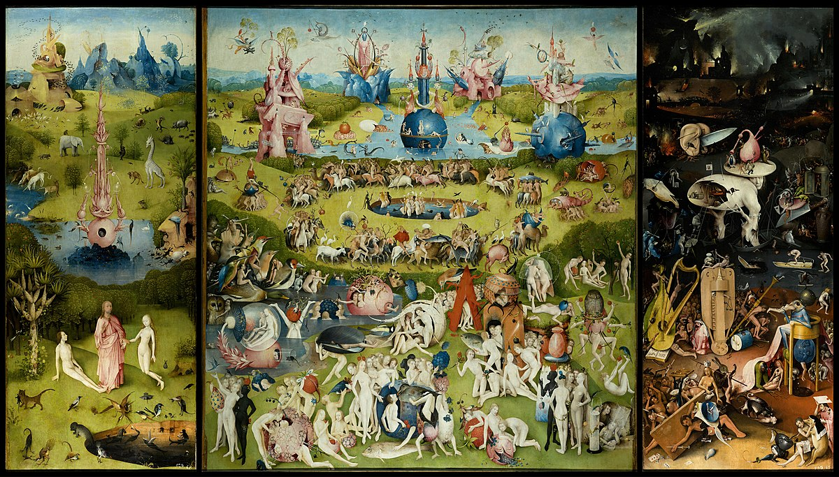
Bosch, Hieronymus. The Garden of Earthly Delights. 1490 – 1510.

The painting itself is a warning to those who find themselves vulnerable to temptation, as it will only lead to eternal suffering under illogical and absurd beings, whose only existence is to inflict suffering. Interestingly, he highlighted The Garden of Eden, displaying humanity’s early innocence in a world filled with impossible creatures and fantastical monuments.

In John Berger’s book on visual art, Ways of Seeing, he comments on this asepct:

In the Middle Ages when men believed in the physical existence of Hell the sight of fire must have meant something different from what it means today. Nevertheless their idea of Hell owed a lot to the sight of fire consuming and the ashes remaining – as well as to their experience of the pain of burns.
Berger, John. (2008) Ways of seeing. London: Penguin.

Since the time of Bosch, the appearance and meaning of Hell may have transformed over time, but the anxiety and horror that has affected humanity has prevailed throughout the ages.

The surrealist movement is related to Dadaism (from Switzerland) influencing it through the shared bizarre and absurd nature within the art establishment, while the Dada movement was made in opposition to war. Surrealism was created by Breton to explore the unconscious mind through art.
One use of Surrealism is absurdity with a secret hidden message to escape censorship under an authoritarian regime.

The Dada movement is famous for its “Anti-art” and mockery of the art world and its critics. It has a distinct yet dynamic style that could be described as bombastic, chaotic, and playful.

While on paper, at first there does not seem to be distinctive differences between Surrealism and the Dada movement, but what separates them is the desired result and the ultimate intentions of the piece. Surrealism aims to uncover and explore illogical concepts that can only be born from the unconscious mind. Alternatively, Dada is more forthright in its intentions and wishes to expose and satirise the horrors of war, “in response to the disasters of World War I” -World War I and Dada, MoMA Learning.

For Dada, life has no meaning, no reason, no purpose, and no logic. For Surrealism, life has meaning; one has to find its logic by unlocking visual and verbal codes secreted in the chambers of the unconscious mind.
Willette, Jeanne. (2011). Comparison of Dada and Surrealism. Art History Unstuffed

In other words, could be described as Dada is nihilist, whilst Surrealism could be described as being more optimistic in its vision.

In terms of encapsulating the message of the Dada movement, there is no better example than John Heartfield, (born Helmut Herzfeld in Germany). Heartfield created collages mocking the Nazi party and all their hypocrisies. He was notably anti-bourgeois, anti-capitalist, and anti-fascist, consequently his art is heavily political.

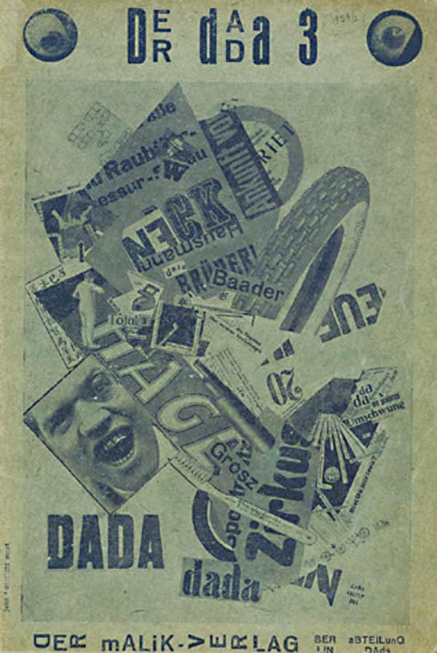
Heartfield, John. Der Dada 3 Journal: The Tire Travels the World (1920). Malik Verlag Publishing.

In 1920 he designed the front cover of Der Dada 3 or The Dada Journals 3. The cover is a photomontage splattered with words flitting in and out of view with no reason or rhyme, craving an audience’s attention. By creating a caricature of communication, Heartfield may be criticising the way information is presented during his time, culminating into a loud, bombastic, confusing mess that is quintessentially Dada.

When adhering the politics, similarly to Dadaism, surrealism leans towards communism. Breton, worked closely with communists in order to achieve the “Liberation of man”.

Censorship was imposed upon Poland and information spread through artists’ use of surrealism.
To make their ideas more wide-spread and accessible, some polish artists employed surrealism in order to avoid censorship under an authoritarian regime.
In her article, The impact of 100 years of artistic creativity on Poland, Natalie Cetera wrote:

The country (Poland) remained under the domination of the USSR from 1989 – a time marked by the communist Polish Workers’ Party government, which saw censorship and the dominance of propaganda art.
Natalia Cetera, The impact of 100 years of artistic creativity on Poland

The surrealist movement was influenced by Symbolism, Abstract art, Metaphysical painting, and the Dada movement.

In turn the surrealist movement had influenced Abstract expressionism, Fantastic art, and Post-modern art.

One such Polish artist, famous for his surrealist paintings during the 1940s was Andrzej Wróblewski. In 1949 he created “Rozstrzelanie V” (Execution V) one of eight oil paintings that represented the German occupation of Poland during World War II.

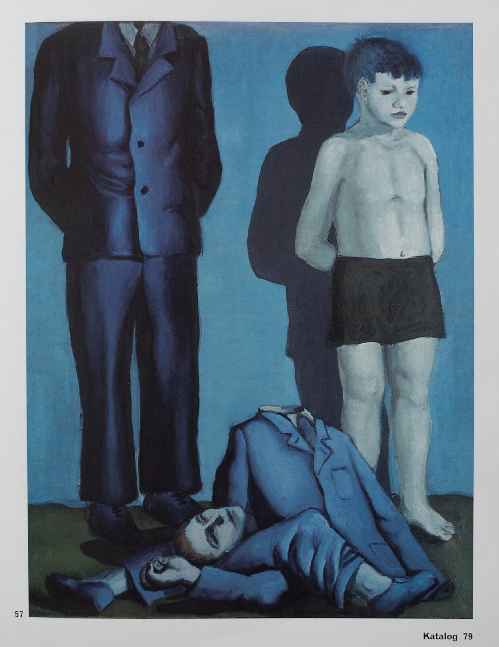
Wróblewski, Andrzej. Rozstrzelanie V. (1949)

Here, Wróblewski composed this painting by using a blue monochrome to highlight the cold and sterile nature of the execution perhaps aiming to stress the cruelty and brutality while suffering under the German occupation. The dead body lies scattered at the feet of a young boy and a suited man whose face is cut off from the canvas, perhaps the next victims? The dead man’s twisted corpse could be a representation on the loss of identity under a fascist government, and how the people who are executed are eventually forgotten and abandoned in favour of the regime.

Jarosław Modzelewski, another Polish painter wrote many years after Wróblewski’s death on the colour blue in Wróblewski’s work:

The way to a corpse is a blue path, although the form, besides the colour, remains very concrete, with no turbidity: departing from this world, indeed, the torso diverted upside down, knees bent in the opposite direction, no longer casting a shadow, the pants are in place while the jacket is fastened by three buttons and it is also blue.
Jarosław Modzelewski,

Another surrealist artist that was involved with Breton and joined the Surrealist group was the Belgian artist René Magritte. Best known for his painting The Son of Man (1964), depicting a man with a green apple obscuring his face.

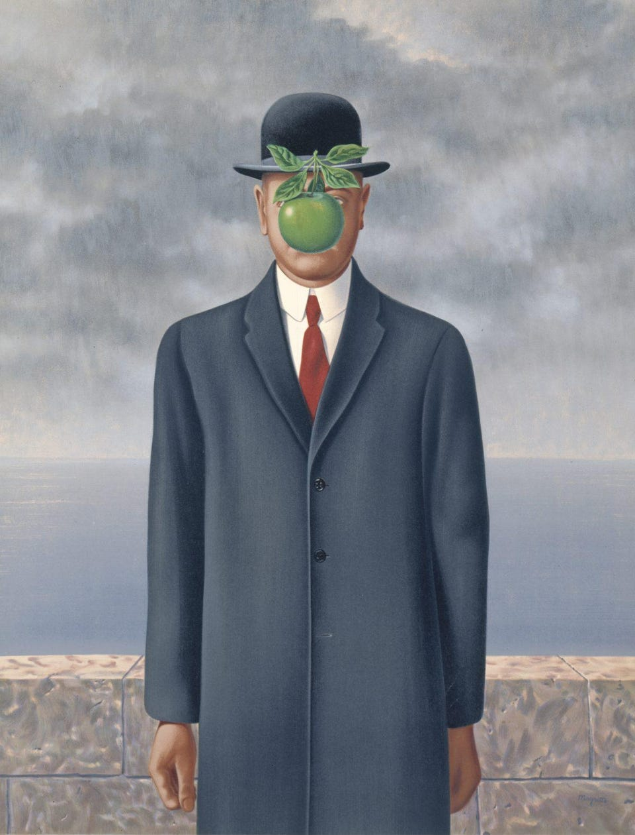
Magritte, René. Son of Man. 1964

In the painting, behind the man is a stone brick wall, a calm sea, and a grey, cloudy sky. However, what is most strange about this portrait is the vivid green apple floating just in front of the figure’s face, obscuring him from the audience’s gaze. Why is it that Magritte chose an apple in particular? In his other paintings he has covered the faces with anything from cloth to birds to flowers, why can it be argued that an apple is the most evocative icon in Magritte’s work?

One can indicate the Christian symbolism of the forbidden fruit from the Tree of the Knowledge of Good and Evil. Maybe it is a metaphor for information and knowledge being hidden from the public. This analysis can be linked back to The Garden of Earthly Delights by Hieronymus Bosch and the theme of sin, except here, the audience is prevented from committing a sin in the first place while The Garden of Earthly Delights is a portrayal of humanity’s sins.

It could also be interpreted as the loss of privacy, no matter how much the audience may want to see behind the apple and uncover the face beneath, it remains unknown and hidden from an unwanted gaze.

Both interpretations can be further argued with the theme of temptation, the audience wants to see behind the apple but is unable to. The audience wants to defy the rules set in place but is powerless against them. All for an otherwise bland and benign yet thought-provoking masterpiece of a painting.

About The Son of Man, in Magritte’s own words during Jean Neyens' 1965 radio interview:

At least it hides the face partly well, so you have the apparent face, the apple, hiding the visible but hidden, the face of the person. It's something that happens constantly. Everything we see hides another thing, we always want to see what is hidden by what we see. There is an interest in that which is hidden and which the visible does not show us. This interest can take the form of a quite intense feeling, a sort of conflict, one might say, between the visible that is hidden and the visible that is present.
Magritte: Ideas and Images, trans. Richard Millen (New York: Harry N. Abrams), (page 172).

An Illustrator such as the Australian author and artist Shaun Tan utilise surrealism to communicate an uncomfortable subject matter to children so they can understand better (e.g., depression, abuse). In the picture book “The Red Tree,” Tan tackles with a non-linear journey through depression, utilising dark surrealist imagery to convey the message and emotions, so children can empathise and put into words what they are feeling so they do not feel as alone without fear of judgement.

Possible influences to Tan’s work include science fiction such as The Twilight Zone television series as well as Ray Bradbury, in a Locus interview Tan says: “I loved (Ray Bradbury’s) intriguing fairytale places, at once sensual and sinister, as convincing and unbelievable as dreams.” Which can be a suitable description of Tan’s own surreal work.

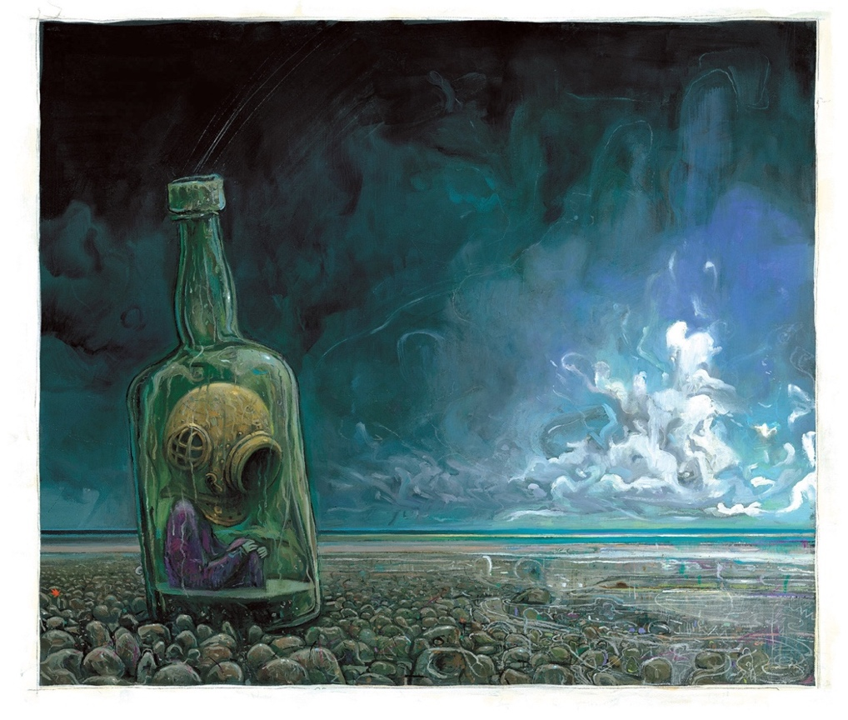
Tan, Shaun. The Red Tree. 2001 (page. 6)

Visceral image of loneliness and isolation through surrealism appear often through surrealism and expressionism. The figure in the illustration is physically and emotionally trapped, unable to express and reach out. The white cloud in the distance is exploding in light, just above the horizon, like hope is far away. In contrast, the figure is locked in shadow to reflect their condition and perhaps as a metaphor of their isolation. In the book the image is accompanied by the text “Nobody understands” to further emphasise the emotions expressed in the figure.

Similarly, in Shaun Tan’s other picture book “Tales from Outer Suburbia” (2008), he examines the “quiet mysteries” of the mundane suburbia, by twisting everyday objects and experiences into fantastical and surreal imagery.

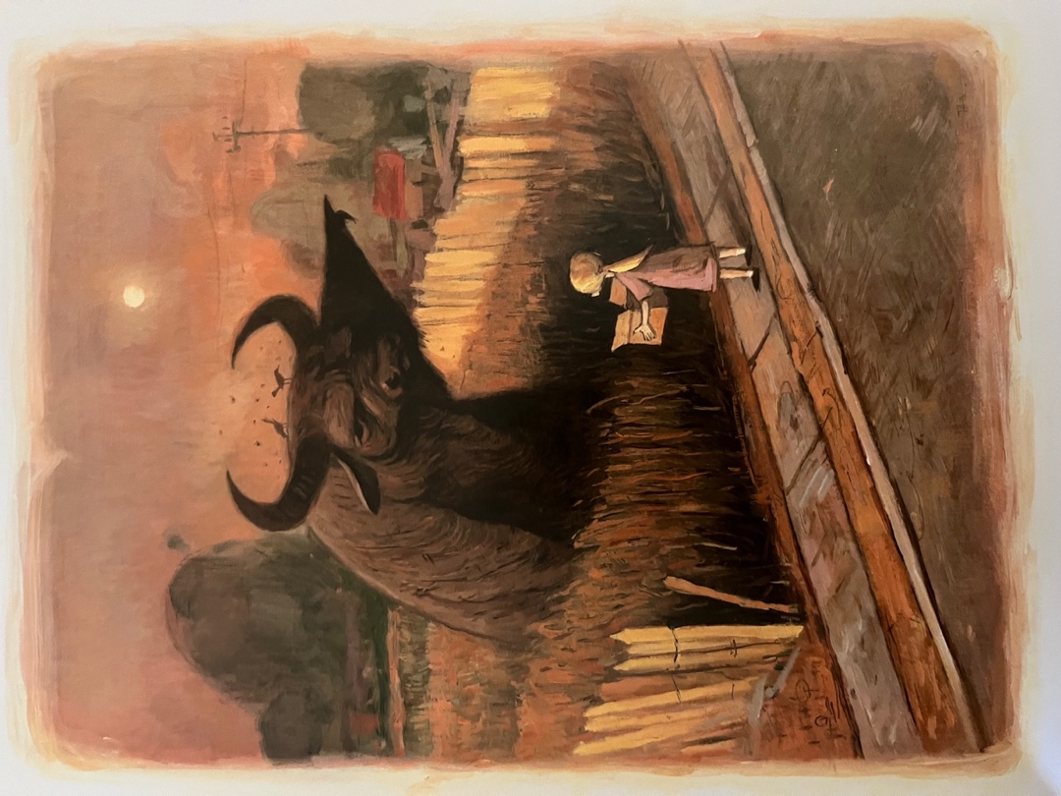
Tan, Shaun. Tales from Outer Suburbia. 2008 (page. 7)

Tales from Outer Suburbia begins by introducing a large buffalo giving directions to a little girl. Despite the strange nature of the image, the buffalo appears friendly and helpful, as indicated by pointing the girl in the right direction. The colour palette provides a warm and inviting atmosphere, the sepia tones possibly reflect Tan’s upbringing in the Australian heat. It stands in contrast to The Red Tree because it depicts a more light-hearted story than the preceding picture book did.

The British children’s illustrator, Anthony Browne, has created many books detailing themes of childhood anxiety, and curiosity. He explores these themes in his book Into the Forest (2005). The story of a boy visiting his grandmother’s house in the forest.

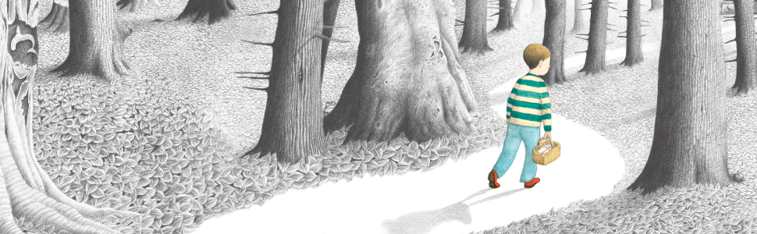
Browne, Anthony. Into the Forest. (2005).

In his picture book Browne masterfully utilises intertextuality, as he visually references classical fairy tale characters whom the protagonist, the boy, interacts with on the way to his grandmother’s house. He further applies this, by linking more characteristics of the boy with Little Red Riding Hood. The story ends by subverting the audience’s expectations, so instead of the grandmother and/ or father being in danger from a wolf, they both remain safe and the father caring for the sick grandmother.

In John Berger’s book Ways of Seeing, he comments “Seeing comes before words. The child looks and recognises before it can speak.” Imagery is a child’s first language. It can understand pictures and their meaning without speaking out loud. In a 2010 seminar in London, Browne discusses his own personal childhood relationship to picture books and fairytales and how fairytales have been told to children and they are “still relevant today as they were two hundred years ago.”

Realism, in contrast to Surrealism, focuses on painted subjects from everyday life. Romanticising the mundane routines of ordinary people of the mid-nineteenth century. Unlike surrealism which explores the fantastical unconscious mind, Realism documents natural and sincere portrays of human life. Realism values authenticity over fantasy.

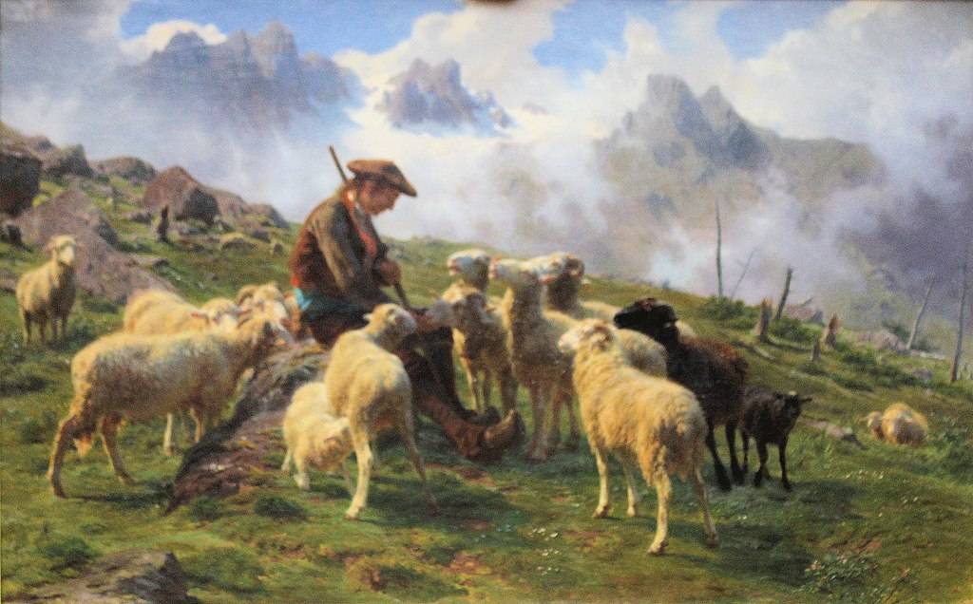
Bonheur, Rosa. (1864). Pyrenean Shepherd Offering Salt to his Sheep.

The French realist painter Rosa Bonheur’s painting Pyrenean Shepherd Offering Salt to his Sheep (1864), a humble shepherd tends to his flock. The sun bears down brightly, and the sheep gather attentively. The atmosphere in the moment is calm but cheerful. The painting is slightly blurry, almost like it was captured on an old camera. The mood of the painting has a quality of intimacy and care.

The cheerful bright colours contrast with the dreary and foreboding monochrome colours featured in Anthony Browne’s Into the Forest.

In conclusion, many art movements have become popular and captivated audiences during their time, yet Surrealism could be especially popular amongst artists due to its wide range of expression and ideas, as well as an exercise in creativity. Many different artists have interpretations of this genre and what it can mean to them: Magritte utilised surrealism to spread his thought experiments, while Wróblewski used surrealism to communicate the devasting effects that fascism has on ordinary people. In contrast, other art movements such as realism may have appealed and captured people’s attention more effectively due to its themes and tropes found in them. There is no doubt, however, that surrealism did not have an incredible impact on the world of illustration.

(2,261 words) need at least 2250

Bibliography
Paintings:

Bosch, Hieronymus. The Garden of Earthly Delights. 1490 – 1510.
Bonheur, Rosa. (1864). Pyrenean Shepherd Offering Salt to his Sheep.

Books:

Berger, John. (2008) Ways of seeing. London: Penguin.
Tan, Shaun. (2001) The Red Tree. Templar Publishing.
Tan, Shaun. (2008) Tales from Outer Suburbia. Templar Publishing.
Tan, Shaun. (2006) The Arrival. Templar Publishing.
Grimm - The Illustrated Fairy Tales of the Brothers Grimm
Klanten, Robert. (2012) Little Big Books: Illustration for Children's Picture Books

Websites and articles:

Willette, Jeanne. (2011). Comparison of Dada and Surrealism. Art History Unstuffed. Available at: https://arthistoryunstuffed.com/comparison-of-dada-and-surrealism/
Voorhies, James. Surrealism. (2004) Metmuseum.org. Available at: https://www.metmuseum.org/toah/hd/surr/hd_surr.htm
Cultural.pl. Executions - Andrzej Wróblewski. Available at: https://culture.pl/en/work/executions-andrzej-wroblewski
Cetera, Natalia. The impact of 100 years of artistic creativity on Poland. Available at: https://artsandculture.google.com/story/the-impact-of-100-years-of-artistic-creativity-on-poland/CAVBymqibR-gKg?hl=en

Smirnova, Ekaterina. (2015). The discreet charm of surrealism in Eastern European animation : when repression fosters creativity. Available at: https://repositorio.ucp.pt/handle/10400.14/23864

Videos:
Curious Muse. (2021). Surrealism in 5 Minutes: Idea Behind the Art Movement. Available at: https://youtu.be/bP2JS4vDvNc
The Canvas. (2022). René Magritte, The Son of Man and The Visible That is Hidden. Available at: https://www.youtube.com/watch?v=4iWgiUkSw_A
BookTrust. (2010). Anthony Browne: Into the Forest and fairytale themes. Available at: https://www.youtube.com/watch?v=vNLdazNHc-c

