
MSc Public Health and Social Care in Practice
LCHS7003 Community Care and Management of Longer-term Conditions

Component 1: Information Booklet of Long-term Condition Management
Topic: Chronic Kidney Disease (CKD)
Lecturer: MUHAMMED KHAN

Student Name: Leelabhai Avadabhai Kuchhadiya
Student ID: 2526423

Words: 3300

Table of Contents
1. Introduction 1
1.1 Definition of Chronic Kidney Disease 1
1.2 Purpose of the Booklet 1
2. Prevalence and Burden 1
2.1 Global Prevalence 1
2.2 UK Prevalence 2
2.3 Public Health Burden 2
3. Aetiology and Risk Factors 3
3.1 Biological Risk Factors 3
3.2 Behavioural and Lifestyle Risk Factors 3
3.3 Social Determinants of Health 3
4. Impact of CKD on Patients, Families and Society and Available Evidence-Based Treatments and Services 4
4.1 Physical Impact 4
4.2 Psychological Impact 5
4.3 Social Impact 5
4.4 Self-Management Theory 6
4.5 Evidence-Based Treatments 7
4.6 NHS Services and Multidisciplinary Care 7
5. Models and Frameworks for Improved Outcomes 8
5.1 UK Model — NHS Comprehensive Model of Personalised Care 8
5.2 International Model — WHO Innovative Care for Chronic Conditions (ICCC) 8
5.3 Critical Comparison 8
6. Local and National Policy Implications 8
6.1 National Policies 8
6.2 Local Interventions 9
6.3 Improving Outcomes through NHS Personalised Care 9
7. Recommendations 10
7.1 Improving Early Detection 10
7.2 Strengthening Self-Management 10
7.3 Enhancing Personalised Care 10
7.4 Improving Integrated Care 11
7.5 Future Public Health Priorities 11
8. Conclusion 11
References 12

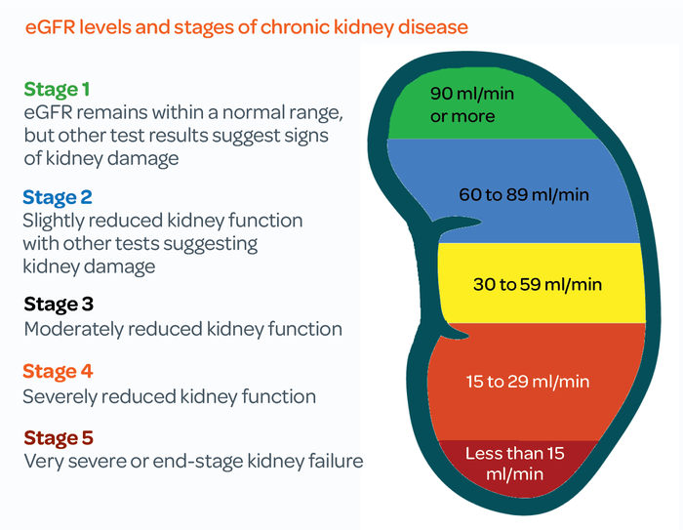
1. Introduction

1.1 Definition of Chronic Kidney Disease
Chronic Kidney Disease (CKD) is a long-term condition characterised by a gradual loss of kidney function over time, resulting in the kidneys becoming less effective at filtering waste products and excess fluids from the blood (National Kidney Foundation, 2023). It is divided into five separate stages utilising estimated glomerular filtration rate, alongside various markers such as albuminuria. The first two stages involve mild damage with good function, while the last three stages indicate progressive impairment, with the final stage often known for requiring dialysis or even transplantation due to kidney failure (NIH, 2018).
CKD Stages
(Source: Kidney Care UK, 2024)

1.2 Purpose of the Booklet
This booklet will focus on targeting adults living with CKD, alongside their family carers, and also healthcare professionals. It will also be delivering evidence-based guidance on early detection, along with holistic and multidisciplinary management, in addition to self-management and personalised care. The paper will also be empowering readers with practical knowledge, which will help in improving health outcomes, reducing complications, along with improving quality of life through informed decisions and collaborative care.

2. Prevalence and Burden

2.1 Global Prevalence
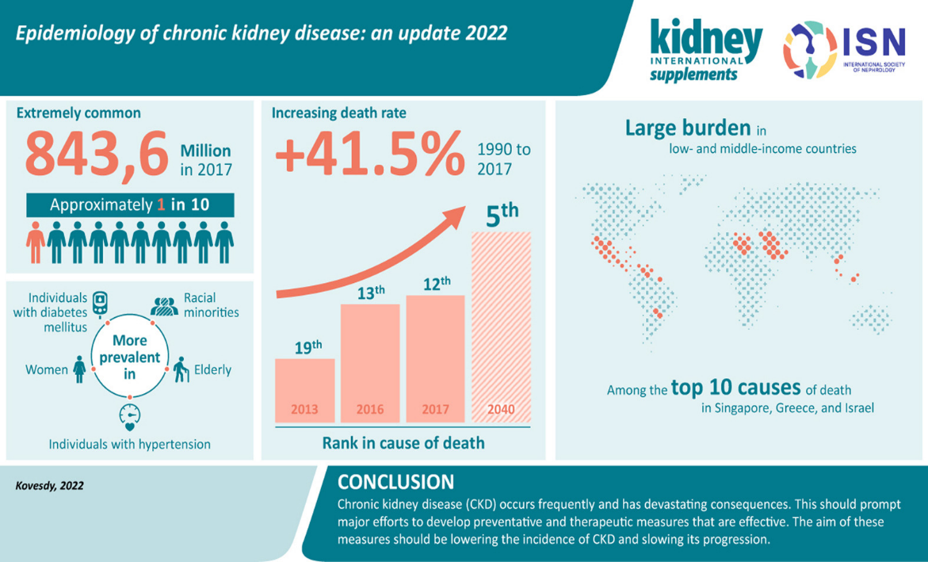
Around the world, CKD is known to have affected around 843,6 million individuals in 2017, which was approximately 1 in 10 individuals. From 1990 to 2017, the death rate is also known to have increased by 41.5%, with projections of ranking 5th in cause of death by 2040 (Kovesdy, 2022). The increasing global prevalence and mortality associated with CKD demonstrate that it is a major public health challenge requiring greater emphasis on prevention, early diagnosis, and long-term disease management.

2.2 UK Prevalence
In the UK, around 7.2 million people are known for having CKD ranging from stage 1 to 5. It is also essential to note that around 3.25 million people in the UK are known to have the later stages of CKD, such as from stage 3 to 5 (Kidney Care UK, 2023). Population growth, ageing, diabetes, along with hypertension, are known for being the primary drivers for CKD to emerge as a critical public health issue (Zhang et al., 2026). It is essential to note that the disease is often known for progressing silently, along with strongly contributing to cardiovascular disease, and placing heavy demands on healthcare services. This growing prevalence highlights the need for strengthened screening programmes, early intervention strategies, and coordinated NHS services to reduce disease progression and improve patient outcomes.
Epidemiology of CKD
(Source: Kovesdy, 2022)

2.3 Public Health Burden
CKD is also known for imposing a significant economic burden of kidney disease in the UK, which is £7.0 billion, with £6.4 billion being direct costs to the NHS. This is around 3.2% of the NHS budget (Kidney Research UK, 2023). Such expense also covers hospital admissions, along with a total of 30,000 adults and children transplants, in addition to complication management.
The condition is also known for increasing the risks of cardiovascular events, alongside hospitalisations, in addition to mortality rates. This also results in contributing significantly to premature deaths and also disability-adjusted life years (Lai et al., 2025). Hence, early detection of CKD remains a national priority as timely intervention is able to slow progression, delay, or even avert kidney failure. This also helps in reducing cardiovascular risks, saving costs, and markedly improving patient outcomes (Ortiz et al., 2025).

3. Aetiology and Risk Factors
The development and progression of Chronic Kidney Disease can be best understood through the Biopsychosocial Model, which recognises that biological, behavioural, and social determinants interact to influence an individual's risk of developing CKD and its long-term progression.

3.1 Biological Risk Factors
Biological factors are known for playing a central role in the development of CKD. The most common causes of CKD in adults are considered diabetes, which is the leading contributor via diabetic nephropathy, and high blood pressure, which leads to damaging kidney blood vessels in addition to cardiovascular disease (NIDDK, 2016). It is also essential to note that ageing is naturally known for reducing kidney function (National Kidney Foundation, 2025a). On the other hand, genetic predispositions, along with autoimmune disorders, such as glomerulonephritis and lupus nephritis, are also responsible for directly injuring kidney tissue (Gorenjak, 2009). These biological factors often interact with one another, increasing the likelihood of progressive kidney damage and ultimately accelerating the decline in renal function.

3.2 Behavioural and Lifestyle Risk Factors
Several risk factors are also modifiable in nature. Obesity is known as a potent risk factor for the development of CKD, while on the other hand, smoking is also responsible for accelerating vascular damage (Kovesdy, Furth and Zoccali, 2017; Yacoub et al., 2010). There is also alcohol, which harms kidney function indirectly (National Kidney Foundation, 2024). It is also essential to note that poor diet, such as high in salt or processed foods, along with physical inactivity, can also lead to worsening hypertension, in addition to diabetes control (Kazi, El-Kashif and Ahsan, 2020). Misuse of medications, especially NSAIDs or particular over-the-counter drugs, is also able to cause acute kidney injury that eventually progresses to CKD (Baker and Perazella, 2020). It is essential to address these through lifestyle changes for preventing and slowing progression. Consequently, promoting healthier lifestyle behaviours and increasing public awareness are essential strategies for reducing the incidence and progression of CKD.

3.3 Social Determinants of Health
Social factors, such as deprivation, lower education, along with limited health literacy, are also known to correlate with higher prevalence, in addition to poorer outcomes (Grant et al., 2023; Mwesigwa et al., 2025). There is also evidence of ethnic disparities, such as higher rates in some minority groups, which are often known for being linked to systemic inequalities in healthcare access (Eneanya et al., 2021). There are also several barriers to timely care, which can lead to exacerbating overall progression. It is essential to improve access, education, along with equity for reducing incidence of CKD. Addressing these wider social determinants through equitable healthcare policies and community-based interventions is essential for reducing health inequalities and improving long-term kidney health outcomes.
Overall, these these biological, behavioural, and social determinants rarely occur in isolation; and the interactions of these determinants influences the cause and progression of CKD indicating the importance of the adoption of holistic prevention strategies and person-centred interventions.

4. Impact of CKD on Patients, Families and Society and Available Evidence-Based Treatments and Services
The Biopsychosocial Model provides a comprehensive framework for understanding the multidimensional impact of Chronic Kidney Disease because the condition affects individuals physically, psychologically, and socially. The biopsychosocial model is known for being developed by George Engel in 1977. It is an improvement on the biomedical model, for taking account of psychological, social and biological factors that are relevant to health and disease (Bolton, 2023). In the case of CKD, reduced kidney function is the biological factor, which interacts with anxiety or depression, which is the psychological factor, and lastly, issues such as financial strain or social support are the social factors.

4.1 Physical Impact
CKD is known for profoundly affecting biological health across multiple systems. Its common symptoms are known for including persistent fatigue, which is mainly caused due to anaemia, along with toxin build-up, in addition to poor sleep (National Kidney Foundation, 2023). Patients are often known for facing resistant hypertension, leading to accelerated kidney damage, along with vascular problems (Shulman and Cohen, 2022). CKD Mineral and Bone Disorder is known for occurring due to kidneys not being able to remove extra phosphorus from blood, leading to high phosphorus. It also results in turning vitamin D into its active form, making it much harder for the body to absorb calcium from food (National Kidney Foundation, 2026). After kidney damage, fluid retention can occur, which causes oedema, swelling in the legs and lungs, and breathlessness (Mayo Clinic, 2023).
There are also cardiovascular complications, which are known as the leading threat, as it increases risks of heart attacks, strokes and also heart failure (Zoccali et al., 2023). There are also additional issues, including reduced mobility, muscle wasting, along with itching among many more, that result in impairing daily life. In further stages, dialysis dependence is known for further imposing major restrictions due to lengthy treatment sessions and various side effects. Such physical burdens result in reduced quality of life, alongside also interacting with both social and psychological factors.

4.2 Psychological Impact
CKD’s psychological toll is also substantial; however, it is often under-recognised. Patients are frequently known for experiencing anxiety and depression, alongside chronic stress, which occurs mainly due to the uncertainty regarding disease progression or even fear of kidney failure (Nagar, Vaidya and Patel, 2021). Several studies are known to have demonstrated that depression is more prevalent in CKD, and that end-stage renal disease is a robust risk factor for adverse outcomes, which include hospitalisation and mortality (Goh and Griva, 2018). It is essential to note that the unpredictable nature of the disease can lead to the development of a profound sense of loss of control over one’s future and body. Body image disturbances among haemodialysis patients lead to social anxiety, embarrassment, depression, decreased self-efficacy, and reduced quality of life. There is also evidence of body image issues, such as weight changes and visible fistulas, among many more, resulting in eroding self-esteem (Yang, 2024).
The Biopsychosocial model results in highlighting vicious cycles where psychological distress results in reduced treatment adherence, along with worsening physical decline. It is also essential to note that integrated mental health support, such as counselling, cognitive behaviour techniques, in addition to peer groups, are helpful in building resilience and improving overall outcomes. Consequently, routine psychological assessment and timely mental health interventions should form an integral part of comprehensive CKD management to improve treatment adherence and overall wellbeing.

4.3 Social Impact
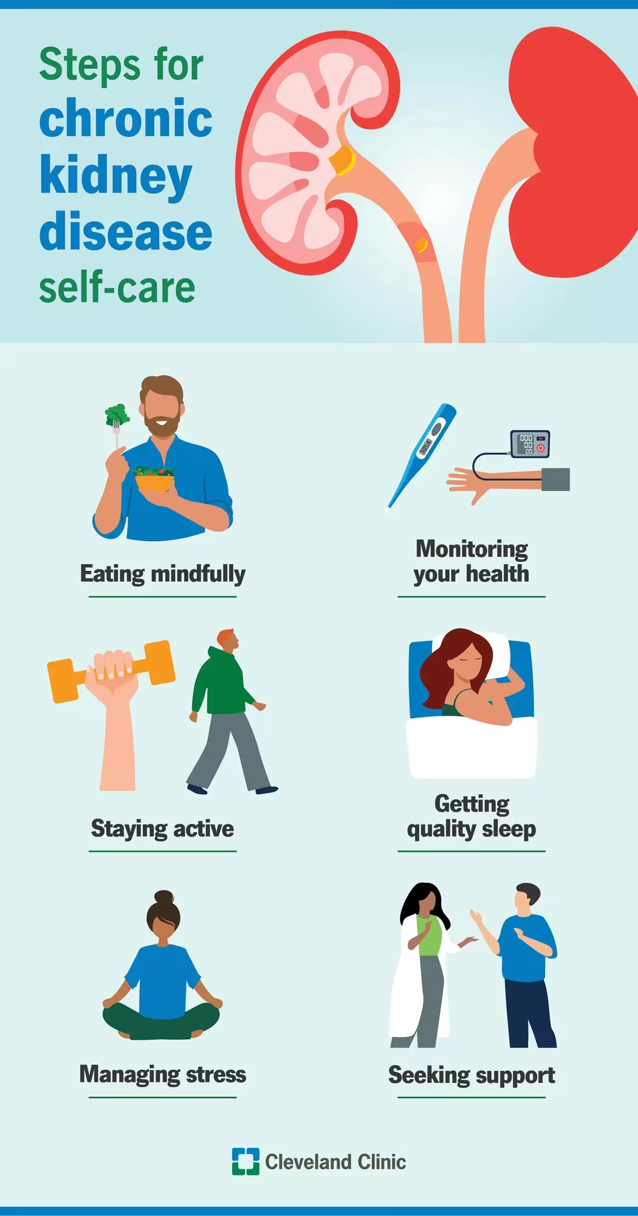
CKD is also known for carrying significant social consequences. Reduced employment, along with early retirement, lost income, in addition to financial hardships, are often known to occur due to fatigue and treatment schedules (Ng, Chan and So, 2023). There are also extra expenses for travel, diet, along with adaptations that add additional pressure. It is also essential to note that relationships also have the possibility to suffer mainly due to changes in intimacy, roles, along with shared activities (National Kidney Foundation, 2025b). On the other hand, social isolation is often known for arising from low energy or embarrassment. Family carers are also faced with bearing heavy burdens, such as managing the patient’s medication, diet, transport, along with emotional support. These are often known for coming out at the expense of their own health and careers, which could lead to career stress and also burnout (Adejumo et al., 2019). Socially, CKD carries a significant economic burden, which increases substantially with increasing disease severity. Support systems are greatly required that will be able to address both patients and family needs. Addressing these wider social challenges through integrated health and social care services can reduce inequalities while improving quality of life for both patients and their carers.

4.4 Self-Management Theory
Self-management has been identified as an essential component in the effective management of patients with CKD. However, it is essential to understand the patients’ experiences, along with the factors that might influence their ability to self-manage for effective develop interventions that support patients with CKD (Lightfoot et al., 2025). Several key practices include medication adherence, along with regular home monitoring of blood pressure, weight, in addition to symptoms and tailored dietary management. It is essential to note that suitable physical activity is able to assist in preserving muscle strength, along with weight control and mood. Education programmes may also help in improving knowledge of some areas related to diabetes care and some self‐management practices (Cashmore et al., 2024). Overall outcomes will improve whenever patients start to feel confident managing their condition with healthcare teams. Such supported self-management approaches also align closely with the NHS Comprehensive Model of Personalised Care by empowering individuals to actively participate in decisions regarding their own health and long-term treatment.

4.5 Evidence-Based Treatments
NHS treatments are known for focusing on slowing the progression of CKD, along with managing complications. It is essential to note that alongside early diagnosis via eGFR, urine tests are also useful in providing a more precise picture of how well kidneys are working (NHS, 2019). There are also ACE inhibitors and ARBs that reduce proteinuria, as those lower the intraglomerular pressure, reducing hyperfiltration (Momoniat, Ilyas and Bhandari, 2019). Patients with CKD in stage 2 to 3 CKD syndrome can also benefit from statin therapy, which has the potential to reduce cardiovascular risk (Ndumele et al., 2026). In the case of advanced CKD, there are several options such as haemodialysis, peritoneal dialysis, and kidney transplantation, which are preferred for suitable patients due to providing better quality of life, alongside survival. There is also conservative management for kidney failure, which means that a health care team continues one’s care without dialysis or a kidney transplant (NIDDK, 2019). The NICE NG203 guideline underpins such evidence-based approaches (NICE, 2021).

4.6 NHS Services and Multidisciplinary Care
High-quality CKD care is known for being dependent on coordinated multidisciplinary teams. General physicians are known for handling early detection and monitoring. Nephrologists are known for providing specialist input. Renal nurses, on the other hand, are able to deliver education, alongside support. Pharmacists help in reviewing medication. Dietitians, on the other hand, are responsible for developing personalised nutrition plans. Psychologists focus on addressing mental health, along with social workers assisting with financial and community needs (Kelepouris et al., 2023). Such a collaborative model is known for integrating all three kinds of support, which are biological, psychological, and social support. This results in ensuring holistic and person-centric care with better continuity, along with fewer complications, in addition to improved patient and carer experiences. Furthermore, multidisciplinary collaboration supports shared decision-making, personalised care planning, and supported self-management, enabling patients to achieve better long-term clinical outcomes while improving their overall quality of life.

5. Models and Frameworks for Improved Outcomes

5.1 UK Model — NHS Comprehensive Model of Personalised Care
The NHS Comprehensive Model of Personalised Care is known for empowering individuals through six different components, which are: Shared Decision Making, Personalised Care and Support Planning, Enabling Choice, Social Prescribing, Supported Self-Management, and Personal Health Budgets (NHS England, 2021). In the case of CKD, such components help in improving overall engagement, along with developing plans for individual needs, in addition to connecting to community support and improving adherence and quality of life.

5.2 International Model — WHO Innovative Care for Chronic Conditions (ICCC)
There is also the WHO Innovative Care for Chronic Conditions Framework, which is known for promoting patient-centred care, along with community partnerships and multidisciplinary collaboration, in addition to prevention and proactive management (WHO, 2002). All of which are promoted across three different levels, which are micro, meso and macro. The framework is known for shifting from acute to chronic care models, which focus on emphasising informed and motivated patients, in addition to prepared teams.

5.3 Critical Comparison
It is essential to note that both models share similar types of emphasis on patient-centredness, along with multidisciplinary teams, in addition to self-management. The NHS model is considered more operational, with particular tools, such as personal budgets, which also suit the UK healthcare system. On the other hand, the ICCC is known for providing wider global strategic guidance with significant community and policy focus.
The strengths of both models include holistic integration, while the limitations are known to involve implementation challenges such as resource constraints. In the UK, the NHS model is known for aligning well with existing structures for CKD, which is also improved by ICCC principles regarding equity and prevention. However, the successful implementation of both frameworks depends upon adequate workforce capacity, sustained funding, and effective multidisciplinary collaboration to ensure that personalised and integrated care can be consistently delivered across different healthcare settings.

6. Local and National Policy Implications

6.1 National Policies
There are several national policies, such as the Renal services of NHS England, the Long Term Plan of the NHS, along with the NICE NG203 Guideline, which focuses on kidney disease assessment and management (NHS England, 2026; NHS England, 2019; NICE, 2021). There is also the UK Kidney Association guidance, which collectively prioritises prevention, early detection, and integrated management (UK Kidney, 2024). These are known for prioritising prevention, along with early detection, in addition to integrated management. They also aim to reduce overall variation in care, along with slowing disease progression. Collectively, these national policies establish a consistent evidence-based framework for delivering high-quality kidney care while encouraging earlier intervention and improved long-term patient outcomes.

6.2 Local Interventions
At the local level, there are various Integrated Care Systems, along with Primary Care Networks (Major et al., 2025). These are known for playing an essential role in the implementation of national strategies. Various community renal services, along with social prescribing link workers, in addition to local dialysis centres, help in translating policy into practice, as they deliver tailored and accessible care much closer to the patients’ home. Such initiatives are significantly helpful in improving early detection of CKD through primary care, along with being able to improve self-management support. Those also help in improving links between primary, secondary and also various community services regarding seamless patient journeys. This collaborative approach enables multidisciplinary teams to deliver coordinated and person-centred care that responds to the individual needs of patients living with CKD.

6.3 Improving Outcomes through NHS Personalised Care
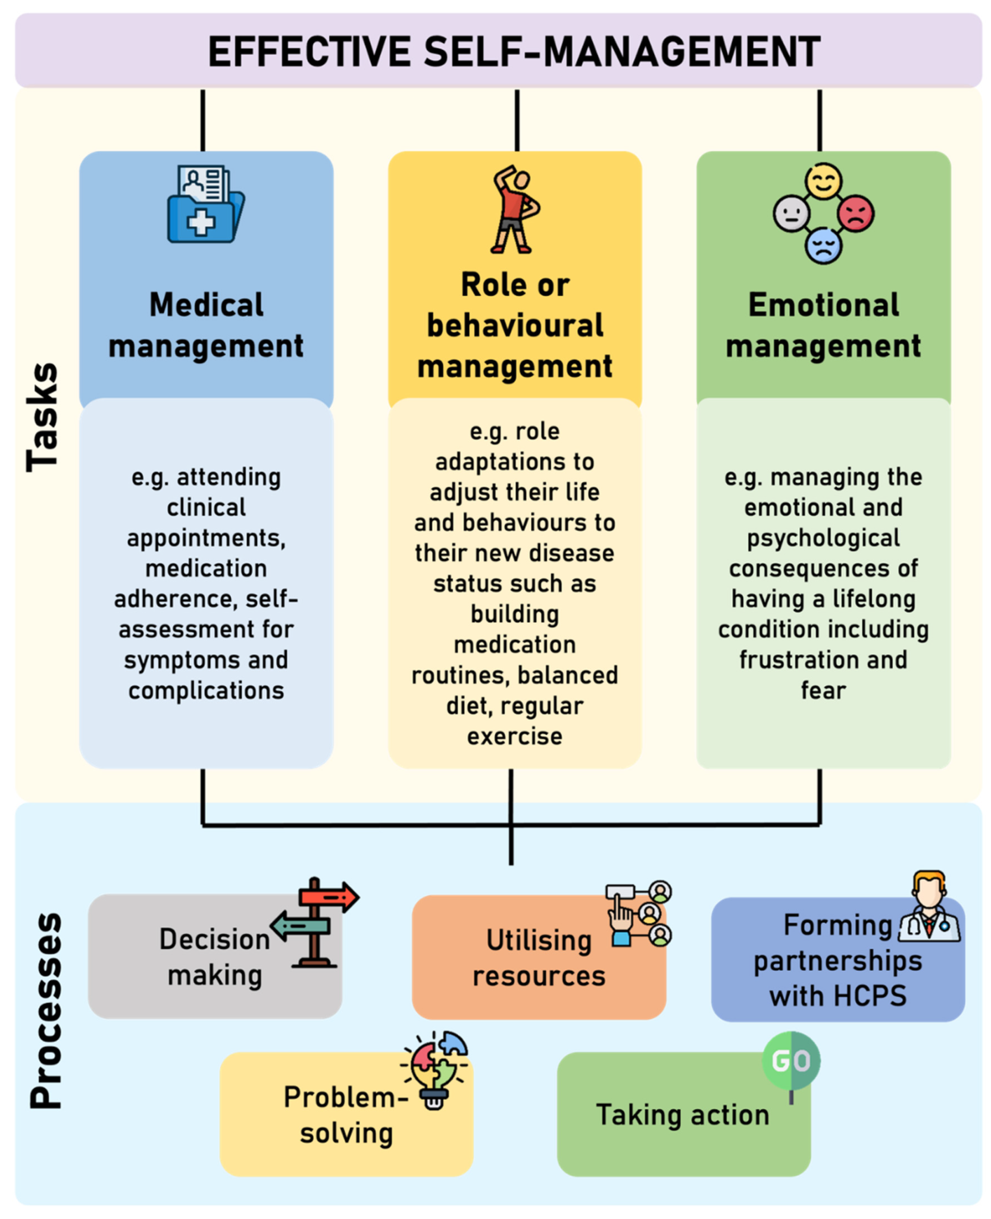
Combined together, such national and local initiatives are known for closely aligning with the NHS Comprehensive Model of Personalised Care (NHS England, 2021). Such initiatives focus on promoting shared decision-making, along with continuity of care. There is also evidence supporting self-management, in addition to patient empowerment, which makes them significant in the case of earlier CKD detection, along with slowing progression, reducing hospital admissions, and also giving patients and carers a better quality of life. Furthermore, personalised care planning and supported self-management enable individuals to actively participate in decisions regarding their treatment, lifestyle modifications, and long-term disease management, thereby improving treatment adherence and health outcomes. Such an integrated approach ultimately results in helping in reducing the burden of CKD on patients, their families and also the NHS while at the same time also encouraging more equitable and effective kidney care.

7. Recommendations

7.1 Improving Early Detection
It is recommended to expand CKD screening in NHS Health Checks, along with primary care. It will be beneficial to target high-risk groups such as patients with diabetes and hypertension, along with ethnic minorities and deprived areas, for achieving early intervention.

7.2 Strengthening Self-Management
It will also be beneficial to enhance access to various educational programmes, along with digital tools, such as apps for monitoring, in addition to providing home devices and implementing structured programmes that will be grounded in Self-Management Theory. This will help in improving adherence, alongside confidence.

7.3 Enhancing Personalised Care
It is also suggested to widen the overall rollout of the NHS Comprehensive Model. Training in shared decision-making, alongside individualised planning, should also be prioritised for better meeting diverse needs.

7.4 Improving Integrated Care
By improving MDT collaboration across primary, along with specialist, community, and voluntary sectors, it will be possible to strengthen local community assistance and also seamless transition.

7.5 Future Public Health Priorities
It is also recommended to target inequalities by implementing culturally sensitive campaigns, along with various health literacy initiatives. On the other hand, it is also suggested to provide better access to services, along with investing in community-based prevention and care. It is essential for research and innovation to keep on supporting sustainable models.

8. Conclusion
It can be stated that CKD is a growing challenge as it requires proactive and holistic responses. It will be possible to achieve better outcomes by focusing on early detection, empowering self-Management, along with multidisciplinary teams, in addition to adopting personalised frameworks such as the NHS Comprehensive Model. By integrating biopsychosocial insights, along with evidence-based care, not only patients, but also their families and health professionals will be able to work together and slow progression, reduce burdens, and also improve quality of life. The primary key will be continued policy support, alongside community action, which will help transform kidney health in the UK and globally. It is essential to note that empowerment through knowledge is the primary step, as taking action today will lead to a healthier tomorrow.

References
Adejumo, O.A., Iyawe, I.O., Akinbodewa, A.A., Abolarin, O.S. and Alli, E.O. (2019). Burden, psychological well-being and quality of life of caregivers of end stage renal disease patients. Ghana Medical Journal, 53(3), p.190. doi:https://doi.org/10.4314/gmj.v53i3.2.
Baker, M. and Perazella, M.A. (2020). NSAIDs in CKD: Are They Safe? American Journal of Kidney Diseases, 76(4). doi:https://doi.org/10.1053/j.ajkd.2020.03.023.
Bolton, D. (2023). A Revitalized Biopsychosocial model: Core theory, Research paradigms, and Clinical Implications. Psychological Medicine, [online] 53(16), pp.1–8. doi:https://doi.org/10.1017/s0033291723002660.
Cashmore, B.A., Cooper, T.E., Evangelidis, N.M., Green, S.C., Lopez-Vargas, P. and Tunnicliffe, D.J. (2024). Education programmes for people with chronic kidney disease and diabetes. Cochrane library, 2024(8). doi:https://doi.org/10.1002/14651858.cd007374.pub3.
Eneanya, N.D., Boulware, L.E., Tsai, J., Bruce, M.A., Ford, C.L., Harris, C., Morales, L.S., Ryan, M.J., Reese, P.P., Thorpe, R.J., Morse, M., Walker, V., Arogundade, F.A., Lopes, A.A. and Norris, K.C. (2021). Health Inequities and the Inappropriate Use of Race in Nephrology. Nature Reviews Nephrology, [online] 18(2), pp.1–11. doi:https://doi.org/10.1038/s41581-021-00501-8.
Goh, Z.S. and Griva, K. (2018). Anxiety and depression in patients with end-stage renal disease: impact and management challenges – a narrative review. International Journal of Nephrology and Renovascular Disease, Volume 11(11), pp.93–102. doi:https://doi.org/10.2147/ijnrd.s126615.
Gorenjak, M. (2009). 4. Kidneys and Autoimmune Disease. EJIFCC, [online] 20(1), p.28. Available at: https://pmc.ncbi.nlm.nih.gov/articles/PMC4975267/ [Accessed 1 Jul. 2026].
Grant, C.H., Salim, E., Lees, J. and Stevens, K. (2023). Deprivation and chronic kidney disease—a review of the evidence. Clinical Kidney Journal, 16(7), pp.1081–1091. doi:https://doi.org/10.1093/ckj/sfad028.
Kazi, R.N.A., El-Kashif, M.M.L. and Ahsan, S.M. (2020). Prevalence of salt rich fast food consumption: A focus on physical activity and incidence of hypertension among female students of Saudi Arabia. Saudi Journal of Biological Sciences, 27(10), pp.2669–2673. doi:https://doi.org/10.1016/j.sjbs.2020.06.004.
Kelepouris, E., St, W.L., Neumiller, J.J. and Wright, E.E. (2023). Optimizing Multidisciplinary Care of Patients with Chronic Kidney Disease and Type 2 Diabetes Mellitus. Diabetes Therapy, [online] 14(7), pp.1111–1136. doi:https://doi.org/10.1007/s13300-023-01416-2.
Kidney Care UK (2023). Facts about Kidneys. [online] Kidney Care UK. Available at: https://kidneycareuk.org/kidney-disease-information/about-kidney-health/facts-about-kidneys/ [Accessed 1 Jul. 2026].
Kidney Care UK (2024). Stage 1 (CKD1) kidney disease. [online] Kidney Care UK. Available at: https://kidneycareuk.org/kidney-disease-information/stages-of-kidney-disease/stage-1/ [Accessed 1 Jul. 2026].
Kidney Research UK (2023). Kidney disease: A UK public health emergency. [online] Available at: https://www.kidneyresearchuk.org/wp-content/uploads/2023/06/Economics-of-Kidney-Disease-summary-report_accessible.pdf [Accessed 1 Jul. 2026].
Kovesdy, C.P. (2022). Epidemiology of chronic kidney disease: An update 2022. Kidney International Supplements, [online] 12(1), pp.7–11. doi:https://doi.org/10.1016/j.kisu.2021.11.003.
Kovesdy, C.P., Furth, S.L. and Zoccali, C. (2017). Obesity and Kidney Disease. Canadian Journal of Kidney Health and Disease, [online] 4(1), p.205435811769866. doi:https://doi.org/10.1177/2054358117698669.
Lai, Y., Long, H., Liang, Z., Wu, C., Wu, L., Liu, C. and Meng, X. (2025). Global burden and risk factors of chronic kidney disease due to hypertension in adults aged 20 plus years, 1990–2021. Frontiers in Public Health, 13. doi:https://doi.org/10.3389/fpubh.2025.1503837.
Lightfoot, C.J., Wilkinson, T.J., Graham-Brown, M.P.M. and Smith, A.C. (2025). Supporting people with chronic kidney disease to self-manage their condition: understanding the lived experiences, needs and requirements, and barriers and facilitators. Journal of Nephrology. doi:https://doi.org/10.1007/s40620-025-02349-8.
Major, R.W., Lakhani, N., Ahmed, Y., Atkin, J., Baines, R., Balment, R., Cheung, C.K., Graham-Brown, M.P., Ellwood, C., Harding, L., Iyasere, O., Jesa, T., Jesus-Silva, J., Jinadu, Y., Khalid, A., Khatri, J., Makkeyah, Y., Martinez, M., Mather, H. and Medcalf, J.F. (2025). Integrated primary and secondary care optimises the management of people with CKD - The LUCID project. Clinical Kidney Journal. [online] doi:https://doi.org/10.1093/ckj/sfaf049.
Mayo Clinic (2023). End-stage Renal Disease - Symptoms and Causes. [online] Mayo Clinic. Available at: https://www.mayoclinic.org/diseases-conditions/end-stage-renal-disease/symptoms-causes/syc-20354532 [Accessed 1 Jul. 2026].
Momoniat, T., Ilyas, D. and Bhandari, S. (2019). ACE Inhibitors and ARBs: Managing Potassium and Renal Function. Cleveland Clinic Journal of Medicine, [online] 86(9), pp.601–607. doi:https://doi.org/10.3949/ccjm.86a.18024.
Mwesigwa, R.N., Nankumbi, J., Ngabirano, T.D., Kabiri, L. and Olwit, C. (2025). Health Literacy and Self‐Care Among Patients Living With Chronic Kidney Disease in a Low‐Resource Setting. Nursing Open, 12(11). doi:https://doi.org/10.1002/nop2.70375.
Nagar, K., Vaidya, A. and Patel, K., (2021). Depression, anxiety and stress among the patient of chronic kidney disease at nadiad city, a cross sectional survey. medRxiv, pp.2021-08.
National Kidney Foundation (2023). Chronic kidney disease (CKD). [online] National Kidney Foundation. Available at: https://www.kidney.org/kidney-topics/chronic-kidney-disease-ckd [Accessed 1 Jul. 2026].
National Kidney Foundation (2024). Alcohol and your kidneys. [online] National Kidney Foundation. Available at: https://www.kidney.org/kidney-topics/alcohol-and-your-kidneys [Accessed 1 Jul. 2026].
National Kidney Foundation (2025a). Aging and Kidney Disease. [online] National Kidney Foundation. Available at: https://www.kidney.org/kidney-topics/aging-and-kidney-disease [Accessed 1 Jul. 2026].
National Kidney Foundation (2025b). Sexual Health and Kidney Disease. [online] National Kidney Foundation. Available at: https://www.kidney.org/kidney-topics/sexual-health-and-kidney-disease [Accessed 1 Jul. 2026].
National Kidney Foundation (2026). Mineral and Bone Disorder (CKD-MBD). [online] National Kidney Foundation. Available at: https://www.kidney.org/kidney-topics/mineral-and-bone-disorder-ckd-mbd [Accessed 1 Jul. 2026].
Ndumele, C.E., Rodriguez, F., Dixon, D.L., Khan, S.S., Mukherjee, D., Bajaj, M., Bangalore, S., Bozkurt, B., Breathett, K., Clarke, S.L., de Boer, I.H., Ellison, D.H., Evangelista, L.S., Heffron, S.P., Kazi, D.S., Kulshreshtha, A., Lingvay, I., Low Wang, C.C., Mercado, C.A. and Morton, J.M. (2026). 2026 AHA/ACC/ADA/ASN Guideline for the Prevention, Detection, Evaluation, and Management of Cardiovascular-Kidney-Metabolic Syndrome: A Report of the American College of Cardiology/American Heart Association Joint Committee on Clinical Practice Guidelines. Circulation. doi:https://doi.org/10.1161/cir.0000000000001453.
Ng, N., Chan, D.N.S. and So, W.K.W. (2023). Health inequity associated with financial hardship among patients with kidney failure. PLos One, 18(6), pp.e0287510–e0287510. doi:https://doi.org/10.1371/journal.pone.0287510.
NHS (2019). Diagnosis - chronic kidney disease. [online] NHS. Available at: https://www.nhs.uk/conditions/kidney-disease/diagnosis/ [Accessed 1 Jul. 2026].
NHS England (2019). NHS Long Term Plan. [online] NHS England. Available at: https://www.longtermplan.nhs.uk/ [Accessed 1 Jul. 2026].
NHS England (2021). Comprehensive model of personalised care. [online] NHS England. Available at: https://www.england.nhs.uk/personalisedcare/comprehensive-model-of-personalised-care/ [Accessed 1 Jul. 2026].
NHS England (2026). NHS commissioning» Renal services. [online] www.england.nhs.uk. Available at: https://www.england.nhs.uk/commissioning/spec-services/npc-crg/group-a/renal-services/ [Accessed 1 Jul. 2026].
NICE (2021). Chronic Kidney disease: Assessment and Management | Guidance | NICE. [online] www.nice.org.uk. Available at: https://www.nice.org.uk/guidance/ng203 [Accessed 1 Jul. 2026].
NIDDK (2016). Causes of Chronic Kidney Disease. [online] National Institute of Diabetes and Digestive and Kidney Diseases. Available at: https://www.niddk.nih.gov/health-information/kidney-disease/chronic-kidney-disease-ckd/causes [Accessed 1 Jul. 2026].
NIDDK (2019). Conservative Management for Kidney Failure | NIDDK. [online] National Institute of Diabetes and Digestive and Kidney Diseases. Available at: https://www.niddk.nih.gov/health-information/kidney-disease/kidney-failure/conservative-management.
NIH (2018). How does chronic kidney disease progress? [online] www.ncbi.nlm.nih.gov. Institute for Quality and Efficiency in Health Care (IQWiG). Available at: https://www.ncbi.nlm.nih.gov/books/NBK492987/.
Ortiz, A., Arreola Guerra, J.M., Chan, J.C.N., Jha, V., Kramer, H., Nicholas, S.B., Pavkov, M.E., Wanner, C., Wong, L.P., Cheung, M., King, J.M., Grams, M.E., Jadoul, M., Tuttle, K.R., Alieri, E., Ashuntantang, G., Bjornstad, P., Chong, K., Correa-Rotter, R. and de Boer, I.H. (2025). Preventing chronic kidney disease and maintaining kidney health: conclusions from a Kidney Disease: Improving Global Outcomes (KDIGO) Controversies Conference. Kidney International. [online] doi:https://doi.org/10.1016/j.kint.2025.04.005.
Shulman, R. and Cohen, J.B. (2022). Resistant Hypertension in Chronic Kidney Disease. Clinical Journal of the American Society of Nephrology, [online] 17(10), pp.1436–1438. doi:https://doi.org/10.2215/cjn.09720822.
UK Kidney (2024). Guidelines & commentaries. [online] UK Kidney. Available at: https://www.ukkidney.org/health-professionals/guidelines/guidelines-commentaries [Accessed 1 Jul. 2026].
WHO (2002). Innovative care for chronic conditions: building blocks for actions. [online] www.who.int. Available at: https://www.who.int/publications/i/item/innovative-care-for-chronic-conditions-building-blocks-for-actions [Accessed 1 Jul. 2026].
Yacoub, R., Habib, H., Lahdo, A., Al Ali, R., Varjabedian, L., Atalla, G., Kassis Akl, N., Aldakheel, S., Alahdab, S. and Albitar, S. (2010). Association between smoking and chronic kidney disease: a case control study. BMC Public Health, [online] 10(1). doi:https://doi.org/10.1186/1471-2458-10-731.
Yang, Y. (2024). The Mediating Effects of Symptom Experiences on the Relationship between Body Image and Quality of Life among Hemodialysis Patients in a Single Center. Healthcare, 12(17), p.1779. doi:https://doi.org/10.3390/healthcare12171779.
Zhang, K., Kan, C., Han, F., Fan, Q., Wang, Y., Li, X., Pan, R., Guo, Z., Hou, N. and Sun, X. (2026). Global Trends and Projections in Chronic Kidney Disease Burden from Diabetes, Hypertension, and Glomerulonephritis: A Population-Based Study. Kidney and Blood Pressure Research, [online] 51(1), pp.72–90. doi:https://doi.org/10.1159/000550353.
Zoccali, C., Mallamaci, F., Adamczak, M., Bueno, R., Massy, Z.A., Sarafidis, P., Agarwal, R., Mark, P.B., Kotanko, P., Ferro, C.J., Wanner, C., Burnier, M., Vanholder, R. and Wiecek, A. (2023). Cardiovascular complications in chronic kidney disease: a review from the European Renal and Cardiovascular Medicine Working Group of the European Renal Association. Cardiovascular Research, 119(11). doi:https://doi.org/10.1093/cvr/cvad083.

