
Assessment 1 – Reading Task complete
Upload your photo of your A3 in-class notes here:
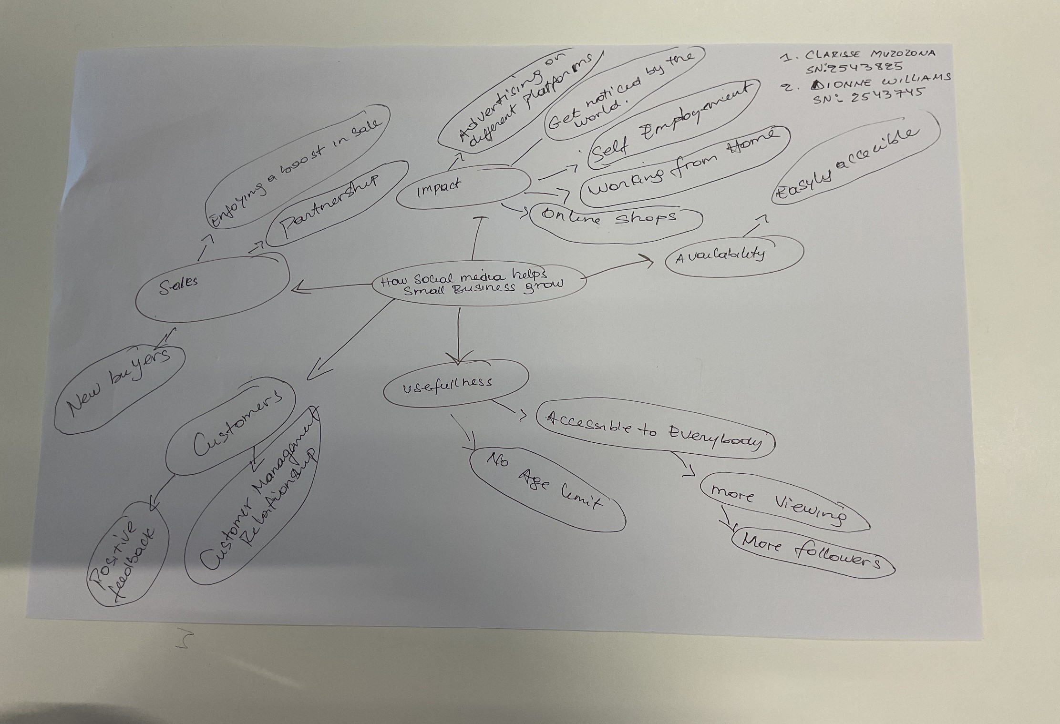

1. Answer these questions using the sentence starters below
a. What is the main idea of the text?
The main idea is that using mind mapping allows you to build on ideas, expand searches, create new avenues to develop or further expand knowledge or business potential for future development or suggestions for growth.
b. What are two key points?
One key point is that it allows the individuals free rain of expounding on knowledge you already garner from articles, clippings, business reviews or just adding additional details that maybe be beneficial to learning new ideas of working.
Another key point is that the use of this way of thinking allows for greater flexibility of ideas, inclusion of more person’s ideas and compounding on shared knowledge for better outcome.
c. What part of the text did you find most important? Why?
The most important part is starting with the main point/idea and brainstorming with colleagues to come up with new ideas and areas that aid in better flexibility for business development.
d. Was anything unclear or difficult to understand?
I was not sure about expounding on the main idea and my colleague and I had different ways we anticipated the outcome to be. When we reread the questions and worked together, we were able to come with a very detailed structure that we felt would be a good business model to develop on and provided clear/branched ideas that we felt were easy to follow and could easily be explained.
e. How did your group help you understand the text better?
My group helped me by providing different feedback on my ideas and how we felt that it could easily be developed into a business model and or be followed to provide acceptable business models and ventures into new possibilities/outcomes for new business satisfaction from a customer’s perspective.
2. One sentence reflection
Question: What did you find challenging about this task?
The hardest part was working together with someone new. We both have very strong personalities and didn’t readily agree on anything. Was it helpful, no. But we put our differences aside and came up with a very solid mind map that was clear, showed initiative, growth and could be easily explained. Moral for me, never judge a book by its cover.
Our joint knowledge and ideas provided several branches of practicality that could be further developed and supported in a clear business structure.

