Cert. HE S4BA Assignment

Software for Business E-Portfolio
Student: Hafeez Rehman
Student ID: 2229728
Module: Software and Apps for Business (ACCA4031)
Lecturer: James Williams

- Task 1: e-Portfolio. https://sites.google.com/view/hafeezrehman220288/home

- 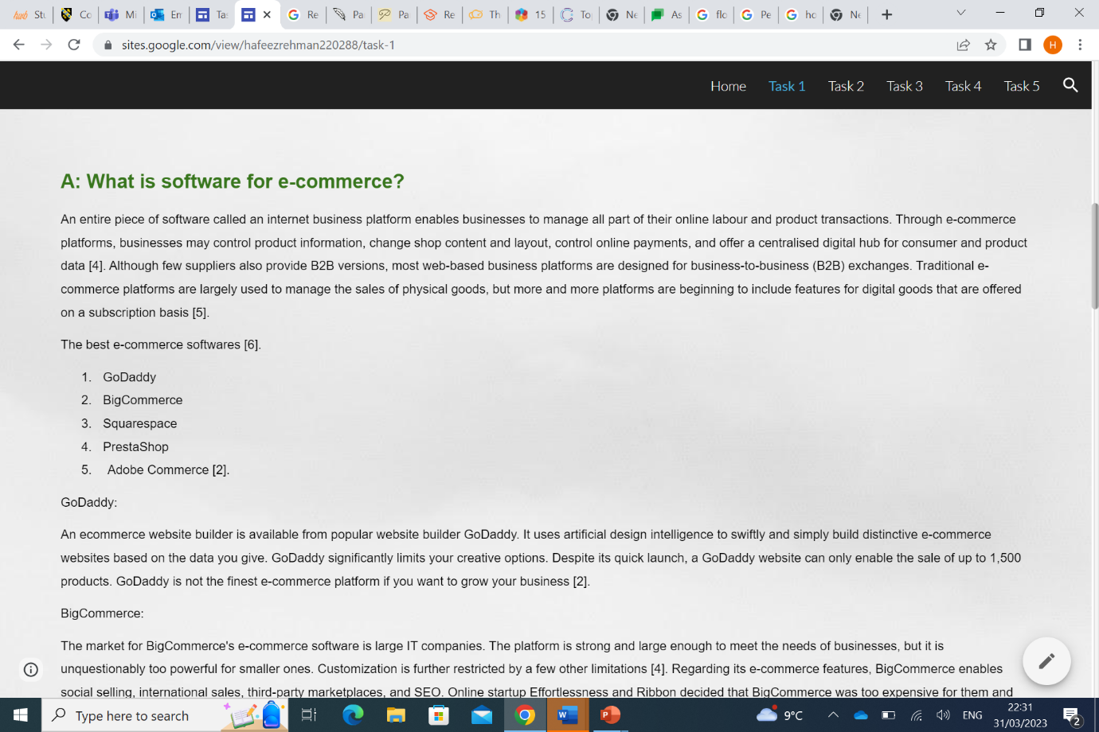
- 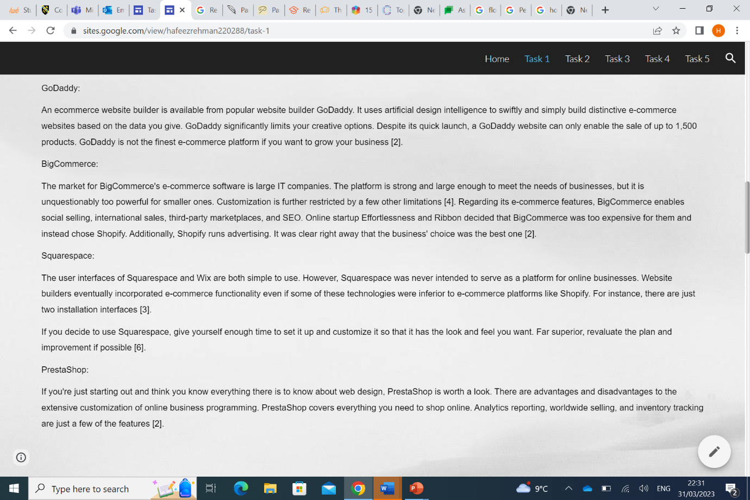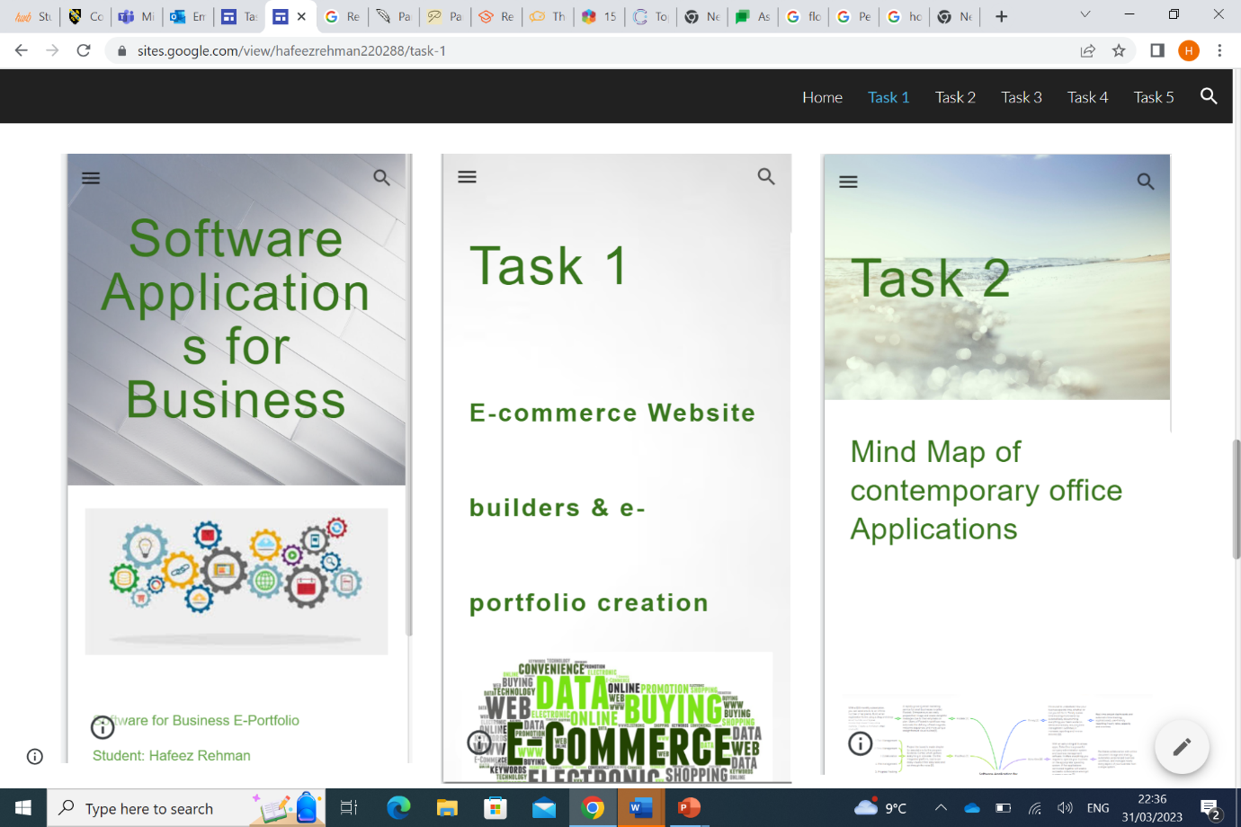
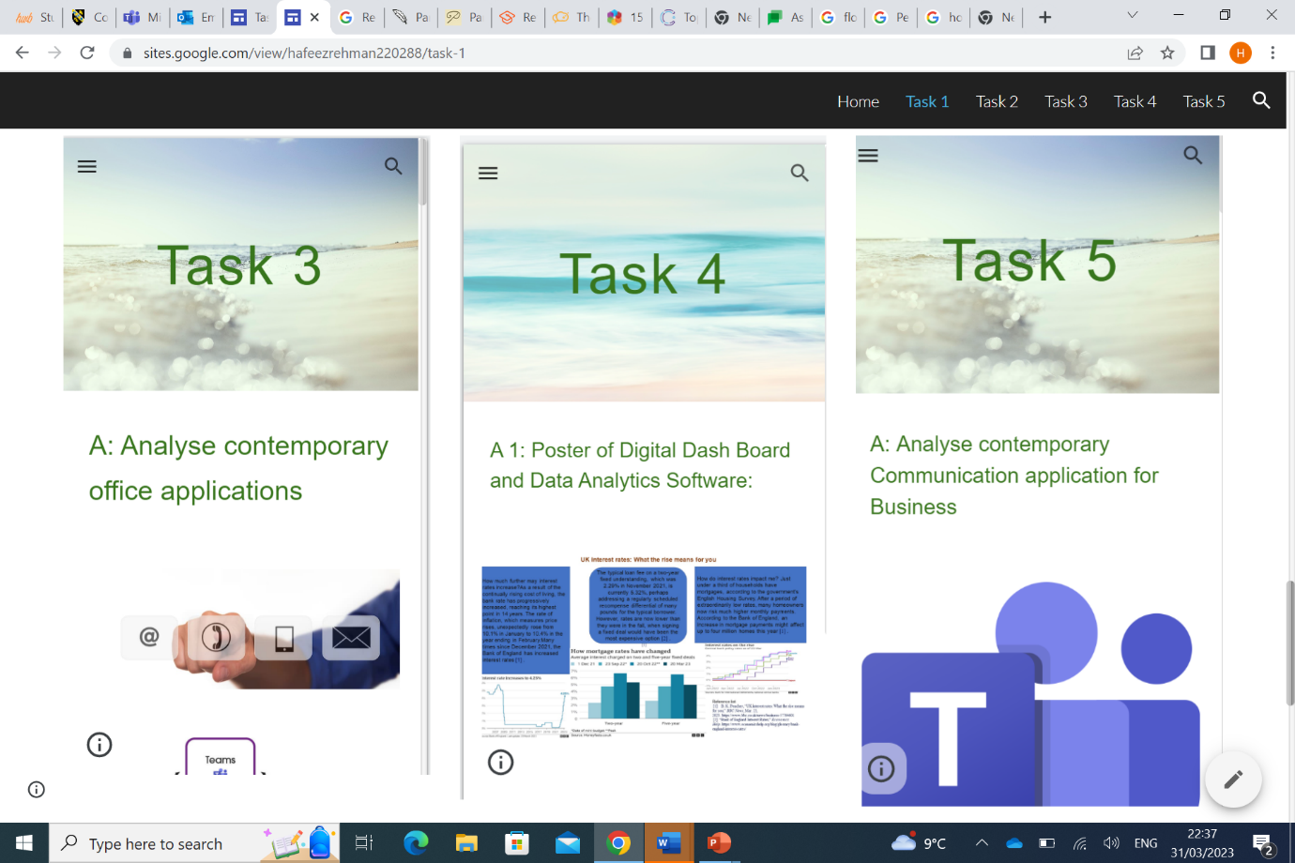

Task 2 – Mind-map.
- 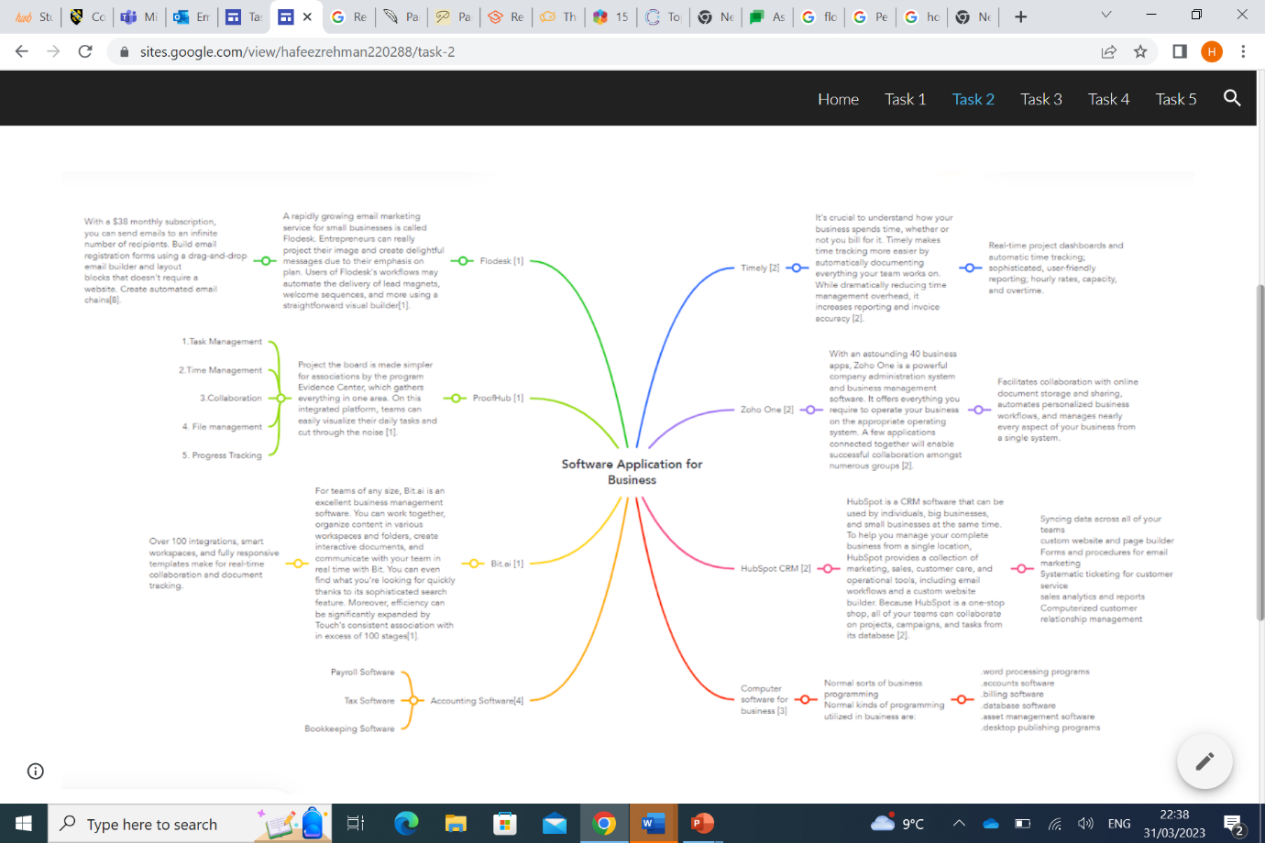.
Task 3 – Office Applications
.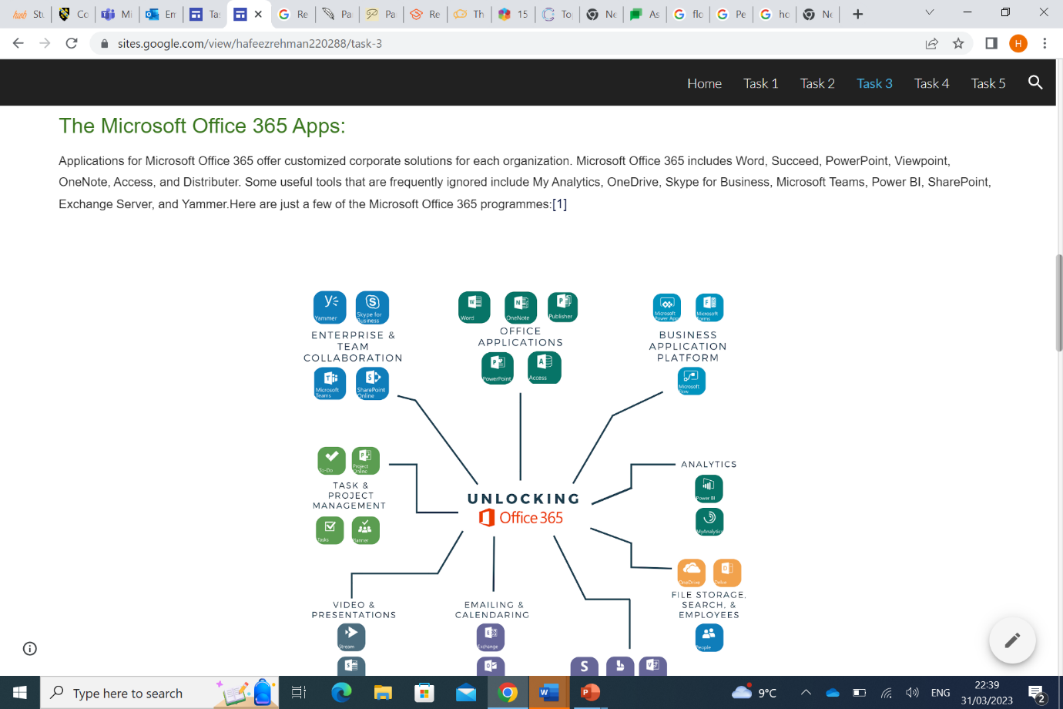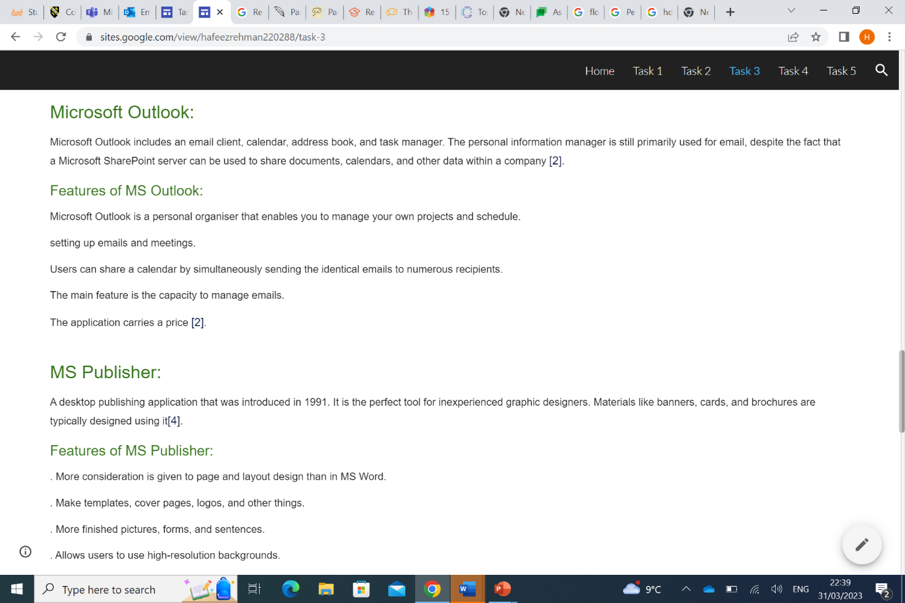
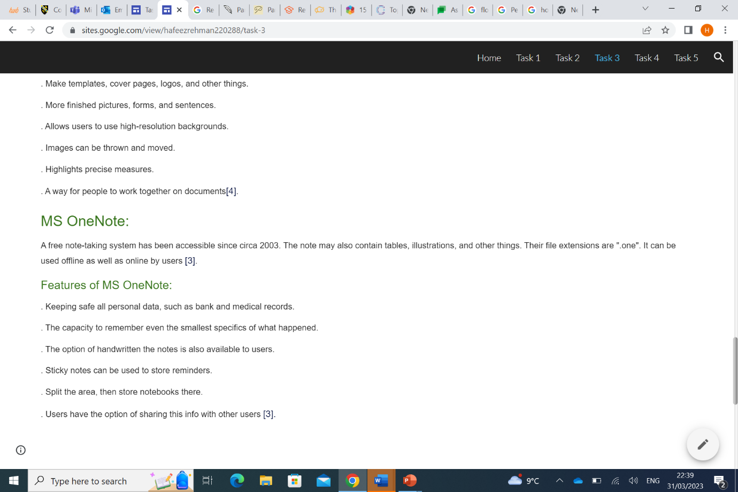

Task 4 – Digital Dashboard and Data Analytics software.

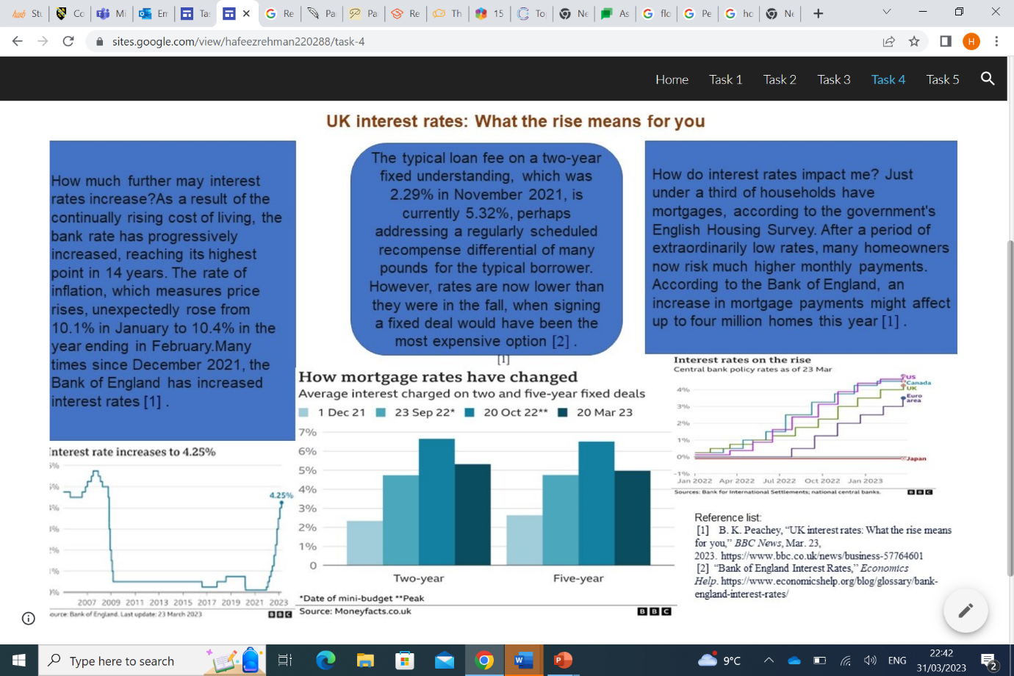

Task 5 - Communication, Collaboration & Project Management

- 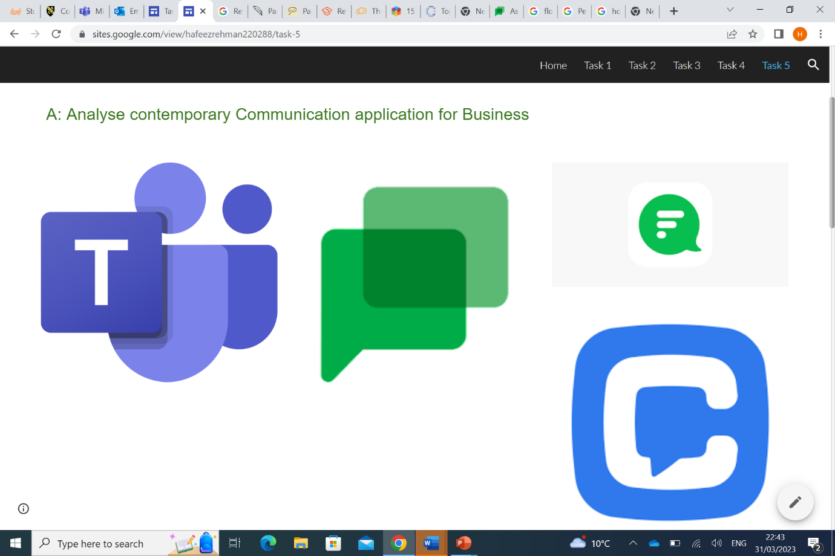
- 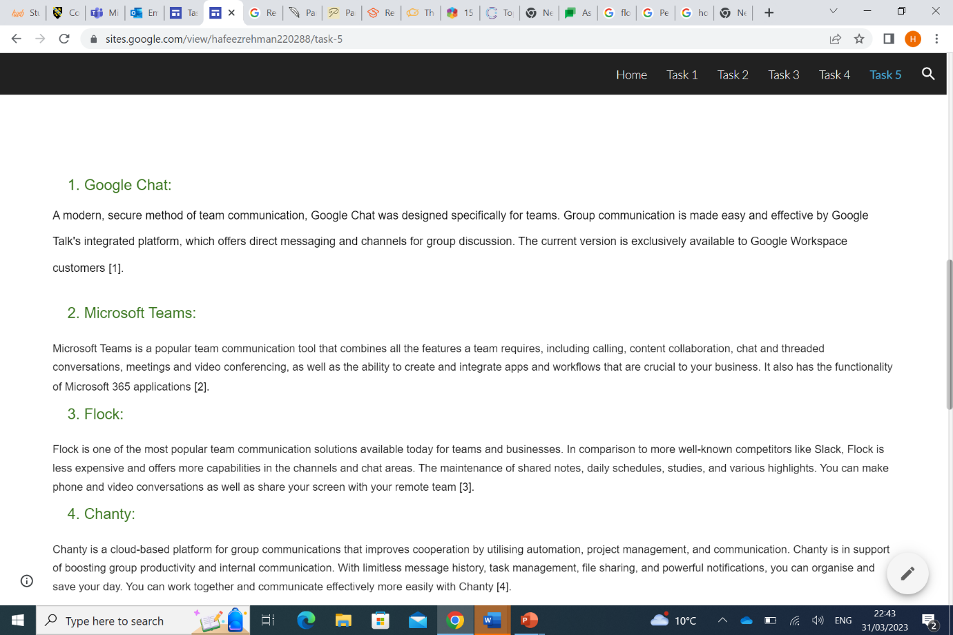.
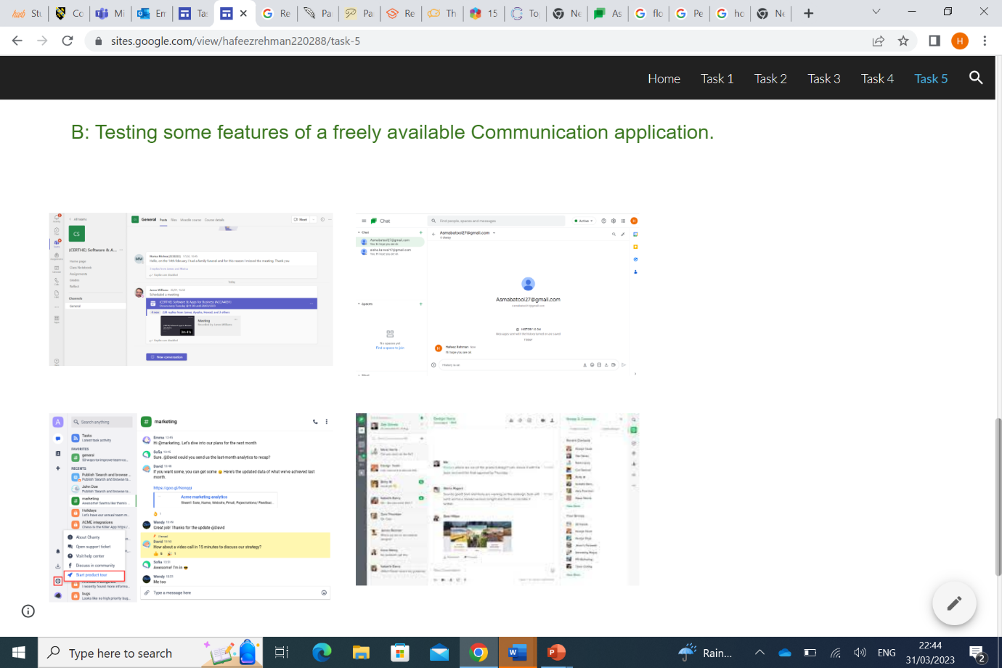

IMPORTANT LINK TEST REMINDER: to ensure your work is accessible for marking it is important to test your work can be accessed by the tutors. To do this either try opening the e-portfolio link in a private/incognito tan in a web browser or sign out of the e-portfolio and to try to open it in a web browser with the link you are providing in this document.

