Assesment1
Software Development
Submit Date:29.04.2022
Student name:(2030117)dENIS gORI
M00NE

Table of Contents
What is a variable and why are they important in writing programs? 2
Explain what an if/else statement is, how and why they are used. 2
Explain why loops are needed in a program and when you might use a for and a while loop. 8
Conclusion 10
References 10

What is a variable and why are they important in writing programs?
What is a variable?
A Python variable is a symbolic name for an object that serves as a reference or pointer. You can refer to an object by its name once it has been assigned to a variable. The data, on the other hand, is still contained within the object.
Why are they important?
Numeric values, characters, character strings, and memory addresses are all examples of variables. Variables are crucial in computer programming because they allow programmers to build programs that are flexible. A programmer can utilize variables to represent data rather than entering it directly into a program.
A variable can have a short name (such as x and y) or a longer name (such as age, carname, or total volume).
Variables in Python have the following rules:
- A variable name must begin with a letter or the underscore character;
- A variable name cannot begin with a number;
- A variable name can only include alphanumeric letters and underscores (A-z, 0-9, and_ );
- Variable names are case-sensitive (age, Age and AGE are three different variables);

Explain what an if/else statement is, how and why they are used.
The if-else condition is used to execute both the true and false parts of a condition. The if block code is run if the condition is true, and the else block code is executed if the condition is false.
- if statement
If the conditional statement is one of the most widely used in most computer languages. It determines whether or not certain assertions must be implemented. If the operator checks for a condition, the set of code in the if block will be run if the condition is true; if the condition is false, the set of code in the if block will not be met.
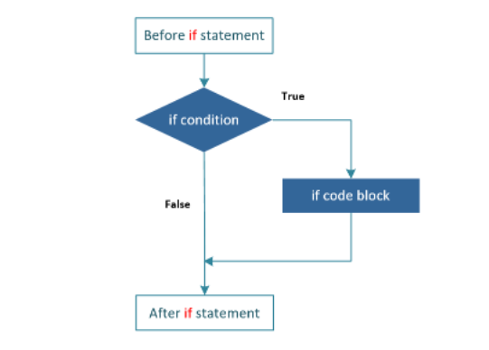
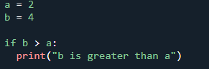
b is greater than a
In this example, we use two variables, a and b, to test whether b is greater than a as part of the if statement. Because a is 2 and b is 4, we know that 4 is greater than 2, thus we print "b is greater than a" on the screen.
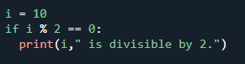
10 is divisible by 2

- If-else statement
If a condition is true, execute the expressions within the if block; if the condition is false, execute the else block, according to the operator.The else block will only be run if the condition becomes false; it is in this block that you will take action if the condition is false.If the condition is TRUE, the if-else operator evaluates the Boolean expression and performs the code block in the if block; if the condition is FALSE, the code block in the else block is executed.
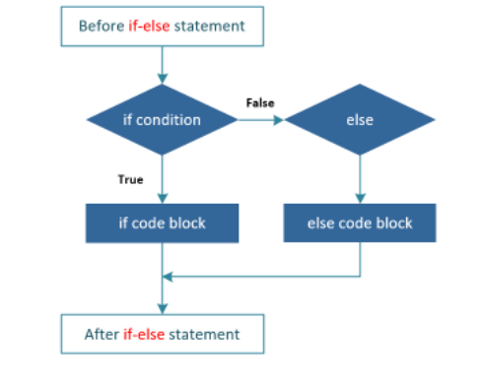
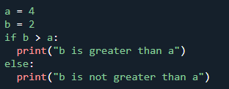
b is not greater than a
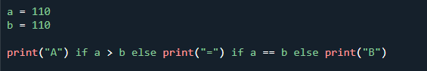
=

if-else program that broadcasts the name and age:
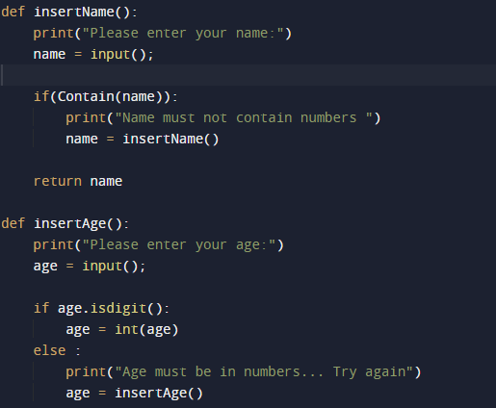
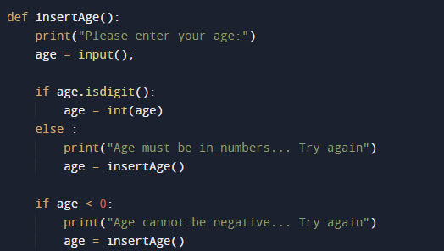
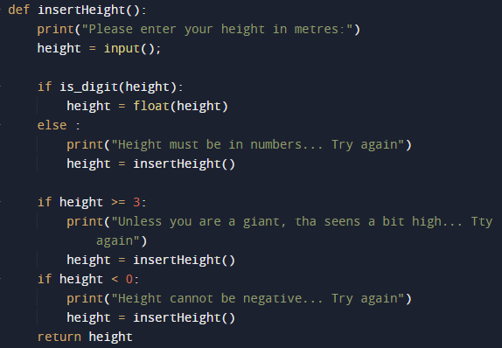
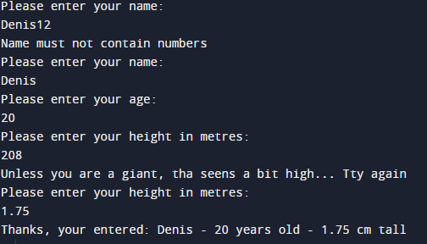
The output is:
C:\Users\user\Python\main1.py

In the above program it is possible to broadcast the name, age and height. Here we use if-else to broadcast this data correctly. If we enter the name with numbers it warns us to use only letters, so with age it warns us to use only numbers, in the same way it works at height where we can not put data with negative or exaggeratedly high.

c) elif statement
Elif stands for "else if." It enables us to check for several expressions at the same time. If the if condition is False, the following elif block's condition is checked, and so on. The body of else is performed if all of the criteria are False. The elif block is executed if the specified condition evaluates to True.
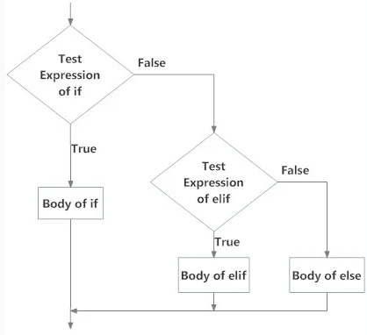

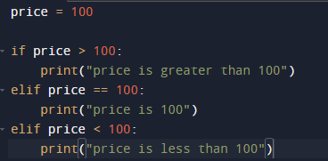
price is 100

The elif criteria are applied after the if condition in the example above. Python will assess the if condition, and if it returns False, it will evaluate the elif blocks and execute the elif block with the True expression. If more than one elif condition is True, the first elif block is executed.

Explain why loops are needed in a program and when you might use a for and a while loop.
Loops are programming constructs that repeat a section of code a predetermined number of times until the intended result is achieved. In programming, repetitive activities are prevalent, and loops are vital for saving time and reducing mistakes.
a) “for” loop
The for loop is a conditional iterative statement in programming that is used to check for particular criteria and then run a block of code continuously as long as those conditions are fulfilled.
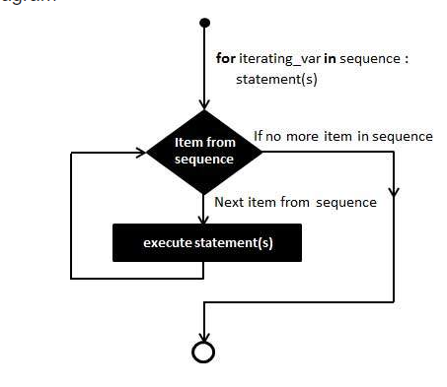
There is example with 3 cycle loops using for.
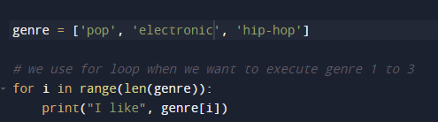
I like pop
I like electronic
I like hip-hop
b) “while” loop
Python While Loop is a programming construct that is used to repeatedly execute a set of statements until a condition is met. When the condition in the program becomes false, the line immediately after the loop is performed.
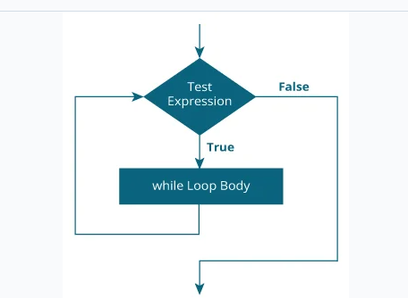

There is examples for with “while” loop:
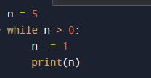
4
3
2
1
0

Here's what's going on in this scenario:
Initially, n is set to 5. The while statement header on line 2 has the expression n > 0, which is true, hence the loop body runs. On line 3, n is decremented by 1 to 4 and then written inside the loop body.When the body of the loop is complete, program execution returns to line 2 at the start of the loop, where the expression is re-evaluated. Because it is still true, the body executes once more, and the number 3 is printed.This process is repeated until n equals 0. When the expression is tested at that moment, it is false, and the loop ends. The loop body's execution would resume at the first statement following it, but there isn't one in this case.

Conclusion

In conclusion I can say that the work was difficult but I managed to do the work, I followed every step of the scenario and with the help of lessons and information provided by the teacher I managed to do all the work on time and without problems

References

[1] | G. v. R. (Guido), Pyton Manual, 1995-01-01.
[2] | C. S. Ong, Pattern for Python, 2000.
[3] | J. Z. &. M. L. R. Bakdash, Repeated measures correlation, 2017.
[4] | P. Berens, A MATLAB toolbox for circular statistics, 2009.
[5] | J. N. S. P. L. S. D. M. R. D. &. I. G. Rouder, Bayesian, 2009.

