Population Health and Digital Health Promotion
Component 1

Name:- Hellyben D. Patel
Student No:- 2318627
Module Title:- Population health and digital health promotion
Module code:- LCHS7007
Lecturer name:- Dr. Ping Wu
Title:- Component Task 1 Blog Task 2 Poster

Table of Contents
Task 1: Blogs
Blog 1: Impact of IoT for a digital health promotion intervention 3
Blog 2: Impact of a digital technology that is designed for a digital Health promotion intervention 5
Task 2: Poster
Background 7
Health promotion values and principles 7
Behavioural Change Theory 8
Expected outcome 10
Conclusion 10
References
References for Blog 1 13
References for Blog 2 13
References for Poster 14

Task 1: Blogs
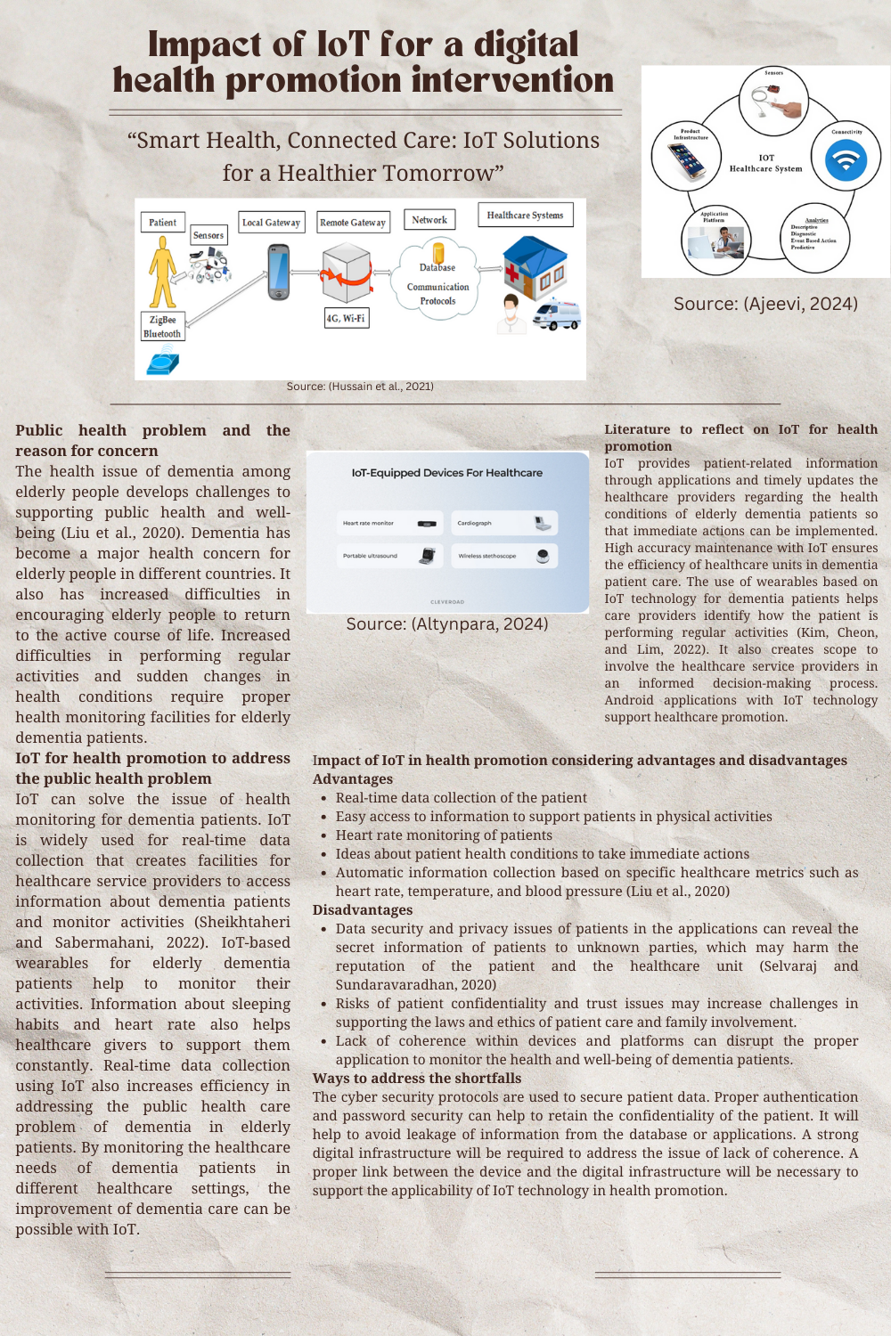

Blog 1: Impact of IoT for a digital health promotion intervention
“Smart Health, Connected Care: IoT Solutions for a Healthier Tomorrow”
Public health problem and the reason for concern
The health issue of dementia among elderly people develops challenges to supporting public health and well-being (Liu et al., 2020). Dementia has become a major health concern for elderly people in different countries. It also has increased difficulties in encouraging elderly people to return to the active course of life. Increased difficulties in performing regular activities and sudden changes in health conditions require proper health monitoring facilities for elderly dementia patients.
IoT for health promotion to address the public health problem
IoT can solve the issue of health monitoring for dementia patients. IoT is widely used for real-time data collection that creates facilities for healthcare service providers to access information about dementia patients and monitor activities (Sheikhtaheri and Sabermahani, 2022). IoT-based wearables for elderly dementia patients help to monitor their activities. Information about sleeping habits and heart rate also helps healthcare givers to support them constantly. Real-time data collection using IoT also increases efficiency in addressing the public health care problem of dementia in elderly patients. By monitoring the healthcare needs of dementia patients in different healthcare settings, the improvement of dementia care can be possible with IoT.
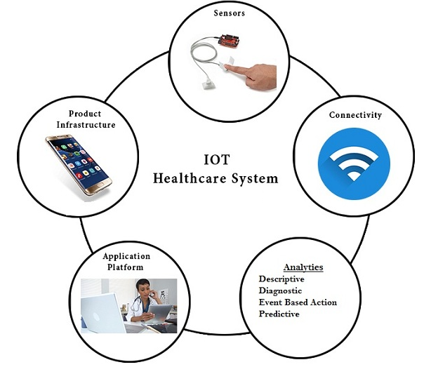
Source: Ajeevi, 2024

Literature to reflect on IoT for health promotion
IoT provides patient-related information through applications and timely updates the healthcare providers regarding the health conditions of elderly dementia patients so that immediate actions can be implemented. High accuracy maintenance with IoT ensures the efficiency of healthcare units in dementia patient care. The use of wearables based on IoT technology for dementia patients helps care providers identify how the patient is performing regular activities (Kim, Cheon, and Lim, 2022). It also creates scope to involve the healthcare service providers in an informed decision-making process. Android applications with IoT technology support healthcare promotion.
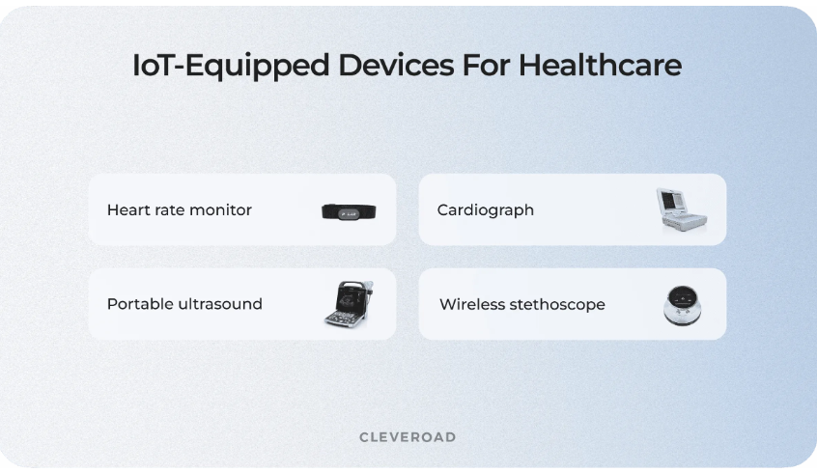
Source: (Altynpara, 2024)
Impact of IoT in health promotion considering advantages and disadvantages
Advantages
- Real-time data collection of the patient
- Easy access to information to support patients in physical activities
- Heart rate monitoring of patients
- Ideas about patient health conditions to take immediate actions
- Automatic information collection based on specific healthcare metrics such as heart rate, temperature, and blood pressure (Liu et al., 2020)
Disadvantages
- Data security and privacy issues of patients in the applications can reveal the secret information of patients to unknown parties, which may harm the reputation of the patient and the healthcare unit (Selvaraj and Sundaravaradhan, 2020)
- Risks of patient confidentiality and trust issues may increase challenges in supporting the laws and ethics of patient care and family involvement.
- Lack of coherence within devices and platforms can disrupt the proper application to monitor the health and well-being of dementia patients.
Ways to address the shortfalls
The cyber security protocols are used to secure patient data. Proper authentication and password security can help to retain the confidentiality of the patient. It will help to avoid leakage of information from the database or applications. A strong digital infrastructure will be required to address the issue of lack of coherence. A proper link between the device and the digital infrastructure will be necessary to support the applicability of IoT technology in health promotion.
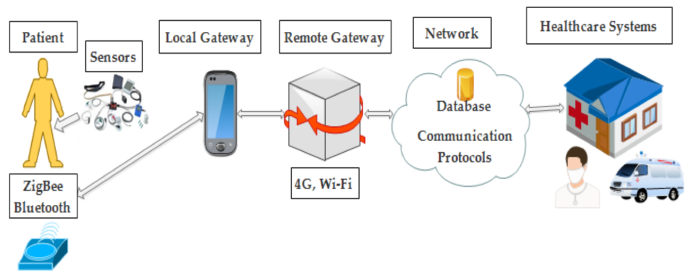
Source: (Hussain et al., 2021)

Blog 2: Impact of a digital technology that is designed for a digital health promotion intervention
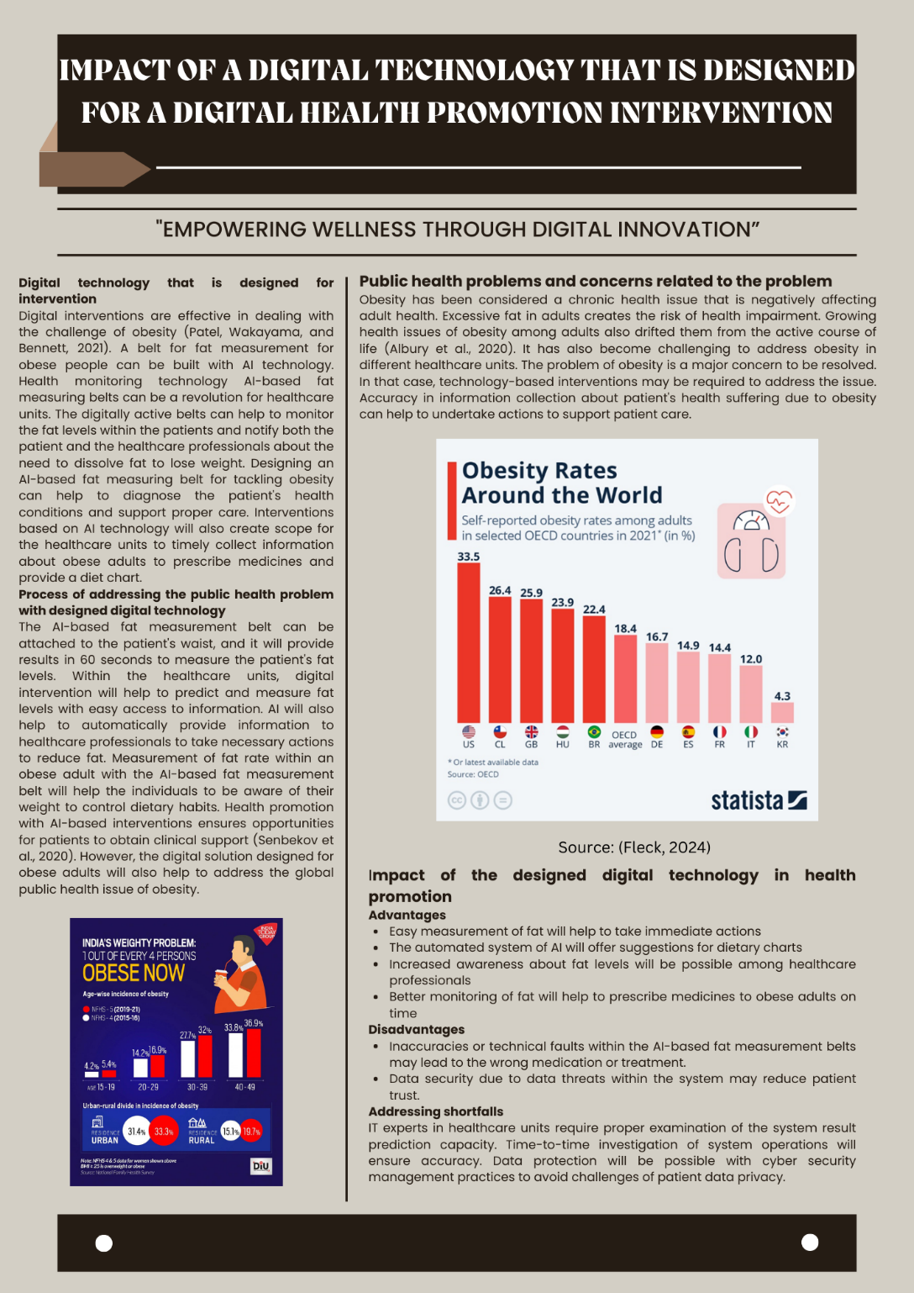
"Empowering Wellness Through Digital Innovation”
Public health problems and concerns related to the problem
Obesity has been considered a chronic health issue that is negatively affecting adult health. Excessive fat in adults creates the risk of health impairment. Growing health issues of obesity among adults also drifted them from the active course of life (Albury et al., 2020). It has also become challenging to address obesity in different healthcare units. The problem of obesity is a major concern to be resolved. In that case, technology-based interventions may be required to address the issue. Accuracy in information collection about patient's health suffering due to obesity can help to undertake actions to support patient care.

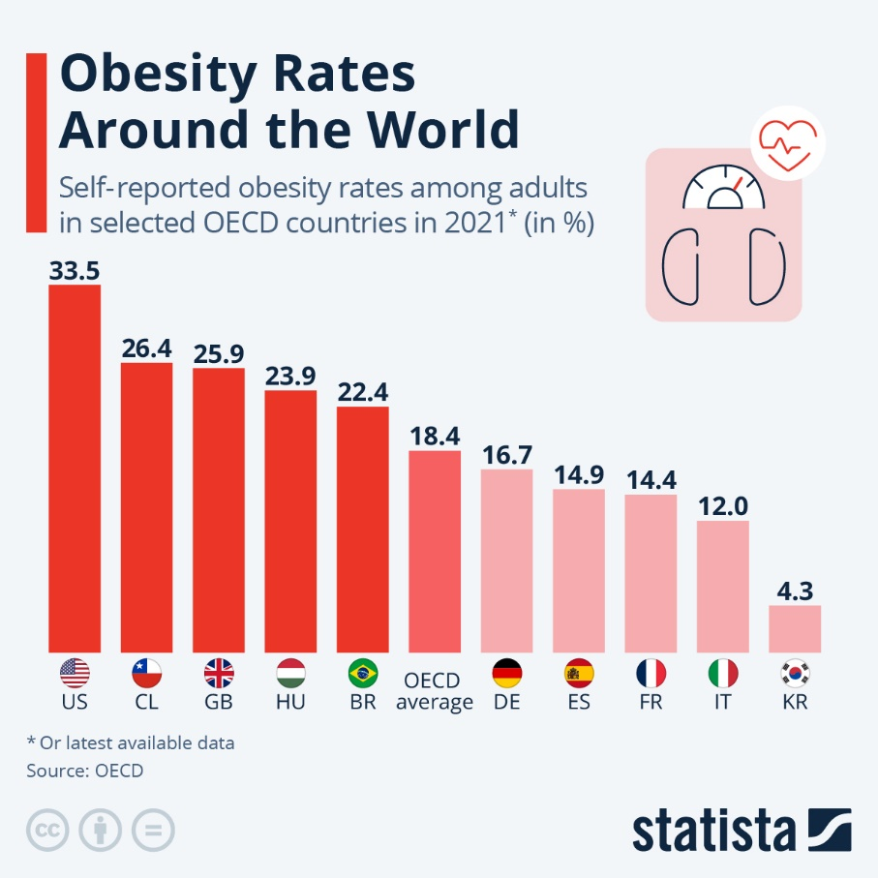
Source: Fleck, 2024
Digital technology that is designed for intervention
Digital interventions are effective in dealing with the challenge of obesity (Patel, Wakayama, and Bennett, 2021). A belt for fat measurement for obese people can be built with AI technology. Health monitoring technology AI-based fat measuring belts can be a revolution for healthcare units. The digitally active belts can help to monitor the fat levels within the patients and notify both the patient and the healthcare professionals about the need to dissolve fat to lose weight. Designing an AI-based fat measuring belt for tackling obesity can help to diagnose the patient's health conditions and support proper care. Interventions based on AI technology will also create scope for the healthcare units to timely collect information about obese adults to prescribe medicines and provide a diet chart.
Process of addressing the public health problem with designed digital technology
The AI-based fat measurement belt can be attached to the patient's waist, and it will provide results in 60 seconds to measure the patient's fat levels. Within the healthcare units, digital intervention will help to predict and measure fat levels with easy access to information. AI will also help to automatically provide information to healthcare professionals to take necessary actions to reduce fat. Measurement of fat rate within an obese adult with the AI-based fat measurement belt will help the individuals to be aware of their weight to control dietary habits. Health promotion with AI-based interventions ensures opportunities for patients to obtain clinical support (Senbekov et al., 2020). However, the digital solution designed for obese adults will also help to address the global public health issue of obesity.
Impact of the designed digital technology in health promotion
Advantages
- Easy measurement of fat will help to take immediate actions
- The automated system of AI will offer suggestions for dietary charts
- Increased awareness about fat levels will be possible among healthcare professionals
- Better monitoring of fat will help to prescribe medicines to obese adults on time
Disadvantages
- Inaccuracies or technical faults within the AI-based fat measurement belts may lead to the wrong medication or treatment.
- Data security due to data threats within the system may reduce patient trust.
Addressing shortfalls
IT experts in healthcare units require proper examination of the system result prediction capacity. Time-to-time investigation of system operations will ensure accuracy. Data protection will be possible with cyber security management practices to avoid challenges of patient data privacy.

Task 2: Poster
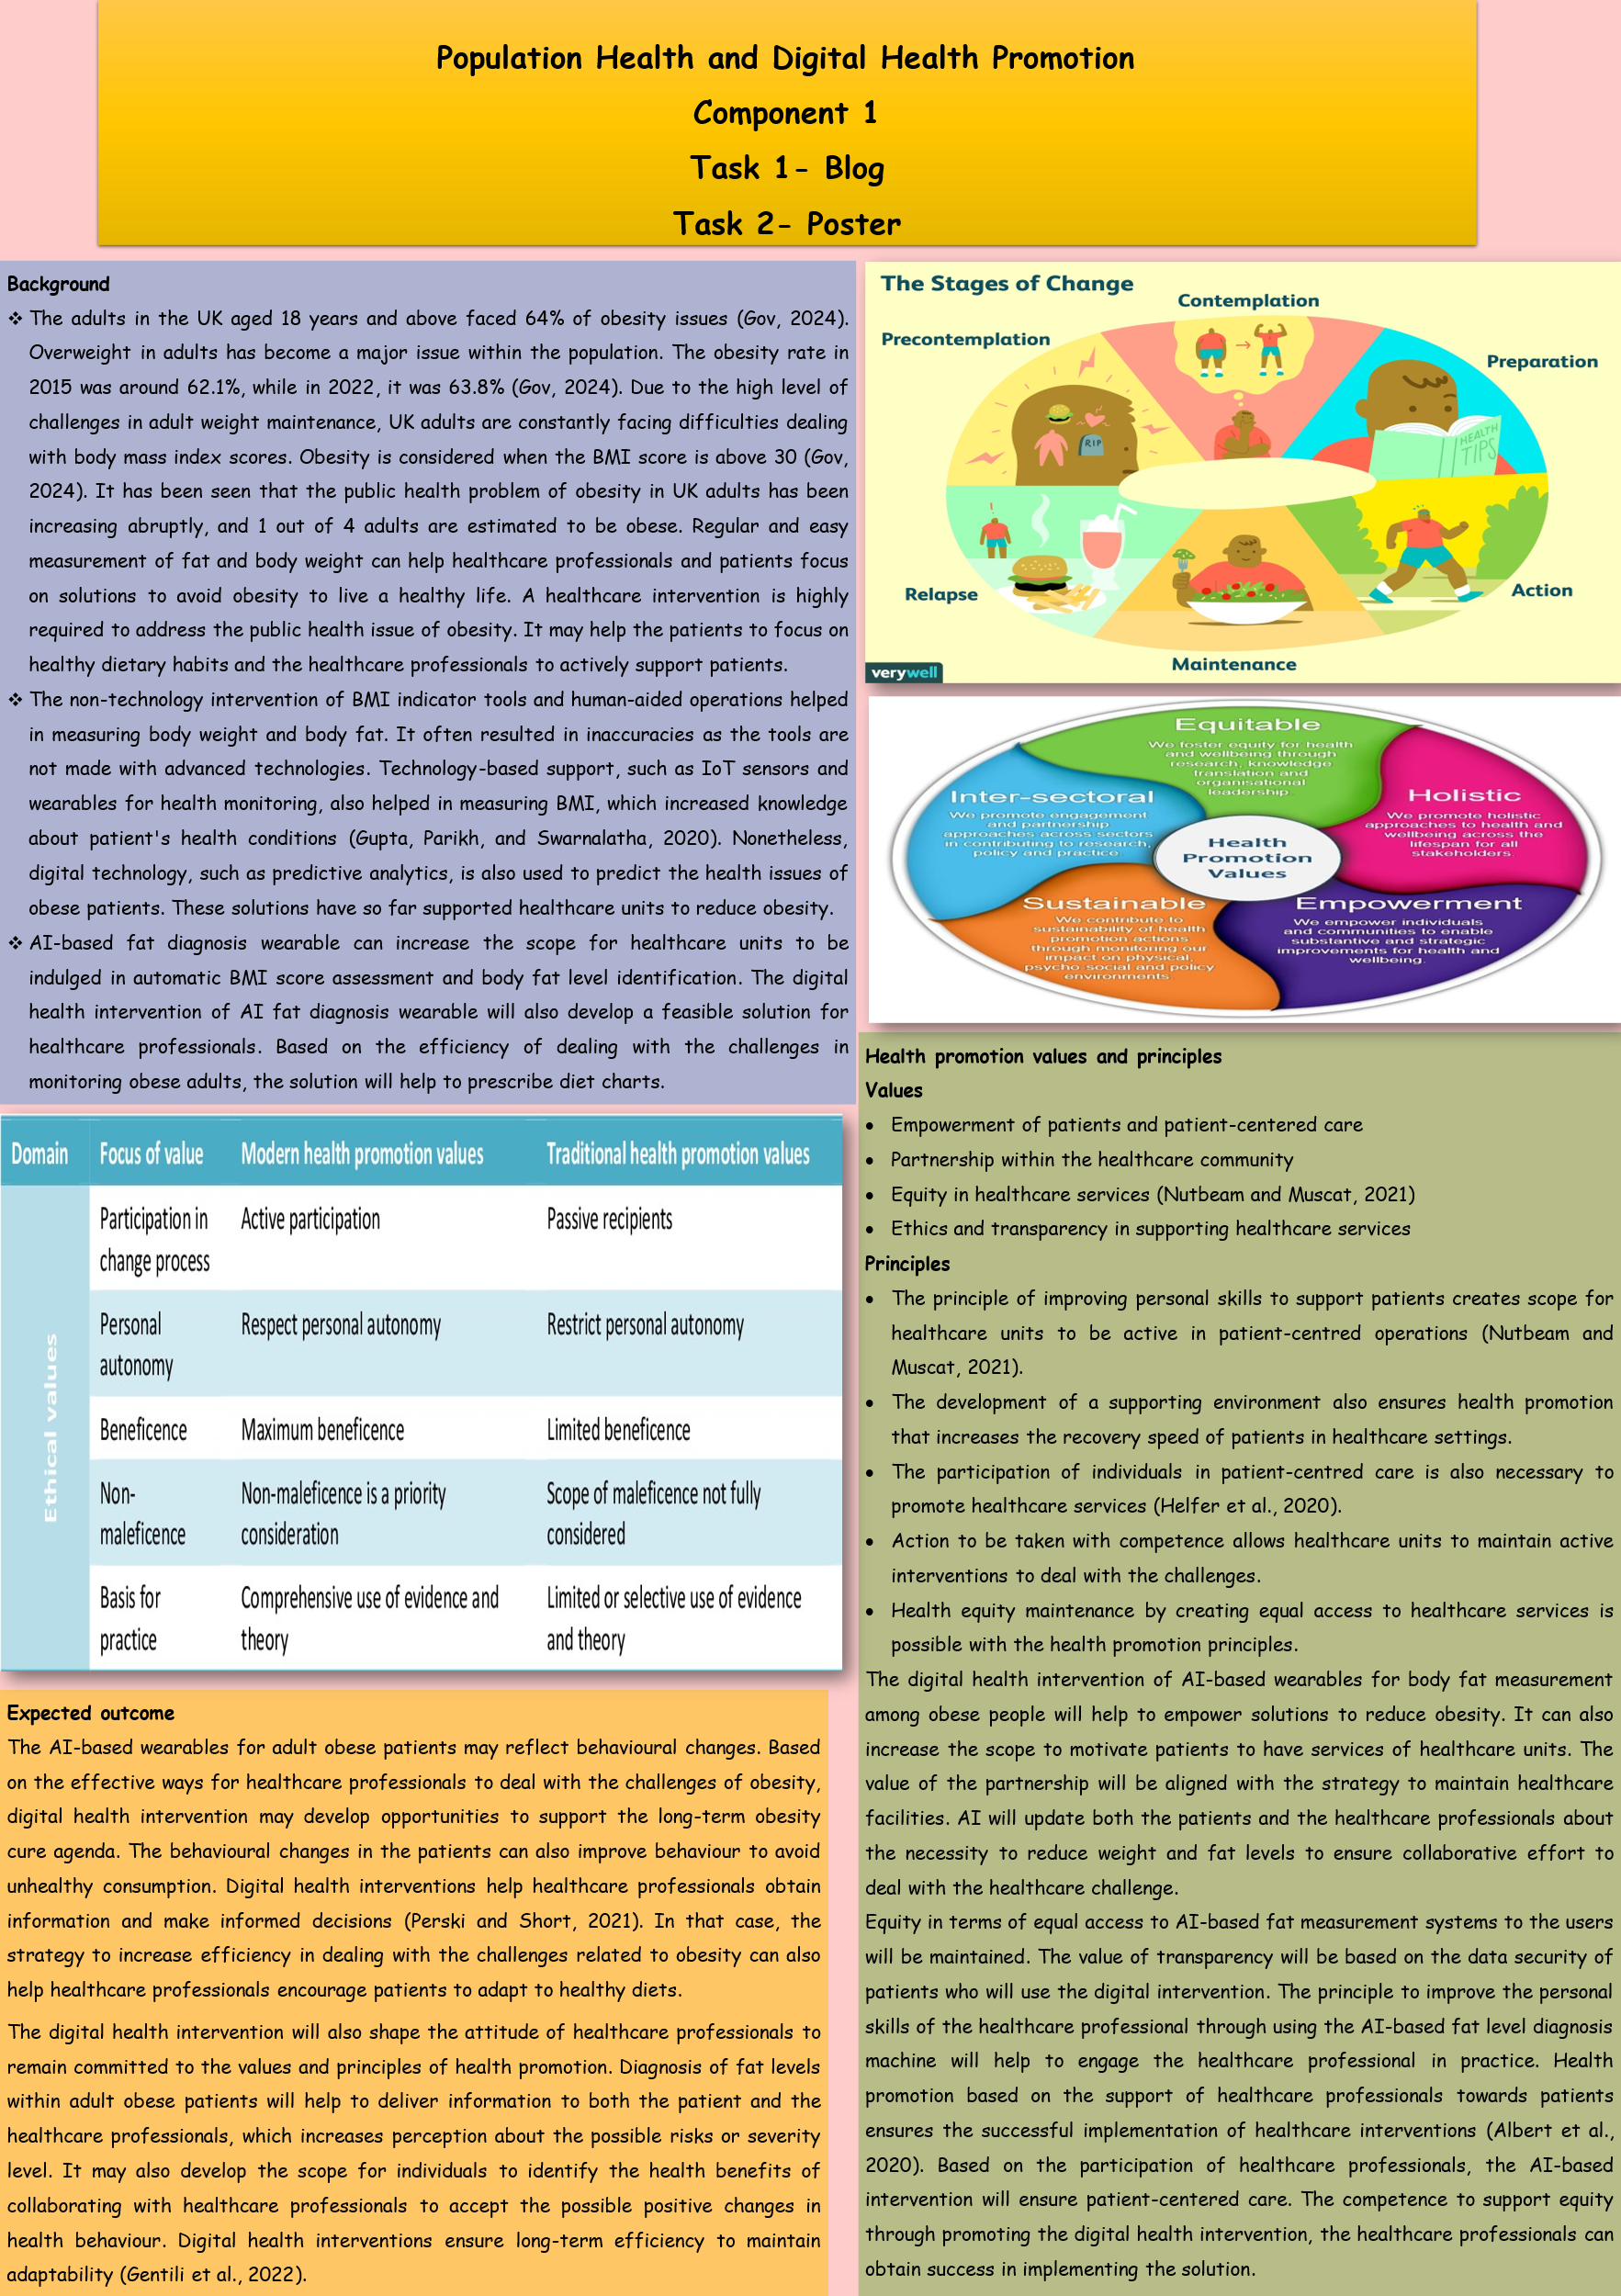
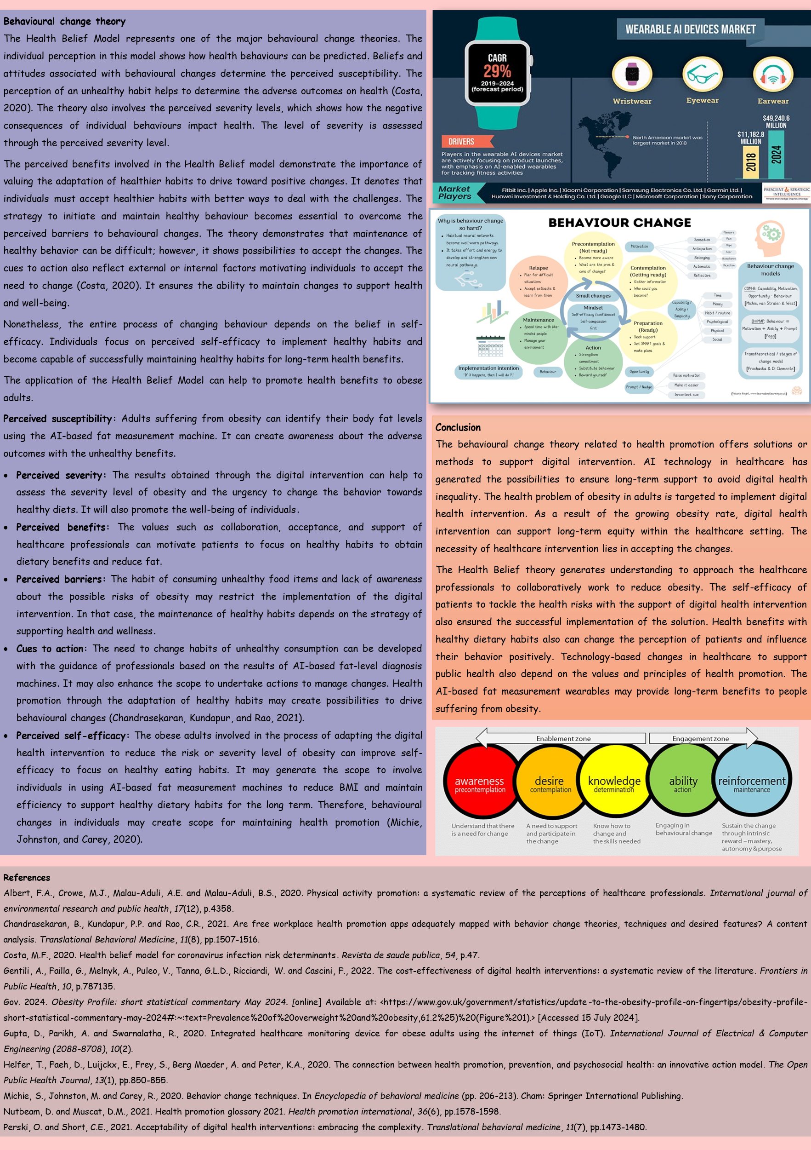

References

References for Blog 1
Ajeevi, 2024. Smart Healthcare - new. [online] Ajeevi. Available at: <https://ajeevi.com/industries/smart-healthcare-2/> [Accessed 30 July 2024].
Altynpara, E., 2024. The overview of IoT in healthcare industry. [online] Cleveroad Inc. - Web and App Development Company. Available at: <https://www.cleveroad.com/blog/iot-in-healthcare/>.
Hussain, A., Ali, T., Althobiani, F., Draz, U., Irfan, M., Yasin, S., Shafiq, S., Safdar, Z., Glowacz, A., Nowakowski, G., Khan, M.S. and Alqhtani, S., 2021. Security Framework for IoT Based Real-Time Health Applications. Electronics, [online] 10(6), p.719. https://doi.org/10.3390/electronics10060719.
Kim, J., Cheon, S. and Lim, J., 2022. IoT-based unobtrusive physical activity monitoring system for predicting dementia. Ieee Access, 10, pp.26078-26089.
Liu, I.T., Lee, W.J., Lin, S.Y., Chang, S.T., Kao, C.L. and Cheng, Y.Y., 2020. Therapeutic effects of exercise training on elderly patients with dementia: a randomized controlled trial. Archives of Physical Medicine and Rehabilitation, 101(5), pp.762-769.
Selvaraj, S. and Sundaravaradhan, S., 2020. Challenges and opportunities in IoT healthcare systems: a systematic review. SN Applied Sciences, 2(1), p.139.
Sheikhtaheri, A. and Sabermahani, F., 2022. Applications and outcomes of Internet of Things for patients with Alzheimer’s disease/dementia: A scoping review. BioMed Research International, 2022(1), p.6274185.

References for Blog 2
Albury, C., Strain, W.D., Le Brocq, S., Logue, J., Lloyd, C. and Tahrani, A., 2020. The importance of language in engagement between healthcare professionals and people living with obesity: a joint consensus statement. The Lancet Diabetes & Endocrinology, 8(5), pp.447-455.
Fleck, A., 2024. Obesity Rates Around the World. Statista Daily Data. [online] 4 Mar. Available at: <https://www.statista.com/chart/20057/obesity-rates-eu/>.
Patel, M.L., Wakayama, L.N. and Bennett, G.G., 2021. Self‐monitoring via digital health in weight loss interventions: a systematic review among adults with overweight or obesity. Obesity, 29(3), pp.478-499.
Senbekov, M., Saliev, T., Bukeyeva, Z., Almabayeva, A., Zhanaliyeva, M., Aitenova, N., Toishibekov, Y. and Fakhradiyev, I., 2020. The recent progress and applications of digital technologies in healthcare: a review. International journal of telemedicine and applications, 2020(1), p.8830200.

References for Poster
Albert, F.A., Crowe, M.J., Malau-Aduli, A.E. and Malau-Aduli, B.S., 2020. Physical activity promotion: a systematic review of the perceptions of healthcare professionals. International journal of environmental research and public health, 17(12), p.4358.
Chandrasekaran, B., Kundapur, P.P. and Rao, C.R., 2021. Are free workplace health promotion apps adequately mapped with behavior change theories, techniques and desired features? A content analysis. Translational Behavioral Medicine, 11(8), pp.1507-1516.
Costa, M.F., 2020. Health belief model for coronavirus infection risk determinants. Revista de saude publica, 54, p.47.
Gentili, A., Failla, G., Melnyk, A., Puleo, V., Tanna, G.L.D., Ricciardi, W. and Cascini, F., 2022. The cost-effectiveness of digital health interventions: a systematic review of the literature. Frontiers in Public Health, 10, p.787135.
Gov. 2024. Obesity Profile: short statistical commentary May 2024. [online] Available at: <https://www.gov.uk/government/statistics/update-to-the-obesity-profile-on-fingertips/obesity-profile-short-statistical-commentary-may-2024#:~:text=Prevalence%20of%20overweight%20and%20obesity,61.2%25)%20(Figure%201).> [Accessed 15 July 2024].
Gupta, D., Parikh, A. and Swarnalatha, R., 2020. Integrated healthcare monitoring device for obese adults using the internet of things (IoT). International Journal of Electrical & Computer Engineering (2088-8708), 10(2).
Helfer, T., Faeh, D., Luijckx, E., Frey, S., Berg Maeder, A. and Peter, K.A., 2020. The connection between health promotion, prevention, and psychosocial health: an innovative action model. The Open Public Health Journal, 13(1), pp.850-855.
Michie, S., Johnston, M. and Carey, R., 2020. Behavior change techniques. In Encyclopedia of behavioral medicine (pp. 206-213). Cham: Springer International Publishing.
Nutbeam, D. and Muscat, D.M., 2021. Health promotion glossary 2021. Health promotion international, 36(6), pp.1578-1598.
Perski, O. and Short, C.E., 2021. Acceptability of digital health interventions: embracing the complexity. Translational behavioral medicine, 11(7), pp.1473-1480.

