Marketing In Practice-BMBM5013

Assignment 2: Campaign Proposal

Student ID: Vimal Maddichetti
Student Name: 2207918
Word Count: 2362

Table of Contents
Introduction 3
1. Starting a Campaign proposal 3
2. Communication channels to use for the proposed marketing campaign 5
3. Campaign ideas for each of the communication channel 7
4. Budget splits 8
5. Measuring the campaign performance 9
Conclusion 9
References 10

Introduction
The subscription meal box company which is a fictional organisation has plans to expand its service offering as a meal box delivery firm with vegan items box as well. With the rampant increase in vegan food demands globally, the company aims to make higher profits by promoting meal boxes to vegan consumers. The vegan cooking box would be the new subscription meal box that the company aims to offer within six months with a budget of 500,000 Euros and aims to bring new members sign-up of 50,000 members. The main marketing objective can be to bring new subscriptions. The marketing campaign needs to be devised to fulfil the main marketing objectives of the company which are to increase brand awareness of the vegan box offerings, increase overall sales with action of 50,000 new members, generate higher leads through the social media platform and enhance share in vegan meal subscription-based firms in the UK. Marketing campaigns are strategic activities which the firm can use to promote the goals and objectives to attain desired results (Veleva and Tsvetanova 2020). The marketing campaign is an important fact that the company would develop in the assessment to fulfil these marketing objectives.

1. Starting a Campaign proposal
The marketing campaign that would be implemented by the company to promote its new offerings. The marketing campaign refers to specific activities which are designed to promote the products and services. The marketing campaign in this context refers to the company which is involved in meal box subscription and aims to promote the new offering of vegan meal boxes by adding a new 50,000 members addition. The company is a subscription-based meal delivery service aiming to provide healthy and customised food meals to professionals. The new offering aims to cater to the vegan population in the UK. It caters to professionals and health conscious individuals to provide them fresh, nutritious, and delicious customised vegan food items.
The vegan offering campaign can prove to be beneficial as the vegan trends in the UK have grown tremendously over the years. The number of vegans has increased by 1.1 million by 2023 and 2024 (Foodmanufacture.co.uk 2024). The maximum vegan trends are among the 30 to 39 year old age group in the UK followed by the 18 to 29 year age group. . The social media platform can be an effective way to target these age groups through the marketing proposed campaign. As opined by Statista (2024), 49% of social media users in the United Kingdom are aged between 30 to 49 years. One quarter of social network users are aged between 18 to 29 years. Hence, the social media platform is apt to target the ideal age range of vegans in the country. In addition to this, more than 28% of the small and medium sized businesses in the UK are generating more sales from social media than other channels. Hence, the food subscription based company can utilise the social media platform to initiate the proposed marketing platform to generate sales.

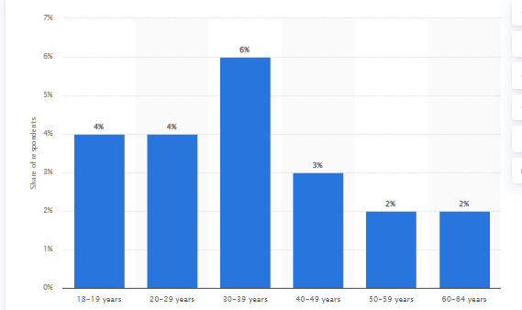
Figure 1: Vegan age groups in UK
(Source: Statista 2024)
Moreover, the fully prepared meals are ready to eat and the company offers flexible subscription offers to pause, cancel or change meal plans as per their convenience. The company has a team of professionals from the food industry sector to bring the best food quality and taste. The marketing professionals with experience in the food industry would play a key role in the marketing campaign. The marketing proposal aims to build urgency to sell its vegan products to get higher member sign-up on the food delivery subscription by offering social offers through the usage of the social media platform. The consumers who avail the vegan food delivery meal box subscription can post a selfie photo with the meal box and post their reviews on any social media platform, specifically Instagram and Facebook with a hashtag to link to the company social media page and also tag their friends. This act by consumers can get them special subscription sign-up offers such as 30% discount on the next subscription and free goodies offering on their next delivery such as vegan cupcakes. The selfies on social media platforms can be shared to friends and a shared referral code will be shared to the referral and the friends. Both would get a 10% discount on the next subscription.
The campaign will have a slogan ‘Your health, our creations’ ‘Post a selfie tag us and win rewards up to 30% on your subscription’
This would be a limited time offering which creates urgency among consumers to do the act and get the special discount. This creates a FOMO among the consumers as part of the marketing campaign. The audience are compelled to purchase the products and deciphers a psychological trick on consumers to grab the opportunities at all instances before the limited time of the offer runs out.

2. Communication channels to use for the proposed marketing campaign
The marketing communication are means through which the firms persuade consumers directly and indirectly about the brands and products (Febriani 2021).The communication channel that has been chosen in the proposed marketing campaign include the social media platform, Youtube, and the website. These are digital marketing channels for organic communication about the company to promote its meal based subscription for vegan meals to consumers in the UK. The two main portals of social media portals being utilised in the proposed marketing campaign are instagram and Facebook along with Youtube. These are the most popular social media platforms in the UK and viable to reach a large target audience for the company to attain its marketing objective to bring around 50,000 new meal subscriptions for new offering vegan meals.
Instagram
Instagram can be an effective communication channel that can be used by the company to promote vegan meals for food based subscription. The Instagram app is accessible through varied devices such as Google, Apple, Android, and Samsung. The app is accessible through the computers as well. The visually attractive images and videos can be posted on the app. The followers can like and comment on the visual posts of Instagram. The brands can use it to attain higher visibility. The brands can use branded hashtags which are trending to be more visible to brands to gain popularity. The hashtags can be an effective way to increase visibility. The Instagram hashtag brings higher engagement than posts which have no hashtags. Hence, it is vital to use these to reach larger target audiences.
Facebook
Facebook is another effective communication channel to reach out to target audiences. Facebook is one of the critical platforms with more than 3 billion active users and the brand can use the platform through a business page for promoting the organic and paid promotions through videos and photos (Chawla and Chodak 2021). Facebook supports the content through images and videos and the captivating engaging visuals can engage prospective consumers. Facebook analytics can be used to meet the target audience needs. The content can be tailored to meet the audience needs and increase engagement and improve the brand experiences. Facebook ads which are paid can utilise where the target audience can be segmented based on geographic region which would be UK for vegan meal subscription company, and select suitable age groups, and specially vegan lovers and professionals who find subscription based meals easier as targets to reach out with the marketing campaigns. These parameters of target audiences ensure the campaign would get the best return on the ad spends.
YouTube
Youtube as the brand is one of the biggest platforms to promote the business where the highly interactive video campaigns can engage audiences and generate good revenues to the firm. The platform can create higher leads to create awareness among target audiences and engage higher target audiences.
Company Website
The company website can be an effective way to reach out to target audiences. The social media platform needs to have a link to the website. Moreover, the website must be SEO optimised to boost visibility and target ideal audiences through optimization by creating social media platforms with relevant content. PPC or pay per click can be an effective way to promote brand by promotional adverts on the internet and when the advertisement are clicked then only the advertisers need to pay.
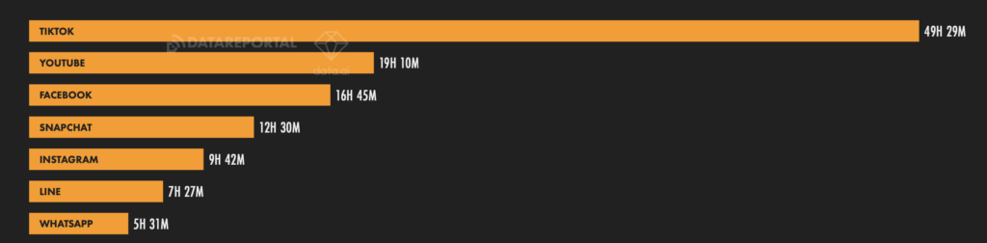
Figure 2:Top trending social media usage in UK
(Source: wearesocial.com 2024)

3. Campaign ideas for each of the communication channel
Instagram
The Instagram app can be used by the company to promote vegan offerings by using trending hashtags such as #veganmeal, #bestofvegan #home-based #freshmeal #subscriptionmeal and other trending key hashtags to get higher brand visibility. Moreover, it needs to have a promotion of the campaign where it states a limited period of time to put a selfie with the meal box and get 30% on the next subscription. The contest as a promotional campaign needs to be advertised on the app through the company page. The users need to click selfies and tag their friends as well for referral code to get an additional 10% discount for vegan goodies on next delivery. The tags can increase the consumers base visibility.
Facebook
The Facebook advertisement portal needs to be used with visually appealing graphics as mentioned for Instagram. In addition to this, the brand can showcase its marketing campaign through a small video without audio of customised vegan meals to the consumers in the UK based on easy subscription through the company app. These need to be prominent to targeted audiences through scrolling through Facebook by placing these marketing promotions campaigns through paid advertisements on the platform.
YouTube
The company can use Trueview ads on Youtube to run the campaign. The ads appear before or after any video and are not skippable for at least 30 seconds.
Company Website
SEO optimization can be an effective way to promote the campaign. The company can create compelling title and meta descriptions to reach target audiences (Papagiannis 2020). The title and meta description can be an effective way to reach out to the target audience telling them clearly the business offering of vegan meals customised subscription based meals.
The PPC can be used through the social media platforms Instagram and Facebook for the company to promote the campaign by appearing as advertisements through scrolling.

4. Budget splits
The following table showcases the budget for the company to promote the vegan meal subscription meals through social media advertising method
Activity | Marketing budget | Actual
Content creation | 50,000 | 30,000
Social advertising | 1,50,000 | 1,00,000
Paid promotions | 2,00,00,0 | 2,50,000
Training and Development | 40,000 | 30,000
Software and tools | 50,000 | 25,000
Free goodies to consumers | 10,000 | 15,000
Total | £500,000 | £400,000

5. Measuring the campaign performance
The Key Performance indicators are marketing metrics that can be used by the company to measure the campaign performance to see if it has attained its marketing goals (Rakshit et al. 2022). The main KPI that target company can use are as follows:
The Return on investment
This metric shows the way the business makes from the specific action. In the context of the company, the investment in social media paid promotions needs to bring higher sales through a higher number of subscriptions.
Conversion rates
These measures of the number of visitors turned subscribers to the company for meal subscriptions through the website and social media campaigns. The subscribers should reach a target of 50,000 new members within 6 months as drafted through the marketing objective.
Social media engagement
The metric relates to the interaction of consumers through shares and likes on social media platforms. The social media engagement metric software can be used to measure this KPI.

Conclusion
In a nutshell, it can be stated that an effective marketing campaign is an effective way to reach out to desired audiences and the company needs to implement it to reach marketing goals. The company needs to follow the proposed marketing campaign which is to have a selfie and tag the brand and other friends to get a 30% discount on the next subscription to vegan meal boxes. The effectiveness of social media marketing is essential to be able to fulfil the marketing objectives which the company needs to fulfil within six months within a limited budget £500,000 and attain success.

References
Chawla, Y. and Chodak, G., 2021. Social media marketing for businesses: Organic promotions of web-links on Facebook. Journal of Business Research, 135, pp.49-65. [Available at: https://www.sciencedirect.com/science/article/pii/S014829632100432X]
Dixon, S.J. (2023) UK social network users by age group 2023, Statista. Available at: https://www.statista.com/statistics/1401021/uk-social-media-users-by-age/ (Accessed: 11 May 2024).
Dodds, W. (2024) More than 1M adopted vegan diet in the UK over past 12 months, foodmanufacture.co.uk. Available at: https://www.foodmanufacture.co.uk/Article/2024/01/23/UK-vegan-population-surged-by-1.1m-during-2023#:~:text=The%20number%20of%20vegans%20in,a%20new%20study%20has%20found. (Accessed: 11 May 2024).
Febriani, S.M., 2021. The effect of marketing communication on brand equity with brand image, brand trust, and brand loyalty as the intervening variables. Marketing, 7(1). [Available at: https://d1wqtxts1xzle7.cloudfront.net/99567515/01_The-Effect-of-Marketing-Communication-on-Brand-Equity-with-Brand-Image-Brand-Trust-and-Brand-Loyalty-as-the-Intervening-Variables-libre.pdf?1678254150=&response-content-disposition=inline%3B+filename%3DThe_Effect_of_Marketing_Communication_on.pdf]
Papagiannis, N., 2020. Effective SEO and content marketing: the ultimate guide for maximizing free web traffic. John Wiley & Sons. [Available at: https://books.google.com/books?hl=en&lr=&id=B4TLDwAAQBAJ&oi=fnd&pg=PR15&dq=SEO+optimization+can+be+an+effective+way+to+promote+the+campaign.+The+company+can+create+compelling+title+and+meta+descriptions+to+reach+target+audience&ots=Q1WvCp-Vlf&sig=1oTUGaU_vQwRwxPXFNpCA-stTL4]
Rakshit, S., Islam, N., Mondal, S. and Paul, T., 2022. An integrated social network marketing metric for business-to-business SMEs. Journal of Business Research, 150, pp.73-88. [Available at: https://www.sciencedirect.com/science/article/pii/S0148296322005380]
Sönmezay, M., 2024. The FOMO effect of social media habits on consumers and the return rate of purchases made under this effect. Ordu Üniversitesi Sosyal Bilimler Enstitüsü Sosyal Bilimler Araştırmaları Dergisi, 14(1), pp.65-80.[Available at: https://dergipark.org.tr/en/download/article-file/2797778]
Underwood, L. (2024) Digital 2024 United Kingdom report shows strong growth in social media, We Are Social UK. Available at: https://wearesocial.com/uk/blog/2024/02/digital-2024-united-kingdom-report-shows-strong-growth-in-social-media/ (Accessed: 11 May 2024).
Veleva, S.S. and Tsvetanova, A.I., 2020, September. Characteristics of the digital marketing advantages and disadvantages. In IOP Conference Series: Materials Science and Engineering (Vol. 940, No. 1, p. 012065). IOP Publishing.[Available at: https://iopscience.iop.org/article/10.1088/1757-899X/940/1/012065/pdf]
Wunsch, N.-G. (2024) Age of Vegans in the UK 2023, Statista. Available at: https://www.statista.com/forecasts/1261046/adults-following-vegan-diet-in-uk-age-group (Accessed: 11 May 2024).

