BMSW5106
Knowledge and Information Management Skills for the Workplace
Knowledge and Information Management of Tesco

Student Name: Rashid Ali
Student ID: 1912549
Lecturer: Yohan Mendis

Table of Contents
Introduction 3
1. Explanation of how Tesco benefits from using Information Systems 3
2. Management Information System used by Tesco and description of the input, processing and output of the system 5
3. How the IT System helps Tesco in achieving competitive advantage using porter’s competitive strategy framework 9
4. Challenges faced by Tesco when implementing new Enterprise Resource Planning (ERP) and the remedies 11
5. Preparation of the steps for the implementation of a new ERP system into Tesco 13
Conclusion 15
Reference list 16

Introduction
Tesco, a multination company established in the year of 1919 by Jack Cohen. The organisation mainly deals with groceries and merchandise which are of general use. Tesco is the world’s third-largest retailer when compared in the scope of gross revenue. The organisation is comprised over five countries with five thousand stores across the whole of Europe and is the leading market in the UK with a share of 28.4% of the total market (Tesco.com, 2021). The business has been implementing new and advanced Information Systems into their organisation for their business development and growth. The study has the aim for the explanation of the ways in which Tesco uses the Information Systems relating to the processing, storing and retrieving of the data or information of the organisation. Moreover, the study explains how Management Information System is used in Tesco with a brief description of the processes. Also, the ways in which the Information Systems enable Tesco to get a competitive advantage over its competitors will also be discussed using Porter’s generic competitive strategy framework, alongside the challenges which are faced when it comes to the implementation of a new Enterprise Resource Planning system and the steps which can be taken for the implementation of such new systems into the organisation
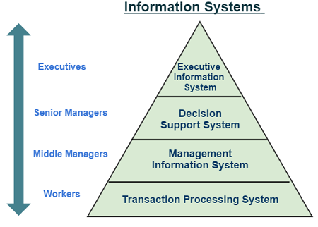
1. Explanation of how Tesco benefits from using Information Systems
Figure 1: Information Systems
(Source: kfknowledgebank.kaplan.co.uk, 2021)
Information systems or IS are designed to help manage and direct the different operations of an organisation or business. A system that mainly deals with the information part of the organisation is termed an Information System. Such systems need to have enough knowledge of what technologies of the information to be used by the organisation so that organisations can grow. Hence, the effectiveness of an Information System lies in the potential to apply the knowledge to help organisations and businesses achieve business success and growth (Kumar et al., 2018). Few examples of IS systems and the benefits of Tesco will briefly be discussed.

- Management Information Systems or MIS, Tesco has successfully implemented the MIS which provides the Managers essential tools for management, evaluation and effective running of all the departments. This enables the organisation to evaluate the previous, current and upcoming information of the organisation. MIS includes software that helps managers in making critical decisions for the organisation. Moreover, Tesco uses these systems for discovering the employee’s working durations and generating monthly reports of the expenses (Nurwidayat et al., 2019).
- Decision Support Systems or DSSs, Tesco uses DSSs System Applications
and Products (SAP) into their systems for the analysis of the success rate in the process of recruitment of new employees, statistics of the application and the causes for the dropouts of these employees. This system is beneficial as Managers can identify trends or behaviour issues that are causing their employees to leave (Agarwal,2014), which will save a lot of downtime and new staff training expenses and can be used to guide and navigate data of the organisation to help in the easy exploration of the information and for the quick taking of any critical decision making.
- Human Resource Management Systems or HRMS, a key system that determines the success or failure of an organisation. HRMS encourage Tesco to provide good transparency between staff and management, the practice of disclosure and openness guided by HRMS are found to be beneficial whereas lack of transparency and disclosure jeopardise employee and organisational trust and can lead to poor staff retention (Kalkora, Lekule, 2019).
- Executive Support Systems or ESSs, a software of the system which is under the control of the various decision-makers, it assists them in making decisions by providing an organised collection of the data with the intention of conveying the portions which require the development in the decision making and the effectiveness of the total decision-making department for better outcomes (Li et al., 2019).
- Oracle Retail Warehouse Management Systems or ORWMS. Tesco has also introduced ORWMS into their systems for the management of their supply-chain distribution processes, this system optimises and helps to manage essential inventory for distribution with real time details such as labour optimisation, prioritisation of tasks, user proximity and manage order picking algorithms (Oracle.com, 2021). As the organisation has a target to supply more than 1 million cases across 10,000 Stock Keeping Units (SKUs) every week, ORWMS plays a vital role benefitting Tesco. Supplies to these warehouses were made possible through the transport of the large capabilities from one location to the other guided by ORWMS (Gupta and Singh, 2018).
- Transactional Processing System or TPS, a part of the Information System that is used for storing, retrieving, collecting, and modifying the transactions of the organisation. Tesco highly relies on its TPS because all of its transactions including the suppliers and customers and every other party involved as the middleman are carried out using the TPS. The barcodes on the products are also scanned by these systems for the recording of the transactions done. There are many features for the TPS some of them are control processing, reliability, quick response and inflexibility. TPS is the main source of the information systems; it is particularly used with the Management Information Systems and Decision Support Systems (Wang and Kogan, 2018).

2. Management Information System used by Tesco and description of the input, processing, and output of the system
In today’s world, the use of technologies for dealing with information has become vital and complex for every organisation. The excessive use of the technologies or systems relating to the information has formed a compulsion for the innovation of new techniques that helps them in processing and managing these information’s for future usage.
Management Information Systems or MIS is used for the conduction of the process of decision making, optimisation and the processing of the data across the various departments of the organisation in a way that is uncomplicated. The MIS helps Tesco streamline the flow of information across the various departments though it requires intelligence and accuracy for the avoidance of misconception and misunderstanding (Tarigan et al., 2019).
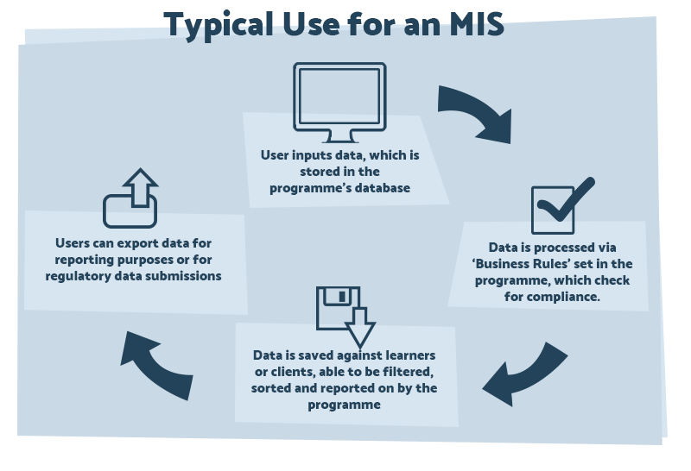
Figure 2: Typical use for an MIS
(Source: Cognisoft.co.uk, 2021)

Discussion of One Management Information System used by Tesco
The Sonetto Channel Information Management System or SCIM.
Created by the IVIS Group and amalgamated with the official website of Tesco and integrated with MIS for the management of the online system and the programmes for the marketing. Tesco has thirty channels and up to fifteen online partner networks (Ivisgroup.com, 2021). The SCIM is a constituent of the Sonetto Retail Suite which is an application program used for the management and gaining control over the flow of the information across the channels (Hertati and Syafarudin, 2018). The Channel Information Manager or CIM is responsible for taking the information in an individual way and distinctly directs the data into every channel of the organisation. The system has to record the information relating to the price, product and promotion which uses the ideas and logic of the business for the accommodation of the information of the content in a spontaneous way across all channels (Pursky et al., 2019). Sonetto assures the quality while the CIM is mainly concerned with the pricing and the product systems by delivering a real-time, accurate and flexible flow of information across all channels.
The SCIM has a huge number of processes that are being supported in limited assistance of IT. The transformation of the information of the products into the desired format for the input and the terminologies are required by every partner of Tesco. Expelling out of the products from the list in accordance with the rules of Tesco for example for the availability of the stock is a dynamic means (Aydiner et al., 2019). The SCIM also helps in the categorisation of the products as per the requirements of Tesco. The selection of the products is also taken for inclusion in the feed list of the organisation. As per the requirement of the format formation of the automated data feeds are also done. It also helps in the construction of a fellowship in an online means (Voronkova et al., 2017).
The website of Tesco is largely popular among the consumers for the goods because of the huge variety of options that are available for the customers to purchase (Tesco.com, 2021). Moreover, SCIM has been an outcome that has more than one disciplinary approach towards the management of Tesco. Also, it has been quite dynamic in nature when it comes to managing the change and the fluctuation of the management process of the organisation. It also interacts with the internal and external environment of the processes of the organisation effectively (Olszak et al., 2018).
There are various examples of the input, processing, and output of the information in the systems of Tesco, few are discussed below:
Input: The input of the data can be defined as the taking of the data into these systems some examples could be.
- Transport: The data of the transportation of the products and services of the organisation are taken for further processing and the output is used for better understanding (Ngwenya et al., 2019).
- Suppliers: The information of suppliers who sell raw materials are managed by these information systems (Tescoplc, 2021).
- Materials: The input of the materials used for the production of the items are also taken in by these information systems (Tescoplc, 2021).
- Information: The whole of the information and the tasks of the information are managed with the help of these information systems (Land, 2018).
Processing: The processing of the information is done for the refinement and the arrangement of the data.
- Designing: After the input, the process which comes into play is the designing of the products of Tesco (Tescoplc, 2021).
- Planning and Scheduling: Tesco plans and schedules with the help of these information systems for the execution of the plans (Tescoplc, 2021).
- System improvement: With the help of these information systems Tesco is able to improve their total process and the way in which the organisation system works (Taniguchi and Onosato, 2018).
- Progressing and control: Tesco has been progressing in its development process with the help of the management information systems (Coenen et al., 2018).
Output: The output is the result that is obtained after the processing of the data.
- Customer satisfaction: While the processing of the products such as designing it is kept in mind that the level of the quality is not compromised in order to have better customer satisfaction.
- Profitability: The organisation benefits from the profitability of the organisation which is the output of the organisation Tesco is able to do so because of their MIS.
- Environmental impact: The output of the products is taken seriously by Tesco so that there is a good impact on the environment (de Camargo Fiorini, and Jabbour, 2017).
- Products and services: Tesco also make sure that its products and services are of outstanding quality and are developed at a low cost using these management information systems (Tescoplc, 2021).

3. How the IT System helps Tesco in achieving competitive advantage using porter’s competitive strategy framework
Porter’s generic competitive strategies describe in which way a company pursues the competitive advantage from the chosen market scope. An organisation pursues one or a maximum of two different types of competitive advantage strategies it can be either by implementing a low-cost strategy or by differentiating itself with dimensions that are valued by the customer for commanding higher price or by market segmentation. The three strategies are examples of the Generic Strategies as these can be implemented to the services or products of all industries from the small to large ones. The strategies were first set by Michael Porter in the book called, “Competitive Advantage: Creating and Sustaining Superior Performance”. The strategies were called Cost Leadership, Differentiation and Focus by Porter and after that, the Focus strategy was divided into Cost Focus and Differentiation Focus (VAHDATI et al., 2018). All the strategies and how they are applied by Tesco in their competitive strategy is discussed below-
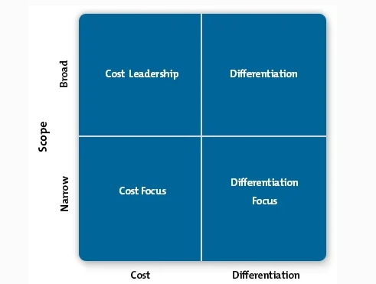
Figure 3: Porter’s Generic Competitive Strategies
(Source: Dombrowski et al., 2018)
- The Cost Leadership Strategy: Porter’s generic competitive strategies are the ways of gaining the competitive advantage in sales and take the sales away from its competitors. There are two ways to achieve this aim within this Cost Leadership Strategy. One is that Tesco can increase its profit level by reducing costs of its products along with charging the customer average prices. Secondly, by increasing the market share at low prices the company can make a reasonable profit as a result of reduced price or cost. Tesco has implemented ORWMS into their strategy just to make sure the supply of the products maintains minimum organisational cost. Two points need to be in focus at the time of applying this strategy and those are- The access to the capital needs to be invested in the technology with effective logistics so that it can bring the costs down. And a low-cost base in the case of labour, facilities and materials need to be maintained for cutting costs below other competitors (Subrahmanyam and Azad, 2019).
- The Differentiation Strategy: The Differentiation Strategy includes the making of products or services which needs to be different or unique from that of other competitors. Tesco used this technique in their production method in their making of products. The process completely depends on the functionality, features, durability, brand image and also the support which the organisation’s consumer values the most. For implementing this strategy Tesco did research on the market and applied The Sonetto Channel Information System via the IVIS Group for digital marketing of the unique products produced by them. The ability to produce premium quality products through effective sales and marketing can bring the benefits offered by differentiation strategy (Dombrowski et al., 2018). However, whenever following the differentiation strategy the organisations keep in mind that the development process and the final product needs to be fine otherwise, the competitors are always there to take advantage of the strategies implied by Tesco.
- The Focus Strategy: The companies who use the Focus Strategy have always planted their eyes in the niche markets and then by understanding the needs of the customers and the dynamics present in the market, they innovate, develop and produce well specified or low-cost products in the market for grabbing the consumers’ attention. However, this strategy is not enough on its own. It needs to take support of another strategy which is a major drawback of this strategy (VAHDATI et al., 2018). Tesco applied this strategy by implementing the MIS system which focuses on the process of decision making, optimisation and analysing the entire data.
Before choosing the perfect generic strategy for any organisation there are three steps that need to be crosschecked and those are- at first the analysis of the strengths, weaknesses, threats and opportunities of a company. Then the company needs to check whether the five internal forces are working perfectly or not and finally need to choose the strategy after analysing all the aspects perfectly so that no risk remains (Subrahmanyam and Azad, 2019). As for Tesco, The Cost Leadership Strategy would be perfect as it will help the organisation to maintain a low pricing strategy within the organisation and ultimately in reducing managing, technology and innovation-related prices.

4. Challenges faced by Tesco when implementing new Enterprise Resource Planning (ERP) and the remedies
Enterprise Resource Planning is a type of software used by organisations to maintain and manage the details of day-to-day business-oriented activities like procurement, accounting, risk management and project management, also the supply chain operation. However, the implementation of ERP can be a bit risky as it affects the business process of the organisation. The application of automated systems and technologies by replacing the manual process is an example of risk in implementing ERP (Ali et al., 2020). Tesco will face multiple challenges at the time of implementing a new ERP system.
Possible challenges:
- Project Management: A challenge that arises at the time of implementing ERP. It includes several stages of discovery, planning, data migration development of software testing and implementation (Al-Lozi and Al-Qirem, 2021). For example, when Tesco has implemented the IS technology which is related to the informational part of the organisation and bears deep knowledge about the organisation, it will be very chaotic in regard to data moving and retrieving in the new software. The risk of losing confidential and important data remains with a new ERP implementation.
- Data Integration: Can be considered as one of the key challenges of a new ERP as it provides single and accurate data of the whole organisation. However, the first step of this ERP implementation comes with migrating the data. Tesco has applied the SAP system software whose main job is to measure the success rate and the detailed rate of employee recruitment and dropout from the organisation. However, implementing it was much more challenging than expected as the information can be spread far and cause loss to the organisation by demolishing the well-planned data transfer system (AlMuhayfith and Shaiti, 2020). Integration of data can be a key challenge and also an opportunity.
- Cost Overrun: Another problem that Tesco may face at the time of implementing ERP. The frequent change of plan that takes place at the time of implementing ERP can cost a lot more money for the organisations and Tesco is not an exception in this case (ElFarmawi, 2019). The SCIM process implemented by Tesco has a huge number of processes that need to be supported by an exclusive and limited number of IT assistance, which cost them a lot of money and that has overrun the past selected budget of Tesco (Tescoplc,2021).

Remedies for overcoming the challenges,
1.The first thing to do is hire a professional ERP project team and Manager who know what measures to take and how to execute the planning necessary for implementing ERP (Hu et al,2019). Keeping a core team for every specified department can help in avoiding hazards caused by the implementation of ERP (Alhayek, 2021).
2.Tesco need to appoint a budget expert who can provide realistic figures regarding the budget for onboarding and implementing new ERP systems and software. This will enable Tesco to manage the finance more easily to avoid overrun and wastage of principle (Jakobson,2017).
3. Increase staff training as the implementation of a new system will require the up skilling of existing employees in order for the new ERP system to function and run smoothly because there remains scope for a low adaptability rate among employees with new technology (Ali et al, 2020).

5. Preparation of the steps for the implementation of a new ERP system into Tesco

Steps of ERP Implementation | Time Duration
Discovery and Planning | 30 days
Design | 22 days
Development | 60 days
Testing | 40 days
Deployment | 35 days
Support and Updates | 25 days
Table 1: ERP Implementation Timeline
(Source: Created by learner)

A typical ERP implementation planning can be separated into six steps, Discovery and Planning, Design, Development, Testing, Deployment and finally Support and Updates. Each of the steps is implemented as follows:
- Discovery and Planning: All of the ERP project and its implementation starts with the discovery and planning stage in which the phase of research and system selection takes place and for completing this stage with proper research and planning (Phaphoom et al., 2018). A company like Tesco will take almost thirty days. An ERP project team needs to be selected in this stage.
- Design: The design phase starts from a detailed design of the ERP system. Generally, this step takes almost twenty-two days of time and in this stage, all the gaps in the plan get mended with scrutinised design (Malik and Khan, 2021). A renowned company like Tesco invests a large amount in the designing phase as the future success of the company and the ERP system depends heavily on this stage.
- Development: After creating a complete and intricate design the phase of developing that design of ERP begins. This process includes configuring, customising, and developing the software to be implemented in the ERP system (Phaphoom et al., 2018). Parallelly with developing the software the ERP team needs to develop the training process as it is mandatory for coping up with the newly implemented automated system. This phase approximately takes a 60 days’ time period.
- Testing: Testing and continuous development of the project and its particular features and models take place in this stage. The initial stage of testing the functions and full capabilities of the software takes place in the period of almost forty days’ time span. The testing process is continuously taking place in the day-to-day activity of the ERP development team (Chofreh et al., 2018). Tesco will begin to train the user and additional vendor support at this stage of ERP system implementation.
- Deployment: This is the phase for which Tesco will strive torwards; the day when the ERP system goes live for testing. One needs to prepare for potential issues at this stage of ERP implementation (Malik and Khan, 2021). The project team needs to be readily active in this stage for answering continuous questions and queries of the users, Generally, this stage takes thirty-five days of time span to complete the testing and rehearsal phase of the ERP system.
- Support and Updates: Nurturing the ERP system after its implementation makes its user happy and comfortable in using it. The project team still remains responsible for the system even at this stage; however, it is the final stage of ERP implementation which continues through almost twenty-five days (Erazo et al., 2017). After this final stage, the ERP system gets completely implemented and nurtured through years.

Implementation schedule & Gant Chart:

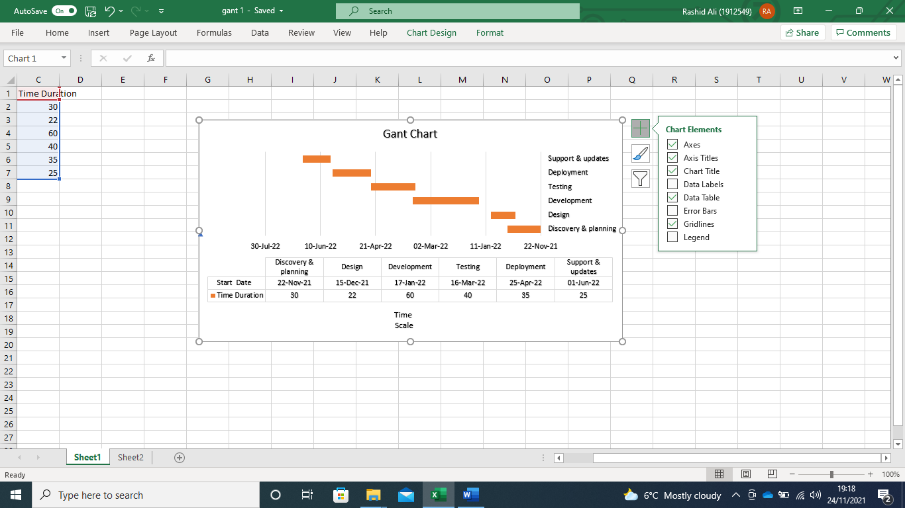

Figure 4: Gant Chart
(Source: created by learner)

Conclusion
The study concludes that the implementation of the information systems and the technologies relating to information has made great impact on Tesco. The different parts of the information systems such as the Management Information Systems and the Transaction Process Systems have played a very crucial role in the development and sustenance of the organisation. Moreover, the Sonetto Channel Information System has been a very effective tool in the building of the Management Information System of Tesco. The remedies which are provided for the challenges such as cost overrun and integration of the data which are faced when the Enterprise Resource Planning is implemented can also be used by Tesco for their development. The study also demonstrates Tesco has used the systems very effectively and that Management Information System has played a key role for Tesco operations and in maintaining advantage over competitors.

Reference list
Agarwal, P., 2014. Benefits and issues surrounding data mining and its application in the retail industry. International Journal of scientific and Research Publications 4 (7) , pp. 1-5.

Alchelaus, M.K. and Chrispina, S.L., 2019. Transparency in higher education human resource management: benefits and challenges. Journal of Education and Social Policy, 6 (4), pp, 120-129.

Alhayek, W.Y., 2021. Implementation Common Failure Reasons for an Enterprise Resource Planning and how to avoid.
Ali, I., van Groenendaal, W.J.H. and Weigand, H., 2020. Enterprise Resource Planning Systems Implementation and Firm Performance: An Empirical Study. Journal of Information Systems Engineering and Management, 5(1), p.em0109.
Al-Lozi, E.M. and Al-Qirem, R.M., 2021. Towards the adoption of Enterprise Resource Planning Systems (ERP) as an effective teaching tool in Higher Education Institutions. Academy of Strategic Management Journal, 20, pp.1-14.
AlMuhayfith, S. and Shaiti, H., 2020. The impact of enterprise resource planning on business performance: With the discussion on its relationship with open innovation. Journal of Open Innovation: Technology, Market, and Complexity, 6(3), p.87.
Aydiner, A.S., Tatoglu, E., Bayraktar, E. and Zaim, S., 2019. Information system capabilities and firm performance: Opening the black box through decision-making performance and business-process performance. International Journal of Information Management, 47, pp.168-182.
Chofreh, A.G., Goni, F.A. and Klemeš, J.J., 2018. A roadmap for Sustainable Enterprise Resource Planning systems implementation (part III). Journal of cleaner Production, 174, pp.1325-1337.

Coenen, T., Coertjens, L., Vlerick, P., Lesterhuis, M., Mortier, A.V., Donche, V., Ballon, P. and De Maeyer, S., 2018. An information system design theory for the comparative judgement of competences. European Journal of Information Systems, 27(2), pp.248-261.

Cognisoft.co.uk. 2021. 'What is an MIS?' Management Information Systems Explained - CogniSoft. [online] Available at: <https://www.cognisoft.co.uk/blog/features/what-is-mis/> [Accessed 18 October 2021].

Conference Series: Materials Science and Engineering (Vol. 640, No. 1, p. 012007).
de Camargo Fiorini, P. and Jabbour, C.J.C., 2017. Information systems and sustainable supply chain management towards a more sustainable society: Where we are and where we are going. International Journal of Information Management, 37(4), pp.241-249.
Dombrowski, U., Krenkel, P. and Wullbrandt, J., 2018. Strategic positioning of production within the generic competitive strategies. Procedia CIRP, 72, pp.1196-1201.
Dong, R., Li, S., Zhang, Y., Zhang, N., Wang, T., Tan, X. and Fu, X., 2018. Analysis of urban environmental problems based on big data from the urban municipal supervision and management information system. Ecological Indicators, 94, pp.52-69.
ElFarmawi, W., 2019. Challenges affecting the implementation of Enterprise Resource Planning (ERP) system: An analysis. Journal of Systems Integration, 10(3), pp.35-43.
Erazo, J., Arboleda, H. and Pino, F.J., 2017, September. Analysis of the software implementation process for ERP Systems. In Colombian Conference on Computing (pp. 297-312). Springer, Cham.
Gupta, B. and Singh, M., 2018. Improving Oracle Retail Merchandising System and Oracle Retail Sales Audit using Functional and Software Security Assurance Testing (Doctoral dissertation).

Hertati, L. and Syafarudin, A., 2018. How the implementation of the industrial revolution 4.0 management information system influenced innovation: The case of small and medium enterprises in Indonesia. Journal of Asian Business Strategy, 8(2), pp.52-62.
implementation of information systems. In Computer-supported Cooperative Work
IOP Publishing.

Hu, Q.L., Liu,J.Y., Hobson,D.B., Cohen, M.E., Hall, B.L., Wick, E.C. and Ko, C.Y., 2019. Best practices in data use for achieving successful implementation of enhanced recovery pathway. Journal of American College of Surgeons, 229(6),pp.626-632

Jakobson. L., 2017. Russian experts: missing actors of the budget process. Post-Communist Economies, 29(4), pp.491-504.

kfknowledgebank.kaplan.co.uk. 2021. Management information systems. [online] Available at: <https://kfknowledgebank.kaplan.co.uk/management-accounting/management-information-systems> [Accessed 18 October 2021].

Kumar, S., Mookerjee, V. and Shubham, A., 2018. Research in operations management and information systems interface. Production and Operations Management, 27(11), pp.1893-1905.

Land, F., 2018. The management of change: guidelines for the successful

Li, C., Han, S., Kumar, S. and Feng, W.X., 2019. The influence of senior executive support informatization on radical innovation performance. Industrial Management & Data Systems.
Malik, M.O. and Khan, N., 2021. Analysis of ERP implementation to develop a strategy for its success in developing countries. Production Planning & Control, 32(12), pp.1020-1035.
Ngwenya, L., Aigbavboa, C. and Thwala, W., 2019, November. Benefits of Human

Nurwidayat, A., Sudarsono, B., Pratiwi, K. and Havity, M.D., 2019. Implementation of Information System in Submitting Employees’ Annual Leave at PT. Tesco Indomaritim. Sinkron: jurnal dan penelitian teknik informatika, 3(2), pp.97-103.

Olszak, C.M., Bartuś, T. and Lorek, P., 2018. A comprehensive framework of information system design to provide organizational creativity support. Information & Management, 55(1), pp.94-108.

Optimising the online marketing Channel for Tesco.Com with IVIS Sonetto Solutions.,2021. [Online] Available at: https://www.ivisgroup.com/portfolio/tesco-direct/ [Accessed 21 November 2021]

“Oracle Retail Warehouse Management System., 2021. | Oracle” [Online] available at: https://www.oracle.com/industries/retail/products/supply-chain-planning/warehouse-management/ [Accessed 21 November 2021]
Phaphoom, N., Saelee, W., Somjaitaweeporn, T., Yuenyong, S. and Qu, J., 2018, July. A Combined Method for Analysing Critical Success Factors on ERP Implementation. In 2018 15th International Joint Conference on Computer Science and Software Engineering (JCSSE) (pp. 1-6). IEEE.
Pursky, O., Selivanova, A., Dubovyk, T. and Herasymchuk, T., 2019, November. Software implementation of trade business process management information system. In CEUR Workshop Proceedings (Vol. 2546, pp. 171-181).
Resource Information Systems in a South African Construction Organisation. In IOP
Subrahmanyam, S. and Azad, S., 2019. Carrefour’s Competitive Strategy-Cost Leadership and Differentiation: A Case Study. Pacific Business Review International, 11(8), pp.137-45.
Taniguchi, A. and Onosato, M., 2018. Effect of continuous improvement on the reporting quality of project management information system for project management success. International Journal of Information Technology and Computer Science (IJITCS), 10(1), pp.1-15.

Tarigan, Z.J.H., Siagian, H. and Bua, R.R., 2019, February. The impact of information system implementation to the integrated system for increasing the supply chain performance of manufacturing companies. In IOP Conference Series: Materials Science and Engineering (Vol. 473, No. 1, p. 012050). IOP Publishing.

Tesco.com. 2021. [online] Available at: <https://www.tesco.com/> [Accessed 18 October 2021].

Tescoplc.com. 2021. [online] Available at: <https://www.tescoplc.com/about/how-we-do-business/> [Accessed 18 October 2021].
Vahdati, H., Nejad, S.H. and Shahsiah, N., 2018. Generic Competitive Strategies toward Achieving Sustainable and Dynamic Competitive Advantage. Revista ESPACIOS, 39(13).
Voronkova, O.V., Kurochkina, A.A., Firova, I.P. and Bikezina, T.V., 2017. Implementation of an information management system for industrial enterprise resource planning. Revista Espacios, 38(49).

Wang, Y. and Kogan, A., 2018. Designing confidentiality-preserving Blockchain-based transaction processing systems. International Journal of Accounting Information Systems, 30, pp.1-18.

