Games Design & Asset Creation 2

Week 1
For the first week of this group project, I helped create and analyse the 2D assets for the game, such as items, the kraken, and the maps design. This was particularly hard as all of my group members had very different ideas of what our game’s style should be and so we had many in depth discussions on what the final style should be. Throughout these discussions we looked at many games, movies, and comics to help influence an art style we could all agree upon. Finally, we all agreed on an art style similar to the videogame ‘Legend of Zelda: The Wind Waker’ as well as ‘Shantae: ½ Genie Hero’ and the cartoonish style of ‘Age of Booty’. Exploring these various styles leading us to the final design of our main character, who we named ‘Pinky Stete’ as he holds a resemblance to the antagonist of the second ‘Toy Story’ movie; ‘Stinky Pete’. I did create my own concept for the main character, but upon reflection and in discussion with the group the design was perceived to be too detailed, and the colour scheme I chose was not like by everyone else. I had wanted to create a character that was gender ambiguous so that any player would be able to picture themselves as the main character. I did this by making the concept design of the character not too feminine and not too masculine.
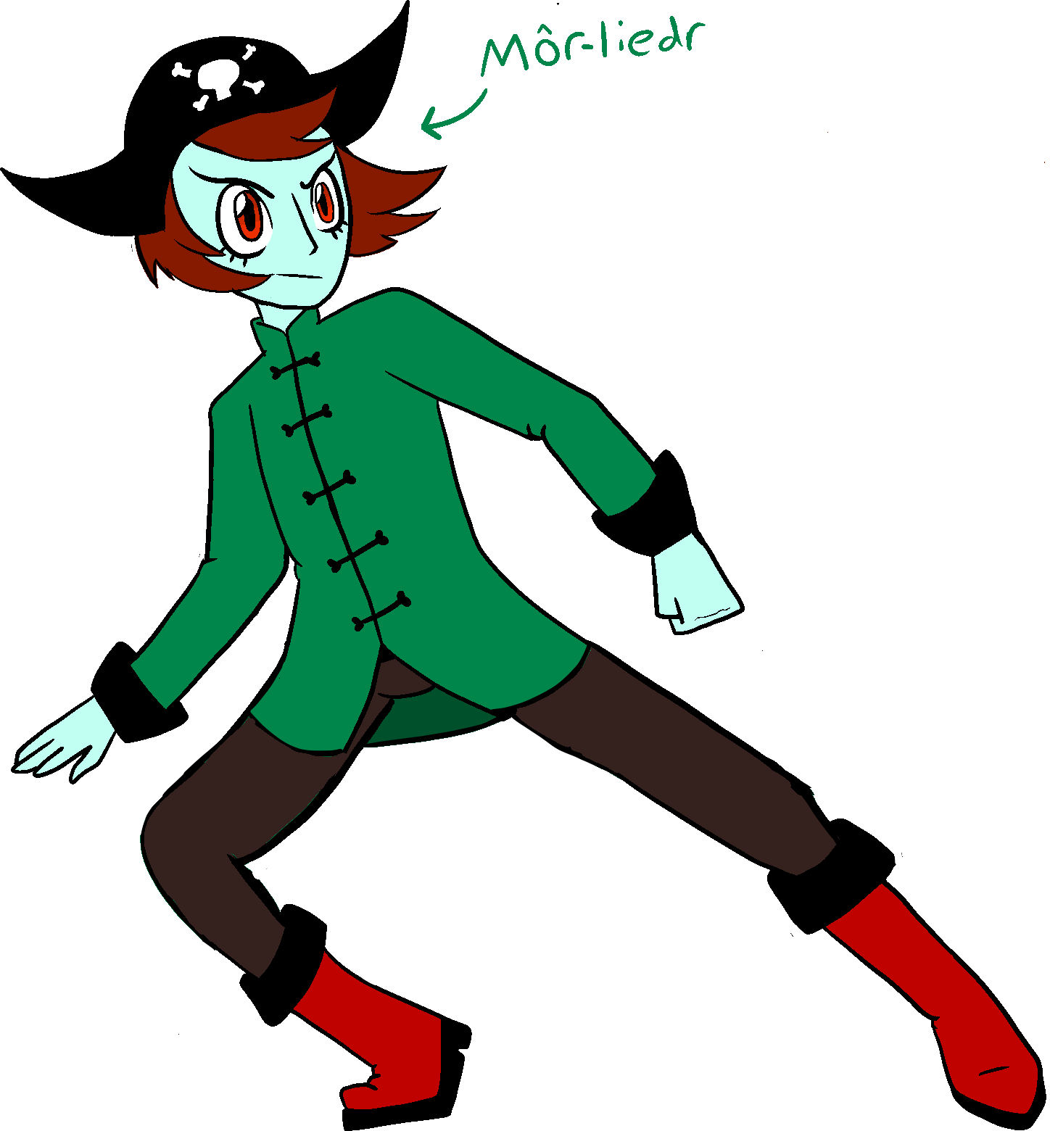

Once the main character’s design was finished, we then went on to designing the items, the kraken and finally the layout of the levels. The item’s designs were quite easy to create as we had already discussed and made decisions on them. The next step was to discuss what each item’s purpose would be to help the player through the level. In the end we came up with 3 item designs; rum (to give the player a boost of energy and in keeping with the pirate concept of the game), a shovel to slow down the kraken and finally a rope to help propel the player across large areas of space. Coming to a solid conclusion with a group while making the aesthetics and art for a game is very important. Looking through multiple books about videogame concept art I found that game developers have very long periods of discussion over what the final look of a game will be. I looked through ‘The Legend of Zelda: Master Works’ and ‘Hyrule Historia’ books in order to get a deeper insight into how the creators of my favourite game franchise come up with the designs and concepts for each of their games. From this picture here you can see three concepts for the design of Princess Zelda for the Breath of the Wild games and how she went through quite the change in styles before the design crew came to a solid conclusion on her design.
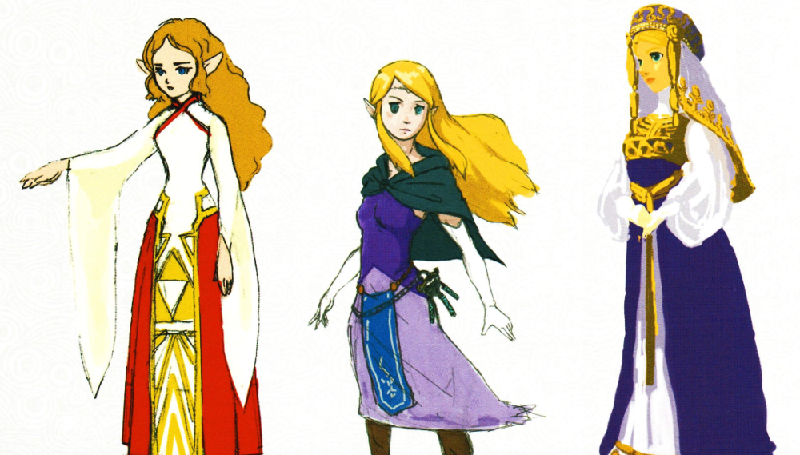
( Nintendo - 20 November 2018 - The Legend of Zelda: Breath of the Wild-Creating a Champion – Dark Horse Books – America)
Week 2
In week 2 we began as a team to look at the different aspects of our game. We decided to split into two groups, one for the technical side, i.e. the games coding, while the other group (which I was a part of) worked on the aesthetics and animations. Initially my role was to work mainly on character sprites as well as animation and colouring. However, following a discussion with one of my team we decided that I would do the colour schemes and colouring for the animations. This meant colouring every frame of animation that my teammate drew up. In the weeks following I dedicated myself to colouring in the animation frames as well as colouring in backgrounds for the game.
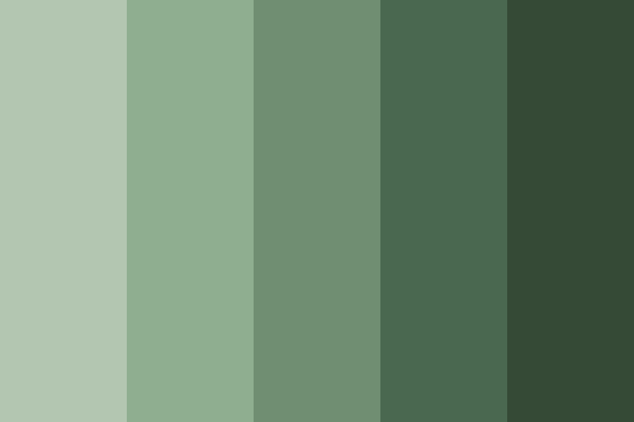
Week 3
During this week I had a few delays with my work due to medical issues. However, I did not let it stop me entirely from getting at least a little bit of work done.
During a conversation with my lecturer, he mentioned that he had noticed that my group didn’t seem to be showing as much enthusiasm for this project as he expected. Following this discussion, I made the decision to get my group together, suggesting that moving forward we have a weekly group meeting to discuss what we had done the previous week and if we needed any help from each other or our lecturer. This idea was well received by my group and from then on, we had a meeting every Monday afternoon, allowing us all to take notes for what we could improve on each of our parts of the project. During these meetings I designated myself as note taker allowing me to record what we had developed and discussed that week. I found this role was good for me, as due to my epilepsy, I sometimes miss discussions so being able to catch up weekly and record our progress was a huge help to both myself and the team.
Week 4
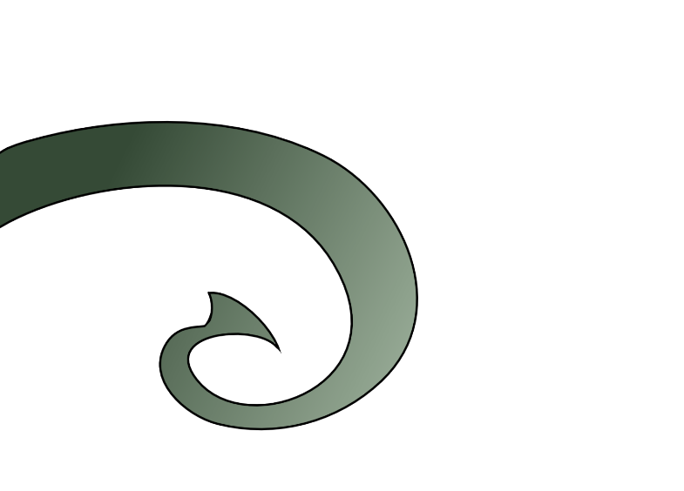
Continuing on from week 3, I kept helping my teammate colour in the animation frames, however this week we hit a problem with the technique I had used to colour them. I had coloured them with a gradient effect in order to create shading, but the animation group pointed out that they were finding that it made animating the tentacles much harder. The only option was for me to re-colour all of the frames then show them to my group to ensure the new colouring was suitable to be animated. I am very glad we decided to have group meetings on a Monday as I may have continued colouring in with the gradient effect right until our deadline and only then found out that it was unusable.
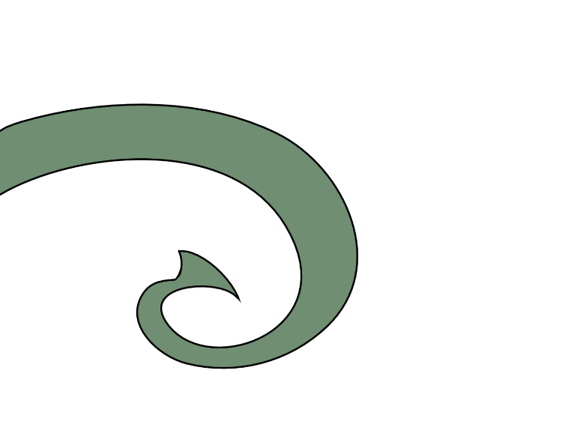

Week 5
This week I was helping with the colouring of the item animations. This consisted mostly the ropes as they were the most commonly used item in the game demo.
As we had not implemented the use of the rum or the shovel, we did not have to animate these, so instead we only animated the rope along with the main character swinging on and off it. These animations were rather tricky as they consisted of a large number of frames with lots of different colours within each character.
For the colour scheme I had originally wanted to go for something more saturated that would mimic real life, like the black and orange of an octopus, but upon reflection of the colour scheme we had chosen as a group it was clear this was far more appealing both to myself as the colourist and the animators.

Week 6
Week 6 was the week before the Easter holidays, so I put in a lot of work re-colouring the animation frames as I didn’t know if I would be able to contact the rest of my group during the holidays. Luckily I met with my teammates before the holiday as they were able to advise me that some of the colouring I had done were incorrect and they helped me correct my mistakes.
Once I had finished the colouring of each set of animation frames, I submitted them to the separate group server which my group had created in order for us to keep track of our progress. I also had my own individual channel in which I could post my work. I had posted my original ideas for the main character on this server, and this had allowed my group to tell me what worked and what didn’t. The cons very much out weighed the pros for the design I pitched.
This week we also began play testing our game, which was quite hilarious since there were a lot of bugs in the game. Finding each of the bugs and faults in the game meant that we could fix and improve the game. However, we still needed to continue to play test the game and involve others outside of our group to also play test it as we needed additional insights and evaluations (outside of our own) to continue improving the play experience.
Week 7
Now, week 7 was the first week of the Easter break and so we had no lectures which meant we didn’t have the opportunity to discuss our progress (or lack of) with our lecturers. However, we did not stop working on our game. We continued to hold the Monday afternoon meetings and even without the invaluable support of our lecturers were able to make real progress on our game. It also gave us time to play the game more. I tried to get my brother to play the game, but he didn’t play it for very long so was unable to get a lot of feedback from him and my parents have no clue or interest in playing computer games. My father did, however, give me some advice on how I should file my work and how I should organise each of the game’s animation frames.
Below is one of the ‘bugs’ that we encountered during out play testing. What occurred was if the main character jumped on a platform, that should have propelled them forward in a certain way, it would instead launch them right off the level and into the void outside of the level. When this happened to me, I had to reload the game and try again.
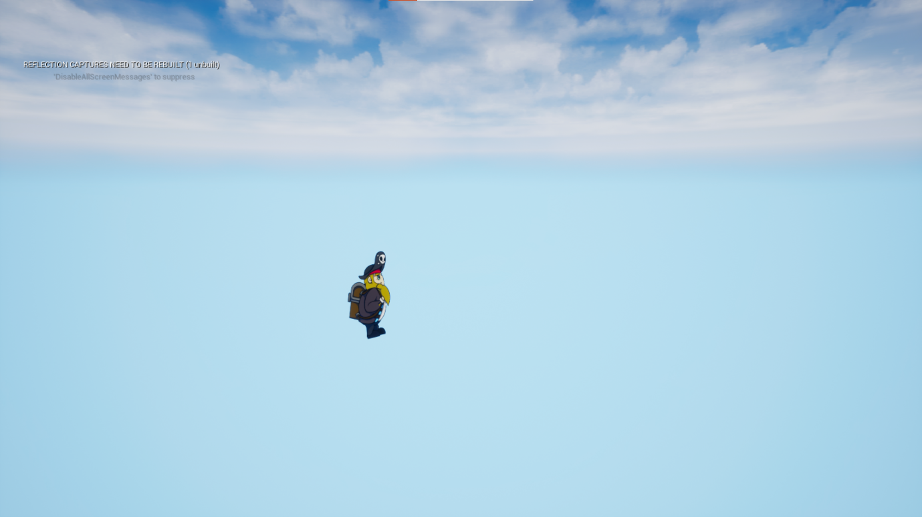

Week 8
Week 8 was the second week of our Easter break and I’m really glad my group decided to continue with our Monday meetings. I had continued to work on the animations during my spare time, and was able to get some great feed back and new frames to colour. I found colouring them wasn’t an easy task but once I got into a rhythm if found I could get the frames coloured quickly enough for my teammates to animate. Which meant that we could replace the simple ball we had been using as a place holder for our main character which hadn’t been very pleasing to look at. The same could be said for the kraken, since it too had been just a white ball until I finished colouring all the versions of the tentacles that my teammate had given me.
By now our game had developed quite a lot and the designs of the characters, items and the level had also developed despite the few bumps we’d hit and overcome during this project.
Week 9
Week 9, the final week on my Gantt Chart. This week I dedicated myself to animating birds flying in the background of the game, to give it a little bit of depth and “realism”. However, reflecting on them I do not think they would work given the current status of the game.
I am also still working on colouring in the final frames of the game’s animations, these include the rope swing animations, the rope animations and finally the ‘Game Over’ animations. These tasks took longer than I expected as they included a lot more colour and colour schemes than I used in past frames. This meant that I needed to find the older frames with the coinciding colour schemes, copy them and apply them to each of the frames. This process took a long time since some of the colour schemes had yet to be created, for example the ropes, which meant I had to come up with colours that would work well for both the level’s design and for the main character.
The skills of colour theory are very important when creating the aesthetics for a game. Every shade of colour used for every part of the game will have a different effect upon a player’s interpretation and interaction with the game. For example, horror games such as ‘Resident Evil’ or ‘Silent Hill’ have very dark, gritty, and saturated colours which is used to make the player feel tense. While more light-hearted games like ‘Super Mario Bros’ or ‘Pokémon’ have bright, cheerful and simple colours which appeal to a younger demographic but also look pleasing to people who enjoy more fun games that do not include vast amounts of gore.
To conclude, as a group my team worked rather well in coming together and producing a demo for our game despite us having a few obstacles at the beginning. These obstacles helped us become stronger as a team and helped us learn how to work with others which is an important skill that we will need in the future if we decide to go into jobs that require lots of team work.
Bibliography/references
- ( Nintendo - 20 November 2018 - The Legend of Zelda: Breath of the Wild-Creating a Champion – Dark Horse Books – America)
- (Nintendo – 13 January 2013 - The Legend of Zelda: Hyrule Historia – Dark Horse Books – America)
- (Nintendo – 2 May 2003 - The Legend of Zelda: The Wind Waker – Nintendo – Japan)
- (WayForward Technologies – 20 December 2016 - Shantae: ½ Genie Hero – WayForward Technologies – California – US)
- (Certain Affinity – 15 October 2008 – Age of Booty – Capcom – Texas – US)
- (Capcom – 22 March 1996 – Resident Evil - Capcom – Osaka – Japan)
- (Team Silent – 31 January 1999 – Silent Hill - Konami – Tokyo – Japan)
- (Shigeru Miyamoto – 15 May 1987 – Super Mario Bros – Nintendo – Japan)
- (Satoshi Tajiri – 27 February 1996 – Pokémon: Red Version - Nintendo – Japan)

