Using loops (2) – For (SOLUTIONS)

1. Write a for loop that counts from 0 to 12 (print the counter on the screen). Note: only two lines of code are required

Sample output:

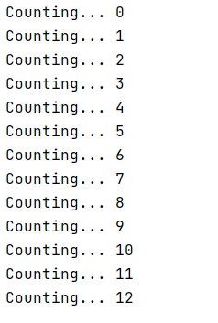

Solution:

for myCounter in range(13):
print("Counting...", myCounter)

2. Write a for loop that counts from 4 to 16 and goes up in increments of 2:

Sample output:

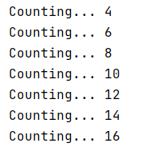

Solution:

for myCounter in range(4, 17, 2):
print("Counting...", myCounter)

3a. Write a for loop that counts from 1 to 12 and goes up in increments of 1.

Sample output:

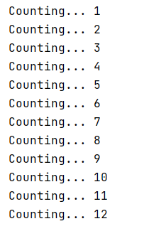

Solution:

for myCounter in range(1, 13):
print("Counting...", myCounter)

3b Adapt your for loop to do some simple calculations to reproduce the 7 times table.

Multiple myCounter by 7 each time around the loop, store the result, and then print the result.

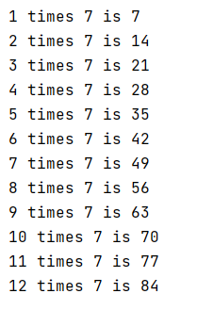

Solution:

for myCounter in range(1, 13):
total = myCounter * 7
print(myCounter, "times 7 is", total)

3c Adapt your solution to allow the user to choose the times table they want.

Sample output:

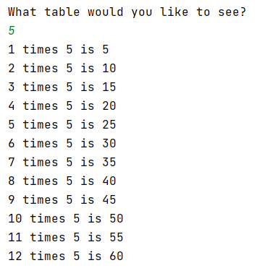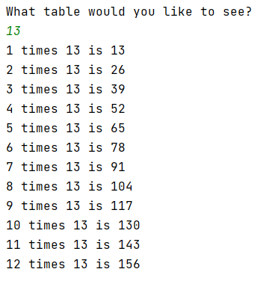

Solution:

print("What table would you like to see?")
userTable = int(input())
for myCounter in range(1, 13):
total = myCounter * userTable
print(myCounter, "times", userTable, "is", total)

4a. Print "XXXXX" on the screen. This is the width (5) of a rectangle.

Using a for loop, repeat this down the screen so that you achieve a 5 x 7 rectangle. You can do this in the two lines of code

Sample output:

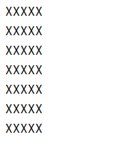

Solution:

for myCounter in range(0, 7):
print("XXXXX")

4b Extend your solution to allow the user to choose the height of their rectangle (but the width stays as XXXXX)

Sample output:

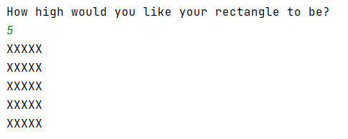

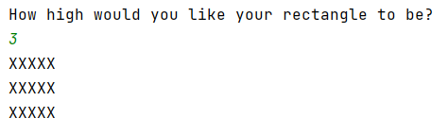

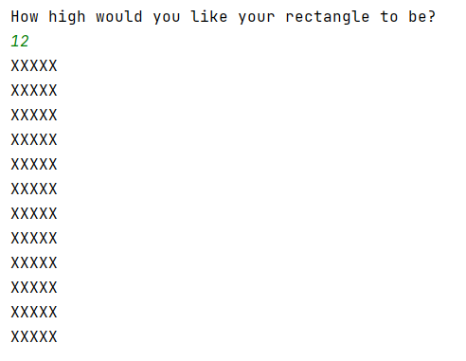

Solution:

print("How high would you like your rectangle to be?")
myHeight = int(input())
for myCounter in range(0, myHeight):
print("XXXXX")

4c (Harder) For the adventurous among you, write a program to allow the user to enter both the width and length. You will need to print just one X - print("X") and use a nested loop.

Sample output:

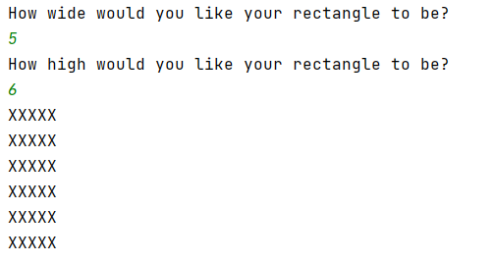

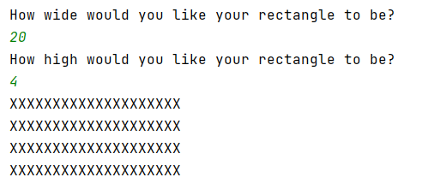

Solution:

print("How wide would you like your rectangle to be? ")
myWidth = int(input())
print("How high would you like your rectangle to be? ")
myHeight = int(input())
for myCounter in range(0, myHeight):
for myCounter2 in range(0, myWidth):
print("X",end="")
print("\n",end="")

5. Write a for loop to print out the traditional children's rhyme "One potato, two potato" (if you don't know the rhyme, see the sample output below)

Most lines are similar, apart from "4" so you will need to stop it printing "potato" on that line only.

Sample output:

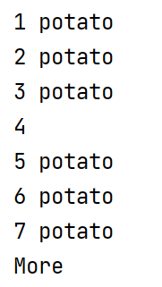

Solution:

print("Potato song")
for myNumber in range (1,8):
if myNumber != 4:
print(myNumber, "potato")
else:
print(myNumber)
print("More")

6. Write a child's program to simulate a rocket blasting off. Use a for loop for the countdown.

Note: You do not have to draw the rocket (but it is fun )

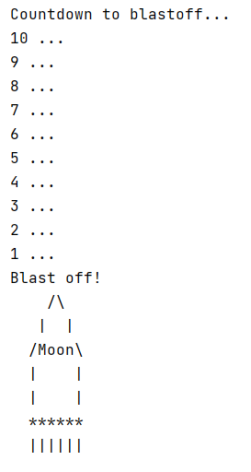

Solution:
print("Countdown to blastoff...")
for counter in range(10, 0, -1):
print (counter, "...")
print("Blast off!")
print(" /\\")
print(" | |")
print(" /Moon\\")
print(" | |")
print(" | |")
print(" ******")
print(" ||||||")

