Cloud Technologies and Docker Demonstration
SUBMITTED BY:
YASH KUMAR BHARATBHAI PATEL
ID:2517670
UNIVERSITY OF WALES TRINITY SAINT DAVID

INTRODUCTION
Cloud computing has emerged as a pillar to the current digital service provision initiatives by allowing organisations to roll out scalable, strong and affordable applications in forms of globally distributed structures. With the ever-growing user demands, cloud-native models have improved to achieve greater elasticity, performance and reliability. Among the largest changes that have taken place in this space is the introduction of containerisation technologies which provide lightweight, portable execution environments which are very different to the use of traditional hypervisor based virtual machines [1]. Containers like Docker have been key in popularising the use of containers-based deployment because of their efficiency, start-up times, and consistent behaviour under varying environment types [2] and have become central to the modern software engineering processes.
Containerisation is also strongly linked with the move to microservices architectures, where applications are broken down into deployable services. This method of architecture improves the concept of modularity, scalability and isolation of failures, which are essential especially in the cloud platforms that are massive in scale [3]. Cloud elasticity also contributes to the responsiveness of the services by automatically enabling systems to scale the distribution of resources to match variable workloads, a feature that is rapidly becoming important in digital services that have unpredictable or global user demand [4]. Also, distributed architectures help achieve a horizontal scaling and distribute load among several nodes, which enhances performance and reliability [5]. The two objectives involved in this assignment are related. To begin with, it offers a workable example of the Docker technologies, such as developing Dockerfiles, building images, running containers, managing storage and publishing images to demonstrate how the process of containerisation works. Second, it analyzes fundamental cloud computing concepts like load balancing, scalability and application gateways using the real-life example of Netflix, a multinational cloud-native organization known to have wide adoption of microservices and AWS architecture. The last part examines the larger motivation of cloud uptake, including the recent studies on distributed systems, cloud elasticity and serverless computing [6].

Section A – Demonstration of Cloud Technology Using Docker (Containerisation)
Containerisation is an essential technology of cloud computing as it allows the applications to run in a reliable and efficient way over a variety of environments. Containers offer a major benefit of minimizing compatibility problems by packaging software and their dependencies into isolated and portable units, which also enhances the speed of deployment. Containers, unlike the traditional virtual machines, share the host kernel and hence the overhead is significantly less and the startup time can be considerably quicker [2]. Docker is the oldest and most commonly used containerisation platform, which provides image building, container lifecycle and distributed deployment workflow tools [1], [3]. The abilities allow Docker to become a mandatory part of the contemporary cloud-native designs [4].

Creating a Docker file
A Docker file is the declarative command that is needed to create a container image. It automates application environment building by specifying base image, file system organization and executable behaviour. Here, an NGINX webserver is deployed with the purpose of serving a static webpage in HTML. The following Docker file has a bare minimum, and efficient and repeatable setup.

FROM nginx:alpine
COPY index.html
/usr/share/nginx/html/index.html
EXPOSE 80
CMD ["nginx", "-g", "daemon off;"]

This approach reflects containerisation best practices, such as using lightweight base images, maintaining immutability and enforcing predictable behaviour across deployments [1], [4].

Screenshot – Docker file

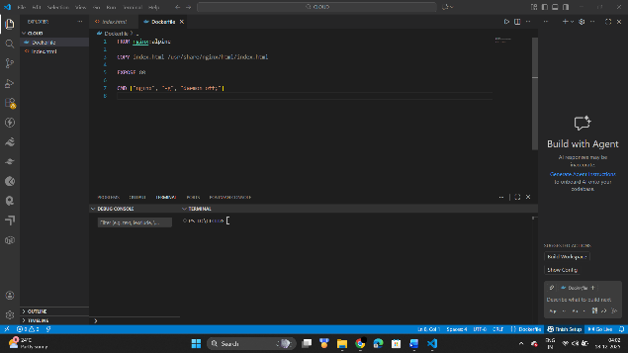
(Dockerfile)

Building the Docker Image
Once the Dockerfile is created, the next step is to build the image and check using the following command:

docker build -t yash-web .
docker images

Docker loads the instructions in a single order, forming a layered filesystem hierarchy that enables effective caching and reuse. It has been demonstrated that this stratified architecture is highly effective at enhancing the responsiveness and performance of container constructs relative to virtual machine images, which have to be snapshots of the entire operating system [2], [3]. Image overlay also saves storage overhead and enables quick deployment between distributed systems.

Screenshot
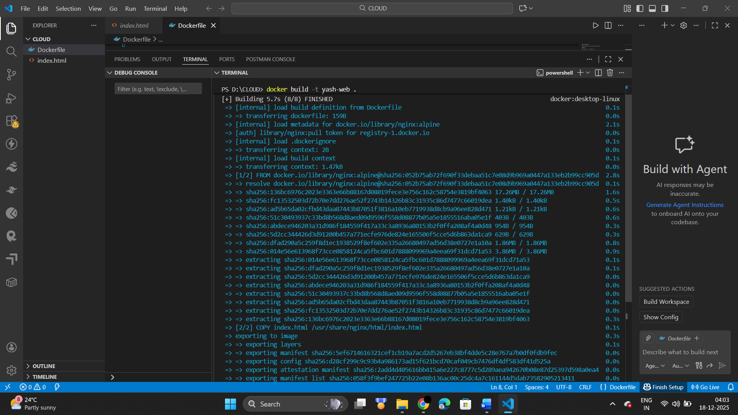
(Building image successfully)

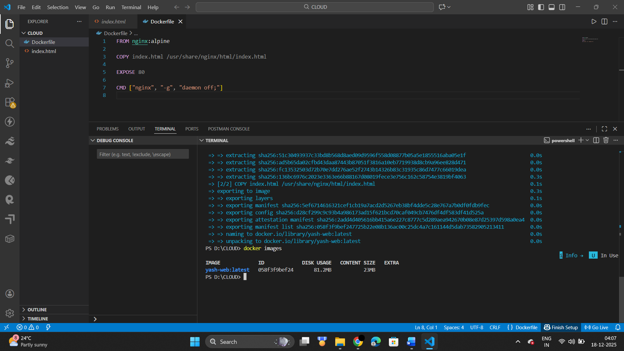
(Docker Image)

Running a Docker Container
After building the image, a container instance can be launched and we can check:

docker run -d -p 8080:80 --name yash-web-container yash-web
docker ps

This command runs the container in detached mode and maps port 80 inside the container to port 8080 on the host machine, enabling external access to the web application. Containers exhibit significantly faster runtime performance and startup latency compared to traditional VMs because they operate in isolated user-space environments without requiring full system boot processes [3], [4]. This efficiency makes containers ideal for microservices, CI/CD pipelines and distributed cloud workloads.

Screenshot
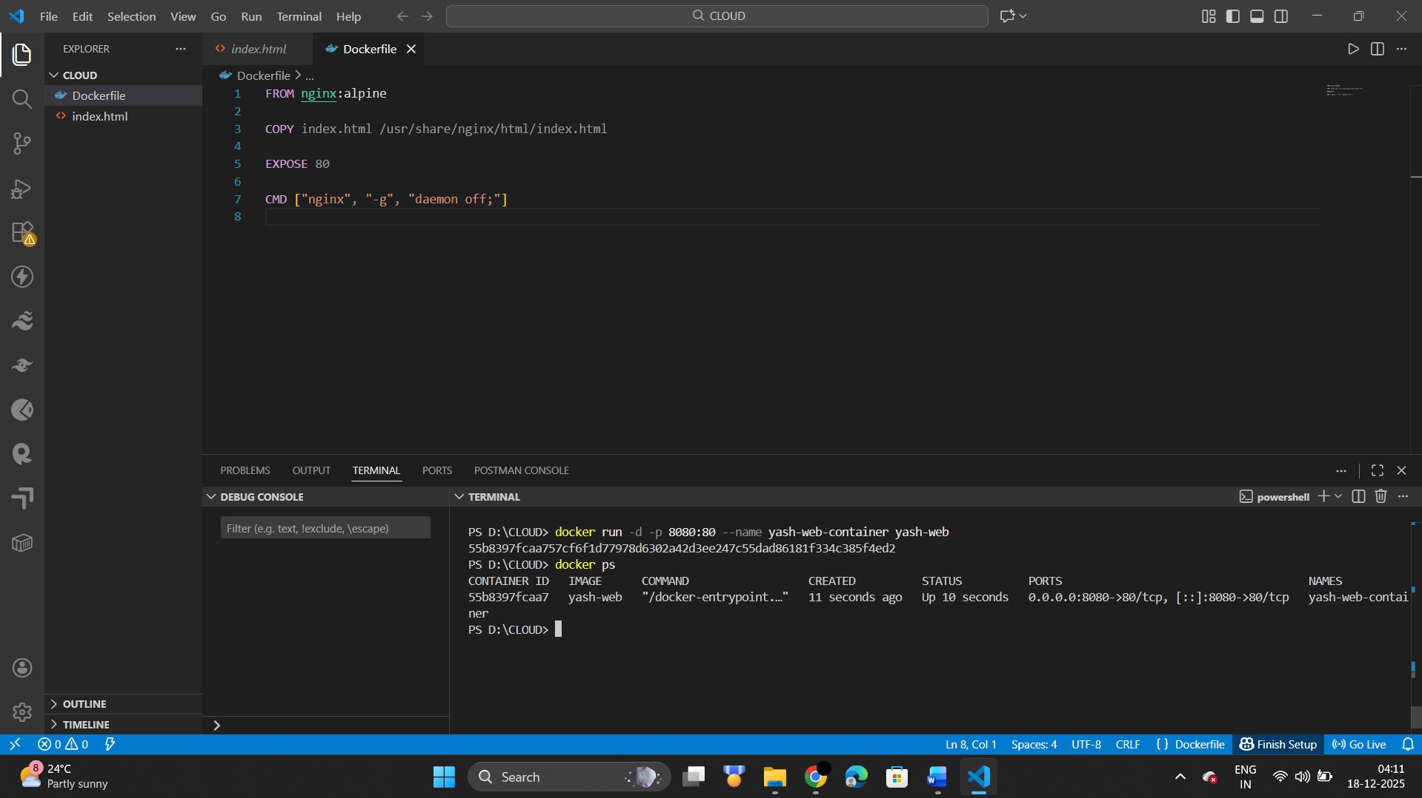
(Docker Container)

Publishing an Image to DockerHub
To enable global access and reuse, Docker images can be uploaded to DockerHub:

docker login
docker tag yash-web yashp1305/yash-web
docker push yashp1305/yash-web

Publishing images allows teams to deploy applications across multiple cloud platforms, automate CI/CD workflows and share containerised services more efficiently.

Screenshot – DockerHub Push
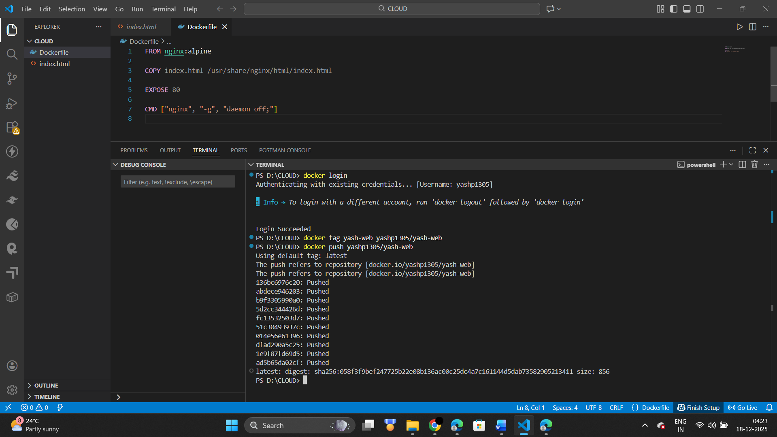
(Docker Image Push)

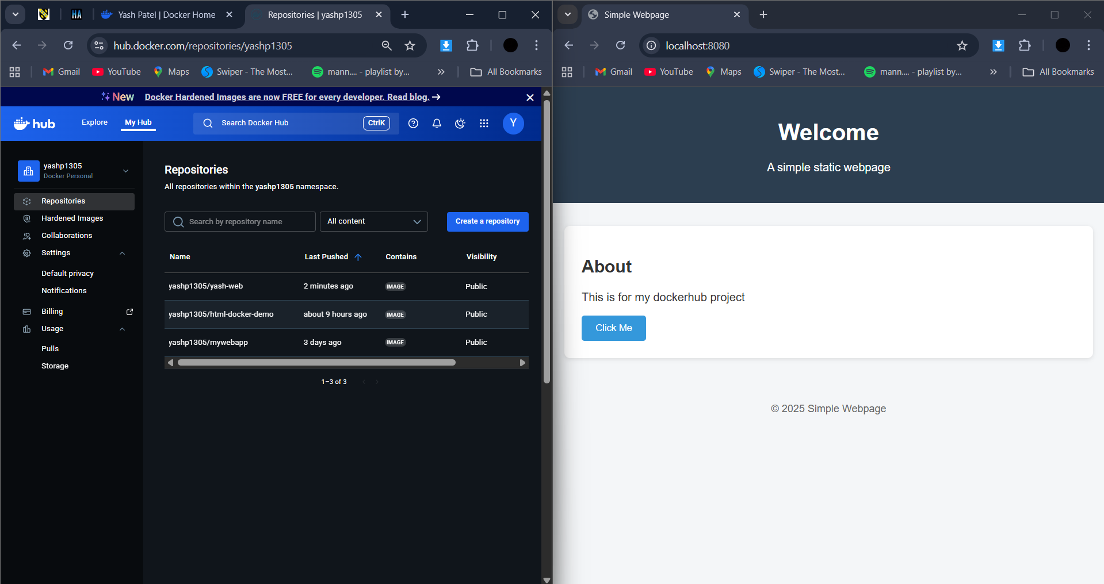
(Output Of Image)

Creating and Using a Docker Volume
Application data often needs to persist beyond the lifecycle of a container. Docker volumes provide a dedicated storage mechanism that maintains data even when containers are removed or replaced:

docker volume create yash-volume
docker run -d --name yash-volume-container -v yash-volume:/usr/share/nginx/html -p 8081:80 nginx:alpine

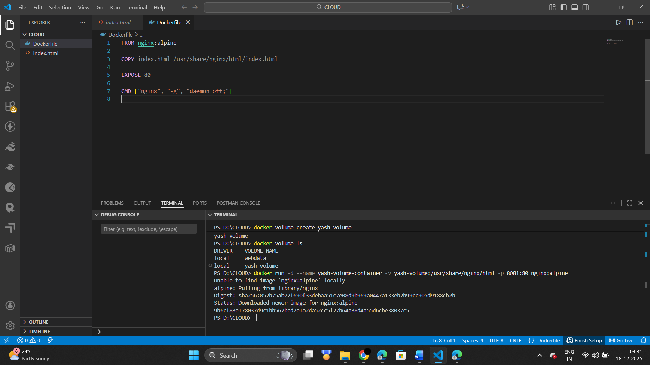
(docker volume)

Volumes are particularly important for databases, log storage and shared file systems. In distributed cloud environments, persistent storage layers ensure that stateful services remain reliable and recoverable [9].

Creating and Using a Docker Network
Docker networks enable communication between multiple containers and are fundamental to microservices-based architectures. The following commands create a custom network and attach a container to it:

docker network create yash-network
docker network ls
docker run -d --name yash-net-container-1 --network yash-network nginx:alpine
docker run -d --name yash-net-container-2 --network yash-network nginx:alpine

Networks support secure, isolated communication channels between distributed application components. Recent studies emphasise the importance of reliable container networking for microservices, load balancing and routing mechanisms in cloud-native systems [11], [12].

Screenshot – Docker Network
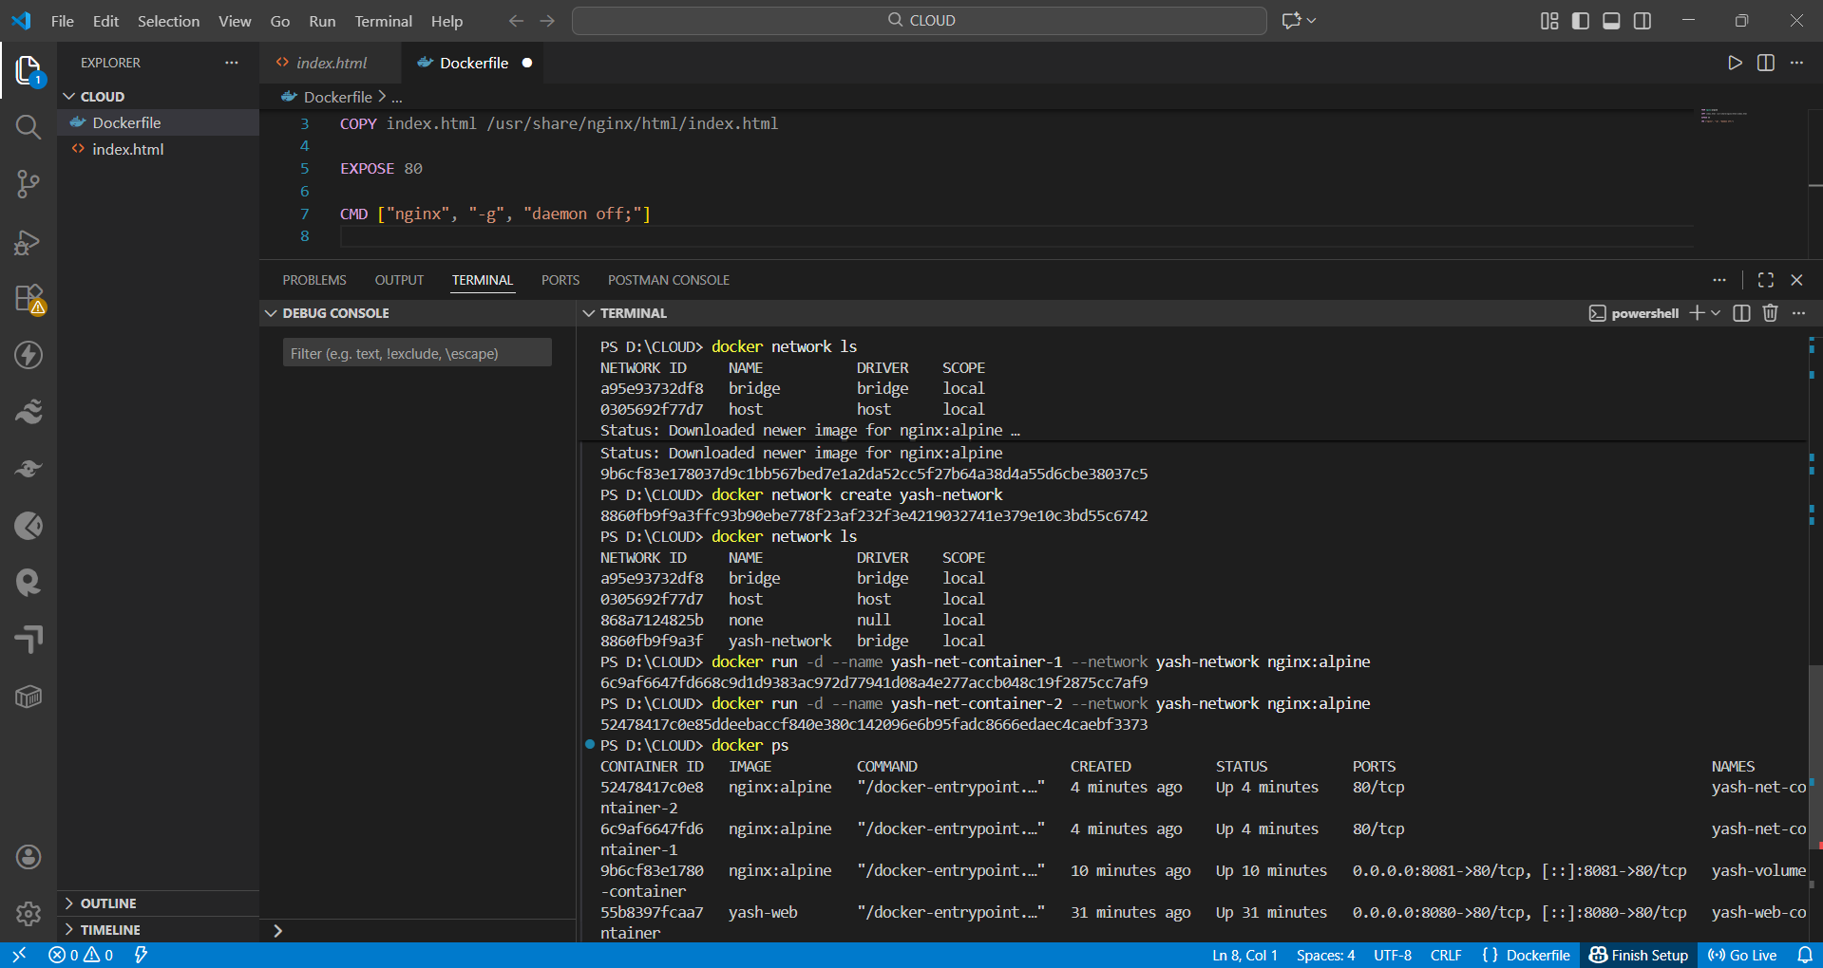
(Docker Network)

Section B – Cloud Computing Concepts Applied to Netflix
Netflix is a highly advanced cloud-based platform in the world and a commonly used example of a large-scale cloud architecture. Following the migration to Amazon Web Services (AWS), Netflix switched to the fully distributed cloud model that is aimed at accommodating huge traffic on the globe, unpredictable demand, and high uptime expectations. In a bid to accomplish this, Netflix is very dependent on three fundamental concepts of cloud computing namely load balancing, scalability and application gateways. These elements are necessary to support the ability to stay constantly available, to guarantee consistency in the performance, and allow millions of users to stream content at the same time globally. Each concept is discussed below and shown to detail how Netflix has combined the concepts to create operational excellence.

Load Balancing at Netflix
One of the most basic technologies that are the basis of cloud-native architecture is load balancing. Its main work is to spread the incoming traffic even within several compute nodes to ensure that no one server is a performance bottleneck or point of failure. This is necessary especially in a micro services based scenario like that of Netflix where one customer request can trigger dozens or even hundreds of individual microservices. Since every microservice executes a particular task, e.g., authentication, recommendations, content metadata, any disproportion in the distribution of traffic will cause the chain effect of delays, service slowdown, or a company collapse. According to the studies on cloud-native, the health, responsiveness, and the overall stability of microservices ecosystems directly depend on the efficient load balancing [11]. On top of dealing with highly dynamic and unpredictable traffic patterns as in the case of video streaming, Netflix must contend with this. The behaviour of viewers varies greatly by region, day, time zone, and events which are synchronized across the globe. The release of popular series, variance in weekends, and releases of seasons all cause unexpected traffic jams. In the absence of clever load-balancing systems that can handle such volatility, Netflix would have difficulties in keeping the latency and throughput low. Thus elasticity and traffic-awareness are well integrated into the routing strategies that are used within the distributed infrastructure of Netflix.
To attain such sophistication, Netflix extensively makes use of Amazon Web Services (AWS). Another of its major services is the AWS Elastic Load Balancer (ELB). ELB does not only monitor the health of backend instances, but also automatically redirects traffic to unhealthy or overloaded nodes. This makes sure that service is delivered continuously and does not require a manual touch. ELB also allows the system update, network outages, or other infrastructure failure to provide seamless failover. By redirection of traffic automatically the platform is highly available even when the components fail, and this helps Netflix to ensure that there is no interruption in streaming.
Moreover, Netflix implements the availability zone-based routing that serves to increase the resilience and redistribute the workloads among the data centres that are geographically separate. Every AWS region has a number of availability zones and spreading traffic between the zones assists in the isolation of failures in particular zones. This plan also enhances fault tolerance and prevents the case of regional outage that has minimum effect to the provision of services all over the world. Simultaneously, the allocation of workloads through the various zones is better in delivering the content, which means that the users find the content delivery faster without any buffering or service lag. To control the distribution of traffic at the global level, Netflix integrates the Amazon Route 53 as a DNS-based load balancing and traffic management service. The route 53 considers several attributes including the latency, geographical position and health of the system to direct users to the nearest or most responsive regional endpoint. The international traffic needs to be directed by this global traffic that will greatly decrease the latency of the international customers enhancing their overall streaming experience. Moreover, Netflix also uses latency-based routing to provide viewers with the best location of an edge to get content.
Load balancers are also at the centre stage in the DDoS mitigation strategy at Netflix. They can absorb and scatter bad or over-loaded traffic by doing so, they can prevent an individual service being overloaded. This is in line with the results in the literature, which underscore the importance of adaptive load-balancing strategies in ensuring a performance does not degrade in the course of a cyberattack or times of high demand [8], [12]. Altogether, the advanced load balancing implemented at Netflix is resilient, scaled and with high-quality user experience, even with the heavy and unpredictable global traffic.

Scalability
Scalability means that a system can automatically change the allocation of resources in accordance with demand. Scalability is not only desirable; it is a necessity to a global streaming platform like Netflix that is subjected to dramatic changes in traffic. Elasticity of the cloud, which has received extensive research in the literature, is viewed as one of the key catalysts of cloud adoption as it affects costs, performance, and reliability [5], [6].Scalability at Netflix is delivered with the help of some AWS services and the technologies developed by Netflix. AWS Auto Scaling Groups enable the addition and removal of compute instances based on the traffic patterns. As demand rises, other instances are automatically provided, making service delivery not to be interrupted. Demand will be reduced, and resources will be scaled, so Netflix will not spend money on paying expenses that are not required. This is consistent with the industry studies that have indicated that elasticity is one of the most important methods of preventing over-provisioning and trimming down operational cost [7].
Besides reactive scaling, Netflix implements predictive scaling models that are driven by machine learning. These models examine past viewing patterns, regional habits and seasonal trends which are expected to predict demand even before it arises. The predictive autoscaling has a major benefit since Netflix can anticipate high traffic operations without necessarily depending on reactive mechanisms, which are likely to respond too slowly. The other key element of the Netflix architecture is horizontal scaling. Since the organisation is based on the microservices ecosystem, almost all components of the platform can be scaled independently. This granular control helps in the increase of efficiency and fault isolation, as well as flexibility. Unlike monolithic systems, where scaling can sometimes demand the need to replicate entire applications, in microservices only the most heavily used services e.g. recommendation engines or video encoding services must be replicated.
Netflix is not alone in its ability to scale its compute resources; it can be expanded to storage infrastructure, content delivery infrastructure, and internal service orchestration. As an example, Netflix video encoding pipeline has to be regularly expanded to handle very large amounts of media content with different resolutions and formats. With the issuance of new titles, the work load of the encoder can skyrocket. To fix this, Netflix uses horizontally scalable containerised workloads that operate on AWS Elastic Container Service (ECS), and Kubernetes based applications. This makes the distribution of the encoding tasks efficient and quick leading to less time being taken to prepare the contents to be distributed globally.
The data management is another aspect of scalability. The data platform of Netflix processes trillions of events every day, such as playback interactions, recommendations, search queries and device telemetry. In order to scale this data ingestion and processing pipeline, Netflix deploys distributed data stores and stream-processing frameworks that can scale workloads to be processed by a large number of nodes in parallel. This is because it is responsive in real-time even with petabytes of information. Scalable data pipelines are also mentioned as very significant in literature related to distributed cloud systems, where the authors point out the reliance of data-driven applications on scalable architectures in order to ensure throughput and accuracy at heavy loads [6]. Besides, the recommendation engine system of Netflix, which is one of the most computationally intensive parts of the company, needs dynamic scaling in order to provide personal suggestions of content to millions of users at the same time. The machine learning models should be constantly trained and updated on large datasets. Scalable cloud infrastructure enables Netflix to allocate these workloads without impacting user experience and platform performance by ensuring that updates take place.
Scalability is also an important factor in disaster recovery and resilience. Netflix uses the multi-region design, which implies that its services operate simultaneously in multiple geographically distributed AWS regions. In case of an inconvenience in one area, it is possible to divert the traffic to another part making the continuity of the service. This multi-region scaling strategy complies with the best practices (resilient system design) with focus on redundancy and geographic distribution as a response to risks of regional outage [7]. Lastly, the scalability improves the innovativeness of Netflix. Experimental features can be deployed by developers in a short period, new algorithms can be tested, or A/B testing campaigns can be rolled out without fear of system overload. The capacity of the cloud to add more resources immediately enables Netflix engineers to repeat fast and optimize features according to user behaviour. This innovation-based application of scalability replicates more general industry results identifying elastic cloud environments to be linked with shorter development cycles and enhanced user satisfaction [5].

Application Gateways
Application gateways constitute an important part of Netflix cloud infrastructure since they allow smart routing, transformation of protocols and controlled access. To regulate interfaces between the client devices and microservices within the company, Netflix relies on AWS API Gateway and Application load balancers (ALB). There are several functions provided by a gateway and some of them are Layer 7 request routing, URL based filtering, terminating the use of the SSL service and authentication.
API Gateway is used as a point where all client requests are received, and only authorized and valid traffic is sent to the system. This plays an important role in shielding microservices against direct exposure as well as delivering a secure perimeter. The rate limiting, caching, and traffic shaping are also provided in modern gateway technologies which is a factor that leads to the enhanced performance and stability. The model indicates more general tendencies of cloud-native architecture where it is identified that traffic management based on gateways is necessary to provide stable composition of services and secure communications [14]. The application of gateways in Netflix thus promotes operational functionality as well as security conformity throughout its distribution service ecosystem.

Combined Benefits
By putting together load balancing, scalability and application gateways, they create a great architectural base that enables Netflix to undertake its operations worldwide. Load balancing will make sure that it is distributed in an efficient way to minimize the latency and service over load. Scalability enables Netflix to quickly change resources based on changing user demand to enhance performance and lower the cost. Application gateways additionally allow secure and controlled access to resources and safeguard internal systems but allow microservices to discover their services and communicate seamlessly between each other. The combination of these technologies helps Netflix to offer a smooth streaming event to millions of users across the globe. These additions of cloud-native capabilities indicate a wider body of research on the role of cloud adoption, indicating that scalability, reliability, security, and flexibility play a key role in global digital transformation [18], [19], [20], [21]. The architecture of Netflix illustrates the way in which these principles can be scaled to support high-need applications that are latency-sensitive.

Section C – Driving Forces Behind Cloud Expansion
The adoption of cloud computing is ever evolving at a high rate in all industries because of its capability to provide scalable, economical, and distributed digital services across the globe. Cloud platforms are becoming essential to organisations to improve operational resilience, get more, faster innovation, and get faster user expectations. This continuous growth is supported by several key drivers, such as the cost efficiency, elasticity, global availability, and the development of the model of computing, including serverless architectures and containerisation. These inspiration drivers are supported and justified by the vast amount of research in the field of cloud computing, distributed systems and enterprise adoption research [18], [19]. The next subsections discuss these forces in detail, as well as compare two dominant models of deployment serverless computing and containerisation.

Cost Efficiency
Capital reduction and the transition to operational expenditure patterns is one of the greatest motivators to the use of the cloud. Instead of spending money on premise based infrastructure, organisations have the option of using pay-as-you-go pricing models that only pay a certain amount based on the resources used. This model minimizes the financial strains that have been linked to the concept of scaling of IT operations and enables both small and large firms to access the advanced computing services [18]. Moreover, the cloud providers take care of the hardware, networking, storage, and maintenance functionality, which enables businesses to concentrate on the area of innovation and service delivery instead of infrastructure management. The literature on cloud adoption in both government and commercial sectors indicates that financial factors and, specifically, cost savings and enhanced budget prediction are always among the key reasons to migrate to the cloud [19], [20]. Also, cloud platforms include multi-level storage, automatic backups, and redundancy options which help to reduce cost of operation and ensure continuity of services. There is also increased cost efficiency due to resource pooling and high utilisation rate by cloud providers. Hyperscale cloud platforms are able to provide economies of scale, which individual organisations cannot achieve because they have to combine workloads of millions of users. Such efficiencies are being manifested in lower competitive prices and quick creation of new managed services which avoids the high cost of in-house expertise.
Cloud services also have the effect of enhancing financial agility as organisations can increase or decrease their capital expenditure on a real time basis. This flexibility makes sure that cost is kept at par with the requirement of the operation so that there will be no such expenses of long term commitment of finance on hardware or data centres which might end up being underutilised. With billing, as cloud workloads vary, the billing scales automatically, which offers more visibility and predictability to the budgeting processes. This is in accord with the research findings that highlight the significance of flexible expenditures models in contemporary IT settings, whose demand might change swiftly due to the fluctuating market conditions [18].
There are also indirection costs of staffing, physical protection, energy use and hardware lifecycle that are minimized through cloud adoption. By transferring such functions to cloud suppliers, organisations are able to redirect internal resources to the strategic activities of the organisation as opposed to the maintenance activities. Research has indicated that such reallocation improves the performance within organisations by allowing innovation-oriented teams to provide new features and services at faster rates [19]. Further, the presence of fully managed services, including database hosting, analytics engines, machine learning platforms, and monitoring tools, also do away with the necessity of specialised internal knowledge, reducing the short-term training needs, as well as long-term personnel expenses.
A second benefit which is related to cost is the issue of disaster recovery and business continuity. Conventional disaster recovery systems are costly to set up and support and demand redundant resources, physical resources and manpower. Disaster recovery solutions on clouds duplication services in various data centres distributed at a fraction of the price. Such systems automatically manage backups, fail overs and redundancy, which enhances resilience to a great extent and minimizes operational costs. According to studies in cloud adoption of the public sector, cost-effective resilience is a major factor that can make or break cloud services transition especially when budgets are tight [20].
All these cost-related advantages have led to the escalating trend of cloud adoption making cloud computing a financially viable and operationally adaptable solution to organisations which want to remain technologically competitive in the long run.

Elasticity and Flexibility
Elasticity has been often referred to as one of the distinguishing features of cloud computing since, with the help of it, a system can automatically scale up or down resources in response to the changing workloads [5], [6]. This is the key to responsiveness of the services and sustainability of performance at unexpected or peak load. Elastic scaling enables applications to increase capacity and decrease it immediately when necessary and avoid resource scarcity or excess over-provisioning.
The studies on distributed systems and cloud elasticity emphasize that resource allocation on a dynamic basis can greatly enhance the system efficiency and minimise the latency in large scale applications [7]. Elasticity is also being more closely associated with the emergence of micro services architecture, whereby individual service units can scale either autonomously based on workload particularities. This scaled-down scaling model provides scalability and lowers the expenses of operations. The autonomic computing principles and machine learning models contribute to modern elasticity mechanisms and allow systems to make intelligent predictions about demand trends and control the resources to prevent the degradation of performance before it even happens [6]. As an illustration, cloud data centres constantly examine telemetry data in order to predict changes in CPU, memory, or network load, so that it can scale proactively. These features are particularly important to applications whose global traffic can vary, are real-time intensive, or whose workload is time sensitive.

Global Accessibility
The other important reason that has motivated the adoption of cloud is the capability to implement and utilize digital services in different parts of the world. Cloud providers have large geographically distributed data centres and thus the organisations have the ability to bring the applications closer to the end-users, thus eliminating latency and enhancing responsiveness. The global infrastructure is used to provide mission-critical services to IoT systems, industrial automation, and intelligent traffic management in various regions [13], [15], [17].
Cloud-based systems are also more reliable with availability zone and region redundancy. With failure of one data centre, there is a possibility to reroute the traffic to another data centre. Such inertia is crucial to organisations that need high availability and disaster recovery. Studies of the use of cloud in the public infrastructure systems show that global access and reliability would play a significant role in the transportation, energy, and smart cities sectors [16], [17]. Moreover, cloud solutions provide single identity management, access control, and compliance systems which makes global operations easier. With these capabilities, organisations can ensure that they have consistency in enforcing security and governance in various jurisdictions, a move that will promote large-scale cloud transformation.

Serverless Computing vs Containerisation
The impressive rise of cloud computing has been accompanied by development of two powerful operation paradigms which are serverless computing and containerisation. The two solutions are scalable to cloud-native applications, but are very different in terms of architecture, performance behavior, and control of operation.

Serverless Computing
Serverless computing is one of the major changes in the design, deployment, and implementation of applications in the contemporary cloud computing systems. It eliminates the work of developers to administer or setup servers, and enables them to implement single units of functionality, on-demand, and to go idle when no longer needed. An example of this model is the popular function-as-a-service (FaaS) systems (e.g. AWS Lambda, Google Cloud Functions, or Azure Functions), which offer a degree of abstraction to such an extent that developers are allowed to only deal with application logic but not infrastructure configuration. Since the cloud provider controls all the features of resource assignment, execution, and scaling, serverless computing significantly eases the aspects of operations as well as enables the application to easily be scaled in line with the varying workloads.
Automatic and nearly real-time scale is also one of the distinguishing features of serverless computing. An occasion transpires, the cloud platform will create new execution resources on demand so that applications can react effectively to both peak bursts and idle time. Billing is done at a fine-grained level usually according to per-execution or per-milliseconds usage metrics, and makes serverless computing especially cost-efficient in applications with intermittent or unpredictable traffic patterns. This granular billing model is an inverse of the traditional hosting methods where a fixed capacity is paid irrespective of how much is utilised or not.
However, in spite of its benefits, serverless computing also has certain technical issues with the most notable cold-start latency. Cold starts are those that take place after a function has been dormant and it has to be reintroduced before it can run. This delay can be very minimal, but in systems where latency is required because of real-time analytics, financial requirements, or even interactive user interfaces, it can have an adverse effect on performance. Recent studies have reported cold-start mitigation as an important aspect of optimisation since the delay that is not predictable may reduce the responsiveness of serverless applications [23]. Different tactics, such as function prewarming, lightweight runtime systems, and predictive scheduling, are under consideration to overcome this drawback.
The concept of serverless computing fits best event-driven architectures, simple APIs, background processing jobs, automation processes, and short workloads. Its advantages are that it has a low overhead of operation, can scale up quickly, and would be very cost effective when applied to the right tasks. Serverless computing is a growing role in the contemporary distributed application design as cloud-native systems continue to develop.

Containerisation
Containerisation offers a better and predictable execution environment by bundling applications with dependencies. Other technologies like Docker enable apps to run in a predictable manner on various systems and still be isolated and portable. Containers have more runtime environment control compared to serverless computing and can be used in long-run services, microservices systems, and rich distributed applications [1], [4]. Containers can also be used with orchestration frameworks such as Kubernetes that include scaling, scheduling, and automated failure recovery in distributed systems. Containerisation is a better option to organisations that demand deterministic performance and multi-service coordination because it is predictable and flexible.

Comparison and Combined Use
However, serverless and containerisation are used to achieve two different purposes, but hybrid approaches using both benefits are common in organisations. Serverless functions can be used to handle short-lived tasks whereas containers can be used to handle persistent services. Studies note that the integration of these models can enhance better utilisation of resources, minimisation of costs of operations and come up with very flexible system architectures [22].

Conclusion
The assignment has given me a practical and theoretical understanding of cloud computing and how current technologies can facilitate scalable, resilient, and distributed digital services across the world. The practical part, which was based on the concrete implementation in Docker, emphasized the necessity of containerisation in the modern application deployment. The Docker exercises demonstrated that containers facilitate lightweight, portable, and efficient application environments through configuring networking, constructing and running container images, and persistent storage. These features are indicative of the trends in the industry in general to minimise resource overhead, enhance deployment reliability, and provide scalability to a wide variety of infrastructure platforms quickly.
The analytical review of Netflix also supported these ideas by presenting a practical example of a large-scale implementation of cloud-native architecture. The implementation of AWS services by Netflix shows how load balancing, elasticity, and application gateways are used in concert to guarantee the high availability and stable performance of millions of users each and every day across the globe. The load balancing spreads the requests to different regions and services and ensures that the latency is kept at low levels and the overload is avoided. Elasticity helps Netflix to scale compute resources dynamically based on the varying traffic flows, so the platform can become responsive even in times of peak traffic. Application gateways offer secure and intelligent routing between hundreds of microservices to secure internal systems and coordinate complex service interactions. These mechanisms combined make distributed architectures, intelligent traffic management, and automated scaling important in maintaining reliable and fault-tolerant cloud services.
The drivers of cloud adoption discussion and the comparison of serverless computing and containerisation highlighted the current development of cloud-native technologies. Organisations are still implementing cloud platforms due to its cost efficiency as well as global coverage, flexibility in operations and the constant technological development. Serverless computing provides a model where the event-based approach is used and automatically scales and has low operational overhead, compared to containerisation which makes long-running services more predictable, controlled, and portable. The two models can be used in developing hybrid architectures that can support various contemporary applications.
Together the results of this assignment show that cloud computing, containerisation and distributed services architecture are the main structure of a modern digital ecosystem. These technologies allow organisations to implement applications in a fast manner, control resources in an intelligent manner and provide a smooth user experience in global networks. With the ever-growing demand of high-performance digital services, cloud-native architectures will still be the focus of innovation, operational performance, and the future development of large-scale computing systems.

Reference List
- Bentaleb, O., Belloum, A.S., Sebaa, A. and El-Maouhab, A., 2022. Containerization technologies: Taxonomies, applications and challenges. The Journal of Supercomputing, 78(1), pp.1144-1181. https://scholar.google.com/scholar?output=instlink&q=info:Rt8K_2Pu-H0J:scholar.google.com/&hl=en&as_sdt=0,5&scillfp=7389887721581653473&oi=lle
- Silva, D., Rafael, J. and Fonte, A., 2024. Toward optimal virtualization: An updated comparative analysis of Docker and LXD container technologies. Computers, 13(4), p.94. https://scholar.google.com/scholar?output=instlink&q=info:uyGnn6933VwJ:scholar.google.com/&hl=en&as_sdt=0,5&scillfp=6663396660884554008&oi=lle
- Potdar, A.M., Narayan, D.G., Kengond, S. and Mulla, M.M., 2020. Performance evaluation of docker container and virtual machine. Procedia Computer Science, 171, pp.1419-1428. https://scholar.google.com/scholar?output=instlink&q=info:PEa9WR2my68J:scholar.google.com/&hl=en&as_sdt=0,5&scillfp=6136894081666211859&oi=lle
- Hardikar, S., Ahirwar, P. and Rajan, S., 2021, August. Containerization: Cloud computing based inspiration technology for adoption through docker and kubernetes. In 2021 Second International Conference on Electronics and Sustainable Communication Systems (ICESC) (pp. 1996-2003). IEEE. https://scholar.google.com/scholar?output=instlink&q=info:2MbuKho_d8sJ:scholar.google.com/&hl=en&as_sdt=0,5&scillfp=1748676736834525126&oi=lle
- Agrawal, D., El Abbadi, A., Das, S. and Elmore, A.J., 2011, April. Database scalability, elasticity, and autonomy in the cloud. In International conference on database systems for advanced applications (pp. 2-15). Berlin, Heidelberg: Springer Berlin Heidelberg. https://scholar.google.com/scholar?output=instlink&q=info:RNHVXZKoRKsJ:scholar.google.com/&hl=en&as_sdt=0,5&scillfp=18213216840694735630&oi=lle
- Ghandour, O., El Kafhali, S. and Hanini, M., 2023. Computing resources scalability performance analysis in cloud computing data center. Journal of Grid Computing, 21(4), p.61. https://scholar.google.com/scholar?output=instlink&q=info:vwg3M084XhAJ:scholar.google.com/&hl=en&as_sdt=0,5&as_ylo=2021&scillfp=16220952449004361190&oi=lle
- Thakkar, R. and Bhavsar, M., 2022, August. Achieving multilevel elasticity for distributed stream processing systems in the cloud environment: A review and conceptual framework. In Proceedings of the 2022 Fourteenth International Conference on Contemporary Computing (pp. 81-90). https://scholar.google.com/scholar?output=instlink&q=info:KfCW6iEpa7cJ:scholar.google.com/&hl=en&as_sdt=0,5&as_ylo=2021&scillfp=17968497878063853348&oi=lle
- Somasundaram, A. and Meenakshi, V.S., 2021. DDOS mitigation in cloud computing environment by dynamic resource scaling with elastic load balancing. Turkish Journal of Computer and Mathematics Education, 12(11), pp.3346-3362. https://scholar.google.com/scholar?output=instlink&q=info:T6WN5-_vIVQJ:scholar.google.com/&hl=en&as_sdt=0,5&as_ylo=2021&scillfp=6261639382508001103&oi=lle
- Perri, D., Simonetti, M., Tasso, S., Ragni, F. and Gervasi, O., 2021, September. Implementing a scalable and elastic computing environment based on cloud containers. In International conference on computational science and its applications (pp. 676-689). Cham: Springer International Publishing. https://scholar.google.com/scholar?output=instlink&q=info:bukozUJCM7IJ:scholar.google.com/&hl=en&as_sdt=0,5&as_ylo=2021&scillfp=4393728374379771620&oi=lle
- Ngo, K.L., Mukherjee, J., Jiang, Z.M. and Litoiu, M., 2022, April. Evaluating the scalability and elasticity of function as a service platform. In Proceedings of the 2022 ACM/SPEC on international conference on performance engineering (pp. 117-124). https://scholar.google.com/scholar?output=instlink&q=info:1yRaCM_fhz4J:scholar.google.com/&hl=en&as_sdt=0,5&as_ylo=2021&scillfp=1480570446214361145&oi=lle
- Wang, H., Wang, Y., Liang, G., Gao, Y., Gao, W. and Zhang, W., 2021. Research on load balancing technology for microservice architecture. In MATEC web of conferences (Vol. 336, p. 08002). EDP Sciences. https://scholar.google.com/scholar?output=instlink&q=info:fLa0drIrND8J:scholar.google.com/&hl=en&as_sdt=0,5&as_ylo=2021&scillfp=5461637173770029296&oi=lle
- Bhattacharya, R. and Wood, T., 2022, September. Bloc: Balancing load with overload control in the microservices architecture. In 2022 IEEE International Conference on Autonomic Computing and Self-Organizing Systems (ACSOS) (pp. 91-100). IEEE. https://scholar.google.com/scholar?output=instlink&q=info:7kRmq85e9K8J:scholar.google.com/&hl=en&as_sdt=0,5&as_ylo=2021&scillfp=3732923717862677800&oi=lle
- Dhingra, S., Madda, R.B., Patan, R., Jiao, P., Barri, K. and Alavi, A.H., 2021. Internet of things-based fog and cloud computing technology for smart traffic monitoring. Internet of Things, 14, p.100175. https://scholar.google.com/scholar?output=instlink&q=info:bTHVdKhrpv8J:scholar.google.com/&hl=en&as_sdt=0,5&as_ylo=2021&scillfp=7754535125310653959&oi=lle
- Bellavista, P., Fogli, M., Giannelli, C. and Stefanelli, C., 2023. Application-aware network traffic management in mec-integrated industrial environments. Future Internet, 15(2), p.42. https://scholar.google.com/scholar?output=instlink&q=info:oFKPxN36GEAJ:scholar.google.com/&hl=en&as_sdt=0,5&as_ylo=2021&scillfp=7651720697226135399&oi=lle
- Sood, S.K., 2021. Smart vehicular traffic management: An edge cloud centric IoT based framework. Internet of Things, 14, p.100140. https://scholar.google.com/scholar?output=instlink&q=info:DX5EqPPrDUUJ:scholar.google.com/&hl=en&as_sdt=0,5&as_ylo=2021&scillfp=12702156906363021167&oi=lle
- William, P., Rajani, D., Gupta, M., Taluja, R., Alawadi, A.H.R. and Yadav, D.K., 2023, July. Edge computing based traffic control management for distributed environment. In 2023 World Conference on Communication & Computing (WCONF) (pp. 1-6). IEEE. https://scholar.google.com/scholar?output=instlink&q=info:THmLY-VeQ7gJ:scholar.google.com/&hl=en&as_sdt=0,5&as_ylo=2021&scillfp=798310360936046213&oi=lle
- Pereira, P., Melo, C., Araujo, J., Dantas, J., Santos, V. and Maciel, P., 2022. Availability model for edge-fog-cloud continuum: an evaluation of an end-to-end infrastructure of intelligent traffic management service. The Journal of Supercomputing, 78(3), pp.4421-4448. https://scholar.google.com/scholar?output=instlink&q=info:mthM-mGTaX8J:scholar.google.com/&hl=en&as_sdt=0,5&as_ylo=2021&scillfp=17127138533362930405&oi=lle
- Zhang, S., Pandey, A., Luo, X., Powell, M., Banerji, R., Fan, L., Parchure, A. and Luzcando, E., 2022. Practical adoption of cloud computing in power systems—Drivers, challenges, guidance, and real-world use cases. IEEE Transactions on Smart Grid, 13(3), pp.2390-2411. https://scholar.google.com/scholar?output=instlink&q=info:jQgiyE4tWvUJ:scholar.google.com/&hl=en&as_sdt=0,5&as_ylo=2021&scillfp=6171605806502900034&oi=lle
- Ali, O., Shrestha, A., Osmanaj, V. and Muhammed, S., 2021. Cloud computing technology adoption: an evaluation of key factors in local governments. Information Technology & People, 34(2), pp.666-703. https://scholar.google.com/scholar?output=instlink&q=info:NKPIgFiW9WUJ:scholar.google.com/&hl=en&as_sdt=0,5&as_ylo=2021&scillfp=14467836144519174046&oi=lle
- Sharma, M., Gupta, R., Acharya, P. and Jain, K., 2023. Systems approach to cloud computing adoption in an emerging economy. International Journal of Emerging Markets, 18(9), pp.3283-3308. https://scholar.google.com/scholar?output=instlink&q=info:-VbYZ5OXthQJ:scholar.google.com/&hl=en&as_sdt=0,5&as_ylo=2021&scillfp=3034382425118411025&oi=lle
- Ali, K. and Johl, S.K., 2023. Driving forces for industry 4.0 readiness, sustainable manufacturing practices and circular economy capabilities: does firm size matter?. Journal of Manufacturing Technology Management, 34(5), pp.838-871. https://scholar.google.com/scholar?output=instlink&q=info:sE7D5l9E-9cJ:scholar.google.com/&hl=en&as_sdt=0,5&as_ylo=2021&scillfp=15211768949128438708&oi=lle
- Wu, S., Tao, Z., Fan, H., Huang, Z., Zhang, X., Jin, H., Yu, C. and Cao, C., 2022. Container lifecycle‐aware scheduling for serverless computing. Software: Practice and Experience, 52(2), pp.337-352. https://scholar.google.com/scholar?output=instlink&q=info:vrV58t3rx1wJ:scholar.google.com/&hl=en&as_sdt=0,5&as_ylo=2021&scillfp=11551136546146560776&oi=lle
- Ghorbian, M. and Ghobaei-Arani, M., 2024. A survey on the cold start latency approaches in serverless computing: an optimization-based perspective. Computing, 106(11), pp.3755-3809. https://scholar.google.com/scholar?output=instlink&q=info:i7lfquZ_9-sJ:scholar.google.com/&hl=en&as_sdt=0,5&as_ylo=2021&scillfp=4034020598657949539&oi=lle
- Short Video demonstrating Docker image, Docker volume and Docker network
https://youtu.be/bVKMEqZdmUE


