HOSPITALITY AND TOURISM MANAGEMENT
RESEARCH TOPIC: “ROLE OF SUSTAINABILITY IN ACHIEVING THE NET ZERO TARGET WITHIN THE HOSPITALITY INDUSTRY OF THE UK: THE CASE STUDY OF THOMAS COOK”

Module: BMIH6001

Student Name: Antonia Lupas
Student ID: 2210502

Lecturer name: Antoinette Milne

I confirm that I have not used any AI tools in the research and creation of this
assignment. I confirm that I have not presented any AI generated materials as my own
work. I confirm I have copies of my drafts, notes, and other resources I used, which I
may be asked to provide in evidence.

Abstract
This research investigated the critical role of sustainability as a framework for the hospitality industry to achieve Net Zero greenhouse gas emissions, utilising the case study of Thomas Cook. Through a PEST analysis and evaluation of strengths and limitations and the complex interplay of macro environmental factors was examined. Findings reveal that while increasing regulatory pressures, consumer demand for eco-friendly options and technological advancements offer opportunities. The case of Thomas Cook highlighted the adoption of the circular economy to realise the ambitious Net Zero target and secure a more environmentally responsible future for the hospitality industry.
Table of Contents
Assignment 1: “Conference Research Paper” 4
Introduction 4
Background of Topic 4
Relevance of the Topic in the Hospitality Industry 4
Research Aim and Objectives 4
Literature Review 5
Sustainable and New Zero Targets in the UK Hospitality Industry 5
Role of sustainability in achieving the Net Zero target of the Hospitality Industry 6
Challenges of Thomas Cook in Achieving Net Zero with Sustainable Initiative 7
Solution to Overcome These Challenges 7
Method 7
Data Collection Procedure 7
Analytical Technique 8
Theme Impact Analysis 8
PEST Analysis 8
Strengths and Limitations 9
Conclusion 10
Recommendations 10
References 12

Assignment 1: “Conference Research Paper”

Introduction

Background of Topic
The UK hospitality industry is increasingly focusing on sustainability due to environmental concerns, rising energy costs, regulatory pressures, and growing consumer demand for eco-friendly options. The sector, which includes hotels, restaurants, pubs and catering services, recognises its significant environmental footprint, contributing to greenhouse gas emissions and waste generation. The primary driver for Net Zero in UK hospitality is the overarching UK government target of achieving Net Zero emissions by 2050 to promote sustainability within the industry (Raturi, 2025). In this context, this research explores the crucial role of sustainability as a pathway for the hospitality industry to achieve Net Zero, using Thomas Cook as a pertinent case study.

Relevance of the Topic in the Hospitality Industry
The hospitality industry, encompassing a wide array of businesses from hotels and restaurants to travel and tourism operators, plays a significant role in the overall carbon footprint and is thus under increasing scrutiny to contribute to this ambitious target. The hospitality industry, contributing significantly to the UK's carbon footprint, estimated at up to 15% of total UK greenhouse gas emissions, is under increasing pressure to align with this national goal (Raturi, 2025). The topic is highly relevant as it directly addresses the urgent need for the hospitality industry to decarbonise in line with global and national Net Zero targets, with the case study of Thomas Cook.

Research Aim and Objectives
The foremost aim of the research paper is “To critically explore the role of sustainability in achieving the Net Zero target within the Hospitality industry, considering the case study of Thomas Cook.”
Objectives
- To understand the relationship between sustainability and achieving the “Net Zero Target” in the hospitality industry
- To critically address the challenges faced by Thomas Cook while implementing sustainable practices to achieve Net Zero Targets
- To critically address the strategies that can be adopted by Thomas Cook to successfully implement sustainable practices

Literature Review

Sustainable and New Zero Targets in the UK Hospitality Industry
Sustainability is the main basis and operational guidelines of the hospitality sector to achieve ambitious “Net Zero goals.” This is not only a simple problem, but also a major concept and behaviour set that needs to be woven on each side of the industry to greatly reduce greenhouse gas emissions and ultimately be rewarded. Considering the stability, hotel companies can systematically cope with carbon results through integrated strategies, including the increase in energy efficiency, the use of renewable energy sources, the introduction of responsible practices, and the emphasis on sustainable sources within the framework of the prototype, water maintenance and confused supply chain (Canale and De Siano, 2025). In the field of modern tourism, the integration of stable practices has become decisive to convert to socially and environmentally conscious travellers. Dealing with the stability of the tourism sector is essential to protect natural diversity, promote biodiversity, expand the rights and abilities of the community, and reduce the environmental impact of tourism. Due to the use of various stable strategies, such as the adoption of green tourism practices and minimising carbon traces of tourism services, the company reduces unfavourable environmental results and improves positive contributions to society and the environment, helping to achieve “Net Zero” goals.
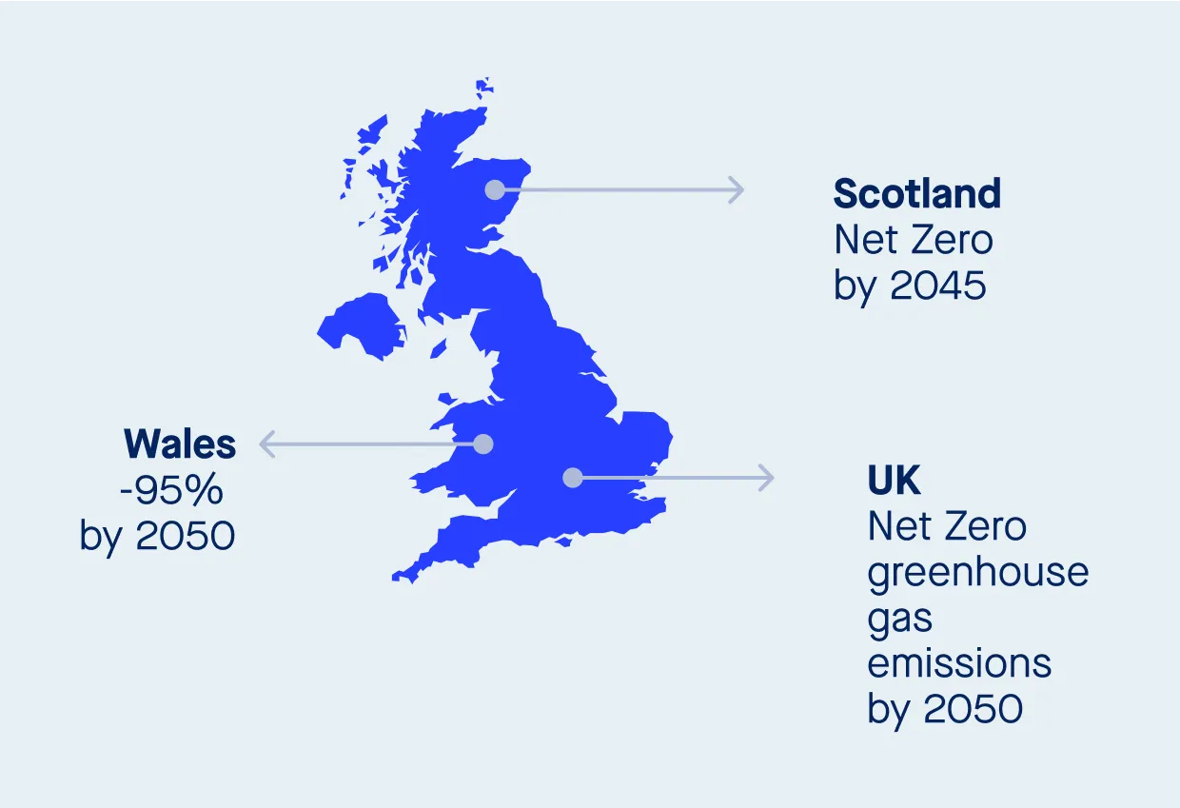
Figure 1: UK Net Zero Emission Target
(Source: Howard-Jones and Hennessy, 2025)
In addition, stability contributes to the integrated perspective beyond direct emissions in operation, including indirect discharge related to purchased products and services, capital goods and transportation, and indirect discharge that requires cooperation with suppliers and stakeholders. Ultimately, the “Net Zero” in the hospitality sector is closely related to the prudent and sustainable implementation of sustainable practices, not only promotes the environmental management culture between the staff and the guests, as well as contributing to the innovation of technology and processes that reduce environmental impacts, and ensures long -term economic stability and stability in the world of climate repayment (Howard-Jones and Hennessy, 2025). The primary driver for Net Zero in UK hospitality is the overarching UK government target of achieving Net Zero emissions by 2050. The sector understands that it must contribute significantly to this goal. A framework with pledges to support the sector in reaching Net Zero by 2040, including eliminating unnecessary single-use packaging by 2025 and reducing food waste by 50% by 2030 (Trabelsi and Boujelbene, 2025). Therefore, in the context of Net Zero, sustainability acts as the framework for implementing strategies to reduce greenhouse gas emissions across all aspects of hospitality operations.

Role of sustainability in achieving the Net Zero target of the Hospitality Industry
The hospitality sector plays an important role in carbon emissions with the use of energy, waste production, water consumption and extensive supply chains. As a result, the perception of how sustainable development initiatives can instruct the industry with a Net Zero is necessary for long-term management of the environment as well as ethical responsibility (Devaraj and Balasubramanian, 2025). Travellers and consumers are increasing and increasing the demand for sustainable hospitality. Studies show that many travellers are actively looking for environmentally friendly houses and are ready to pay more for these options. Companies that take the lead to introduce sustainable practices and make efforts for Net Zero can mention the customer's environmental sector to increase the loyalty of the brand and increase their reputation. Thomas Cook's historical and current efforts on sustainable development, and the progress of declaring goals and discharge decreases, can provide valuable information to other hospitality companies on a Net Zero (Huatuco et. al., 2025). Research on achievements and obstacles faced by these important players can help to form an effective strategy and prevent possible problems.

Challenges of Thomas Cook in Achieving Net Zero with Sustainable Initiative
Addressing the challenges that Thomas Cook encounters in implementing sustainable practices for Net Zero highlights a multifaceted array of issues, including the considerable financial challenges linked to extensive infrastructure improvements and the shift to renewable energy across their wide-ranging network of hotels, resorts and travel services (Thomascook, 2025). From airlines to local service providers, the complex characteristics of the global supply chain, including multiple partners, create an important obstacle to maintaining uniform stability and accurate discharge (Bera et. al., 2025). In addition, effective attraction and education of large and diverse customers on the importance of sustainable travel options requires careful communication and stimulus strategies to help them participate in environmentally friendly initiatives. Inertia related to large-scale existing organisations can interfere with the rapid and changing changes necessary to achieve an ambitious Net Zero goal, which requires powerful leadership and fundamental change in the operating culture and priorities.

Solution to Overcome These Challenges
In order to solve the difficulties related to the adoption of the circular economy, such as minimising energy consumption due to the dependence on renewable energy sources, it is necessary to raise the customer perception of the Thomas Cook community and improve cooperation (Howard-Jones and Hennessy, 2025). This is to perform detailed waste and energy evaluation to guide the concentrated behaviour, and to convert to efficient energy sources through investment, on-site and procurement of energy efficient technology, while promoting and preceding the beneficial partnership with local suppliers to create clear communication and engagement. It helps to promote circular practices and cut emissions, and implements extensive, role-specific training for all employees to integrate sustainable actions into their daily tasks and cultivate a culture of environmental stewardship across the organisation.

Method

Data Collection Procedure
The collection of secondary data for this study will include a systematic examination of publicly accessible information from official publications of Thomas Cook, such as annual reports and sustainability reports, press releases and websites of both the former and current entities, like Thomas Cook. In addition to the main and regulatory documents on environmental policies, this research has dealt with related industrial reports and documents on the stability of hospitality and along with academic research obtained using the online database (Costa and Costa, 2022). Target keywords like Net Zero Emission, Sustainability and Environmental Effectiveness are used to extract relevant information on historical and current initiatives for sustainable development, reduction of emissions and problems faced. In addition, in order to thoroughly understand the progress of the set, this research has been used to critically evaluate the trustworthiness and relevance of these sources.

Analytical Technique
The PEST analysis technique can be employed as a method for collecting secondary data by systematically examining the “Political, Economic, Social, and Technological factors” influencing the role of sustainability in achieving Net Zero within the hospitality industry, specifically concerning Thomas Cook (Clegg et. al., 2021). This involves researching government regulations and incentives related to environmental sustainability and Net Zero targets. A PEST analysis on the role of sustainability in achieving the Net Zero target within the hospitality industry, particularly through the lens of Thomas Cook, reveals a complex interplay of macro-environmental factors.

Theme Impact Analysis

PEST Analysis
Political Impact- The hospitality sector is trying to reduce emissions by increasing national rules and international agreements such as the Paris Convention, which provides fines for potential incentives and not observation of sustainable practices. In 2050, the UK's legally mandatory clean goal is to establish a strong national structure.
Economic Impact- The initial investment costs for sustainable technologies and infrastructure can be a barrier to Thomas Cook. However, the long-term advantage of reducing energy consumption, reducing waste management and environmental concerns offers significant economic opportunities (Gangadhari et. al., 2025). Carbon price mechanisms can also encourage efforts to achieve the net-zero target of Thomas Cook. Analysing the economic viability and cost implications of implementing sustainable practices and the impact of carbon pricing on the hospitality sector.
Social Impact- The UK government is investigating changing consumer preferences and societal pressures towards eco-friendly travel and the demand for sustainable tourism options. Consumers are raising their perception of relatively stable travel options, which is more and more influential on the choice of procurement that proves environmental responsibility and provides more environmentally friendly alternatives by applying pressure on hospitality companies such as Thomas Cook. Ignoring this customer preference and awareness can damage the reputation and loss of market share.
Technological Impact- It has been evaluated that exploring the availability and adoption of innovative green technologies and digital solutions can facilitate emission reduction and resource efficiency within Thomas Cook's operations and the broader hospitality landscape. Technology in the field of digital platforms for renewable energy sources, energy efficiency solutions, waste management technologies and tracking and carbon emissions can create an important resource for the hospitality industry to reduce the environmental impact and move to a net-zero (Estales and Coley, 2025). It also creates an innovative and competitive advantage for Thomas Cook and can carry out and supply and supply chains.

Strengths and Limitations
Analysis of the strengths and weaknesses of Thomas Cook based on the analysis of pests to achieve net-zero goals with stability is a mixed picture. The fight may include the ability to raise funds for the first sustainability initiative due to its size, which can be instructed as a sustainable option by using the message and the efficient exchange of the product when the current financial conditions, large -scale operating ability and various sectors can be used in various sectors and potentially widely used customer base (Muir, 2025). Nevertheless, noticeable restrictions come from the political environment, and it may require expensive compliance with the changes in the rules, the economic problem of eco-friendly investment balance with the competitive price of the market, and the social complexity that truly changes the chain. In addition, the financial instability, which characterised the company by 2019, can lead to a reduction in short-term costs for long-term sustainable investment, which requires significant cultural changes to successfully work for ambitious net-zero goals. With the participation of multiple external partners, the meaning of the supply chain creates an important restriction on maintaining continuous stability and thoroughly reducing emissions in all areas (Mosey and Vornicu, 2025). By analysing Thomas Cook's current sustainability initiatives, particularly in carbon monitoring and reduction, and comparing them against the broader Net Zero goals for the hospitality and tourism sector, this case study can assess the company's potential trajectory towards achieving Net Zero emissions.

Conclusion
In conclusion, the case of Thomas Cook, the net-zero route of the hospitality sector is filled with important functions and noticeable problems. Despite the growing regulatory requirements, despite the transition of strong motivation and emissions to reduce powerful motivation and emissions, the industry faces significant economic obstacles. Therefore, it is suggested that to effectively introduce thorough sustainability practices in all areas of the hospitality sector, to achieve an ambitious and sustainable future for travel and tourism, with circular economic preferences.

Recommendations
Promoting the use of energy-efficient technologies
To encourage the use of energy applications in Thomas Cook, smart lighting systems that adapt to the occupancy of the rooms and the energy management system, such as LED bulbs, sensors, and smart thermostats, can be implemented (Khatter, 2023). The use of renewable energy sources, such as solar panels, is encouraged by these technologies, which also allow guests to manage electricity and optimise energy use according to their current demands.
Offering training to the staff of Thomas Cook
Providing sufficient training to hotel employees is essential for the adoption of sustainable practices at Thomas Cook. Improved guest interaction tactics, waste reduction methods, and appropriate energy management may all be included in the training (Legrand et. al., 2022). Additionally, raising awareness among employees and visitors is crucial to advancing sustainable practices at Thomas Cook.
Implement regulations and policies to support sustainable practices
The UK government has designed several policies and a regulatory framework to reduce emissions and support sustainable development of the tourism industry. Specifically, hotels are generating huge emissions from their operations, including home stays, restaurants, bars, along cafes. Therefore, Thomas Cook can reduce its emissions by activities such as incorporating environmental laws along with practices and incorporating the “Environmental Protection Act 1990” to control pollution generated from the operation of the hospitality industry in the UK (Achmad and Yulianah, 2022). Climate change actions and policies also prevent hotels from generating plastic waste, GHG and CO2 emissions and can encourage Thomas Cook leaders to take the necessary steps required to reduce global carbon footprints.
Hotel Carbon Measurement Initiatives
The Hotel Carbon Measurement Initiative, or "HCMI," focuses on the hotel's water, power, and waste management practices while also helping to calculate the total amount of emissions generated by hotel operations. Transportation-related CO2 emissions are also measured. Therefore, the Thomas Cook application of HCMI can help identify areas that require development. This method may also be used to measure the rooms' carbon footprints daily.
Implementation of the Circular Economy
By limiting waste and optimising resource reuse, the circular economy model is used in hotels, which lowers emissions and waste. Furthermore, it promotes environmentally conscious conduct among visitors and enhances a hotel's overall quality of life (Khatter, 2023). The trash produced by hotels' everyday operations can be decreased by giving priority to the use of long-lasting and environmentally friendly products. Using local suppliers can help cut down on transportation-related emissions while also assisting local companies in expanding and creating jobs.

References

Achmad, W. and Yulianah, Y., (2022). Corporate social responsibility of the hospitality industry in realizing sustainable tourism development. Enrichment: Journal of Management, 12(2), pp.1610-1616.
Bera, M., Das, S., Garai, S., Dutta, S., Choudhury, M.R., Tripathi, S. and Chatterjee, G., (2025). Advancing energy efficiency: innovative technologies and strategic measures for achieving net zero emissions. Carbon Footprints, 4(1), pp.N-A.
Canale, R.R. and De Siano, R., (2025). Tourism, Growth and Sustainability: Investigating New Strategies to Promote Growth. Springer Nature.
Clegg. S.R, Skyttermoen. T. Vaagaasar .A.L, (2021) Project Management: A Value Creation Approach. Sage, London
Costa, V. and Costa, C. (eds) (2022) Sustainability and competitiveness in the hospitality industry. Hershey, Pennsylvania: Business Science Reference.
Devaraj, L. and Balasubramanian, P., (2025). Optimizing the Redistribution of Surplus Food in the Hospitality Sector: A Paradigm Shift Through the Implementation of Food Donation Systems for a Sustainable Future. Sustainability, 17(8), p.3556.
Estales, R. and Coley, D., (2025). Towards net-zero futures: Modular Passivhaus design as a solution to meeting national carbon targets for new housing. Building Services Engineering Research & Technology, p.01436244251317000.
Gangadhari, R.K., Karadayi‐Usta, S. and Lim, W.M., (2025), February. Breaking barriers toward a net‐zero economy. In Natural resources forum (Vol. 49, No. 1, pp. 138-159). Oxford, UK: Blackwell Publishing Ltd.
Howard-Jones, P.A. and Hennessy, L., (2025). Understanding progress in climate change and sustainability education in four state-funded secondary schools in England. Environmental Education Research, pp.1-17.
Huatuco, L.H., Candia, J.R., Mathew, R.C. and Porles, G.Z., (2025). Unravelling net zero practices, strategies and barriers among businesses in a UK region. International Journal of Business Performance Management, 26(8), pp.1-22.
Khatter, A., (2023). Challenges and solutions for environmental sustainability in the hospitality sector. Sustainability, 15(15), p.11491.
Legrand, W., Chen, J.S. and Laeis, G.C., (2022). Sustainability in the hospitality industry: Principles of sustainable operations. Routledge.
Mosey, D. and Vornicu, R., (2025). Achieving net zero carbon through construction procurement and contracting. Environmental Law Review, p.14614529241308340.
Muir, A., (2025). Environmental, Social and Governance (ESG) adoption in the Hospitality and Tourism Industry. Available at SSRN 5126254.
Raturi, P., (2025). Marine Tourism and Climate Change Impacts. Educohack Press.
Simangan, D., Fisher, J., Ide, T., Koubi, V., Sharifi, A., Alfredo, K., Candelaria, J.L., Dalby, S., Hendrix, C., Kharrazi, A. and Oswald-Spring, Ú., (2025). Twelve research agendas for advancing the peace-sustainability nexus. Peace and Sustainability, 1(1), p.e100008.
Thomascook, (2025) Thomas Cook Travels UK [Online] Available at: https://www.thomascook.com/ [Accessed on 2nd May 2025]
Trabelsi, H. and Boujelbene, Y., (2025). Sustainable Development in the Tunisian Hotel Sector: A Case Study of Using LED Lighting and Photovoltaic Systems. Energies, 18(8), p.1902.

