.

MODULE NAME: SUSTAINABLE HOSPITALITY & TOURISM MANAGEMENT
MODULE CODE: BMIH5006
ASSIGNMENT NAME: DESTINATION MANAGEMENT: STONEHENGE AT SALISBURY IN THE UNITED KINGDOM
STUDENT NAME: ALEXANDRA MADALINA GHITA
STUDENT ID: 2108320
LECTURER: RUTH TAYLOR-DAVIES

CONTENTS
INTRODUCTION 3
CHOSEN DESTINATION BACKGROUND 3
PILLARS OF SUSTAINABLE TOURISM 5
TOURISM SUSTAINABILITY PRACTICES 6
BUTLER’S LIFE CYCLE MODEL AND DOXEY’S IRRIDEX MODEL 7
CONCLUSION 10
REFERENCES 11

INTRODUCTION

This conversation takes place at the tourist attraction Stonehenge in Salisbury, England. The entire report is focusing on the pillars of sustainability in relationship with Stonehenge (Stonehenge – our commitment to the environment, 2022). Nearly 87% of travellers are actively engaged in sustainable tourism adaptation. In fact, the majority of travellers (around 39%) are betting on tourism as a fully sustainable destination (Sustainability, 2021). Crises and natural disasters are two major obstacles to sustainable travel destinations (Sustainability, 2021). Furthermore, tourism concerns can be divided into multiple categories based on implementation dependencies on environmental variables, cultural characteristics, and the implicit ethnicity of the site’s travellers must protect. A growing number of eco-conscious travellers are now investing at least 60% of their income in tourism (Sustainability, 2021).

CHOSEN DESTINATION BACKGROUND

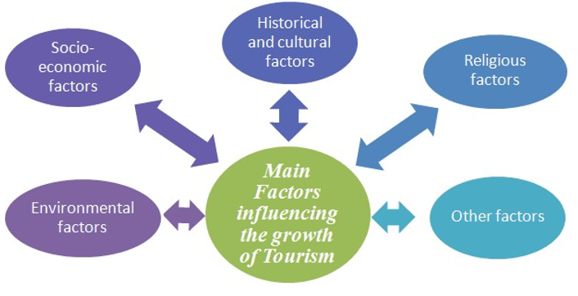
If anyone wants to learn more about sustainable tourism, they should consider a vacation to Stonehenge in Salisbury, UK. One of the wonders of the world, Stonehenge is rich in archaeology. In addition, this World Heritage site reflects prehistoric migration in the form of giant sculptures (Wanner et al., 2020). All relevant monuments, arranged in a circle, offer every sanctity to Neolithic and Bronze Age, to travellers (Hopkins, 2020). Therefore, the prospect of existing geological formations that can attract the attention of all tourists as part of prehistoric times dating back at least 5000 years is very important for the construction of long-term tourist attractions.

Figure 1: Factors that can be associated with sustainable tourism (Martinez, 2019)
In contrast, the flexibility that allows a destination to rise to the level of a major tourist attraction is its sustainability. As Kyriakaki and Kleinaki (2022) point out, the popular tourist attraction Stonehenge is no exception. Luxurious amenities installed at the venue to highlight sustainability include: refund system for visitors, regular bus service for tourists, give travellers a sense of nature and beauty, hiking trails through green spaces and use of environmentally friendly materials in consumer services.
All of the above, greatly increase the value of this place as a sustainable tourist destination. Moreover, all of these opportunities, combined with the region's eco-friendly approach, attract at least 6.2 million tourists annually (Martinez et al., 2017). 2019). Total tourist numbers have fallen from 10% to 15% despite the difficult situation caused by COVID-19, but the inclusion of sustainability keeps tourists coming on a regular basis.
On the positive side, Stonehenge remains a popular tourist destination due to the use of certain terms such as 'Place of the Dead', which leaves tourists with a sense of mystery and ambiguity. According to Alfaro-Navarro et al. (2020), another concept of 'healing place' encourages individuals to believe that emotional release and spiritual fulfilment can be achieved in a quiet environment. In addition, the site is associated with a “moon cult” or “astronomical observatory” location, so it is guaranteed to be the centre of attention in summer (Sangchumnong and Kozak, 2018). Through these related challenges, the sustainability footprint associated with sustainable tourism in that particular location is maintained.

PILLARS OF SUSTAINABLE TOURISM

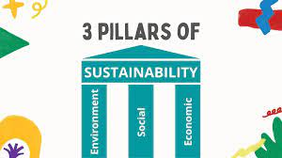
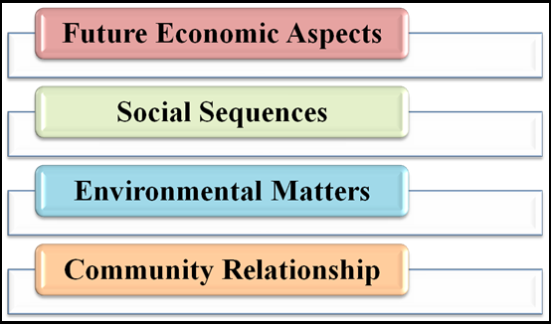

Figure 2: Pillars of sustainability (Source: first is self-developed and second (Simon, 2022)

Some concerns relate to the intensity of all material presented on site, including any methodological differences during conflict and intimidation. In fact, conditions related to future economic factors, social flows, environmental issues, community interactions, etc. are relevant to the sustainability of tourist destinations (Belias et al. 2018). The self-reliance of all individuals and their direct efforts to restore the solid foundations of all tourist destinations are described as more important (Seraphin, 2018). The risk of contamination, damage to historical or natural property, and violation of laws by visitors to certain overseas locations is negotiable. In this connection, the observations table in the previous section on disaster registration and response was developed.
The ongoing debate in the UK about the risks associated with Stonehenge has greatly undermined the concept of a sustainable tourist destination.
In spite of appearances, not all guests to Stonehenge are willing to pay the cost for supportability. In truth, indeed less than 50% of the populace needs to advance economical urban improvement by expanding the costs of tourism items and administrations. This may be due to a need of tourism data, or supportability isn't however a mainstream tourism procedure within the UK. In fact, at the time of composing, the tourism segment in Salisbury, UK (Salisbury City Board 2023) has no specify of a tourism sustainability set-up for the city.
The Stonehenge Guest Center gotten a really great rating in BREEAM certification. This worldwide appraisal looks at execution in terms of natural, social and financial maintainability. A BREEAM evaluated improvement is subsequently a more economical environment that progresses the well-being of the individuals who live and work in it, whereas making a difference to moderate characteristic assets (Stonehenge – our commitment to the environment, 2022).
In 2018, a modern armada of carry buses was conveyed to transport guests between the Guest Center and Akmens. Six cars with the most recent Euro 6 motors guarantee a calmer and cleaner drive. They are more naturally neighbourly, offer more wheelchair space and offer a high-contrast inside for outwardly impeded visitors. They have joined forces with Grist Natural Reusing to reuse 100% of the squander collected at Stonehenge to optimize reusing and guarantee nothing closes up in landfill. The zone of ​​the guest centre and stone circle has been protected as a chalk corridor. This implies that it isn't moved forward with fertilizers or anything, but is cut and cleaned each year.
Some options for the visitors as well, to sustain the tourism within the area, are mentioned by the responsible, such as: Eating out responsibly, Re-usable Coffee Cups, Sustainable Shopping etc.

TOURISM SUSTAINABILITY PRACTICES

Local authorities and the British government are grappling with potential threats to tourist destination Stonehenge. UNESCO also warned that the property could lose its heritage status if proper measures are not taken. This stone structure is 4,500 years old, older than the pyramids of Egypt. Plans to build a road next to the building have raised concerns about the monument and threats to tourists. From this point of view, a comprehensive disaster prevention plan is essential. The existing infrastructure will be improved according to future project requirements.
In addition to all physical facilities, standard tourist services are provided through security checks, adequate human resources, tourist information kiosks, orientation services and immediate funding opportunities (Chigora et al. 2020).
The destination is part of a sustainable plan, which needs improvements, as it not at its finest. Is one example of a plan that can be improved, in order to bring the destination closer to its goal of becoming a sustainable tourism destination.

BUTLER’S LIFE CYCLE MODEL AND DOXEY’S IRRIDEX MODEL

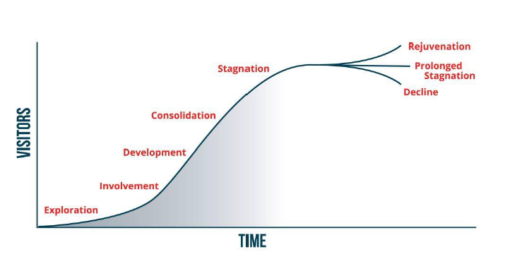
Figure 3: Butler's life cycle model (Source: Elyes, 2020)

Described as the concept of identifiable cycles in tourist destination development and use a simple S-curve to illustrate its ups and downs, with specific steps in the evolutionary sequence detailed along with different trends that may occur in the future, is the whole concept beneath Butler’s life cycle. The suggestions of utilizing this demonstrate for tourism asset arranging and administration are inspected within the setting of the proceeded weakening of natural quality and the ensuing decay in engaging quality of many tourist attractions.
There's no question that tourism regions are energetic, creating and changing over time. This advancement is the result of a number of components, counting changes in guest inclinations and needs, the slow weakening and conceivable substitution of physical resources and offices, and the changes (or vanishing) of pre-existing normal and social destinations that advanced tourism. Factors such as the prosperity of the urban area contributed to its early popularity. These patches will remain in some cases, but may be used or become less important than the imported patches for various reasons.
According to the most credible approach, the tourism sector needs to adapt to expected changes to achieve sustainability. In fact, the volume of organized activity in specific sectors accounts for more than 95% of the total (Joo et al. 2018). On the other hand, maintaining partnerships is equally important for future growth (Liu et al. 2021). The surroundings of scenic spots and the habitats of many birds and animals will be protected to enhance the tourist experience. No plastic is allowed at this location. Clean energy sources such as solar and hydropower are gaining attention for power generation and other applications. Providing maximum comfort for tourists while minimizing the impact on the environment.
On the other hand, in order for visitors to spend their time comfortably, it is important to conserve water and electricity by using appropriate functional toilet accessories, lighting, and energy-saving technologies. The integration of recycling programs is becoming increasingly important. In fact, recycling and reusing all paper products and equipment is essential to reduce pollution in specific geographic areas. On the other hand, chemical management artefacts were similarly relevant to remediation at each site (Tan and Ismail, 2020).
It can attract the public and even attract them to visit the site and promote itself through the scenic beauty and uniqueness associated with it (Tan and Ismail, 2020). In addition, it is essential in tourism to preserve value systems and realize their applicability to all (Sangchumnong and Kozak, 2018). In fact, enjoying any site like Stonehenge in Salisbury, UK hopes to be promoted as a global phenomenon to all visitors.
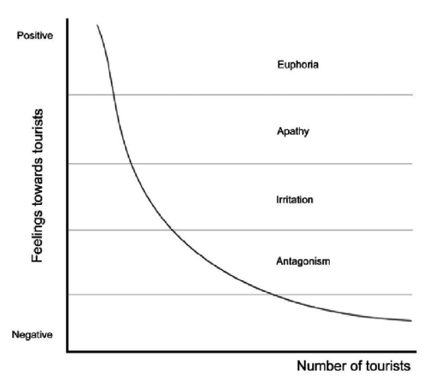

Figure 3 Doxey’s Irridex model (Source: Mahmut, 2021)

Also called Irridex, this system was developed by Doxey in 1975. It is based on understanding local attitudes towards tourists, including their changing attitudes towards tourists and the growth of tourism in all stages of a destination's lifecycle. His one such proposal was made by George Doxey, whose name is unknown to all but tourism researchers.
Long et al. (1990) support this hypothesis by showing that public sentiment is initially positive, but changes to an unfavourable mood when thresholds are crossed. According to the Irridex model, residents' perceptions of tourism change in a predictable, one-way order over time. This means that people's perceptions and responses to tourism are uniform (Mason et al. 2000).
A PESTLE survey can be conducted on a destination to explore past disaster history and management factors of the site to find all options for sustainable tourism growth, and also to make sure the plan already in place, can be improved. The availability of flexibility for all sensitive elements of sustainability paves the way for pollution reduction (Sangchumnong and Kozak, 2018). In fact, increased pollution can be reduced by 'green' activities. On the other hand, illegal trade can be severely restricted (Joo et al. 2018). People facing poached animals and other natural resources can limit demand and ultimately suffer people's thoughts and concerns.
Because the local environment is the most essential aspect, it should be prioritised. Every day, a large number of people visit Stonehenge in England. Local administration faced a significant task in keeping the region clean. As a result, it is the duty of the tourist. On the other hand, lowering carbon dioxide emissions is an obvious way to minimise the greenhouse impact, and tourism services also assist protect the "ozone layer" from depleting. Indeed, heritage that continually focuses on maintaining historical artefacts (sculptures, monuments, etc.) may emphasise everyone's living standards (João et al., 2017). Furthermore, evaluation and maintenance procedures can have a significant impact on local communities and their inhabitants.
In fact, the pressure to evict people from urban centres opens up the possibility of promoting green tourism in the future (Sangchumnong and Kozak, 2018). Identifying all relevant objects and their security implications, as well as forming a compelling public stance on the situation, is critical for future prospects (Joo et al., 2018). Therefore, united support and its focus, as well as the positive mindset of all tourists around the world, could perhaps make certain scenarios more effective in the years to come.

CONCLUSION

Several risk factors can be identified from current discussions at Stonehenge in the UK, but existing authorities may be viewed as passive bystanders. In this case, environmental factors should be taken into account. In addition, comprehensive and precise rules and procedures have been developed to prevent loss of UNESCO World Heritage Sites due to planned road construction. The interest status of all subsectors, the safety of all critical technologies, and the assessment of common tourism issues will then continue to be considered as goals in the calculations, as appropriate. The responsible of this tourism destination to become a sustainable one and to have an improved plan, will have to work closely with any person that can bring a plus to the tourism within the area, alongside with the council of Salisbury, UK.

REFERENCES

Alfaro Navarro, J.L., Andrés Martínez, M.E. and Mondéjar Jiménez, J.A., (2020). An approach to measuring maintainable tourism at the nearby level in Europe. Current Issues in Tourism, 23(4), pp.423-437.
Belias, D., Velissariou, E., Kyriakou, D., Varsanis, K., Vasiliadis, L., Mantas, C., Sdrolias, L. and Koustelios, A., (2018). Tourism buyer behavior and elective tourism:
the case of agrotourism in Greece. In Imaginative Approaches to Tourism and Relaxation (pp. 465-478). Springer, Cham.
Chigora, F., Mutambabra, E., Ndlovu, J., Muzurura, J. and Zvavahera, P., (2020). Towards Setting up Zimbabwe Tourism Goal Brand Value Factors through Economical Community Inclusion. African Diary of Neighborliness, Tourism and Recreation, 9(5), pp.1094- 1110.
Graci, S. and Van Vliet, L., (2020). Looking at partner recognitions towards maintainable tourism in an island goal. The Case of Savusavu, Fiji. Tourism Arranging & Improvement, 17(1), pp.62-81.
Hopkins, D., (2020). Feasible portability at the interface of transport and tourism: Presentation to the extraordinary issue on 'Innovative approaches to the consider and hone of economical transport, portability and tourism'. Diary of Maintainable Tourism, 28(2), pp.129-143.
João, P., Couto, G., Pimentel, P. and Oliveira, A., (2018). Tourism exercises and companies in a economical experience tourism goal: The Azores. Tourism & Administration Considers, 14(4), pp.25-38.
Kyriakaki, A. and Kleinaki, M., (2022). Arranging a feasible tourism goal centering on tourists' desires, discernments and Encounters. GeoJournal of Tourism and Geosites, 40(1), pp.225-231.
Liu, C.H., Jiang, J.F. and Gan, B., (2021). The predecessor and result conduct of maintainable tourism: coordination the concepts of showcasing methodology and goal picture. Asia Pacific Diary of Tourism Investigate, 26(8), pp.829-848.
Mahmut Demir, Ali Dalgıç, Fatma Doğanay Ergen (2021). Handbook of Investigate on the Impacts and Suggestions of COVID-19 on the Tourism Industry (2 Volumes). Accessible at: DOI:10.4018/978-1-7998-8231-2
Martínez, J.M.G., Martín, J.M.M., Fernández, J.A.S. and Mogorrón-Guerrero, H., (2019). An examination of the soundness of country tourism as a craved condition for maintainable tourism. Diary of Trade Inquire about, 100, pp.165-174.
Sahli, Elyes. (2020). Tourism Goal Advancement an Application of Butler's (1980) Tourism Region Life Cycle Show to Hammamet, Tunisia. 10.13140/RG.2.2.26359.55209.
Salisbury City council (2023). Accessible at: https://salisburycitycouncil.gov.uk/ (Accessed: 01 June 2023).
Sangchumnong, A. and Kozak, M., (2018). Economical social legacy tourism at boycott Wangka Town, Thailand. Anatolia, 29(2), pp.183-193.
Seraphin, H., Gowreesunkar, V., Roselé-Chim, P., Duplan, Y.J.J. and Korstanje, M., (2018). Tourism arranging and advancement: The Caribbean beneath the highlight. Diary of Goal Promoting & Administration, 9, pp.384-388.
Slivar, I., (2018). Partners in a visitor destination–matrix of conceivable connections towards maintainability. Open Diary for Investigate in Financial matters, 1(1), p.1.
Simon (2022) The three columns of maintainability clarified, Supportability Victory. Accessible at: https://sustainability-success.com/three-pillars-of-sustainability/#google_vignette (Accessed: 02 June 2023).
Stonehenge – our commitment to the environment (2022). Accessible at: https://www.english-heritage.org.uk/siteassets/home/visit/places-to-visit/stonehenge/plan-your-visit/6745-sh-sustainability-a4-email.pdf (Accessed: 02 June 2023).
Sustainability (2021) Sustainability | Extraordinary Issue: Goal Brand Value and Maintainability: Issues for Advancement. Accessible at: https: //www.mdpi.com/journal/sustainability/special_issues/destinationbrand_sus (Accessed: 26 May 2023).
Tan, P.Y. and Ismail, H.N., (2020), February. Audits on interrelationship between transportation and tourism: Viewpoint on maintainability of urban tourism advancement. In IOP Conference Arrangement: Soil and Natural Science (Vol. 447, No. 1, p. 012065). IOP Distributing.
Wanner, A., Seier, G. and Proebstl-Haider, U., (2020). Arrangements related to maintainable tourism–an evaluation and comparison of European arrangements, systems and plans. Diary of Open-air Amusement and Tourism, 29, p.100275.
Weber, F., (2019). Request for feasible tourism. In Corporate sustainability and obligation in tourism (pp. 265-281). Springer, Cham.

