Six Sigma Green Belt
A report investigating the cause and reduction of moisture within a compressed air system.

Module - ACMA 5005
Lecturer – Andrew Thorn
Student – Elliot Jenkins 2029907

Table of Contents
1. Introduction 4
2. Define 5
2.1 Problem statement 5
2.2 Process Map 6
2.3 SIPOC 7
2.4 SWOT analysis . 8
2.5 Voice of Customer 9
2.6 Project Charter. 11
3.0 Measure 12
3.1 Identify Measurement Variations 12
3.2 Collection Plan 12
3.3 Data Collection. 13
4.0 Analyse 18
4.1 Coal sample analysis 18
4.2 Coke Rate Delay Pareto Analysis. 19
4.3 Blast Furnace 4 Coal line pressures. 20
4.4 Injector trips 21
4.5 5 whys 22
5.0 Improve 23
5.1 Generate Improvements 23
5.2 Cost Analysis. 24
5.3 Improved Process Map 25
6.0 Control. 26
References 27

Figure 1 Process Map of compressed air. 7
Figure 2 SIPOC table 7
Figure 3- SWOT Table 8
Figure 4- Voice of Customer diagram 10
Figure 5 - Project Charter 12
Figure 6 - GCI sample machine 14
Figure 7 - Coal sample table 15
Figure 8 - RAG system 16
Figure 9- Shift report 16
Figure 10 - Cost of coke delays 2022 17
Figure 11 - Injector with no blockage 18
Figure 12 Blocked Injector 18
Figure 13 Coal sample analysis 19
Figure 14 Delay and costing of using coke 20
Figure 15 Coal line pressures BF4 21
Figure 16 Injector trips 22
Figure 17 New proposed Dryers 25
Figure 18 New Process Map 26
Figure 19 SAP maintenance 27

Introduction

The following report investigates and analyses the high moisture content within the conveying air system used by the Coal Injection Plant at Tata Steel. Within The Granulated Coal Injection Plant, coal is transported from the yards via conveyor belts, to the Screen House where coal is crushed using Magco Coal Crushers. Coal that is less than 5mm is transported via another conveyor belt to one of two coal Dryers. Moisture levels can be anything between ten and five percent within the coal when first brought from the yards, when coal has passed through the Dryers moisture levels are below one percent. Coal is pneumatically transferred via a stream phase system which consists of two vessels that work in tandem by filling, pressurizing up to one bar, and dispensing over to the coal silos.
The coal silos also use a pneumatic system that pressurizes and dispenses coal within multiple vessels into injectors, which are screw feeders. These screw feeders distribute coal into lances with a pressure of around 4 and a half bar, half a bar above furnace pressure, if the pressure was lower than the furnace pressure there would be a catastrophic event as there would be furnacing gases coming back towards the furnace.
Coal is conveyed using compressed air, and the compressed air is generated by four compressors within the department totalling around twenty-one thousand cfm. These compressors are the main supply of all conveying air used for transporting coal to the silos, silos to the furnaces, and all other compressed air required on the Blast Furnaces.
This report will look in depth at the issues that are created by moisture within the compressed air, predominately causing wet coal blockages within the coal lances supplying the Blast Furnaces. This report will look at the root causes and will implement a solution by following the DMAIC approach.

Define

2.1 Problem statement

After coal is crushed and dried within the Granulated Coal Injection plant it is then conveyed using compressed air generated by four compressors. Due to the excessive amount of moisture within the compressed air produced by the compressors, blockages are caused within the coal lances between the coal silos and blast furnaces. The Blockages are due to the mixture of coal and wet compressed air.
The impacts of having coal blockages within these lines can potentially cause wasted man-hours isolating and removing the obstructions, worst case scenario would result in the Blast Furnace charging a hundred percent all coke burden instead of coal resulting in increased costs of £40,000 an hour.

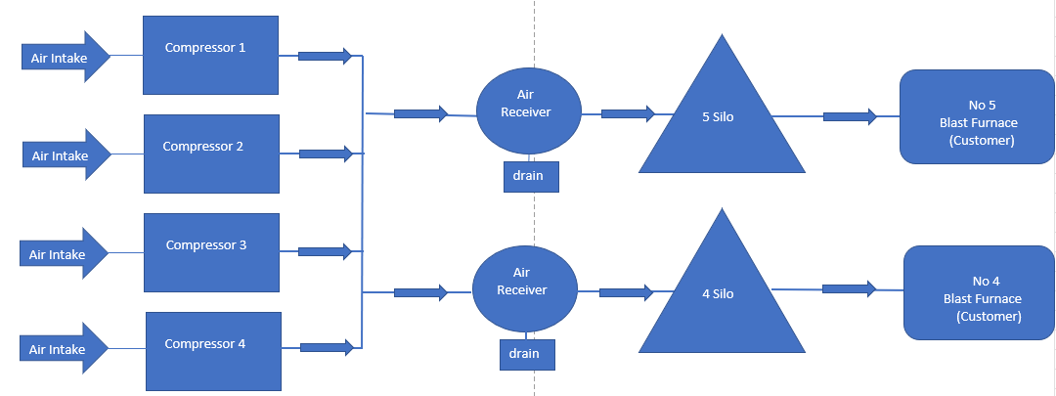
2.2 Process Map

A process map was carried out to visualise the entire process graphically, to help understand the process flow easier and more efficiently. Figure 2 shows the process in which air is drawn into the compressors, the compressors compress the air and feed the air receivers, the air receivers supply the coal silos, who lastly supply the Blast Furnaces with product coal. This map was shared within the team to later identify improvement areas within the process map, and also to identify if there was any waste within the process. (Harris, 2019)

Figure 1 Process Map of compressed air.

2.3 SIPOC

As well as conducting a process map diagram it was also essential that a SIPOC table ( supplier, input, process, output and customer) was recorded. This was to help with brainstorming activities later in the project, but also to identify who the stake holders are and give an overview of key information needed. A SIPOC table can help distinguish processes before they can be developed. (Marinova, 2019)

Figure 2 SIPOC table
Supplier | Input | Process | Outcome | Customer
Who are the suppliers necessary for this product or service? | What have the suppliers provided for use in the process and how will these supplies be used? | What are the start and endpoints of the process, bottlenecks, and major steps involved? | What is the final product or service of each process step? | Who are the customers of the product or service and what are their expectations for it?
Granulated Coal Injection | Raw Coal | Coal is crushed below 5mm and dried to below 1% moisture level. | Product Coal is produced which is conveyed by compressed air. | Blast Furnace 4 and Blast Furnace 5. Expectations are for the coal to be below 5mm in size and less than 1% moisture level.
Granulated Coal Injection | 4 x Compressors | 4 x Compressors compress atmospheric air. | 7 bar pressure of compressed air is produced , used to convey product coal. Compressed air is very wet. | Blast Furnace 4 and Blast Furnace 5. Expectations are for the air to be below 1% moisture and over 7 bar pressure.

2.4 SWOT analysis .

A SWOT ( strength, weakness, opportunities and threats) table was carried out to help promote discussion between the team. As the project is being conducted internally with no external parts outside of the company the discussion only included the strengths and weaknesses on the issue at hand. By carrying out SWOT analysis the team are able to identify the strengths within the process and build on them in order to improve, but it also shows the limitations within the process.
The key points taken from the SWOT analysis is that the company is willing to improve the process and that there are several solutions to the problem identified. The main weaknesses identified overall are linked to the same issue, that moisture within the compressed air causing process issues, waste man power and high process costs. (PESTLEANALYSIS, 2016)

Figure 3- SWOT Table

Strengths
- Companies’ willingness to improve the process.
- Compressors are reliable although providing moist air.
- Personnel dedicated to improving process.
- Several solutions available to potentially reduce or control moisture within compressed air.
- Analysis into problem could educate employees around process.

Weaknesses
- Vents cracked open to allow moisture out, also wasting compressed air.
- Process knowledge within new process team.
- Time spent on compressed air system when there are other areas of plant needing maintenance.
- Moisture in compressed air can take a Blast Furnace off coal.
- Blockages in coal lines can take manning off other breakdowns causing further failures.
- Vents shut by personnel resulting in further blockages.

2.5 Voice of Customer

When defining the problem, it is imperative to speak to the downstream customer, to identify their concerns and what is affecting them the most. Sometimes key information can be collected by simply talking to the customer, this data can be very specific and may need to be validated further into the project. (Luck, 2022)
The customer in this project is both Blast Furnaces as they require the coal that is stored in the Granulated Coal Injection Silos. Below shows a basic VOC diagram which helps to visualise the main requirements from the customer.
Product Coal is less than 5mm
Coal blockages below 5 per shift
Conveying air is dry.
Compressors are reliable.
Product Coal is below 1% moisture
Coal is available when needed

Figure 4- Voice of Customer diagram

Customer
(Blast Furnaces)

Using the Voice of Customer diagram shown in figure 4 it demonstrates the key requirements that are expected from the supplier, the supplier being Granulated Coal Injection Plant. Using this diagram, we can see the key expectations from them are that they need to be provided with product coal no larger than 5mm, product coal that is below 1% moisture, for there to be less than five blockages per a twelve-hour shift, for the compressed air to be dry and for there to be a supply of coal when required.
There are a few main points that corroborate with our problem statement, and requirements that are not currently being met by the supplier.
- Compressed air is wet.
- Product coal is above 1% moisture.
- On average there are over 5 blockages per shift.
- Coal can sometimes be unavailable due to the high amount of blockages.

2.6 Project Charter.
Project Title -
Analysing and proposing a solution to high moisture within the compressed air system used to convey coal to the Blast Furnaces.
Problem Statement – Compressed air that is used for conveying coal to the Blast Furnaces contains high moisture. Due to the high moisture in the compressed air, combined with the product coal, the results are blockages occurring with the coal lances. These blockages can cause the Blast Furnaces to change burden to all coke resulting in costs of up to £40,000 an hour.  Project Scope:  - Identify the root cause of moisture.  - Analyse findings.  - Research possible solutions to moisture.  - Select the best solution.  - Implement the chosen solution. | Roles and Responsibilities.  Leader -  - Elliot Jenkins  Team Member -  - Jay Harris  - Gavin Chappell
Goals  - To reduce the moisture within the compressed air, therefore reducing the coal blockages.  Business Benefit.  - By reducing the number of blockages can reduce the wasted man-hours unblocking pipework.  - By reducing the number of blockages can stop the Blast Furnaces from going all coke thus saving a potential £40,000 an hour. | Time Frame ( Proposed )
  Start of project. | April -22
  Resource confirmed. | May - 22
  Investigate the root cause. | July - 22
  Analyse causes. | Sept - 22
  Research solutions | Dec - 22
  Implement solution | Feb -23
  Monitor implemented solution. | April - 23
Figure 5 - Project Charter

3.0 Measure

3.1 Identify Measurement Variations

For data not to variate a plan has to be in place in order to keep the data reliable. An example of this would be to collect samples the same time of day, or to collect the samples using the same measurement device. If two different measurement devices such as moisture analyser mentioned below were not calibrated the same the measurements provided would be in accurate and could make your results inaccurate. It is important for the collection methods to be thought about before implemented. (Naik, 2019)

3.2 Collection Plan

There are several types of data that can be collected and used to identify and prove the disruption in which coal blockages are causing to the Blast Furnaces process. Below are the main sources of data that can be collected that can later be analysed. All data was collected during the 2022 financial year.

- Coal samples taken, dried and recorded by the process shift teams.
- Shift reports identifying how many blockages there were during a twelve-hour shift.
- Blast Furnace coal lance pressures.
- Blast Furnaces Injector data.
- Coke rate delay tracker.
- BF4 Coal Line Pressures vs Coal Rates.

3.3 Data Collection.

When collecting coal samples, it is essential to create a data collection plan to keep the data being recorded consistent (Hessing, 2013). By recording the coal samples from the same collection points at the same intervals it will keep the data credible by avoiding deviation. It was decided that samples would be taken every twelve hours , times chosen would be 08:00 and 22:00, they would be taken at three different locations during the process. Before the coal is crushed, after the coal is crushed and after the coal has been originally dried were considered to be the best points in which to samples. These samples would then be cooked and sampled by a moisture analyser. The moisture analyser used is shown in figure 6.
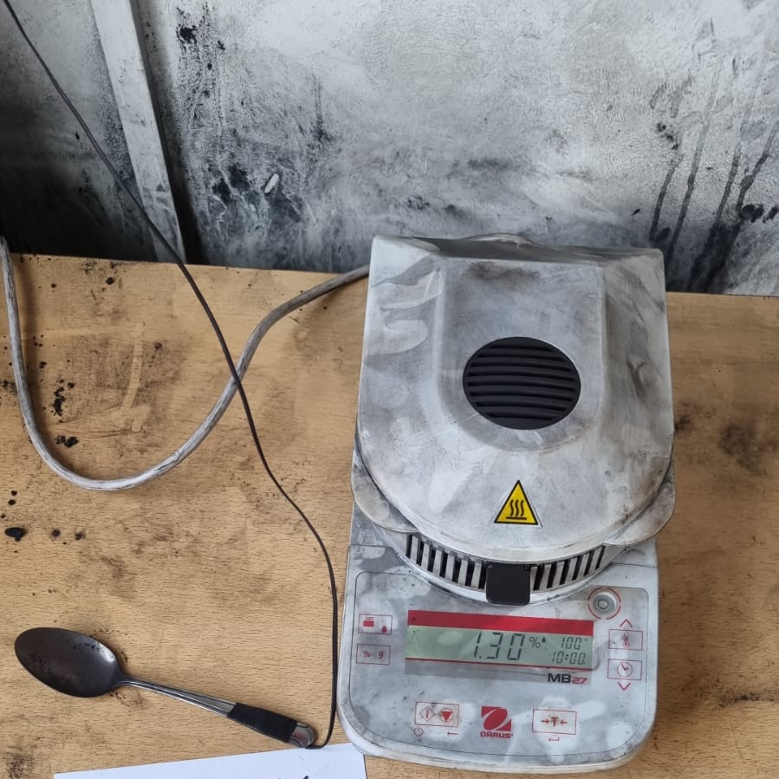

Figure 6 - GCI sample machine

The table that was constructed as shown in figure 7, it also contains lump count which was data required for another project that is currently on going. The data was taken over a six-month period to examine the moisture levels at various points in the process to compare against the samples of moist coal found in the blocked coal lines. Also, it was important to check the coal sample after it had been dried to make sure we are meeting the customers expectation of providing dry coal.
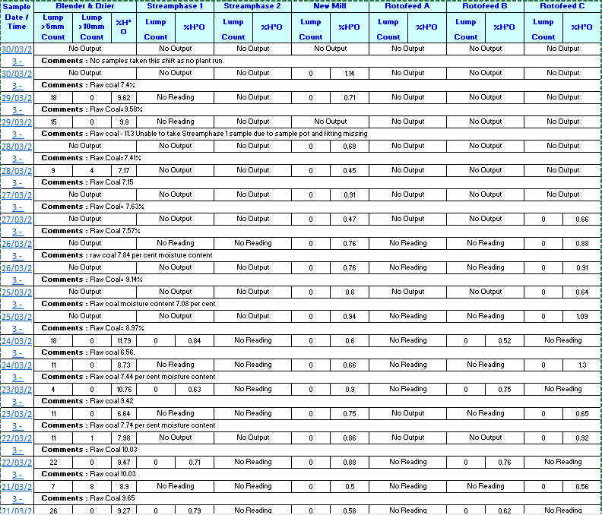

Figure 7 - Coal sample table

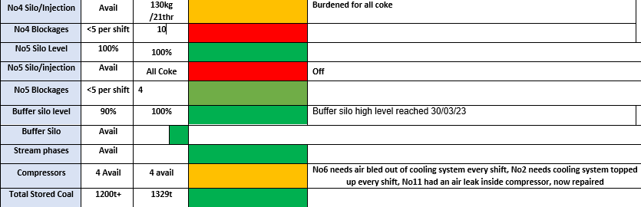
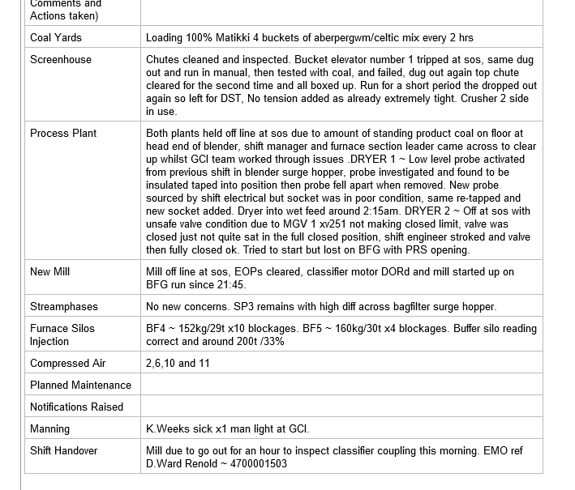
Other Data that needed to be collected were via the shift reports, coal blockages are recorded within the shift reports at the end of a twelve hour shift. This is then added to a RAG system where if the number is below five it is green and within specification, if the number is over 5 it is deemed as red which is out of desired specification. Below is an example of the shift report with a high number of blockages recorded, where the RAG table is highlighted red due to this high number.
Figure 8 - RAG system
Figure 9- Shift report

Information regarding the cost of coke delays for the period of 2022 had to be collected from the technical team within the Blast Furnaces, this was collected by the team and placed into a table as shown below. This data showed the main delays and factors of why Blast Furnace 4 had to charge more coke, with the cost shown next to the delay to show the impact of using more coke.

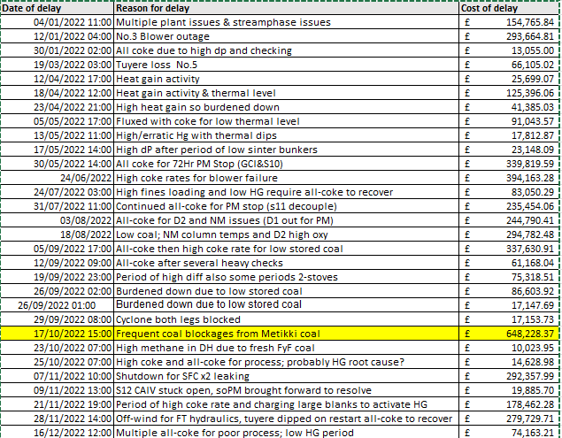
Figure 10 - Cost of coke delays 2022

Other information that was available was the line pressure of the coal lances on Blast Furnace 4 during the use of Mitiki coal. Information was provided over the year 2022 where we could exam the pressure within the coal lines between 4 silo and Blast Furnace 4. This information could tell us the rate at which the coal is blocking within the line by the pressure in the coal lance rising.
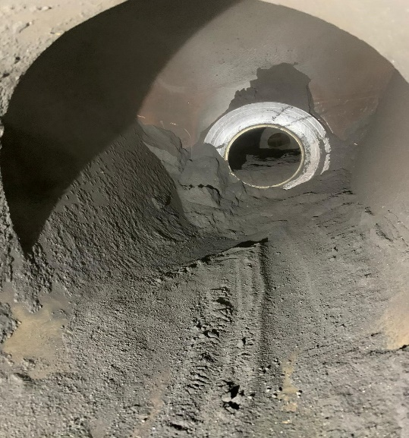
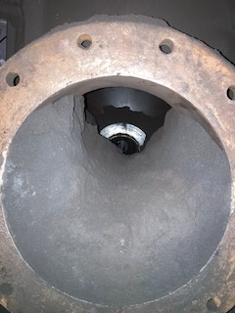
Additional sources of data that can be collected from Blast Furnace 4 are information on the amount of injector trips occur over the 2022 year. An injector is a screw which feeds the coal lines below them which is then transported to the Blast Furnaces. If the current that turns the screw injector rises due to a blockage within the injector housing the injector will trip, this will then require the injector to be cleaned out. If enough of the injectors trip it will cause the Blast Furnaces is charge all coke due to the instability of not having enough coal. Figure 11 shows an injector blocked due to wet coal and figure 12 shows how the injector should look when opened up for inspection. By having to open the injector to be cleaned out wastes not only man hours but can overall affect the stability of Blast Furnace.

Figure 11 - Injector with no blockage
Figure 12 Blocked Injector

4.0 Analyse

Coal sample analysis

With the coal samples collected by the shift team over a period of six months it showed us the following data.

Raw Coal | Crushed Coal | Dried Coal
> 5 % moisture on average | > 5 % moisture on average | < 0.8% on average

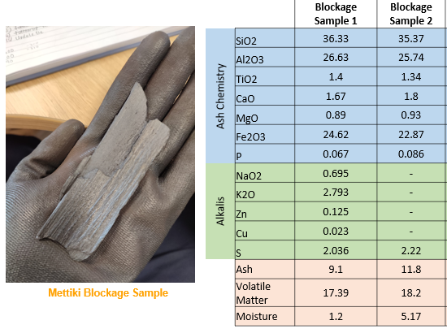
The most important figure is the dried coal, as it is on average to be lower then 1% expected by the customer. The dried coal is then transported via the compressed air to the coal silos, where samples have been taken from the injector blockages and send for analysis as shown below.
Figure 13 Coal sample analysis
The sample taken from the injector has been found to be 5.17% moisture level, which is 4% higher than the required 1%, this is indicating that moisture is getting into our system between the dryers and the silos. This is indicating that moisture is within our compressed conveying air.

Coke Rate Delay Pareto Analysis.

Using the table shown previously in figure 10, a graph was able to be constructed to graphically show the main delay and cost of charging coke instead of coal.

Figure 14 Delay and costing of using coke
The graph clearly shows us that the biggest cost throughout the year for using coke was the period when frequent blockages from using Metikki coal. This is the same period in which the coal sample previously discussed was sent away and was found to be over 5% moisture level. The cost of this delay was almost double the cost of most other delays.

4.3 Blast Furnace 4 Coal line pressures.
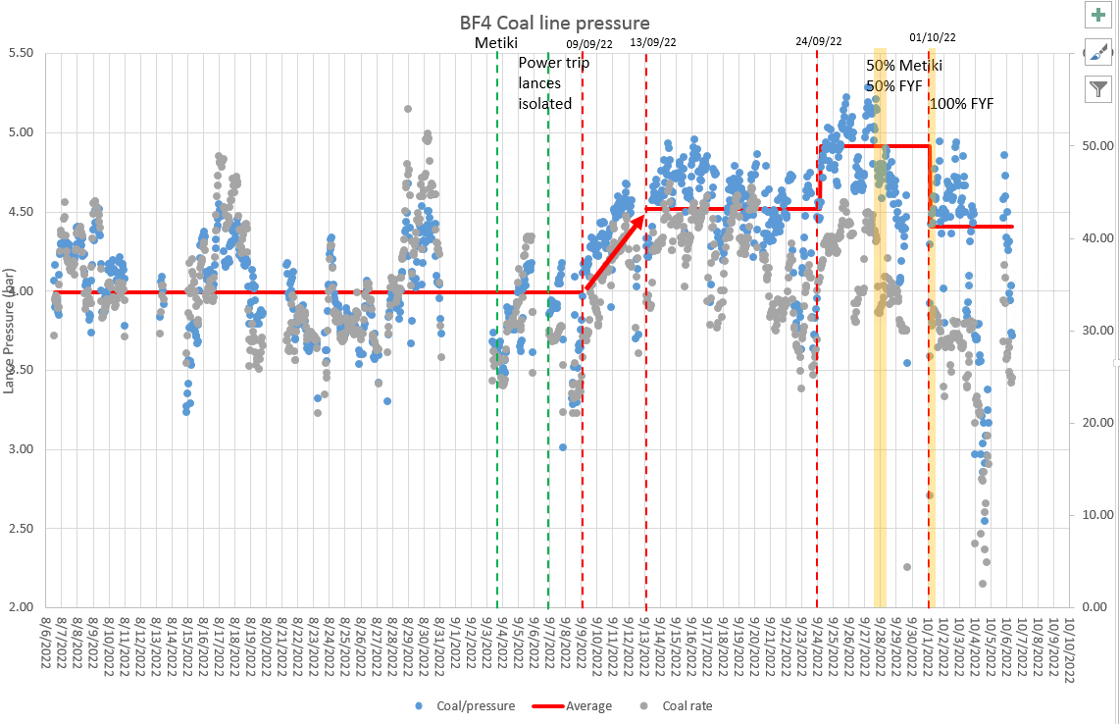
Figure 15 Coal line pressures BF4

The graph in figure 16 shows that when the Mitikki coal was introduced the line pressure increased from 3 bar to almost 5.5 bar, this is indicating that the coal lines are starting to block. The grey dot is indicated as the coal rate, which you can see when the coal line pressure rises to 5.5 bar the coal rate starts to follow dramatically. This is due to the coal no longer able to convey through the coal lance due to the build up of moist coal.

4.4 Injector trips
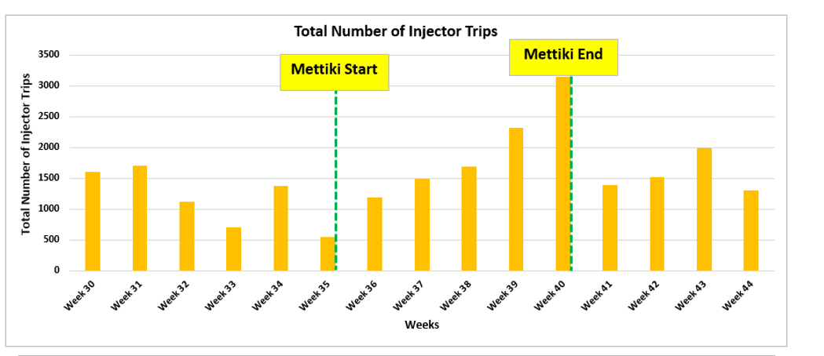
Figure 16 Injector trips

Figure 16 shows the amount of injector trips, as highlighted when Metikki was added to the coal blend the amount of coal trips rose from 500 to 3000 before being removed from the blend. Metikki coal is seen to have a high Hargrove index which it means it is a softer coal and more susceptible to moisture within the compressed air due to its finer size fractions. Each trip required the injector vessel to be isolated and clean out, the period shown with the highest trips resulted in the highest cost in delays shown in figure 14. This resulted in costs of over £650,000.

4.5 5 whys

When analysing the data, it was evident to see that moisture is present within the coal kept at the coal silos, to analyse our findings further a 5 why was carried out to find out the root cause. The 5 why technique can be a quick and direct route to identify a root cause when used correctly. (mind tools, 2022)
- Why is there moisture within our coal in the silos?
- Because there is moisture within the conveying air lines.
- Why is there moisture within our conveying air lines?
- Because there is moisture within the compressed air.
- Why is there moisture within our compressed air?
- Because there are no air dryers after the compressors.
- Why are there no air dryers after our compressors?
- Because they were not considered when installing compressors.
- Why were they not considered when installing compressors?
- Because the firm that were installing them went bankrupt and closed.

By conducting the 5 whys the conclusion has been met that the air dryers were not considered when installing the compressors. When discussed with the departmental area engineer it was mentioned that the firm Ultra Air that had installed the compressors went bankrupt after the installation and was the historic reason why there were never installed.
After finding this information, it is essential for some type of air dryer to be investigated and potentially installed to reduce or eliminate the moisture content within our conveying air lines.

5.0 Improve

5.1 Generate Improvements

The clear improvement that is required within the process is to add air dryers. By adding air dryers, it will:
- Eliminate moisture within the system.
- Reduce erosion within the pipe work.
- Improve efficiency.
- Most importantly reduce coal blockages.
There are several types of air dryers suited for the type of compressors that are located in the GCI, refrigerant or desiccant dryers are the main types most commonly used.

Refrigerant Dryers
These air dryers are the most commonly used, consisting of an air-to-air heat exchanger and an air-to-Freon heat exchanger. The compressed air is processed in two phases. Firstly, it passes through an air-to-air heat exchanger where the incoming air is cooled by the outgoing air, while the outgoing air is simultaneously heated. Secondly, the compressed air flows through an air-to-Freon heat exchanger where it is cooled further, leading to the condensation of moisture and the removal of free water droplets. Despite this, the compressed air's relative humidity remains at 100%. Lastly, the compressed air is heated again by the incoming air, which reduces the relative humidity of the outgoing air below 50%. (Copco, 2017)
Blower purge desiccant dryers.
These utilize a blend of ambient air, heat, and a small amount of compressed air. During the drying phase, moist compressed air travels through the desiccant, which adsorbs moisture from bottom to top. In the regeneration process, an external blower pulls in ambient air and passes it over a heater. The heated air then moves through the wet desiccant, which pushes out the adsorbed moisture. A cooling purge follows the heating stage. Once the heating process is complete, dry compressed air from the outlet of the adsorbing vessel is expanded over the hot desiccant tower to cool it down before use. After this stage, the roles of the two towers are switched automatically, as in the heatless process. (Allen, 2020)

5.2 Cost Analysis.

As shown in figure 10 the biggest coke delay for 2020 was due to coal blockages, which was just under £650,000.
When investigating and consulting with Atlas Copco who supply air dryers, and Bijur Delmon who install the air dryers on behalf of Atlas Copco, I was provided with approximate prices for fitting blower purge desiccant dryers.
Costing of pipework and installation of air dryers: £200,000.
Costing of air dryers - £500,000.
Total cost: £700,000.
The total cost is £50,000 more than the biggest coke delay cost in 2022. This could eliminate future coke delay costs caused by moist coal blocking coal lines, when consulting with Atlas Copco they were confident that there will be future blockages due to the non-existent air dyers present. By installing air dryers could improve the process massively.
Below is the proposed solution with the new dryers highlighted by the blue arrows.

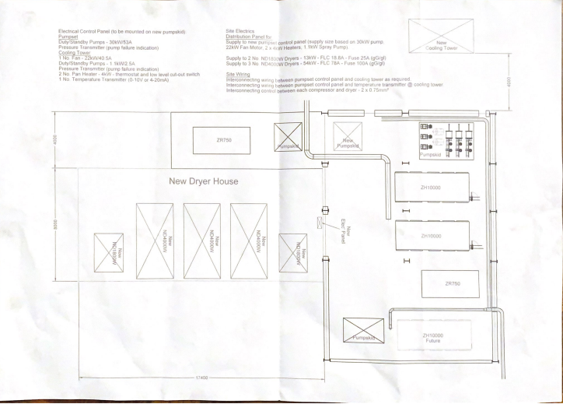
Figure 17 New proposed Dryers

5.3 Improved Process Map
Figure 18 New Process Map

As shown in figure 18, the proposed new air dryers located between the compressors and the air receivers, note that for visual proposed there air two air dryers on the process map where there are being four proposed by Atlas Copco.
Air Dryer
Air Dryer

6.0 Control.

If the air dryers were to be implemented, there would have to be a maintenance plan provided by Atlas Copco. Currently with the compressors there are monthly servicing carried out by Atlas Copco engineers who report back to the Tata Steel Engineer, if there are any issues with the compressors they are planned in to be fixed when the process allows it.
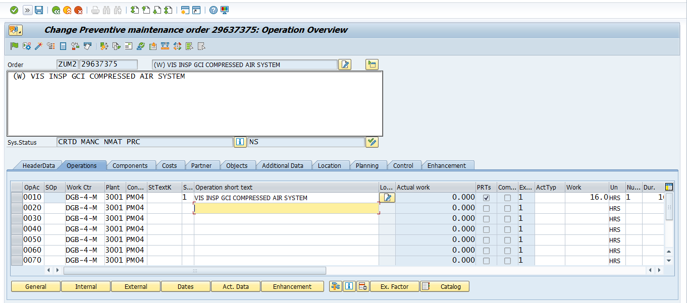
Tata Steel also have maintenance checks of the cooling system that is used by the compressors, this is managed using the SAP system which generates the monthly maintenance checks when they are due on a database.
Figure 19 SAP maintenance

References

Allen, M. (2020). What you need to know about compressed air desiccant dryers. [online] The Engineer. Available at: https://www.theengineer.co.uk/content/product/what-you-need-to-know-about-compressed-air-desiccant-dryers [Accessed 31 Mar. 2023].
Copco, A. (2017). White paper Compressed air drying. [online] Available at: https://www.atlascopco.com/content/dam/atlas-copco/compressor-technique/oil-free-air/documents/2937016013%20whitepaper%20EN%20LR.pdf [Accessed 31 Mar. 2023].
Harris, E. (2019). Six Major Benefits of Process Mapping. [online] Triaster.co.uk. Available at: https://blog.triaster.co.uk/blog/six-major-benefits-process-mapping.
Hessing, T. (2013). Data Collection Plan. [online] Six Sigma Study Guide. Available at: https://sixsigmastudyguide.com/data-collection-plan/.
Luck, I. (2022). 5 Voice of Customer Benefits—The Important Ones. [online] CustomerGauge. Available at: https://customergauge.com/blog/voice-of-customer-(Luck, 2022)
Marinova, I. (2019). What is a SIPOC Diagram: Examples, Benefits and Disadvantages. [online] Kanbanize Blog. Available at: https://kanbanize.com/blog/sipoc/#:~:text=What%20Are%20the%20Benefits%20of%20SIPOC%3F%201%20SIPOC.
mind tools (2022). MindTools | Home. [online] www.mindtools.com. Available at: https://www.mindtools.com/a3mi00v/5-whys.
Naik, S. (2019). What is Measurement System Variation? [online] LSSSimplified. Available at: https://lsssimplified.com/what-is-measurement-system-variation/.
PESTLEANALYSIS (2016). Benefits of SWOT Analysis. [online] pestleanalysis.com. Available at: https://pestleanalysis.com/benefits-of-swot-analysis/#:~:text=Benefits%20of%20a%20SWOT%20Analysis%201%20Cost-effective%20You.

