A Reflection on my personal learning experience using the “KOLB” model of reflection

Contents:
Page 1: Table of Contents

Pages 2-3: Introduction, Explanation of Kolb’s Reflective Cycle & Reflective Practice

Pages 4-6: Public Speaking & giving presentations

Pages 6-7: CV writing

Pages 8-10: Time Management

INTRODUCTION:

The aim of this paper is to analyse my development in three specific areas of my personal learning experience.
The topics that I have chosen are ones that I believe to be of high importance in order to achieve optimal success in my future career and they are also the ones that I believe I require the most development in.
They are:
- Public Speaking & Giving Presentations
- CV Writing
- Time Management & Organisation of Study

I will be using the Kolb Reflective Cycle to analyse these three key areas.

David Kolb first published his learning styles and model of reflection in 1974. They have since been used by many to assess their own personal learning experience.
It is also referred to as the “Experiential Learning Cycle” and this is because the basis for the model is one’s own experience which is analytically reviewed in a further three stages.
The four stages are:
- Completing an experience by doing an activity
- Reflecting and Observing the experience
- Concluding and learning from the experience
- Using the experience for planning future tasks
This is a visualised example of the reflective cycle:
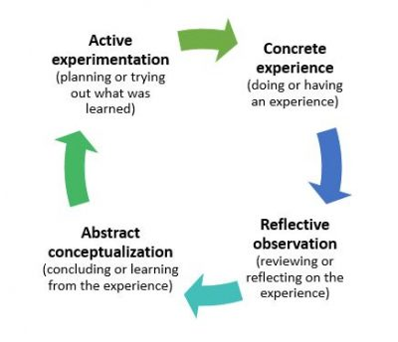
I will examine the value of reflection as a useful method of observing one’s experiences in learning by citing work from those considered to be academic leaders in terms of research into this practice.

Chris Argyris & David Schon addressed the necessity for using models of reflection within the context of one’s own learning and professional practice in 1974. Schon further developed the point in 1983, noting that the most skilled professionals are those who are reflective practitioners. According to Johns (2000) reflective practice is initially something that requires conscious effort however not long after, it becomes an automatic thought process.

This practice is not only used for those who are examining their own learning but also for those who are teaching. As such, reflective practice has become a foundation for many teacher education programmes worldwide.
(see Richert, 1990; Russell, 1997; Tom, 1985; Valli, 1993; Zeichner, 1983).
With these scholars’ theories in mind, we can understand the relevance of using these models of reflection to assess our own learning today.

Public Speaking & Presentation Skills
Prior to beginning University, I had had almost no experience in public speaking or creating and delivering a presentation. As soon as I completed high school, I began working within the hospitality industry, where most of what we do on a day to day basis involves practical, hands on work. However, I noticed relatively early on that in order to progress to more senior management positions within my chosen industry, it is essential to demonstrate effective leadership. Part of demonstrating effective leadership is being able to be an excellent orator to motivate your team and to deliver engaging presentations regarding performance, targets and forecasts.

Based on a study conducted by the University of Birmingham, 2018, the most important thing to consider before public speaking is understanding and being passionate about the topic you are presenting. The second most important thing to consider is significant preparation in order for the presentation to be a success.

Using David Kolb’s Model of Reflection, I have used his four separate stages to break down my own experience with analysing and further developing my public speaking and presentation skills.

The First Stage “Doing or having a concrete experience”: My first experience with public speaking was when I had to take part in a presentation that was to be the result of group work. In order to communicate within the group, it was imperative to have adequate public speaking skills to communicate my thoughts, suggestions and ideas. Unfortunately, due to lack of previous experience in this field, this first occasion felt to me, to be a negative one.

The Second Stage “Reviewing or reflecting on the experience”: After this experience, I reflected on it and decided that in order to get an idea of how to be comfortable with public speaking it was best to watch people who conduct this kind of work regularly. I consulted a platform that broadcasts a wide range of presentations on various topics called “TEDx”. I viewed many of these videos in order to understand more about the techniques that these professionals use.

The Third Stage “Concluding or Learning from the experience”: To cement what I had learnt from watching a series of presentations online, I thought that I should conclude my learning by also reading some scholarly articles surrounding this topic.
“More than anything else, it’s the personal impression you make that determines whether or not the audience accepts your message. You must come across as likeable and trustworthy.” (Forbes, 2010)
“If you are afraid of public speaking, you are not alone. Marinho, de Medeiros, Gama, and Teixeira (2016) studied college students to determine the prevalence of fear of public speaking. In a group of 1,135 undergraduate students (aged 17–58), over half of those surveyed reported a fear of public speaking. Almost the entire group surveyed (89.3%) wanted classes to improve public speaking. (Vogel W, 2018)

The Fourth Stage “Planning/Executing what was learned”: Using what I have learnt from a mixture of TEDx talks and scholarly articles, I decided to apply this knowledge to my most recent presentation in December 2020. I definitely saw a vast improvement in my own confidence when speaking publicly and also an improvement in the conciseness of my PowerPoint presentations. This, I feel can be attributed to the extensive research I conducted after my initial experience with this.

CV Writing
Many highly capable people fail to get the jobs they desire, not due to a lack of experience or lack of a desired personality for the said vacancy but due to poor and ineffective CV writing.
“Your CV is the first chance you get to make a good impression on a potential employer. A top-quality CV will considerably boost your chance of getting a face-to-face interview, so it is worth spending time and effort on the content and presentation. It will make all the difference in obtaining the position you want. You must therefore highlight your skills, expertise and value.” (Thomas, H. 2007)
The First Stage: “Doing or having a concrete experience”: I was fortunate enough not to be rejected multiple times by potential employers as a result of poor CV writing. This is partly due to the fact that the hospitality industry in which I have spent all of my professional employment is less reliant on “the perfect CV” in order to hire someone, due to the aforementioned practical elements of the industry. My first employer did however alert me to the fact that my CV was poorly organised and that it would be in my favour to rectify it to attain success in my future endeavours.
The Second Stage: “Reviewing or reflecting on the experience”: Reflecting on his comments regarding my first CV, I took into consideration what employers are looking for when reading an excellent CV. I used some of the following citations as a framework for drafting a new, enhanced CV.

“The first 15-20 words of your resume are critically important “because that’s how long you usually have a hiring manager’s attention” (Lees, 2010)

“It’s tempting to list every job, accomplishment, volunteer assignment, skill, and degree you’ve ever had. But don’t. “A resume is a very selective body of content. It’s not meant to be comprehensive. If it doesn’t contribute to convincing the hiring manager to talk to you, then take it out,” (Heifetz, 2009)

The Third Stage: “Concluding or Learning from the experience”: Although it is sometimes difficult and uncomfortable to accept failure and listen to constructive criticism it was extremely helpful to me that I went through this process of improving my CV.

The Fourth Stage: “Planning/Executing what was learned”: In order to test the potential success of my new CV, I decided to upload my CV onto the public version of “Caterer.Com”. This is a leading hospitality recruitment website and if the employee allows their CV to be viewed publicly, they can attract potential employers who are able to view CV’s available publicly on the website.
Over three months, I was contacted by more than 8 different recruiters, some of whom were representing some of the most well-known, luxury hospitality brands that hold some of the most coveted vacancies within the industry.

Time Management/Organisation of Study

In order to be an effective professional and in order to get the most from my university study and from my career, it is imperative to have good time management skills and to organise my studies well.

Time management and organisation is everything, without it, tasks become more stressful and complicated than necessary and often, the final work will suffer as a result.

Time is limited – therefore it is essential to find a way to manage this limited resource.

“As you accomplish more each day, make more sound decisions, and feel more in control, people notice. Leaders in your business will come to you when they need to get things done. And that increased exposure helps put you in line for advancement opportunities.” (Gallo, A. 2015)

The First Stage: “Doing or having a concrete experience”: Perhaps due to a fear of the unknown and being unsure of how to approach the task, I procrastinated and once left a task to the last minute. I realised however, when it came to the moment where I had to rush to complete it, that my experience was far more stressful than it should have been and I could have probably achieved a higher score, had I began working on the assignment earlier.

The Second Stage: “Reviewing or reflecting on the experience”: Procrastination has always been one of my weaknesses, not due to laziness but more due to fear of starting a task that I don’t have a clear plan of how to successfully complete. However, the fear of the unknown was much more appealing to me than the stress of having to carry out a task “last minute” again. Due to this, I decided that as soon as I was given a task, I would gather the motivation within myself to start planning how I would complete that assignment. This would set the ball rolling for the end of procrastination for me, with the hope that moving forward I would never rush my work again.

The Third Stage: “Concluding or Learning from the experience”: Researching online, I came across “The Eisenhower Decision Matrix”. See below a diagram of the aforementioned:

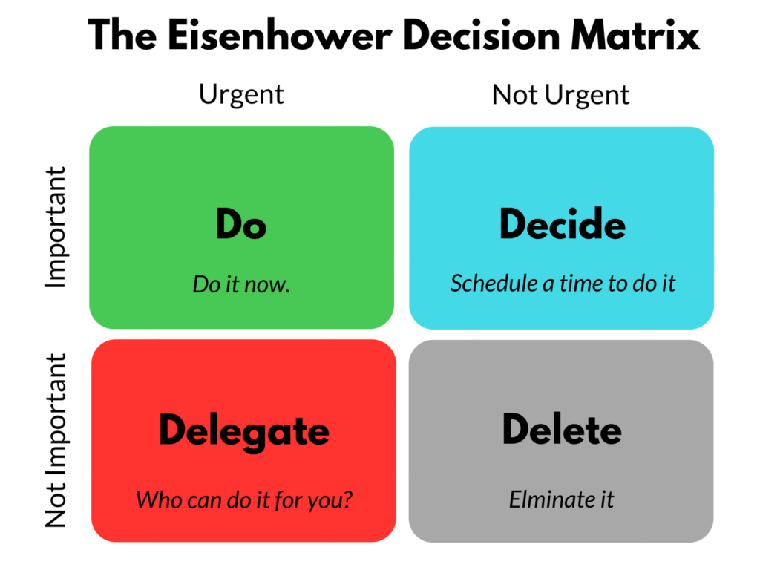
This was extremely useful to me in terms of simplifying and organising my workload.

“Most successful people have one thing in common, they start their day early, as it gives them time to sit, think, and plan their day.” (Conlon, C. 2016)

I have now begun to use this matrix to organise my day to day studies and work commitments and it has significantly reduced the amount by which I procrastinate.
The Fourth Stage: “Planning/Executing what was learned”: The next most important thing after learning all of these techniques to improve my management of time and organisational skills, is to implement it.
Investing in a planner has also aided my endeavours in this regard.
Now, whenever I have a task to complete, I start planning and drafting it immediately. Aside from the obvious positive effects this has had on my learning experience and the results of my University work, this has also benefitted me greatly in my employment.
Being in a management position in my industry, and keeping in mind that my aim is to be promoted even higher in this industry, it was essential that I got this issue of procrastination under control and reflective cycles have been invaluable in attaining this.

