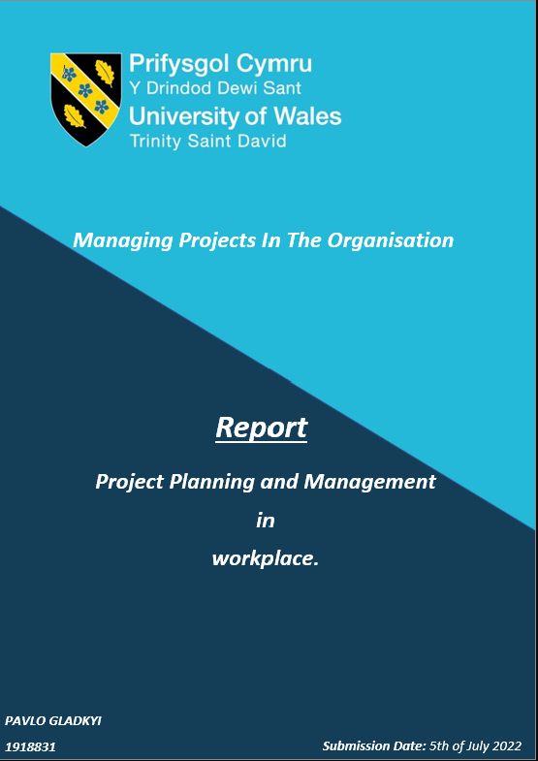

Executive Summary.

In this report, Pavlo discussed available Project Management tools and theories and examined their usability and practical application during the "Ukrainian refugees - are they welcome in the UK?" project that Group C delivered as a part of their Managing Projects In The Organisation assignment.
This assignment consisted of three parts: blogs, project presentation and report. Each of these parts was created to show Pavlo's understanding of Project Management and practically demonstrate his knowledge during the project delivery.
As the project team already represented the project, the discussion in this report will be arround the critical assessment of Project Management tools and techniques used as a support mechanism for the Project Life Cycle.
Additionally, the "Ukrainian refugees - are they welcome in the UK?" project-related information is available in the report's appendices.
The author found the Project Management tools helpful in supporting the project. However, he also criticised their practicality and versatility. Moreover, he concluded that each project is unique, and a flexible approach is recommended to achieve the best results.

Table of Contents

List of Figures. 1
1.0 Introduction. 2
2.0 Findings. 3
2.1 Project Initiation phase. 3
2.2 Project Planning phase. 4
2.3 Project Execution phase. 6
2.4 Project Closure phase. 8
2.4 Project Evaluation. 9
3.0 Conclusions. 10
Reference List. 11
Appendices. 12

List of Figures.

- Figure 1: Group C – Team Skill MIX………………………………………………4

- Figure 2: Project Quad Chart………………………………………..……………...5

3. Figure 3: Project Stakeholders Analysis………………………………..…………..6

4. Figure 4: Project Work Breakdown Structure……………….……….…………...7
5. Figure 5: Project Gantt chart (Completed)……………………………………….. 7
6. Figure 6: Project Risk Assessment Grid.……………………………………..…….8

7. Figure 7: Ukrainian Refugees-are welcome in the UK? - project Evaluation…....9

1.0 Introduction.

This formal report was created on 14/06/2022 at the request of the module lecturer - Doctor Shehla Khan, as a part of Pavlo's Gladkyi assignment.
To meet the deliberated requirements for the assignment, Pavlo submitted his report via Turnitin on 01/07/2022.

The main purpose of this report is to demonstrate the author's understanding of project management and his ability to use available PM tools to manage projects within the workplace.

Additionally, within the report context, Pavlo discussed and critically analysed project management tools and techniques and their purpose in each project stage.

The overview and the author's reflection are provided on the Quad chart, Stakeholders analysis, Work Breakdown Structure and Gantt chart.

Moreover, as a part of a practical demonstration of the obtained knowledge and developed skills, Pavlo completed the project related to the Homes for Ukraine program, created by the UK government in response to the ongoing Russian military attack on Ukraine and genocide of the Ukrainian people.
The project's main aim was to raise awareness of the ongoing war, refugees' needs, and barriers they can face during the Sponsorship scheme application. In addition, project objectives included primary and secondary research to find available help in Wales and propose feasible solutions to improve Ukrainian refugees' integration and ameliorate their overall experience.

During the project, Pavlo held a project manager role and supported his team of three people through all the project phases ensuring quality deliverables.

This report also contains all the produced project-related charts, questionnaires and other materials, which are located in the appendices.

To complete this report on a sufficient level, Pavlo used various credible sources of information such as governmental websites, articles, blogs, and in-person communication.

2.0 Findings.

Every project within the organisation starts with an idea to deliver a change or improve an existing process (Frederick, 2014). Thus the fundamental differences between the project and process are apparent – the project has a predetermined duration with a defined start and end and limited resources. In contrast, the process is a repeatedly performed task, where a defined set of steps lead to its accomplishment (SYDLE, 2021).
Moreover, Wuilleumier (2022) states that the process focuses on work standardisation and project on work improvements. Hence the project must have a clear aim and objectives and organised unique activities to ensure its deliverables.
Consequently, Project Management (PM) exists to manage project phases and mitigate any foreseeable risks or eventualities that can defer a successful project delivery. That is why the project manager must have specific leadership traits, multi-faceted skill sets, and a clear vision of the team members' professional profile that will allow completing the project.
Indeed, without a proficient manager project will be less likely to succeed (APM, 2019). However, Windsor (2021) argued that external and internal contexts must also be considered a potential project threat.
According to Brown (2021), the Project Life Cycle (PLC) has a structure that defines the boundaries of the easily distinguishable phases – Initiation, Planning, Execution and Closure, where each stage depends on the previous stage's completion. Moreover, this structure exists to facilitate project team navigation by avoiding chaos and allowing organised workflow in each specific project phase time frame (Naybour, 2020).
It is noteworthy that various PM tools can support different PLC phases to increase the efficiency of the project activities, such as planning or monitoring, and, more importantly, help focus on the main objectives throughout the project (ZOHO, 2022).
In contrast, inappropriate use of PM tools and techniques can lead to project failure (Quiambao, 2021). However, the influence of project tools on the positive project outcome is still debatable (Goncalves, 2018).

2.1 Project Initiation phase.

According to Heagney (2016), the project initiation phase is highly important to confirm the idea of what and why must be achieved, the project time frame, decide on a project manager position and form a project team.
Furthermore, the project team forming process could be done using a Belbin's team roles test. Therefore members can evaluate their strengths and working styles, gather a deeper understanding of their most suitable team roles to contribute to project objectives achievement, and add value to the team (Harrin, 2022).
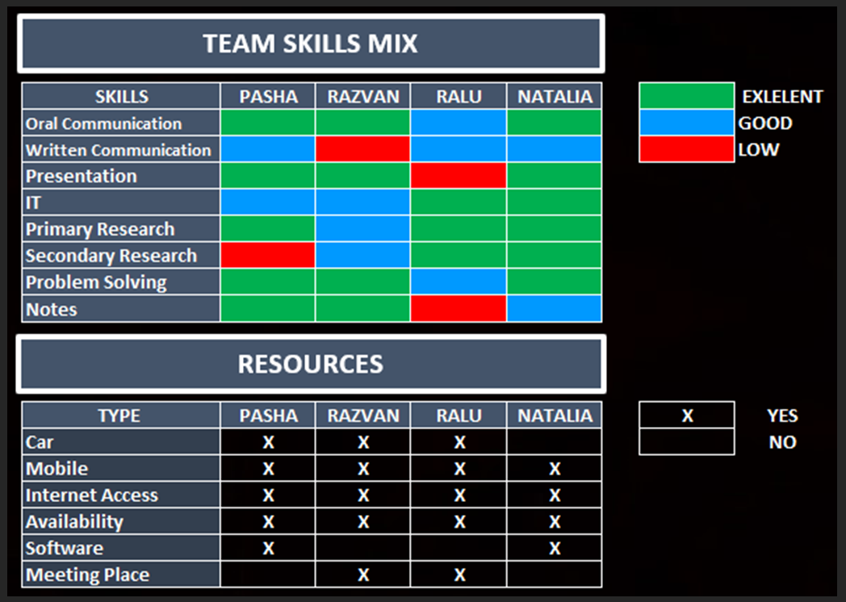
As a project manager, the report's author formed a team of four people to tackle a research project related to the ongoing Russian invasion of Ukraine and the situation of displaced Ukrainian people seeking shelter in the UK (Brown, 2022). The team roles were allocated based on Belbin's team roles test and the Team Skill Mix results (Belbin, 2022).

Figure 1: Group C – Team Skill MIX.
During the informal discussion, the project team decided that the research field of the project would focus on the Homes for Ukraine governmental initiative and the Sponsorship scheme in particular (gov.uk, 2022). This decision was deemed beneficial for all stakeholders, technical feasibility and plethora of available resources to produce deliverables.
Additionally, the report's author used the Iron Triangle framework to evaluate and balance three interdependent crucial aspects of the project, where time, cost and quality directly correlate and affect the project scope and also to ensure a SMART status of the project scope (Ebbesen and Hope, 2013).

2.2 Project Planning phase.

The successful Initiation phase accomplishment and creation of the Quad Chart led to a clear understanding of further planning, critical success factors and desired project outcomes.
Keenan (2020) stated that this tool is a one-page technical document of succinctly presented project-related information divided into four basic categories to visualise project details and facilitate planning and rapid decision-making.
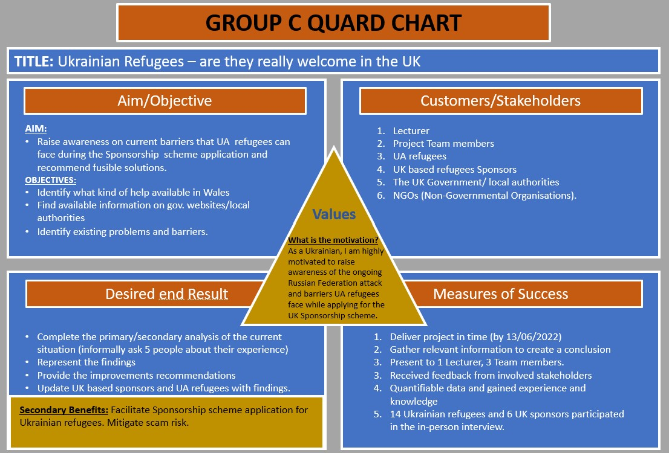
For instance, as the project aimed to raise awareness of the current barriers that Ukrainian refugees can face during the Sponsorship scheme application, the project's title has an attractive function to target a wide range of audiences in the society and internal and external stakeholders.

Figure 2: Group C – Quad Chart.
The defined aim and objectives in the first Quad chart field are connected with measurable or unmeasurable desired end results whereby they can be quantitively and qualitatively measured in the fourth chart's field – Measure of success accordingly. Furthermore, the second field reveals all stakeholders, whether they have direct or indirect benefits or different involvement and impact levels.
Moreover, as depicted in Figure 2, the first field is linked with the third and describes what actions will make project deliverables attainable. For instance, the project team must conduct primary and secondary research to identify existing problems and barriers and help available in Wales.
The Quad chart also contains the motivation behind why this project must be done and secondary benefits that provide a comprehensive and deeper view of the subject.

Additionally, in this phase, it is useful to undertake a Stakeholders Analysis (SA) to have a detailed comprehension of all involved in the project parties, their level of input and influence and needed actions to keep them interested (Riley, 2018).
As an advantage, the SA provides clarity and understanding of stakeholders and allows prioritising them accordingly. However, it is hard to disagree with Guthrie (2021) that the SA is usually a static document that precludes stakeholders' volatility during the project time scale, especially in long-duration projects. Similarly, Leonard (2020) declares that SA is a time-consuming activity where assessment itself can be subjective or biased, as it will provide focus mainly on the most important stakeholders.
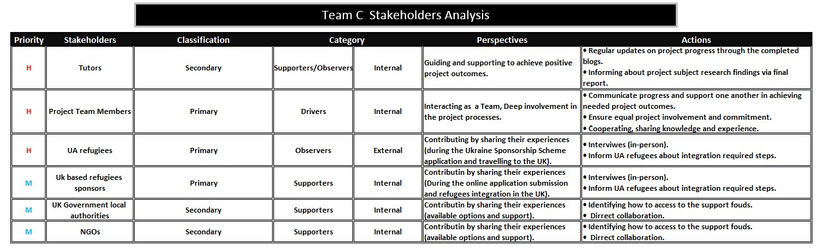

Figure 3: Group C – Stakeholders Analysis.

2.3 Project Execution phase.

The Execution phase comprises resources and tasks assignment, establishing the progress tracking system, primary and secondary research, risk assessment and performance monitoring. According to Ransom (2019), all these activities aim to deliver a final product and can be supported by PM tools to increase project management efficiency by visualising tasks' accomplishment progress.
The report author used a top-down approach to complete a Work Breakdown Structure (WBS) – a result-orientated chart tree to manage the project workflow and break tasks from the Quad chart box three into smaller portions (Kukhnavets, 2022). Moreover, the benefits of the WBS are apparent, as the project and tasks correlation is easily illustrated and can be logged into the Gantt chart for further project execution progress monitoring in the required timeline (Gantt, 2019).
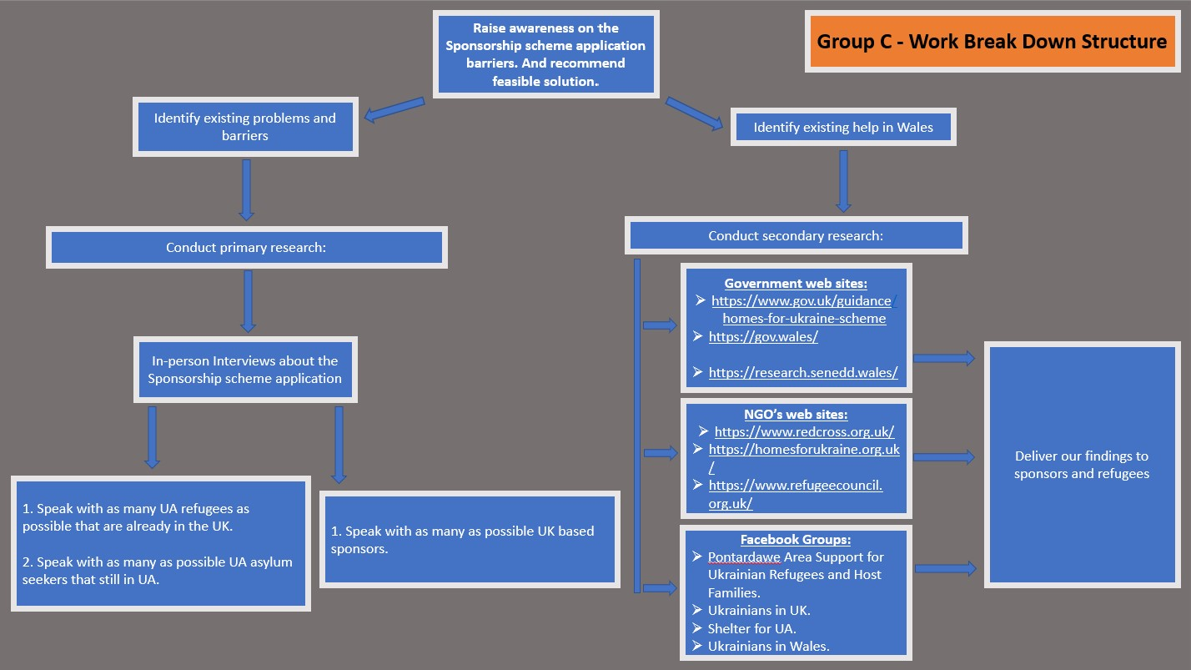

Figure 4: Project Work Breakdown Structure (WBS).
On the contrary, the WBS cannot be used for monitoring and flexible task adjustments. Furthermore, it must be accompanied by a Gantt chart diagram as its clear layout of task dependencies facilitates scheduling and progress tracking. However, the report's author argues that creating the additional tool is time-consuming and impugned the WBS actual necessity in this particular project, where a simple list of tasks and activities can be more applicable.
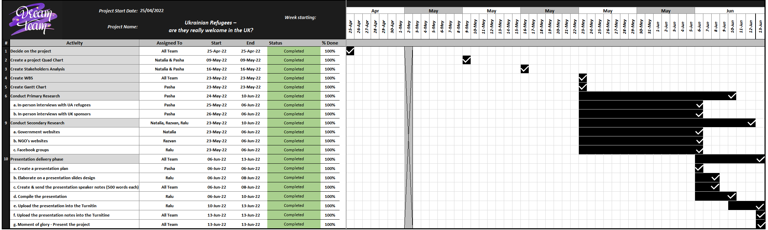

Figure 5: Project Gantt chart (Completed).

2.4 Project Closure phase.

According to Lucid Content Team (2019), a project closure phase is the formal finalisation and presentation of deliverables. Furthermore, during this phase, the project status must be communicated to all stakeholders.
However, Eby (2021) argues that project closure is a critical last phase of the PLC, as it helps define the organisational culture, gives a sense of accomplishment and provides learning experiences.
It is worth mentioning that the Gantt chart is not the only existing solution to monitor the project. Although the Gantt chart has tremendous monitoring power, this tool has limitations related to the risk tracking options (Project-Management.com, 2018).
As a solution, the project Group C used a dynamic Risk Analysis Grid, which provides agility and room for manoeuvre and remedial actions implementation (Boogaard, 2022). Moreover, identified by SWOT and PESTLE analysis, risks could be categorised and evaluated throughout the project to mitigate or eliminate risks through the action plan (Gray, 2016).
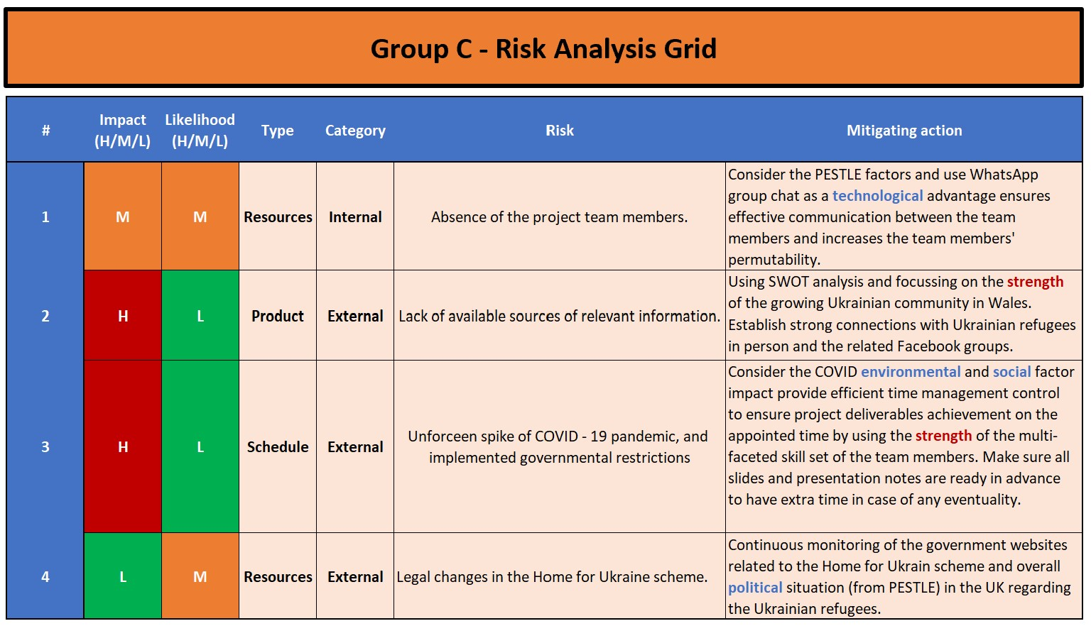

Figure 6: Project Risk Assessment Grid.
In addition to risk category and type, the impact and likelihood are also considered, which play a crucial role in risk prevention measures (AuditBoard Inc., 2021).

2.4 Project Evaluation.

Evaluation is unequivocally one of the essential parts of the project that allows the project team to reflect on all previous stages and evaluate their performance and final goal achievement (Landau, 2022).
Indubitably, that monitoring and evaluation are two different processes. Although they share similar tools and methods, they have fundamental differences and project activities.
For instance, Surbhi (2017) states that monitoring is a part of the project control system and evaluation is an analytical and reflection process.
Similarly, The AiA Team (2019) contends that monitoring is a continuous internal process related to progress and performance control. In contrast, evaluation is usually an externally conducted systematic analysis of the overall value of the project activities' outcome.
Intrinsically, evaluation is an analytical process with a broader scale of expertise that focuses on further improvements (Pearline, 2017).
Following the project closure procedure, the Group C project team produced deliverables and introduced measurable and quantifiable results during the project presentation.
Moreover, as a project manager, the report's author assessed project outcomes and team performance, evaluated critical success factors indicated in the Quad chart box four and created a lesson learned conclusion.
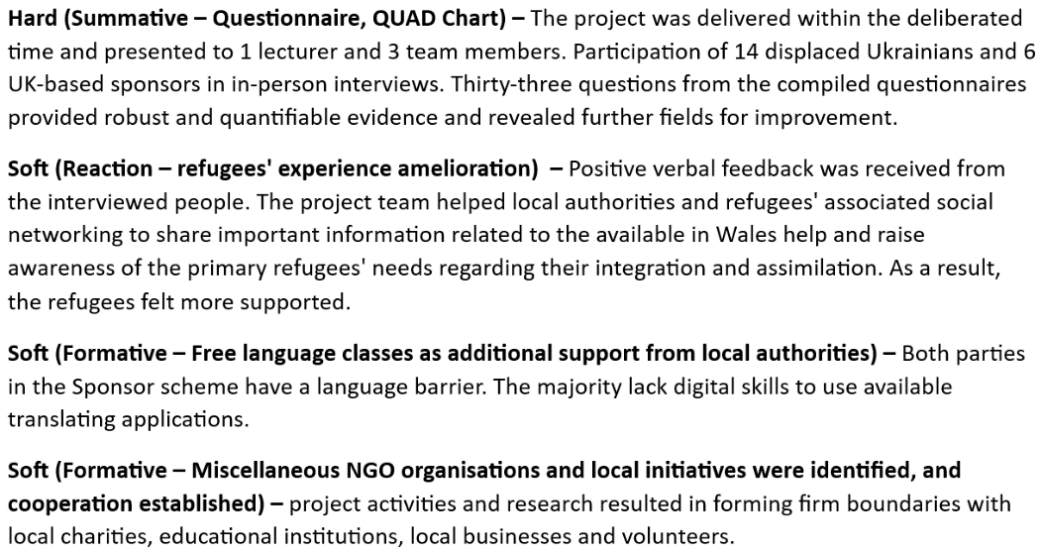

Figure 7: Ukrainian Refugees – are welcome in the UK? - project Evaluation.
SAPM (2014) declares that the evaluation method can de Subjective and Objective. Moreover, both these methods must be used equally during the evaluation as they will complete one another and provide a comprehensive picture. Therefore the project evaluation process must be complex and also incorporate summative, illuminative, formative and participative evaluations of the whole project.

3.0 Conclusions.

To recapitulate the findings. After the research on the available Project management tools and their practical application throughout the "Ukrainian refugees – are they welcome in the UK?" project, it was concluded that all aforementioned in this report PM tools are helpful and fit for the purpose of providing clarity to the different PLC phases and supporting and organising project-related activities and tasks.

The report's author understands the necessity of the PM tools as a part of the PM learning process. However, he noticed that in this particular project, using some of the tools was redundant and time-consuming.
Thus, each project is unique in its purpose, scale, cost and timeframe. Hence, there are no right or wrong tools or methods to use as long as they are cost-effective and ensure quality deliverables.

Nonetheless, there is no doubt that existing PM tools and methods make the project delivery process more straightforward and structured.
Ultimately, the project's successful outcome not only depends on PM tools and methods but is also influenced by internal and external contexts, effective teamwork and the leadership abilities of the project manager.

Regarding the delivered project, subjectively, as a project manager, Pavlo can declare an overall project success. The quantifiable results were introduced during the presentation and aligned with the Measure of success box in the Quad chart.
Moreover, the objective evaluation of the project outcome also confirmed the achievement of all described in the project scope goals.

Additionally, the project team performance was excellent and consistent throughout all project stages. The team members' high level of dedication, responsiveness and proactivity enabled them to finalise the project by providing quality deliverables in the required time.

Pavlo's post-project self-reflection revealed certain areas for further improvement related to practical communication skills and information delivery. Hence, Pavlo will work on his writing skills.

Reference List.

APM (2019). What does a project manager do | APM. [online] Apm.org.uk. Available at: https://www.apm.org.uk/jobs-and-careers/career-path/what-does-a-project-manager-do/ [Accessed 11 May 2022].
AuditBoard Inc. (2021). What Is a Risk Assessment Matrix? And Why Is It Important? [online] AuditBoard. Available at: https://www.auditboard.com/blog/what-is-a-risk-assessment-matrix/ [Accessed 28 Jun. 2022].
Belbin (2022). Belbin Team Roles. [online] Belbin. Available at: https://www.belbin.com/about/belbin-team-roles [Accessed 28 Jun. 2022].
Boogaard, K. (2022). What is a Risk Matrix? (With Example) | Wrike. [online] www.wrike.com. Available at: https://www.wrike.com/blog/what-is-risk-matrix/#What-is-a-risk-assessment-matrix-in-project-management [Accessed 3 Jun. 2022].
Brown, D. (2022). Ukraine invasion: Russia's attack in maps. BBC News. [online] 24 Feb. Available at: https://www.bbc.com/news/world-europe-60506682 [Accessed 28 Jun. 2022].
Brown, L. (2021). 5 Phases of Project Management Life Cycle You Need to Know - Invensis Learning Blog. [online] Invensis Learning Blog. Available at: https://www.invensislearning.com/blog/5-phases-project-management-lifecycle/ [Accessed 12 May 2022].
Ebbesen, J.B. and Hope, A. (2013). The Iron Triangle: Embedding Sustainability into Project Constraints - Northumbria Research Link. Northumbria.ac.uk, [online] 2(3). Available at: http://nrl.northumbria.ac.uk/11311/ [Accessed 12 May 2022].
Eby, K. (2021). Project Closure Guide | Smartsheet. [online] www.smartsheet.com. Available at: https://www.smartsheet.com/content/project-closure [Accessed 27 Jun. 2022].
Frederick, T. (2014). The reasons for undertaking projects. [online] Business Support for Entrepreneurs. Available at: https://www.fftsbiz.com/the-reasons-for-undertaking-projects/ [Accessed 28 Jun. 2022].
Gantt (2019). What is a Gantt Chart? Gantt Chart Software, Information, and History. [online] Gantt.com. Available at: https://www.gantt.com/ [Accessed 27 May 2022].
Goncalves, I. (2018). Why Project Management Software Fails? A Foolproof Guide to Choose the Right Tool. [online] Brief Chat & Task Manager. Available at: https://gobrief.com/blog/boost-your-productivity/team-management/project-management-software [Accessed 28 Jun. 2022].
gov.uk (2022). Ukraine Family Scheme and Ukraine Sponsorship Scheme (Homes for Ukraine) Visa Data. [online] GOV.UK. Available at: https://www.gov.uk/government/publications/ukraine-family-scheme-application-data/ukraine-family-scheme-and-ukraine-sponsorship-scheme-homes-for-ukraine-visa-data--2 [Accessed 7 Jun. 2022].
Gray, B. (2016). How to Effectively Conduct a PESTLE & SWOT Analysis. [online] Linkedin.com. Available at: https://www.linkedin.com/pulse/how-conduct-pestle-swot-analysis-byron-gray [Accessed 3 Jun. 2022].
Guthrie, G. (2021). Improving long-term business health with stakeholder theory. [online] Backlog. Available at: https://backlog.com/blog/improving-long-term-business-health-stakeholder-theory/ [Accessed 28 Jun. 2022].
Harrin, E. (2022). 10 Reasons Why Teamwork Matters in Project Management. [online] https://rebelsguidetopm.com/. Available at: https://rebelsguidetopm.com/10-reasons-why-teamwork-matters-in-project-management/ [Accessed 28 Jun. 2022].
Heagney, J. (2016). Fundamentals of project management. 5th ed. New York: Mcgraw-Hill.
Keenan, R. (2020). A brief intro to Quad(rant) charts» Positioning Insights. [online] Positioning Insights. Available at: https://positioninginsights.com.au/quad-charts/ [Accessed 12 Jun. 2022].
Kukhnavets, P. (2022). Work Breakdown Structure (WBS) in Project Management. [online] Gantt Chart GanttPRO Blog. Available at: https://blog.ganttpro.com/en/how-to-create-a-work-breakdown-structure-wbs-with-project-planning-templates/ [Accessed 27 May 2022].
Landau, P. (2022). Improving Your Project Evaluation Process - ProjectManager.com. [online] ProjectManager.com. Available at: https://www.projectmanager.com/blog/improving-project-evaluation-process [Accessed 6 Jun. 2022].
Leonard, K. (2020). Advantages and Disadvantages of Stakeholders. [online] Chron.com. Available at: https://smallbusiness.chron.com/advantages-disadvantages-stakeholders-32179.html [Accessed 28 Jun. 2022].
Lucid Content Team (2019). 7 Steps to Nail the Project Management Closure Process | Lucidchart Blog. [online] www.lucidchart.com. Available at: https://www.lucidchart.com/blog/nailing-the-project-management-closure-process [Accessed 27 Jun. 2022].
Naybour, P. (2020). Explain 5 Benefits of a Project Lifecycle. [online] Parallel Project Training. Available at: https://www.parallelprojecttraining.com/blog/explain-5-benefits-of-a-lifecycle/ [Accessed 28 Jun. 2022].
Pearline, D. (2017). What is the difference between monitoring, evaluation, and control? [online] Quora. Available at: https://www.quora.com/What-is-the-difference-between-monitoring-evaluation-and-control [Accessed 28 Jun. 2022].
Project-Management.com (2018). Advantages and Disadvantages of Gantt Charts. [online] Project-Management.com. Available at: https://project-management.com/advantages-and-disadvantages-of-gantt-charts/ [Accessed 27 Jun. 2022].
Quiambao, L. (2021). 5 Reasons Why Project Work Plans Fail and How to Avoid Them. [online] www.wrike.com. Available at: https://www.wrike.com/blog/5-reasons-why-project-work-plans-fail-and-how-to-avoid-them/ [Accessed 28 Jun. 2022].
Ransom, N. (2019). The Execution Phase of Project Management - Video & Lesson Transcript | Study.com. [online] Study.com. Available at: https://study.com/academy/lesson/the-execution-phase-of-project-management.html [Accessed 28 Jun. 2022].
Riley, J. (2018). Stakeholders and Stakeholder Mapping. YouTube. Available at: https://www.youtube.com/watch?v=gc55hPIFW8w [Accessed 20 May 2022].
SAPM (2014). Duality of Project Management: Objective vs. Subjective factors – SAPM: Course Blog. [online] https://blog.inf.ed.ac.uk/sapm/2014/03/07/response-to-duality-of-project-management-objective-vs-subjective-factors/. Available at: https://blog.inf.ed.ac.uk/sapm/2014/02/14/duality-of-project-management-objective-vs-subjective-factors/ [Accessed 28 Jun. 2022].
Surbhi (2017). Difference Between Monitoring and Evaluation (with Comparison Chart) - Key Differences. [online] Key Differences. Available at: https://keydifferences.com/difference-between-monitoring-and-evaluation.html [Accessed 28 Jun. 2022].
SYDLE (2021). Post title. [online] SYDLE. Available at: https://www.sydle.com/blog/projects-and-processes-what-is-the-difference-614e00a1a9d8415db45a9230/ [Accessed 28 Jun. 2022].
The AiA Team (2019). Differences Between Monitoring and Evaluation. [online] Analytics in Action. Available at: https://analyticsinaction.co/differences-between-monitoring-and-evaluation [Accessed 28 Jun. 2022].
Windsor, G. (2021). External and Internal Factors to Include in Project Planning. [online] BrightWork.com. Available at: https://www.brightwork.com/blog/external-and-internal-factors-to-include-in-project-planning [Accessed 28 Jun. 2022].
Wuilleumier, I. (2022). Project vs. Process: Difference & Examples. [online] Pipefy. Available at: https://www.pipefy.com/blog/difference-projects-processes/ [Accessed 28 Jun. 2022].
ZOHO (2022). What are the Top Project Management Tools? - Zoho Projects. [online] Zoho. Available at: https://www.zoho.com/projects/project-management-tools.html [Accessed 28 Jun. 2022].

Appendices.

Primary Research – Questionnaire



