Climate Change and Visual Activism Vlog Assignment

What is global warming?
Global warming is the increase of the earth’s surface temperature; one severe negative impact is rising sea levels. According to NASA the average global sea height has risen by 102.5 millimetres since 1993 (NASA, 2023). This occurs as more GHGs are being emitted the atmosphere and being absorbed causing it to be highly concentrated. Resultantly, less heat from the sun is trapped keeping the planet warmer than it would be without them (NASA, 2023). Consequently, the cryosphere is melting causing the albedo affect and creating a negative feedback loop. As the ice melts there are less reflective surfaces so more heat radiation is absorbed as oppose to being reflected (Met Office , n.d.).

Local Issues
Average sea levels are rising and although is a global issue it is apparent in Swansea. This is causing many issues in Wales, meaning mitigations such as seawalls are having to be put in place. The Senedd, however, have estimated these mitigations are costing on average £200 million of damage annually from flooding and sea level rise. Senedd have predicted this cost will increase 18 fold by 2080 putting severe stress on the economy (Paris, n.d.).The future of Swansea is under threat both environmentally as a coastal city and its economy.

Mitigations and Solutions
Mitigations to the coastal erosion are already being implemented such strengthening Mumbles Sea Wall (Swansea Council, 2018). Long term projects such as the Blue Eden Project can act as long term solutions (Swansea Council, 2021); it aims to use the tidal range to produce renewable energy. This means Swansea will be able to run on renewable energy and therefore emitting less GHGs.

Dissemination of the Vlog
This vlog will be posted across many social media platforms. I intend to maintain the consistency by creating a social media account with the same name and branding. The viewer would have a sense of familiarity within the branding and it would feel more trustworthy. The first social media platform I would use is TikTok as it is renowned for short videos which would engage the viewer. I would then post this on Instagram, Facebook and Twitter so it would be shown on the ‘explore page’ and be amongst other related viewers. When posting I would use relevant hashtags with the videos, as according to the digital marketing institute to attract people with similar interests and those whom have previously interacted with other posts with the same or similar hashtags (O'brien, 2022). This then helps building a larger community around the subject and show within existing communities faster to help spread the word.

Vlog Storyboard

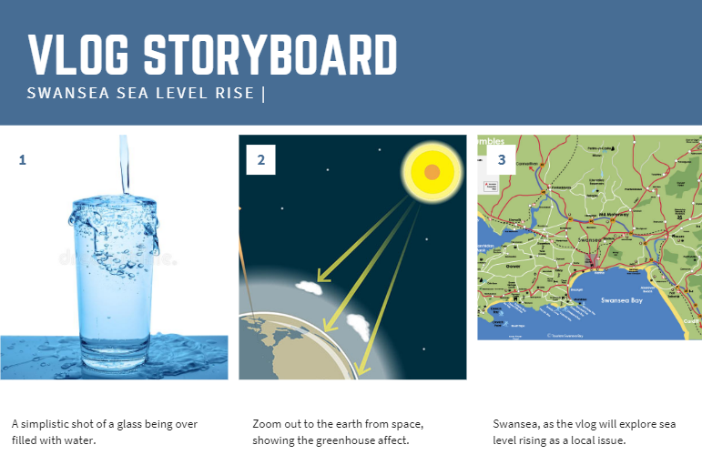
(Alisali, 2023) (British Geological Survey, 2023) (Tourism Swansea Bay, 2023)

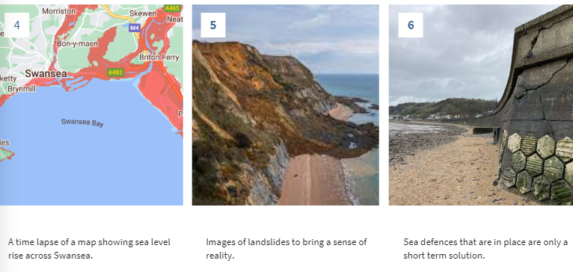
(Climate Central, 2021) (Millen, 2021) (Youle, 2022)
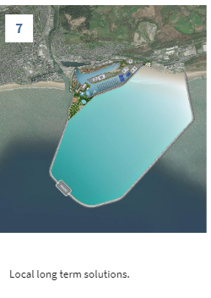
(Swansea Council, 2021)

References
A., 2023. 676 Water Overflowing Glass Stock Photos, Images & Pictures. [Online]
Available at: https://www.dreamstime.com/overflowing-mineral-water-transparent-glass-drops-bu-overflowing-mineral-water-transparent-glass-drops-image119980903
[Accessed 28 01 2023].
British Geological Survey, 2023. The greenhouse effect.
Climate Central, 2021. Land Below 5.0 Meters of Water. [Online]
Available at: https://coastal.climatecentral.org/map/12/-3.9121/51.615/?theme=water_level&map_type=water_level_above_mhhw&basemap=roadmap&contiguous=true&elevation_model=best_available&refresh=true&water_level=5.0&water_unit=m
[Accessed 28 01 2023].
Met Office , n.d. Albedo. [Online]
Available at: https://www.metoffice.gov.uk/weather/learn-about/weather/atmosphere/albedo
[Accessed 28 01 2023].
Millen, R., 2021. Huge landslide causes biggest rockfall in 60 years on West Country coast, Dorset: Somerset Live.
NASA, 2023. Global Climate Change Vital Signs of the Planet. [Online]
Available at: https://climate.nasa.gov/vital-signs/sea-level/
[Accessed 28 01 2023].
NASA, 2023. Global Climate Change Vital Signs of the Planet. [Online]
Available at: https://climate.nasa.gov/faq/19/what-is-the-greenhouse-effect/#:~:text=The%20greenhouse%20effect%20is%20the,it%20would%20be%20without%20them.
[Accessed 28 01 2023].
O'brien, C., 2022. Digital Marketing Institute. [Online]
Available at: https://digitalmarketinginstitute.com/blog/how-to-use-hashtags-in-social-media#:~:text=A%20hashtag%20is%20a%20word,your%20posts%20and%20encourage%20interaction.
[Accessed 28 01 2022].
Paris, V., n.d. Is Wales ready for sea level rise and flooding? , Cardiff: Research Service.
Swansea Council, 2018. Mumbles coastal protection project, Swansea: GOSS.
Swansea Council, 2021. £1.7 billion Blue Eden project announced for Swansea, Swansea : GOSS.
Tourism Swansea Bay, 2023. Map Of Swansea Bay. [Online]
Available at: https://www.tourismswanseabay.co.uk/untitled-page-2021-11-02-152616/
[Accessed 28 01 2023].
Youle, R., 2022. Wider prom and new seawall approved for Mumbles, Swansea: Wales Online.

