Programme BA Business Management Module Community Engagement Module Code LCBB4011 Lecturer Dr.Akash Puranik Assignment Title Assessment Component Community Engagement Portfolio Student ID:2315021 Student Name Ana Maria Haba | 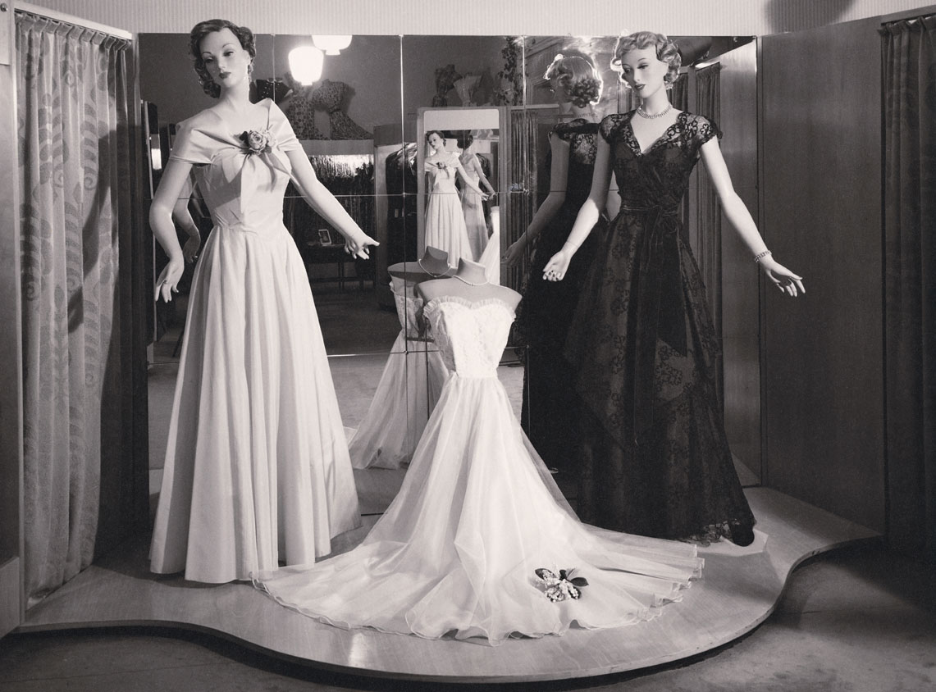
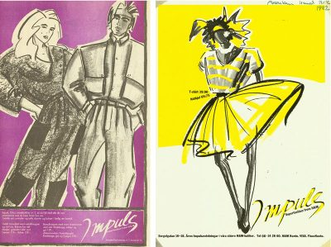 | 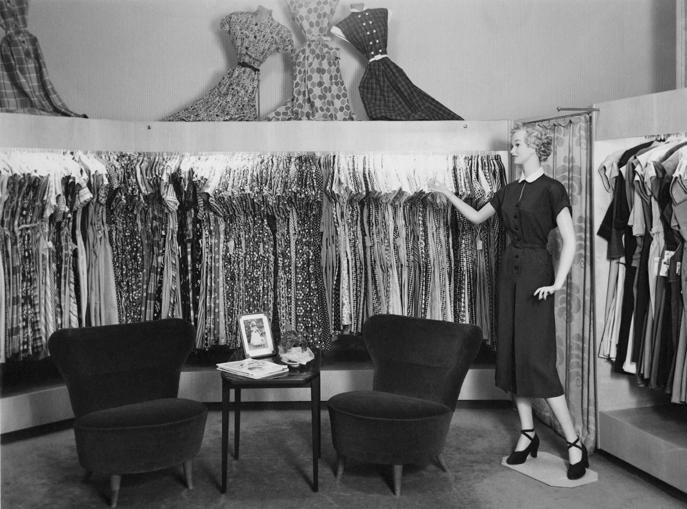
  - History 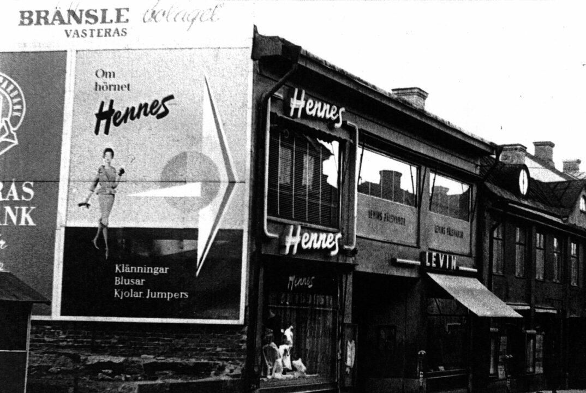
Our founder had a vision. Erling Persson wanted to make great fashion available and affordable to everyone and do this in the right way. From a single store in 1947 we became a family of brands offering fashion and design to customers worldwide. This is our story.

Erling Persson, inspired by a New York City trip, opened Hennes, a womenswear store in Västerås, Sweden, in 1947, designing the iconic Hennes logotype himself.

In 1952, Stockholm's first Hennes store opened, and in 1954, the company launched a pioneering full-page color ad in Sweden's largest daily, demonstrating the power of marketing.
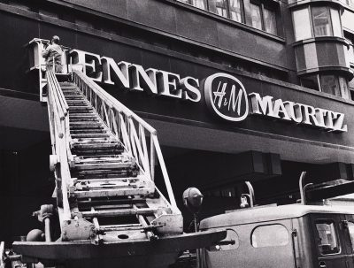

an ’70
- 1968 After Hennes buys out Stockholm-based Mauritz Widforss, a retailer of fishing and hunting gear, the company renames itself Hennes & Mauritz. The shops begin stocking men's and kids' apparel, meeting the needs of every family member in terms of style. 1969 With 42 locations, Hennes & Mauritz is rapidly expanding. These are the decades when the global expansion starts. Norway is ranked #1, then Denmark, the United Kingdom, and Switzerland. Five or six additional stores open annually, indicating an even faster rate of expansion. Hennes & Mauritz begins marketing undergarments in 1973. Anni-Frid Lyngstad, an ABBA member, becomes the company's first "supermodel" to be -.

- In 1974, Hennes & Mauritz is listed on Stockholm Stock Exchange, rebranded as H&M. In 1977, the Impuls concept was launched, inspired by US denim stores.

’60s-’70s

’80s-’90s

’00s-’10s

’20s-

Erling Persson, inspired by a New York City trip, opened Hennes, a womenswear store in Västerås, Sweden, in 1947, designing the iconic Hennes logotype himself.

1952
The first Hennes store opens in Sweden’s capital, Stockholm.
1954
Hennes takes out a full-page colour ad in Sweden’s largest daily, a pioneering belief in the power of marketing.

Inside the first Hennes store in Västerås, Sweden

The ’60s and ’70s

1951 The first Hennes store opens in Stockholm, the capital of Sweden. 54 Hennes adopts a bold approach to marketing by placing a full-page color advertisement in Sweden's biggest daily. Within the original Hennes store located in Västerås, Sweden
These are the decades when the global expansion starts. Norway is ranked #1, then Denmark, the United Kingdom, and Switzerland.
The company is expanding its operations by opening five or six additional stores annually.

- In 1973, Hennes & Mauritz began selling underwear, and ABBA member Anni-Frid Lyngstad became the first "supermodel" to be photographed for the company.
1974
- Hennes & Mauritz is listed on the Stockholm Stock Exchange.
- The stores are rebranded with the abbreviation “H&M”.
- In 1977, H&M launched the Impuls concept, introducing teenagers to its own version of the brand, inspired by US denim stores.

The ’80s and ’90s
In the 1980s, the foundation is laid for the upcoming global expansion. New openings include the first H&M stores in Germany and the Netherlands.

1980
The groundwork for the impending global expansion is done in the 1980s. The first H&M stores to open are in the Netherlands and Germany.
1982
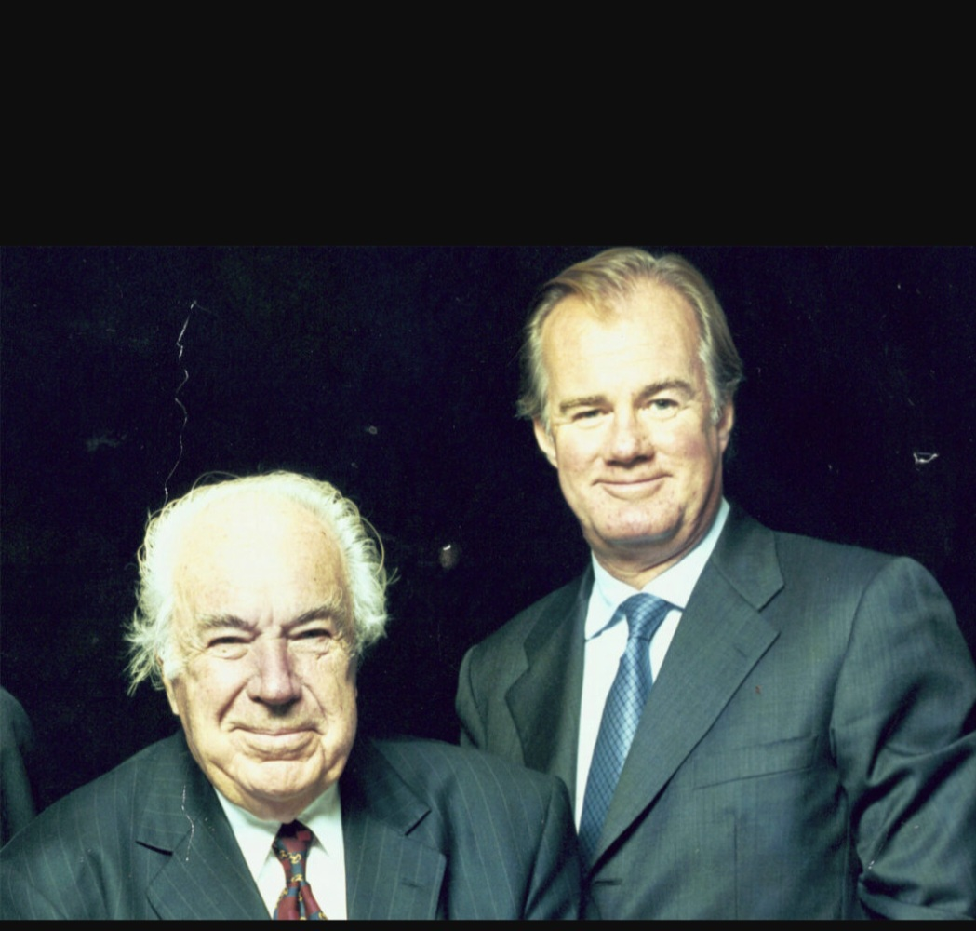
The company gets its second ever CEO, as Erling Persson steps aside to make room for his son, Stefan Persson.ĺ

’80s-’90s

’00s-’10s

’20s-

The ’40s and ’50s
1947
Inspired by his trip to New York City the year before, Swedish entrepreneur Erling Persson opens a new womenswear store in Västerås, Sweden. He calls it Hennes, Swedish for “Hers”. The soon-to-be-famous Hennes logotype is designed by the founder himself.

1952
The first Hennes store opens in Sweden’s capital, Stockholm.
1954
Hennes takes out a full-page colour ad in Sweden’s largest daily, a pioneering belief in the power of marketing.

Inside the first Hennes store in Västerås, Sweden

The ’60s and ’70s

1968
Hennes acquires the Stockholm-based hunting apparel and fishing equipment retailer Mauritz Widforss, and the name is changed to Hennes & Mauritz. The stores start offering men’s and children’s clothing, covering fashion needs for the entire family.
1969
The expansion is rapid: Hennes & Mauritz has 42 stores.
During these decades, the international growth begins. Norway comes first, followed by Denmark, the UK, and Switzerland.
The growth pace increases even further, with five or six new stores opening every year.

1973
– Hennes & Mauritz starts selling underwear.
– ABBA-member Anni-Frid Lyngstad becomes the first “supermodel” to be photographed for the company.
1974
– Hennes & Mauritz is listed on the Stockholm Stock Exchange.
– The stores are rebranded with the abbreviation “H&M”.
In 1974, Hennes & Mauritz began selling underwear, and ABBA member Anni-Frid Lyngstad became the first "supermodel" to be photographed for the company.
The ’80s and ’90s
In the 1980s, the foundation is laid for the upcoming global expansion. New openings include the first H&M stores in Germany and the Netherlands.

In 1980, H&M fashion sold directly to customers' homes through the acquisition of Rowells, a Swedish mail order company, before the term "e-commerce" was coined.
1982 Erling Persson leaves to make place for his son Stefan Persson, becoming the company's second-ever CEO.

1990
The famous annual underwear campaigns are launched featuring supermodel Elle Macpherson, gaining a lot of media attention.

Models from "The Big Six," which included Christy Turlington, Cindy Crawford, Elle Macpherson, Linda Evangelista, and Naomi Campbell, starred in H&M advertisements during the 1990s.The European expansion continues with the addition of four more markets in the 1990s.
- 1998
- – H&M starts offering online shopping. The first online market is Sweden.
- – The first H&M store opens in Paris.

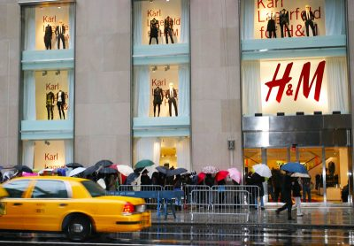
Throughout the 1990s, the European expansion continues with four new market.
1998
– H&M starts offering online shopping. The first online market is Sweden.
– The first H&M store opens in Paris.
1998

- H&M starts offering online shopping. The first online market is Sweden.

- The first H&M store opens in Paris.

The ’00s and ’10s
In 2000, Erling Persson's dream of opening a major H&M flagship store on Fifth Avenue in New York was realized, marking the start of the company's expansion outside Europe.
2002
H&M publishes the first Corporate Social Responsibility Report, marking the beginning of our Sustainability reporting journey.
2004
H&M and Karl Lagerfeld take the world of fashion by surprise, teaming up to show that design isn’t a question of price.

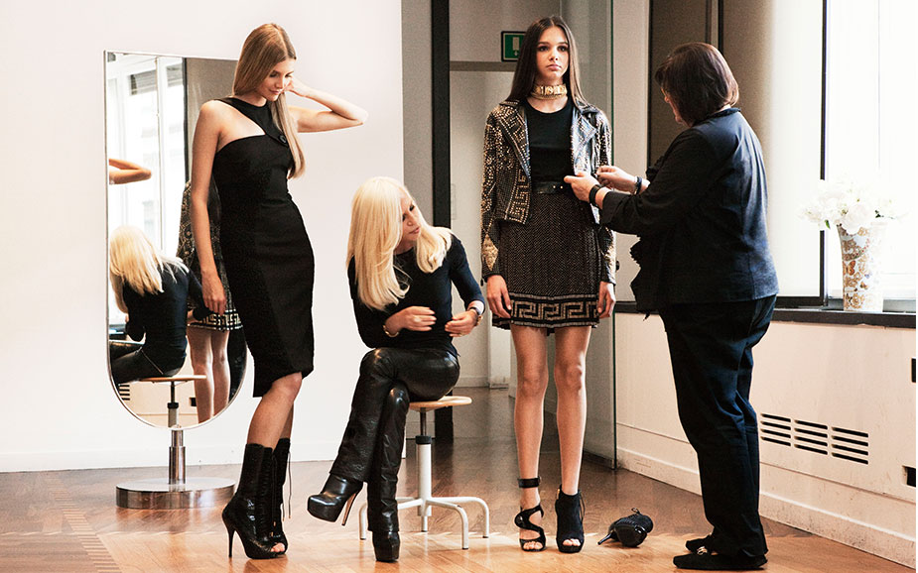
https://hmgroup.com/wp-content/uploads/2023/04/HM-Historical-Collaboration-Jimmy-Choo.jpg

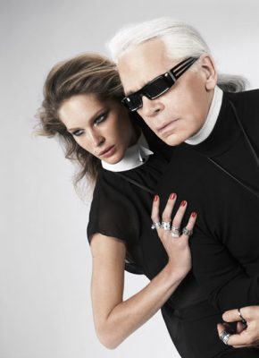

H&M has collaborated with global fashion giants like Stella McCartney, Roberto Cavalli, Versace, and Alexander Wang, as well as A-list celebrities, to make their designs accessible to global fashion enthusiasts.
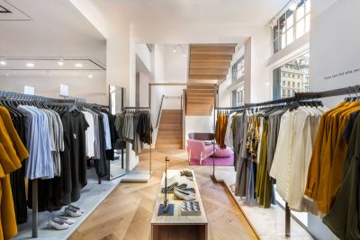
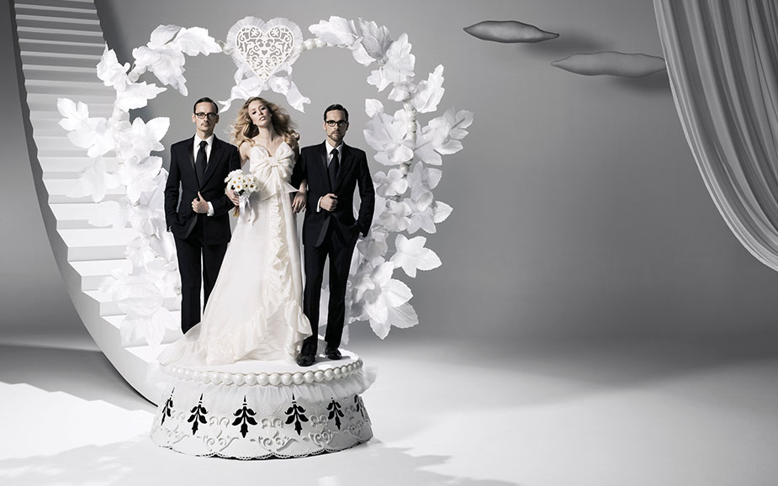
In 2007, H&M opened its first stores in Shanghai and Hong Kong SAR, marking 60 years since the first Hennes store, and launched its first portfolio brand, COS, in London.
2008
Weekday, Monki, and Cheap Monday are welcomed to the H&M group through the purchase of FaBric Scandinavien AB.

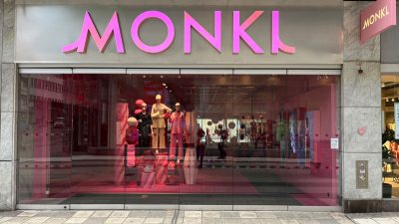

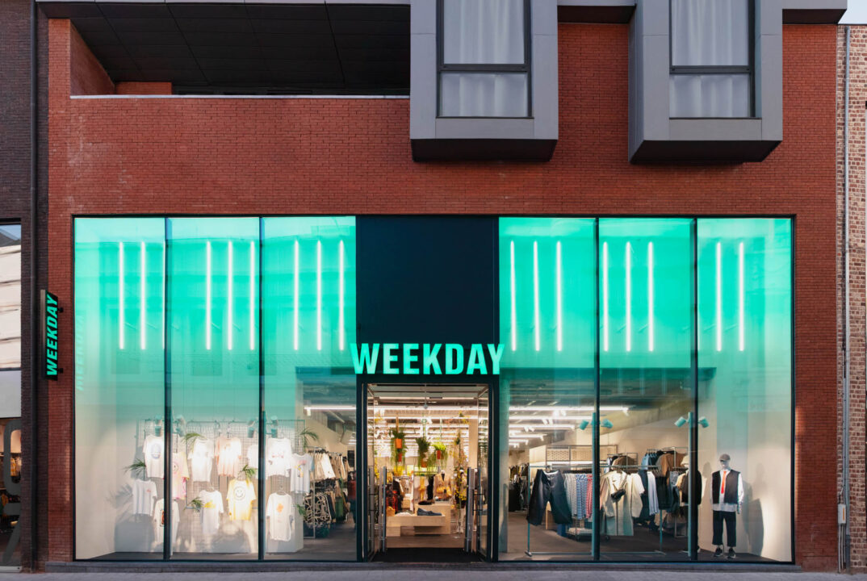
2009
- Home styling becomes more fun thanks to the launch of H&M HOME.
Karl-Johan Persson, Erling Persson’s grandson, takes over as CEO.


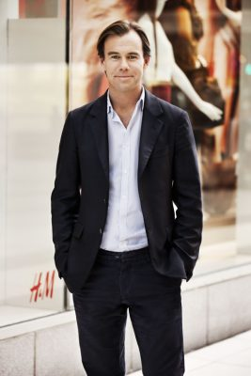
2010

H&M launches its first collection made entirely out of sustainable materials, with many more sustainable initiatives to follow.

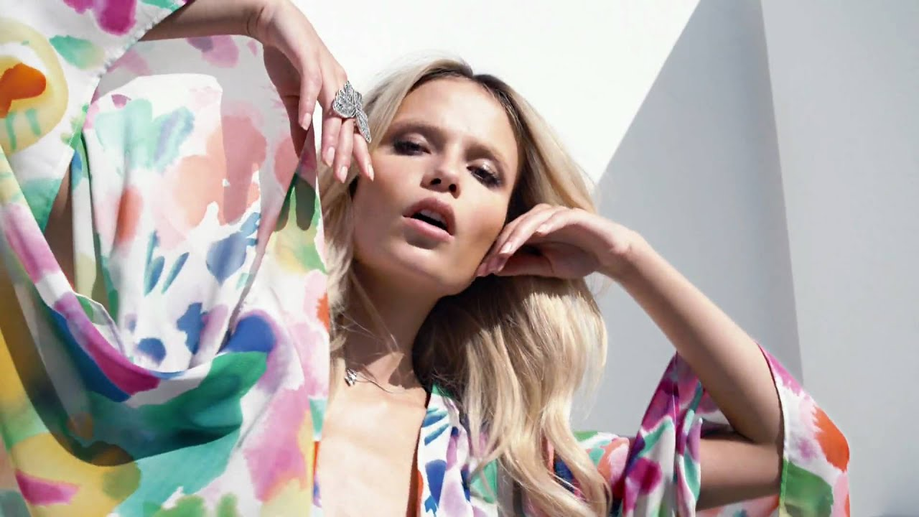

History
Our founder had a vision. Erling Persson wanted to make great fashion available and affordable to everyone and do this in the right way. From a single store in 1947 we became a family of brands offering fashion and design to customers worldwide. This is our story.

’40s-’50s

’60s-’70s

’80s-’90s

’00s-’10s

’20s-

The ’40s and ’50s
1947
Inspired by his trip to New York City the year before, Swedish entrepreneur Erling Persson opens a new womenswear store in Västerås, Sweden. He calls it Hennes, Swedish for “Hers”. The soon-to-be-famous Hennes logotype is designed by the founder himself.

1952
The first Hennes store opens in Sweden’s capital, Stockholm.
1954
Hennes takes out a full-page colour ad in Sweden’s largest daily, a pioneering belief in the power of marketing.

Inside the first Hennes store in Västerås, Sweden

The ’60s and ’70s

1968
Hennes acquires the Stockholm-based hunting apparel and fishing equipment retailer Mauritz Widforss, and the name is changed to Hennes & Mauritz. The stores start offering men’s and children’s clothing, covering fashion needs for the entire family.
1969
The expansion is rapid: Hennes & Mauritz has 42 stores.
During these decades, the international growth begins. Norway comes first, followed by Denmark, the UK, and Switzerland.
The growth pace increases even further, with five or six new stores opening every year.

1973
- Hennes & Mauritz starts selling underwear.
- ABBA-member Anni-Frid Lyngstad becomes the first “supermodel” to be photographed for the company.
1974
- Hennes & Mauritz is listed on the Stockholm Stock Exchange.
- The stores are rebranded with the abbreviation “H&M”.
1977
- Teenagers get their own version of H&M as the Impuls concept is launched, inspired by denim stores in the US.
- H&M introduces cosmetics into its assortment.

The ’80s and ’90s
In the 1980s, the foundation is laid for the upcoming global expansion. New openings include the first H&M stores in Germany and the Netherlands.

1980
Long before the term “e-commerce” was born, sale of H&M fashion moves into customers’ homes through the acquisition of Rowells, the Swedish mail order company.
1982
The company gets its second ever CEO, as Erling Persson steps aside to make room for his son, Stefan Persson.

1990
The famous annual underwear campaigns are launched featuring supermodel Elle Macpherson, gaining a lot of media attention.
Throughout the 1990s, models from “The Big Six” – Cindy Crawford, Christy Turlington, Claudia Schiffer, Elle Macpherson, Linda Evangelista and Naomi Campbell – are featured in H&M’s campaigns.

H&M’s underwear campaigns with Elle Macpherson (left) and Naomi Campbell

Throughout the 1990s, the European expansion continues with four new markets.
1998
- H&M starts offering online shopping. The first online market is Sweden.
- The first H&M store opens in Paris.
The ’00s and ’10s
2000
A major H&M flagship store opens on Fifth Avenue in New York, realising Erling Persson’s dream. The opening of the first store in the US marks the start of the expansion outside Europe.

The first Corporate Social Responsibility Report is released by H&M in 2002, which launches our sustainability reporting initiative.
2004
H&M and Karl Lagerfeld take the world of fashion by surprise, teaming up to show that design isn’t a question of price.

Since this first designer collaboration, H&M has teamed up with fashion giants such as Stella McCartney, Roberto Cavalli, Versace and Alexander Wang, as well as with many A-list celebrities, to make their design accessible to fashion fans globally.

Viktor & Rolf ♡ H&M

The expansion of online sales continues, initially to European countries.
2007
- H&M goes Far East, opening the first stores in Shanghai and Hong Kong SAR.
- Marking 60 years after the first Hennes store opened, our first portfolio brand COS is born. The honour of hosting the first store goes to London.

2008 Weekday, Monki, and Cheap Monday join the H&M group after FaBric Scandinavien AB was acquired.

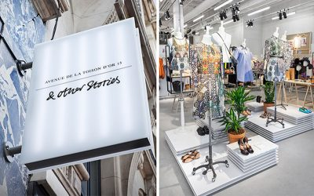

In 2009, H&M HOME launched a fun home styling experience, and Karl-Johan Persson, Erling Persson's grandson, became CEO.

2010
H&M launches its first collection made entirely out of sustainable materials, with many more sustainable initiatives to follow.

- In 2013, H&M launched its first H&M Studio show during Paris Fashion Week, releasing biannual limited-edition collections.
- The H&M Foundation, a non-profit, was established by the Stefan Persson family, promoting the collection of old textiles for reuse and recycling in H&M stores worldwide.
– H&M&M Group launches yet another brand: & Other Stories, with design studios in Stockholm, Paris and Los Angeles.
- With its ongoing rapid growth, &M today has locations across Europe, North America, the Middle East, Asia, Africa, South America, and Australia.

- In 2015, H&M Foundation launched The Global Change Award to accelerate the transition to a circular fashion industry, and launched the H&M Beauty concept.

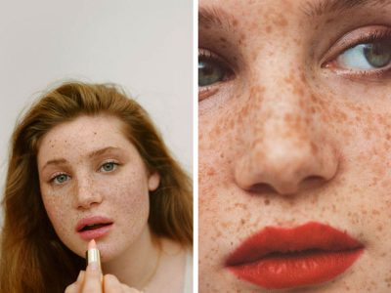
In 2017 The brand ARKET, which was developed as a contemporary marketplace providing a wide but well-chosen assortment of useful and classic necessities, opens its first physical location on Regent Street in London and operates an online store serving eighteen European markets.
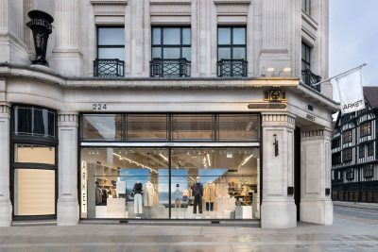
2018, The updated logo Afound launches its initial online and retail locations in Sweden. Afound is a brand-new online store offering deeply reduced apparel and accessories from well-known brands as well as those owned by the H&M Group.
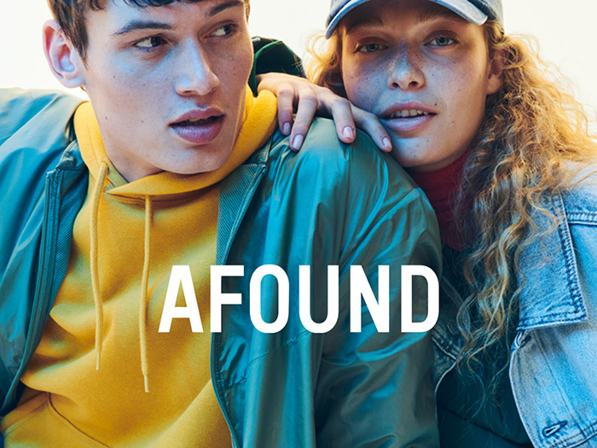
2019 saw H&M emerge as the world's first major fashion company to offer comprehensive product-level details regarding materials and the supply chain.
- The H&M Group bought a larger stake in Sellpy, an online marketplace for used goods. The primary owner is currently H&M Group.

Integration of digital and physical sales channels continues as H&M is now present online in more than 50 markets.
The ’20s and onwards
In 2020, Stefan Persson stepped down as board chair, and Karl-Johan Persson was elected, while Helena Helmersson became the new CEO.
In 2021, H&M launched Singular Society and Creator Studio, while H&M Innovation Stories showcased themed collections promoting sustainable materials and production processes.
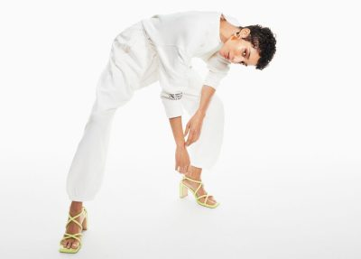

- H&M Group integrated the annual and sustainability reports for the first time, as an important yet natural step in our development.

- The newest H&M sports brand H&M Move was launched worldwide.

- H&M Group set ambitious climate targets in 2022, aiming to reduce absolute greenhouse gas emissions by 56% by 2030, 90% by 2040, and achieve net-zero emissions by the same year.
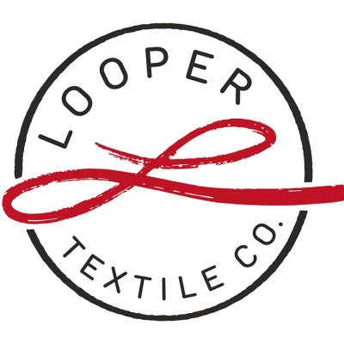
2023

Looper Textile Co., a joint venture between H&M Group and Remondis, focuses on collecting, sorting, and selling used and unwanted garments and textiles.
H&M Group has launched All in Equestrian, a new equestrian sports lab.
In 2024, H&M Group issued an inaugural EUR 500 million green bond to finance its circularity and climate roadmap.

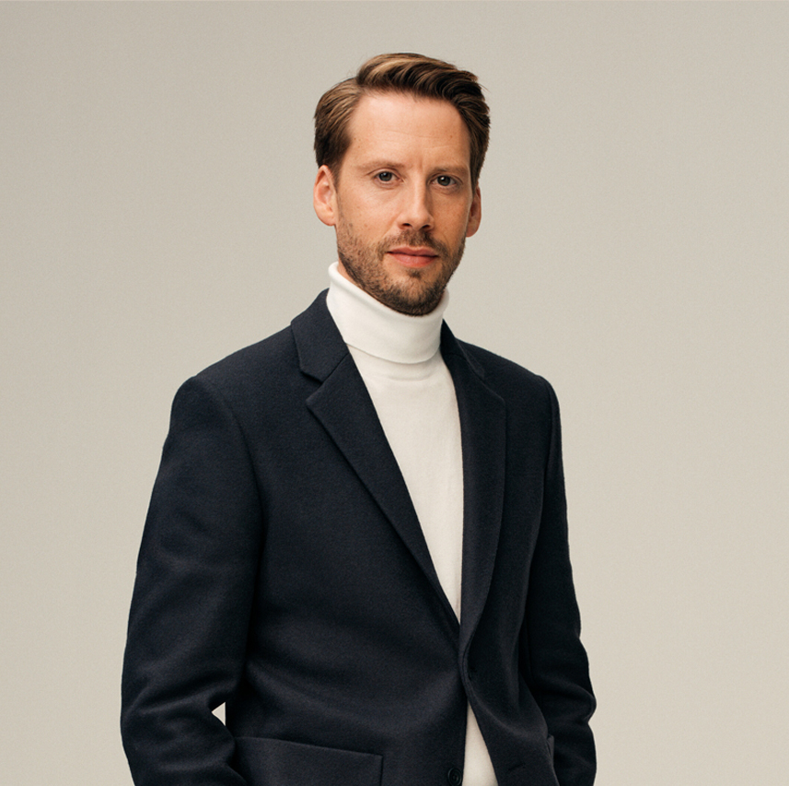

- Daniel Ervér, former H&M brand CEO, has been appointed as President and CEO of H&M Group, which operates in over 75 global markets, with nearly 60 offering online sales.

- H&M Group, founded in 1947 in Sweden, has grown into a global fashion and design company with over 70 stores and 60 online markets.

- Our omni-model combines brands and business ventures to meet customer expectations, providing convenient and inspiring experiences globally, including in stores, online platforms, and social media.
- Our expansion strategy is centred on achieving omni-channel growth, which involves further integrating our digital and physical channels to enhance and complement each other. This approach aims to create a seamless and comprehensive customer journey.

- H&M Group operates 4,338 physical stores in 77 markets and online sales in 60, offering its brands through both physical and digital channels.
- Number of stores per region (31 May 2024)

- - The people from Scandinavia - The European West - The European Union - Europe's south South and North America — Africa, Oceania, and Asia

- In 2023, the company reported a 6% increase in net sales, a 34 billion SEK cash flow, a 13 billion SEK profit, and an average of 143,000 employees.
Number of markets and outlets for each brand as of May 31, 2024

Brand Stores Store Markets Online Markets
H&M 3,832 77 60
COS 238 47 38
Monki 59 15 29
Weekday 49 14 29
& Other Stories 71 25 32
ARKET 36 14 31
Afound 0 0 7
H&M HOME* 34 15 45
Sellpy 0 0 24

H&M HOME is available in concept stores and shop-in-shop at 447 H&M stores.

COS, Monki, Weekday, & Other Stories, and ARKET offer Global selling, allowing customers to shop in around 70 additional markets, with the exact number varying per brand.

H&M HOME is available in concept stores and shop-in-shop at 447 H&M stores.

COS, Monki, Weekday, & Other Stories, and ARKET offer Global selling, allowing customers to shop in around 70 additional markets, with the exact number varying per brand.
https://hmgroup.com/brands/hm/
Why sustainability is important to us
For nearly 30 years, our business focuses on sustainability, offering customers the best combination of fashion, quality, price, and sustainability, ensuring sustainable fashion is not exclusive.

Progress has been made, but more is needed in the industry to reduce climate impact, improve social impact, and build a better fashion system transparently.

This section of our website provides information on our goals, strategies for achieving them, and the standards and policies that guide our work.

Essentials of sustainability For those who are unfamiliar with our work on sustainability, we suggest perusing these pages to gain a synopsis of our efforts:

Leyla Ertur, our Director of Sustainability, discusses our approach to sustainability, our main difficulties, and our emphasis areas in this interview and brief film.
Explore H&M Group's recent reports and rankings on our awards and recognitions page, where you can read others' opinions and see their positive feedback.
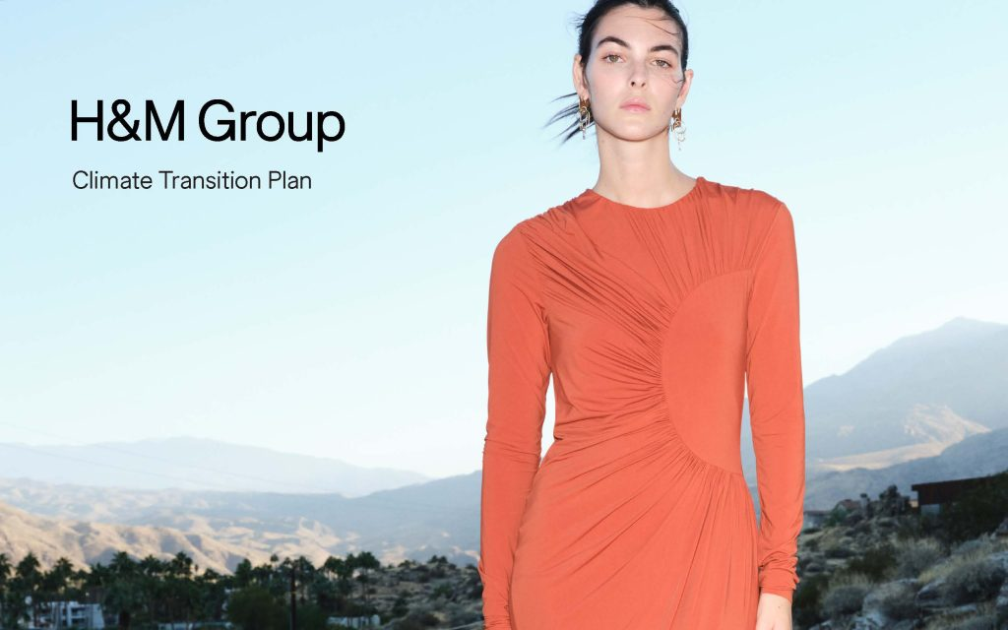
Visit our Sustainability Disclosure to see a detailed overview of our accomplishments and lessons learned from the previous year, along with our priorities for the upcoming one.
Climate and circularity
Our goal is to achieve net-zero greenhouse gas emissions by 2040, reduce water consumption, ensure wastewater quality, and contribute to a circular ecosystem, decoupling growth from resource use.
Acting to combat climate change
The company has developed a four-step action framework to minimize negative impact and maximize positive contribution. They closely monitor GHG emissions across their value chain, ensuring transparency and openness about progress.
Our priority is to reduce emissions by 56% by 2030, as 70% of a garment’s climate impact occurs during manufacturing.
Our operations will be powered entirely by renewable energy sources, and we will collaborate with partners and suppliers to enhance their utilization of renewable energy, heat, and steam.

Our business is committed to promoting circularity by investing in and scaling up more regenerative systems across all aspects of our products, supply chains, and customer journeys.
Utilize data and AI to enhance production efficiency by adjusting assortment levels and ensuring supply is in line with demand.
Cooperation is key for swift transformation, supporting legislation for decarbonization of value chains and a 1.5°C temperature cap.

A fresh case study: our supply chain's decarbonization
To achieve our climate goals, we must decarbonize our supply chain, as demonstrated by our support for a supplier to electrify a factory.
A new document called the Climate Transition Plan
We've combined all of our efforts to lower emissions into a single plan. It covers our objectives and the steps we are doing in many business domains.
Fresh case study: interim fixes
The company is utilizing biomass as a transitional solution to reduce emissions due to limited access to renewable energy and unreliable grid connections.

