
APPENDIX GA36c

LEVEL 6 ASSESSMENT SPECIFICATION

Student name: | Sharlene Bernard | Student ID number: | 1902958
Programme: | PGCE Secondary English
Module: | The learner: who am I teaching?
Module code: | ECAD6007 | Contribution to Overall Module Assessment (%): | 100%
Lecturer: | Siân Brooks | Internal Verifier: | Libby Chancer
Assignment Title: | A critical evaluation and the identification of next teaching and learning steps focusing on a case study of an individual learner or a group of learners, based on an observed critical incident. | Word count (or equivalent):  4,008 (not including appendices) | Equivalent to 5000 words.
Submission deadline: | 29/10/19 (deadline 23:59) | Return date of provisional marks & written feedback: | 25/11/19
Submission method: | All written assessments, where practical and possible, must be submitted via Turnitin unless otherwise instructed by the Lecturer. (Please DO NOT put this assessment specification into Turnitin or it will match many similarities with other students’ submissions.)  Alternative submission method (if applicable):  Late submission of the assessment will result in a late penalty mark. Penalties for late submission: Up to one week late, maximum mark of 40%. Over one week late, 0%. Only the Extenuating Circumstances Panel may approve a change to submission dates.
Academic honesty / referencing: | Academic honesty is required. In the main body of your submission you must give credit to authors on whose research and ideas your work is based. Append to your submission a reference list that indicates the books, articles, etc. that you have used, cited or quoted in order to complete this assessment.
A critical evaluation and the identification of next teaching and learning steps focusing on a case study of an individual learner or a group of learners, based on an observed critical incident.
Introduction:
Clive Sutton wrote in his book, Communicating in the Classroom, “Education is about the meanings each pupil takes away with him or her” (Clive, p.48, 1981). This is why it is so vital for teachers to consistently assess and evaluate their classroom pedagogy, to ensure that each pupil is having the best education that they can. In particular, it is important for teachers to evaluate any critical incident that can take place in their classroom. A critical incident can be a big or small incident that causes an individual to evaluate and analyse it. This incident does not necessarily have to be a negative incident; it can also be a positive one, as a positive incident can also be critically analysed and evaluated. It causes you to think critically about an incident in order to improve your teaching pedagogy and practise for future use. This is particularly useful for teachers as it encourages them to reflect on their teaching methods, ensuring that they can and will be the best teachers that they can be. For example, this could be something as small as realising that it could be better for students to answer questions by raising their hands as it enhances classroom management; or it could be that a teacher realises that recapping the previous lesson at the start of the lesson is incredibly beneficial, so students can learn more efficiently and the teacher would also be able to see how well the students understand the topic.
Observation:
School X is an 11 to 18, mixed community school. While it is an English medium school, Welsh is enforced and often encouraged; the teachers greet their students in Welsh, the dates are in Welsh and there is some Welsh writing on the walls. It is a very large school with subject based buildings and, approximately, 1,500 students. School X is a very supportive school and caters for everyone, with no prejudice. The average amount of children eligible for free school meals are 17.4% in schools, which is lower than School X, who has 23.3% of pupils who are eligible. Approximately 41% of their students are from 20% of the most deprived areas in Wales (Estyn). But these students still have the same experiences and school life as the rest of the students; there is no discrimination as the school encourages their students to be respectful, responsible and aspirational members of their community. School X gives every student an opportunity to go on school trip, which is a significant part of their school experience and social skills. Teachers also follow a ‘no shouting’ rule (unless circumstances force them not to) which gives the students a slightly more respected relationship with their teachers. Following Donaldson’s report and the new curriculum, this school is very respectful and is doing very well.
There are many different types of useful observation strategies that we could have used for this assignment, however, I found it easier as a participant observer and wrote things down as they happened in the classroom (McLeod 2015). This is because I could have an open mind of what I would critique: not looking out for something in particular and then missing something else that is important. However, by doing this, I may also risk losing my focus by not having something in my mind and possibly feeling overwhelmed by observing so much at one time. Social psychologist, Kathy Sylvia, used this method of observation to study children whilst they were playing. As explained by Saul McLeod on his website, simplypsychology.org (2015), one of the strengths of this strategy is that it “gives the researcher the opportunity to study the total situation it often suggests avenues of enquiry not thought of before” (McLeod 2015). Thus, supporting my argument that, because you are not focused on one set idea, you have the capability to explore other things that you may notice during your observation. Danny L. Jorgenson also supports in his book, Participant Observation: A Methodology for Human Studies (1989), by stating that it is “a strategy for gaining access to otherwise inaccessible dimensions of human life and experience” (Jorgenson, p.23, 1989). This strategy allows you to view it with an open mind and to also have the opportunity of seeing something natural. However, McLeod goes on to explain that “other variables cannot be controlled” (McLeod 2015). Different factors affect different classroom situations, and even the smallest incident can have a massive impact on the class, such as a fire alarm going off or having the lesson after their break or lunch time. No two lessons will be the same; so, while this is quite useful for someone who is looking for a critical incident to analyse, it will not always be fair as there are different scenarios affecting the classroom. There are positive and negatives to each type of observation methodology. Each individual will have a preferred method of observation and will be better at one type more than another.
The critical incident that I will be evaluating is one that happened in a Year 9 mixed ability English class. The students were, as a class, reading Harper Lee’s To Kill a Mockingbird. This lesson was after their break time, so they were still quite excited, but after a few minutes, they settled down. Before reading, the teacher asked the students who the character Dill was – they thought that he was the father. She then explained to them that he was their neighbour. However, when she asked them the next few questions, such as their thoughts on the book, she asked for hands up and consistently kept asking the More Able and Talented (MAT) students. Later on, while they were in the middle of reading, the teacher asked them if any of them knew what entailment meant. Again, the teacher picked the MAT student. He was struggling to define what it meant and so another student put their hand up to answer; she was eager to be picked as she kept waving her hand to the teacher and tried to make herself bigger. However, the teacher ignored her and encouraged the MAT student to answer. With the encouragement, he was soon able to provide a definition. The MAT student looked proud of being able to give an answer, but the other student looked disappointed at not being chosen. This would have greatly impacted their confident to answer question in class; improving one students’ but impairing the other students’. This critical incident relates to Donaldson’s Four Purposes: 1. Ambitious, capable learners; 2. Enterprising, creative contributors; 3. Ethical, informed citizens; and 4. Healthy, confident individuals (Dauncey, 2015). The incident relates to these purposes as it promoted the MAT students’ ambition and capability; the teacher encouraged him to give an answer and reassured him that he could do it. It also helped the student, and the rest of the class, become more informed citizens. The MAT student would have also become a more confident individual. In contrast, these purposes do not relate to the other student who was ignored. Her confidence and ambition could have worsened by not being able to answer and seeing that the teacher may have had more faith in another student. While the third purpose still relates to her, as it made her more informed by hearing someone else’s answer, she did not have the chance to tell the teacher what she thought the answer was. By only choosing students who are more likely to answer correctly the teacher is not allowing herself the opportunity to check how well the other students understand the topic, or for the students to gain confidence in answering questions; risking the chance to give a wrong answer and then be informed of the right one. E. C. Wragg and G. Brown state in their book, Questioning in the Secondary School (1993), that one of the common errors is asking questions only of the brightest and most likeable pupils (Wragg and Brown, p.28, 1993). All of the pupils should be treated equally and be provided with the same opportunities during lessons.
Literature Review:
Carol Dweck’s Mindset Theory relates to his incident very well. Dweck’s theory establishes that people either have a ‘fixed mindset’ or a ‘growth mindset’ (Dweck, p.6-7, 2006). Dweck explains that the fixed mindset creates an urgency to prove to yourself over and over while the growth mindset is based on the belief that your basic qualities are things that you can cultivate through your efforts (Dweck, p.6-7, 2006). In this incident, the teacher could have promoted the MAT students’ growth mindset by encouraging him to answer questions and continuously praising him for his correct answer. However, by doing this, the teacher, in turn, risked putting the rest of the class, especially the student who was ignored, into a fixed mindset. By praising the MAT students and supporting them more, the other students would subconsciously realise that they do not need to answer as the teacher would ask the MAT students, which could put their understanding of the topic and motivation at risk. This could also put more pressure on the students who are always expected to answer, especially with the constant praise. As Dweck explains, “we should keep away from a certain kind of praise – praise that judges their intelligence or talent” (Dweck, p.177, 2006). This creates pressure, an immense fear of failure and, if they do fail, it seems as though they could fall into a fixed mindset. However, Abigail Beall states on her blog, that psychologists have conducted a study and have found little correlation with the growth mindset and academic studies (Beall 2018) – so it may not be as important as Dweck claims it is. Beall states that psychologist Brooke Macnamara, who co-authored the study, says that they “found a significant but weak relationship between growth mindsets and academic achievement” (Beall 2018). This shows that the mindsets may not be as important as Dweck says they are. There are differing opinions and outcomes in the studies that connote different things. This could suggest that the level of academic achievement could be achieved by the level of motivation, confidence and understanding that a student has. There could also be other factors that differ, such as whether some students had a bad day, the age of the students and the level of difficulty of the work. However, Carol Dweck directly responded to Macnamara, on her blog, Mindset Scholar Network, that her “disagreement with Macnamara rests on exactly what one considers to be a meaningful effect size for an educational intervention” (Dweck 2018). This is very problematic as it shows us that a personal perception and opinion is what is causing these disagreements. A difference in the students’ outcomes can make a great conflict in the educational psychology world. Therefore, while Carol Dweck’s theory is very influential and effective, it is evident that there simply needs to be more research done on it. There is a lot of criticism towards it, thus meaning that if more research is done, then it will be more effective to see whether it truly matters and whether letting children know whether they have a growth or fixed mindset will help them achieve things.
Motivation is critical in a pupil’s learning; if they are not motivated then they may not learn as effectively or have grades as good as someone who is motivated. Therefore, it is a teachers’ duty to try to engage pupils in their lessons as they will then become interested in the subject more and, in turn, will become motivated. In the critical incident that was observed, the teacher tried to engage pupils by asking questions; however, as she only asked the MAT students for answers, they became more engaged and motivated whilst other students did not. Richard Argent et al talks about motivation in his book, Motivation and Learning (1976). Argent et al mentions that you can increase a child’s capacity to learn by increasing their motivation to do so (Argetn et al, p.52, 1976). This shows us that children learn more efficiently when they are motivated and “see learning as valuavle” (Argent et al, p.11, 1976). This can also relate to teachers explaining the learning objectives at the start of the lesson because it shows the students what the success criteria should look and/or sound like. They will be able to see what they will be doing and will therefore be much more prepared as they will know what to expect. However, motivation also correlates with a student’s confidence; if they are not confident then they may not accept or try any challenges. As Carol Dweck explains, “challenges are a threat to self-esteem” (Dweck, p.3, 1999). Potentially, when a student fails, and continuously fails, they may no longer try, and will lose motivation to learn and will no longer remove themselves from their comfort zone. Dweck also points out that:
“we’ve bought into the entity theory, in which children require constant success to feel good about themselves and in which failures send a negative message about intelligence and worth. (…) These practises also convey an entity theory of intelligence to our children” (Dweck, p.127, 1999).
This shows that we must not encourage children to value their worth, purely based on their intelligence. This will put them in a fixed mindset and they could possibly lose motivation to improve. Teaches must motivate and encourage students to improve, without putting an emphasis on intelligence. By putting an emphasis on intelligence, it risks causing anxiety and pressure on students. The best way to keep all of the students motivated is to cater to every students’ needs, particularly in mixed ability classes. This way, the teachers would be able to help track pupil progress and have something prepared for everyone; no student would feel left out or of less worth. The students would feel that they can achieve as much as everyone else as it should not be an explicit difference in the students’ activities, to not make anyone feel different. There is a lot of evidence surrounding motivation being one of the key factors of improving learning, which shows that it must be true; many psychologists and theorists agree that it is mandatory. It is the responsibility of the teacher and parents to support the student in gaining, retaining and using their motivation to get the best out of their education and simultaneously improve their confidence. There are many different ways for teachers to discover whether their students understand their work and stay motivated and engaged; one of which, is Assessment for Learning.
Assessment for Learning (AFL), synonymous with Formative Assessment, is another effective way of learning but also has some debates surrounding it. As defined by an Assessment for Learning website, it is “the process of seeking and interpreting evidence for use by learners and their teachers to decide where they are and where they need to go and how” (Education Services Australia). This method of teaching is commonly used throughout schools as it is very effective. The teacher mentioned in the critical incident that was observed also used this method as a way to gain knowledge of what the students understood. In his lecture, Dylan Wiliam praises AFL and strongly encourages it, and states that, “it differs from assessment designed primarily to serve the purpose of accountability, or of ranking, or of certifying competence” (Wiliam, p.8, 2009), which shows that it is a method designed to work on pupils’ understanding of different subjects and topics, instead of focusing on pupils’ grades. Rather than have students memorise facts and ways to improve their memory, they are actually learning and being given the chance to ask for help for when they do not understand something. Bill Boyle and Marie Charles also praise AFL in the book, Formative Assessment for Teaching and Learning (2014). Boyle and Charles point out that it is “serving to support children’s learning rather than grade pupil outcomes” (Boyle and Charles, p.7, 2014). They also state that it also supports the teachers as it allows them to plain their lessons better and to plan what materials they will need (Boyle and Charles, p.10, 2014). However, there has been some criticism on AFL. Nikki Booth argues on her website, Impact: Charted College of Education, that it could be better and improvements should be made. Booth states that while the idea of giving students’ feedback, “what seems likely to happen in practise is that students look at their score, compare it with the person nearest to them, and ignore the comments” (Booth 2017). This shows us that it would likely waste a lot of teachers’ time because the comments would be ignored; children and young people have a natural competitiveness and want to know how their peers did in comparison to them, so may ultimately not read any of the feedback given. And, because the classes are large, it would be quite hard to ensure that everyone has read their comments. However, it is important to note that Booth does not disagree with AFL; she simply thinks that there are improvements to be made. One suggestion that Booth made was to encourage the use of asking questions to the class and have them use whiteboards to give answers (Booth 2017). However, it is easy for students to copy the answer from the person sitting next to them, and for some to give in to peer pressure; if they see people with most of the same answers, they may think that their own answer is wrong and so copy their answer. Booth also suggests to use peer and self-assessment and continuing to give feedback (Booth 2017). These suggestions are very useful because it can engage pupils more and help build their team work skills. Overall, there seems to be a lot of agreement with the use of AFL and Formative Assessment. While feedback is hard to give all of the time in different ways, it is important for the teacher to find out what way is most beneficial for each class, and themselves. It is vital to give feedback to students because it supports their learning, supports the teachers understanding of how well their students are doing and can motivate students to do better.
Reflection/Evaluation:
Upon reflection, I feel as though I have learnt a lot about teaching pedagogy, being a teacher and what it means to engage students in their learning. There were different types of teaching examples that I had the opportunity to observe but they all ultimately involved passion in their subject and providing support for students. I found my critical incident very interesting (see Appendix 1 and 2) as it provided me with the chance to observe a reading lesson. As a trainee English teacher, I would also be teaching English lessons that consisted of mainly reading. It was a very useful experience to see the questioning techniques that this teacher used, especially in comparison to other subjects and other topics being taught in English lessons. This gave me a better understanding of how and when to use certain types of questions. However, possibly due to the Hawthorne Effect, the teacher only asked certain students to answer questions. But, on the other hand, I was very impressed with how the teacher managed the classroom. Whilst some students did not seem to be very engaged, they did behave and settled down well. What I would take from this lesson, is the structure that the teacher had; she was well prepared and settled the students quickly. This could have been due to the students knowing what to expect; when I observed them, they were already on Chapter Two of Harper Lee’s To Kill a Mockingbird, which shows that they have already had previous lessons studying it. The teacher had also made it clear to them that they would be reading the whole book, in preparation for their A Level studies. The possible solutions to the elements of this lesson that, in my opinion, could be improved, was that there could have been more class discussions at the end of the lesson to ensure that the students understood what they have just read; there could also be one at the start of the lesson to recap what they had learnt and read in the previous lesson. This is because, they only have this reading lesson once every two weeks, so it could be easy to forget some things when they also have a lot of other lessons during the week as well. A class or group discussion would also provide an opportunity for more students to get involved. Another solution to provide more engagement, understanding and class involvement, would be to have a student read a paragraph each. A final solution would be to have different techniques that would provide an opportunity for everyone to answer. For example, a popular questioning technique is to write the students’ names on a lollipop stick and then use them to choose a student to answer the question. This can then also lead to a class discussion as all of the students would already be prepared and engaged. From this observation, my next step will be to research questioning techniques, class engagement and different ways to recap the previous lesson. I will research this by observing more lessons, researching theories and evaluating my own pedagogy; specifically analysing what worked and what did not work. It is crucial to evaluate teaching methods to improve your professional and personal development. The most important way to become a better teacher is to critically analyse the things that have gone well during your teaching day, and the things that did not; and how to improve on the things that did not. This can be done by self or peer evaluation, or even by asking the students. This could be done by asking them to write something they did and did not like on a post-it note or by asking them to fill in a questionnaire; however, this would have to be done anonymously to avoid the students from feeling any type of anxiety or pressure of consequence for writing about what they did not like about the lesson. This is constructive criticism which should not be taken personally; the feedback from yourself, your peers and students should be taken in a professional manner, in order to be the best teacher that you can be.
Conclusion:
In conclusion, I feel as though this observation went very well. I took the approach of a participant observer and therefore had the opportunity to see the realities of the classroom life. As I saw the pedagogy take place, and the students’ reactions, I made critical notes. This was very useful and inspiring as I had the opportunity to observe different teaching techniques and a variety of year groups. This observation approach links to the role of the reflective practitioner in Wales as I was able to critically reflect and analyse what I observed; what went well and possible solutions for what did not go as well. It links to the new Professional Standards for Teaching and Leadership, set up by the Welsh Government. These standards help set out clear expectations about effective practise, enable practitioners to reflect on their practise, celebrate their success, and support practitioners in finding ways to improve on their professional development (Gov.wales). The Welsh Government says that, “The new Professional Standards for Teaching and Leadership reflect practise that is consistent with the realisation of the new curriculum” (Gov.wales). This shows us that consistent reflection is a vital part of becoming a good teacher; you learn from, not only your mistakes, but the elements that you do well, and you learn how to continuously improve this. The British Education Research Association (BERA) also supports and encourages reflectiveness and research education engagement (BERA). There are more companies and theorists that support this, which shows us that we should all be critically reflecting on what we do, in whatever our job role is, in order to become better at our profession and better at our jobs.

Word count: 4,008

Appendix 1 – the critical incident observation

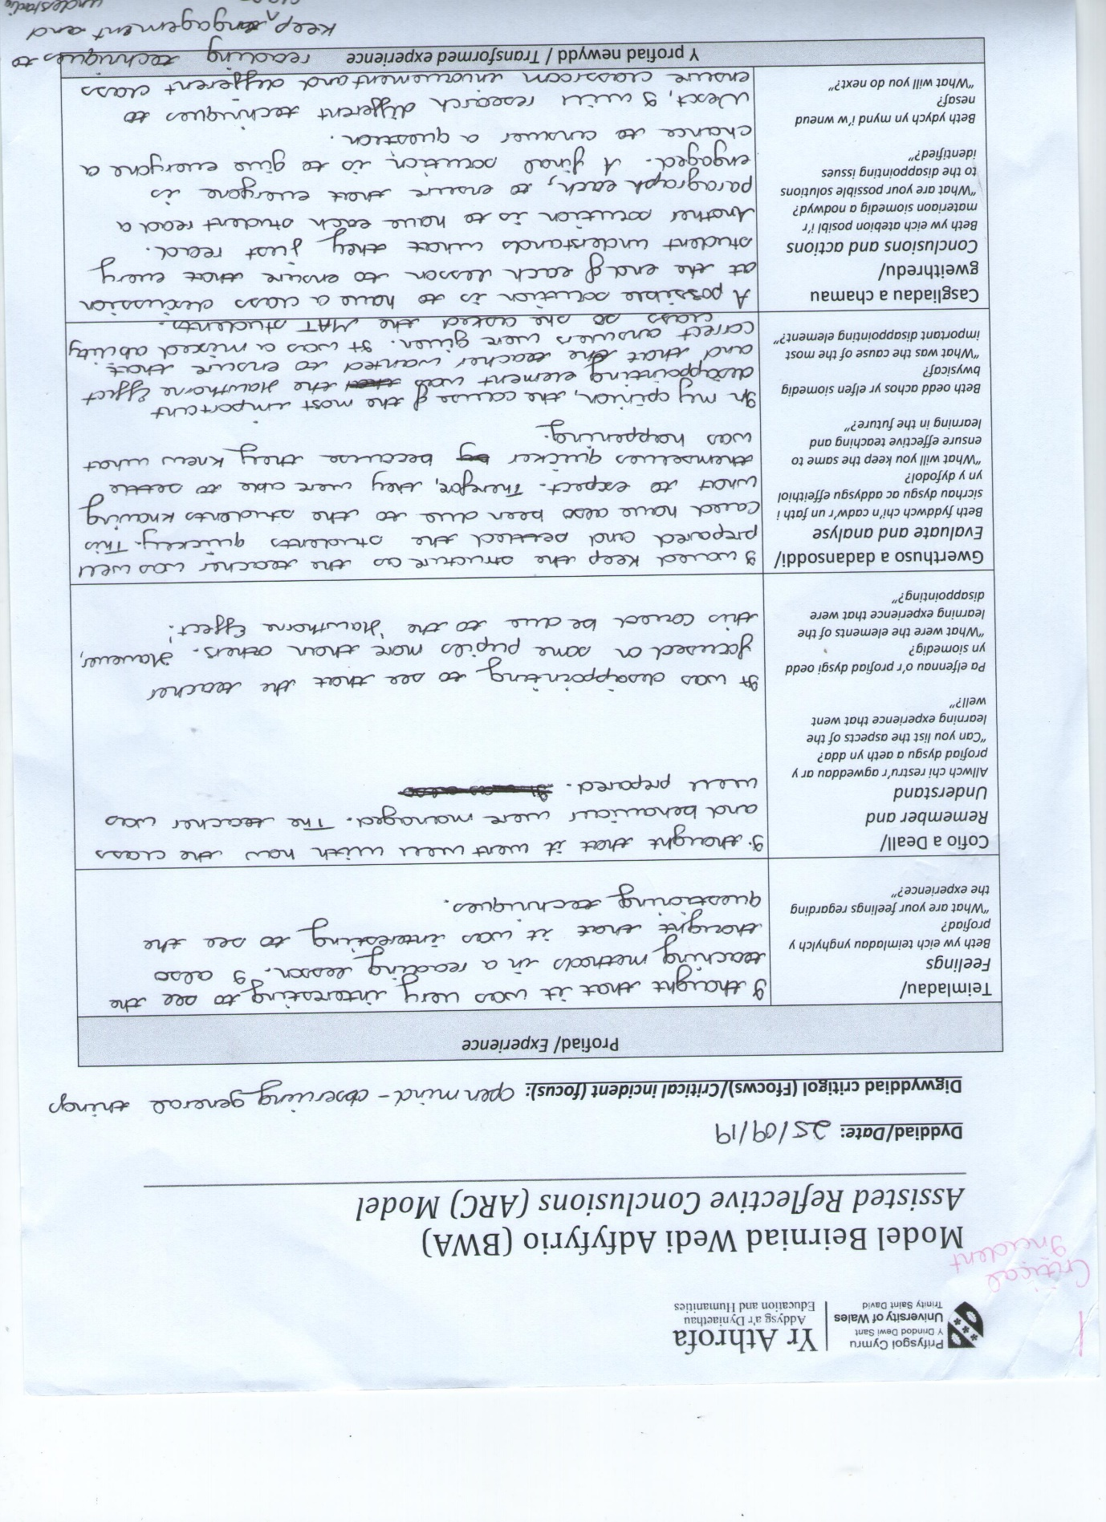
Appendix 2 – critical incident arc sheet

Appendix 3 – critical incident 2 arc sheet


Appendix 4 – critical incident 2 arc sheet
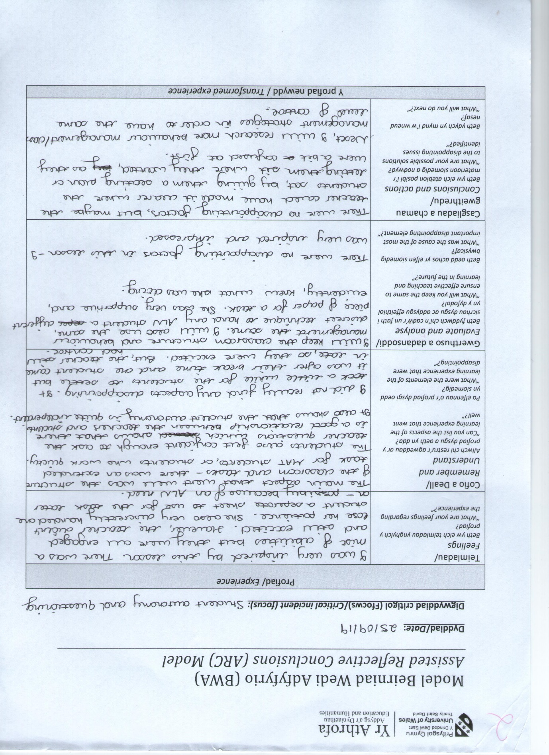

Appendix 5 – critical incident 3 observation
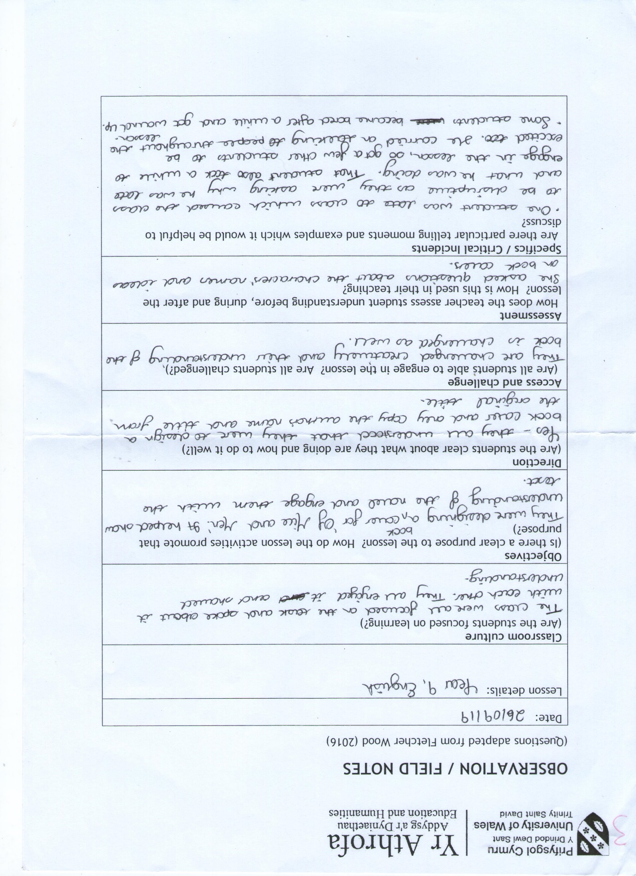

Appendix 6 – critical incident 3 arc sheet
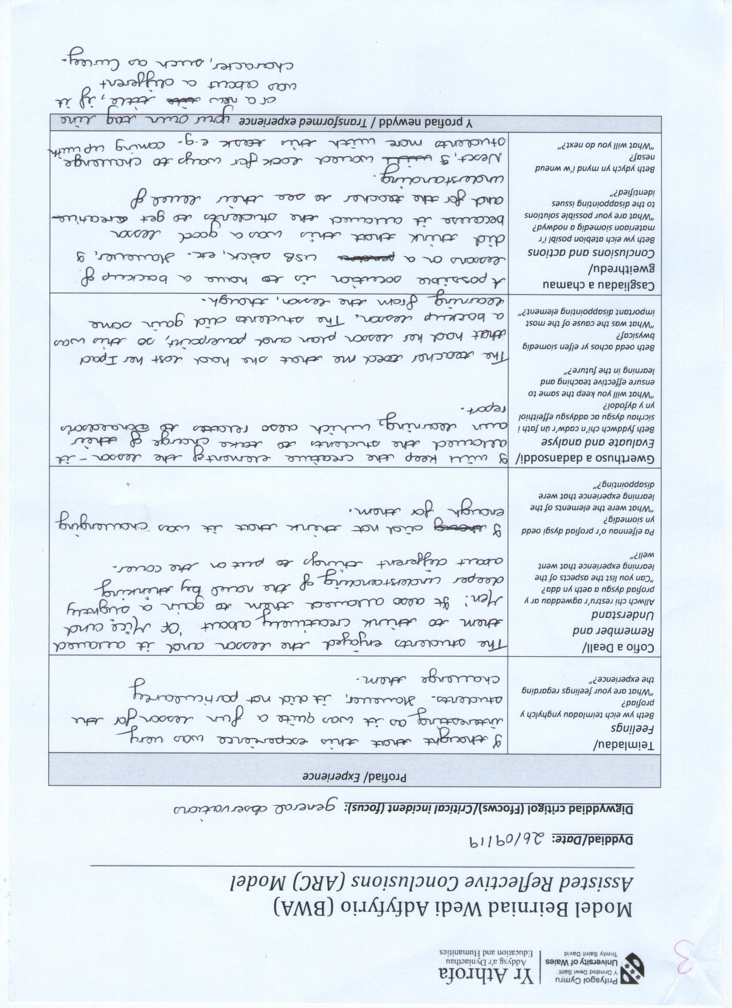

Appendix 7 – critical incident 4 observation


Appendix 8 – critical incident 4 arc sheet
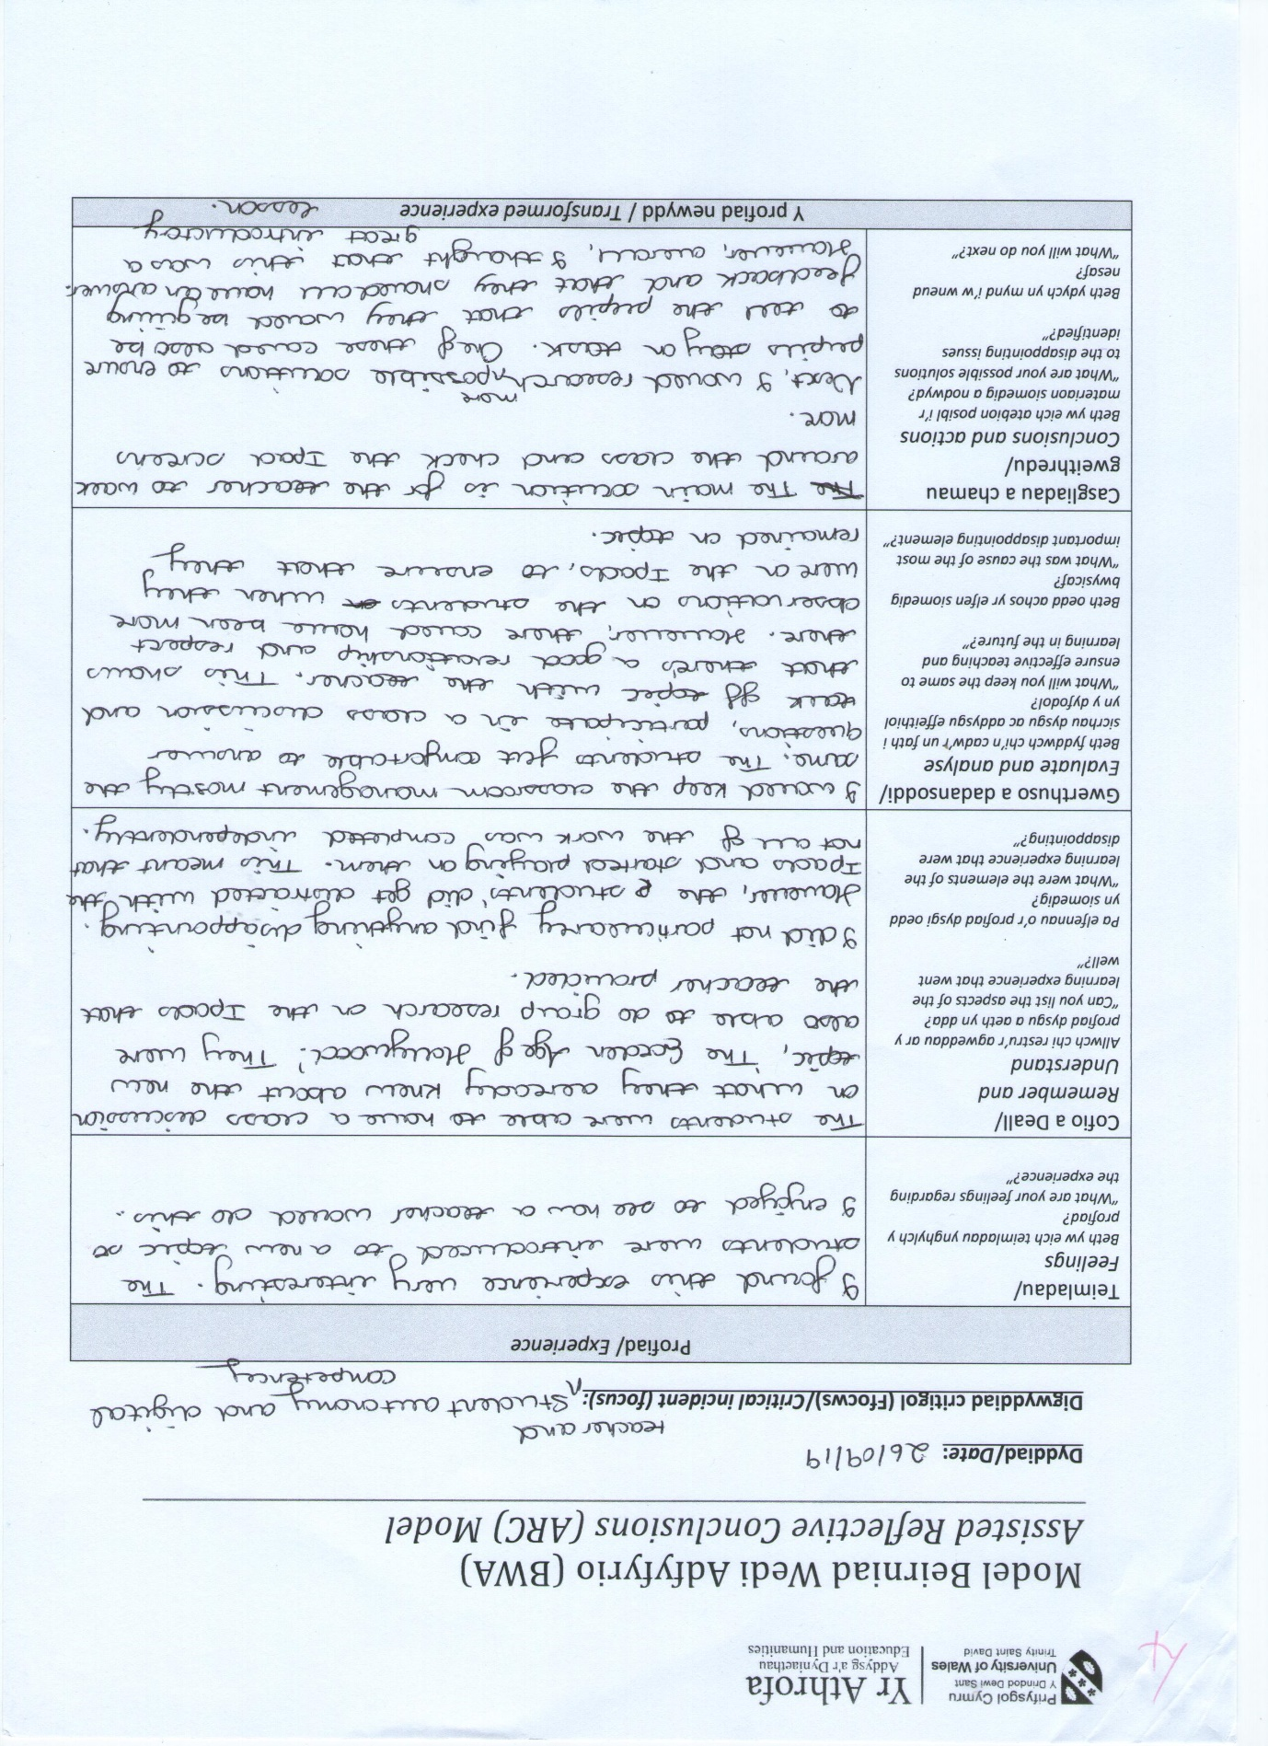

Reference List:
Appendices 1-8
Books:
Argent, Richard et al. 1976. Motivation and Learning. The Open University Educational Studies: A Second Level Course. Personality and Learning Block 3. Great Britain. Print.
Boyle, Bill and Marie Charles. 2014. Formative Assessment for Teaching and Learning. SAGE Publications. London, California, New Delhi, Singapore. Print.
Dweck, Carol S. 1999. Essays in Social Psychology: Self-Theories: Their Role in Motivation, Personality and Development. Edwards Brothers, Lillington. USA. Print.
Dweck, Carol S. Mindset: How You Can Fulfil Your Potential. 2006. US Random House, UK Robinson. London. 2007. Print.
Jorgenson, Danny L. Participant Observation: A Methodology for Human Studies. 1989. SAGE Publishing, Ltd. USA. 1990. Print.
Sutton, Clive. 1981. Communicating in the Classroom. Hodder and Stoughton Education, British Library Cataloguing. Great Britain. Print.
Wragg, E. C. and Brown, G. Questioning in the Secondary School. 1993. Routledge. USA and Canada. 2001. Print.
Websites:
Beall, Abigail. Wired. Everyone’s Favourite Psychology Theory Isn’t All It’s Cracked Up To Be. 2018. https://www.wired.co.uk/article/growth-mindset-education-psychological-theory-children-mirage. Accessed 10th October 2019.
British Education Research Association. ‘About’ Section. https://www.bera.ac.uk/. Accessed 20th October.
Booth, Nikki. Impact: Charted College of Teaching. What is formative assessment, why hasn’t it worked in schools, and how can we make it better in the classroom? 2017. https://impact.chartered.college/article/booth-what-formative-assessment-make-better-classroom/. Accessed 13th October, 2019.
Dauncey, Michael. National Assembly for Wales Research Service. Donaldson Review: The ‘purposes’ and content of a Curriculum for Wales. 2015.
https://seneddresearch.blog/2015/03/17/donaldson-review-the-purposes-and-content-of-a-curriculum-for-wales/. Accessed 10th October, 2019.
Dweck, Carol. Mind Scholars Network. Carol Dweck Responds to Recent Criticisms of Growth Mindset Research. 2018. https://mindsetscholarsnetwork.org/carol-dweck-responds-recent-criticisms-growth-mindset-research/#. Accessed 10th October 2019.
Education Services Australia. Assessment for Learning. N/A. https://www.assessmentforlearning.edu.au/professional_learning/intro_to_afl/introduction_key_questions.html. Accessed 10th October 2019.
Estyn Report. Treorchy Comprehensive School. Estyn. 2016. file:///E:/UWTSD/Assignment%201/Treorchy%20Comprehensive%20School.pdf. Accessed 7th October, 2019.
Welsh Government. Professional Teaching and Leadership Standards: national approach to professional learning. Gov.wales. 2019. https://hwb.gov.wales/professional-development/national-approach-to-professional-learning/professional-teaching-and-leadership-standards-national-approach-to-professional-learning. Accessed 20th October, 2019.
McLeod, Saul. Observation Methods. 2015. https://www.simplypsychology.org/observation.html. Accessed 7th October, 2019.

