Drill press improvement report
The aim of this report is to analyse and develop the drill press concept model in accordance with design for X. This will be done by reducing the number of components used in the model while also reducing the cost of manufacturing and the time it takes to assemble the drill press.
This report begins by looking at the initial concept design and highlighting some of the features that need to be addressed. Some of the things to look out for will be obsolete parts, excessive use of fixings such as screws, nuts and bolts and features that may prove difficult to assemble due to the design.
The required number of units is 500 per week. This is 100 units per day in a 5-day work week meaning that reducing lead times is important to ensure the required quantity is fulfilled.
Analysis of the drill press concept model
Figure 1 shows the left side of the drill press concept model. Just from looking at the model, flaws in the design are apparent. Figure 1 annotation A highlights an unnecessary fixing on the concept model. The intended purpose of this small clip is to stop the main sliding unit when it reaches the lowest point however the guide shaft in this is model is too long so the clip wouldn’t stop the movement of the main sliding unit, instead the movement of the main sliding unit is constrained by the length of the link arm highlighted in figure 2 annotation B. increasing the length of this part would increase the drilling depth making the drill press useful in applications where a deeper hole is required. The third part that is designed to constrain the depth of movement on the drill press is highlighted in figure 1 annotation D. this stopper is an adjustable section that allows the user to implement their own drilling depth. This means there are 3 features of the concept model performing the same task with only 1 of the features giving the user the ability to adjust the drilling depth. The number of features can be reduced by redesigning the link arm allowing the user to adjust the drilling depth making it a multifunctional feature and reducing the number of components.
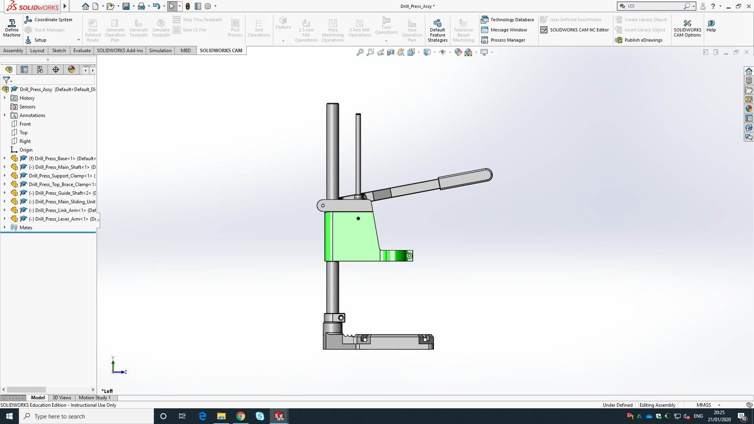Figure 1: analysis of original drill press concept model (Left side)
A. Unnecessary fixing
B. Assembly inefficiency
D. Unnecessary Part
C. Part larger than required
The second inefficiency, highlighted on figure 1, is a design feature that makes the assembly of the drill press difficult. This main sliding unit design covers the spring attachment inside. By creating an opening in the side of this part it would allow easier access to the spring attachment making the assembly process quicker and aiding in the repair or replacement or the spring during the product lifecycle.
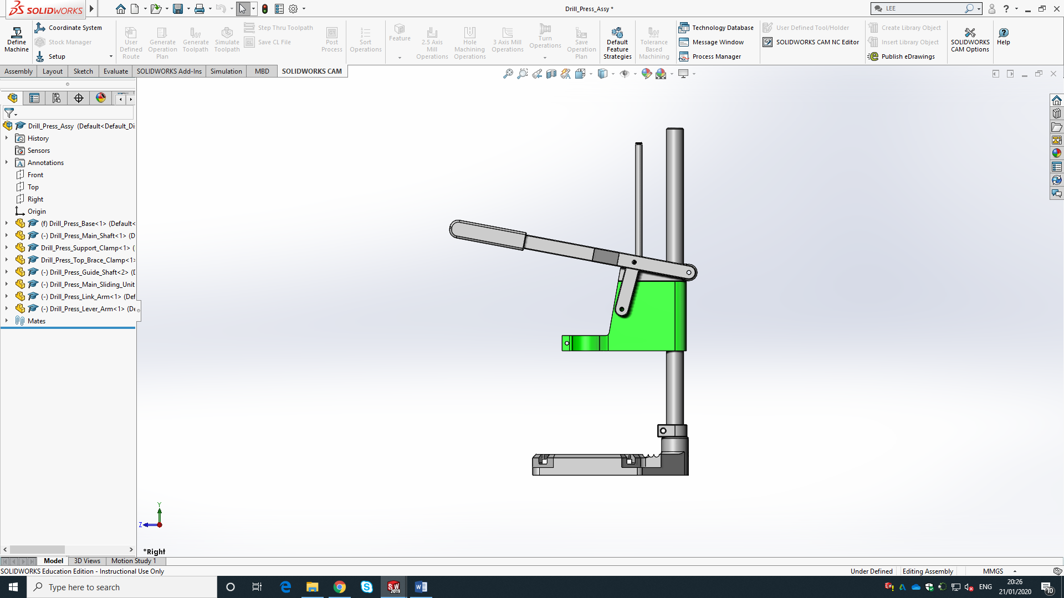 Figure 2: analysis of original drill press concept model (Right side)
B. Part controls drill depth
A. Unnecessary part

Finally, figure 2 annotation A highlights the handle of the drill press which as an unnecessary part. This is because the handle is created from two separate sections. The main part is similar to the link arm and is made of steel and the grip would be a moulded plastic section which will then be fixed on. This can be done by moulding the grip onto the steel bar, bolting it on or gluing it into place. However, these processes can be time consuming and may cause problems at the end of the product lifecycle when the product is being recycled.

- Implementing Changes to the concept model
The drill press main sliding unit is the most important and complex part of the drill press. It will be a die cast steel part with a paint finish on the exterior surfaces. I have changed the Drill press main sliding unit to contain a large opening in the side, As seen in figure 3. This opening will assist in the assembly of the product, particularly when inserting the spring. This cut-out will also reduce material used in the part reducing the cost of materials. The cut-out includes a step with a female snap fitting feature. This will accommodate for the main sliding unit cover which will be a moulded plastic part allowing it to snap into place without any additional fixing methods, covering the spring. This prevents damage to the exposed spring and makes the product safer for the user.
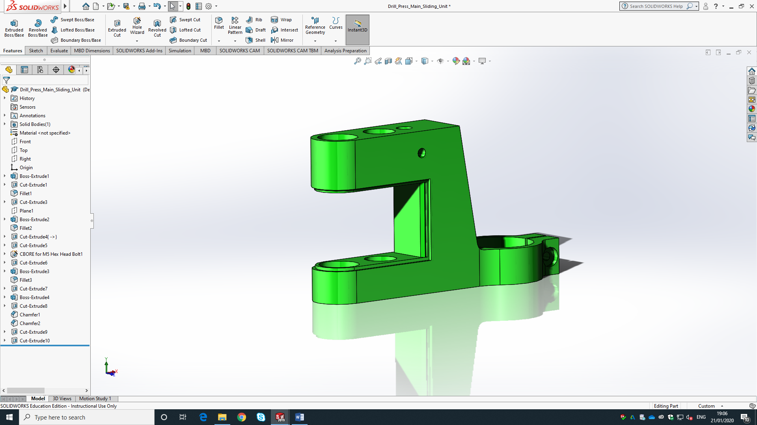Figure 3: Drill press main sliding unit with opening
Cut-out
step
Female snap fitting

The main sliding unit cover, as seen in figure 4, is a symmetrical U shape design making it impossible to fit upside-down. This will prevent errors in assembly and save time. The part is guided by the step design of the opening, As seen in figure 3 and will snap to the main sliding unit when pushed into place. This uses the elasticity of the plastic to bend the plastic outwards as it is pushed onto the snap fitting before it springs back locking it into place.
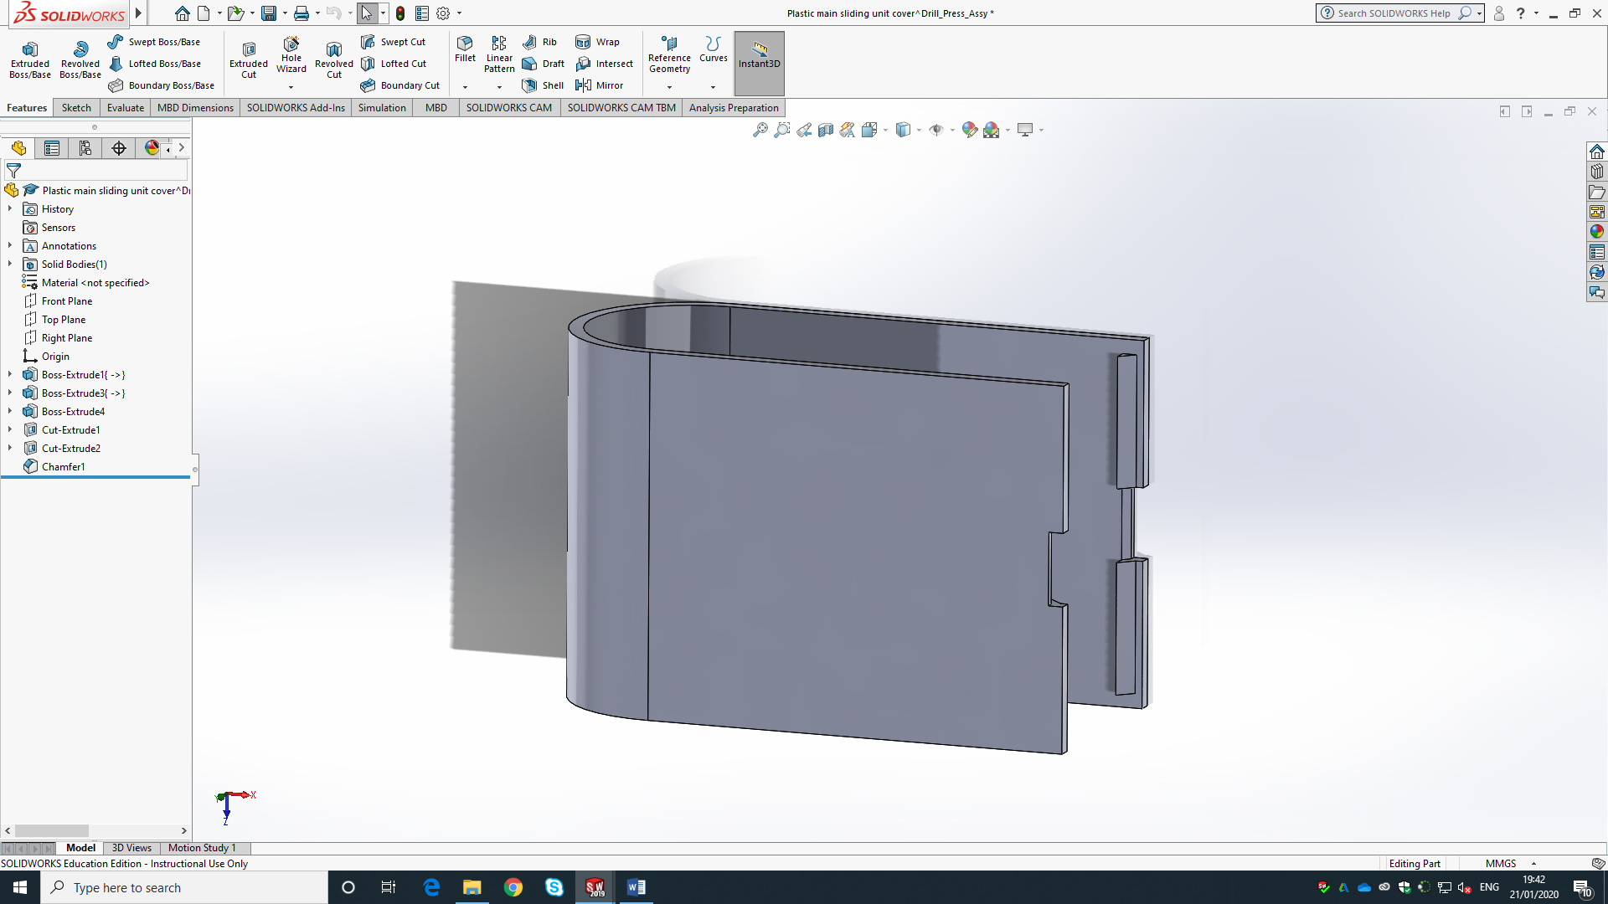Figure 4: main sliding unit cover
U shaped design
Male snap fitting
Cut-out for removal

This part may need to be removed throughout the life span of the product to either change the spring, lubricate the shaft or at the end of the product life span to be recycled. To accommodate for this plastic cover has a small cut out that allows the user to pop the cover off using a flat head screwdriver. This means the snap fitting doesn’t use any additional fixings such as screws however it can still be easily removed.
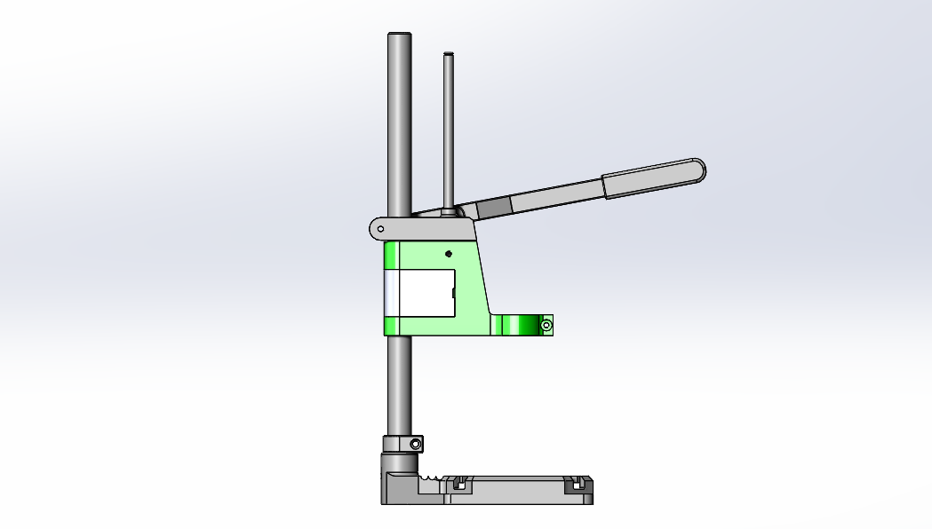Figure 5: drill press model with changes made to main sliding unit (Left side)

Figure 5 shows the drill press assembly with the changes made to the main sliding assembly. This view shows the guide shaft nearly as long as the main shaft. This guide shaft moves with the main sliding unit as the handle is pulled and the drill is lowered. At the top of the guide shaft there Is a clip. This clips intended purpose is to stop the guide shaft from sliding out of the top brace clamp which is fixed to the main shaft. This clip has been made obsolete due to the length of the guide shaft and it is also performing a job that can be done by other existing components on the drill press assembly model.
The main sliding unit will be die cast however this will then undergo finishing techniques such as sand blasting and coating as it needs to be a precise and well finished product. The hole that accommodates for the main shaft will then be drilled to give it a smoother and more precise finish. This is important as a precise finish will ensure good movement within the product. The main sliding unit cover will be made of a hard plastic, such as ABS. this will hold its shape however it will allow for a small amount of flexibility which allows for the snap fitting to work while also ensuring the cover returns to its previous shape meaning it will become a tight fit without falling off.
Firstly, due to the length of the guide shaft this clip will never reach the brace clamp as the movement is constrained by the link arm. This means that even when the drill press handle is pulled to the limit of movement, the clip will not engage with the brace clamp. By removing this clip there is no functionality lost however the time it takes to assembly the drill press and the number of components is reduced. Removing this clip also simplifies the manufacturing of the guide shaft as there is no need for the groove to allow for the clip. This is a small change but would make a difference to the manufacturer by saving a small amount of time and reducing a component.
The length of the guide shaft is also something that can be changed. Reducing the length of the guide shaft will reduce the materials used making the part cheaper to produce.

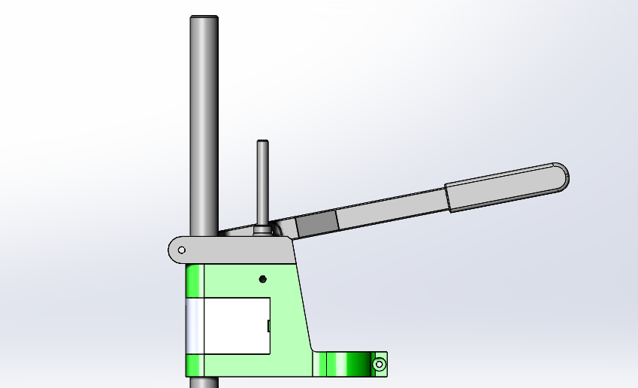Figure 6: close view of the shortened guide shaft without the clip fixing
Main Shaft
Guide Shaft (Shortened)
Top Brace Clamp

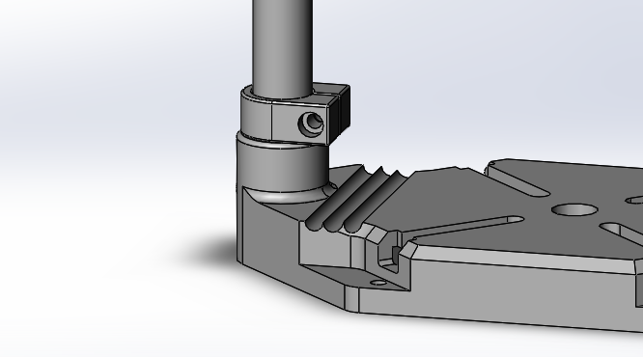
Figure 7: Image of the concept model, highlighting the support clamp in a red circle

The support clamp as seen in Figure 7 circled in red, can be removed as it is not an essential part of the assembly and does not add value to the drill press. the support clamp is a moulded plastic part that slides along the main shaft and can be fixed into place using a nut and bolt. The purpose of the support clamp is to work as a stopper allowing the user to create their own constraints on the movement of the drill press, however there is no way of accurately measuring where the clamp should be placed making the use of the clamp inaccurate. Removing the support clamp will not affect the functionality or the working efficiency of the product and will be one less component to produce and assembly while also reducing fixings.
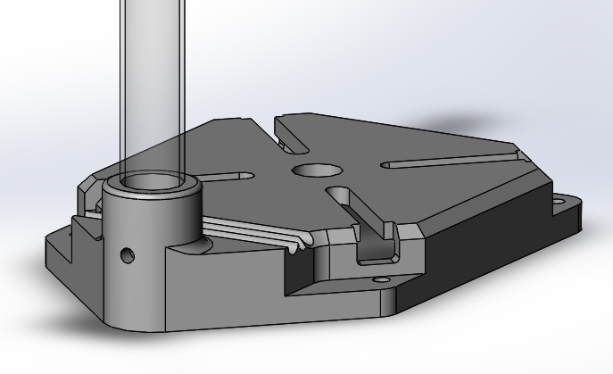
Figure 8: base with hole for bolt highlighted

Figure 8 shows a hole, highlighted in the red circle, which accommodates the bolt to hold the main shaft into place. To accommodate for the bolt the hole would need to be drilled and tapped to give it a thread matching the bolt. However, by welding the shaft into place this process can be removed.
The main shaft will be created by a process that incrementally curves a strip of sheet metal, in this case steel, until it can be welded down a seem and any access material is shaved off however the manufacturer of the pillar drill press will most likely purchase the steel stock as it is a commonly used material and can be bought for cheap in a large verity of sized and lengths.
The drill press base will be sand cast and then the top, or the working face of the bed will be machined to make create a flat smooth surface. The hole for the main shaft will then be finished with a drill to ensure a tight fit ensuring the top of the drill press won’t wobble during use. while the rest can be left with the uneven sand cast texture as it will not affect the performance of the product.
To further reduce the number of fixings the main shaft can be welded to the base of the drill press as they are both steel, so they do not need to be separated for recycling. This can be done before assembly of the full drill press.
The original concept model is made up of 8 modelled components. These components don’t include fixings such as clips, washers, nuts and bolts. The 8 modelled components also include a plastic grip which is integrated into the Lever arm part, Totalling to 9 core components in the concept model.
The grip design would be a moulded plastic part that will slide onto the end of the lever arm and bolted to fix it in place. Alternatively, the grip can be made from steel to avoid the need to separate for recycling. This could then be welded on as it would not need to be removed at the end of the products lifecycle eliminating the removable fixing and reducing the assembly time.

Conclusion
The Final concept model includes 9 parts, these parts are the Base, Main shaft, support clamp, top brace clamp, guide shaft, main sliding unit, link arm, lever arm, Grip and the main sliding unit cover. While remaining at the same number of components as the original model, many parts have been developed or eliminated to reduce the materials and processes used during the production process. the main sliding unit and the guide shaft have both had waste material removed making the product weigh less and easier to handle while also saving money on materials per component.
Changes have also been made in order to make the internal workings of the main sliding unit more accessible to the user allowing for a quick and easy assembly.
The changes made to the drill press concept model are the main sliding unit cutout, the main sliding unit cover, the removal of the guide shaft clip and reducing the length of the guide shaft. The support clamp has also been removed and the grip has been changed inorder to remove the fixings and make the product easier to recycle. The main shaft will also be welded rather than bolted into place.
The total number of fixings has been reduced from 8 to 5, with 4 of the fixings being standardized components and the final fixing being a snap fitting which is integrated into the components. This takes the number of aditional fixings down to 4.
Improvement chart
 | Original model | Redesigned model | Improvment
Number of components | 9 | 9 | 0
Number of fixings (Total) | 8 | 5 | 3
Screw fixings | 7 | 4 | 3

(the number of components in the table above considers the lever arm and grip as two separate parts, however, they are a single part within the solidworks model)

