LIVING WITH MULTIPLE SCLEROSIS

1 | Understanding multiple sclerosis
Multiple sclerosis is a chronic immune-mediated disease affecting the brain, spinal cord and optic nerves. Immune activity damages myelin and sometimes the underlying axons, interrupting nerve messages. Symptoms vary widely, and an individual’s experience cannot be predicted from diagnosis alone. MS is not infectious and there is no cure, although disease-modifying therapies (DMTs), rehabilitation and personalised support can improve outcomes (WHO, 2023; NICE, 2026a).
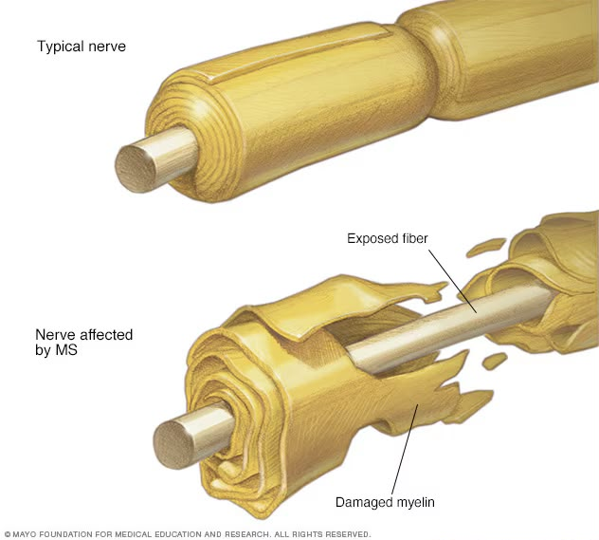
(Maya clinic, 2024)
Relapsing–remitting MS involves attacks followed by partial or substantial recovery; secondary progressive MS describes disability accumulation after a relapsing phase; and primary progressive MS involves progression from onset. These categories support clinical decisions but can hide fluctuations, invisible symptoms and individual priorities. The 2024 revised McDonald diagnostic criteria, incorporated into updated NICE guidance, combine clinical history, MRI and other investigations; faster diagnosis must still be balanced against the risk of misdiagnosis (NICE, 2026a; Montalban et al., 2025).

2 | Worldwide and UK burden
Worldwide | United Kingdom
3.1 million people; approximately 1 in 2,600 (MSIF, 2026). | More than 150,000 people; around 1 in 400 (MS Society, n.d.-a).
The global Atlas estimate draws on reporting from 133 countries covering 93% of the world’s population. Differences in case finding and surveillance mean figures should not be treated as exact counts or directly comparable snapshots. Increasing reported prevalence may reflect better diagnosis and survival, rather than a proportional increase in new disease (MSIF, 2026; Walton et al., 2020).
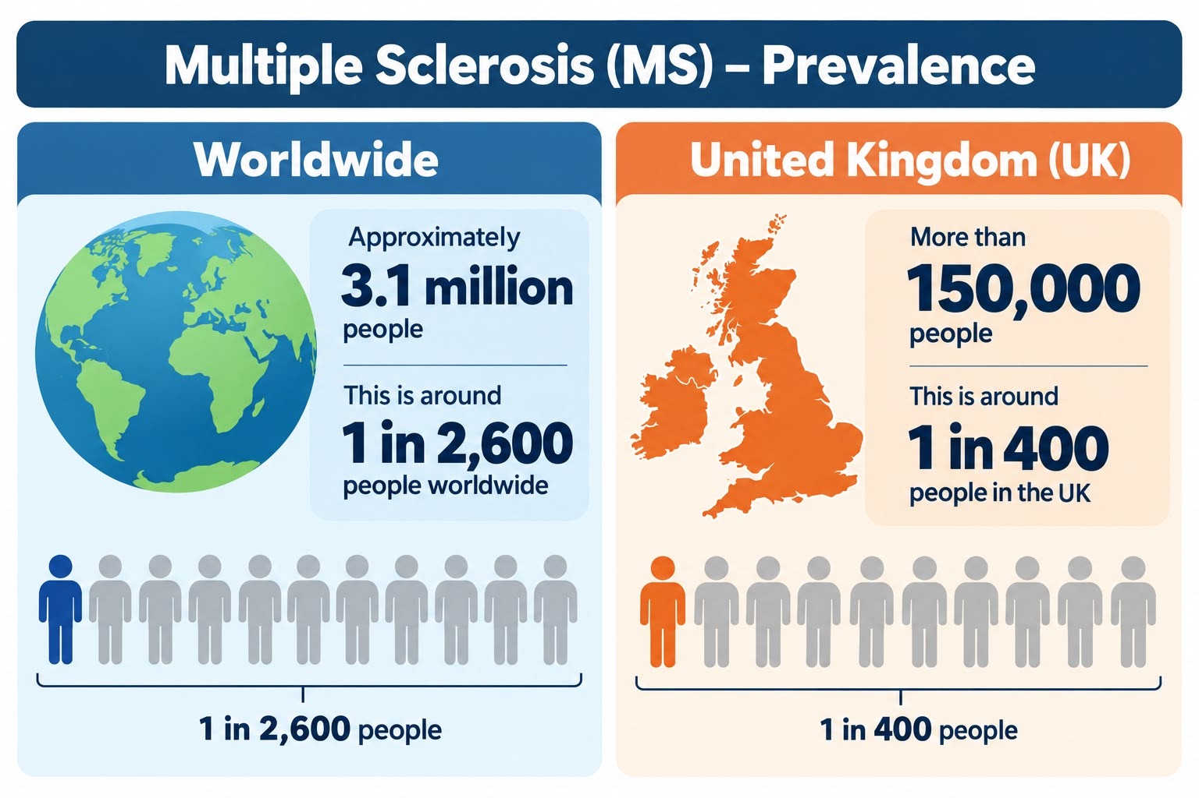
MS has consequences beyond neurology appointments: employment disruption, adaptations, rehabilitation, medicines monitoring and unpaid care create significant social and economic costs. Average estimates mask variation by disease severity, geography and household resources; planning based solely on headline prevalence risks missing people with complex needs (Neurological Alliance, 2024; MS Society, n.d.-b).

3 | Risk factors and aetiology

Factors people cannot readily change
Sex and age: MS is more common in women and is often diagnosed in early or middle adulthood; these are population patterns, not diagnostic tests (WHO, 2023; MSIF, 2026). Genetic susceptibility: having an affected relative increases risk, but MS is not inherited through a single deterministic gene (Reich et al., 2018). Epstein–Barr virus (EBV): longitudinal evidence strongly links previous EBV infection to later MS, although infection is common and cannot by itself explain who develops MS (Bjornevik et al., 2022).

Potentially modifiable exposures
Smoking is associated with MS susceptibility and poorer progression; cessation has clear wider health benefits (Hedström et al., 2013; NICE, 2026a). Childhood or adolescent obesity is linked with higher future risk, but this is probabilistic rather than individually causal (Munger et al., 2013). Low vitamin D status and reduced ultraviolet exposure are associated with risk, although observational studies are vulnerable to confounding and reverse causation; supplements are not established as a way to prevent MS (Ascherio et al., 2014; WHO, 2023).
Critical evualation: a strong association is not automatically proof that changing an exposure prevents MS. Risk communication should acknowledge uncertainty and avoid blaming people for a complex immune disorder. EBV research is compelling, but translation into preventive vaccination strategies remains an active research question (Bjornevik et al., 2022; Reich et al., 2018).

4 | Physical, psychological and social impact

Physical implications
Fatigue, weakness, visual disturbance, pain, spasticity, balance difficulties, bladder or bowel problems, sexual dysfunction and cognitive changes can limit daily activities (NHS, n.d.; NICE, 2026a). Fatigue may be severe despite little visible disability. Mobility scales and MRI are valuable, but alone they miss what matters to a person trying to work, parent or manage a home. Assessment should include patient-reported priorities and the effects of symptoms together, not as isolated complaints (NICE, 2026a; Compston and Coles, 2008).
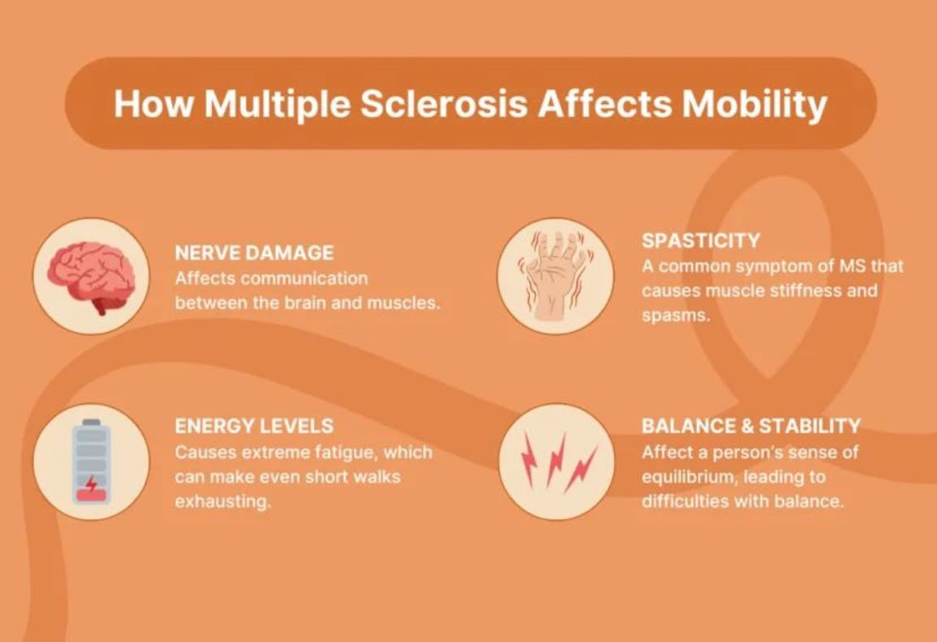
(NICE,2022)

Psychological implications
Uncertainty about relapse, independence and treatment can contribute to anxiety, depressed mood and changed identity. Cognitive fatigue may be misread as disinterest, damaging confidence and relationships. Depression is treatable and should not be dismissed as inevitable. Psychological interventions may help, but distress also reflects housing, money, stigma and service access; prescribing alone will not resolve those causes (Boeschoten et al., 2017; NICE, 2026a; Mind, n.d.).

Social implications and inequality
Unpredictable symptoms can disrupt education, employment, transport, parenting and social participation. Flexible working and reasonable adjustments may preserve employment, while inaccessible transport and fragmented care can worsen isolation. Social impacts differ by income, disability access and local service availability, so an identical care plan will not produce equitable outcomes (Equality Act 2010; MS Society, n.d.-b; Neurological Alliance, 2024).

Family and unpaid carers
Relatives may organise medicines, appointments, personal care and emotional support while managing paid work or school. Caring can be meaningful but may also produce fatigue, financial pressure and altered relationships. Children’s needs and the wishes of the person with MS must be considered explicitly. NICE recommends discussion of social-care needs and regular support reviews; the Care Act 2014 provides a framework for carers’ assessments in England. Assuming that families can always absorb more work is neither sustainable nor person-centred (NICE, 2026a; Care Act 2014; Carers UK, 2025).

5 | Evidence-based treatment through the NHS

Disease-modifying therapies
Specialist neurologists offer DMTs according to MS type, disease activity, eligibility, safety and patient preference. NHS options include ofatumumab, ocrelizumab, cladribine, ublituximab, fumarates and other agents for eligible relapsing disease; ocrelizumab is also an option for eligible early primary progressive MS. These medicines reduce inflammatory disease activity but do not cure MS, and require monitoring for infections and other harms. NICE technology appraisals and the NHS England algorithm guide access, while shared decision-making must address pregnancy plans, monitoring burden and individual risk tolerance (NICE, 2026a; NICE, 2025a; NICE, 2024a; NHS England, 2026a).

Relapse management and rehabilitation
Not every worsening symptom is a relapse: infection and other causes should be excluded. NICE advises timely assessment of functionally significant relapse and recommends oral methylprednisolone 0.5 g daily for five days, with intravenous treatment for selected severe situations. Steroids can shorten relapse symptoms but are not a substitute for long-term disease control. Physiotherapy, occupational therapy, speech and language therapy, continence care and neuropsychology address participation and independence (NICE, 2026a; NHS, n.d.).

Symptom management
Individualised exercise, fatigue self-management, energy conservation and cognitive behavioural techniques can help fatigue; baclofen may be considered for goal-directed spasticity management, with adverse effects reviewed. Pain, sleep, mood and bladder problems need separate assessment. Rehabilitation benefits depend on accessibility, continuity and realistic goals: a referral without timely appointments or transport support may have limited effect (NICE, 2026a; NICE, 2022b; Cochrane Rehabilitation, 2023).

6 | Two models for improving long-term outcomes

UK model: NHS personalised care / social prescribing
NHS England’s Comprehensive Model for Personalised Care emphasises shared decision-making, personalised care and support planning, supported self-management, social prescribing, personal health budgets and choice. For MS, a link worker may connect someone to peer support, accessible exercise or welfare advice, complementing specialist treatment. Its strength is attention to what matters beyond MRI outcomes. Its weakness is uneven local voluntary-sector capacity and the risk that referral to community resources substitutes for adequately funded clinical care (NHS England, 2019; NHS England, 2023a; NICE, 2021a).
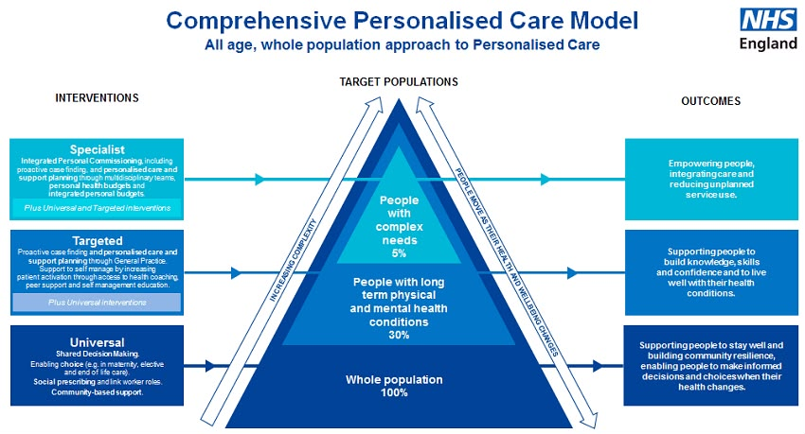
(NHS, 2024)

International model: Chronic Care Model
Wagner’s Chronic Care Model brings together informed patients, proactive multidisciplinary teams, decision support, clinical information systems, self-management support and community resources. In MS, structured annual reviews and accessible specialist advice could reduce fragmented care. However, the model originated in a different healthcare context and assumes resources and digital infrastructure that may not be equally available. It should be adapted with equity measures and patient-defined outcomes rather than implemented as a checklist (Wagner et al., 2001; WHO, 2016; NICE, 2026a).
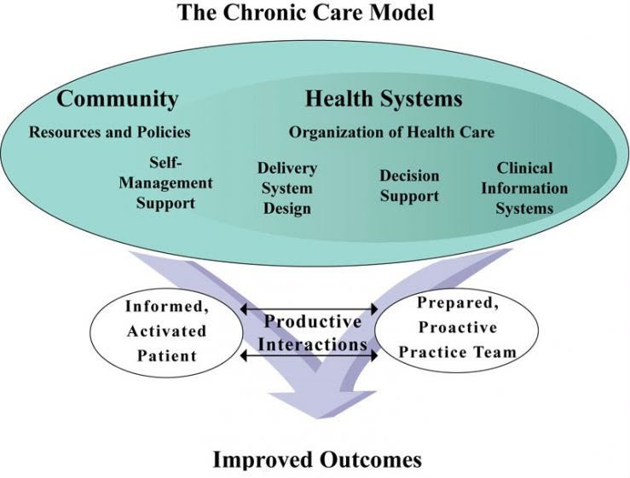

Comparison: personalised care places stronger emphasis on personal goals and community connection; the Chronic Care Model emphasises reliable system organisation. Combining the two offers a stronger approach than either alone, provided that continuity, language access and carer support are measured (NHS England, 2019; Wagner et al., 2001).

7 | National and local health and social-care agendas

National implementation
The NHS Long Term Plan and NHS personalised care policy promote prevention, integrated services and supported self-management. NICE NG220 specifies coordinated multidisciplinary care, a named contact and at least annual comprehensive review; NICE appraisals and NHS England prescribing algorithms aim to standardise access to DMTs (NHS England, 2019; NICE, 2026a; NHS England, 2026a). The Health and Care Act 2022 strengthened integrated care systems (ICSs), while the Care Act 2014 establishes duties relevant to adult social care and carers. These frameworks support joined-up care in principle, but workforce shortages, delayed rehabilitation and differences in local commissioning can undermine delivery (Health and Care Act 2022; Care Act 2014; Neurological Alliance, 2024).

Local implementation: an England ICS example
At local level, an integrated care board (ICB), NHS trust, general practice, council social-care services and voluntary organisations should agree referral pathways for neurology, rehabilitation, mental health and social prescribing. A practical local initiative would provide an MS nurse contact, rapid relapse advice, accessible annual review and referral tracking. This is a proposed implementation framework rather than a claim that every ICB already offers these services. It requires co-design with people living with MS, budget ownership and publication of outcomes by deprivation and disability to identify gaps (NHS England, 2023b; NICE, 2026a; NHS England, 2022).
Critical evaluation: policy success cannot be judged by publishing pathways alone. Commissioners should examine time to diagnosis, DMT access, missed appointments, therapy waiting times, patient experience, employment participation and carer wellbeing. Digital-first systems may improve convenience for some but exclude those with cognitive, sensory or connectivity barriers unless non-digital alternatives remain available (NHS England, 2023b; Equality Act 2010).

8 | Recommendations: person-centred care and self-management
- Offer an early, understandable discussion of diagnosis, prognosis uncertainty and DMT options, with accessible written information and a follow-up appointment within six weeks (NICE, 2026a; NICE, 2021a).
- Co-produce a care plan with the person’s own goals, an MS nurse contact, annual multidisciplinary review and rapid re-entry when symptoms change (NICE, 2026a; NHS England, 2019).
- Provide supported self-management: fatigue pacing, safe physical activity, smoking cessation, vaccination advice, symptom diaries and clear relapse escalation guidance, without placing all responsibility on patients (NICE, 2026a; WHO, 2016).
- Integrate mental health, occupational support, welfare rights, social prescribing and accessible transport into routine assessment; evaluate uptake across disadvantaged groups (NHS England, 2023a; Equality Act 2010).
- Ask carers separately about strain, consent and support needs; offer information about assessments and respite and consider young carers (Care Act 2014; Carers UK, 2025).
- Measure outcomes that matter to patients—fatigue, participation, independence and experience—alongside relapse and MRI indicators (NICE, 2026a; Wagner et al., 2001).

9 | Advanced disease and end-of-life care
MS is not automatically a terminal illness, and many people live for decades with the condition. However, severe progressive disability, recurrent infection, swallowing problems or other complications may justify palliative care involvement. Palliative care is not synonymous with stopping active treatment: it can improve comfort, communication and family support alongside neurological care. Sensitive advance care planning should reflect the person’s values and may cover preferred place of care, future decision-making and treatment limits, without pressuring anyone to make choices prematurely (NICE, 2026a; NICE, 2019; NHS England, 2022).
The priority is to preserve dignity and autonomy, assess pain and distress, coordinate community nursing and specialist palliative services where appropriate, and provide bereavement support to families. Discussions should be revisited as circumstances change, especially if cognition or communication deteriorates (NICE, 2019; NICE, 2026a).

10 | Conclusion
MS illustrates why long-term condition management must go beyond medicines. Modern DMTs can reduce disease activity for eligible patients, but fatigue, emotional uncertainty, work disruption and carer strain remain major concerns. Combining coordinated NHS care with personalised support and equitable local services offers the strongest route to better quality of life. The test of policy is whether people experience timely, continuous and meaningful support—not simply whether a service pathway exists.

Reference list
- Ascherio, A. et al. (2014) “Vitamin D as an early predictor of multiple sclerosis activity and progression”, JAMA Neurology, 71(3), pp. 306–314. https://doi.org/10.1001/jamaneurol.2013.5993.
- Bjornevik, K. et al. (2022) “Longitudinal analysis reveals high prevalence of Epstein–Barr virus associated with multiple sclerosis”, Science, 375(6578), pp. 296–301. https://doi.org/10.1126/science.abj8222.
- Boeschoten, R.E. et al. (2017) “Prevalence of depression and anxiety in multiple sclerosis: a systematic review and meta-analysis”, Journal of the Neurological Sciences, 372, pp. 331–341. https://doi.org/10.1016/j.jns.2016.11.067.
- Care Act 2014, c.23. Available at: https://www.legislation.gov.uk/ukpga/2014/23/contents.
- Carers UK (2025) State of Caring. Available at: https://www.carersuk.org/for-professionals/policy/policy-library/.
- Cochrane Rehabilitation (2023) Rehabilitation evidence resources. Available at: https://rehabilitation.cochrane.org/.
- Compston, A. and Coles, A. (2008) “Multiple sclerosis”, The Lancet, 372(9648), pp. 1502–1517. https://doi.org/10.1016/S0140-6736(08)61620-7.
- Equality Act 2010, c.15. Available at: https://www.legislation.gov.uk/ukpga/2010/15/contents.
- Health and Care Act 2022, c.31. Available at: https://www.legislation.gov.uk/ukpga/2022/31/contents.
- Hedström, A.K. et al. (2013) “Smoking and two human leukocyte antigen genes interact to increase the risk for multiple sclerosis”, Brain, 136(3), pp. 653–664. https://doi.org/10.1093/brain/awt003.
- Mind (n.d.) Mental health information and support. Available at: https://www.mind.org.uk/information-support/.
- Montalban, X. et al. (2025) “Diagnosis of multiple sclerosis: 2024 revisions of the McDonald criteria”, The Lancet Neurology. Available at: https://pubmed.ncbi.nlm.nih.gov/?term=2024+revisions+McDonald+criteria+multiple+sclerosis.
- MS International Federation (MSIF) (2026) Number of people living with MS across the world surpasses 3 million for the first time. Available at: https://www.msif.org/news/2026/09/11/over-3-million-with-ms/.
- MS Society (2021) Causes of MS. Available at: https://www.mssociety.org.uk/about-ms/what-is-ms/causes-of-ms.
- MS Society (n.d.-a) MS in the UK. Available at: https://www.mssociety.org.uk/about-ms/what-is-ms/ms-in-the-uk.
- MS Society (n.d.-b) Work and money. Available at: https://www.mssociety.org.uk/living-with-ms/work-and-money.
- Munger, K.L. et al. (2013) “Childhood body mass index and multiple sclerosis risk: a long-term cohort study”, Multiple Sclerosis Journal. Available at: https://pubmed.ncbi.nlm.nih.gov/?term=childhood+body+mass+index+multiple+sclerosis+Munger.
- National Institute for Health and Care Excellence (NICE) (2019) End of life care for adults: service delivery (NG142). Available at: https://www.nice.org.uk/guidance/ng142.
- National Institute for Health and Care Excellence (NICE) (2021a) Shared decision making (NG197). Available at: https://www.nice.org.uk/guidance/ng197.
- National Institute for Health and Care Excellence (NICE) (2022b) Medicines associated with dependence or withdrawal symptoms (NG215). Available at: https://www.nice.org.uk/guidance/ng215.
- National Institute for Health and Care Excellence (NICE) (2024a) Ublituximab for treating relapsing multiple sclerosis (TA1025). Available at: https://www.nice.org.uk/guidance/ta1025.
- National Institute for Health and Care Excellence (NICE) (2025a) Cladribine for treating relapsing multiple sclerosis (TA1053). Available at: https://www.nice.org.uk/guidance/ta1053.
- National Institute for Health and Care Excellence (NICE) (2026a) Multiple sclerosis in adults: management (NG220), updated 3 June 2026. Available at: https://www.nice.org.uk/guidance/ng220.
- Neurological Alliance (2024) Optimal clinical pathway for adults with neurological conditions. Available at: https://www.neural.org.uk/.
- NHS (n.d.) Multiple sclerosis. Available at: https://www.nhs.uk/conditions/multiple-sclerosis/.
- NHS England (2019) The NHS Long Term Plan. Available at: https://www.longtermplan.nhs.uk/.
- NHS England (2022) Palliative and end of life care: statutory guidance for integrated care boards. Available at: https://www.england.nhs.uk/eolc/.
- NHS England (2023a) Social prescribing. Available at: https://www.england.nhs.uk/personalisedcare/social-prescribing/.
- NHS England (2023b) Integrated care systems. Available at: https://www.england.nhs.uk/integratedcare/.
- NHS England (2026a) Treatment algorithm for multiple sclerosis disease-modifying therapies, updated 5 August 2026. Available at: https://www.england.nhs.uk/publication/treatment-algorithm-for-multiple-sclerosis-disease-modifying-therapies/.
- NHS England (n.d.) Comprehensive model for personalised care. Available at: https://www.england.nhs.uk/personalisedcare/comprehensive-model-of-personalised-care/.
- Reich, D.S., Lucchinetti, C.F. and Calabresi, P.A. (2018) “Multiple sclerosis”, New England Journal of Medicine, 378, pp. 169–180. https://doi.org/10.1056/NEJMra1401483.
- Wagner, E.H. et al. (2001) “Improving chronic illness care: translating evidence into action”, Health Affairs, 20(6), pp. 64–78. https://doi.org/10.1377/hlthaff.20.6.64.
- Walton, C. et al. (2020) “Rising prevalence of multiple sclerosis worldwide: insights from the Atlas of MS, third edition”, Multiple Sclerosis Journal, 26(14), pp. 1816–1821. https://doi.org/10.1177/1352458520970841.
- World Health Organization (WHO) (2016) Framework on integrated, people-centred health services. Available at: https://www.who.int/teams/integrated-health-services/clinical-services-and-systems/service-organizations-and-integration.
- World Health Organization (WHO) (2023) Multiple sclerosis. Available at: https://www.who.int/news-room/fact-sheets/detail/multiple-sclerosis.

