Reflective Report: Principles of Health and Social Care Practice
ANISA KARIM
2407467

Table of Contents
Introduction 3
Task 1: Reflection on the Importance of Principles 3
Task 2: Practical Examples of Concepts in Practice 4
Task 3: Self-Reflection as a Health and Social Care Professional 6
Reference List 10

Introduction
Providing quality health and social care in the United Kingdom is supported by a series of fundamental principles which are aimed at safeguarding the service users and the attainment of professional excellence. In this report, a critical reflection approach will be used to consider three main pillars including person-centred care, partnership working and ethical practice. Discussing these notions in theoretical terms, practical contexts, and self-reflection, the given assignment aims at proving how they improve the results of care and form the image of the contemporary healthcare professional.

Task 1: Reflection on the Importance of Principles
The importance of person-centred practice, collaboration and teamwork, and ethics cannot be overemphasised in the framework of the National Health Service (NHS) of the UK and the sphere of social care. These principles, however, are not just plain social constructs but are ingrained in the law and professional codes of conduct to safeguard the safety and human dignity of people.

Person-Centred Care
Person-centred care in its simplest form can simply be described as a move away of the one-size-fits-all model of medical care and to instead a holistic approach that takes into consideration the values and preference of the person. Rogers (1951) listed empathy, congruence, and unconditional positive regard as the needed humanistic care components. This in practice entails the consulting of service user in all decisions in respect to treatment. The significance of such a principle is emphasised by the Care Quality Commission (CQC, 2023), which states that person-centredness is one of the markers of outstanding rating of a service. Placing the patient at the centre will allow care providers to minimize health disparities and enhance patient satisfaction.

Partnership Working
Partnership working This is the teamwork approach between the various professionals (multidisciplinary teams), organisations, and even the service users. Health and Social Care Act (2022) underlines the importance of the duty to collaborate as complex health needs may involve the involvement of social workers, GPs, nurses, and therapists at the same time. The partnership working helps to avoid the silo effect, which is the loss of information between the departments and may result in the failure of care. Glasby (2017) believes that integrated care is the key to the long-term management of the long-term diseases that are widespread amongst the aging population.

Ethical Decision-Making
Ethics offers the moral of the medical context. Biomedical ethics have four pillars that include autonomy, beneficence, non-maleficence, and justice; these help professionals to make challenging decisions (Beauchamp and Childress, 2019). The autonomy is extremely critical, because it provides the right of a patient to refuse to be treated with the assistance of Mental Capacity Act (2005). Ethics make sure the provision of care to a person is just (justice) and the results of an intervention at all times outnumber the risks (beneficence and non-maleficence). The lack of solid ethical background would damage the trust between the people and the healthcare system.
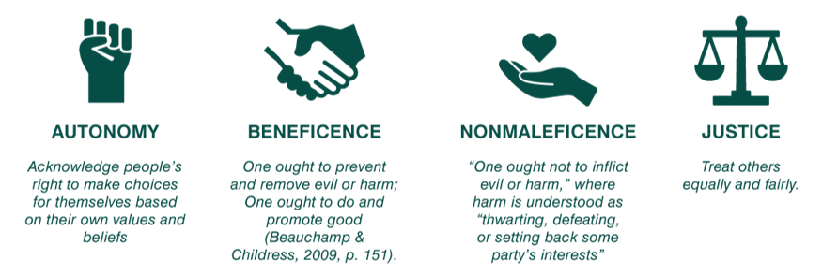
Figure 1: 4Pillars

Task 2: Practical Examples of Concepts in Practice
As an example of these principles we can refer to the case of Mrs. A, a 82-year-old female patient with problems with physical mobility and at an early stage of dementia, but she wants to stay at her home because she has fallen on several occasions.
Application of Person-Centred Care
It is in this case that person-centred care was employed by using a What Matters to Me assessment instead of a clinical risk assessment. Although the clinical staff was worried about the possibility of additional falls, Mrs. The greatest value she placed in her independence and affiliation to her local community. Through honoring her decision to remain at home, the care staff applied the concept of a positive risk-taking, which is the idea advocated by the Care Act (2014), which states that local authorities should foster individual well-being.

Partnership Working in Action
To support Mrs. A multidisciplinary team (MDT) meeting was called upon to fulfill the wish of A. This involved her GP, a local occupational therapist (OT) and a social worker and Mrs. A’s daughter. Home modifications were prescribed by the OT with a community warden scheme also being arranged by the social worker. This partnership guaranteed the distribution of the load of care and that Mrs. One of them had a smooth home-hospital transition. This is consistent with the NICE (2018) recommendations regarding the topic of peoples experience in adult social care services, it supports the idea of achieving the optimal coordination of care transfer to achieve better outcomes.

Addressing Ethical Challenges
There was an ethical issue of Mrs. A’s ability to comprehend the dangers of single living. The staff needed to strike balance between beneficence (safekeeping her against falls) and autonomy (her right to decide how she is to be housed). The team decided that Mrs. had the best interests by using the Mental Capacity Act (2005) "best interests" framework. A was able to make this particular decision. The issue of resource allocation (justice) was also resolved by making the home changes effective in comparison to the expensive price of a placement in a residential care institution. This practical use demonstrates that these principles are both not merely theoretical provisions but also valuable tools and means to overcome the challenges of the modern UK healthcare.
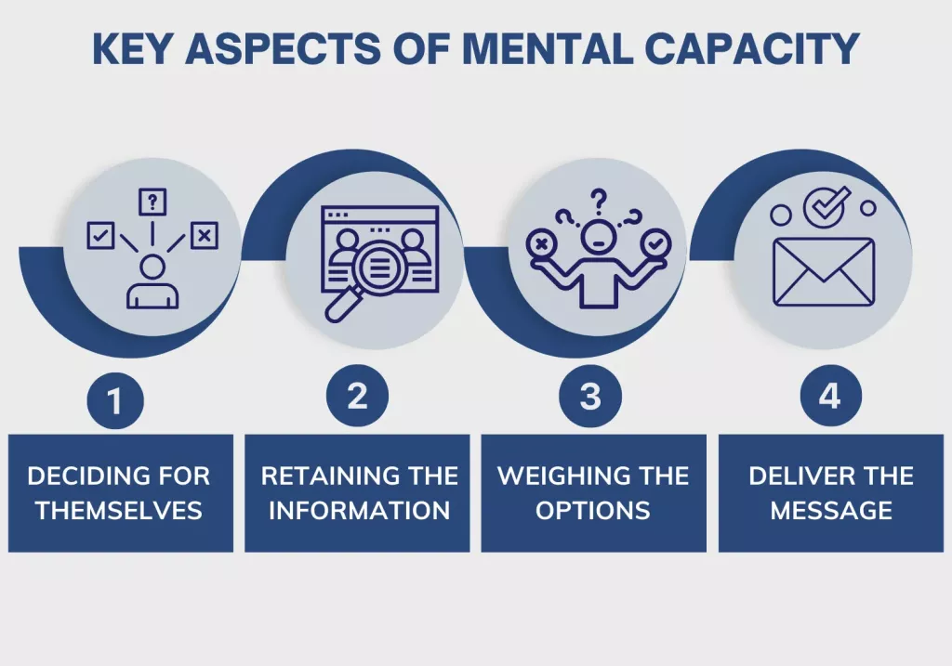
Figure 2: the Mental Capacity Act (2005) "best interests" framework

Task 3: Self-Reflection as a Health and Social Care Professional
Since I will be working as a future health and social care professional, I see that I will have to base my daily activities on the principles of person-centredness, partnership and ethics. This part makes use of the first-person perspective to examine my existing capabilities, developmental priorities and a professional development plan.

Influence of Principles on My Daily Practice
Person-centred care is not a policy; it is my prism when regarding my everyday work. I got to know that communication is not the flow of information but an essential form of therapy. Through active listening and an open posture, one of the roles I can perform is validation of lived experiences of service users. This is much closer to the Hierarchy of Needs (1943) by Maslow. Precisely, by making a patient feel heard and respected, I am meeting its needs of the Esterem category. A patient who does not satisfy these psychological needs may not possess the drive/motivation/self-efficacy involvement in rehabilitation or self-management of their condition. Person-centredness will prevent me from adopting a clinical-only view of the issue, but a holistic social model of care, through treating the person behind the diagnosis.
Partnership also predisposes my professional conduct by reminding me about the importance of the inter-professional respect. Different departments can easily join forces in a high-pressure facility such as the NHS. I also make an effort to close these gaps by creating clear and brief documentation and acting proactively to seek feedback on matters by people in other fields. An example is that in case of the recognition of a possible safeguard problem or a complicated nutrition need, I know that it is my mandate to facilitate, which entails the involvement of other experts like social workers or dieticians in ensuring comprehensive care. Such a collaborative attitude acknowledges the fact that the service user is best off when the web of care is closely knit and communicative.
Ethics are my guide in terms of morality, especially in matters of balancing confidentiality and safety. I am consciously using the ethical framework as stipulated by the Data Protection Act (2018) every time I work with sensitive patient data. In addition, the principle of autonomy may be the most challenging issue in the daily practice most of the time. I have understood that observing the right of a service user to take unwise decisions, which the Mental Capacity Act (2005) guarantees their right to, is one of the core features of ethical maturity. It makes me overcome my paternalistic instincts and merely give the individual every bit of information he or she requires to make a sound decision.

Detailed Skills Assessment and SWOT Analysis
To make my development go, I have performed a SWOT analysis on my professional portrait in detail:
- Strengths: My main strength is high level of emotional intelligence and interpersonal communication. I can also rate building rapport with service users with diverse background quite fast, and this is necessary in establishing trust. Moreover, I possess a strong that has developed a strong foundation in the Care Act (2014) and how well being of individuals should be promoted in any care environment.
- Weaknesses: I also encounter some weaknesses in that I find myself getting overwhelmed whenever I have to make a decision related to the ethical aspect mainly to make decisions based on the principle of "Justice" verses the principle of Beneficence. An illustration here is when there are scarce resources, I experience difficulty with the emotional challenge involved in prioritising the patient and denying the attention the other patient needs. Moreover, I know very little about the particular local authority funding processes, and it is a technical area of my professional that lacks.
- Opportunities: The advent of Health and Social Care Act (2022) and the establishment of Integrated Care Boards (ICBs) is an extensive opportunity to me to study about large-scale strategic partnership working. I also would like to explore the digital health technologies that will allow improving the person-centred monitoring and patient involvement.
- Threats: The present situation in the care sector in the UK, which is marked by a high turnover of staff and their elevated burnout, is a threat to my personal capacity to retain the high quality of care I hope to. There exists a threat that the tasks-oriented care will replace the person-centred care because of time limitations.
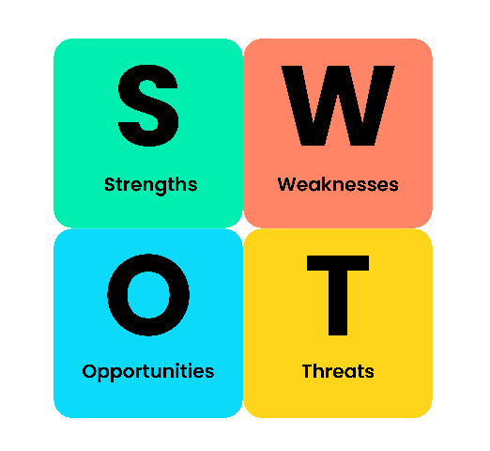
Figure 3: SWOT

Linking Theory to Professional Growth
Professional accountability heavily depends on the connection between the theory and practice. It is a lesson of Maslows theory that a patient cannot concentrate on the Self-Actualisation or complicated medical healing when his/her needs have not been satisfied in the categories of Safety or Physiological. As such, my practice will provide comforts such as warmth, food, and use of security first before other medical interventions.
Also, professional codes of conduct, including the Nursing and Midwifery Council (NMC, 2018) or the Health and Care Professions Council (HCPC) offer the ethical foundations of my career. According to these codes, I am required to lead people first and then practice effectively. Considering these codes makes me understand that being a professional is a process of becoming as opposed to being a destination. I need to always compare my activities with such norms so that I could be confident not only doing a job, but than maintaining a trust dedicated to the people.

Strategic Plan for Future Enhancement
To enhance my professional capability, I have developed a three-part strategic action plan for the next twelve months:
- Specialist Ethical Training (CPD): I will take a certified course related to the Mental Capacity Act (2005) and Deprivation of Liberty Safeguards (DoLS). This will specifically solve my weakness in how to deal with ethical dilemmas by equipping me with legal and moral framework of making difficult decisions without hesitation or blame.
- Multidisciplinary Immersion: I will arrange shadowing days with other professionals who are not within my area of practice, including occupational therapists and community mental health teams. Through this knowledge about the unique experiences and terminologies of other partners, I will be able to add value to multidisciplinary team (MDT) meetings, which will further improve the quality of integrated care.
- Gibbs Reflective Cycle Adoption: To make sure that my learning is not interrupted, I would apply the Gibbs (1988) Reflective Cycle following completion of every complex case. The process of going through the descriptions, feeling, evaluation, analysis, conclusion, and the plan of action can help me to convert all the difficult experiences into the learning process. This will help my practice not turn to a stagnated point and make it person-centred and evidence-based.

Conclusion
The UK health and social care is governed by the principles of person-centred care, partnership working and ethics which form the core. This reflection has made me understand that they are not rules but dynamic practices that should always be taken care of, involving emotional work and self-criticism. Following these rules, utilising legislative provisions such as the Care Act (2014), and being targeted on the well-being of each person, I will be able to make contributions to a healthcare system that will not only be efficient but also highly caring and fair.

Reference List
Beauchamp, T.L. and Childress, J.F. (2019) Principles of Biomedical Ethics. 8th edn. Oxford: Oxford University Press.
Care Act 2014, c. 23. Available at: https://www.legislation.gov.uk/ukpga/2014/23/contents
Care Quality Commission (CQC) (2023) The State of Health Care and Adult Social Care in England 2022/23. London: CQC. Available at: https://www.gov.uk/government/publications/state-of-health-and-adult-social-care-in-england-2023-to-2024
Data Protection Act 2018, c. 12. Available at: https://www.legislation.gov.uk/ukpga/2018/12/contents
Gibbs, G. (1988) Learning by Doing: A Guide to Teaching and Learning Methods. Oxford: Further Education Unit.
Glasby, J. (2017) Evidence-Based Practice in Health and Social Care. 2nd edn. Bristol: Policy Press.
Health and Care Professions Council (HCPC) (2016) Standards of Conduct, Performance and Ethics. London: HCPC. Available at: https://www.hcpc-uk.org/standards/standards-of-conduct-performance-and-ethics/
Health and Social Care Act 2022, c. 31. Available at: https://www.legislation.gov.uk/ukpga/2022/31/contents
Maslow, A.H. (1943) ‘A theory of human motivation’, Psychological Review, 50(4), pp. 370–396.
Mental Capacity Act 2005, c. 9. Available at: https://www.legislation.gov.uk/ukpga/2005/9/contents
National Institute for Health and Care Excellence (NICE) (2018) People’s experience in adult social care services: improving the experience of care and support for people using adult social care services. London: NICE. Available at: https://www.nice.org.uk/guidance/ng86
Nursing and Midwifery Council (NMC) (2018) The Code: Professional standards of practice and behaviour for nurses, midwives and nursing associates. London: NMC. Available at: https://www.nmc.org.uk/standards/code/
Rogers, C.R. (1951) Client-Centered Therapy: Its Current Practice, Implications and Theory. London: Constable.
Thompson, N. (2021) Anti-Discriminatory Practice: Equality, Diversity and Social Justice. 7th edn. London: Red Globe Press.
World Health Organisation (WHO) (2015) WHO Global Strategy on People-Centred and Integrated Health Services. Geneva: WHO. Available at: https://www.who.int/health-topics/integrated-people-centered-care

